
EPISODE 23
18 August 2026

KEY LEARNING
Students will explore the topics explained in the BTN Science Week 2026 Special including agricultural science, cultural burning, living on Mars and a school seed program.

CURRICULUM
Science – Year 5
Examine how particular structural features and behaviours of living thins enable their survival in specific habitats.

Science – Year 6
Investigate the physical conditions of a habitat and survival of living things is affected by changing physical conditions.

Science – Year 5 & 6
Investigate how scientific knowledge is used by individuals and communities to identify problems, consider responses and make decisions.

HASS Year 5
The impact of the development of British colonies in Australia on the lives of First Nations Australians, the colonists and convicts, and on the natural environment.
Design and Technologies – Years 5 & 6
Explain how and why food and fibre are produced in managed environments.

  - Teacher Resource

Science Week 2026

Focus Questions
As a class, discuss the stories featured in the BTN Science Week 2026 Special. Students will then respond to the following focus questions:

Agricultural Science
- How did most humans find food before agriculture began?
- What is thought to have encouraged people to start planting crops?
- Name two ways modern agriculture can have a negative impact on the environment.
- Give two examples of new technologies being developed to make farming more sustainable.
- Why do you think the development of agriculture is described as changing the world forever? Use examples from the BTN story to support your answer.

Cultural Burning
- What percentage of Australia's native plants respond positively to fire?
  - 25%
  - 50%
  - 75%
- How do the seeds from Banksia plants respond to fire?
- How can ash from fires help seeds grow?
- How are cultural burns different to naturally occurring bushfires?
- What are some ways you can learn about Country? Give 1-2 examples.

Living on Mars
- What type of planet is Mars?
  - Rocky planet
  - Gas giant
  - Ice giant
- Mars is considered the most Earth-like planet in our Solar System. True or false?
- What is Mars’ atmosphere mainly made of?
- Why can’t humans live on Mars right now? Give 2-3 reasons.
- What are some challenges scientists need to overcome to send humans to Mars?

Seed School
- What is the purpose of the SEEDS program?
- What does SEEDS stand for?
- A lot of Australian native plants are at risk of disappearing. True or false?
- Why are Australian native plant species becoming endangered? Give 2-3 reasons.
- Choose one native plant species from the BTN story. Draw a botanical drawing of the plant and include its scientific name.

Activity: Agricultural Science Key Words
Students will brainstorm a list of key words that relate to the BTN Agricultural Science story. Here are some words to get them started. Ask students to write what they think is the meaning of each word then check these against the dictionary definition.

Sustainable Farming
Methane
Neolithic Revolution
Domesticated
Agriculture
Hunter and Gatherer
Biodiversity
Deforestation

Activity: What’s in your lunchbox?
Introduce your students to the idea of food production, resources and the development of agriculture. Working in pairs, ask students to look at their lunch or imagine a typical meal. Choose one item of food and discuss:
- Where did it come from?
- How was it grown or produced?
- What resources were needed?
- How might people have got this food 12,000 years ago?

Reflect on the following questions:
- What was the most surprising thing you discovered about your food?
- What did you learn about where your food comes from?
- How did this activity change the way you think about the food you eat?
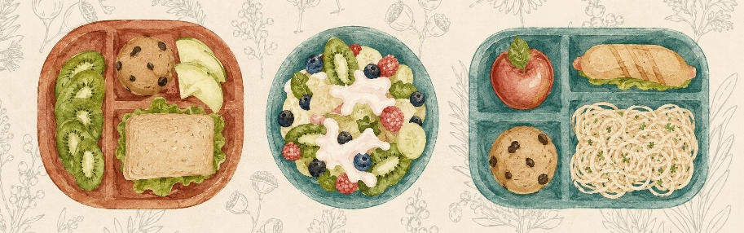

Activity: Investigating Agriculture
Students will investigate how agriculture has changed over time and how farming has shaped people, places and the environment. Choose one or more of the questions below to explore.

Investigate the past
- Why did some communities begin growing crops instead of only hunting and gathering food?
- How did changes in Earth’s climate influence the development of agriculture?
- How did agriculture change the way humans lived?
- How did farming contribute to the growth of cities and civilisations?

Investigate Australia
- How have First Nations Peoples cared for and managed Country?
- How did European farming practices change Australian landscapes after colonisation?
- What environmental challenges do Australian farmers face?

Investigate the environment
- What impact does modern farming have on the environment and biodiversity?
- How can science and technology help farmers produce food more sustainably?
- What are some innovative ways scientists are trying to feed a growing global population?
- If you could invent one new farming technology, what would it do? What problem does it solve?

Activity: Design a farm for the future
Ask students to imagine what might farming look like 100 years from now. They will create a labelled diagram of a farm that could operate for the next 100 years. Their diagram should show:
- Crops
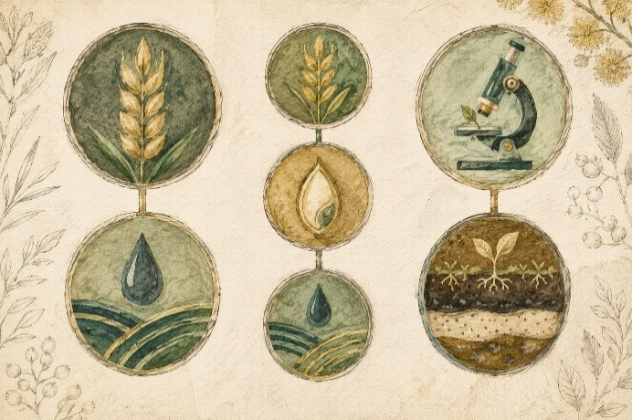
- Animals
- Water sources and irrigation
- Native vegetation
- Habitat for wildlife
- Ways to reduce waste
- Ways to protect soil
- Farming technology
- Renewable energy
- A strategy for reducing environmental degradation

Students write 150–200 words explaining how their farm balances food production and environmental protection.

Activity: Cultural Burning
Students will learn more about First Nations fire practices. After watching the BTN Cultural Burning story, hold a class discussion using the following discussion starters.
- What do you THINK about what you saw in this video?
- What does this video make you WONDER?
- What did you LEARN watching the the BTN Cultural Burning story?
- Think of three questions you would like to ask about the BTN story.

Resources
These ABC Education videos show Indigenous fire practitioners explaining cultural burning. They explore how this practice helps manage the land and lowers the risk of large bushfires.

The Kimberley: Traditional burns
Big Weather: Benefits of Indigenous fire practices video.

Class Discussion
After watching the videos, students can discuss and respond to the following questions:

- What is cultural burning?
- What is a `cool burn’?
- How is cultural burning different to a hazard reduction burn?
Think Pair Share
Students use the TPS strategy to answer this question: How can fire protect and restore the environment?
- Why is protecting the tree canopy important during a cultural burn?
- How can cultural burning help biodiversity?
- What is mosaic burning in cultural burns?
- Why is local knowledge important when managing fire?
- Fire management is part of how First Nations Peoples look after Country. What does this mean?
- How can we learn from First Nations Peoples about caring for Country?

Venn Diagram
Ask students to create a Venn diagram comparing a `hazard reduction burn’ done by emergency services with a traditional `cultural burn’ led by Traditional Owners. Share your diagram with a classmate.



Hazard reduction burn
Cultural burn

Activity: Why do seeds love fire?
Research a native Australian animal or plant (for example; the echidna, grass tree or banksia).
How does it survive a low-intensity cultural burn? What adaptations does it have? What benefits does it get from the new growth that happens just weeks after the fire?

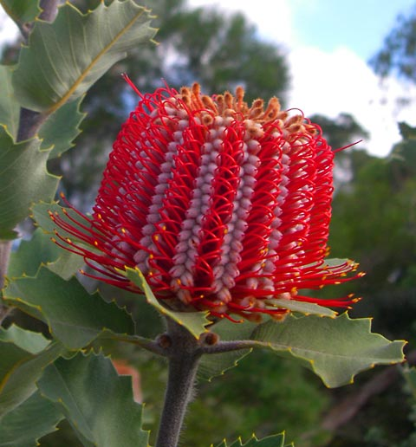  Banksia | 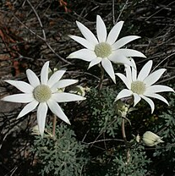  Flannel flowers

Activity: Mars Q&A
Are you curious about Mars? Students will make a list of questions they have about the BTN Living on Mars story and space exploration. Students will use the internet to find answers to their questions and share their findings with the class. Students will use the facts they have discovered about Mars to create a quiz and then test their classmates.


Why do we study planets?
What do you know about Mars?

Activity: Life on Mars
Students will plan and design a settlement on Mars that will sustain human life. The following questions can help guide students’ research:
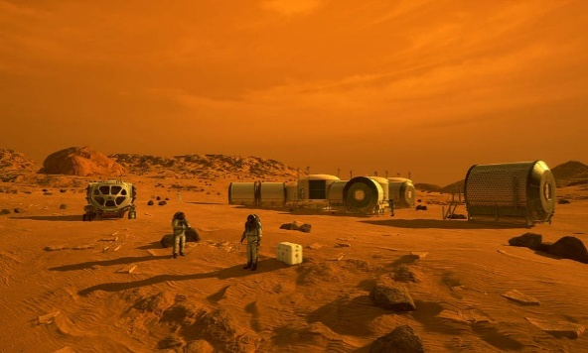
- What are the conditions like on Mars?
- What needs to be considered when planning a colony on Mars? For example:
  - Water supply
  - Atmosphere (air supply)
  - Temperature
  - Food production
  - Gravity
  - Waste management
Further Learning
Write a science fiction story about your journey to Mars and what you found when you arrived.
- What materials could be used to build a space settlement?
- Create and advertisement or poster to advertise your colony.

Activity: Australian Native Seeds
Class Discussion
Discuss the BTN Seed School story as a class, using the following questions to guide the discussion.
- What is the difference between an Australian native plant and an introduced plant?
- Why do we need native plants?
- What native plants do you know? Make a list.
- What things are threatening our native plants?
- What are seed orchards?
- Why is it important to collect native seeds?

Get to know the plants in your school yard
- Students choose a plant in their school grounds.
- Describe the plant they have chosen using words and an illustration. Describe the different parts of the plant and any other interesting features.
- Can students identify what type of plant it is? Find its botanical name.
- Is the plant native or an introduced species?
- Are there any bugs or wildlife on or near the plant? Make and describe observations, include sketches.
- How much sun, shade and water does the plant get?

Improve the biodiversity in your school yard
Students will work together to plant and care for native plants in their school yard. Ask them to consider the following:
- Which plants are native to your area? What kind of native plants will you plant? Where will you source the native seeds or plants?
- What conditions does the plant need to grow?
- Where will it look the best? Where will it be most appreciated?
- What materials and tools are needed?
- Predict and record the growth rate, for the first days/weeks/months, and see whose predictions are most accurate.
- Include an information label next to the plant for other students to learn more about it and the biodiversity of your school yard. Include the botanical name, when it was planted and some basic information.
- Prepare a map of your school yard which highlights important plants in your school yard.

Start Collecting
Get your class involved in seed collecting. Students collect samples of Australian native plants and remove the seeds for storing. Seeds need to be kept cool and dry in either cloth or paper (not plastic). Make plantable seed paper, seed balls or seed pots using the seeds you have collected. Build a seed library to help give and take local seeds to grow in your community.
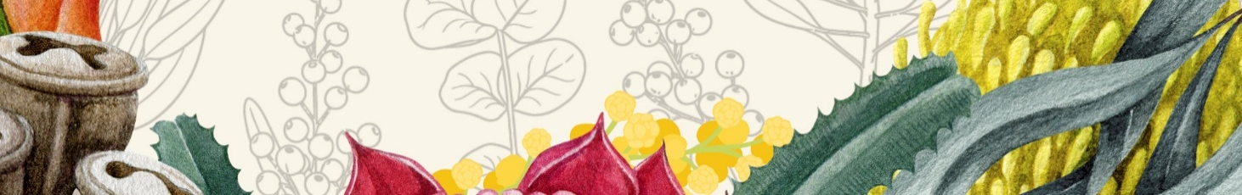

Activity: Australian Wildflowers
This year ABC Radio National is celebrating some of Australia's most spectacular wildflowers — from seasonal blooms in WA, to tropical flowers around Darwin, and the wonderfully weird world of orchids.

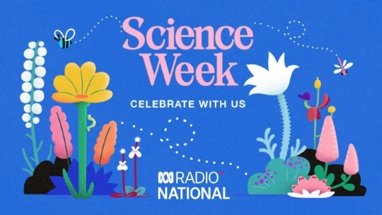
What's your favourite wildflower? Vote now

To help you join in, we've put together a free downloadable ABC Science Week Wildflower Poster & Colouring-In Pack featuring our wildflower contenders. Resources are available on the website for download.

Activity: Science Week Profiles
Students will research the life and achievements of one of the people featured in the BTN Science Week 2026 Special, Frances Bodkin or George Goyder. Students will create a timeline poster and prepare an oral presentation summarising key events in their life and their contributions to Australian science and society.

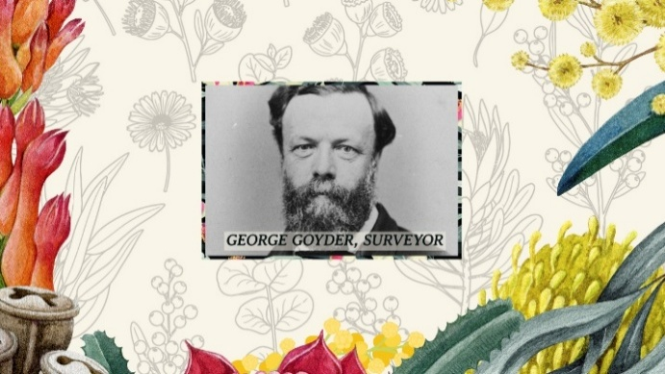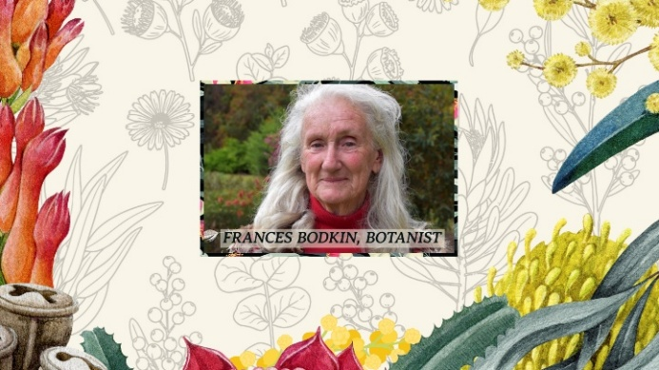

Timeline Poster
Your students’ task is to create a timeline poster, responding to the following areas of research.

Research
- Early Life - Information about your significant person’s parents. When/where was your significant person born? What type of education did your significant person receive?
- Family - Personal information; Was your significant person married? Did they have children?
- Legacy - What event and/or action led to them becoming a significant person? What did they do that had an impact on the lives of others?
- 2 x ‘Interesting Facts’ and 2 x ‘Did You Know?’
- A minimum of 6 and a maximum of 10 photos with captions.
- Include a bibliography on the back of your poster.

Further Research
Students will choose one of the activities to further investigate their significant person.

Interview
- Imagine you could sit down and talk to them. What questions would you ask about their life and achievements?
Portrait
- Plan and create a portrait.
- Explore and experiment with different techniques and mediums to produce a portrait.
5 w’s
- What are some of the key events in their life?
- Write a summary for one key event, which answers the 5 W’s – Who, What, Where, When and Why?

Useful Websites
- Seeds of Science – ASTA Teacher Resource Book

Agricultural Science
- The development of agriculture – National Geographic
- Agricultural science resources – Department of Primary Industries, QLD Government

Cultural Burning
- What is cultural burning? – Australian Museum
- Burn Off Season – BTN

Living on Mars
- Life on Mars – BTN
- All About Mars – Space Place NASA
- Humans in Space: Mars - NASA
- Space Seeds – BTN
- Water on Mars – BTN

Seed School
- Endangered Seeds – BTN
- Doomsday Seed Vault – BTN

  - Teacher Resource

BTN Transcript: Episode 23 – 18/8/2026

Hi I'm Amelia Moseley and you're watching BTN. But not just any BTN. Today we have a Science Week special for you. We'll explore the theme of this year's Science Week, Seeds of Science, by delving into the history and future of agriculture, find out what it would take to grow food on another planet, and we'll meet some kids helping to preserve endangered plants.

Agricultural Science

Reporter: Wren Gillett

INTRO: First up today let's take a look at the science behind agriculture. That's pretty important, because it keeps us all fed. So, how did farming start? And how are scientists working to make it better? Wren has the answers.
Around 12,000 years ago.

WREN: Been out gathering?
JUSTINA: Yeah.
WREN: About to go hunting.
JUSTINA: Yeah.
WREN: Hey, wouldn't it be cool if like, instead of looking for food, it was just like here. And we also like, lived here, like all the time?
JUSTINA: Yeah.
WREN AND JUSTINA: Yeah.
WREN GILLETT, REPORTER: Yeah, it was about 12 thousand years ago, when people in an area known as the Fertile Crescent decided to do things a little differently.
You see, up until then, as far as we know, humans pretty much exclusively hunted and gathered, moving around from place to place to find food.
WREN: This stuff grows out of the ground.
JUSTINA: Yeah.
WREN: So, what if we put this in the ground? Maybe we can grow more?
JUSTINA: Yeah.
A few moments later.
WREN: Introducing, agriculture.
CROWD: Agriculture, yeah.
It was a revolutionary idea, and it didn't stop at grains.
WREN: Wait.
WREN: How about instead of me killing you, you come home and live with me and raise a family.
GOAT: That sounds alright actually.
WREN: And then I'll kill you later.
GOAT: What?
WREN: Nothing.
GOAT: Oh, okay.
And just like that, well, not exactly like that, but you get the gist, the world changed forever. When people didn't have to travel to eat, cities started to develop, and their residents had more time to do other things. Like writing and reading.
JUSTINA: I just learnt my first word.
And craftsmanship.

WREN: I call it a shoe.
It also led to professional armies. Oh, and a whole lot more disease.
Agriculture wasn't invented in a single location. Across the world, different communities were making similar discoveries, and eventually, these spread far and wide, triggering what historians now call the 'Neolithic Revolution'.
Today, crops and farms cover about 4.8 billion hectares. That's about one-third of all the ice-free land on Earth.
And thanks to modern tech, like industrial harvesters and drones, churning out food has never been easier or faster. Every day, the world eats about 15 billion kilograms of food. That's the same weight as more than 100 thousand blue whales.
But all of this has come at a cost. Farming has had a huge impact on ecosystems around the world. It's the biggest driver of biodiversity loss worldwide. It's linked to around 90 per cent of global deforestation, produces more than a quarter of the world's greenhouse gas emissions, and uses around 70 per cent of our freshwater. And here in Australia, post colonisation, we haven't always farmed super efficiently.
MICHELLE, CSIRO: When settlement occurred, I think that perhaps the mistake that was made was to think that you could just bring a system from, say, the United Kingdom and implement it in Australia. Because if you think about them, very different climates, very different soils, very different in many, many ways.
Michelle is from the CSIRO, which is Australia's national science agency, and since it was founded, one of its main jobs has been improving Aussie agriculture.
MICHELLE COSGROVE, CSIRO: It's about how do we produce the food that the planet needs in the most sustainable way and utilising our resources in the most efficient way.

Right now, they're looking at lots of ways to make farming more sustainable. There's precision agriculture, which is all about making sure water and fertiliser go exactly where they're needed most. There's crop genetics, which helps match plants to the environments they'll grow best in.
MICHELLE COSGROVE, CSIRO: So, we might simply choose a plant from another area and bring it to Australia, or we might breed two plants together to deliver an enhanced plant.
They're also finding new foods for our cattle, so they burp and fart out less greenhouse gases.
MICHELLE COSGROVE, CSIRO: So, future feed is now a feed for cattle that has been is based on seaweed and it's a red brown seaweed that they utilize. It's called asparagopsis and it's been shown to be an inhibitor of methane.
And it's not just happening in Australia. Around the world, agricultural scientists are working towards the same goal. Whether it's finding more environmentally friendly sources of protein, like lab-grown meat and insects or developing new farming techniques. Scientists are also working on ways to help farmers adapt to a changing climate.
MICHELLE COSGROVE, CSIRO: For me it's how do we do all of those things delivering science but doing it in partnership with our farmers, our growers, the ones who are the curators and managers of our landscapes.
WREN: Who knew agricultural science would turn out to be so important.
JUSTINA: Yeah.
JUSTINA: What's science?

Profile: George Goyder

Rookie Reporter: Finn

If you drive north from South Australia's coast, you'll see the landscape change. Wheatfields and green fields turn into saltbush and red open plains. That's what happens when you cross the Goyder Line, an imaginary boundary that's shaped Australian agriculture since it was drawn in 1865 by George Goyder
George was born in Liverpool in 1826 and studied surveying in Glasgow before moving to Australia at the age of 22. In 1851, he moved to Adelaide where he started as a draftsman, eventually rising to become the colony's Surveyor-General, helping to map uncharted lands, plan towns and assign farmland.
In 1857, he travelled north and was surprised by what he saw, land that had been described as dry and barren was in full flower, with large inland lakes.
The water is fresh and clear as crystal the ground is covered with a sweeping sheet of the most luxuriant herbage the country is eminently suitable for run-holders.
Thanks to his report, many hopeful farmers travelled into South Australia's centre. But a few months later, those freshwater lakes had become puddles of mud; the farmers faced ruin. It taught Goyder an important lesson about the outback and how quickly the landscape could change after rain.
In 1865, following some years of drought, Goyder went north again. His job was to draw a line on the map between land that could be farmed and land that was too dry. Goyder’s line proved to be very accurate, although not everyone listened to his advice. North of the line you can still see homes that were abandoned when periods of rain gave way to drought.
Goyder did other surveying trips, including one to the Northern Territory where he mapped out the settlement that would become Darwin. George Goyder died in 1898, but you can still see his name in many places, buildings, waterways, electoral maps, and roads and most importantly, the line that still guides Australian agriculture and marks the start of the southern outback.

Cultural Burning

Reporter: Tatenda Chibika

INTRO: Of course, long before there were farms in Australia, Indigenous people were developing their own ways to manage the fragile environment. And one of those ways was the practice of cultural burning. Let's find out what that is and why fire is such an important part of our eco system

Quahli Newchurch, Kaurna Kardla: I'm Quahli Newchurch and I'm a proud Kaurna, Narungga, Kokotha woman.
Quahli Newchurch: I want to pay my respects to country where we meet today. We are on Kaurna Yerta and I want to share these respects for the ancestors of place who I know watch over us always.
Quahli works for Kaurna Kardla which means fire.
It’s a business which shares knowledge about caring for the land and a practice that's been done for tens of thousands of years.
Quahli Newchurch: For a long time, our natural landscape has been looked at as wild and untamed and don't touch it, it's pristine without people. But that has never been the case. Our landscape was always managed, and it was always managed with fire.
Fire has always been part of the Australian environment. Our continent can get hot and dry which can make it easier for vegetation and other fuels to ignite and burn.
Over time, our plants have evolved. 75 per cent of Australia's native plants respond positively to fire. For example, the seeds from Eucalyptus trees are encased in protective gumnuts and some species use heat from fire to help release them and some Banksia plants produce hard cones that open up after fires and drop seeds onto the ground. The ash from the fire also adds nutrients back into the soil helping those seeds to grow.
Victor Steffensen, Living Knowledge Network: Also, we have our black ash and that black ash comes from the grass and that is the really good fertiliser for the soil.
Cultural burns are generally smaller, slower and cooler than naturally occurring bushfires and can be quite different from the prescribed burns authorities use to reduce bushfire risk.
Quahli Newchurch: When you are at a prescribed burn, all systems go. It is hot, it is smoky, some of the objectives are to burn right down to nothing. Whereas for us, we want to ensure that our soils are protected by making sure we're not burning everything all at once. It is that mosaic pattern across our landscape to ensure that there's still foods and there's still habitat not just for the larger animals, but all the invertebrates as well.
But, colonisation interrupted the passing down of some traditional knowledge about caring for Country and Quahli says a reduction in cultural burning over the centuries has had a big impact.
Quahli Newchurch: Everything becomes overgrown and dense.
Quahli Newchurch: So, animals lose their food plants, they lose their habitat and everything just starts trying to survive in this unmanaged space.
Quahli Newchurch: That density is where we then see the wildfires come through and such.
devastating fires because the fuel load in the landscape is so high.
Tatenda: In 2021, a cultural burn was held right here at Tuthangga.
It was Australia's first cultural burn in a capital city and the first one on Kaurna country since colonisation.
Quahli Newchurch: As someone who had previously worked in western management, I had always wondered like why I felt like I was banging my head against a brick wall really. I felt like we weren't getting anywhere long term and something was missing. And that day I just remember standing and crying because the answer was so simple. Yeah. What's missing was us and our fire.
Quahli says the world can learn a lot from its First Peoples and their thousands of years of knowledge and she says you're never too young to start learning about country.
Quahli Newchurch: Go for walks in your natural landscape. Get to know your plants, the plants that grow around you and their cycles. Sit and listen to the birds and the insects in the space. Start to form that connection with country.
Quahli Newchurch: Talk to mob, get to know the community where you live and be respectful and listen to the information that's shared and be our allies, promote cultural land management and support Aboriginal people getting back on country and getting our land management practices back on country.

Profile: Francis Bodkin

Rookie Reporter: Eva

Did you know that ants can tell when it's going to rain? Or that Gymea lily flowers show that whales are coming into nearby waters? These are just a couple of interesting things Aunty Frances Bodkin says she's learnt as an iconic Australian botanist and descendant of the D'harawal people of the Bidjigal clan.
Fran was born in 1937, under a tree on the street in Darlinghurst in Sydney while her mum was on the way to the hospital. She says people often say that's why she loves trees and plants so much.
When she was little, her mum and nan would take her through the bush and show her native flora and how it could be used for food and medicine. Fran decided to spend her life studying plants even more closely by becoming a plant scientist or botanist.
She went to university and studied environmental science. She carried out research and discovered more about the importance of certain plants growing together. Over the years, she recorded information on plants how to identify them, grow them, use them, care for them. "Maybe I'll write a little book of useful plants for the home garden" she thought.
But like the plants around her, the book grew and grew, and in 1986 it was published as the Encyclopedia Botanica. It's a reference guide to native and exotic plants in Australia and features more than 11 thousand different species. Including ones that many people didn't know about before Fran's book. It became really popular, not just in Australia, but around the world. It helped people understand how important and special our native flora is and how Aboriginal knowledge can be an important source for science. That's something that had mostly been ignored throughout Australian history, including in the field of botany.
But Fran's work didn't end there. She published more books with knowledge from her culture. She helped create many Native Gardens including the Australian Botanic Garden Mount Annan or Yandel'ora in Sydney and bush-tucker gardens in lots of schools around the country. You might even have one at your school.
Today Aunty Fran still loves plants and studying them and her lifelong commitment to her culture, education and protecting the environment has had a lasting impact on Australia and the world. Thanks Aunty Fran.

Life on Mars

Reporter: Justina Ward

INTRO: Now let's forget our planet for a minute. What would it take to plant the seeds of life much, much further away on Mars? Justina found out why we're so fascinated with landing on the red planet and whether it would ever be possible to live there.

Okay we're ready to light this candle. Let's go to Mars.
For years we humans have been writing stories about going to Mars.
JUSTINA: And some insist it's more than sci-fi.
Bas Lansdorp, CEO of the defunct Mars One: When humans land on Mars the whole world will be inspired to believe.
Elon Musk, SpaCEX CEO: Space X wants to be able to take you to the Moon, take you to Mars, and beyond.
Space agencies and private companies are working towards sending humans to Mars and some even want us to live there
Elon Musk, SpaceX CEO: One day we will indeed occupy Mars.
But is that even possible? Well, if you’re looking for an earth like planet in our solar system. Mars is probably the best you're gonna get.
DAVID FLANNERY, QUT Associate Professor: Mars is really the only other rocky planet in the inner solar system that we can easily travel to and investigate the surface environment.
In fact, some reckon Mars may have once supported life. That doesn't mean it can support it now. See one of the things that makes life so liveable on Earth is our atmosphere, which contains the right chemical ingredients Including nitrogen, oxygen, carbon dioxide, Argon and water vapor. Mars has a much thinner atmosphere which is mainly carbon dioxide.
JUSTINA: What would happen if I tried to take a breath on Mars?
DAVID FLANNERY, QUT Associate Professor: You'd probably breathe in just fine but there's very, very little oxygen there so you wouldn't take many breaths.
JUSTINA: Not ideal
DAVID FLANNERY, QUT Associate Professor: Not ideal.
On top of that temperatures range from about 20 to -153 degrees Celsius. There's also no ozone layer to block the Sun's UV rays and no global magnetic field to shield the planet from space weather and radiation. So, if we ever want to call Mars home we'd need some serious protection.
DAVID FLANNERY, QUT Associate Professor: You'd be constantly irradiated. And over time, that would be very bad for you. You'd end up with cancers, for example.
JUSTINA: Water's another big problem.
You see, while some ice exists below the surface, we'd have to figure out how to extract it to drink and grow food.
JUSTINA: Do you think we could grow potatoes like Matt Damon did in The Martian?
DAVID FLANNERY, QUT ASSOCIATE PROFESSOR: So, we don't have those nice dark fertile soils we might plant potatoes in on Earth. We've got this highly toxic red sandy soil that's full of molecules like bleach. They'll oxidize and destroy organic material including those potatoes and so we need to improve them, not just with nutrients which astronauts could provide like Matt Damon's character did in The Martian, but we'd also need to remove those toxic components.
DAVID FLANNERY, QUT Associate Professor: There'd be a lot of dust that you would probably bring back into a habitat as well. You might in fact want to keep your spacesuit on the outside, sort of come out of it through a little portal, so that you keep all of that toxic stuff on the outside.
JUSTINA So, yeah, there's some pretty big challenges.
Some say way too many to seriously think of living on Mars.
JUSTINA: So, what about just a visit? How do you think that's possible?
DAVID FLANNERY, QUT Associate Professor: For sure, yes, just like we've been to the Moon, and we've collected samples and we've come back. I'm sure actually that that will happen on Mars in the not-too-distant future.
Not that it will be easy. Getting to Mars would take 6 to 9 months, and you have to time the trip carefully, because the distance between Earth and Mars is constantly changing. You'd need to take a lot of food, water and oxygen. Figure out how to land safely, and how to get home again. But these are all things that scientists are serious working on now.
Some say a trip to Mars isn't worth the time, money and potential lives it would cost, but others say it could have all sorts of benefit to people here on Earth that we don't even know about yet. Plus, it'd be pretty cool.

Seed School

Reporter: Jack Evans

INTRO: Finally, today we're heading to Happy Valley in South Australia where Jack caught up with some students taking part in a program to help preserve endangered plant species one seed at a time.

JACK EVANS, REPORTER: Armed with trowels, forks and a whole heap of seeds, these students are on a mission to save Australian wildlife from extinction. For the past year Happy Valley Primary School has taken part in the SEEDS Program.
ROSE: Firstly, I'll tell you what SEEDS stands for. It stands for the Stewardship of Endangered and Endemic Species. Endemic is the second E and the D. Seeds is all about helping our endangered native plants to live on so they don't die out because without them our ecosystem will fall apart.
MITCH: Pretty much we're planting endangered species of seeds and we plant them to help the environment
Yeah, unfortunately a lot of Australian native plants are at risk of disappearing.
RHYS MORGAN, GREEN ADELAIDE: There's a range of levels for endangered species, from critically endangered, which means it's very close to going extinct and disappearing, through to vulnerable. They're threatened by things like weeds, invasive species, overgrazing, climate change and habitat destruction.
That's where SEEDS comes in. It matches schools in South Australia with the seeds of one or more threatened species.
HANA: We've been given the coastal daisy. Its scientific name is Brachyscome Parvula, and we also have the Anther flax lily. It's Dianella longifoli.
RHYS MORGAN: The aim is to get the school kids actively involved in the conservation of some of our most threatened species
These guys do everything to see the seed go from sow to grow.
MITCH: We put them into the gibberellic acid, which will help them become from dormant to actually being able to be planted and will most likely be able to turn into a flower or whatever the seed will be.
HANA: And then we kind of like, yeah, plant the seeds on like, into those like beds and then we put fertilizer, nature fertilizer and then it like waters on them sometimes and we've been very careful with them.
A couple of months later and you end up with seed orchards, a collection plants grown just for their seeds. These guys collect them and donate some to the South Australian Seed Conservation Centre.
ROSE: For the coastal daisy, we use these bags, we open them up, we tie them around the stalk of the flower. We wait till they're pollinated first, then we tie it around the stalk. The seeds will fall off of the flower into the bag, so then we don't lose the seeds in the soil. Some we keep to plant more plants here and then those plants will be transported to places like the Happy Valley Reservoir to be planted in their natural habitat.
They say it's great to know their helping a rare plant to survive
GRACE I like when we're planting and learning about more stuff.
HANA: It's fun and it makes me feel like special and I really like that
MITCH: It just feels like you're actually doing something good for the environment and like you're helping.
ROSE: We need these plants in our ecosystem because without them our ecosystem falls apart because every single living thing takes its part to build a strong community.

Closer

Well, that's it for this year's Science Week special. I hope it's planted a few seeds of knowledge in your head. We'll be back next week with another special, this time for Book Week. And in the meantime, Newsbreak will be here keeping you up to date with the latest news. And on Friday, you can join in with BTN Live where ABC Science Reporter Ella is going to show us some experiments you can do at home. Have a great week and I'll see you soon.

