Episode 21
4th August 2020



Victoria Lockdown
- Discuss the BTN Victoria Lockdown story as a class and record the main points of the discussion.
- Melbourne has been placed under stage ______ coronavirus restrictions.
- What do the new restrictions mean?
- What are the restrictions in regional Victoria being upgraded to?
- How do the kids interviewed in the BTN story feel about the new restrictions?
- When will be restrictions be in place until?
- Why are the harsher restrictions needed?
- What are people in Sydney being asked to wear, especially on public transport?
- What questions do you have after watching the BTN story?
- What words of support would you send to kids in Victoria?

Raise the Age?
- What did the BTN Raise the Age story explain?
- Dujuan is from Arrernte and Garrwa Country. Find these areas on a map of Australia.
- Where did Dujuan travel to, to speak to the United Nations Assembly?
- Who does Dujuan want to run his school?
- Complete the following sentence. Dujuan wants the age limit for kids put in jail raised from 10 to _____.
- What is a youth detention centre?
- What impact can being put in a youth detention centre have on kids aged 10-13?
- The government council decided not to raise the age. True or false?
- What ratio of kids younger than 14 in youth detention centres are Indigenous?
- How did this story make you feel?

Hiroshima Anniversary
- Where is Hiroshima? Locate using Google Maps.
- During which war was Hiroshima bombed?
- What was the name of the US aircraft that dropped the bomb on Hiroshima?
- What kind of bomb was dropped?
- The process of spilling atoms to create a huge amount of energy is called nuclear ______________.
- What is the name of the US navy base that Japan attacked in December 1941?
- What was the Manhattan Project?
- Which city was bombed three days after Hiroshima?
- What impact did the bombings have on the people of Hiroshima and Nagasaki?
- What do you understand more clearly since watching the BTN story?

Check out the Hiroshima Anniversary resource on the Teachers page.

World Alopecia Day
- Retell the BTN World Alopecia Day story to another student.
- Who did Britt donate her hair to after having a haircut?
- What is alopecia?
- How did alopecia affect Tabitha?
- Complete the following sentence. Alopecia is caused by a person's __________ system.
- Hair loss for people with alopecia is permanent. True or false?
- How does wearing a wig make Tabitha feel?
- What is Tabitha’s message to other kids with alopecia?
- Send a message of support to Tabitha in the comments section of the BTN World Alopecia Day story.
- What did you learn watching the BTN story?

Punk Magazine Kid
- Briefly summarise the BTN Punk Magazine Kid story.
- Where in England does Arlo live? Find using Google Maps.
- Why did Arlo start a punk magazine?
- What is in Arlo’s magazine? Give two examples.
- Who would Arlo like to interview for his magazine? Name one person.
- Arlo is a massive fan of what music group?
  - Led Zeppelin
  - Pink Floyd
  - The Rolling Stones
- Where in the world has Arlo sold his magazine? Name one country.
- What does Arlo find difficult about making a magazine?
- What advice does Arlo give to other kids who want to make a magazine?
- Think of a concept for a new magazine. Design a front over of the magazine.

Check out the Punk Magazine Kid resource on the Teachers page.

Teacher Resource
Episode 21
4th August 2020

Hiroshima Anniversary

Students will learn more about the bombing of Hiroshima and the impact it had.


HASS – Year 5 & 6
Develop appropriate questions to guide an inquiry about people, events, developments, places, systems and challenges.

Locate and collect relevant information and data from primary sources and secondary sources.

Sequence information about people’s lives, events, developments and phenomena using a variety of methods including timelines.

HASS – Years 6 & 7
Examine primary and secondary sources to determine their origin and purpose.

HASS – Year 7
Construct significant questions and propositions to guide investigations about people, events, developments, places, systems and challenges.

Present ideas, findings, viewpoints, explanations and conclusions in a range of texts and modes that incorporate source materials, citations, graphic representations and discipline-specific terms, conventions and concepts.


- Where is Hiroshima? Locate using Google Maps.
- During which war was Hiroshima bombed?
- What was the name of the US aircraft that dropped the bomb on Hiroshima?
- What kind of bomb was dropped?
- The process of spilling atoms to create a huge amount of energy is called nuclear ______________.
- What is the name of the US navy base that Japan attacked in December 1941?
- What was the Manhattan Project?
- Which city was bombed three days after Hiroshima?
- What impact did the bombings have on the people of Hiroshima and Nagasaki?
- What do you understand more clearly since watching the BTN story?


Personal response
After watching the BTN Hiroshima Anniversary story, ask students to finish one or more of the following incomplete sentences:
- This story made me wonder why…
- It was interesting to learn that…
- This story made me feel…
- BTN covered this story because…

Class Discussion
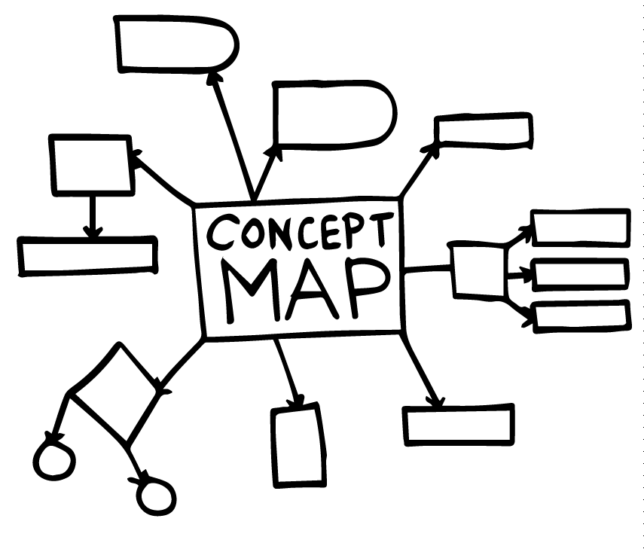Discuss the information raised in the BTN Hiroshima Anniversary story. Ask students to record what they know about Hiroshima on a mind map. What questions do students have? Use the following questions to guide discussion:

- Who was Japan at war with?
- What events led to the bombing of Hiroshima?
- What happened after the bombing of Hiroshima and Nagasaki?
- What is the aim of Hiroshima Day?

Key Words
Students will brainstorm a list of key words and terms that relate to the BTN Hiroshima Anniversary story. Here are some words to get your students started.
Nuclear | Atomic bomb | Radiation
Surrender | Allies | Destruction


Timeline of main events
Students will research significant events in the lead up to the bombing of Hiroshima and Nagasaki and create a timeline. Below are some examples of information to include. Students can create an Interactive timeline or choose another way to display the information.
December 1941
Japan attacks Pearl Harbor. The US enters WWII
September 1939
Germany invades Poland. World War II begins.

August 6, 1945
Atomic bomb dropped on Hiroshima


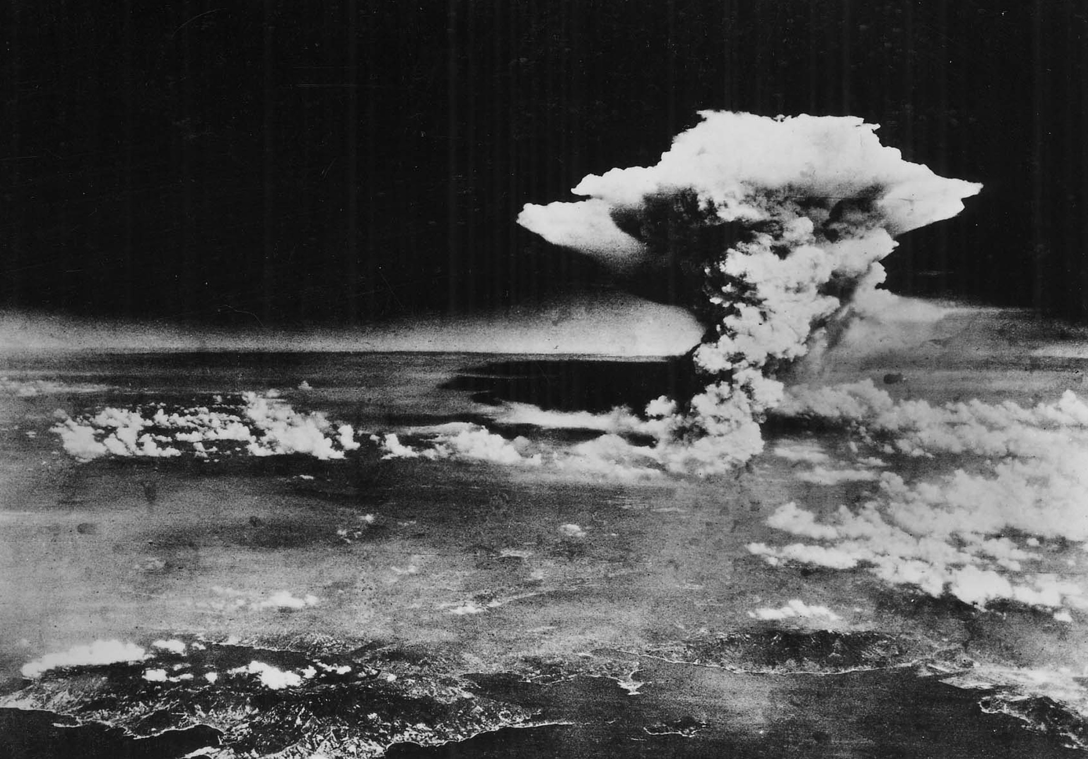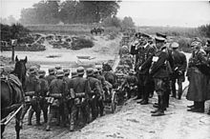
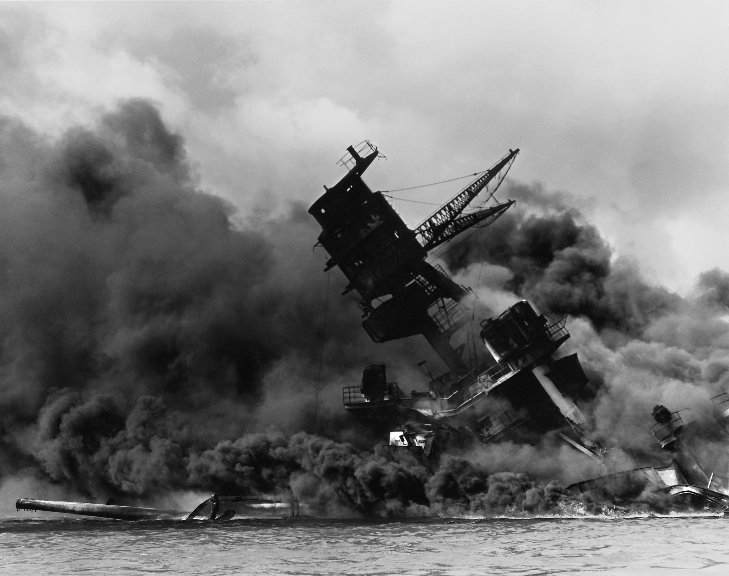

Inquiry Questions
Students will explore the bombing of Hiroshima in more detail. After watching and discussing the BTN Hiroshima Anniversary story, what questions do students have and what are the gaps in their knowledge? Students can complete the following KWLH organiser to explore their knowledge and consider what they would like to know and learn.
What do I know? | What do I want to know? | What have I learnt? | How will I find out?
Here are some possible questions for students to research:
- Why were the Japanese and the United States at war?
- What was the Manhattan Project?
- Why was Hiroshima chosen as a target to be bombed?
- How did people around the world feel about the bombing of Hiroshima?
- What was the long-term impact of the atomic bombs on Hiroshima and Nagasaki?
Sadako’s story
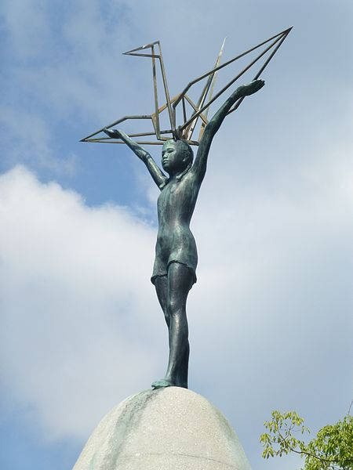The origami crane has become a symbol of peace, through the story of a Japanese girl called Sadako. As a class or individually read Sadako and The Thousand Paper Cranes by Eleanor Coerr. Alternatively, read about Sadako Sasaki’s story here. Students can also watch the BTN Hiroshima story to learn more about the story of Sadako. Discuss the story and respond to the following questions:
- How did Sadako’s story make you feel?
- What ancient Japanese tradition did you learn about? Describe the legend.
- Describe the importance of Sadako’s story to a friend or family member.

Statue of Sadako – Hiroshima Peace Park
The Thousand Crane Club
Every year Hiroshima International School receives thousands of paper cranes from schools, organisations and individuals around the world. Get your school involved in the Thousand Crane Club and make your contribution to peace by folding 1000 cranes to be placed in the Peace Park at Sadako’s monument.

Visit the Thousand Crane Club website for instructions on how to make paper cranes and requirements for how and where to send your paper cranes. There must be 1000 folded paper cranes and they must be strung together in strands no longer than 170cm, which are tied together in a bunch, to be accepted for hanging.
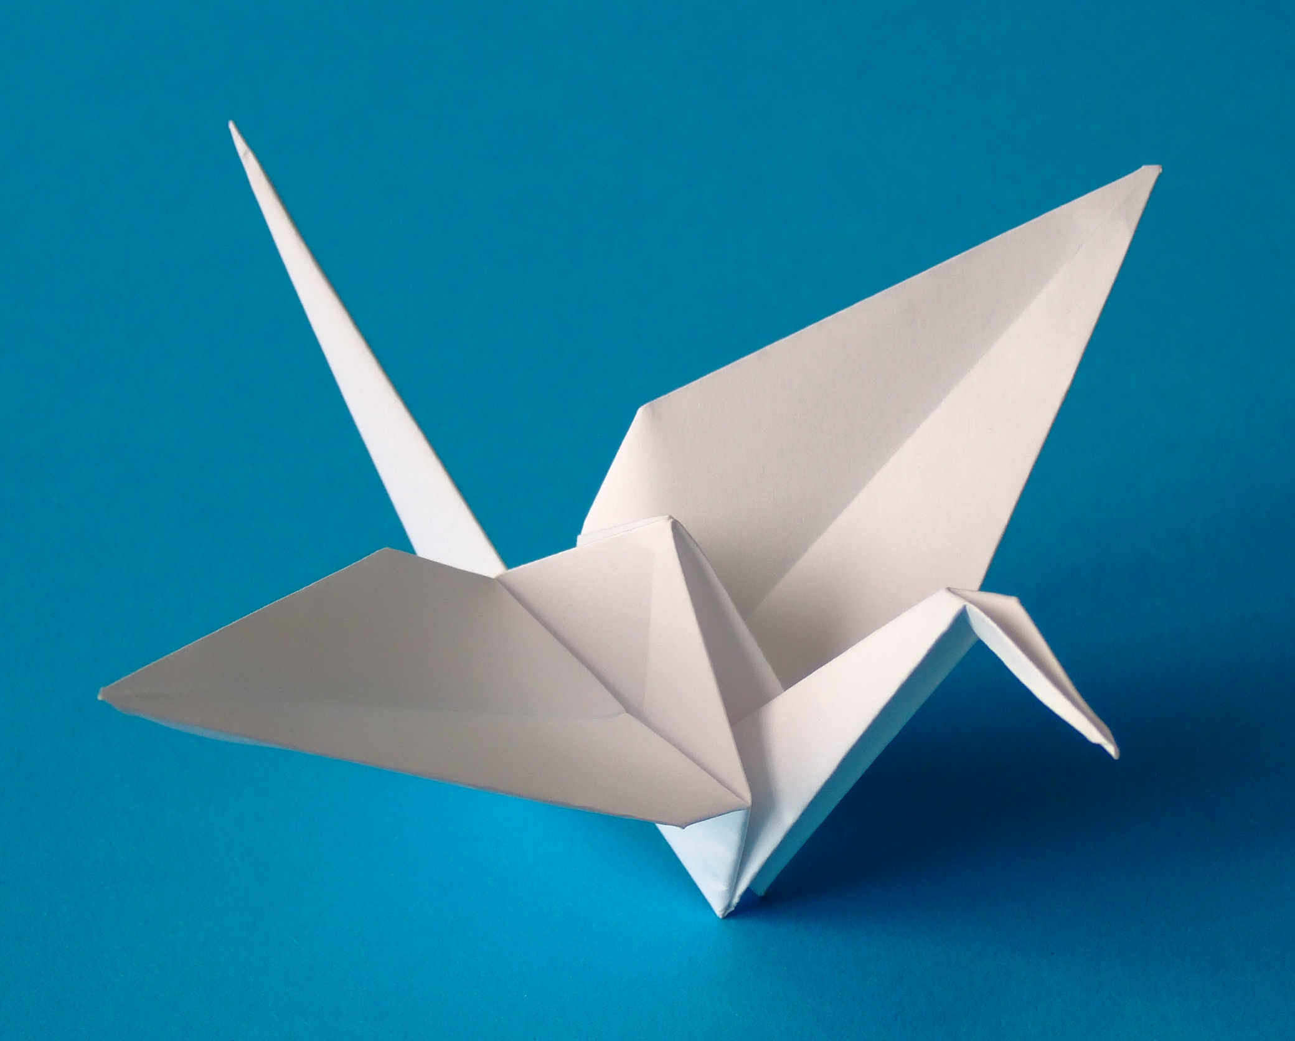

Watch this YouTube video made by Hiroshima International School – How to fold a paper crane

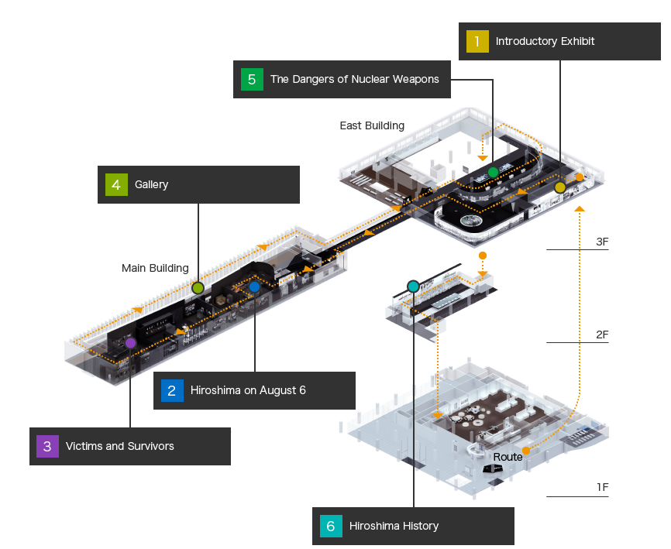
Hiroshima Peace Memorial Museum
Take a virtual tour of the Hiroshima Peace Memorial Museum to learn more about the impact of the bombing on Hiroshima. Explore different spaces withing the museum including:
Hiroshima on August 6
Victims and Survivors
The Dangers of Nuclear Weapons
Hiroshima History

Hiroshima Special
Watch the Hiroshima: A Newsround Special to learn more about the impact of the atomic bombing of Hiroshima. As students watch the special, ask them to reflect on the following:
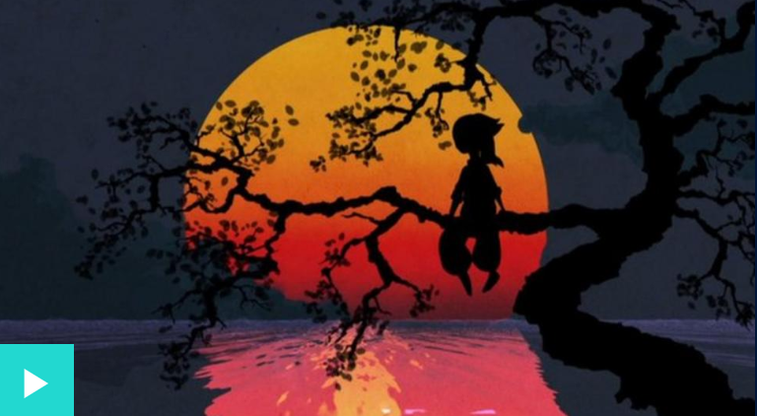
- Bun Hashizume was 14 years old when Hiroshima was bombed. What did you learn listening to her story?
- What information in the special was surprising?
- What questions do you have after watching the special?
- How did the stories told make you feel?
Learn more about WWII
Watch these BTN stories to learn more about World War II. Students can then respond to the discussion questions.

BTN VE Day

- 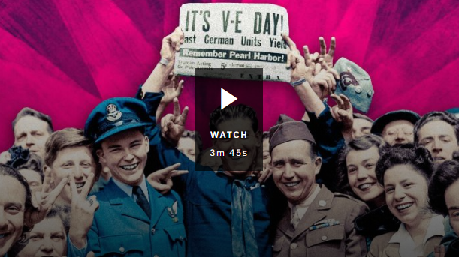What happened on the 8th May 1945?
- What year did World War II start?
- Who was the leader of the Nazi Party?
- The German invasion of _________________ marked the beginning of WWII.
- Who were the Axis powers?
  - Germany, Poland and Italy
  - Germany, Italy and Japan
  - Germany, Italy and the Soviet Union.
- Who were the Allied forces?
- In Germany and German occupied countries, the Nazis imprisoned and killed millions of people, mostly Jewish, in what's known as the _________________.
- What does VE stand for?
- The surrender of which country marked the end of WWII?

BTN Second World War

- 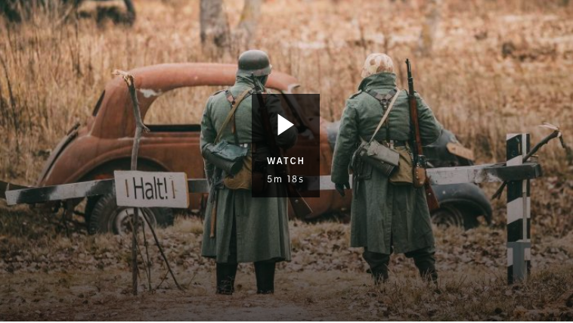At the end of the First World War what document did many countries sign?
- Who was Adolf Hitler?
- What year was Austria invaded by the Nazis?
- Who were Britain’s and France’s Allies?
- In 1941 Japan bombed Pearl Harbor. Where in the US is Pearl Harbor?
- What was the Holocaust?
- In which country did the US drop two nuclear bombs?
- What words would you use to describe the Second World War?
- What questions do you have about the BTN story?

Quiz Questions | Your Answer
- In which country is Hiroshima?
  - South Korea
  - Japan
  - China
- During which war was Hiroshima bombed?
  - WWI
  - WWII
  - Vietnam War
- Hiroshima was bombed in 1944.
  - True
  - False
- What kind of bomb was dropped on Hiroshima?
  - Petrol
  - Hydrogen
  - Atomic
- What was the name of the aircraft that carried the atomic bomb that was dropped on Hiroshima?
  - Spruce Goose
  - Enola Gay
  - Memphis Belle
- Which city was bombed three days after Hiroshima?
  - Nagasaki
  - Tokyo
  - Fukushima
- The radioactive waste from the atomic bomb killed thousands of people after the war.
  - True
  - False
- How old was Sadako when Hiroshima was bombed?
  - 2 years old
  - 12 years old
  - 22 years old
- The surrender of Germany marked the end of WWII.
  - True
  - False
- This year is the 75th anniversary of the bombing of Hiroshima.
  - True
  - False
Answers: 1b, 2b, 3b, 4c, 5b, 6a, 7a, 8a, 9b, 10a

Hiroshima – BTN
https://www.abc.net.au/btn/classroom/hiroshima/10526118

What happened in Hiroshima – Newsround
https://www.bbc.co.uk/newsround/33733410

Hiroshima: A Newsround Special – Newsround
https://www.bbc.co.uk/newsround/33795551

From Hiroshima - Kids Peace Station
http://www.pcf.city.hiroshima.jp/frame/kids_e/hiroshima.html

Virtual Tour - Hiroshima Peace Memorial Museum
http://hpmmuseum.jp/modules/exhibition/index.php?action=FacilityView&facility_id=4&lang=eng

Folding a Paper Crane Video – Hiroshima International School
https://www.hiroshima-is.ac.jp/folding-a-crane/

VE Day – BTN
https://www.abc.net.au/btn/classroom/ve-day/12201810

Second World War
https://www.abc.net.au/btn/classroom/second-world-war/11460762

Teacher Resource
Episode 21
4th August 2020

Punk Magazine Kid
Students will investigate the technical and symbolic elements of magazines. Students will create their own magazine.

English – Year 6
Compare texts including media texts that represent ideas and events in different ways, explaining the effects of the different approaches.

English – Year 7
Understand that the coherence of more complex texts relies on devices that signal text structure and guide readers, for example overviews, initial and concluding paragraphs and topic sentences, indexes or site maps or breadcrumb trails for online texts.

Analyse and explain the effect of technological innovations on texts, particularly media texts.

Media Arts – Year 5 and 6
Explain how the elements of media arts and story principles communicate meaning by comparing media artworks from different social, cultural and historical contexts, including Aboriginal and Torres Strait Islander media artworks.

Media Arts – Year 7 and 8
Analyse how technical and symbolic elements are used in media artworks to create representations influenced by story, genre, values and points of view of particular audiences.

Present media artworks for different community and institutional contexts with consideration of ethical and regulatory issues.
- Briefly summarise the BTN Punk Magazine Kid story.
- Where in England does Arlo live? Find using Google Maps.
- Why did Arlo start a punk magazine?
- What is in Arlo’s magazine? Give two examples.
- Who would Arlo like to interview for his magazine? Name one person.
- Arlo is a massive fan of what music group?
  - Led Zeppelin
  - Pink Floyd
  - The Rolling Stones
- Where in the world has Arlo sold his magazine? Name one country.
- What does Arlo find difficult about making a magazine?
- What advice does Arlo give to other kids who want to make a magazine?
- Think of a concept for a new magazine. Design a front over of the magazine.

Class Discussion
As a class discuss the BTN Punk Magazine Kid story using the following questions as a guide. Record the main points of discussion on a mind map with MAGAZINE at the centre.

- 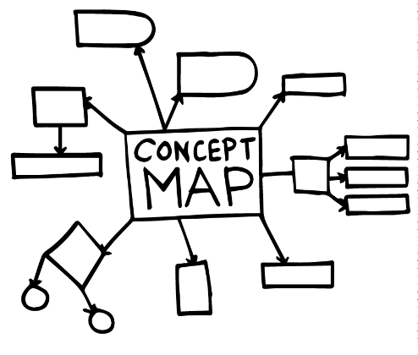What words do you associate with magazines?
- What magazines do you know?
- What do magazines have in them?
- Why do people read magazines?
- What is the difference between printed magazines and online magazines?

Students will then respond to one or more of the following:
- Think of a question you would like to ask the kid featured in the BTN Punk Magazine Kid story.
- Leave a message in the comments section on the BTN Punk Magazine Kid page.
- If you could make your own magazine what would it be about?
Glossary
Students will brainstorm a list of key words that relate to the BTN Punk Magazine Kid story, magazine design and production. Students may want to use pictures and diagrams to illustrate the meaning and create their own glossary. Here are some words to get you started.
Genre | Target audience | Masthead
Production | Layout | Coverlines
Language | Publish | Composition

Analyse a magazine
Choose a magazine that is age appropriate to share with your class (alternatively, students can bring in a magazine they read to share with the class. It could be an old issue of a magazine they have at home or an online magazine). As a class, investigate the technical and symbolic elements of the magazine, using the following questions to guide discussion:

- What genre is the magazine? For example, art, music, design, entertainment, or sport.
- How would you describe the magazine’s front cover?
- What terminology is used to describe the elements of a magazine’s front cover? E.g. masthead, price, image, coverlines. Use your class glossary to identify the different elements. Add to your class glossary as you find new terminology.
- What topics are covered in the magazine?
- Can you find any advertising? What proportion of the magazine is advertisements?
- What other features do you notice in this magazine? For example, interviews, games, advice columns, contents page.
- Who do you think the target audience is for this magazine? Who do you think the magazine appeals to?

If you are analysing more than one magazine in your class, ask students to respond to the following:
- Sort and categorise the magazines into genre categories. What other genre categories do you know about?
- How are the magazines similar or different?

Further research
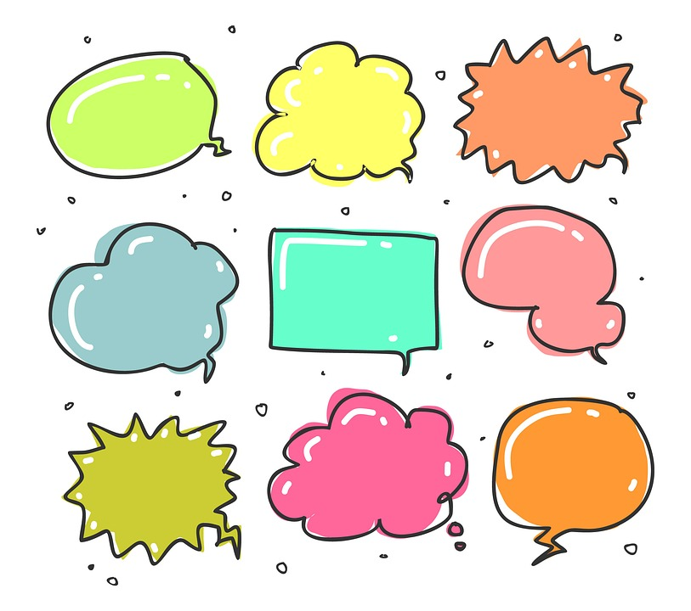Students will develop their own question/s for inquiry about the production of magazines and the magazine industry. Students will collect and record information from a wide variety of sources. Students may develop their own question for inquiry or select one of the questions below.
Why do magazines have advertising?

What is the difference between printed and online magazines?

What are the types of jobs in magazine publishing?

Design a front cover
Students will think of an idea for a new magazine and create a cover for the magazine. Students will need to identity their target audience, magazine genre and write a summary describing what the magazine is about. Once students have created their front cover, they will need to annotate and explain each element (e.g. masthead, main image, coverlines) in their design.

Create your own magazine
Students will create a magazine about a topic of their choose or alternatively your class can collaborate to produce a magazine about a topic you are already studying. Use the following to guide students when making their magazine.

Explore | Make a list of topics that you are interested in, it could be something you know a lot about already or a topic you’re interested in but would like to learn more.  Visit the BTN website to search for topics that you’re interested in, click on the search button to find a range of stories. Here are some ideas:  - Aboriginal art  - Space Science  - Aquaponics  - Opera  - Sustainability  - Beatboxing  - Tennis
Plan | Write a plan for your magazine:  - What is your magazine about? Write a summary.  - What is your magazine called?  - Who is your target audience? Explain.  - What will you magazine include? For example, feature report, interviews, surveys, columns, games, letter from the editor, persuasive text, articles.  If you are collaborating and making a class magazine, assign different roles and responsibilities to each student.
Research | Spend one hour a week researching your topic or area of interest. Collect and record information from a wide variety of primary and secondary sources.  - Primary sources – Through using primary sources, that is a document like a diary, photograph or a physical object, that was written or created at a particular time, we can gain an understanding of what might have happened at a place in time.  - Secondary sources – Secondary sources are documents written after an event has occurred, providing “second-hand” accounts of that event, person, or topic. Unlike primary sources, which provide first-hand accounts, secondary sources offer different perspectives, analysis, and conclusions of those accounts.  Will you interview people to include in your magazine? What questions will you ask? How will you record your interview?  - Determine who you will interview, for example, family, friends, a teacher or expert.  - Prepare for your interview by writing some questions that you will ask your interviewee. Write open-ended questions. Open-ended questions have no right or wrong answer and can’t be answered with a ‘yes’ or ‘no’.
Write content | Start to write content for your magazine. If you are writing an article about an issue, consider whether you need to present one view or both sides of the issue.  Ask another classmate to read what you have written, checking for typos and incorrect grammar.
Create | - Decide whether your magazine will be in print format or digital.  - Create a design sketch before making your magazine. Think about background colours, font type and size and headings.  - Develop graphics to use throughout your magazine to support your text.  - If you are publishing your magazine you will need to take into consideration copyright on images you use.  - Consider using Canva to make your magazine which includes many templates to choose from.

Kids projects
Take a look at the following BTN stories to learn about other projects that kids are working on at home and in their classrooms around Australia. Students will think about what their hobbies or passions are and then consider creating a magazine about the topic. Alternatively, students may want to create a blog.

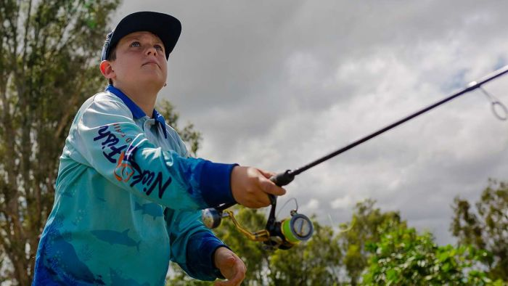  Making school fun with fishing – Meet a kid who is using math, geography and English doing what he loves most. | 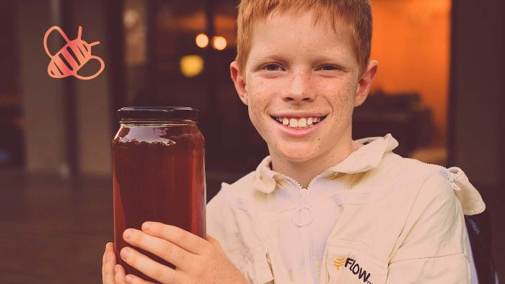  Bee Business – Finn is making honey. Well it’s the bees making the honey, but Finn's worked hard to learn how to keep the bees and collect his product.
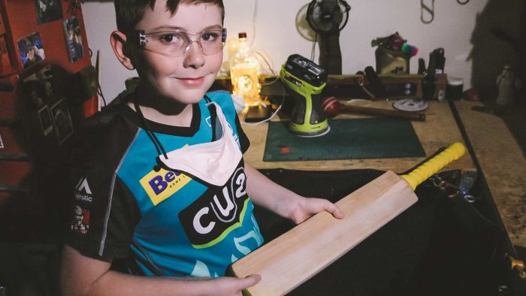  Cricket Bat Kid - We meet 10-year-old Riley who spends his spare time refurbishing old cricket gear and giving it to kids who need it. | 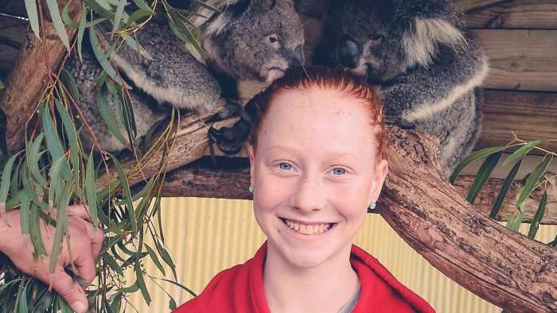  Koala Carer – Libby is worried that some native animals are at risk of disappearing & she didn’t want to wait until she was older to do something about it.
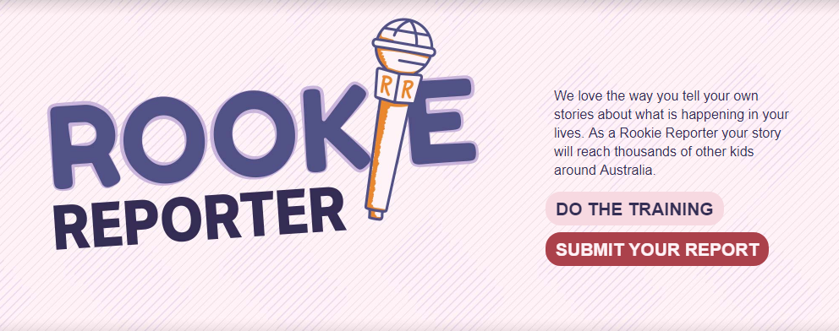Become a Rookie Reporter
Are your students passionate about a topic or issue and would like to create their own feature report?

The Rookie Training section on the website gives students some great tips for making their own news story. Check out some of our rookie reporter stories from kids around Australia and the world for inspiration! We would love to see your reports, send them into the BTN via this email address btn@abc.net.au

How a 10-year-old created a lock down print hit for punk fans – BBC
https://www.bbc.com/news/av/entertainment-arts-53480366

Rookie Reporter – BTN
https://www.abc.net.au/btn/rookiereporter/

BTN Transcript: Episode 21 – 4/8/20

Hey, Amelia Moseley here and you're watching BTN. Check out what's coming up. We find out how the bombing of Hiroshima changed the world 75 years ago, learn what it's like to have alopecia and meet a young punk fan who's started his own magazine.

Victoria Lockdown

Reporter: Cale Matthews

INTRO: But first today to Victoria. As you probably know, things aren't going too well there at the moment. There's been a big spike in COVID-19 cases in Melbourne and to try to bring it under control, the government's brought in some really tough new restrictions. Let's find out more.
It's the announcement nobody wanted to hear.
DANIEL ANDREWS, PREMIER OF VICTORIA: I am declaring a state of disaster across Victoria.
Yep, after days and days of hundreds of new cases, Victoria's government has taken some drastic action including tough lockdowns and extra power to police to enforce those restrictions. Regional Victoria will be upgraded to stage 3 lockdowns while Melbourne's been bumped up to stage 4. This means people won't be allowed to leave their house between 8pm and 5am, exercise and shopping will be restricted to within 5km of your home and remote learning for all school students starts from Wednesday.
AMELIE: It feels more real. It feels more close to home. Definitely the first time around I didn't know anyone that knew anyone who had COVID or was affected by it and now we kind of do.
BEN: I think it’s important to keep us safe and make sure the virus doesn't spread.
Young Victorians like Amelie and Ben say it's been pretty tough news to hear.
AMELIE: It kind of didn't hit me until a few hours later and we were having dinner and I just like stopped and my parents were like hey, you all good? And I was like yeah it just kind of clicked.
Amelie's in year 11 and she says going back to remote learning will throw up some challenges.
AMELIE: Everyone says that year 11 is the year that you’re supposed to be like, get an idea of what year 12 is gonna be like and it’s kinda like your blueprint and we don’t really have that anymore so year 12 is gonna be a bit weird and a bit stressful.
At the moment it's just Victoria that's on lockdown and while the COVID-19 numbers are low in other states everyone's being really careful, especially in New South Wales. People in Sydney are now being asked to use masks in some situations, like on public transport and experts say we all need to keep socially distancing. It's likely that Victoria will stay in lockdown until at least September and everyone's hoping that by working together we'll be able to stop the virus from spreading.
BEN: If we keep doing these restrictions the virus isn't going to spread more and less people are going to get it and so the restrictions will ease.

CALE: Definitely. I hope you stay safe and hopefully things start to get a bit better. Fingers crossed, hey.

BEN: Fingers crossed.

News Quiz

Do you know what made Queensland’s premier so angry last week? Was it people refusing to get tested for COVID-19, people not wearing masks or people coming back from Melbourne and not going into quarantine? It was C. Two women tested positive to the virus after flying in from Melbourne via Sydney and not telling authorities where they’d been.

On New South Wales’s Central Coast homes were damaged when strong tides and ferocious waves ate away the coastline. What’s that process called? Is it corrosion, erosion or collision? It’s called coastal erosion and it’s a big problem for a lot of Aussies who live on the coast.
Can you name this Australian businessman? It’s Clive Palmer and he’s in the news for taking the Western Australian government to court over its border closure. He says it goes against the Australian Constitution, which guarantees free movement of people and trade between states.

Two US astronauts are back on Earth after this Dragon space capsule splashed down in the Gulf of Mexico. What’s the name of the company that built it? It’s SpaceX. It’s the first private space company to carry astronauts to and from the International Space Station.
And NASA’s latest Martian probe has blasted off. Do you know its name? Is it Phoenix, Perseverance or Pathfinder? It’s Perseverance. It’ll take seven months for the rover to get to Mars and, if it lands successfully, it’ll spend it’s time collecting rocks and looking for signs of ancient life.
The nominations came out last week for America’s biggest TV awards. What are they called? The Logies, the Emmys or the Oscars? They’re the Emmys. Organisers have decided to go ahead with the awards despite COVID-19 and hold a virtual ceremony in September. This year five Australians have been nominated.

Raise the Age?

Reporter: Jack Evans

INTRO: Now you probably know that if you commit a serious crime, you can end up in prison, right? But what happens if you're just a kid? Well, there's been a lot of debate about that in Australia recently. Some people have been pushing to raise the age of criminal responsibility from 10 to 14 so younger kids don't end up in youth detention centres. And you're about to meet a young Aussie who's pretty passionate about that. Take a look.
DUJUAN: My name is Dujuan, I am 12 years old. I am from Arrernte and Garrwa Country. I came here to speak with you because the Australian Government is not listening. Adults never listen to kids like me, but we have important things to say.
Last year Dujuan, his father and his grandmother travelled all the way from Central Australia to Geneva in Switzerland. There Dujuan spoke to the United Nations Assembly about some of the things he and his family want to see changed.
DUJUAN: I want my school to be run by Aboriginal people. I want adults to stop cruelling 10-year-old kids in jail.
DUJUANS GRANDMOTHER: We want to see the age limit raised from 10 to 14 because it's not right that 10-year olds are in jail. It makes me feel sad because no child should be in jail especially at 10 they're just babies at the moment.
That’s something a lot of people have been talking about lately.
ARCHIE ROACH: Children as young as 10 shouldn't be in jail.
BRIGGS: Prison is no place for a child, we need to raise the age.
You see here in Australia if you commit a serious crime and you're over 10 you can end up in a youth detention centre. It's sort of like a prison but it's designed for young people. Kids in youth detention centres still have the chance to take school classes or practice other job skills. But some say that 10 is too young for anyone to be locked up.
ROXANNE MOORE, NATSILS: The medical evidence is really clear that prisons are really harmful for young people and it has a huge impact on kids for the rest of their lives.
Roxanne is a lawyer who has been working on a campaign to raise the minimum age a kid can be placed in youth detention to 14.
ROXANNE MOORE, NATSILS: Governments should be looking at what supports kids need in order to have happy and healthy lives.
Last week the government council in charge of changing laws met but decided to not raise the age. They say they need more time to work out what would replace the current system if the age was lifted. While it’s an issue that could affect any Aussie kid, more than half of kids younger than 14 in youth detention are Indigenous.
ROXANNE MOORE, NATSILS: Aboriginal and Torres Strait Islander kids are pushed into the criminal justice system because of racism and because of disadvantage. Lots of them are missing the key supports in their life. Things like having a house or having culturally appropriate education or having supports around mental health for example.
These were the sorts of issues that Dujuan wanted to draw the world's attention to.
DUJUAN: I was always worried about being taken away from my family. I was nearly locked up in jail.
Recently he starred in a documentary, called In My Blood It Runs, which showed what it’s like growing up in Australia for some Aboriginal and Torres Strait Islander kids. Dujuan says he'd like to travel to Parliament House to show his film to the Prime Minister and ask him for help.
DUJUAN: I'm going to ask him if he could change the law and if he could make things better in life for us kids and to ask him if he could make a school out on my homeland and ask him if he could change the juvenile detention centre age from age 10 to 14 and if he could stop the racism in Australia.

Hiroshima Anniversary

Reporter: Olivia Mason

INTRO: This week people in Japan and around the world will mark the 75th anniversary of the bombings of Hiroshima and Nagasaki. That was the only time nuclear weapons have ever been used in war and it had a huge impact on the whole world. Liv found out more.

NEWSREADER: The Enola Gay's mission starts from Tinian in the Marianos. The crew has had their final briefing on weather and air scene rescue. Only yesterday they have been told of the true power of the weapon they are to carry.
OLIVIA MASON, REPORTER: At 2.45 a.m. on the 6th of August, 1945, a US aircraft called the Enola Gay took off towards Japan.
NEWSREADER: The massive bomb has been loaded.

Six and a half hours later, it dropped a nuclear weapon, or atomic bomb on the city of Hiroshima instantly killing up to 80,000 people. At the start of the Second World War in 1939 there was no such thing as an atomic bomb. But there were scientists who realised that it was possible to create a huge amount of energy by splitting atoms in a process called nuclear fission and some were worried about what would happen if Nazi Germany developed such a weapon first.
At that point the US wasn't actually involved in World War II but that changed in December 1941 when Japan attacked the US' navy base at Pearl Harbor in Hawaii. The US and Japan were now at war and the American government secretly began development of the world's first nuclear bomb. It's code name, the Manhattan Project. More than 100,000 people were involved in the research, although many didn't know what exactly they were working on.
On July the 16th, 1945 the US successfully detonated the first atomic bomb at a test site in New Mexico. Meanwhile, the war had turned for the Allies and on the 8th of May 1945 Germany surrendered. But Japan didn't and in the Pacific, fighting still raged between Japan and the Allies, including the US, Australia and the UK. So, the United States' government decided to use its new weapon. 3 days later, the US dropped a second atomic bomb on another Japanese city called Nagasaki. Less than a week later, Japan surrendered, and World War II finally ended.

But for the people of Hiroshima and Nagasaki, the nightmare of the bombings and the destruction they left behind was far from over. As well as the instant destruction, the nuclear weapons left radioactive waste and spread nuclear fallout, which is a radioactive dust that can make people really sick. In the months and years after Hiroshima and Nagasaki, hundreds of thousands died from being exposed to the radiation left behind by the bombs.

NEWSREADER: First, you'll duck, then you'll cover.
Nuclear weapons and peoples' fear of them would go on to have a huge impact on the world for decades. Eventually, many countries around the world agreed to stop making and testing them. But some say we need to do more to make sure they're never used again. Here in Hiroshima, the bomb will never be forgotten.

STUDENT: Hiroshima is very peaceful and beautiful right now. It doesn’t look like it was destroyed 75 years ago.

STUDENT: Because of COVID-19 the Peace Memorial Park was closed for the anniversary but I came here the surrounding area for the moment of silence at 8.15am but on other years people gather at Peace Park to pray and take the moment of silence and at night there is a lantern floating ceremony where people release a lot of lanterns right here on this river.

STUDENT: Every survivor strongly claims that nuclear weapons should be abolished as they cause pain and suffering.

STUDENT: Hiroshima is known to symbolise peace and continues to keep the memory alive of the devastation the took place 75 years ago.

Did You Know?

Did you know paper cranes have become a symbol of peace in Hiroshima? That's because of the true story of a young girl named Sadako who was poisoned by the atomic bomb. Before her death she set herself the goal of making 1000 paper cranes.

Ask a Reporter

If you have any questions about that story you can ask me live on Friday on Ask A Reporter. Check out our website for all the details.

World Alopecia Day

Reporter: Brittany Evins

INTRO: Did you know that Saturday was International Alopecia Day? Alopecia is a condition that causes hair loss and it can affect people of all ages. Our reporter Brittany went to meet a young person with alopecia and found out how her own hair's being used to help others.

BRITTANY EVINS, REPORTER: Hi, I'm Britt and this is my hair. I’ve been growing it pretty much my whole life. That means I’ve got a lot to spare, and you know what? There are people out there who could really use this hair, so I’ve decided to cut it off.

So, this was me back in February when I decided it was time for a bit of a change. I decided to donate my hair to a charity that makes wigs for kids. There are lots of reasons that kids might need a wig, maybe because they're going through chemotherapy or because they've got something called alopecia. To find out more about that, I decided to ask an expert. This is Tabitha. She's had alopecia nearly all her life.
TABITHA: Alopecia is a condition where you lose your hair you can lose it just on your head or all over your body, I lost it all over my body and now I'm starting to lose my eyebrows too.
She told me that alopecia is caused by a person's immune system. It's designed to fight germs to keep us healthy, but sometimes it gets kinda confused. In people with alopecia, the immune system attacks the hair follicles and that means the hair can fall out. For some people, it's just temporary and for others it might be permanent. But it's not dangerous and you can't catch it.
TABITHA: When you lose your hair, it is sad in a way but then I look at the positives, like I can't get nits now and I don't have to really worry about washing my hair that much. It does make me feel a bit special because I'm the only one in my school that has it, so I feel special that I have it.
Tabitha has a few different wigs and hats that she can mix and match.
TABITHA: So there's Velcro and there's also Velcro attached to the hair like that so you take it off.
But wigs made from human hair can cost thousands of dollars. They're often handmade which takes a long time, usually around 8 to 10 weeks and each one uses about 10-20 ponytails. That's where my hair comes in. It was long and it hadn't been dyed which made it perfect for wig-making. The charity I donated it to gives wigs to kids like Tabitha so they can feel comfortable.
TABITHA: Yeah it makes me feel special that I can be included, so I don't feel left out because I don't have hair.
But of course, not every kid without hair wears a wig and Tabitha says in the end it doesn't matter if you have hair or not. Her message to other kids with alopecia is that they should be themselves and do whatever makes them feel good.
TABITHA: I would tell them that they shouldn't be afraid to not wear wigs or beanies because it doesn't matter what other people think it’s what you think about yourself. With alopecia it’s not the look it's the inside that counts, that's my saying and people sometimes think it's the looks that matters but it's not really, it's the inside.

Did You Know?

Did you know wigs have been used for thousands of years? Ancient Egyptians used to shave their heads and wear wigs. The richer you were, the more wigs you owned. They were also popular in ancient Mesopotamia, Crete, Greece and Persia.

Sport

The NRL match between the Knights and the Storm has sparked a bit of controversy and it wasn't because of anything happening on the field. Fans did a pretty average job of social distancing and police and the league weren't impressed. The stadium's had to drop its capacity from 6000 to 5000 and they've been told to spread out fans in future games. As for the game itself, the Storm got up and are just 1 point off top spot.
The 2020 Super Netball season's underway and reigning champs, the Swifts, are off to a flying start. They knocked off the Giants in a tight contest. The Swifts were 5 points down at half time but were able to snatch the win, thanks to a couple of the new 2 point super shots.
Meanwhile in the US, the NBA is back in action at its new Disney World bubble. Only people who have quarantined and tested negative for COVID-19 are allowed in, but fans won’t totally miss out thanks to these big screens they can virtually cheer on their teams. In a twist of fate, the very first points of the season were scored by Rudy Gober, the guy who triggered the whole shutdown when he tested positive to coronavirus back in March.
And Lewis Hamilton's scored a record seventh British Grand Prix victory. But it wasn't all smooth sailing or, well, driving. Tyres were having a real tough time staying on their cars throughout the entire race and Hamilton's Mercedes was no exception with a puncture on his final lap.

Punk Magazine Kid

Rookie Reporter: Arlo

INTRO: Finally, today. Let's meet a young music fan from the UK who's been putting his time in isolation to good use. He's created his own magazine called Pint-Sized Punk. And while it started as a fun English project, he now sells copies all around the world. Here's Arlo.
ARLO: Hi my name is Arlo, I’m the Pint-Sized Punk. I’m in England in a tiny little town called Saltford right in between Bristol and Bath. My love of punk came from my Mum and Dad. Punk music is like loud guitar music with frumpy drums. I decided to start the ‘zine’ because let’s face it, home school was getting a bit boring and I was getting frustrated. But my Mum also asked me what I wanted to write about, and I wanted to write about music. The ‘zine’ is about my love of music and it has got puzzles, illustrations, interviews, comics and more junk and nonsense. The coolest person I’ve interviewed so far, that’s a hard one, I’ve interviewed lots of cool people. I ask the artists questions on music, as well as other topics.

ARLO: How old were you when you started playing guitar?

FONTAINES DC: I started playing when I was around ten, maybe a bit younger, maybe eight.

ARLO: Banksy designed a T-shirt for your last event, do you know his identity?

BEAK: No, he’s like Father Christmas.

ARLO: What is the stinkiest gig you’ve ever played?

DREAM WIFE: The bathrooms had burst upstairs.

ARLO: Marmite yes or no?

FONTAINES DC: I don’t mind it but I’m not a fan.

ARLO: Marmite is like the English version of vegemite, you either love it or you hate it.

ARLO: My dream interview for my magazine would be Janelle Monae, Nadine Shah, Robert Plant maybe because I’m a massive Led Zeppelin fan. It has been pretty hard trying to make this magazine, the whole process has been hard. There have been some easy bits like the interview but like packaging it and sending it out. The ‘zine’ has gone to lots of places to Dubai, Sweden, Germany, USA and of course Australia. For me, being a punk, means you do things other people would not normally do. When I became the Pint-Sized Punk, I got more confidence. My advice for other kids who want to make a ‘zine’ just do what you want, don’t take yourself seriously, have a laugh, make it fun.

Closer

Way to go Arlo. Well that's it from us for now. We'll be back next week with a special episode to commemorate 75 years since the end of the Second World War. And of course, Newsbreak will be here every weekday to keep you up to date so check it out online or on ABC Me. Have an awesome week and I'll catch you soon. Bye.

