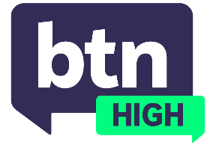
  EPISODE 29
  4th June 2025
  KEY LEARNING
  Students will discuss the social, cultural and environmental impacts of
  viral collectibles such as
  ‘blind boxes’.
  CURRICULUM
  Health and PE – Years 7 and 8 (v8.4)
  Health and PE – Years 7 and 8 (v9.0)
  Economics and Business – Year 9 (v8.4)
  Economics and Business – Year 9 (v9.0)
  Economics and Business – Year 10 (v8.4)
  Economics and Business – Year 10 (v9.0)
  Media Arts – Years 9 and 10 (v8.4)
  - Teacher Resource

Blind Boxes

Focus Questions
Discuss the BTN High story as a class and record the main points of discussion. Students will then respond to the following:
- Have you purchased a blind box before? If so, why did you buy it and how did you feel about unboxing it?
- Why do you think blind boxes appeal to young people?
- What are the social impacts of blind boxes?
- What are the environmental impacts?
- Are there any ethical concerns about blind boxes? Explain.
- What does ‘Manufactured Scarcity’ mean?
- Do you think the way we engage in blind box products will change in the future?

Activities
- Design your own blind box and create an advertising campaign marketing your product to fellow students.
- Research the history of blind boxes and write a feature article about their popularity.
- Write a persuasive essay about the positive and negative impacts of blind boxes.

