

**EPISODE 31**  
7th November 2023

**KEY LEARNING**

Students will view a range of BTN stories and use comprehension skills to respond to a series of focus questions.

**CURRICULUM**

**English – Year 4**Use comprehension strategies to build literal and inferred meaning to expand content knowledge, integrating and linking ideas and analysing and evaluating texts.

**English – Year 5**

Use comprehension strategies to analyse information, integrating and linking ideas from a variety of print and digital sources.

**English – Year 6**

Use comprehension strategies to interpret and analyse information and ideas, comparing content from a variety of textual sources including media and digital texts.

**English – Year 7**

Use comprehension strategies to interpret, analyse and synthesise ideas and information, critiquing ideas and issues from a variety of textual sources.

Teacher Resource

**Focus Questions**

As a class, discuss the stories featured in the episode of BTN Classroom and record the main points of the discussion. Students will then respond to the following focus questions.

# AI Laws

1. What does AI stand for?
2. How can AI be misused? Give one example.
3. What was the purpose of the global AI Safety Summit?
4. What are some benefits of using AI? Give an example.
5. What do you think about the issue? Discuss in pairs.

# Remembrance Day

1. When did WWI start and finish?
2. Most of the fighting in WWI happened on the ___________ Front.
3. How was technology used to fight the war?
4. An armistice is an agreement to…
   1. End fighting
   2. Enlist more troops
   3. Delay fighting
5. What do you understand more clearly since watching the BTN story?

Check out the [teacher](https://www.abc.net.au/btn/weekly-teacher-resources/10746906) resource on the Archives page.

# Dinosaur Extinction

1. How long ago did dinosaurs live?
2. What caused the Chicxulub crater?
3. Where is the Chicxulub crater? Find on a map.
4. How did dust contribute to the extinction of the dinosaurs?
5. What percentage of life went extinct when the dinosaurs died?
   1. 5%
   2. 55%
   3. 95%

Check out the [teacher](https://www.abc.net.au/btn/weekly-teacher-resources/10746906) resource on the Archives page.

# Australian Kids’ TV

1. What are some Australian TV shows? Make a list.
2. Why do families think Australian TV is good for kids? Give 2 reasons.
3. How much has Australian made kids’ TV decreased since the quotas were removed?
   1. 8%
   2. 48%
   3. 84%
4. At the moment, streaming platforms like Netflix and Disney+ don't have to make any Australian content. True or false?
5. Do you think there should be more Australian TV shows? Why or why not?

# Space Kids Competition

1. What is the purpose of the kids’ SOS project?
2. What was the aim of the Kids in Space competition?
3. Who were the winners of the competition?
4. What did Team NT invent? Describe.
5. What did you like about the BTN story?



**EPISODE 31**  
7th November 2023

**KEY LEARNING**

Students will develop a deeper understanding of World War I including its impact on the world and Australia’s involvement.

**CURRICULUM**

**HASS – Year 5 and 6**

Sequence information about people’s lives, events, developments and phenomena using a variety of methods including timelines.

Locate and collect relevant information and data from primary and secondary sources.

Develop appropriate questions to guide an inquiry about people, events, developments, places, systems and challenges.

Teacher Resource

**Remembrance Day**

# Focus Questions

Discuss the BTN story as a class and record the main points of the discussion. Students will then respond to the following:

1. When did WWI start and finish?
2. Most of the fighting in WWI happened on the ___________ Front.
3. How was technology used to fight the war?
4. An armistice is an agreement to…
   1. End fighting
   2. Enlist more troops
   3. Delay fighting
5. What do you understand more clearly since watching the BTN story?

# Activity: Personal Response

Students will write a personal response to the BTN story. Ask students to finish one or more of the following incomplete sentences:

* The Remembrance Day story made me wonder why…
* Learning about World War One made me feel…
* The words I would use to describe WWI are…

# Activity: Class Discussion

Discuss the BTN story as a class. Ask students what they know about World War One and Remembrance Day. Use the following questions as a guide:

* What event began WWI?
* Why did Australian become involved in WWI?
* What is Remembrance Day?
* What does it mean to commemorate?
* How do we commemorate Remembrance Day in Australia?



What questions do you have?

What do you know about World War One?

# Activity: Glossary

Students develop a glossary of words about World War One. Below are some words to get you started. Add words and meanings to your glossary as you come across unfamiliar words.

|  |  |  |
| --- | --- | --- |
| ENLIST | ALLIANCE | ARMISTICE |
| COMMEMORATE | TRENCHES | ALLIES |

# Activity: Research

Discuss the information raised in the BTN Remembrance Day story. What questions were raised in the discussion and what are the gaps in students’ knowledge? The following KWLH organiser provides students with a framework to explore their knowledge on this topic.

|  |  |  |  |
| --- | --- | --- | --- |
| What do I **know**? | What do I **want** to know? | What have I **learnt**? | **How** will I find out? |
|  |  |  |  |

Students will develop their own question/s to research or choose one or more of the questions below.

* Why did Australia join World War I? How did Australians contribute to the war effort?
* What impact did World War I have on Australian society, both during the war and after it ended?
* How did new technologies like machine guns and tanks, impact WWI?
* What was life like for soldiers in the trenches during the War?
* How did the Treaty of Versailles contribute to the end of WWI and the conditions in Europe afterward?
* What was the Armistice and how did it bring an end to WWI?
* What role did propaganda play during World War One and how did it influence public opinion?
* How did the aftermath of WWI pave the way for World War II?
* What do you know about your community during WWI? Does your local community have a World War I or II memorial or honour board? How does your local community commemorate Remembrance Day?
* What symbols or traditions are associated with Remembrance Day? Choose one to explore in detail.

# Activity: Visual literacy

In this activity students will examine, analyse and query a range of images from World War One. Students will choose one of the photographs below (alternatively, students can find an image themselves to analyse). Students will then respond to the following:

* Write a short paragraph describing what you see in this photograph.
* When and where was the photo taken?
* What do you think is happening?
* Write a caption for each image using your own words.
* What question/s would you like to ask about the photo? Choose one of your questions to investigate in more detail.

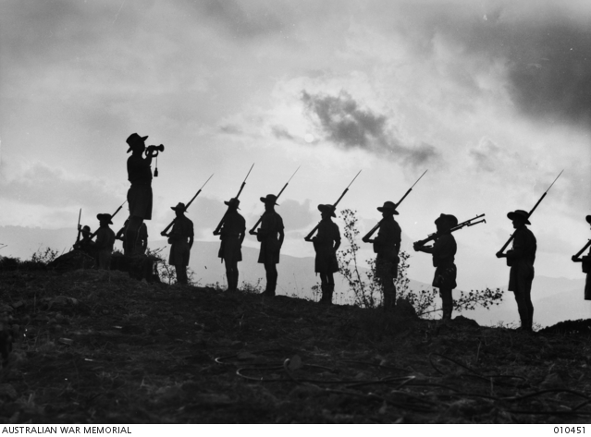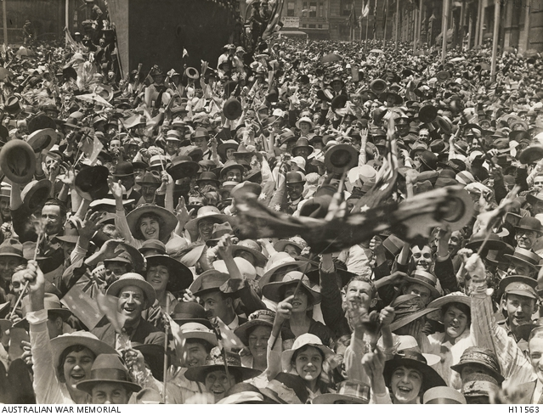

|  |  |
| --- | --- |
| [Australian War Memorial](https://www.awm.gov.au/collection/H11563)  Collection Item C550 | J06392 [Australian War Memorial](https://s3-ap-southeast-2.amazonaws.com/awm-media/collection/010451/screen/4108624.JPG) |

[Australian War Memorial](https://s3-ap-southeast-2.amazonaws.com/awm-media/collection/A02022/screen/4166297.JPG) [Australian War Memorial](https://s3-ap-southeast-2.amazonaws.com/awm-media/collection/J06392/screen/4143755.JPG)

|  |
| --- |
|  |
|  |

# Activity: WWI Memorial Box

In this activity, students will explore how objects can help tell the story of war. Students will use the internet to ‘collect’ a range of items and categorise them into primary and secondary sources. Students will reflect on each item by responding to a range of questions.

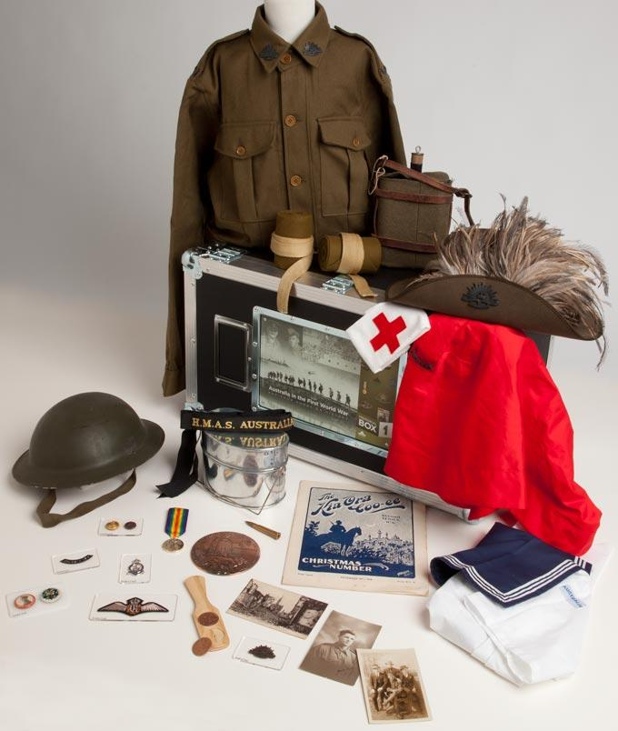Before starting this activity analyse the [Australian War Memorial’s WWI Memorial Box](https://www.awm.gov.au/learn/memorial-boxes/1). Then, individually or in pairs, students will use the following as a guide as they create their own memorial box:

* ‘Collect’ 6 items to create your own WWI memorial box. Use the internet to find your memorial box items, including equipment, objects, works of art, photographs, letters, diary entries, or souvenirs.
* Include an illustration/photo and a description of each object. Why did you include each object in your memorial box? Are there any stories related to the object?
* Categorise the objects into two columns, is it a primary source or secondary source?

# Activity: Indigenous Service

Students will find out more about Indigenous Australians’ service in the military. Encourage them to develop their own questions about the topic. Here are some questions to help guide their research:

* Why did Indigenous people enlist in the war?
* Which wars did they serve in?
* What rights did Indigenous people have during WWI? For example, could they vote and were they included in the census?
* What entitlements did they have when they returned from war?
* What do you think life would be like for Indigenous Australians who served in the war?
* How has the contribution made by Indigenous servicemen and servicewomen been recognised?

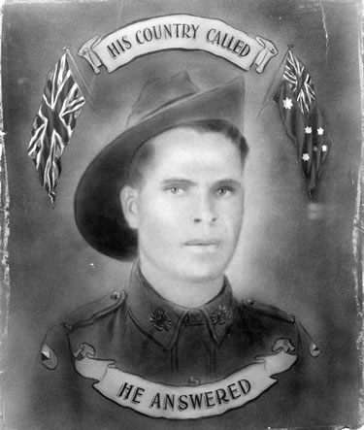Discuss with students ways to display the information. These could include:

* A postcard written from the perspective of the soldier to their family explaining what life was like at war. Include photography, drawings or maps to decorate the front of the postcard.
* Create a timeline showing Indigenous Australians’ involvement in the military.

# Activity: World War I and Australia

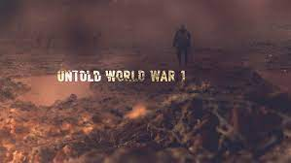When Australia joined World War I, thousands ofyoung Australians from regional towns left their normal lives for war. [Untold Stories from Australian WWI Memorials](https://www.abc.net.au/education/digibooks/untold-stories-from-australian-wwi-memorials/101750628) is an interactive that tells the stories of those honoured on memorials around Australia.

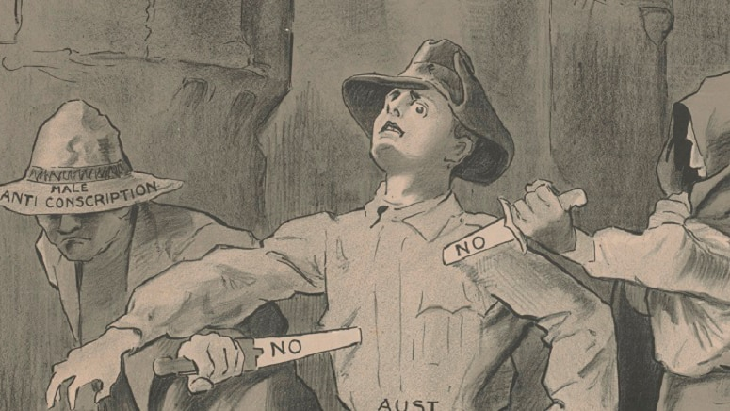[The Home Front](https://www.abc.net.au/education/digibooks/the-home-front/101877294) is a collection that focuses on the experiences of Australians on the home front during WWI. Through issues such as enlistment, the cost of war and conscription, it explores the impact of war at both the personal and national levels.

# Useful Websites

* [First World War 1914-18](https://www.awm.gov.au/articles/atwar/first-world-war) – Australian War Memorial
* [1918: Final Victory and Armistice](https://www.awm.gov.au/visit/exhibitions/1918/victory) – Australian War Memorial
* [Researching a First World War Soldier: A step by step guide](https://www.awm.gov.au/research/guide/ww1-steps) – Australian War Memorial
* [World War I: Snapshot of Australia at the time of the outbreak](https://www.abc.net.au/news/2014-08-04/world-war-i-snapshot-australia-time-of-outbreak/5634632?nw=0) – ABC News
* [Life in the Trenches](https://www.abc.net.au/btn/classroom/life-in-the-trenches/10526704) – BTN
* [The Gallipoli Story](https://www.abc.net.au/btn/classroom/life-in-the-trenches/10526704) – BTN
* [WWI Centenary](https://www.abc.net.au/btn/classroom/wwi-centenary/10527914) – BTN
* [Remembrance Day History](https://www.abc.net.au/btn/classroom/remembrance-day-history/10611738) – BTN
* [The Story of WWI](https://www.abc.net.au/btn/classroom/the-story-of-wwi/10611764) – BTN
* [Signing the Armistice](https://www.abc.net.au/btn/classroom/signing-the-armistice/10611748) – BTN



**EPISODE 31**  
7th November 2023

**KEY LEARNING**

Students will learn more about the causes of dinosaur extinction.

**CURRICULUM**

**Science - Year 4**

Earth’s surface changes over time as a result of natural processes and human activity.

**Science - Year 5**  
Living things have structural features and adaptations that help them to survive in their environment.

**Science - Years 5 & 6**

Science involves testing predictions by gathering data and using evidence to develop explanations of events and phenomena and reflects historical and cultural contributions.

Scientific knowledge is used to solve problems and inform personal and community decisions.

**Science - Year 6**  
Sudden geological changes and extreme weather events can affect Earth’s surface.

**Science - Year 7**  
Classification helps organise the diverse group of organisms.

Scientific knowledge has changed peoples’ understanding of the world and is refined as new evidence becomes available.

Teacher Resource

**Dinosaur Extinction**

# Focus Questions

Discuss the BTN story as a class and record the main points of the discussion. Students will then respond to the following:

1. How long ago did dinosaurs live?
2. What caused the Chicxulub crater?
3. Where is the Chicxulub crater? Find on a map.
4. How did dust contribute to the extinction of the dinosaurs?
5. What percentage of life went extinct when the dinosaurs died?

# Activity: Class Discussion

Discuss the BTN Dinosaur Extinction story as a class and record the main points on a mind map with DINOSAURS in the centre. Students will respond to the following:

* What do you know about what caused the extinction of dinosaurs?
* When did the extinction happen?
* What did you learn from this story?
* What does this story make you wonder?
* Think of three questions you would like to ask about the story.
* Make a list of words related to this story. Use this list of words to help form a class glossary.

# Activity: Q&A

Are you curious about dinosaurs? Students will make a list of questions they have about the BTN story and the extinction of dinosaurs. Students will use the internet to find answers to their questions and share their findings with the class.

How did dinosaurs become extinct?

Why do we study dinosaurs?

# Activity: Glossary

Students will brainstorm a list of key words that relate to the BTN Dinosaur Extinction story. Here are some words to get them started.

|  |  |  |
| --- | --- | --- |
| PALAEONTOLOGIST | FOSSIL | PREHISTORIC |
| CRETACEOUS PERIOD | EXTINCTION | DINOSAUR |

Ask students to write what they think is the meaning of each word (including unfamiliar words). They will swap definitions with a partner and ask them to add to or change the definition. Check these against the dictionary definition.

Further activities for students:

* Students will add to their glossary by downloading the transcript for the BTN Dinosaur Extinction story and highlight all the words that relate to the topic.

# Activity: KWLH

Discuss the information raised in the BTN Dinosaur Extinction story. What questions were raised in the discussion and what are the gaps in students’ knowledge? The following KWLH organiser provides students with a framework to explore their knowledge on this topic.

|  |  |  |  |
| --- | --- | --- | --- |
| What do I **know**? | What do I **want** to know? | What have I **learnt**? | **How** will I find out? |
|  |  |  |  |

Students will develop their own question/s to research or choose one or more of the questions below. Encourage students to collect and record information from a wide variety of sources and present the information they find in an interesting way.

* When did dinosaurs live? Choose one dinosaur from each of the following geological periods: Triassic, Jurassic, Cretaceous and Cenozoic. Record your findings on a timeline.
* How does finding fossils help scientists learn about the past?
* What evidence have scientists found to help understand how dinosaurs became extinct?
* What is the role of a palaeontologist? What are the different parts to the job of a palaeontologist and what skills do they need to have? Present your information in a creative way.

# Activity: Dinosaur Profile

Students will imagine they are palaeontologists and study a type of dinosaur in as much detail as possible. Students will investigate the dinosaur using the following questions to guide their research and then present their findings in an interesting way. Students can use the animal profile worksheet at the end of this activity to record their findings. Encourage students to use a range of sources to find their information.

**Research**

Students will research and create a profile of a dinosaur. Students can use the Animal Profile at the end of this activity to record their findings.

* What is its scientific name? What does its name mean?
* Is it known by any other names?
* What did it look like? Describe.
* How big was it? Length, height, and weight.
* What did it eat?
* Where did it live? Where have its fossils been found?
* How long ago did it live?
* When did it become extinct?
* What was the cause/s of its extinction?

**Further Investigation**

Students will respond to one or more of the following questions.

* How long did dinosaurs live on Earth? Investigate when the Tyrannosaurus rex lived compared to when the Stegosaurus lived. In what geological periods did they live?
* Modern birds are a kind of dinosaur. True or false? Explain your answer.
* How did dinosaurs get their names? Use these words in your answer: genus, scientific name, the specific epithet, Greek or Latin.
* Are we drinking the same water as the dinosaurs? Explain your answer.
* Where have the most dinosaur fossils been found? Highlight these places on a map.
* How often are palaeontologists uncovering new dinosaurs? Find a news report with the latest discovery.

# Activity: How do Dinosaurs get their names?

During this activity students will become palaeontologists and create a new dinosaur species! Students will imagine they have discovered a new species of dinosaur which has never been discovered before and give it a scientific name.

**Class Discussion**

Find a range of pictures of dinosaurs and ask your students if they can name any of them and write some examples of dinosaur names on the whiteboard.

Introduce the concept of scientific naming, which is used to name all living organisms. Dinosaur names are often made up of combinations of Greek or Latin words that describe the dinosaur’s appearance, characteristics, or behaviours of the animal. For example, "Tyrannosaurus" means "tyrant lizard" and "Triceratops" means "three-horned face". Some dinosaurs are named after the people who discovered them, and others are named after the place where they were [discovered](https://wonderopolis.org/wonder/how-do-dinosaurs-get-their-names). Explain that the Genus name (the first word) is capitalised, and the species name (the second word) is in lowercase.

Below are some Greek and Latin words which have been used in dinosaur names.

|  |  |
| --- | --- |
| Word (Greek or Latin) | Meaning |
| *tyranno*  *rex*  *raptor*  *tri*  *stego*  *compso*  *bronto* | *tyrant*  *king*  *robber*  *three*  *roof*  *pretty*  *thunder* |

**Group Activity**

In small groups students will use their imagination and come up with a list of scientific names for new dinosaurs. Students will follow the structure (Genus species) and consider the dinosaur's appearance or behaviour. Student will share their scientific names and explains their meanings.

**Individual Activity**

Students will choose one name from their list and then respond to the following questions:

* What have you named your dinosaur? Explain the origins of the name. Is it named after a person or a place? Is the name something that describes its characteristics or behaviour?
* What did your dinosaur look like? Describe any interesting or unusual features.
* How big was it? What was its height and length?
* What did it eat?
* Where did it live?
* When did it live? When did it become extinct?

**Further Activities**

* Draw a picture of the new dinosaur species using only a black felt-tip pen on a piece of A4 art paper – include as much detail as you can. You may want to draw a scientific illustration or draw the animal in its natural habitat. Label important features.
* Create a 3D model of your new species using upcycled materials.
* How possible do you think it is that your new species exists? Explain your answer.
* Present your dinosaur to the class. Present using [Prezi](https://prezi.com/) or [Canva](https://www.canva.com/).

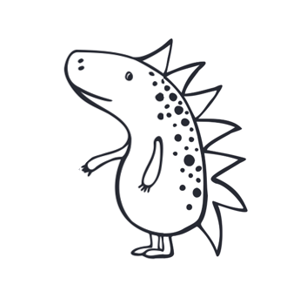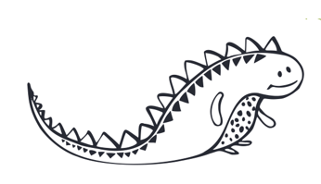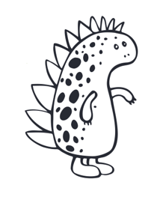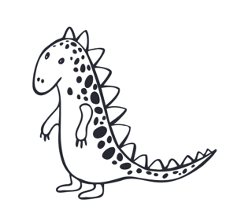

# Useful Websites

* [Giant Aussie Dinosaur](https://www.abc.net.au/btn/classroom/giant-aussie-dinosaur/13380610) – BTN
* [Dinosaur-killing asteroid in Yucatan Peninsula unleashed 2,000 gigatonnes of dust into the atmosphere, new research suggests](https://www.abc.net.au/news/2023-10-31/dinosaur-asteroid-dust-impact-research/103042488) – ABC News
* [Extinction](https://education.nationalgeographic.org/resource/extinction/) – National Geographic Education
* [Mass Extinctions](https://education.nationalgeographic.org/resource/mass-extinctions/) – National Geographic Education
* [The Dino Directory](https://www.nhm.ac.uk/discover/dino-directory.html) – Natural History museum
* [Dinosaurs](https://www.abc.net.au/btn/classroom/dinosaurs/10528672) – BTN
* [What are fossils?](https://australian.museum/learn/australia-over-time/fossils/) – Australia Museum
* [Dinosaurs: Collection](https://education.nationalgeographic.org/resource/dinosaurs/) – National Geographic Education
* [Fossil](https://education.nationalgeographic.org/resource/fossil/) – National Geographic Education



Teacher Resource

**BTN Transcript: Episode 31 – 7/11/2023**

Hey. I'm Amelia Moseley and you're watching BTN. Thanks for hanging out with us again, let’s see what's coming up on today’s show. We learn about the First World War, find out more about the dusty end of the dinosaurs and tune in to a study about Aussie kids’ TV.

# AI Laws

Reporter: Joe Baronio

*INTRO: But first up today to artificial intelligence. We've all heard talk about how AI can lead to cheating and fake news. But some are worried it could pose a more serious risk to humanity and that's why world leaders have been working to bring in laws to control AI before it can control us. Here’s Joe.*

Xander: Everything alright, Joe?  
  
JOE: I've got my eye on this thing.   
  
Xander: I see that.

JOE: I don’t trust it. I don’t like it. It knows too much.  
  
Joe Baronio, BTN Reporter: Policing a computer isn't actually as weird as it seems. See, recently, we've heard a lot about AI and the many different ways it can be used or misused, from writing essays to voice cloning and deepfakes, among other things.

KING CHARLES III: As some of you may know, I have long been a fan of the game Minecraft.  
  
JOE: But what if it took over the world?   
  
Computer: What if I took over the world?  
  
JOE: Hey.  
  
We've seen what can happen when AI gets too smart in Hollywood movies that is.

BENJI DUNN: A self-learning, truth-eating, digital parasite.

ETHAN HUNT: The Entity.

But leaders around the world are starting to worry that this kind of thing could actually become a reality, and many experts reckon AI tech is developing faster than laws can keep up.

BENJI DUNN: Well, it was bound to happen sooner or later.

US President Joe Biden, seen here talking about a magic pistachio nut.  
  
Deepfake Joe Biden: I got lost in a grocery store and couldn't find my way out. But that's when I saw it, a glowing pistachio.  
  
Umm, no that's fake. The real Joe Biden recently signed an executive order setting new rules to tackle some of the problems AI could cause before it gets out of hand.

The order will help protect against all kinds of AI risks, from job losses and spreading fake news, to building weapons, by making tech companies share information and test results before they release new programs and requiring AI-generated content to be watermarked so you can tell it was made by machines.   
  
JOE: But the US aren't the only ones concerned about these computer brainiacs.  
  
Last week, Britain hosted the world's first AI safety summit where around 100 officials and tech giants came together to talk about regulation.   
  
Elon Musk, X CEO: It's one of the existential risks that we're facing, it’s potentially the most pressing one.  
  
The United Nations also announced a new advisory group to look at the issue on an international level.  
  
Antonio Guterres, UN Secretary-General: It is already clear that the malicious use of AI could undermine trust in institutions, weaken social cohesion and threaten democracy itself.  
  
Even AI companies like OpenAI, the creators of ChatGPT, have called for their field to be regulated.  
  
Sam Altman, OpenAI CEO: My worst fears are that we cause significant we, the field, the technology, the industry, cause significant harm to the world.   
  
Computer: Hey, AI tech isn't all bad.  
  
JOE: Yeah, you would say something like that.   
  
No, the computer is right.   
  
JOE: Was that you?  
  
It can help organise our lives, make businesses and workers more efficient, and help us come up with ways to solve big problems like climate change or diseases.  
  
Joe Biden, US President: We're going to see more technological change in the next ten, maybe next five years than we've seen in the last 50 years.

Poppy Gustafsson, Darktrace CEO: The fastest way that we can benefit from this innovation is by making it really safe. The safer it is, the faster we will adopt it.  
  
So, what do you reckon?   
  
STUDENT: I think they should make more rules about like age restrictions.  
  
STUDENT: I think they should make some rules about how to use them safely and use them properly for their purpose.  
  
STUDENT: Because as we know, like, there are lots of naughty and cheeky people out there. And they can use AI for bad purposes.

# News Quiz

The students of Goodwood State School near Bundaberg have thanked firefighters for saving their school from bushfires.

VOXIE: Thank you for helping us.

VOXIE: Thank you for putting out all the great fires.

Which state are they in? Which state are they in? Goodwood is in Queensland, which has been hit by hundreds of bushfires over the past week. They’ve destroyed farmland and dozens of homes. There are still fires burning around the country and authorities say it’s really important to listed to advice and follow your bushfire plans.

Which one of these footballers won this year’s Ballon d’or? Aitana Bonmati, Salma Paralluelo, or Sam Kerr? It was Spanish Midfielder Aitana Bonmati. Sam Kerr came second. She’s been nominated for the prestigious prize ever since it was offered to women, but she’s never actually won. Meanwhile Lionel Messi walked away with his eighth golden ball.

And speaking of big events, the Southern Hemisphere’s biggest Christmas Pageant has taken place in which capital city? It’s in Adelaide. Hundreds of thousands of people came to see the 90-year-old parade and see the big man himself.

VOXIE: I love Santa Claus!

VOXIE: We’ve been good all year!

# Remembrance Day

Reporter: Michelle Wakim

*INTRO: This Saturday at 11 o'clock on the 11th day of the 11th month Australians mark Remembrance Day, just like millions of others around the world. It's also known as Armistice Day and commemorates the signing of the agreement that ended World War One. Michelle found out more about that war and how it changed the world.*

MICHELLE WAKIM, REPORTER: This is what the world was like before the start of World War I. Films were silent, cars looked like this, and there were a lot of hats. The world map also looked pretty different. This was a time of empires, when powerful European countries were taking other territories, forming alliances, amassing huge armies and navies, and competing for power. Many people thought that a war was coming.   
  
It started with an assassination. Gavrilo Princip, a Bosnian-Serbian student, shot Archduke Franz Ferdinand, heir to the throne of the Austro-Hungarian Empire, on June 28th, 1914. It triggered a war between Austria-Hungary and Serbia, and because of those alliances and tensions we mentioned earlier, the war quickly grew.

Germany was allied with the Austro-Hungarian Empire, while Serbia was supported by Russia, which was friends with France. Then when Germany invaded neutral Belgium to get to France, the UK joined the fight. That side was known as the Triple Entente, or The Allies. Not long after, the Ottoman Empire got involved on the other side, known as the Central Powers.It wasn't just the scale of the war that made it different. There was also new technology that changed the way it was fought. Machine guns made it hard for armies to move across open land, so trench warfare was born. It was slow and brutal. As well as bombs and bullets, disease and cold killed thousands of people.   
  
There were moments of light, like a famous story from the Western Front. As Christmas approached in 1914, British soldiers could hear their German enemies singing carols from the trenches. On Christmas Day, both sides laid down their weapons, exchanged gifts and played a game of soccer. But, of course, the truce didn't last.  
  
As the war went on more technology was designed to break the deadlock, like accurate guns, planes, and poison gas. The first tank prototype was built in September 1915. It wasn't bullet proof or high tech, but it meant conflict could eventually move out of the trenches.   
  
As part of the British Empire, Australia was involved in the war from the start. Around 400,000 young men volunteered, along with around 3,000 women. Many had never been overseas and were keen to see the world and serve their King and country. Most were sent to the Western Front, which was one of several major fronts in the war, including the east and the Middle East, where Australians also played a big role.  
On April 25th, 1915, Australian and New Zealand soldiers landed in Gallipoli, a peninsula in what we now know as Türkiye. More than 50,000 ANZACS fought alongside British and French troops in the eight-month long campaign, and more than 8,000 Australians died. While the Allies didn't win the campaign, to many Australians, Gallipoli become a symbol of national identity.   
  
The war dragged on for three more years, taking a huge toll on the countries at its heart. Russia had a revolution, and eventually left the fight, while America joined at the end of 1917, helping to shift things in favour of Britain and its allies.   
  
By late 1918, it was over. Germany and its allies had all been defeated, and on the 11th of November, leaders met in a train carriage in France. Germany signed a formal agreement, called an armistice, to stop the conflict. At 11 am the fighting stopped, and in many countries around the world, there were celebrations.   
While the war was over, around 20 million people were dead. Empires fell, and Germany was officially blamed for the war, forced to disarm, surrender its colonies, and make huge payments to the Allies. World War 1 changed history. At the time, it was known as ‘The Great War’ or ‘the war to end all wars’. Of course, that wasn't true, and an even deadlier war was only 21 years away.   
  
But, the 11th of November, is still seen as an important day for many countries around the world; a time to reflect on the horrors of the first world war and all the wars since; and to hope for a more peaceful future.

**Dinosaur Extinction**

Reporter: Joe Baronio

*INTRO: Now here's a question for you: What killed the dinosaurs? If you said an asteroid well, you're right but there's more to the story. A recent study has looked into the role that dust played in the dinos' demise. Here's Joe.*

Joe Baronio, BTN Reporter: Dust is annoying for anybody, and dusting can be too. But dinosaurs really don't like it and for a good reason. See, around 66 million years ago, dinosaurs didn't have aprons or feather dusters. They were just hanging out as the dominant species on planet Earth. But that all changed when a massive asteroid, more than 9 kilometres wide smashed into the Earth's surface right here on the Yucatán Peninsula in Mexico, now known as the Chicxulub crater. It hit the ground at a zippy 20 kilometres per second, or about 58 times faster than the speed of sound. Causing a ripple effect of earthquakes, tsunamis, volcanic eruptions, massive fires, and even poisonous rain. But according to some complex new research from scientists in Belgium, those aren't what ultimately ended the reign of the dinos. It was...   
  
Dinosaur: Dust. lots and lots of dust.   
  
Mike Lee, South Australian Museum: The explosion basically blew a hole the size of Tasmania into the Earth's crust. So, you imagine vaporizing Tasmania, and then throwing all that dust into the air and blocking out the sun.   
  
That's around 2,000 gigatonnes of dust causing what the researchers call impact winter.  
  
JOE: So, all of that dust would have been a pretty bad time for these guys. What would it have been like?  
  
MIKE: It would have been catastrophic. The dust cloud hung in the air for a decade, it would have been pitch black for two years, and really gloomy for maybe a decade.  
  
And a lack of sunlight is very bad news for pretty much all life on Earth. See, plants rely on photosynthesis which is when they absorb sunlight and turn it into food. But thanks to all that dust blocking the sun plants started to die, and then the animals that fed on the plants died, and the animals that fed on those animals died. Yeah, you can see where this is going. The dust cover also caused the temperature on Earth to plummet by up to 15 degrees Celsius, which many creatures weren't evolved to deal with.   
  
MIKE: In that sort of nuclear winter or asteroid winter 95 percent of the species on Earth perished.   
  
Of course, that leaves 5 percent that did survive, including the ancestors of, well, everything. Mammals like us, fish, reptiles, and even some dinosaurs.  
  
JOE: So, these are descendants of the creatures that did survive the impact, how did anything survive it?  
  
MIKE: Yes, when the meteorite hit the Earth, modern birds were around, and birds are a subgroup of dinosaurs.  
  
Mike says these avian dinosaurs had a few tricks up their wings, get it. Like being able to fly so they could find food and shelter, and, like smaller mammals that survived they didn't need to eat so much food and could dig around in the ground to find seeds, something their descendants are still really good at.  
  
JOE So, what do you reckon would have happened if the asteroid didn't hit Earth?  
  
MIKE: If the asteroid didn't hit, dinosaurs would have continued to rule the world. And who knows, they might have evolved intelligence, and BTN would probably be made by dinosaurs.

**Aussie Kids’ TV**

Reporter: Thomas Midena

*INTRO: How many of the TV shows you watch are made in Australia (besides this one of course)? It's something a group of researchers have been looking into as part of a study into Aussie TV content. And they say Aussie kids TV might be in a bit of trouble. Take a look.*

STUDENT: Some TV shows I like to watch are Bluey, BTN, Survivor.  
  
STUDENT: I like to watch Bluey, The Amazing Race.  
  
HORRIBLE HISTORIES: Gentlemen, we are facing a great war. War.?  
  
THOMAS MIDENA, REPORTER: Today, there are more TV programs available for us to watch than ever. Across so many channels, and streaming platforms, on all of these devices, from countries all over the world. But how much of the TV that we watch is from the country we live in? Australia. Yeah, thanks.  
  
STUDENT: BTN and Bluey are Australian. Lego Masters, I think is Australian. And Amazing Race, Survivor, Masked Singer, I think they make Australian versions.  
  
STUDENT: Survivor, The Masked Singer.

STUDENT: Most of my favourite TV shows are Australian.  
  
THOMAS: Sounds like these kids are big fans of Aussie TV. And according to new research, so are many families around Australia.  
  
ASSOCIATE PROFESSOR LIAM BURKE, SWINBURNE UNIVERSITY OF TECHNOLOGY: While there's lots of exciting shows from all over the globe, people are still eager to see their own experiences reflected on screen.  
  
Liam Burke is a part Australian Children's Television Cultures: a group of researchers who are interested in how we watch locally made kids TV in the era of streaming services. They've found that 83 percent of parents think it's important that children see Australian-made TV programs. Families say they like the way that Aussie TV can teach young people about Australia, its people, landscape and history. They also love shows with an Aussie sense of humour.  
  
ROUND THE TWIST: We don't have time for this, he's gonna have a baby any minute now.  
  
THE INBESTIGATORS: Pretty sure there's no such thing as an aloe vera plant. 'Allo Vera, how are you today, Vera?  
  
TV shows are also a way for people overseas or new Australians to get a taste of Aussie culture.  
  
LIAM: So, we've spoken to parents from overseas, who use shows like Little Lunch and inBESTigators to better understand the school system here. So, it seems more familiar for them and seems more familiar for their children.  
  
THOMAS: But the researchers say Australia isn't making as many kids TV shows as we used to. See, back in the 60s, the Australian government brought in quotas to make sure most shows on free-to-air TV were Australian. And for quite a while there was a quota for Children's TV. But making these shows is expensive, and networks argued that kids weren't watching as much free-to-air TV anymore. So, in 2020, the government agreed to get rid of the quota on Australian-made Children's TV. Since then, locally made kids’ TV has decreased by more than 84 percent.  
  
Meanwhile, streaming platforms like Netflix and Disney+ don't have to make any Australian content. But that's set to change next year. The government's going to bring in rules for streaming platforms, so they'll have to make a certain amount of Australian content.  
  
LIAM: And what we're hoping is that as part of those new regulations, that there will be safeguards for local kids TV so future generations can enjoy the kids TV we've had for the past couple of decades.  
  
THOMAS: Do you think that there should be more Australian TV shows?  
  
STUDENT: Yes.   
  
STUDENT: Yes, I do. Because I think it would be good if people all around the world can see how Australians live.  
  
THOMAS: But now, I'm just gonna put on *my* favourite show.

**Sport**

This weekend saw the end of an incredible career as AFL star Erin Phillips played her final game for Port Adelaide.

COMMENTATOR: It’s the Erin Phillips show!

And kicked a goal in the Power's 58 point smashing of GWS. Phillips leaves the game as the AFL-W's most decorated player.  
  
Over to the cricket world cup where Australia have beaten England. Adam Zampa had a particularly good night taking 3 wickets making him the leading wicket taker for the tournament so far.

ADAM ZAMPA: Probably the most satisfying ODI I’ve ever played, to be honest.  
  
And finally, the Para Matildas are off to a ripper start at the Asia-Oceania Championships in Melbourne. They won their first game against Japan 3 nil.

COMMENTATOR: And the first goal of the tournament. Who else but Georgia Beikoff? A wonderful start for Australia.

And on Day 2 of the tournament, they scored goal after goal against Nepal. Finishing 10 nil.  
  
**Space Kids Competition**

Reporter: Michelle Wakim

*INTRO: Finally, today to kids in space. But spoiler alert, they're not actually there yet anyway. That's just the name of the competition which got kids around Australia to come up with a spacey invention that could improve our lives, either on Earth or beyond. Take a look.*

MICHELLE WAKIM, REPORTER: Climate change, over-population, and space junk. These are just some of the issues we face here on earth, and beyond. So, who's going to come up for solutions for these problems? Hmm, I reckon these guys might be able to help us out.   
  
STUDENT: The sonar I made is all about capturing a photo of an underwater animal’s life.   
  
STUDENT: We're trying to build a habitat on the moon for Artemis 3. And our solution is by designing and printing a team of rovers.   
  
STUDENT: Our project is called the S.O.S. which stands for Small Organism Sanctuary, and it's basically a habitat after bushfires so that cats and wild animals have places to stay and aren’t getting hunted down by wild cats or animals.   
  
These students have just competed in the first ever ‘Kids in Space’ competition. The comp was all about using space tech, that’s stuff like rockets, satellites and space craft, to solve problems. Some students even came up with a way for their teacher to live happily on the moon.   
  
STUDENT: He wants to get away from us basically he doesn't want to teach us anymore.  
  
TEACHER: They don't like me. They want to send me away. So, they've designed me ways to eat, ways to get water, some entertainment things. So, they've done a really good job.   
  
That's right, they’ve thought of absolutely everything.   
  
STUDENT: I made an ice cream station, because you can't eat the regular ice cream that we have down here, and if you're like me, you can't actually survive without ice cream.   
  
The competition was tough, with 10,000 students participating from all across Australia. And the winners were.  
  
ANNOUNCER: Team Victoria, and Team Northern Territory.  
  
Ok there's a lot of them.  
  
ANNOUNCER: Well done. Well done. Well done. And, well done.  
  
Yep. Team Victoria and Team NT turned out to be joint winners this year, with some pretty speccy inventions. The Victorians created a way to grow food in space hydroponically, which means without using soil. And Team NT developed a sonar system to work out the best time to cross Cahills Crossing, a stretch of water home to saltwater crocs. The project is designed to spread excitement about STEM subjects and careers, and it looks like it might have done the job.   
  
STUDENT: Very, very exciting   
  
STUDENTS: Kids in space!

**Closer**

Ah, I love your work. Well, that's it for this week's show. I hope you've had fun and learned a thing or two or three. If you want to learn even more there's heaps to see and do one our website and there's BTN High and BTN Newsbreak. Have a great week and I'll see you soon. Bye.