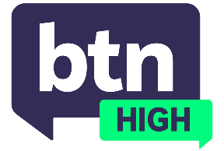
  EPISODE 29
  3rd June 2026
  KEY LEARNING
  Students will explore what the Children’s Online Privacy Code is, and discuss online privacy.
  CURRICULUM
  Digital Technologies – Year 7 and 8 (v9.0) - 1
  Digital Technologies – Years 7 and 8 (v9.0) - 2
  Digital Technologies – Years 9 and 10 (v8.4)
  Digital Technologies – Years 9 and 10 (v9.0)
  Health and PE, Years 9 and 10 (v8.4)
  Health and PE - Years 9 and 10 (v9.0)
  - Teacher Resource

Online Privacy Code

Focus Questions
Discuss the BTN High story as a class and record the main points of discussion. Students will then respond to the following:
- What does our ‘digital footprint’ mean?
- What sort of data can contribute to our digital footprint?
- In a digital context, what are ‘cookies’?
- Why is online privacy important?
- How does your online persona differ from your real-life personality?
- Do you actually read the "Terms and Conditions" before downloading an app? If not, what could the consequences be?
- What are some of the possible consequences of data leaks?
- In your own words, explain what the Children’s Online Privacy Code is.
- What would you like to see included in the Code?

Activities
- Create a campaign about the importance of online safety that could be used in and around your school.
- The eSafety Commissioner’s website contains an Online Safety Classroom Agreement. In small groups, create an agreement for your class or school.
- Research another country that has rules or codes around children and online privacy. Present your information as a slideshow.
- In small groups, discuss how you keep your personal details and information safe online and brainstorm ideas on how to further this.

