The Trackless Tram: A Game-Changer for 21st Century Transport
Peter Newman, Mike Mouritz, Sebastian Slate-Davis, Charlie Hargroves, and Daniel Conley, Curtin University Sustainability Policy Institute (CUSP), Curtin University, Perth, Australia
The world is about to adopt a new approach to transport. Autonomous and electric vehicles linked to smart, new urban systems are enabling the idea of ‘local shared mobility’, which is rapidly entering the psyche and planning frameworks of the world’s cities. At the same time however, there are concerns about what happens along urban corridors where there have been decades of growth in both heavy and light rail. Heavy rail carries 20 times the capacity of a freeway lane and is likely to have a continuing role with local shared mobility options providing feeder services for stations. But what about light rail, where will it fit? Is it redundant?
As it turns out not only have cars improved in technology recently but so has light rail with the invention of a range of technologies including driverless guidance systems, electric propulsion with storage and recharging, and the replacement of metal tracks with ruber tyres, which transforms the current type of light rail into what is referred to as Autonomous Rail Technology (ART), Guided Electric Transit System (GETS), or simply a ‘Trackless Tram’. The CUSP team has been working on light rail for several decades and predict that ‘Trackless Trams’ will be a game-changer for cities.
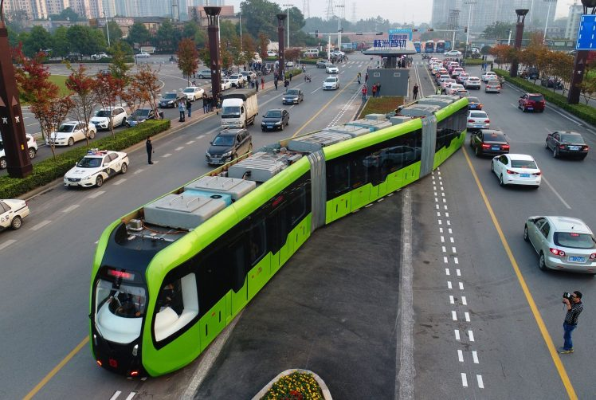
Figure 1: The Trackless Tram invented in Belgium being demonstrated in China
The ‘Trackless Tram’ can travel at 70km/hour through city streets with rapid acceleration and deceleration while carrying between 300 to 500 passengers depending on it’s use of 3 or 5 carriages. It is effectively a standard light rail set of carriages, affording all the benefits of a light rail such as a sleek aerodynamic desgn, rapid loading doors, ride quality, passenger safety, and fixed-route land-value creation, with three important distinctions:
- Minimal Disruption. The running gear is replaced with rubber tires intended to run on asphalt or concrete. Thus there is no digging up of streets, very little disruption to businesses, houses or traffic, though space must be found in the roadway, probably replacing parking as with LRT. While many light rail projects take years to build, the Trackless Tram can be installed virtually overnight (with stations being prefabricated for rapid onsite erection).
- Electric. The Tram is electric and is powered by lithium ion batteries located on the roof which are rapidly recharged (30 seconds) at solar powered platform-style-stations during service and can be fully charged while out of service at a depot. These stations can provide feeder nodes for recharging local shared mobility – E-Bikes and AV-EV’s.
- Autonomous. The Tram is driverless and navigates the corridor by following virtual railways made up of magnetic strips or sensors painted onto the road. The more that a separate road space can be provided the better as otherwise it will not flow well even with AV sensors. The Tram capacity along a single lane would be roughly 10 times the amount that can be carried in cars.
Trackless Trams can be constructed locally in most cities and are estimated to cost in the range of $10-17 million per kilometre. This cost is 3-4 times less than costs suggested for light rail in most cities and around 10 times less than the Sydney CBD and South East Light Rail which had massive costs in its replacement of services under the road. The value proposition of TT’s is based on its value for money, its innovation and its potential to attract private financing.
A Model for Financing and Implimentaton
As with all transport options the Trackless Tram system will require financial investment, however it has a significant advantage over bus systems as like a light rail the Tram is designed to follow a long term fixed route and as such is able to attract urban development around fixed stations. The Tram stops provide passenger loading platforms, battery recharging, and links to local shared mobility options but most of all will provide a constant stream of pedestrians. Development is thus attracted to the Tram stop area for up to 1km in radius. Such land value increases in transit oriented development (TOD’s) can be captured to enable the Tram system to be financed. This value capture has been applied in many cities around the world however results have been mixed as often the corridor and station location selection is done by transport agencies with little concern for land development opportunities. Japan, Hong Kong and many other cities are now using more land development-oriented market-based approaches.
CUSP has created a way to leverage the land value increase in a manner that engages with the private sector, called the ‘Entrepreneur Rail Model’ (ERM). Beginning with a focus on rail options and now being applied to Trackless Trams, the ERM suggests a method of financing corridor public transport which is based on establishing partnerships between local governments along the corridor, developers, the community and financial institutions like superannuation companies, as well as with state and national governments. The mechanism of the ERM then leverages real partnerships to select routing and station locations that both deliver transport services to the community and increase the value of specifically chosen land parcels. For instance a ‘Special Improvement District’ type approach would see developments on such land along the route paying for the stations and contributing to the carrriges and road preparations - and even operating the tram system in that corridor.
This process may involve the creation of a ‘City Tram Company’ (CTC) to function as a collaborative legal entity, capable of gathering revenue streams and able to borrow from Superannuation Funds/Banks based on development opportunities with risk guarantees from federal government (as being developed for City Deals in the UK and Australia). It would work closely with state agencies. This CTC must bring together the various partners and overcome the silos and barriers in the ‘creation phase’ to help design the ‘rules’ and clarify the risks and rewards. The challenge here is to bring together a grouping of local authorities along a proposed corridor and other partners in a way that can identify the various annuity streams from transport and non-transport elements, including development opportunities within a special improvement district corridor.
While Government support is needed, some cities are finding that the less reliance on government capital the more likely the project is to succeed as the need for public funds is escalating in other non-market based areas. There may be government funding such as special rate increment schemes and parking levy funds but these have political challenges and should only be examined if the more enterprising land development approaches are found insufficient. In essence the implementation vehicle needs to be an entity or alliance of the stakeholders which drives the project.
Different approaches will be needed in different jurisdictions and organisational structures might include alliance structures, mutual structures, and cooperative structures. The first step is to find how an alliance of common interests along the corridor can be achieved.
Early demonstrations of the TT technology can be viewed here and here, and a visualisation of how the technology might look in an Australian context here which was developed for a Sydney concept by Marie Vershuer and Neville Binning (Perth consultants). Note that like most transport visualisations they do not do justice to the focussed TOD’s that could be produced around the stations.

