

History of Stargazing
- Before watching this story discuss in pairs what you know about stars. Share your thoughts with the class.
- What is a constellation?
- There are twelve zodiacal constellations. Name one.
- Complete this sentence. The ancient Babylonians used the twelve constellations in the night sky as a _____________.
- What do the Yolngu people in the Northern Territory call Orion’s Belt?
- Which star did the Polynesians use to navigate the ocean?
- What did Galileo Galilei prove about the Earth and Sun?
- How many planets orbit the Sun?
- What world record are the kids in the story trying to break?
- Illustrate as aspect of this story.

Hubble Space Telescope
- What does the Hubble Space Telescope story mainly explain?
- How fast does the Hubble telescope travel?
- Why are a lot of space telescopes built on mountains?
- What year was the Hubble telescope launched into space?
  - 1980
  - 1990
  - 2000
- Describe some the images that the Hubble telescope has captured.
- What has the Hubble Space Telescope enabled scientists to see?
- Complete the following sentence. The Hubble _____ Field is a series of images taken in 1995.
- Who launched one last mission to upgrade and repair the Hubble telescope in 2009?
- What does the Hubble telescope look like? Drawn a picture.
- What did you learn watching the BTN story? Make a list of 3 facts.

Aboriginal Astronomy
- Briefly summarise the Aboriginal Astronomy story.
- Most people think that Stonehenge was a prehistoric planetarium used to observe and map the stars. True or false?
- About how old do they think Stonehenge is?
- In which state is the Wurdi Youang stone arrangement and how old do scientists think the site may be?
- What is a constellation?
- The Yolngu people know the saucepan as…
- What does it tell the story of?
- Describe the Emu in the Sky constellation.
- How did Indigenous people use the sky as a calendar?
- What constellations do you know? Share what you know with another student.

Teacher Resource

History of Stargazing


Students will explore, identify and investigate stars, planets and constellations.


Science – Year 5
The Earth is part of a system of planets orbiting around a star (the sun).

Scientific knowledge is used to solve problems and inform personal and community decisions.

Science – Year 7
Predictable phenomena on Earth, including seasons and eclipses, are caused by the relative positions of the sun, Earth and the moon.


- Before watching this story discuss in pairs what you know about stars. Share your thoughts with the class.
- What is a constellation?
- There are twelve zodiacal constellations. Name one.
- Complete this sentence. The ancient Babylonians used the twelve constellations in the night sky as a _____________.
- What do the Yolngu people in the Northern Territory call Orion’s Belt?
- Which star did the Polynesians use to navigate the ocean?
- What did Galileo Galilei prove about the Earth and Sun?
- How many planets orbit the Sun?
- What world record are the kids in the story trying to break?
- Illustrate as aspect of this story.


Watch the BTN History of Stargazing story and discuss as a class. What questions were raised in the discussion and what are the gaps in their knowledge.
The following KWLH organiser provides students with a framework to explore their knowledge on this topic and consider what they would like to know and learn.

What do I know? | What do I want to know? | What have I learnt? | How will I find out?

Students will develop their own question/s for inquiry, collecting and recording information from a wide variety of sources.

- Does everyone see the same sky at night?
- Why do we see different constellations at different times of the day?
- What things are only visible in the southern hemisphere? Why?
- Which way do the stars move across the sky?
- Where should I look to see the planets?

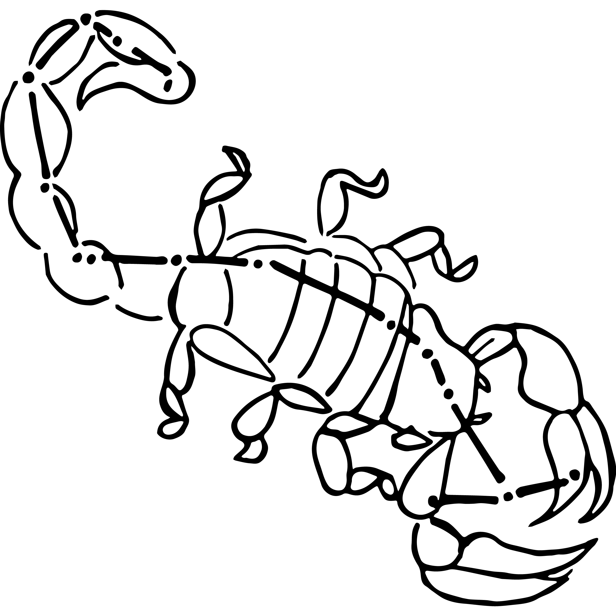
Daytime stargazing
Bring the stars to your students by using an online application to discover and explore stars, planets and constellations in the classroom. Before starting this activity download a free app like SkyView onto your classroom hand held device/s. This activity may need to be modified depending on the number of devices available to students.

- If possible dim the lights in the classroom to create the feeling that it is night time. Students will sit on the ground with SkyView open on their hand-held device.

- Students will point their device at the sky to locate and identify planets, stars and constellations. There is the option to turn on night mode. Students can learn more about what they find by selecting a celestial body and tapping on it. Give students time to explore the night sky.
- Hold a class discussion. What did your students find?
- Students will choose one constellation that they want to learn more about. Students may want to consider choosing the zodiacal constellation in which they were born. Students will develop their own question/s for inquiry, collecting and recording information from a wide variety of sources.
- Students will think of creative ways to display their findings.

Stargazing for beginners
Watch this ABC Education video to learn how you can use just your hands and a compass to locate stars in the sky. What is the unit of measurement used when you're measuring distances between objects in the sky?

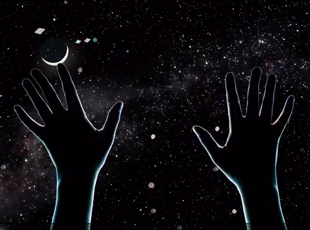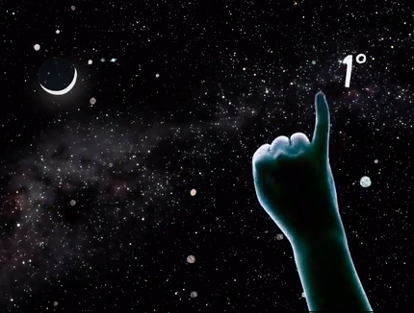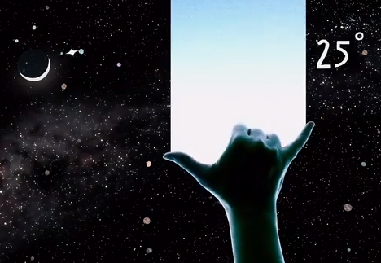

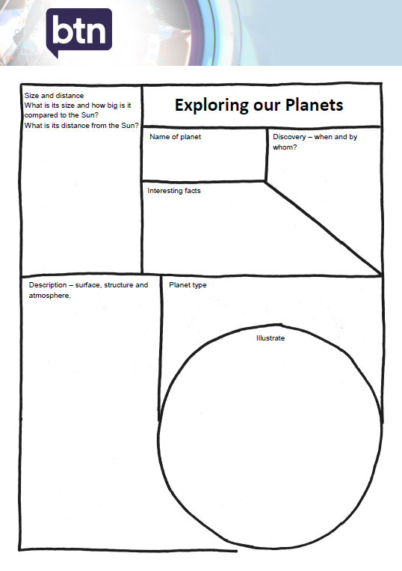
Planet profile
Students will create a profile of one of the planets in our solar system using a range of sources of information. Students will include a history of the planet they have chosen and respond to one or more of the following questions:
- What is its distance from the sun (kms)? Where is it in the solar system?
- What size is the planet? Record its diameter and its size compared to the sun.
- What does the planet look like? Describe the surface of the planet using words and pictures.
- What type of planet is it? (e.g. terrestrial, gas giant or ice giant)
- When and who discovered the planet?
- How was it named?
- List 10 interesting facts about the planet
- Use a Venn diagram to compare and contrast the planet you have chosen with other planets in our solar system. Compare and contrast the size of the planets, the distance from the sun and its physical features.

Students can use this template to record their findings.

Visualising our solar system
Make a scale model of the planets in our solar system. In small groups, students will represent the size of the sun and the planets in our solar system as accurately as possible. Students need to agree on an approximate scale for their model. The model should begin with the sun and show planets in order. Use this calculator to help determine size and scale. http://www.exploratorium.edu/ronh/solar_system/

- What scale will you use to model the solar system?
- What materials or found objects will you use to represent the sun and each of the planets?
- What surprised you about you about this activity?

Following this activity, students will agree on a scale to represent the distance of the planets from the sun. Calculate and record the distances using a spreadsheet. Consider modelling your findings on your school oval. In this BTN story we demonstrate the scale of our solar system, using a bowling ball, a pin, a peppercorn, a pecan, a hazelnut and a peanut, on a racecourse! Watch this ABC Education video to help you visualise the size and scale of our solar system.

BTN Space stories
Students watch the following BTN space stories and answer the questions.

BTN Aboriginal Astronomy

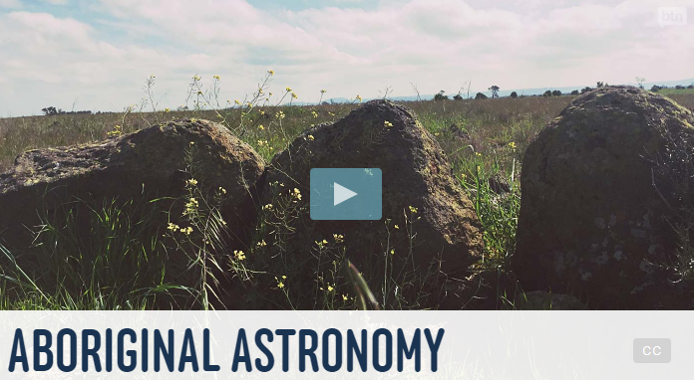
- Briefly summarise the Aboriginal Astronomy story.
- Most people think that Stonehenge was a prehistoric planetarium used to observe and map the stars. True or false?
- About how old do they think Stonehenge is?
- In which state is the Wurdi Youang stone arrangement and how old do scientists think the site may be?
- What is a constellation?
- The Yolngu people know the saucepan as…
- What does it tell the story of?
- Describe the Emu in the Sky constellation.
- How did Indigenous people use the sky as a calendar?
- What constellations do you know? Share what you know with another student.

BTN Understanding Space story
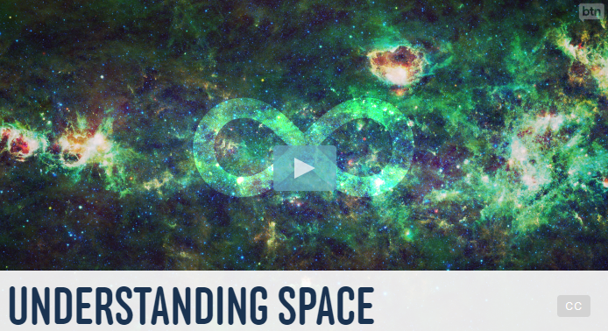
- What is the BTN story investigating?
- How many planets are there in our solar system?
- Our solar system is just one of more than ________solar systems in the Milky Way.
- Finish the following sentence: The Milky Way is just one of hundreds of billions of…
- Where does Martin work?
- How does Martin explain the centre of the universe?
- How is space like the surface of a balloon?
- What was surprising about this story?
- Name three things you learnt watching this story.
- Illustrate an aspect of this story.


ABC – Stargazing Live
http://www.abc.net.au/ourfocus/stargazing/

ABC Science – Star Hunt
http://www.abc.net.au/science/starhunt/

NASA – Solar Systems Exploration
https://solarsystem.nasa.gov/

BTN – Amateur Astronomer
http://www.abc.net.au/btn/story/s4183263.htm

ABC – How the sky works: A beginner’s guide to finding stars and planets
http://www.abc.net.au/news/science/2017-04-04/a-beginners-guide-to-finding-planets-and-constellations/8373718

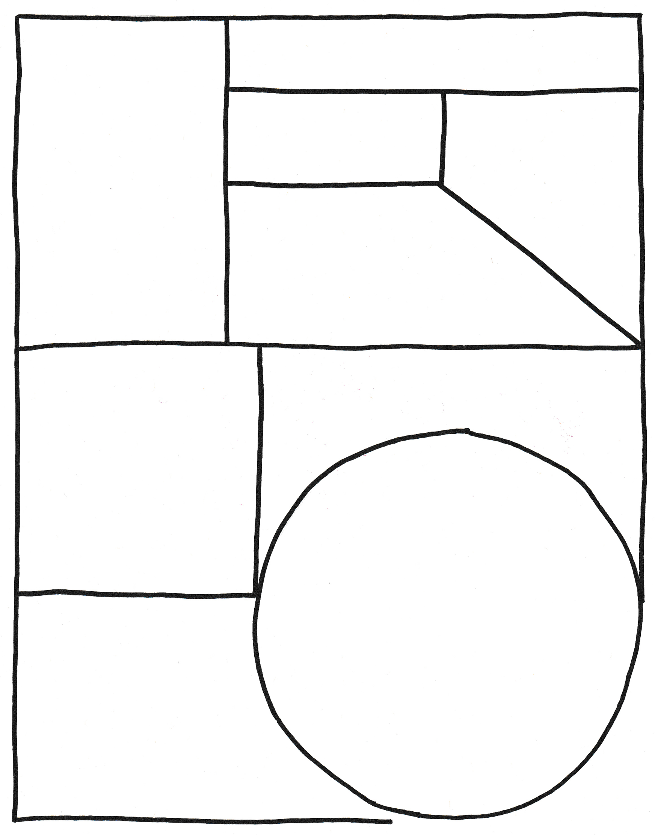

Size and distance of planet
What is its size and how big is it compared to the Sun?
What is its distance from the Sun?
Exploring our Planets

Name of planet

Discovery – when and by whom?

Interesting facts
Description – surface, structure and atmosphere.
Illustrate

Planet type

Teacher Resource
Hubble Space Telescope
Students will explore how telescopes help scientists to explore space. Students will explore, identify and investigate stars, planets and constellations.

Science - Years 5 & 6
Science involves testing predictions by gathering data and using evidence to develop explanations of events and phenomena and reflects historical and cultural contributions.
Scientific knowledge is used to solve problems and inform personal and community decisions.
Scientific knowledge has changed peoples’ understanding of the world and is refined as new evidence becomes available.

Science – Year 5
The Earth is part of a system of planets orbiting around a star (the sun).

Science – Year 5 & 6
Science involves testing predictions by gathering data and using evidence to develop explanations of events and phenomena and reflects historical and cultural contributions.

Science – Year 7
Predictable phenomena on Earth, including seasons and eclipses, are caused by the relative positions of the sun, Earth and the moon.

- What does the Hubble Space Telescope story mainly explain?
- How fast does the Hubble telescope travel?
- Why are a lot of space telescopes built on mountains?
- What year was the Hubble telescope launched into space?
  - 1980
  - 1990
  - 2000
- Describe some the images that the Hubble telescope has captured.
- What has the Hubble Space Telescope enabled scientists to see?
- Complete the following sentence. The Hubble _____ Field is a series of images taken in 1995.
- Who launched one last mission to upgrade and repair the Hubble telescope in 2009?
- What does the Hubble telescope look like? Drawn a picture.
- What did you learn watching the BTN story? Make a list of 3 facts.

Discussion
After watching the BTN Hubble Space Telescope story students will respond to the following:

- What do you THINK about what you saw in the Hubble Space Telescope story?
- What does this video make you WONDER?
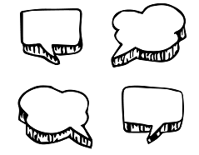
- Think of three questions you have about the BTN Hubble Space Telescope story. Remember that good questions are open-ended (have no right or wrong answer and can’t be answered with a ‘yes’ or ‘no’).
- Leave your comment on the BTN Hubble Space Telescope story page.


Glossary
Students will brainstorm a list of key words that relate to the BTN Hubble Space Telescope story. Students may want to use pictures and diagrams to illustrate the meaning and create their own glossary. Below are some words to get your students started.
Orbit | Astronomer | Galaxy
Universe | Observatory | Atmosphere
Telescope | Black Hole | Star

KWLH
Hold a discussion after watching the BTN Hubble Space Telescope story. What questions were raised in the discussion (what are the gaps in their knowledge)? The following KWLH organiser provides students with a framework to explore their knowledge on this topic and consider what they would like to know and learn.

What do I know? | What do I want to know? | What have I learnt? | How will I find out?

Research questions for inquiry
Students will determine a focus for their inquiry and develop a key question to guide their inquiry (below are some examples). Students will collect and record information from a wide variety of sources (internet, books, newspaper and magazines).

- Why is the telescope called Hubble? Where did its name come from?
- How is Hubble similar or different to other telescopes?
- What have we learnt from the Hubble telescope? Make a list and then choose one of the Hubble’s discoveries to explore in more detail.
- Why is space discovery important?
- How will space exploration change in the future? Make a prediction about how space exploration will change in the future. Illustrate your prediction/s and provide an explanation.


Visual literacy
In this activity students will examine, analyse and query a range of images taken by the Hubble telescope. Students will choose one or more of the images below or find an image of their choice taken by the Hubble telescope. Alternatively, students can look at what Hubble saw on their birthday. Students will then respond to the following:

- What are your first impressions of the image? What does it remind you of?
- Write a short paragraph describing what you see in this image. Write a caption for the image.
- When and where was the photo taken?
- Imagine you are an astronomer examining the images taken by the Hubble telescope. Explain using as many scientific words and terms as you can.
- What questions do you have about what you see in the image?

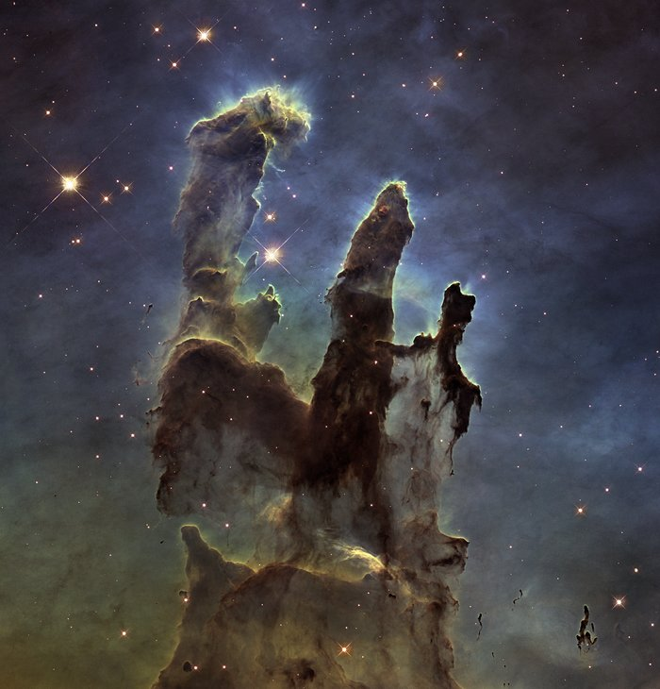  Link | 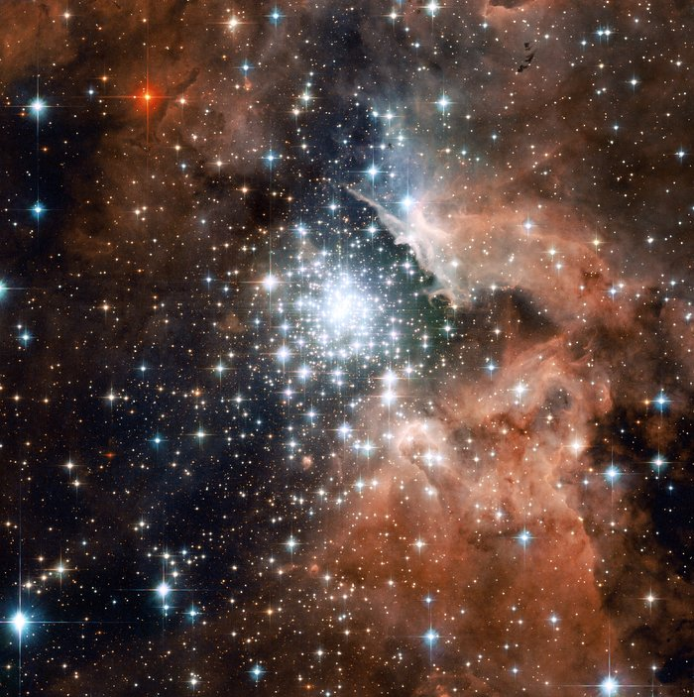  Link
Aboriginal Astronomy
In this activity students will look at examples of Aboriginal astronomy and the Dreaming stories about them. Refer to ABC Science for more information and images to refer to whilst working through this activity.

Emu in the Sky
Ask students to look at the photographs below showing the Aboriginal Emu in the Sky constellation. Draw their attention to the dark dust clouds, not the stars. The Emu in the Sky lines up with a rock carving in Ku-Ring-Gai Chase National Park. Students can also try to find the Emu in the Sky constellation using free App SkyView. To spot the emu, students will look south to the Southern Cross; the dark cloud between the stars is the head, while the neck, body and legs are formed from dust lanes stretching across the Milky Way.

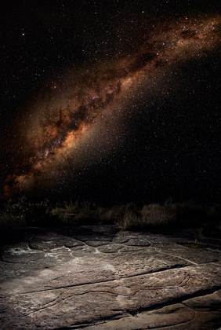  Source: ABC Science (link to image) | 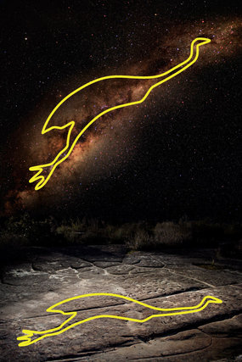  Source: ABC Science (link to image)

Questions for students:
- What can you see in the picture?
- Where in the night sky can the Emu in the Sky be found? Students can have a go at looking for it.
- Emu in the Sky has featured in Aboriginal storytelling for thousands of years with many different language groups have their own interpretation of the Emu. Research and retell one or more of the stories.
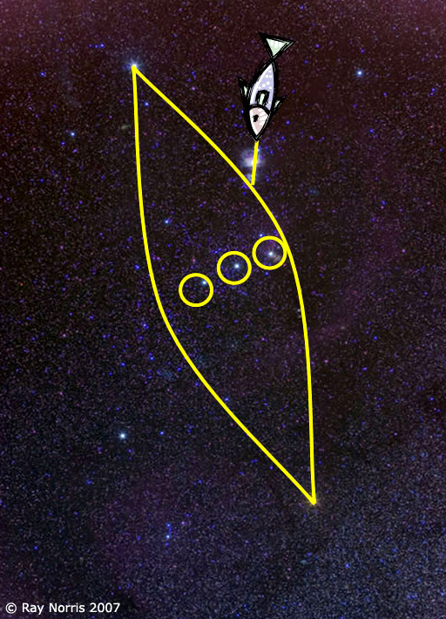
The Canoe in Orion
Ask students to look at the constellation Orion and answer
the following questions:
- What can you see in the picture?
- What is the constellation known as in Australia?
- Where in the night sky can the Canoe in Orion be found? Students can have a go at looking for it.
- What do the Yolngu people in Northern Territory know it as?
- Retell the traditional Yolngu story about the three brothers in a canoe.

Source: ABC Science (link to image)
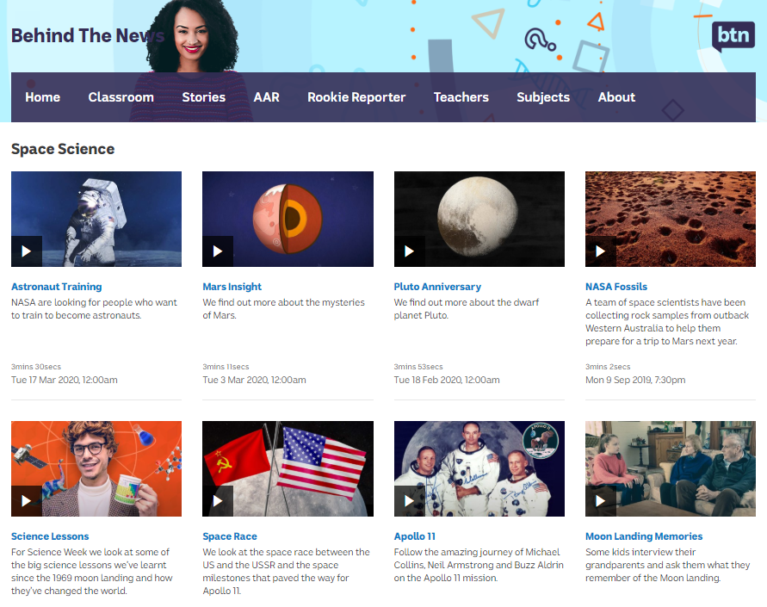
BTN Space Science stories
Visit BTN’s collection of stories which focus on space science and space exploration. After watching any one of the BTN videos ask students to respond to the discussion questions (to find the discussion questions and teacher resources go to the related BTN Classroom Episode and download the Episode Package).

Link to collection of BTN Space Science stories
https://www.abc.net.au/btn/space-science/10614248

Hubble Birthday – BTN
https://www.abc.net.au/btn/classroom/hubble-birthday/10526648

Hubble Space Telescope – NASA
https://www.nasa.gov/mission_pages/hubble/main/index.html

Hubble: Happy 30th birthday to Nasa's Hubble Space Telescope! – CBBC
https://www.bbc.co.uk/newsround/52365257

Hubblesite - NASA
https://hubblesite.org/

What did Hubble see on your birthday? – NASA
https://www.nasa.gov/content/goddard/what-did-hubble-see-on-your-birthday

Teacher Resource
Aboriginal Astronomy
Students will develop a deeper understanding of Aboriginal astronomy and Dreaming stories about them.

Science - Years 5 & 6
Science involves testing predictions by gathering data and using evidence to develop explanations of events and phenomena and reflects historical and cultural contributions.
Scientific knowledge is used to solve problems and inform personal and community decisions.
Scientific knowledge has changed peoples’ understanding of the world and is refined as new evidence becomes available.

Science – Year 5
The Earth is part of a system of planets orbiting around a star (the sun).

Science – Year 7
Predictable phenomena on Earth, including seasons and eclipses, are caused by the relative positions of the sun, Earth and the moon.

- Briefly summarise the Aboriginal Astronomy story.
- Most people think that Stonehenge was a prehistoric planetarium used to observe and map the stars. True or false?
- About how old do they think Stonehenge is?
- In which state is the Wurdi Youang stone arrangement and how old do scientists think the site may be?
- What is a constellation?
- The Yolngu people know the saucepan as…
- What does it tell the story of?
- Describe the Emu in the Sky constellation.
- How did Indigenous people use the sky as a calendar?
- What constellations do you know? Share what you know with another student.

After watching the BTN story, respond to the following questions:

- What did you SEE in this video?
- What do you THINK about what you saw in this video?
- What does this video make your WONDER?
- What did you LEARN from this story?
- How did this story make you FEEL?
- What was SURPRISING about this story?

Class discussion
Begin with a discussion about what students know about astronomy.
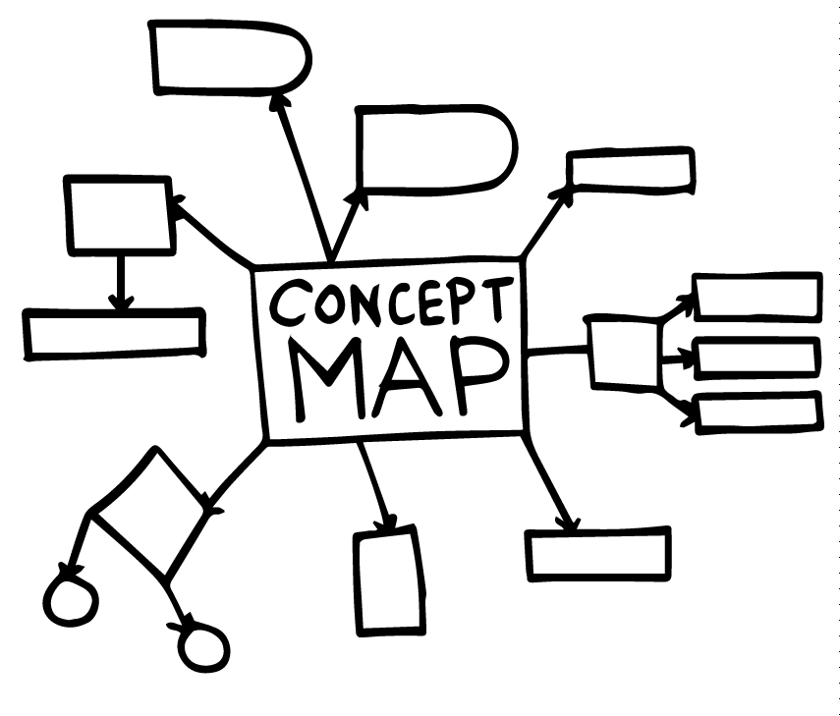
Clarify their understanding or terms such as astronomy, astronomer and constellation.
Have they seen or heard about any constellations?
Students discuss in pairs or as a class what they know about Aboriginal astronomy. Record their responses on a concept map.
The following questions may be helpful in guiding the discussion:
- Why are Aboriginal people called the first astronomers?
- How did Aboriginal people use the sky as a calendar?
- How did the stars help Aboriginal people understand their universe?
- Is it important to learn about the Aboriginal night sky? Give reasons for your answer.
Aboriginal Astronomy
In this activity students will look at examples of Aboriginal astronomy and the Dreaming stories about them. Refer to ABC Science for more information and images to refer to whilst working through this activity.

Emu in the Sky
Ask students to look at the photographs below showing the Aboriginal Emu in the Sky constellation. Draw their attention to the dark dust clouds, not the stars. The Emu in the Sky lines up with a rock carving in Ku-Ring-Gai Chase National Park. Students can also try to find the Emu in the Sky constellation using free App SkyView. To spot the emu, students will look south to the Southern Cross; the dark cloud between the stars is the head, while the neck, body and legs are formed from dust lanes stretching across the Milky Way.

Source: ABC Science (link to image) | Source: ABC Science (link to image)

Questions for students:
- What can you see in the picture?
- Where in the night sky can the Emu in the Sky be found? Students can have a go at looking for it.
- Emu in the Sky has featured in Aboriginal storytelling for thousands of years with many different language groups have their own interpretation of the Emu. Research and retell one or more of the stories.
The Canoe in Orion
Ask students to look at the constellation Orion and answer
the following questions:
- What can you see in the picture?
- What is the constellation known as in Australia?
- Where in the night sky can the Canoe in Orion be found? Students can have a go at looking for it.
- What do the Yolngu people in Northern Territory know it as?
- Retell the traditional Yolngu story about the three brothers in a canoe.
Source: ABC Science (link to image)
Become an Amatuer Astronomer
Stargazing tips:
- Check local weather conditions on the Bureau of Meteorology website
- Choose a location away from street lights
- Take 10-15 minutes to let your eyes adjust to the dark
- Use a red light to preserve your vision (make one by covering a torch with red cellophane)

Students will become familiar with the finding constellations in the night sky. Begin by explaining to them that the stars move across the sky as one. Stars rise in the east and set in the west, just like the sun and moon do. The following animation shows stars moving through the night sky over a 24 hour period. The area of sky we see at night is determined by how far north or south of the equator we are.
Ask students to brainstorm a list of constellations that they know. Do they know how to find them?

Stargazing Activities
Learn how to find your way around the night sky, spotting stars, planet and galaxies. The ABC Science Sky Tour has winter and summer tours or take a virtual tour.
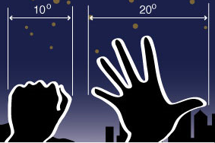
Learn how to Measure the sky with your hands. Astronomers measure distances in the sky in degrees. Students follow the step-by-step instructions to learn how to use their hands to measure the sky in degrees.

Explore the night sky using interactive software. The Stellarium is a free planetarium for your computer. It shows a realistic sky in 3D.

Google Sky allows students to explore planets. Turn the `Sky’ button on in Google Earth to change to sky view.

Further Investigations
- Explore in more detail how Aboriginal people used the sky as a calendar.
- Find out more about the Wurdi Youang stone arrangement in Victoria.

ABC Science - Beginners guide to the night sky
http://www.abc.net.au/science/starhunt/

ABC Science – Australia’s First Astronomers
http://www.abc.net.au/science/articles/2009/07/27/2632463.htm?site=starhunt&topic=space

Emu Dreaming - Australian Aboriginal Astronomy
http://www.emudreaming.com/Examples/WurdiYouang.htm

ABC News – The world’s oldest observatory? How Aboriginal astronomy provides clues to ancient life
http://www.abc.net.au/news/2016-10-12/aboriginal-astronomy-provides-clues-to-ancient-life/7925024

