EPISODE 19
19th July 2022

KEY LEARNING
Students will view a range of BTN stories and use comprehension skills to respond to a series of focus questions.

CURRICULUM
English – Year 4
Use comprehension strategies to build literal and inferred meaning to expand content knowledge, integrating and linking ideas and analysing and evaluating texts.

English – Year 5
Use comprehension strategies to analyse information, integrating and linking ideas from a variety of print and digital sources.

English – Year 6
Use comprehension strategies to interpret and analyse information and ideas, comparing content from a variety of textual sources including media and digital texts.

English – Year 7
Use comprehension strategies to interpret, analyse and synthesise ideas and information, critiquing ideas and issues from a variety of textual sources.
  - Teacher Resource

Focus Questions
As a class, discuss the stories featured in the episode of BTN Classroom and record the main points of the discussion. Students will then respond to the following focus questions.

COVID Update
- In pairs, discuss the main points of the COVID Update story.
- How have COVID restrictions changed recently? Give two examples.
- What impact is COVID having on travel?
- What can people do to help stop the spread of COVID?
- Name three things you learnt watching the BTN story.

Varroa Mite
- Varroa mite has been found in which state?
- What impact does it have on honey bees?
- What has been done to stop the spread of Varroa mite?
- How much is the Australian honey industry worth?
  - $7 million
  - $17 million
  - $70 million
- Why is it important to protect bees?

Check out the teacher resource on the Teachers page.

World Population
- In November this year, the world population is set to reach:
  - 8 million
  - 8 billion
  - 8 trillion
- Why did the Industrial Revolution lead to an increase in population?
- Population growth has a huge impact on the planet. Give some examples.
- What has contributed to human population growth?
- Why can a shrinking population be a problem?

James Webb Pictures
- The James Webb Space Telescope is the successor to which telescope?
- What is the name of a giant cloud of dust and gas in space?
  - Galaxy
  - Nebula
  - Quasar
- How long ago did the Big Bang occur?
- How will the James Webb Space Telescope help us to understand space?
- What questions do you have about the story?

Centenarian Art
- What is the Centenarian Portrait Project?
- What did Misha learn about Cecil’s life?
- Why did Misha use the photo taken after the radio interview to base her portrait on?
- What elements of the portrait reflect Cecil’s life?
- What do you think makes a portrait interesting?

Check out the teacher resource on the Teachers page.

EPISODE 19
19th July 2022

KEY LEARNING
Students will investigate the biology of bee species in Australia and their role in food production.

CURRICULUM
Science – Year 4
Living things have life cycles.
Living things depend on each other and the environment to survive.

Science – Year 5
Living things have structural features and adaptations that help them to survive in their environment.

Science – Year 6
The growth and survival of living things are affected by physical conditions of their environment.

  - Teacher Resource

Varroa Mite

Focus Questions
Discuss the BTN story as a class and record the main points of the discussion. Students will then respond to the following:
- Varroa mite has been found in which state?
- What impact does it have on honey bees?
- What has been done to stop the spread of Varroa mite?
- How much is the Australian honey industry worth?
  - $7 million
  - $17 million
  - $70 million
- Why is it important to protect bees?

Activity: Class Discussion
Students will discuss the BTN Varroa Mite story in pairs and then share their thoughts with the class.
- What do you THINK about what you saw in this video?
- What does this video make you WONDER?
- What did you LEARN watching the the story?
- Think of three questions you have about the BTN story.

Activity: Class Discussion
Discuss the BTN story as a class. Create a class mind map with BEES in the middle. Ask students to record what they know about bees. What questions do they have? In small groups, ask students to brainstorm responses to the following questions and their share with the class:
- What do you know about bees?
- What are some threats to bees?
- Why is it important to protect bees?

Activity: Glossary
Students will brainstorm a list of key words that relate to the BTN Varroa Mite story. Here are some words to get them started.

POLLEN | PARASITE | THREATS
BIOSECURITY | POLLINATION | HABITAT

Activity: Bee research
The KWLH organiser provides students with a framework to explore their knowledge on the topic of bee species and consider what they would like to know and learn.

What do I know? | What do I want to know? | What have I learnt? | How will I find out?

Questions to research
Students will collect and record information from a wide variety of sources. Students may develop their own question for inquiry or select one of the questions below.
- How are honey bees and native bees similar or different? Explore the taxonomy of bees and categorise the information you find using the classification system.
- What does a honey bee habitat look like? Study the habitat of honey bees and create a diorama of its habitat. Compare the habitat of a honey bee to native bees.
- If native bees don’t produce honey, do we need them? Why are native bees important?
- How many native bees do we have in Australia? Choose one native bee species and find 3 interesting facts about the species.
- Why do honey bees love hexagons? Watch this TEDEd video to learn more.
- What are some threats to bees? Find out what bees need to survive.
- What is the life cycle of a bee? Use a diagram to help illustrate the different stages. Watch this ABC Education video to learn more.
- How do bees make honey? Use a storyboard to help explain the process of how honey bees make honey.
- What is the role of the queen bee, drone bee and worker bee? How do they interact? What is a robber bee? Create a comic to illustrate how a bee colony operates.
- What might happen if we don’t look after bees? Make some predictions. Imagine that bees have tragically become extinct and then write a news article telling people why they have become extinct and how this will impact on people’s lives.

Activity: Species profile
Students will research and write a profile about the honey bee species. Students can use the animal profile worksheet at the end of this activity to record their findings. Encourage students to use a range of sources to find their information.

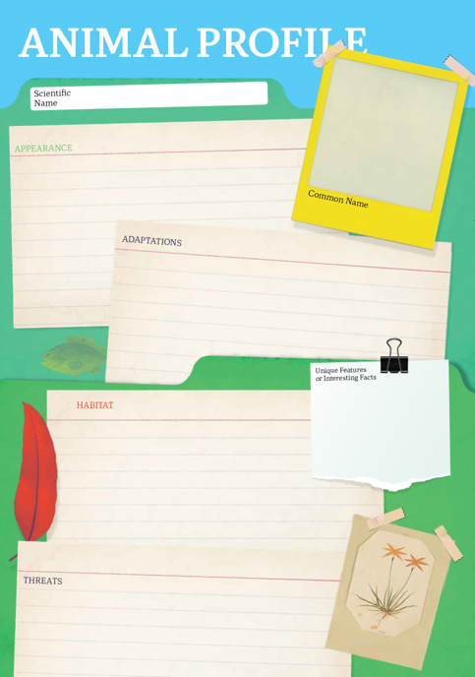
Research
Students will research the honey bee species and create a profile. Students can use the Animal Profile at the end of this activity.
- Illustration or photo
- Scientific and common name
- Appearance
- Habitat
- How does it survive in its environment? What are some of its adaptations?
- Conservation Status
- Threats
- Unique features
- Interesting facts

Share
- Share and compare your findings with your classmates.
- Present your research in an interesting way.
- Think of ways to raise awareness about bee species in Australia.

Action
- What steps can you take to help protect bee species in Australia.
- Design a honey bee garden for your school. Include a map, a bee hotel, special features and make a list of the top 10 honey bee attracting plants.

Useful links for students’ honey bee research:
- Honey Bee – Australian Museum
- Honey Bee – National Geographic Kids
- 10 Facts about Honey Bees – National Geographic Kids
- Honey Bee – Britannica

Activity: Biological illustration
Students will create their own biological illustration of a bee species. This activity encourages students to develop their observation skills and reinforce their understanding of biological concepts.

Explain to students that in their illustration they need to draw what they see (using photographs/videos that they find in books and on the internet). Students will need to think about size, shape, texture and patterns; and include as much detail as possible.

Students can use the following as a guide as they create their scientific drawing:
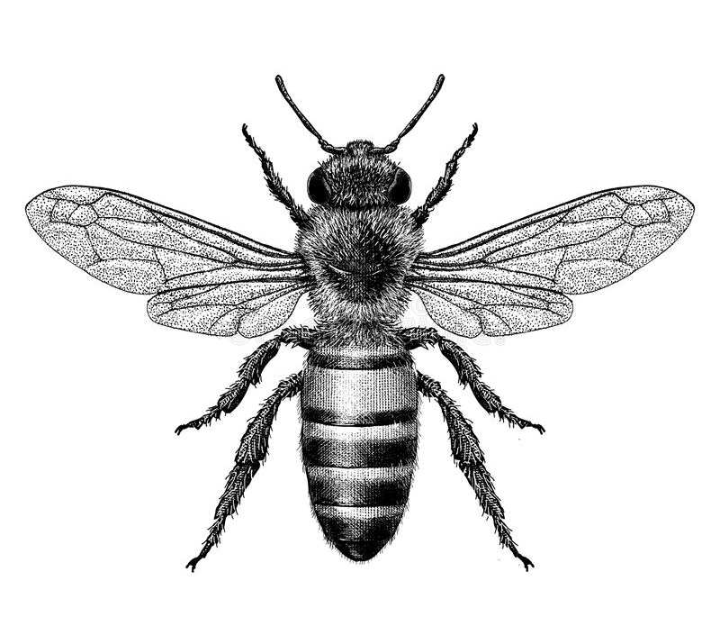
- Find photographs and/or videos of the animal to observe. What key structures and anatomy will you focus on in your drawings?
- Draw the animal to scale (include a ratio on the drawing).
- Include its scientific and common name.
- Add labels – to show size, colour and texture. Include labels to show the bee’s head, thorax and abdomen.

For more information about scientific drawing in the classroom, visit this website Sketching for observation. Consider sending your students’ drawings into your local museum to display as an exhibition.

Activity: Biodiversity
Improve the biodiversity in your local environment
Students will work together to help and introduce a native bee species into their school yard. Ask them to consider the following:
- What kinds of animal species have you seen in your school yard? Can you see any bees, butterflies, or insects? Where will you look? What evidence is there to show bees live there? Explore your school yard and record what you discover.
- What type of habitat do bees need and what do they need to survive? Are there any bee-friendly gardens in your community you could visit to learn more? Identify any bee-friendly plants in your school yard. Are there places for bees to drink water and make their nests?
- What are some threats to bee species that are caused by humans? How can you reduce these threats in your school yard?
- What materials and tools will you need to build a bee-friendly habitat? Consider writing a guide or procedure manual explaining how to build the new habitat. You might want to build a bee hotel.
- Build the habitat as a class and present the habitat to your school community. Teach students in other classes about the new habitat and involve them in caring for the new habitat.
- Prepare a map of the habitat which highlights key features. Include information labels in the habitat (for example, QR codes next to key features in the habitat) for other students to learn more about the habitat and the biodiversity of your school yard. Include scientific information about the species. Include botanical names of any plants which are part of the habitat, when it was planted and some basic information.

Useful Websites
- World Bee Day – BTN
- Junior Beekeepers – BTN
- Bee Heroes – ABC Education
- Bee Hotel – ABC Gardening Australia
- Curious Kids: How do bees make honey? – The Conversation
- Why bees are so important to the environment – SA Dept for Environment and Water
- What is varroa mite and how could it impact Australia’s bee industry and food production? – ABC News
- Honey Bee – Australian Museum

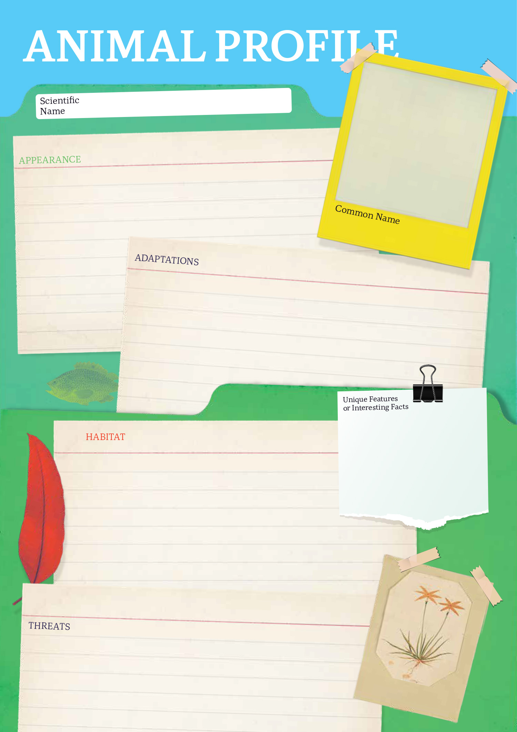

EPISODE 19
19th July 2022

KEY LEARNING
Students will investigate artworks in the Centenarian Portrait Project. They will create a portrait of a person who is special to them.

CURRICULUM
Visual Arts – Years 3 & 4
Explore ideas and artworks from different cultures and times, including artwork by Aboriginal and Torres Strait Islander artists, to use as inspiration for their own representations.

Use materials, techniques and processes to explore visual conventions when making artworks.

Visual Arts – Years 5 & 6
Explore ideas and practices used by artists, including practices of Aboriginal and Torres Strait Islander artists, to represent different views, beliefs and opinions.

Develop and apply techniques and processes when making their artworks.

Plan the display of artworks to enhance their meaning for an audience.
  - Teacher Resource

Centenarian Art

Focus Questions
Discuss the BTN story as a class and record the main points of the discussion. Students will then respond to the following:
- What is the Centenarian Portrait Project?
- What did Misha learn about Cecil’s life?
- Why did Misha use the photo taken after the radio interview to base her portrait on?
- What elements of the portrait reflect Cecil’s life?
- What do you think makes a portrait interesting?

Activity: Class Discussion
Discuss the Centenarian Art story as a class using the following questions to guide discussion:
- What is a portrait?
- Why do we create portraits?
- What can portraits tell us about a person?
- What makes a portrait interesting?

- What words would you use to describe the Centenarian Portrait Project? What do you think is the message of the project?

Ask students if they can think of any famous portraits. (Mona Lisa, Vincent van Gogh, Frida Kahlo, Marilyn Monroe).

Activity: Glossary
Students will brainstorm a list of key words that relate to the BTN Centenarian Art story. Here are some words to get them started.
CENTENARIAN | PORTRAIT | COMPOSITION
BACKGROUND | POSE | EXPRESSION

Activity: Responding to Artwork
Students will select one of the portraits below or choose another from the Centenarian Portrait Project. They will analyse and reflect on the portrait and then respond to the questions below.
- What is your first impression of the portrait? What is the first thing you notice?
- What does the facial expression tell us about the person?
- What would you ask the person in the portrait?
- How would you describe the portrait to someone who hasn’t seen it?
- What do you think the artist is trying to communicate about their subject?
- How does the portrait make you feel? What do you like about it?

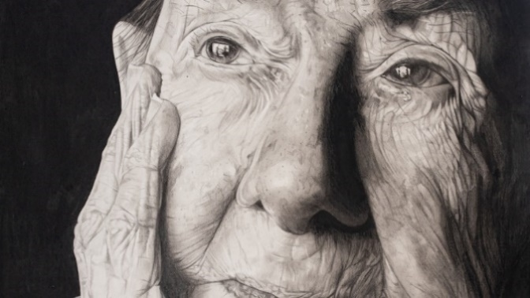  Vallerie by Neve | 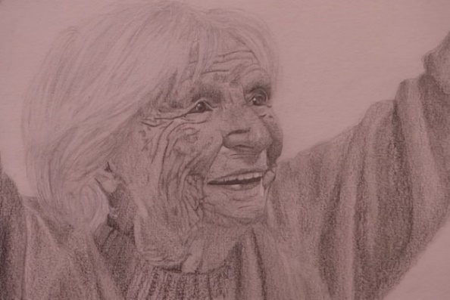  Catherina by Olympia
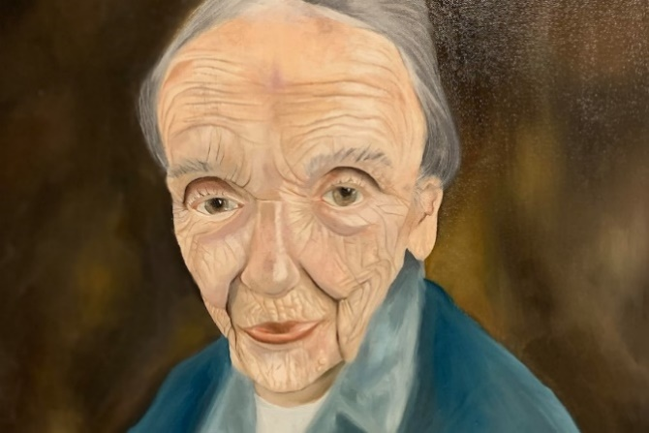  Velta by Tilda | 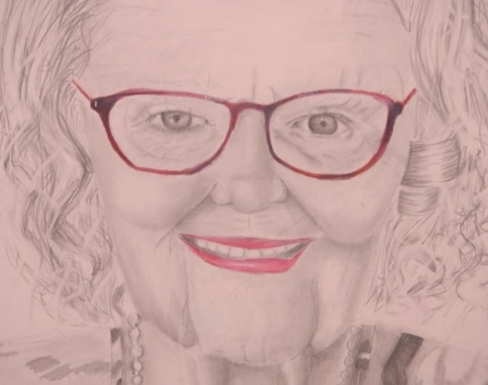  Barbara by Skylah

Activity: Create a portrait
Students will create a portrait of a person who is special to them; it could be a grandparent, great grandparent, aunt, uncle or other family member. Use the following as a guide.
- Choose someone who is known to you and who knows you and plays a significant role in your life.
- Write 2-3 sentences explaining who the person is and why you chose them.
- What technique/s will you use to create your portrait? Think about colours to reflect mood or feelings.
- Organise a live sitting with your subject, where you and your subject are together, and you are working on their portrait. Complete your portrait using photographs of your subject as a reference. Give your portrait a title. Write 2-3 sentences about your portrait.

Class Exhibition
Curate a class exhibition of your students’ portraits and choose a title for the exhibition. Invite students from other classes at your school to attend your exhibition. Consider holding your exhibition at your local library or local council.

Activity: Choose a project
Students choose one of the following projects to work on and then present their work to a partner, small group or the class.
Self Portrait
Create a self-portrait which represents you. Think about what style you will use to create your self-portrait and what colours reflect your mood or feelings. Write an artist’s statement to go with it.
Explore a Famous Portrait
Choose a well-known portrait or self-portrait. Record as much as you can about the artwork in 15 minutes. Create your own portrait inspired by the artist’s style and technique.
Australian Portrait Artist
Investigate the life and work of a famous Australian portrait artist. The National Portrait Gallery is a good place to start your research.
Archibald Prize
Find out more about the Archibald Prize. Investigate the 100+ year history of the Archibald Prize and present your findings in an interesting way.

Useful Websites
- South Australian teenagers celebrate centenarians through portrait project – ABC News
- The Centenarian Portrait Project by Teenagers – Embraced
- Young Archie 2021 - BTN
- History of Portraits - BTN

  - Teacher Resource

BTN Transcript: Episode 19 - 19/7/2022

Hey everyone, Nat here and welcome to a whole new term of BTN. Here's what's coming up today. Planet Earth gears up for a population milestone, Australia's bees face a mite-y challenge, and the James Webb Telescope gives us an awesome glimpse of our universe.

COVID Update

Reporter: Joe Baronio

INTRO: But first up today, we're going to talk about COVID. I know, it's been a little while. But, as I'm sure you're all aware, it's still very much a thing and it's still having a big impact on lives, businesses, and holiday plans. Here's Joe to tell you where we're at.

Kid: Grandpa, can you tell me a story?
Grandpa: Certainly. Now, this one is from way back in the day. See, back in my day there was this thing, and it took over the whole world. You couldn't travel anywhere, for while you couldn't even go outside. It was called covi-
Kid: COVID. You know that's still a thing, right?
Yeah, while you might not hear about it quite as much as you did way back in, well, last year, COVID-19 is very much still here. In fact, experts say some parts of Australia are in the middle of a new wave of the virus, with states and territories still recording thousands of cases each day.
Dr Bruce Willet, Royal Australian College of GPs: This so called third wave appears to be, that it's going to be, close to, or perhaps even exceed the initial first wave that we had in January.
Kid: Most of the cases are the Omicron strain.
Grandpa: I remember that one, been around a while...
Kid: But there are a few new variants. They're called BA.4.
Spore 1: Sup.
Kid: And BA.5.
Spore 2: Hello.
Grandpa: What's the difference?
Well, these two variants are kind of like the OG Omicron but have different mutations which basically means they're more contagious. Lovely. Plus, experts reckon the lack of restrictions could have something to do with the number of cases. As you are all probably well aware, you now don't have to show proof of vaccination in many places anymore, and you don't even have to be vaccinated to enter the country. Meanwhile, the must have fashion item of the past 2 years, face masks, are now only required in high-risk settings like hospitals, chemists, and aged care.
Kid: Guess I better put this on.
Even airlines have started easing restrictions around mask wearing on planes. Speaking of which, we can travel freely again. Sort of. You see COVID is causing massive problems for airlines and airports. Staff shortages are causing scenes like this, and there have been a tonne of reports of lost luggage, with some airline workers saying there just aren't enough staff to grab all the luggage. It's not just impacting airports but also businesses around the country, with people getting sick and not being able to work. Then there are supply problems around the world making it harder to get hold of all sorts of things like foods, household supplies and some medications, just to name a few.
Grandpa: It's not exactly a fairy-tale ending, is it?
Kid: Well, it's not actually that bad.
Experts reckon vaccinations have helped to protect a lot of people from ending up in hospital. Anyone over 30 in Australia can now get a fourth shot and companies are working on boosters that will specifically target Omicron. And there's also COVID-19 antiviral treatments that are becoming available for people who are at high risk, and of course, we can all play a role in stopping the spread by doing those things we've got pretty good at over the past couple of years. Keeping our distance, washing our hands, and isolating if we're sick.
KID: And we all lived happily ever after. Goodnight.
Grandpa: Don't even need me to tuck you in, alright.

News Quiz

Can you name the UK’s soon-to-be-ex-prime minister? Yep, it’s Boris Johnson and during the holidays he stepped down as leader of his party after a few scandals including some parties he held during lockdowns.

BORIS JOHNSON, BRITISH PRIME MINISTER: It is clearly now the will of the parliamentary Conservative Party that there should be a new leader of that party, therefore a new prime minister.

He’ll be hanging onto the top job until September when his party decides on a replacement.

The president of which country has resigned after protestors stormed the presidential palace and tried out the luxuries inside. Was it Myanmar, Bangladesh or Sri Lanka? It was Sri Lanka. The country has been facing huge economic problems and shortages of basics like food and fuel and protesters blamed the government.

SRI LANKAN RESIDENT: When you see the luxuries in this house it is obvious that they don’t have time to work for the country.

What country did Australia’s Prime Minister visit last week for the Pacific Islands Forum? Was it the Solomon Islands, Papua New Guinea, or Fiji? It was Fiji. Leaders from around the Pacific and the world were there to talk about issues affecting the region like security and climate change.

And which Aussie tennis player was defeated by Novak Djokovic in the Men’s Singles final at Wimbledon? It was Nick Kyrgios.

NICK KYRGIOS: First of all, I just want to congratulate Novak and your team, of course, you’ve won this championship I don’t even know how many times anymore.

NOVAK DJOKOVIC: Nick, you’ll be back. I really respect you a lot. I think you are a phenomenal tennis player and athlete. OK it’s officially a bromance.

Varroa Mite

Reporter: Michelle Wakim

INTRO: Now to a different type of health crisis facing Australia's bees. Recently a pest called Varroa mite was discovered in some hives in New South Wales, and it triggered a huge quarantine operation. Michelle went to meet some young bee keepers to find out more.

DUGALD SAUNDERS, NSW MINISTER FOR AGRICULTURE: Unfortunately, today, we’re seeing more concern around the possible spread of Varroa mite.

Aussie bees have been hit with a devastating epidemic. There've been outbreaks, contact tracers, travel restrictions and now a hard lockdown. Does this sound familiar?
DUGALD SAUNDERS, NSW MINISTER FOR AGRICULTURE: The decision has been made by the Department of Primary Industries to actually enforce a statewide lockdown of movement of hives and bee products.
But this isn't COVID. The culprit is a tiny mite called Varroa Destructor, and it causes, well, destruction.
TYLER: Varroa mite is an external parasite. It pretty much hitches a ride on the back of a bee and then it will enter the hive and then they spread to other bees. And then they go into more holes and then it just spreads like wildfire. They also give bees diseases and stuff. One is like a wing malfunction, which they can’t fly so they’re pretty much crawling bees that have nothing to do really.
MICHELLE: Oh, so sad.
TYLER: Yeah, pretty much.
These guys keep bees at school. They learn about them and how to care for them, so they know how devastating Varroa mite can be. In fact, it's thought of as the biggest threat to honeybees in the world and, until recently, Australia was one of the very few places free of the pest.
DUGALD SAUNDERS, NSW MINISTER FOR AGRICULTURE: We are the cleanest, greenest producers of honey around the world.
But that changed when the mites were discovered in New South Wales’ hives and the race to stop the spread began.
TYLER: If they don't lock down, well then, it’s just going to keep spreading obviously, and if we want to keep Australia Varroa mite free then we need to lock all the bees down.
More than 1,500 hives in New South Wales have now been destroyed.
DAVID VIAL, BEEKEEPER: My 150 plus hives will all be non-existent by this time next week, I’m assuming. Devastated. A lot of hard work that's gone down the drain.
GRAHAM CREED, ABC NSW WEATHERMAN: Not only do you lose your current stock, but because we've had the bushfires, we've had the drought, we've now had flooding, bee numbers are reduced anyway so once you then try to go out and restock, there’s just no bees available.
So far, Varroa mite hasn’t been found outside of New South Wales, which is a good thing, not just for Australia's $70 million dollar honey industry, but because bee problems are problems for all of us.
TYLER: They’re a key part to our environment. Without bees, nothing really survives. Without them, our eco-system is just going to go down.
ARIA: Without bees, we won't have any product of like, vegetables or that. So, we’ve got plants, obviously, but without bees, we can’t actually transform the pollen to another plant which, therefore, no products will be made.
Yep. These little guys play a really important role in helping all sorts of plants reproduce. In fact, every third piece of food we put into our mouths has been pollinated by a bee, which is why these young beekeepers are passionate about protecting our busy little friends.
TYLER: Who would have thought a little insect, but it contributes massively towards our eco-system.

World Population

Reporter: Michelle Wakim

INTRO: Now for some big news for the humans of planet Earth. According to the UN, in a few months there will be 8 billion of us. That's a lot of people. Michelle found out more about what the population milestone means for us and how much more crowded it's likely to get in the future.

Take a look at that number. That's how many human beings you share the planet with right now. As people die and people are born, that number changes. But each second it ticks up. And, on the 15th of November this year, the world population is set to reach 8 billion people.

The Earth hasn't always been this crowded. In fact, it took around 200 thousand years for the population of homo sapiens, that's us, to go from zero to one billion. But that changed somewhere around here. The Industrial Revolution brought machines and technology that changed the way people lived. Food was easier to grow, and advances in sanitation and medicine meant fewer people died.
MICHELLE, REPORTER: You see, a few centuries ago, it was pretty common for families to have six or more kids knowing that not all of them would survive until they were adults. But when that started to change, the population exploded.
By 1927 there were 2 billion people, by 1960 there were 3, and people started to worry there'd soon be more babies than the planet could handle.

TELEVISION PRESENTER, 1966: The population of the world was growing so fast that it would be jam-packed full in November 2026 AD.

OK, we aren't quite jam-packed yet. But there's no denying that all those extra people have had a huge impact on the planet. Keeping us housed, fed and watered takes a lot of land, a lot of water and a lot of non-renewable resources. And we produce a lot of waste in the form of rubbish and air pollution which has hurt our oceans and led to global warming. As the population gets bigger, experts say we're going to have to get a lot better at sharing the planet. We'll need to design better cities which can fit more people in more comfortably, come up with cleaner, more efficient ways of getting around and building stuff, and develop new ways of making more food with less land and resources.
But just because the population is growing now, that doesn't mean it'll keep growing. In fact, the rate of growth has already started to slow down, and the UN says there’s a good chance it’ll stop at around 11 billion people. That's because, basically, things are getting better. When people, and women in particular, have access to good healthcare, education and jobs, they tend to have fewer kids. And that's been happening for a while now in many countries around the world, including here in Australia where, on average, women have less than two kids each.
But while too many people can be a problem, not enough can be too. If the population shrinks, there are fewer workers and not as many people buying things, which can hurt the economy. It also means there's an ageing population, where there aren't enough young people to look after the old people. These are some complicated issues that are going to affect all of us, as we head to 8 billion and beyond.

James Webb Pictures
Reporter: Joe Baronio

INTRO: Let's leave the Earth now and travel through space and time. Last week the James Webb Telescope gave us some of the most detailed and amazing pictures that we've ever seen of the universe, including glimpses of what things were like billions of years ago. Here's Joe to explain.

Michelle: Woah. Is this, like, Doctor Who?
JOE: Who?
Michelle: Never mind. What is this?
JOE: What this? This is my time machine and I'm about to go billions of years into the past. Do you wanna come for the ride?
Michelle: Yes.
JOE: Alright. Hold on. There ya go.
Michelle: This is just a picture.
Alright, so, this might not seem like time travelling but it kind of is. Let me explain, what you're looking at here are thousands of galaxies and stars, some of which existed billions of years ago. These are the first official pictures taken by NASA's new James Webb Space Telescope.
Joe Biden, US President: Light from other worlds, orbiting stars, far beyond our own. It's astounding to me when I read this, and I saw it. I mean it really is.
This field of galaxies, stars, and nebulae is named SMACS 0723. Catchy. And it's been released alongside other stunning pics, with slightly catchier names, like the Carina Nebula, Stephan's Quintet, and the Southern Ring Nebula. It's a super exciting moment for space lovers and astrophysicists like this guy, Professor Karl Glazebrook.
Prof. Karl Glazebrook, Astrophysicist: Relieved. Happy. Excited. I literally have been waiting for this telescope for like, 20, 25 years.
James Webb is the successor to the Hubble Space Telescope, which back in 1995 took this image of the exact same patch of the cosmos as James Webb. But, thanks to new tech and a much bigger lens, it's now clearer than we've ever seen before.
Prof. Karl Glazebrook, Astrophysicist: Firstly, there's some very bright stars in the foreground, those are stars in our own galaxy. Then in the middle distance you have a cluster of galaxies.
And some of those distant galaxies and stars appear just as they were after the Big Bang, 13.8 billion years ago. So, how is that possible?
JOE: Time travel and the speed of light.
Here on Earth, it might seem that the speed of light is instant. But the actual speed of light is 299,792,458 metres per second, which is rather zippy, sure, but these galaxies are really far away. Like more than 47 trillion kays away. So, it's taken light around 5 billion years to travel this far, which basically means we're looking 5 billion years into the past.
Michelle: So, this isn't actually time travel then?
JOE: No, no it is. I think.
Prof. Karl Glazebrook, Astrophysicist: Yeah, technically it is time travel. The further away we look, the further back in time we're seeing.
What you've seen here is just a tiny piece of the sky, about the equivalent of a grain of sand held at arm's length away. And each spec is a galaxy that contains billions of stars and planets and yeah, you get the idea. The universe is vast. Astrophysicists like Professor Karl will be analysing these new pictures and data from the James Webb Telescope closely to work out just how many galaxies there are, when they formed, and maybe even look for planets like ours.
Prof. Karl Glazebrook, Astrophysicist: It's possible that James Webb could discover earth-like habitable worlds. It's going to be a great few years. We're optimistic for a long lifetime of science.
Michelle: Wow, that's actually pretty impressive.
JOE: Right? But wait, do you want to see more? There's so much more to see.
Michelle: Uh, I actually need to go find a proper bathroom, now.
JOE: Um. Alright. Toodeloo.

Quiz

What's the name of a giant cloud of dust and gas in space? Is it a galaxy, a nebula or a quasar? It's a nebula. Some nebulae are known as star nurseries because they're where stars are formed as gravity slowly pulls the gas and dust particles together.
Sport

This is the shot that secured Cameron Smith his first major victory.

CAMERON SMITH, PROFESSIONAL GOLFER: I’m going to fall apart here I know. The last couple of years has really started to pay off. This one definitely makes it worth it.

The Queenslander has won the British Open Championship. Getting 5 birdies in a row and finishing the tournament at 20 under. He's taking home golf's oldest and arguably most famous prize, the Claret Jug which turned 150 years old this year. He's also getting about $4 million. This makes him the fifth Aussie to win the Open and the first since 1993.

CAMERON SMITH, PROFESSIONAL GOLFER: This one’s for OZ.
And Queenslanders are still gloating after taking out what's been called one of the best Origin matches of all time. There were only four points the difference in the final two minutes then Ben Hunt did this. There were big celebrations for the underdogs while Sydney were served humble pie after their Premier lost a bet that left the Harbour Bridge glowing maroon.

Centenarian Art

Reporter: Gladys Serugga

INTRO: Living to the age of 100 is a pretty big achievement, one that's probably worthy of a portrait, don't you think? Well, our next story is about a project that's paired 100 young artists with 100 centenarians, that is, people aged 100 or more and the result has been some impressive works of art and some really special friendships. Check it out.
For months Misha's been working on a really special project, one that's a hundred years in the making. It's called the Centenarian Portrait Project.
MISHA: It's about 100 teenagers and 100 hundred-year-olds. And we're all painting our 100-year-olds and we get the opportunity to meet them.
The pairs meet up and learn about each other’s lives, then the teenagers create a portrait to honour their stories.
MISHA: I came here and met Cecil and it was incredible. I was really nervous. I thought, oh, maybe we wouldn't click at all. But he was so like talkative, just like a very open person. And it made it so much easier.
CECIL: I started off, a boy, living in the country 150 miles north of Adelaide.
By the time he was 10, his family moved to Adelaide.
CECIL: Well, at that age, you obviously prefer the city because the schools are better equipped, roads are better. Wintertime roads aren't much fun when you're trying to ride a bike.
MISHA: Meeting Cecil I think we both got to see into each other's worlds which was really incredible. It's really interesting because it like gives me insight on what happened in the 1930s. I'm a bit of a history girl and it kind of shows you how privileged we are in our lives that it's so different from what it was like back then.
As part of the project Misha and Cecil got invited to speak about their experience working together on the radio and on the day, Misha took a photo.
MISHA: It was both of our first time on the radio. And I thought it was crazy because I was 14, and he was 100 years old. And the fact that we could have an experience that kind of like, bridged us both, like our age gap, it didn't matter at all. So, I decided to use the photo right after that interview, because it really captured his happiness and how exciting he found everything in life.
MISHA: Cecil do you want to see a photo of your portrait? Would you like to see a photo?
CECIL: Yes, if you want me?

MISHA: Uh, it’s hanging in the portrait right now. Yeah, this is the finished portrait. Do you like it?
CECIL: That's a portrait. Looks like me sitting in the lounge.
MISHA: So, my painting has his special chair from his bedroom then in the background I thought I would do some writing because he's quite a writer himself, especially into family history.
The more she got to know Cecil, the more Misha realised just how much he loved his wife, Kathleen. So, she painted her name on the portrait too.
MISHA: Every time I heard about him talking about his wife, I could just hear the love in his voice. I hope they look at Cecil's smile. I think his smile is his biggest characteristic. He's just always smiling, always so happy. I've never like really realised how portraits capture the essence of a person. So, I think it's so much more interesting now. Now that I've done one, I kind of look at people and I think this is how I would paint you maybe which is really cool.
CECIL: The fact that she, Misha was able to improve on what the camera did and make it more realistic, more like me. And it's a pleasure to get to know her for somebody, who's got so much talent. She's only a young girl and I hope that she has a great career ahead of her.
MISHA: I just wanted to say thank you very much, Cecil, you've taught me so much in my time with you. And I couldn't have done this portrait. Just knowing about your life has helped me so much in my life and taught me so many things about how to live a good life and be a good person. So, thank you. You're an incredible person.

Closer

Awesome stuff Misha. Well, that's it for today. Thanks for tuning in. We'll be back with more stories and quizzes and all that other stuff next week. In the meantime, there's heaps to checkout online including resources for your teachers and a BTN YouTube channel if you're 13 or over. Have a great week and we’ll see you next time.

