
EPISODE 23
20th August 2024

KEY LEARNING
Students will view a range of BTN stories and use comprehension skills to respond to a series of focus questions.

CURRICULUM
English – Year 4
Use comprehension strategies to build literal and inferred meaning to expand content knowledge, integrating and linking ideas and analysing and evaluating texts.

English – Year 5
Use comprehension strategies to analyse information, integrating and linking ideas from a variety of print and digital sources.

English – Year 6
Use comprehension strategies to interpret and analyse information and ideas, comparing content from a variety of textual sources including media and digital texts.

English – Year 7
Use comprehension strategies to interpret, analyse and synthesise ideas and information, critiquing ideas and issues from a variety of textual sources.
  - Teacher Resource

Focus Questions
As a class, discuss the stories featured in the episode of BTN Classroom and record the main points of the discussion. Students will then respond to the following focus questions.

Gambling Ads
- What was the main point of the BTN story?
- What percentage of Australians have gambled in some form or another?
  - 40%
  - 60%
  - 80%
- Studies show if you're exposed to gambling from a young age, you're more likely to gamble when you're older. True or false?
- Why hasn’t the Australian prime minister agreed to an outright ban of gambling ads?
- Do you think gambling ads should be banned? Why or why not?

Google Monopoly
- What year was Google launched?
- Google owns YouTube. True or false?
- What percentage of searches online go through Google?
  - 70%
  - 80%
  - 90%
- How much did Google spend in 2021 to make sure they were the automatic search engine on many popular phones?
- What did you learn watching the BTN story?

Pet Ownership
- Before watching this story, predict what you think the BTN Pet Surrenders story will be about?
- Why are more people surrendering their pets?
  - Rental crisis
  - Cost of living
  - Changing lifestyles
  - All of the above
- What are some things you need to think about before getting a pet?
- Has the number of people surrendering their pets increased or decreased?
- What was surprising about this story?

Check out the teacher resource on the Archives page.

Indigenous Art
- Discuss the BTN Indigenous Art story as a class.
- What type of art did the artists featured in the story make? Name the medium/s they used.
- What are ochres and how are they used in First Nations art?
- What type of art was Albert Namatjira famous for?
  - Dot art
  - Rock art
  - Watercolour painting
- Name three facts you learnt watching the BTN story.

Check out the teacher resource on the Archives page.

Game Creators
- What is the name of the game created by Sam, Jacob and Ben?
  - Swipe it
  - Swipee
  - Wipe out
- How did the kids in the BTN story come up with the idea for their game?
- What is the objective of the game?
- The YES summit helped the game creators get an international licensing deal. True or false?
- What did you like about the BTN story? Discuss in pairs.

EPISODE 23
20th August 2024

KEY LEARNING
Students will investigate the responsibilities of owning a pet.

CURRICULUM
English – Year 4
Use comprehension strategies to build literal and inferred meaning to expand content knowledge, integrating and linking ideas and analysing and evaluating texts.

English – Year 5
Use comprehension strategies to analyse information, integrating and linking ideas from a variety of print and digital sources.

English – Year 6
Use comprehension strategies to interpret and analyse information and ideas, comparing content from a variety of textual sources including media and digital texts.

HASS – Year 4
Reflect on learning to propose actions in response to an issue or challenge and consider possible effects of proposed actions.
  - Teacher Resource

Pet Ownership

Focus Questions
Discuss the BTN story as a class and record the main points of the discussion. Students will then respond to the following:
- Before watching this story, predict what you think the BTN Pet Ownership story will be about?
- Why are more people surrendering their pets? Give 1 example.
- What are some things you need to think about before getting a pet?
- Has the number of people surrendering their pets increased or decreased?
- What was surprising about this story?

Activity: Note taking

Students will practise their note-taking skills while watching the BTN Pet Ownership story. After watching the story, ask students to reflect on and organise the information into three categories. What information in the story was...?
- Positive
- Negative or
- Interesting

Activity: Class Discussion
Students will respond to one or more of the following questions after watching the BTN story:
- Do you own a pet (or have ever owned a pet)? What sort of pet?
- What are some positives of owning a pet? What are some negatives or challenges?
- What do pets need to be happy and healthy. Working in small groups, make a list. Share with the class.
- Why have animal welfare charities seen a big rise in pets being given up by their owners?
- What should people consider when choosing a pet? (lifestyle, home environment, cost).
- Think of three questions you have about the story.

Activity: Glossary
Students will brainstorm a list of key words that relate to the BTN Pet Ownership story. Here are some words to get them started.

PET OWNERSHIP | RESPONSIBLE | SURRENDER
ANIMAL WELFARE | COST OF LIVING | EXPENSE

Ask students to write what they think is the meaning of each word (including unfamiliar words). They will swap definitions with a partner and ask them to add to or change the definition. Check these against the dictionary definition.

Activity: Information Report
Students will create an information report about owning a pet. The following may help guide students’ research:
- What are the basic needs of pets? (food, exercise, shelter, medical care).
- What are the responsibilities of a pet owner?
- What are the consequences of not looking after a pet?
- Interesting facts.

Structure and features of an information report
Information reports are factual texts written to inform and provide detailed facts about a topic. Discuss with students what they already know about the purpose, structure, and features of an information report. Use the following as a guide to use with students.
- Purpose – An information report provides information to the reader by stating facts.
- Structure – see table below.
- Language features – write in the present tense, use technical or scientific words, and write in the third person.

Students can then use the following structure to help write their report. They can present their reports using publishing software or as a brochure.

Title - States the topic.

Introduction - The opening statement explains the subject of the report and includes a definition or short description.

Body - Facts grouped into paragraphs. Starts with a topic sentence. Include subject specific language. Text features such as sub-headings, labelled diagrams, charts and captioned photographs may be included.

Conclusion - A summary of what the topic is about and end with an interesting fact.

Activity: Reporter for a day
Students will be a reporter for a day and investigate the issues highlighted in the BTN Pet Ownership story. Write an online news report for kids explaining why animal welfare charities have seen a big rise in pets being given up by their owners. Student’s reports will answer the 5 W’s – Who, What, Where, When and Why?


Things for students to think about:
- Who is your target audience? Use age-appropriate language and themes.
Who, What, Where, When and Why?
- Write a headline that is short and to the point.
- Use words and pictures in your report.
- Find information from a variety of sources.
- Present the facts and/or opinions clearly and accurately.

Activity – Choose a Project
Individually or in small groups, students will choose one of the following projects to work on and then present their findings to the class.


Pros and cons of pet ownership
Create a T Chart to highlight the positives and negatives of owning a pet.

Quiz
Create a true/ false or multiple-choice quiz to test your classmate’s knowledge about a pet of your choice.
Survey
Survey your classmates to work out the percentage of people who own a dog or cat (or other type of pet). Display your results as a graph.
Summary
Summarise the pet ownership story in three sentences. Share your summary with another student. How did your summaries differ?

Useful Websites
- Animal rescue organisations under strain as owners cast off COVID pets and designer breeds – ABC News
- Pet Ownership – RSPCA
- Pet Adoption during COVID-19- BTN

EPISODE 23
20th August 2024

KEY LEARNING
Students will explore and analyse Aboriginal and Torres Strait Islander art and create their own artwork inspired by their family.

CURRICULUM
Visual Arts – Years 5 & 6
Explore ideas and practices used by artists, including practices of Aboriginal and Torres Strait Islander artists, to represent different views, beliefs and opinions.

Develop and apply techniques and processes when making their artworks.

Visual Arts – Years 7 & 8
Experiment with visual arts conventions and techniques, including exploration of techniques used by Aboriginal and Torres Strait Islander artists, to represent a theme, concept or idea in their artwork.

Analyse how artists use visual conventions in artworks.
  - Teacher Resource

Indigenous Art

Focus Questions
Discuss the BTN story as a class and record the main points of the discussion. Students will then respond to the following:
- Discuss the BTN Indigenous Art story as a class.
- What type of art did the artists featured in the story make? Name the medium/s they used.
- What are ochres and how are they used in First Nations art?
- What type of art was Albert Namatjira famous for?
  - Dot art
  - Rock art
  - Watercolour painting
- Name three facts you learnt watching the BTN story.

Activity: See, think and wonder

After watching the BTN Indigenous Art story, students will respond to the following questions:
- What did you SEE in this video?
- What did you LEARN from this story?
- What was SURPRISING about this story?
- What QUESTIONS do you have about this story?

Activity: Class Discussion
Discuss the BTN story as a class. Ask students to record what they know about Aboriginal and Torres Strait Islander art. What questions do they have? In small groups, ask students to brainstorm responses to the following questions:
- How would you describe the art in the BTN Indigenous Art story? Describe the style, technique and colours.
- Complete this sentence. Something that really caught my eye was….
- What did you like about the art?
- What questions do you have about the artwork?

Activity: Exploring Indigenous Art
Students will explore and analyse Aboriginal and Torres Strait Islander art to understand its cultural significance and techniques. They will then create their own artwork inspired by their family heritage, reflecting on how their family story can be expressed visually.

Class Discussion
Begin with an introduction to Aboriginal and Torres Strait Islander cultures. Highlight the diversity of Aboriginal and Torres Strait Islander cultures and the role of art in storytelling and cultural expression.

Art Analysis
Provide students with a range of Aboriginal and Torres Strait Islander artworks, including dot paintings, bark paintings, carvings, and weavings. Explain common themes, symbols, and techniques used in these artworks. Below are some examples of artworks created by Aboriginal and Torres Strait Islander artists. Students will analyse one or more artworks and then respond to the questions below.

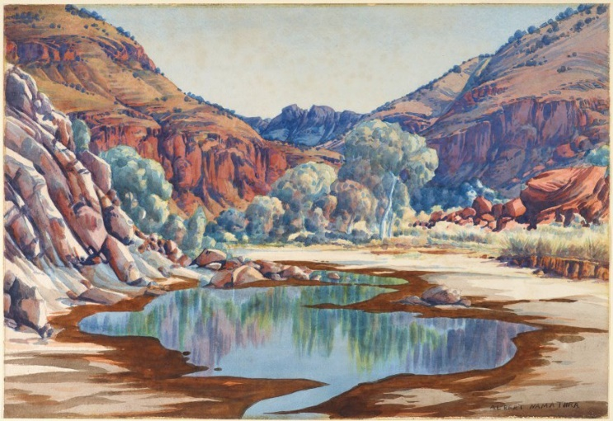  Albert Namatjira (Source: Art Gallery NSW) | 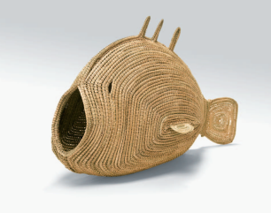  Pondi (Murray River cod), Yvonne Koolmatrie  (Source: Art Gallery of South Australia)
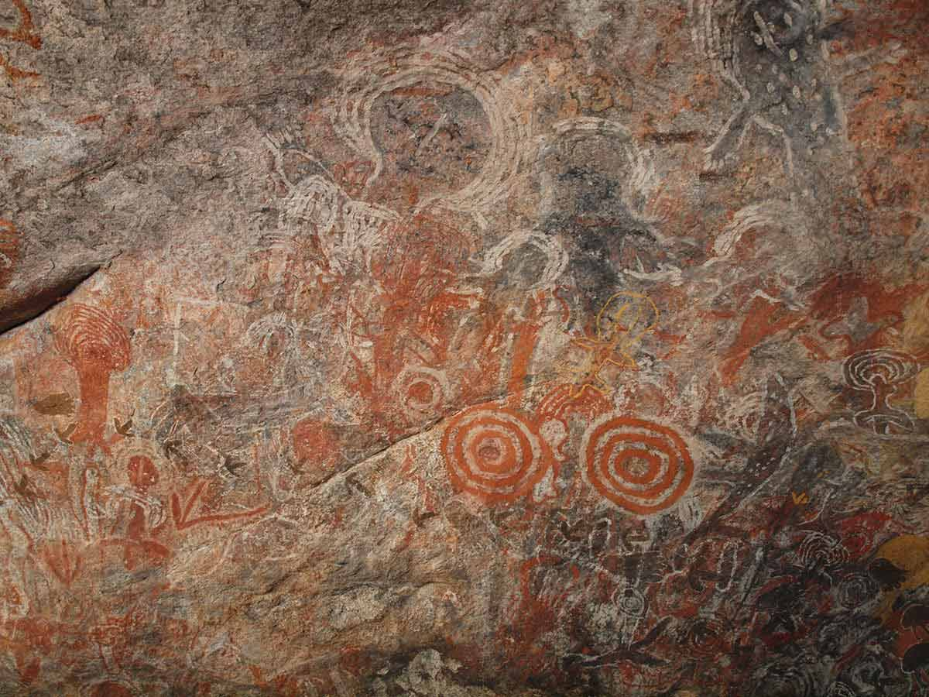  First Rock Art (Source: National Museum Australia) | 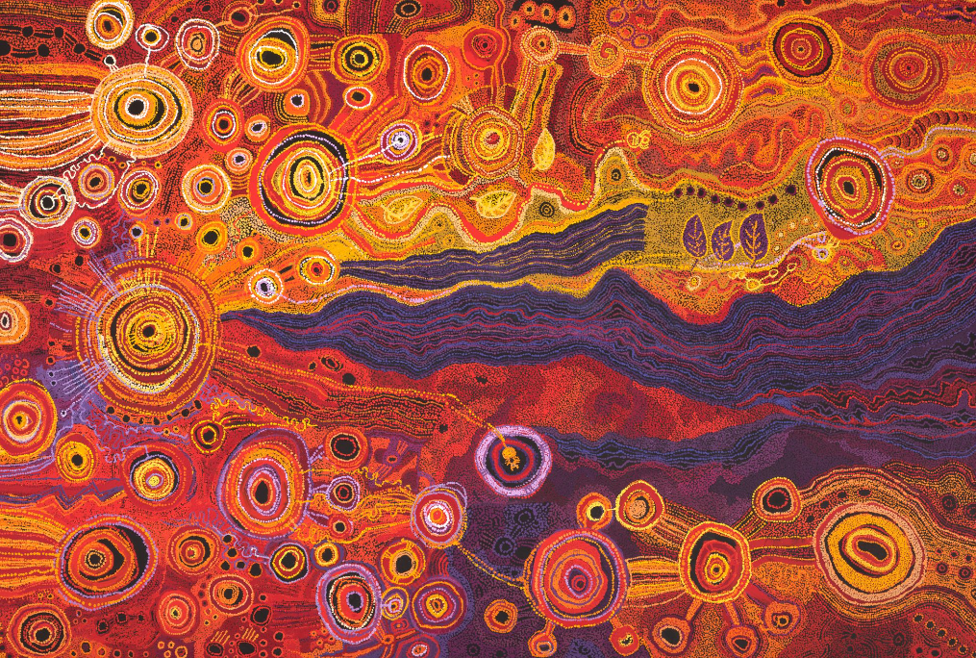  Tjungkara Ken, Sandra Ken, Yaritji Young, Freda Brady, Maringka Tunkin, Pitjantjatjara people, (Source: NGA)

Students will analyse an Aboriginal and Torres Strait Islander artwork and respond to one or more of the questions below.
- Record as much information as you can about the artwork in 15 minutes. Record everything you see. The longer you look the more you will see. Write 5 dot points about your first reactions of the artwork. Who or what do you think the artwork is about? What does it remind you of? What does it make you think about?
- Who created the artwork?
- What is the name of the artwork?
- What colours have been used in the artwork? How do the colours contribute to the artwork’s meaning?
- What symbols or patterns do you notice? What might these symbols represent?
- How was the artwork made? Is it a painting, print, sculpture or another type of artwork? What materials were used to make it? What techniques does the artist use?
- What do these artworks tell us about Aboriginal and Torres Strait Islander culture and their connection with the land?
- What questions do you have about the artwork?

Create an Artwork
Students will create their own artwork inspired by their family heritage, reflecting on how their family story can be expressed visually. Students will brainstorm ideas for their artwork including family symbols, significant events, or personal stories.

Brainstorm
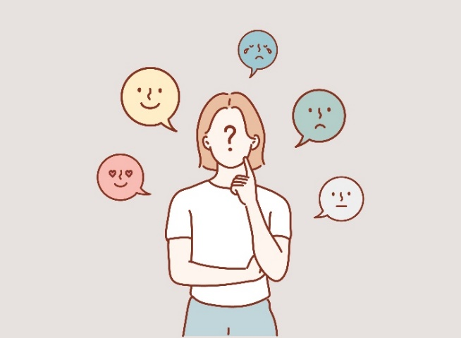
Students can respond to the following questions to help guide their brainstorming.
- Where were you born?
- What language/s do you speak?
- What is your favourite activity to do as a family?
- What do you celebrate?
- Do you have any special ceremonies that your family participates in?
- What are some symbols that represent these celebrations and ceremonies?
- What do you think is unique and special about your family?

Create
Students will create an artwork based on their family. They will include symbols or styles that reflect their family’s heritage or a personal story. They can use techniques learned from Aboriginal and Torres Strait Islander art if they choose.

Below are some guidelines for students as they create their artwork.
- Use colours that you feel reflect you and your family.
- What style will you use to create your artwork?
- What symbols might reflect your culture?

Experimenting with Colour
Experiment with paints and mixing colours to find a colour or a palette of colours that represents you and your family.

- What is your favourite colour? Why?
- Think about how this colour makes your feel or if it reminds you of a personal experience.
- What does the colour represent?

You can create different tints of the colour by adding varying amounts of white paint to make it lighter. You can create different shades of the colour by adding varying amounts of black paint to make it darker. Experiment with different brushstrokes and different amounts of paint on your brush.

Themes and Symbols
Think about the things that you love and the things that are precious to you and your family. How can you represent these stories in your artwork, though symbols?

It could be your pets, family celebrations, or a personal story about an event that you experienced with your family.

What symbols can you use in your art to represent these things?

Students will write an artist's statement to go with their artwork, explaining the symbols they’ve used and the story they have told through their art.

Exhibition
Curate a class exhibition of your students’ artworks and choose a title for the exhibition. Invite students from other classes at your school to attend your exhibition. Consider holding your exhibition at your local library or local council.

Activity: Visit an Art Gallery
Plan a trip to your local art gallery to explore its Aboriginal and Torres Strait Islander art collection. Look for prints, paintings, and sculpture. Alternatively, if you are unable to physically visit an art gallery, visit an online art gallery. For example, visit the National Gallery of Australia to explore a range of Aboriginal and Torres Strait Islander art. Students can work individually or in small groups, using the following as a guide.

Step 1: Plan your visit
As a class, plan a trip to your local art gallery to explore its Aboriginal and Torres Strait Islander art collection. You will need to think about the following:

- What do you already know about Aboriginal and Torres Strait Islander art?
- What do you want to learn? Write 5 questions that you would like to investigate.
- How will you get there and how long will you need to visit the exhibition?
- Can you meet a tour guide or education guide to show you around?
- What will you need to take with you?

Step 2: Explore the art gallery
When you arrive at the art gallery, visit the Aboriginal and Torres Strait Islander art collection. Spend time visiting each artwork. Choose one of the artworks (painting, print, sculpture) that you will focus on for this project.

Write down as much information as you can about the artwork in 15 minutes. Record everything you see in detail. The longer you look the more you will see. Consider looking at it from different angles, up close and far away.
- Is it a painting, print, sculpture or another type of artwork?
- What materials were used to make it?
- Describe what it looks like, including colours, shapes and patterns.
- How does the artwork make you feel?

Draw a picture of the artwork including as much detail as possible.

Step 3: Back at school
When you get back to school you will write a short description explaining more about the artwork you focused on.

Reflect on the artwork and use the internet to learn more about the artist. Respond to the following.
- What attracted you to the artwork?
- Did you enjoy looking at the artwork? Why?
- What were your first impressions of the artwork?
- How would you describe the artwork to someone who has never seen it before?
- Is it contemporary or traditional?
- If you could interview the artist, what questions would you ask them about the artwork? If the artist is alive, find out if you can contact them for an interview.
- What is the ‘story’ behind this artwork?
- Where is the artist from?
- Interesting facts

Useful Websites
- Who Are We? – Adelaide Festival Centre
- First Rock Art – National Museum Australia
- Indigenous Art – BTN

  - Teacher Resource

BTN Transcript: Episode 23 - 20/8/2024

Hey, I'm Amelia Moseley and you're watching BTN. Thanks for joining us for another show. Let's see what's coming up. We find out why Google got into legal trouble in the US, meet some cats and dogs looking for a forever home, and learn how to play a game created by schoolkids.

Gambling Ads

Reporter: Jack Evans

INTRO: But first today, let's talk about gambling ads - right now, the government is looking into toughening up laws designed to restrict where and when they can be shown. But some would like to see an outright ban. Here's Jack.
JACK EVANS, REPORTER: I'm going to bet that you've seen a gambling ad before.
KID 1: Yes.
JACK: I knew it.
JACK: Can I make a bet?
KID 2: Sure.
JACK: You've seen a gambling ad before?
KID 2: Yes.
JACK: Knew it! Knew it.
JACK: Can I make a bet with you that you've seen a gambling ad.
KID 3: Yes, I have.
JACK: Okay, I'm gonna bet that you've seen a gambling ad before.
KID 4: Yeah, I have seen a few.
JACK: Yeah, everyone has 100% of people based on this survey.

To be fair, that's a pretty easy bet to win, because gambling ads are kind of hard to miss in Australia.
KID 1: They're all over the like TV and stuff. There's ads, like on YouTube and stuff as well.
About a million are televised each year and they seem to be working. Australia is actually one of the biggest gambling countries in the world with about 80% of Aussies having gambled in some form or another, but that comes at a cost. For a while now we've known that gambling is really addictive, and each year Aussies lose billions of dollars to it. Studies have found that if you're exposed to gambling from a young age, you're more likely to gamble when you're older. Which is why there are rules to protect young people from seeing gambling ads.
These rules include restrictions on where and when the ads can be played. For example, you can't show a gambling ad during any programs with a G rating or just before, during or after live sporting events. But some reckon lots of ads are still making their way to younger viewers and that the government should be doing more.
Last year the late MP Peta Murphy led an inquiry into gambling and gave 31 recommendations. One of which was to completely ban gambling ads across TV, radio and newspapers by 2027. Now the government is looking at toughening up laws around gambling ads. But the PM hasn't agreed to an outright ban, because he's worried it would have a big impact on free to air tv stations. You see Gambling ads are worth more than $300 million in Australia with a lot of that money going to the tv stations that play them. Some of those stations are already struggling.
BILL SHORTEN, MINISTER: Now some of the free to air media need gambling ad revenue at any time in order to just stay afloat.
Others say that's not a good enough excuse and more than 70 high profile Aussies have signed a letter to the government calling for a ban.
SARAH HANSON-YOUNG, GREENS SENATOR: It is time for Peta Murphy's legacy to be realised.
JACQUI LAMBIE, INDEPENDENT SENATOR: So just do it. Show some goddamn courage for once in your lives.
The Governments expected to be debating the laws this week. So, we'll have to wait and see, if we continue to see, gambling ads.
KID 1: People who haven't started like, who haven't started gambling, but were thinking about it. I think it would stop them from doing it,
KID 2: If they've already started gambling, then I'm pretty sure they'll still keep going.
KID 3: Maybe they could compromise it with, like something whenever. They could actually put it on it, like a certain time at night, and like, certain adults still see it, but the kids don't,
KID 4: If, like, the new generations, like, don't see gambling ads now, they're less likely to gamble in the future.
News Quiz
What’s the name of this award statue? Is it an Oscar, a Logie or an Emmy? It’s a Logie, Australia’s TV awards which were handed out on the weekend. Larry Emdur won this year’s gold Logie, while 15-year-old Felix Cameron became the youngest person to win two Logies in one year for his role in Boy Swallows Universe.

FELIX CAMERON: I'd like to thank my friends, family, my brother and my sister, and my mum and dad.
AUDIENCE: Aww!

This is Nusantara the brand-new Capital City of which country? It’s Indonesia. The government there decided to build a new capital on the island of Borneo because Jakarta is overcrowded and literally sinking. Nusantara isn’t quite finished yet, in fact it could be another 20 years before it is, but last week the president officially inaugurated it and held his first cabinet meeting there.

Speaking of making things official, Kamala Harris is about to become the presidential nominee for which US political party. It’s the Democratic Party. This week it’s holding its National Convention, which is where the nominees for president and Vice president are officially introduced.

Meanwhile, out in space a couple of Astronauts are still stuck there because of problems with which spacecraft. Is it the Dragon, the Starliner or the Soyuz? It’s Boeing’s Starliner. Butch Wilmore and Suni Williams took it on its first crewed mission to the ISS for what was supposed to be an eight-day visit back in June. They’re trying to fix its helium leak and faulty thrusters, but they might just have to stay in orbit for a few more months.

STEVE STICH, NASA PROGRAM MANAGER: The team is doing great. The joint Boeing and NASA team is doing well. They're working side by side with each other every day. We're methodically working through the data, and we'll come home when we're ready.

And what new mysterious discovery have researchers made at Stonehenge in England? Did they find the remains of a wooden boat, that one of the stones came from Scotland or that there’s a dinosaur buried underneath? They found that the stone at the centre of the ancient monument actually came from Scotland. It’s known as the Altar Stone, and it's mostly buried underground but it's actually almost 5 metres long and weighs 6 tonnes.

ANTHONY CLARKE, PHD STUDENT: But this discovery that it came from north east Scotland, at least 700km away, is going to have big implications for how we understand movement and the transfer of people in Neolithic Britain.

Google Monopoly

Reporter: Wren Gillett

INTRO: Now to this little internet company which you might have heard of? For a long time now Google has been the world's biggest search engine. But now a court in the US has ruled that it's actually broken the law. by using its power to nudge out the competition. Wren looked into it.

WREN GILLETT, REPORTER: Hey Sas…
SASKIA MORTAROTTI, REPORTER: Yeah?
WREN: is cereal a soup?
SASKIA: I don't know, just Google it?
WREN: Do straws have one hole or two?
SAS: I don't know, just Google it?
WREN: Is water actually wet?
SAS TEXT: GOOGLE IT....
When we have a big question or a silly little one, there's one place that most of us go. In fact, 99,000 people are Googling something every second. So how did one company become synonymous for looking things up on the internet?
INTERNET VIDEO: “Take a spin now you're in with the techno set, you're going surfing on the internet"
Back in the early days of the internet, finding what you wanted was a little tricker.
INTERNET VIDEO: First you need to know that everything on the internet has an address, and all web addresses start with http, colon, double backslash.
WREN: So to make things easier, search engines were invented.
They're basically programs that organise the internet for us and make websites easier to find, and there used to be lots of them.
SAS: Oi Wren, which orange came first, the colour, or the fruit?
WREN: Hmmm ooh, let's Ask Jeeves.
Yeah this was a search engine, along with this, and this, and this. Most worked by looking for keywords in web pages and ordering results by how many times the word appeared. Then in 1998, these two guys launched a new search engine that they called, yep, Google. Google used a slightly different way of ranking pages, which prioritised the most popular and commonly linked to pages. And it was a big success. In the 2000s, Google exploded. We got Google image search, Google news, Google maps, Gmail. In 2005, they bought the smartphone operating system Android. And In 2006, they bought YouTube.
YOUTUBE: "Ouch Charlie, OOOOOUUUCH… Charlie!!".
Google also made a lot of money by selling ads and using people's searches to make them more targeted. Today 90 per cent of searches online go through Google, and 95 per cent on smartphones. The site is so popular that it's become a verb.
SAS: Google it.
WREN: And some say that's a problem.
You see, when any company gets too big, it makes it harder for others to compete, which is bad for everybody, because it means there's less pressure on them to do a good job, and less opportunity for others to do something better. It's why many countries have laws designed to stop that from happening. And recently, Google was found guilty of breaking those laws in the US. The court said Google spent billions of dollars to deliberately make it harder for other companies to compete.
DR ZENA ASSAAD, AUSTRALIAN NATIONAL UNIVERSITY: So, they've been found guilty of specifically exclusive contracts with both Apple and Samsung as being the default engine within their services.
Google says it hasn't done anything wrong, and that its search engine is only popular because, well, it's good. It plans to appeal the court's decision. Meanwhile the court is still working out
how to punish Google for breaking the law. It could be forced to sell parts of its business, or even share its data with rivals. But ahh yeah, nothings been decided yet. So...
WREN: As for the future of the world's most popular search engine, well that's one thing we can't Google the answer to just yet.
Did you know?

Did you know Google is named after a math’s term. A "googol" is 10 to the power of 100.

Pet Surrenders

Reporter: Saskia Mortarotti

INTRO: Now to something a lot of us love a lot, and that is our pets. But recently, animal welfare organisations say they've seen a big increase in the number of pets being surrendered by their owners. Sas went down to the RSPCA to find out what's going on. Take a look.
HANDLER: Rio. Touch. Yes, well done.

SASKIA MORTAROTTI, REPORTER: Meet Sicario, or Rio for short. He's a three-year-old American Staffordshire cross and he knows quite a few tricks.
IZZIE DEW, RSPCA: He's a gorgeous boy. He absolutely loves people. He loves his snacks. He's really great to walk on the lead, despite his large size. So we're really hoping that we can find Sicario the right fit.

SAKIA: You are very friendly. Oh, you're gorgeous.
SASKIA: Rio is just one of the dogs here at the RSPCA looking for his forever home after being given up by his previous owner.
IZZIE: He was surrendered because his owners were moving and they weren't able to take him. Unfortunately, the rental crisis has caused a lot of owners to have to surrender their animals to us. Sicario has been with us for four months now, trying to find his perfect family.
SASKIA: Animal welfare charities right across Australia say this year they've seen more animals like Rio needing a new home. So, why might we be seeing an increase in pet surrenders?
CAROLYN JONES, RSPCA: There's no doubt that a lot of people are struggling with the cost of living. And also some people struggle to find a rental accommodation which accepts pets. So, yes, there have been more people probably wanting to surrender animals.
REAL ESTATE AGENT: What have I got?
BIDDER: 20.
BIDDER: 162.
AGENT: One, six and two.
WOMAN: 660, but that's ages away.
SASKIA: Yeah. As you have probably heard, lots of things have become more expensive in the past few years. From houses, to petrol, to bills and groceries. Pet food included. It means that some people have had to make some tough decisions. Including giving up their furry friends up for adoption. Then there's covid. A few years ago, when we were all in lockdown, lots of people adopted pets and now that the world's opened back up, people's lifestyles have changed.
CAROLYN: There's definitely fewer adoptions happening at the moment. I think a lot of people have gone back to their usual routines. They maybe don't have the same amount of time to care for an animal.
SASKIA: Carolyn says that sometimes people don't realise that looking after a pet isn't just about cuddles. There's grooming, vet bills, training, exercise, food and it all takes a lot of commitment. But she says for many people it's well worth it. Which is why charities like the RSPCA, work with owners to help them keep their pets. And if it still doesn't work out, they do their best to find them the perfect new home.
CAROLYN: Once we've found out all about that surrendered animal and that animal's come into our care, then our staff work really hard to look at, well, what's kind of a home is this animal suited to. The job of our staff is to make sure that they're going to the best person so that they have a loving and forever home.
RSPCA PERSON: How many puppies can fit on my lap?!
SASKIA: But it takes a lot of work, and shelters say an increase in surrenders can make things hard to care for every animal that needs it. But there are things we can do to help.
CAROLYN: We have lots of ways that people can help us with our work, and there's lots of volunteer roles. You have to be over 18 to volunteer here, but there's lots of roles in caring for animals and all sorts of other things you can do. But also, there's opportunities to adopt or foster animals.
SASKIA: Carolyn says while pets can be a lot of work, they're also pretty great, and if you've got the time and the love to give them, then you'll have a friend for life.

Indigenous Art

Reporter: Jack Evans

INTRO: Now to an exhibition in Adelaide that's showing off the artwork of some talented First Nations students. Jack went down to have a look and found out more about all the different types of Indigenous art. Check it out.

JACK EVANS, REPORTER: Who are we? That's the question a group of South Australian First Nations students asked themselves, when they created these artworks.
STUDENT 1: I thought about my family and who made me who I am today, and I thought of like my country as well.
STUDENT 2: So, my silk painting that I created is about my Nan's connection with her community and how she tells her story.
STUDENT 3: I did on experiences I've had recently. So, one of them was about a camp I'd just been on, the kids on country camp.
The silks and ceramics were made during workshops run by brother and sister Temaana and Iteka.
TEMAANA, ARTIST: It was a really cool opportunity for the students to be able to explore that - who they are as Aboriginal people, what makes up their identity, and put that into an art piece.
STUDENT 3: I've done a lot of art and stuff. I like painting. I do a lot of painting at school, but never done silk painting before so that was, yeah…
STUDENT 4: When he said we were gonna be painting on silk, I didn't know what he meant, because I've never done it. But it was fun.
So, what exactly is First Nations art? Well apart from this and that. But surely there's a more definite answer. It's something people have been doing here on this continent for more than 55,000 years.
TEMAANA, ARTIST: I've always thought of it as a spectrum. So, one long line, one end you have traditional Aboriginal art, and the other end you have contemporary, and one piece can be anywhere along that line.
Contemporary First Nations art first came to the world’s attention in 1934 when First Nations people at the Hermannsburg mission in the NT were taught how to paint with water colours. One of those artists was Albert Namatjira, who's artwork became famous around the world.
Another significant movement was in 1971 when students in Papunya, just north of Alice Springs, were encouraged to transfer the dreaming stories they were dotting in the sand onto canvas. Giving us the first paintings to use symbols and dots which have become sort of staples for First Nations art. But while the use of dots and symbols might be common across the country, the meaning and style will be different depending on who the artist is and who their language group is. Today First Nations art can be, well anything really.
TEMAANA, ARTIST: On the other end of the line, you might have something like digital art, which is very contemporary, very modern, and somewhere in between, you might have something like a canvas.
So, what connects all First Nations art? Well, it's got something to do with why the art was created in the first place, and that is to tell a story.
ITEKA, ARTIST: We didn't have a written language. Everything we passed on with knowledge was passed on through art and ceremony and dance and stories and everything.
TEMAANA, ARTIST: So many stories that are from Ayata, from our country, up in the Flinders and Yorke Peninsula and Simpson Desert. And by using those stories and implementing them into our art, it's a way of connecting to those stories, also to our land and culture.
And now they're helping the next generation of First Nations artists to tell their stories.
STUDENT 2: Walking in through the doors and just having my art and all the other student’s art just displayed on the walls. It's right there. I didn't expect it to be all sort of all fancy.
STUDENT 3: It's just cool that, like people will be able to come in and see all this amazing art.

Sport

The world's fastest bikers have gone head to head at the Austrian Moto Grand Prix. While it looked like Spain's Jorge Martin had it in the bag to begin with, that all changed when he was hit with a penalty, turning this tricky corner.

COMMENTATOR: Well, this is a gift. This is playing right into the hands of Pecco Bagnaia.

Yep, Italy's Francesco Bagnaia ended up winning the race by just 3.23 seconds.

FRANCESCO BAGNAIA: The win today is fantastic. The win yesterday was fantastic.
Now to some bikes without engines. On Sunday, the big winner of the femme tour de France was announced. Katarzyna Niewiadoma.

KATARZYNA NIEWIADOMA: I knew that I just had to pace myself smart and give my best in the last five kays.

The Polish champ won by just four seconds, the narrowest margin of any tour de France race.
And finally, prepare to roar with laughter, or at least giggle, because you're witnessing this year's T-Rex World Championships. The annual event where people get together, dress up, and yeah, run as fast as they can. 'Do Your Homework' won the 12-16 category, while 'My Rex Girlfriend' dominated the women's section, and 'Fossilizer' proved the fastest dinosaur over 50. Haha, aren't those names just DINOmite, get it. Ha.

Game Creators
Reporter: Justina Ward

INTRO: Finally, today we're going to meet some young game developers, but maybe not the type of game you're thinking. Ben, Sam and Jacob invented a card game which is now being sold around the world.
Justina found out more.

Justina: What are the chances? And then I can go Swipee.
Jacob: Ah yes Swipee.
Justina: I don't know why I thought I was gonna win.
Jacob: Maybe next time don't challenge the creators of the game.
Justina: So how did you come up with the idea for Swipee?
SAM: Back in July of 2022, we're in the back of the classroom finished with all of our work. And the teacher gave us some cards to play with. Once we played all the games we knew of, we started creating own rules for the game.
Justina: So, was there a moment where you thought, "Oh, I think this game could really take off"?
Jacob: I think it was when we started getting all that positive feedback that we thought the game could go further.
Justina: Swipee!
SAM: The objective of the game is to clear out your whole deck of 9 and by doing that, you need to get three of the same cards in a row or a column and then swap them out.
BEN: Five main rules of Swipee, you can swap cards with another player.
PLAYER: Can I trade you this poo for that devil?
PLAYER: Ah Yes.
BEN: You can put your card in the discard pile, pick up one from the draw pile.
BEN: You can take the top card from the discard pile.
BEN: And you can swap cards adjacently horizontally or vertically in your deck.

Jacob: The fifth rule is the special cards and there are three special cards. There's the wipeout card

Jacob: There's the steal card.

PLAYER: Alright, Jacob, I'm going to steal your monocle guy.
PLAYER: Oh, dang it!
Jacob: And then there's the rainbow card.
Jacob: This rainbow is now poo. Swipee.
Justina: So how did go about designing the game and all the rules and stuff?
SAM: So we originally drew out lots of our sketches on iPads and I've got the old sketches and stuff on here.
Jacob: We were gonna do a sport version and underwater version and an Australian animals’ version and we'd especially like to do some licensed versions.
SAM: Like the AFL, because we're all really big fans of the sport.
Justina: So what did you have to do to take this game to the next level?
Jacob: We like added in the special cards which my sister created. We spent six months refining the rules and the game and we got some demo packs made and we needed to get a bank account so we could order the packs, and we needed help with postage.

JACOB: This one is for two packs going to Elson Victoria. I wonder where that is.

Justina: What was it like when you got your first order?
Jacob: Yeah, when we got our first order, we were, like, really stoked.
JACOB: We have got four new orders. One for two packs and three singles.
BEN: Oh, nice. I'll go get them. Here we go.
Justina: And you've signed a deal recently. Can you tell us about that?
SAM: After we did our school fundraiser, our principal invited us to the YES summit, which is the Young Entrepreneural Summit and they posted that on their socials and then the Fantastic Factory found us and they've given us the licensing agreement to go international.
Jacob: We're all really excited that a game that came from the back of the classroom could come this far.
Justina: So what do you plan on doing with all the money you're making?
BEN: We want to put lots of way for reinvesting to order new packs and all that. Looking for charity to donate to. But I'd like a Land Cruiser when I'm 16. I'm sure lots of us would like a car.
Justina: Are there any big plans for Swipee in the future?
Jacob: So we have plans to make new additions like AFL version, and we have a new addition that's going to be out in store soon, which is the monsters edition.
Justina: So do you have any advice for other kids wanna create their own game?
BEN: I'd say no idea's silly.
SAM: Just follow your own dream really. Mistakes happen and that's fine.
Jacob: And yeah, just like keep trying and never give up.
Closer

Awesome work guys, I can't wait to challenge Justina to a game. Well that's all we have for this week, but we'll be back with more before you know it and, in the meantime, you can check out our website or catch Newsbreak right here in the studio every weeknight keeping you up to date. Have a good one and I’ll see you soon. Bye.

