

**EPISODE 25**  
30th August 2022

**KEY LEARNING**

Students will view a range of BTN stories and use comprehension skills to respond to a series of focus questions.

**CURRICULUM**

**English – Year 4**Use comprehension strategies to build literal and inferred meaning to expand content knowledge, integrating and linking ideas and analysing and evaluating texts.

**English – Year 5**

Use comprehension strategies to analyse information, integrating and linking ideas from a variety of print and digital sources.

**English – Year 6**

Use comprehension strategies to interpret and analyse information and ideas, comparing content from a variety of textual sources including media and digital texts.

**English – Year 7**

Use comprehension strategies to interpret, analyse and synthesise ideas and information, critiquing ideas and issues from a variety of textual sources.

Teacher Resource

**Focus Questions**

As a class, discuss the stories featured in the episode of BTN Classroom and record the main points of the discussion. Students will then respond to the following focus questions.

# Northern Hemisphere Drought

1. What objects have the droughts in Europe uncovered?
2. Name at least 3 countries affected by drought at the moment.
3. What percentage of the United States is in drought?
4. Experts say the droughts in the northern hemisphere could end up being the worst humans have seen for ________years.
5. What did you learn watching this story?

# Fire Rating Update

1. What is the Fire Danger Rating System?
2. Why are they changing the Fire Danger Rating System?
3. How many categories does the new Australian Fire Danger Rating System have?
4. What does the Fire Danger Rating System tell us?
   1. How likely a fire is
   2. How dangerous a fire is
   3. How may fires there are
5. What questions do you have about the story?

Check out the [teacher](https://www.abc.net.au/btn/teachers/) resource on the Teachers page.

# Wear It Purple Day

1. What does Wear it Purple day celebrate?
2. What is George’s role in the day?
3. Why did George want to get involved in Wear it Purple day?
4. In what year was marriage equality achieved in Australia?
   1. 1978
   2. 1998
   3. 2017
5. Why is Wear it Purple Day important to the students in the BTN story?

**Overland Telegraph Anniversary**

1. In the 1800s, how did people in Australia communicate with the rest of the world? What was a disadvantage of this form of communication?
2. How were messages sent on the telegraph?
3. Morse code uses a combination of dashes and dots to symbolise each ________________.
4. Why did Charles Todd want to build a telegraph line from Adelaide to Darwin?
5. How did the Overland Telegraph change communication in Australia forever?

Check out the [teacher](https://www.abc.net.au/btn/teachers/) resource on the Teachers page.

**Guam Dog Rescue**

1. Where is Guam? Locate using Google Maps.
2. About how many stray dogs are there in Guam?
   1. 700
   2. 7500
   3. 75000
3. What are the stray dogs known as?
4. Why are the dogs being sent to the United States?
5. How are they spreading the word about the stray dog project?



**EPISODE 25**  
30th August 2022

**KEY LEARNING**

Students will learn about Australia’s new fire danger rating system. Students will learn more about the science of bushfires.

**CURRICULUM**

**HASS – Year 5**  
The impact of bushfires or floods on environments and communities, and how people can respond.

**Science – Year 5 & 6**  
Scientific knowledge is used to solve problems and inform personal and community decisions.

**Science – Year 6**

Sudden geological changes and extreme weather events can affect Earth’s surface.

**Science – Year 7**

Scientific knowledge has changed peoples’ understanding of the world and is refined as new evidence becomes available.

**PLEASE NOTE:** Talking about bushfires may be upsetting for some children and may cause some discomfort, distress and/or anxiety. Please refer to the following links for information on how to talk to children about bushfires and upsetting news.

[UNICEF](https://www.unicef.org.au/blog/news-and-insights/january-2020/how-to-talk-to-your-children-about-australia-s-bushfires) has created a guide about how to talk to children about the bushfires.

[Kids Helpline](https://kidshelpline.com.au/teens/issues/coping-natural-disasters) has some information to help children cope with natural disasters.

[BTN](https://www.abc.net.au/btn/features/upsetting-news/10500572) has a short video about the Important Things to Remember about Upsetting News.

Teacher Resource

**Fire Rating Update**

# Focus Questions

Discuss the BTN story as a class and record the main points of the discussion. Students will then respond to the following:

1. What is the Fire Danger Rating System?
2. Why are they changing the Fire Danger Rating System?
3. How many categories does the new Australian Fire Danger Rating System have?
4. What does the Fire Danger Rating System tell us?
   1. How likely a fire is
   2. How dangerous a fire is
   3. How may fires there are
5. What questions do you have about the story?

# Activity: Class Discussion

Discuss the BTN Fire Rating Update story as a class. Ask students to record what they know about bushfires and the fire danger rating system. What questions do they have? Use the following questions to help guide discussion:

* Have you seen a fire danger rating system before? If so, where did you see it?
* Why do we have a fire danger rating system?
* What does a fire danger rating tell you?
* How can you find out about what the fire danger rating is each day?
* Who forecasts the fire danger rating each day?
* What does AFDRS stand for?
* What questions do you have?

What questions do you have about the story?

What did you learn from the story?

# Activity: Test your knowledge

After students have watched the BTN Fire Rating Update story as a class, test their knowledge on what they have learnt about the new fire danger rating system. Ask students to match the action people need to take for each fire rating level.

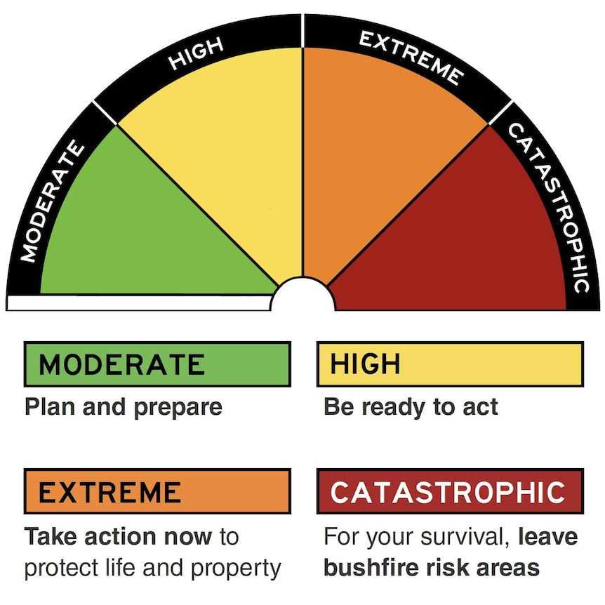

**Take action now** to protect life and property

For your survival, **leave bushfire risk areas**

**Be ready to act**

**Plan and prepare**

# Activity: Quiz

|  |  |
| --- | --- |
| 1. **Australia has a new fire danger rating system because the old system was too confusing.**   A. True  B. False   1. **When does the new Australian Fire Danger Rating System (AFDRS) come into action?**   A. 1st September 2022  B. 25th December 2022  C. 1st January 2023   1. **How many different types of vegetation or fuels will be included in the new AFDRS?**   A. 1  B. 3  C. 8  Quiz Answers: 1A, 2A, 3C, 4B, 5B, 6B | 1. **What does the new AFDRS tell us?**   A. How likely a fire is  B. How dangerous a fire is  C. How many fires there are  **5. How many fire danger ratings does the new system have?**  A. 2  B. 4  A. 6   1. **What describes the amount of fallen bark, leaf litter and small branches in the landscape?**   A. Fuel moisture  B. Fuel load  C. Fuel type |

# Activity: Inquiry Research

After watching the BTN Fire Rating Update story, hold a questions and answers discussion to encourage students to engage with the topic and learn more about the science of bushfires and their impact on communities, individuals and the environment.

What questions were raised in the discussion and what are the gaps in students’ knowledge? The following KWLH organiser provides students with a framework to explore their knowledge on this topic.

|  |  |  |  |
| --- | --- | --- | --- |
| What do I **know**? | What do I **want** to know? | What have I **learnt**? | **How** will I find out? |
|  |  |  |  |

Students will develop their own question/s to research or choose one or more of the questions below. Encourage students to collect and record information from a wide variety of sources and present the information they find in an interesting way.

* 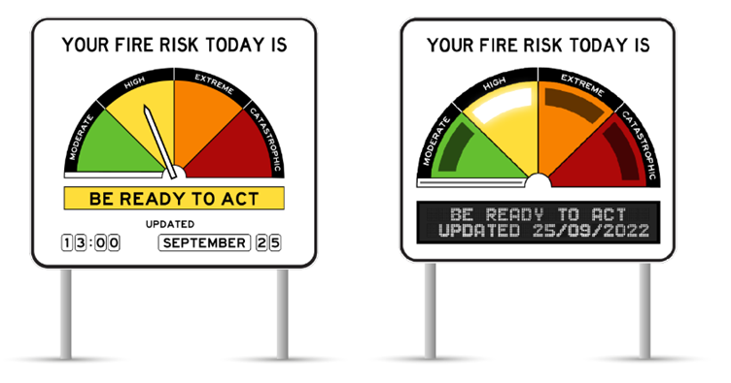Why do we have a new Australian Fire Danger Rating System? Why is it better than the previous systems?
* What are the different ratings in the new Australian Fire Danger Rating System? Describe what each rating means.
* What will the Fire Danger Ratings look like? Illustrate the new sign. Explain what each of the features and elements are on the sign.
* Why is it important to have a fire danger rating system?
* How do bushfires start? (Think about fuel, weather and geographical conditions).
* What are fuel types? List the 8 different fuel types. Show a map which highlights the different fuel types across Australia.
* What is cultural burning? How can we learn from First Nations Peoples about looking after Country? To learn more about cultural burning, go to the [Firesticks website](https://www.firesticks.org.au/about/cultural-burning/). This [Traditional burning video](https://www.sbs.com.au/news/traditional-burning-reviving-indigenous-cultural-burns-for-bushfire-management) explores bushfire management practices in more detail.
* What role does fire play in keeping the [ecosystem](https://www.environmentforyouth.com.au/glossary/ecosystem/) healthy?
* Research a major bushfire occurrence in Australia. Include the following information in your investigation: Where the fire started, what caused the fire and the damage it caused.

# Activity: Campaign

Students will design a public education campaign to raise awareness about the new Australian Fire Rating Danger System. As a class look at this [AFDRS poster](https://www.afac.com.au/initiative/afdrs/article/afdrs-brochure) and ask your students how it could be more kid friendly. Record their responses.

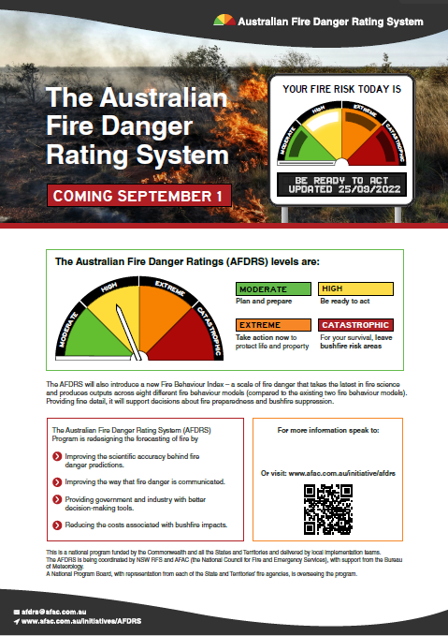Students will then create their own poster to educate kids around Australia about the new Australian Fire Danger Rating System. Students will need to think about their campaign’s aim, target audience, and the value of raising awareness in their community. Use [Canva](https://www.canva.com/) to design a poster to put up around your school and the wider community.

To create a school awareness campaign, students will need to identify the following:

* What do the new fire danger ratings look like? Where can people find the signs?
* How can you find out what the fire danger rating is each day?
* What is the most dangerous fire rating?
* Who forecasts the fire danger rating each day?
* What action should you take (for each of the fire danger ratings)?

National Council for Fire and Emergency Services – [AFDRS poster](https://www.afac.com.au/initiative/afdrs/article/afdrs-brochure)

* How can we be prepared for a bushfire?

Some questions to consider when designing your campaign:

* What is the campaign’s main aim?
* Do you have a slogan or message? What is it?
* Who is your target audience?
* What is the best way to communicate the message?

Discuss with students how they will get their message out there to help raise public awareness. Some possibilities include:

* Short film or animation
* Community service announcement (for television or radio).
* Press release (create posters to be put up around the school).

# Activity: BTN Stories

As a class watch one or more of the following BTN stories to learn about bushfires and their impact on people and the environment. After watching any one of the BTN videos ask students to respond to the discussion questions (to find the discussion questions and teacher resources go to the related BTN Classroom Episode and download the Episode Package).

|  |  |  |
| --- | --- | --- |
| [Black Summer Bushfires](https://www.abc.net.au/btn/classroom/20200204-ep1-btn/11911010) | [Bushfire Kids Visit](https://www.abc.net.au/btn/classroom/bushfire-kids-visit/11703500) | [Fire Preparations](https://www.abc.net.au/btn/classroom/fire-preparations/10525718) |
| [Bushfire Season](https://www.abc.net.au/btn/classroom/bushfire-season/11505884) | [Pet Bushfire Safety](https://www.abc.net.au/btn/classroom/pet-bushfire-safety/10522082) | [Burn off Season](https://www.abc.net.au/btn/classroom/burn-off-season/10522544) |

# Useful Websites

* [Updated fire danger rating system will be rolled out next month. Here's what you need to know](https://www.abc.net.au/news/rural/2022-08-21/bushfire-fire-danger-rating-system-updated-with-four-levels/101324830) – ABC News
* [Bushfire Season](https://www.abc.net.au/btn/classroom/bushfire-season/11505884) – BTN
* [Fire Danger Ratings are changing soon](https://www.rfs.nsw.gov.au/news-and-media/fire-danger-ratings-are-changing-soon#:~:text=The%20new%20Fire%20Danger%20Ratings,white%20wedge%20sitting%20under%20Moderate.) – NSW Rural Fire Service
* [Fire Heroes](https://www.abc.net.au/btn/classroom/fire-heroes/11910482) – BTN
* [Burn Off Season](https://www.abc.net.au/btn/classroom/burn-off-season/10522544) – BTN
* [Australian Fire Danger Rating System](https://www.afac.com.au/initiative/afdrs/) – National Council for Fire and Emergency Services
* [Australian Fire Danger Rating System (FAQs)](https://www.afac.com.au/initiative/afdrs/afdrs-faqs) – National Council for Fire and Emergency Services



**EPISODE 25**  
30th August 2022

**KEY LEARNING**

Students will learn more about the history of the Overland Telegraph Line and how it changed the lives of Australians.

**CURRICULUM**

**HASS – Year 5**

The impact of a significant development or event on an Australian colony.

Develop appropriate questions to guide an inquiry about people, events, developments, places, systems and challenges.

Teacher Resource

**Overland Telegraph**

# Focus Questions

Discuss the BTN story as a class and record the main points of the discussion. Students will then respond to the following:

1. In the 1800s, how did people in Australia communicate with the rest of the world? What was a disadvantage of this form of communication?
2. How were messages sent on the telegraph?
3. Morse code uses a combination of dashes and dots to symbolise each ________________.
4. Why did Charles Todd want to build a telegraph line from Adelaide to Darwin?
5. How did the Overland Telegraph change communication in Australia forever?

# Activity: What do you see, think and wonder?

Students will watch the BTN Overland Telegraph story, then respond to the following questions:

* What did you SEE in this video?
* What do you THINK about what you saw in this video?
* What did you LEARN from this story?
* What was SURPRISING about this story?
* What QUESTIONS do you have?

# Activity: Class Discussion

Students will discuss the BTN Overland Telegraph story in pairs and then share their thoughts with the class.

* Before the Overland Telegraph, how did messages come from Britain?
* When was the Overland Telegraph Line built?
* Why was it built?
* How were messages sent?
* How did it change the lives of people in Australia?

# Activity: Glossary

Students will brainstorm a list of key words that relate to the BTN Overland Telegraph story. Here are some words to get them started. 

|  |  |  |
| --- | --- | --- |
| TELEGRAPH | OVERLAND | ISOLATED |
| MORSE CODE | COLONIES | ELECTRIC TELEGRAPH TECHNOLOGY |

# Activity: Overland Telegraph Research

Discuss the information raised in the BTN Overland Telegraph story. What questions were raised in the discussion and what are the gaps in students’ knowledge? The following KWLH organiser provides students with a framework to explore their knowledge on this topic.

|  |  |  |  |
| --- | --- | --- | --- |
| What do I **know**? | What do I **want** to know? | What have I **learnt**? | **How** will I find out? |
|  |  |  |  |

Students will develop their own question/s to research or choose one or more of the questions below. Encourage students to collect and record information from a wide variety of sources and present the information they find in an interesting way.

* How did the Telegraph Line connect Australia with Britain? Why do you think this was considered important?
* Map

  Description automatically generatedWhat were some of the challenges constructing the Overland Telegraph Line?
* Telegraph messages were sent using Morse code. Find out when Morse code was invented and how it works.
* How did the Overland Telegraph Line impact the lives of people in the late 1800s?
* How did the Overland Telegraph Line open up inland Australia?
* Explain why the Overland Telegraph Line was described as the `greatest engineering feat carried out in nineteenth century Australia’.

# Activity: Visual literacy

In this activity students will analyse a range of images of the Overland Telegraph Line. Students will choose one or more of the images below and respond to the following:

* What is happening in the image? What people, objects or activities can you see?
* What does the image tell you about the Overland Telegraph Line?
* Create a caption for each image.
* What questions do you have about what you see in the image?

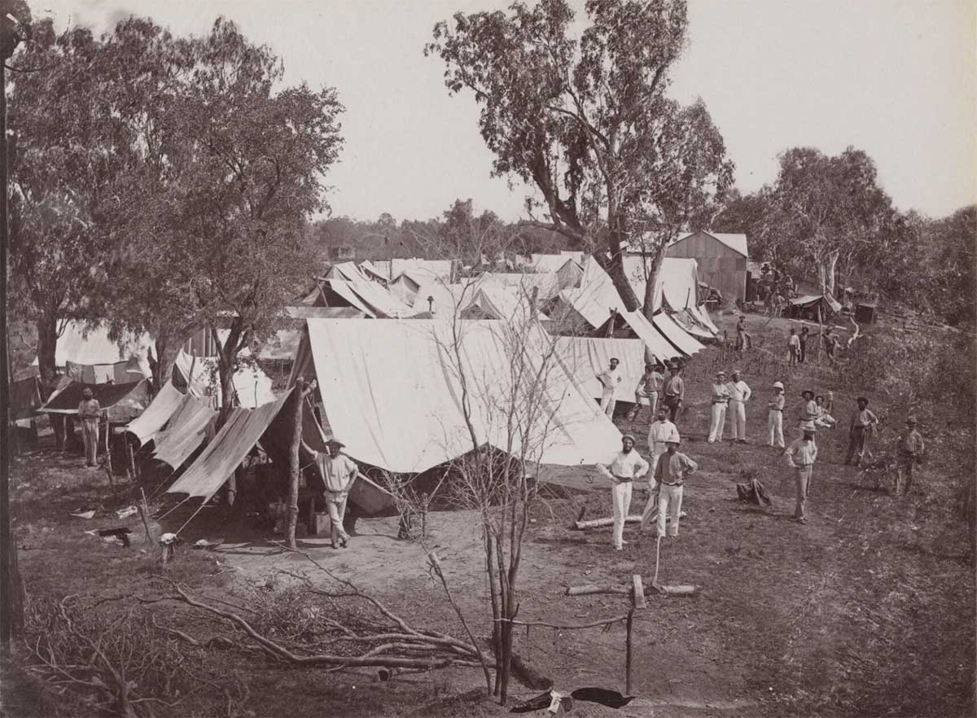

[Source of image](https://upload.wikimedia.org/wikipedia/commons/a/ac/Overland_Telegraph_Darwin.jpg) [Source of image](https://www.nma.gov.au/__data/assets/image/0003/546042/MA58074098-Camp-Overland-Telegraph-1200w.jpg)

# Bob Carew up a pole of the Overland Telegraph Line.

[Source of image](https://live-production.wcms.abc-cdn.net.au/4af3181a57e0936df20d899f3ba5d5c9?impolicy=wcms_crop_resize&cropH=510&cropW=766&xPos=26&yPos=100&width=862&height=575) [Source of image](https://upload.wikimedia.org/wikipedia/commons/8/8c/Overland_Telegraph.jpg)

# Activity: Morse Code

Explain to students that telegraph messages were sent and received in Morse code. Students will use Morse code to write a short message and then ask a partner to decode it. Students can also send their message by flashing a torch light.

# Students can also use the [Morse Code Translator](https://morsecode.world/international/translator.html) to type a message and translate it to Morse code.

# Useful Websites

* [The Overland Telegraph Line revolutionised Australia 150 years ago and broke its extreme isolation](https://www.abc.net.au/news/2022-08-22/overland-telegraph-line-150-years-since-completed-/101347644) – ABC News
* [Overland Telegraph Line remembered as significant feat with complex history on 150th anniversary](https://www.abc.net.au/news/2022-08-22/overland-telegraph-line-anniversary-150-years-indigenous-history/101359394) – ABC News
* [Overland telegraph](https://www.nma.gov.au/defining-moments/resources/overland-telegraph) – National Museum Australia
* [The Overland Telegraph Line: Telegraph Collection](https://www.migrationheritage.nsw.gov.au/exhibition/objectsthroughtime/1871-the-overland-telegraph-line-telegraph-collection/index.html) – Migration Heritage Centre

|  |  |
| --- | --- |
|  |  |



Teacher Resource

**BTN Transcript: Episode 25- 30/8/2022**

Hey, I'm Amelia Moseley and you're watching BTN. Thanks for hanging out with us again. Let’s see what’s coming up on today’s show. We find out why Aussie kids were wearing it purple on Friday, learn about a piece of engineering that changed Australia and meet the super mutts of Guam.

# Northern Hemisphere Drought

Reporter: Amelia Moseley

*INTRO: All that soon, but first today to the massive drought that's affecting a lot of places in Europe, America, Africa and China. There have been record breaking temperatures, wildfires and water shortages and some mysterious appearances in lakes and rivers. Check it out.*

Sunken ships in Serbia, 'ghost gardens' in England, a 7000 year old Stonehenge in Spain, and an unexploded World War Two bomb in Italy! These are just a few of the unusual things that have appeared across Europe and the UK lately! But it's not some strange mystery, or even the work of clever archaeologists. It's because of a serious drought drying up lakes and rivers.  
  
Record breaking heatwaves, and a serious lack of rain have lead to the worst droughts some countries have ever seen! You can see some pretty creepy evidence in Germany where so called 'hunger stones' have appeared, marking the water levels from past droughts, some dating back decades.

It's killing off fish, cattle and crops which is already causing food shortages. There have been big wildfires, like these ones in France where people had to be evacuated. And the low water levels are causing some big problems for ships, which can't get through carrying important goods. There are also serious worries about a shortage of clean water. In some villages in France and small towns in England, taps literally ran dry.  
  
BRITISH RESIDENT: If you don't have running water it makes you question all the most basic sort of complexities of life, and that's what it's been like in the last few weeks.  
  
Other parts of the world are also struggling with a really bad drought. Like more than 70 per cent of the US where this river revealed 113 million year old dinosaur footprints. Plus, parts of Central and South America, Africa and China too where ancient Buddha statues re-appeared. Here, the world's third biggest river, the Yangtze, is turning to puddles.   
  
While droughts like this do happen naturally, experts say this could end up being the worst drought humans have seen for 500 years, and they're warning that if the world doesn't act quickly on climate change we could be seeing these conditions go on longer and happen more often in the future.  
  
Dr Laurence Wainwright, Lecturer at University of Oxford: We have to ask the question whether some of these regions are going to be even habitable in 50 or 100 years and I truly call on politicians around the world to look at this. It's time to get moving, it’s seriously time to get moving.  
  
Some reckon we also need to get better at conserving our most precious resource.  
  
Nuria Hernández-Mora, New Water Culture Foundation Co-Founder: Water is scarce and that we have to use it wisely, and we have to think very well about how to use it in a context where there will be less available in years to come.  
  
Many countries have brought in water restrictions to try to conserve as much as possible and where people need drinking water it's being trucked in to help. And as for these treasures from the past? Well, it's been amazing to see them, but most people are hoping they'll disappear underwater again soon.

# News Quiz

While parts of the world are in drought, other areas are getting too much rain. 33 million people have been affected by devasting floods in which country? It’s Pakistan. A monsoon has caused rivers to rise and wash away buildings, roads and bridges killing more than 1000 and leaving many more homeless.

Can you name the American sports superstar who made an appearance at a press conference with the PM and Indigenous Australians minister Linda Burney on the weekend? It’s Shaquille O’Neal. The NBA legend is on a speaking tour of Australia and took some time to meet the leaders and to voice his support for the Indigenous Voice to the Parliament.

Can you guess what this sound is? An aeroplane flying over a canyon, a blizzard in Antarctica or a black hole? It’s a black hole. NASA recorded sound waves coming from the black hole in the Perseus Galaxy cluster with its Chandra X-Ray space telescope then translated it into this creepy sound that we can hear.

Can you name the space telescope that took this amazing picture of Jupiter? It’s James Webb! The 10 billion dollar telescope is really earning it’s keep showing the fifth planet in the most amazing detail we’ve ever seen with its faint rings and even auroras at the poles.

17-year-old Mack Rutherford has just become the youngest person to do what? Swim the English Channel, fly solo around the world or climb Mount Everest? He’s become the youngest person to fly solo around the world. Rutherford made his way across 52 countries in his specially prepared ultralight plane. He was following in the footsteps um, contrails, of his older sister Zara who is the youngest woman to fly solo around the world.

**Fire Rating Update**

Reporter: Amal Wehbe

*INTRO: Experts are warning that parts of Australia could be in for a bad bushfire season this summer and they say it's important we know what to do, which is why they've just introduced this, a new set of bushfire safety ratings. Amal went to a national conference to find out more about them and how they could help to save lives.*

# Yeah I know right now in most of the country it's cold and wet. So bushfires might be the last thing on your mind. But in a country like Australia the risk of bushfires is never too far away. AMAL: And here at the National Council for Fire and Emergency Services, they're getting ready! At this conference, emergency services from around Australia get together to figure out how to keep us safe. And it looks like there's some pretty cool stuff here! Like snazzy new fire trucks! Virtual reality. Firefighting robots! New uniforms. And some very important speakers. Emba, what do you have to say about fire safety? But cool gadgets and fire dogs aren't the only things that will keep us safe in fire season and one of the big things they're talking about here at the conference is fire ratings. ROB ROGERS, NEW SOUTH WALES RURAL FIRE SERVICE: So kids may have seen them as their driving on the road, the signs on the side of the road, and they light up like a watermelon. And so it tells people that if a fire starts on that day, how dangerous it could be, and the higher it gets on that scale, the more dangerous those fires are. At the moment Australia uses something called the McArthur Meter to measure fire danger based on things like how much rainfall there's been, the humidity, temperature and windspeed. It has six categories, ranging from low or moderate to catastrophic. But the ratings are a little different from state to state and they only predict fire danger in forests and grasslands which only represent about a third of Australia. Fires can happen in all sorts of vegetation and burn differently in different places. AMAL: So now Australia is scrapping the old system and bringing in a new one. The new Australian Fire Danger Rating System only has four categories: Moderate, high, extreme and catastrophic. And for each one there's a clear instruction. Plan and prepare, be ready to act, take action now and leave the bushfire area. Experts say the new ratings are simpler and they'll apply to the whole country. They also use 8 new types of vegetation to predict how dangerous a fire will be. The new system was trialled in New South Wales last season and Rob says it gave people a better idea of what to expect and exactly how dangerous conditions were. ROB ROGERS, NEW SOUTH WALES RURAL FIRE SERVICE: It wasn't giving quite as many danger periods as the other system. So it was giving less false alerts. So it was more accurate. The new ratings will start on the first of September and Rob says it's important that we get to know them and make sure we start getting ready now. ROB ROGERS, NEW SOUTH WALES RURAL FIRE SERVICE: If kids are looking at this, have a chat to mum and dad and say, how about we talk about what this means and let's have a plan and make a plan that works for our home.

# Wear It Purple Day

Reporter: Jack Evans

*INTRO: Last Friday lots of schoolkids around Australia were wearing purpleand not just because it's a good colour because it was Wear it Purple Day. It’s all about showing support for young LGBTQIA+ people and Jack met one of the day's ambassadors and found out more about it.*

# JACK: Hi, George. GEORGE: Hello. JACK: How are you? GEORGE: Good. How are you? JACK: I'm very good. I can see you're wearing a purple shirt. GEORGE: Yes, wear it purple. JACK: Ah, got the logo and everything. GEORGE: Yes! In case the shirt didn't give it away, George is one of the ambassadors for Wear It Purple Day. GEORGE: So it's a day to recognize and you know, celebrate the LGBTQ community. And to like, I guess, educate people as well, on what sexuality and gender identities. JACK: What made you go? Yes, I definitely want to be an ambassador. GEORGE: Because I was bullied in primary school in year seven. And I think all the hate actually, like, motivated me to do something so that other people don't have to go through what I went through. George says that for many people within who identify as LGBTQIA+, it's not always easy to feel accepted and supported. GEORGE: When I was first sort of figuring out who I am, I thought I was weird, didn't think it was normal, you know, and I wish I could just tell myself that being gay is okay. And, you know, being bisexual or lesbian or transgender, all that stuff, it's okay. He says that Wear It Purple Day is a chance to not only raise awareness and show support, but also reflect on the ongoing fight for equality here in Australia. For a long time it was actually illegal to be in a same sex relationship in Australia and it wasn't really until the late 1960s that things started to change. With campaigns that fought to get rid of discriminative laws and change social attitudes towards people with different gender and sexual identities. PROTESTOR 1: People just don't believe that homosexuals exist. PROTESTOR 2: We're proud of who we are and we're going to act upon that basis. In 1978, the first Sydney Gay and Lesbian Mardi Gras was held. It was a protest against discriminative laws, but it quickly turned violent. STEVE WARREN, 78er: That’s when it got really violent, really scary and it really got out of control. PETER DE VAAL, 78er: We saw our sisters and brothers for no good reason being bashed up. That didn't stop people from protesting and by the late 1990s homosexuality was finally decriminalised across all of Australia. In the years that followed the fight for equality shifted to other areas, like anti-discrimination and eventually marriage equality which was achieved in 2017. Today many people say there is still a lot of work to be done, not just here in Australia. There are still many countries where people can end up in jail or worse for being open about their identity. But just last week, Singapore changed that. LEE HSIEN LOONG, PM: There is no justification to prosecute people for it nor to make it a crime. It's why many people, including George say that it's important to have days like Wear It Purple. GEORGE: The LGBTQ community already gets, like, a lot of hate as it is. So I think it's really important to create a safe space and community for that group, especially in the youth area, because I feel like they don't get I guess the love of they deserve. He says that it's an opportunity for businesses, organisations and of course schools to show their support and celebrate. JAY: Wear it purple day is really important to celebrate especially in the school environment, it takes away the stigma around the LGBTQ community. HANNAH: Having these types of days makes people more aware they're engaging with our community in a way they may have never done before. . DEVON: Having like, that support system, like knowing that you are recognised within the school. It's like a really nice comforting feeling. LYCAN: Never be afraid to be who you are, because there's nothing worse than hiding that. Overland Telegraph Anniversary

Reporter: Amal Wehbe

*INTRO: Now, can you imagine living in a time where the only way to communicate with people overseas was sending letters? Well that was the case in Australia until the overland telegraph came along. It just celebrated its 150th anniversary, so Amal found out it changed our country.*

JOE: Dearest Lillian, I miss you a lot in London. How is life in the colony?  
  
Yeah, if you lived in Australia in the 1800s, writing a letter was really the only way to communicate with the rest of the world.  
  
JOE: I have decided I cannot wait any longer. I will be making the long journey to see you. If you love me, meet me under the bridge on the 1st of May and we can run away together.   
  
AMAL: Oh no!  
  
But the problem with letters is that they took weeks or even months to get there, which isn't just bad for romances but also trade keeping up with news and well just staying in touch. But all that changed thanks to the telegraph.  
  
GRAHAM TUCKER, GAWLER OLD TELEGRAPH STATION MUSEUM: Well, the telegraph probably was the greatest thing in those days that happened.  
  
Graham works at this museum which used to be a telegraph station! Telegraphs worked by sending electrical signals along a wire. By stopping and starting that electrical signal you can create a pattern or code like Morse code!  
  
AMAL, REPORTER: Morse code is a universal language developed by a guy called Samuel Morse. It uses a combination of dashes and dots to symbolise each letter.   
  
A dot is a short signal, and a dash is a longer one. And when you put them together you can make words. That's morse for Amal, by the way. By the 1860s Sydney, Melbourne and Adelaide were connected by telegraph.  
  
GRAHAM TUCKER, GAWLER OLD TELEGRAPH STATION MUSEUM: So that if you want to tell Melbourne, something about the footy, Adelaide and Melbourne was instant Morse code connection.   
  
But there was still no telegraph line that connected Australia to the rest of the world. Something that South Australian post master general Charles Todd was determined to change. He wanted to build a telegraph line that ran all the way from Adelaide to Darwin then under the sea to Java. From there Australia could connect to a system of underwater telegraph wires that had already been laid by Great Britain. But nothing like it had ever been done before. Only a few European people had ever made this 3,200 kilometre journey over Australia's harsh and mostly unfamiliar desert. And now workers had to set up 36,000 telegraph poles for the wire to travel on as well as repeater stations where people would receive and pass on Morse code to the next station. The teams had help from Indigenous people who shared knowledge of how to navigate the land. But there was also violence and trauma for First Nations people  
  
HARROLD DALYWATERS: It was pretty scary back then. You know, the first time they’d seen machinery. They were scared, frightened. Didn't wanna move away from the land but they ended up working together.   
  
2 years later on the 22nd of August 1872 Charles Todd sent out a message from Alice Springs to Adelaide. It was seen as one of the greatest feats of engineering the world had ever seen. And it changed communication in Australia forever.  
  
GRAHAM, GAWLER OLD TELEGRAPH STATION MUSEUM: The big difference was no longer did we have to wait six months or even three months to get messages backwards and forwards. This can be done now in hours. They were done by Morse code. Di da di da da di da.  
  
In the beginning telegrams were pretty expensive so most were from government officials and businesses. But as time went on they got cheaper and started to replace letters. Of course eventually we got telephones. And then the internet. And these days the only place you're likely to see a machine like this is in a museum.  
  
AMAL, REPORTER: And even though we don't really use the telegraph anymore, people say it's an important part of Australia's history, I just said bye!

# Quiz

Do you know what letters are represented by this Morse code pattern? It's SOS, which is a well-known distress signal that's been used for more than 100 years by sailors and other people who were in trouble and needed help.

**Sport**

The AFLW season is off to a flying start. For the first time all 18 teams are in the league and they've already given us some games to remember including the nailbiter between the Cats and the Tigers on the weekend. Georgie Prespakis kicked a goal in the last minute to give Geelong the win over Richmond.

There was some big news for Aussie F1 fans last week when Daniel Riccardo announced he'd been dropped by McLaren. The Aussie driver hasn't had a heap of success lately, but there was still a year left on his on his contract, so it was a bit of shock. But the eight-time Formula One champ says he isn't done yet  
And if you prefer your sport a little more, um, Jurassic, well this is the event for you. The 2022 T-Rex Derby was held at Emerald Downs in the USA and, as you can see, it involved a whole bunch of people running a race while dressed as Tyrannosaurus Rexes. It’s a bit random, but cool.

**Guam Dog Rescue**

Reporter: Amelia Moseley

*INTRO: Finally today, let's meet some super cute stray puppies and dogs from a tiny island in the Pacific. They're finding new homes on the other side of the world with the help of some dedicated volunteers. Check out.*

Meet Winnie, Raya and Kygo. These little pups all look right at home here on the United States mainland. But they are actually from a warm, tropical place called Guam.  
  
It's here in the Pacific Ocean, near Japan and North Korea. Ah, we might have to zoom in a bit. A bit more. There we go! While it's a long way away from the United States it's actually a US territory.  
  
And this little island has a big problem. It's just 500 square kays in size with a population of 168 thousand people and about 170 thousand dogs; around 75 thousand of which are strays! They're known as boonies or super mutts cause they're a tough mix of everything!  
  
DR MARIANA TURNER, GUAM VETERINARIAN: So the boonies are the jungle here, right? We don't say oh, out in the jungle, we say we're going we're going to the boonies.  
  
LAUREN CABRERA, CO-FOUNDER BOONIE FLIGHT PROJECT: They were, you know, brought over by troops during World War Two to help in the, in the battles also and then more dogs came in over the years and over time, it's kind of become like, their own breed of dog.   
  
And getting Boonies off the streets is tough!  
  
DR MARIANA TURNER, GUAM VETERINARIAN: It's also an issue for the animals too because they do get hit by cars, they are subject to all the diseases they can get just from being strays, so it's really not a great situation all around.  
  
Then came the COVID pandemic and an opportunity! The US started running low on puppies!   
  
LAUREN CABRERA, CO-FOUNDER BOONIE FLIGHT PROJECT: During the pandemic everybody stateside got bored and adopted a puppy so suddenly people couldn't find puppies to adopt!

And since the only commercial airline on Guam doesn't allow pets, Lauren started an organisation to charter private jets to fly boonie pups like Raya and Kygo, to their new homes!  
  
LAUREN CABRERA, CO-FOUNDER BOONIE FLIGHT PROJECT And since then we've shipped 400 dogs to over 25 states. We pick them up off the street and from the shelter, we get them healthy, we get to know them , and we find their home stateside.   
  
And social media's really helped spread the word.  
  
LAUREN CABRERA, CO-FOUNDER BOONIE FLIGHT PROJECT: We have a TikTok video that has almost 15 million views of a dog we caught who had a jar on her head.   
  
That poor little pup was Winnie! She's now healthy and happy in her new furever home on the US mainland.  
  
Now it's hoped even more of these tropical cuties will be able to find a new home far, far away from their old one.  
  
LAUREN CABRERA, CO-FOUNDER BOONIE FLIGHT PROJECT: They're very smart. They have good manners. They're good with kids. The puppies are very trainable.   
  
MARY STINSON, BOONIE DOG OWNER: They are really one of the best dogs. They are always happy when they see new people and they are very cuddly.

**Closer**

Aww, cutest story ever. Well that's it for this week. I hope you've enjoyed the show. Don’t worry, we'll be back before you know it, and in the meantime there's plenty to see and do on our website and, of course, Newsbreak will be right here in the studio every weeknight keeping you up to date. Have a good one and I’ll see you real soon. Bye.