KEY LEARNING
Students will view a range of BTN stories and use comprehension skills to respond to a series of focus questions.

CURRICULUM
English – Year 4
Use comprehension strategies to build literal and inferred meaning to expand content knowledge, integrating and linking ideas and analysing and evaluating texts.

English – Year 5
Use comprehension strategies to analyse information, integrating and linking ideas from a variety of print and digital sources.

English – Year 6
Use comprehension strategies to interpret and analyse information and ideas, comparing content from a variety of textual sources including media and digital texts.

English – Year 7
Use comprehension strategies to interpret, analyse and synthesise ideas and information, critiquing ideas and issues from a variety of textual sources.
  - Teacher Resource

Recycling Special
As a class, discuss the stories featured in the episode of BTN Classroom and record the main points of the discussion. Students will then respond to the following focus questions.

Plastic Waste Problem
- Summarise the BTN Plastic Waste Problem story using your own words.
- How much plastic waste does the world produce each year?
  - 4 million tonnes
  - 40 million tonnes
  - 400 million tonnes
- What percentage of plastics are recycled in Australia?
- Why did REDcycle stop recycling soft plastics from supermarkets?
- What is the meaning of International Plastic Overshoot Day?

Fishing Lure Business
- How did Olly get into making fishing lures?
- What is the name of Olly’s business?
- Describe the lures that Olly makes.
- Explain how Olly makes the fishing lures.
- How does he make the lures sustainable?

Fashion Waste Scheme
- How many tonnes of clothes end up in landfill each year in Australia?
- What is fast fashion?
- What percentage of global carbon emissions does the fashion industry create?
- Where do a lot of fashion brands make their clothes to cut production costs?
- What is the new scheme started by the Australian Fashion Council called?
  - Seamless
  - Sewmore
  - Stitchless
- What can we do to reduce fashion waste?
KEY LEARNING
Students will investigate the plastic waste problem and take action to reduce their consumption of plastic.

CURRICULUM
Geography – Year 4
The use and management of natural resources and waste, and the different views on how to do this sustainably.

HASS – Year 4
Reflect on learning to propose actions in response to an issue or challenge and consider possible effects of proposed actions.

Science – Year 4
Science knowledge helps people to understand the effect of their actions.

Science – Years 5 & 6
Scientific knowledge is used to solve problems and inform personal and community decisions.

Science – Year 7
Scientific knowledge has changed peoples’ understanding of the world and is refined as new evidence becomes available.

  - Teacher Resource

Plastic Waste Problem

Activity: What do you know?
Before watching the BTN Plastic Waste Problem story, use the following questions to guide a class discussion:
- What do you know about the plastic waste problem?
What questions do you have about the story?
- How much plastic waste does your household produce each week? Make an estimation.
- Have you got any soft plastics or other plastic packaging in your lunchbox? Record what you see.
- How could you reduce your plastic waste consumption?
- What questions do you have after watching the BTN story?

Language and Vocabulary
Single-use plastics, microplastics, landfill, short-life plastic, non-biodegradable, upcycling, recycling, sustainable packaging.

Activity: Six Hat Thinking
As a class, use Edward De Bono’s Six Hat Thinking to explore the issues raised in the BTN Plastic Waste Problem story. Make your own coloured hat cut outs and place on the floor. Students will take it in turns answering questions in relation to what they already know about the issue, what they have learned from the story and what they want to learn further about the topic. Ask students to respond to the following questions:

- How did the BTN Plastic Waste Problem story make you feel?
- What do you know about plastic waste?
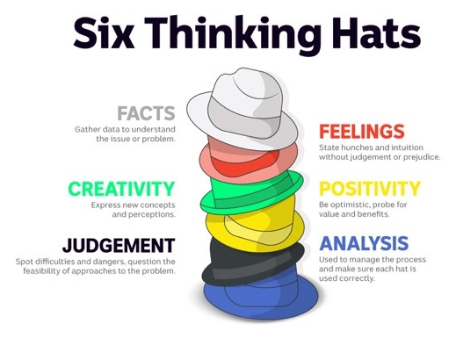
- What have you learnt from the story?
- Were there any positives from the story? If so, what were they?
- What are some of the negatives or challenges that you learnt from the story?
- Why is it important to find out more about the plastic waste problem?
- What questions were raised during this activity? Think of three questions you would like to ask about the story.
- What do you want to learn further about this topic?

Reflection
After this activity, ask students to reflect on what they have learnt and the questions they have about the plastic waste problem. Students can include details about how their thinking on this issue has changed.

Activity: Research project
Discuss the information raised in the BTN Plastic Waste Problem story. What questions were raised in the discussion and what are the gaps in students’ knowledge? The following KWLH organiser provides students with a framework to explore their knowledge on this topic.

What do I know? | What do I want to know? | What have I learnt? | How will I find out?

Students will develop their own question/s to research or choose one or more of the questions below.
- What are some examples of soft plastics and other plastics that you use daily? Conduct a plastic waste bin audit over one week either at home or school.
- What percentage of plastic gets recycled in Australia? Investigate the percentage of recycling for other materials (e.g., metal, glass, paper, electronics). Plot your findings on a graph.
- What are recycling companies turning plastic waste into?
- What is the history of plastic? Explore the history and development of plastic and plot your findings on a timeline.
- Who invented plastic? Create a biography.
- What happens to the soft plastic you throw away? Explore the journey of soft plastic from production, to landfill and its impact on the environment.
- Why can’t soft plastics be put in your home recycling bin?
- Should there be incentives for people who reduce, reuse, and recycle? What do you think the incentives should be?
- How do you think our plastic consumption affects the environment?

Activity: Take Action
Discuss with students what their school already does to reduce waste. For example, their school might have recycling programs, rubbish audits, or clean up days. Does your school have an Environmental Management Plan or team? In small groups, ask students to brainstorm how their school could improve what it already does to reduce waste.
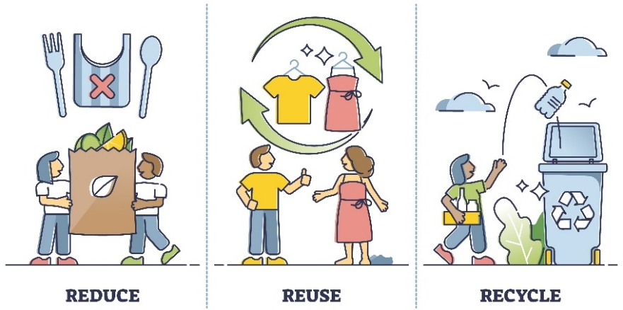
- Make a list of new ways that your school could reduce the amount of waste it creates and new ways that you can deal with the waste it creates.
- Share and compare your ideas with the class.
- Choose 1 of your ideas to present to your SRC or the school leadership team.

Here are some suggestions:
- Nude food days.
- Run a workshop to learn how to make reusable beeswax food wrappers.
- Audit rubbish created in one day. How much plastic waste is there?
- Contact your local council or other schools to find out what they are doing to reduce waste.
- Hold your own school’s clean-up day.
- Start a school compost or worm farm.
- Hold a zero-waste day.

Reflection
- What did you find interesting?
- What was challenging?
- What did you enjoy about this activity?
- What worked well and what would you do differently next time?

Activity: Visual literacy
In this activity students will analyse the image below which illustrates the soft plastics problem we are facing and the impact it has on our environment. Students will analyse the image and respond to the following:

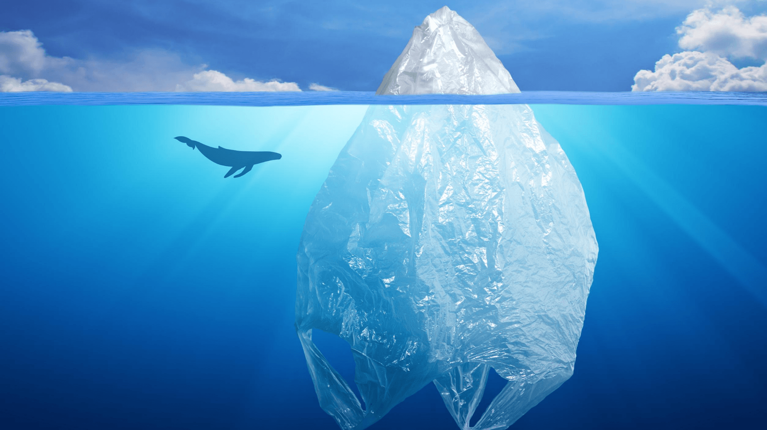
- What is happening in the image? Create a caption.
- What do you think the image is trying to tell us?
- What does the plastic bag represent?
- How does the image make you feel?
- What questions do you have about what you see in the image?
Clean Up Australia

Activity: Choose a project
Individually or in small groups, students will choose one of the following projects to work on and then present their findings to the class.

Persuasive writing
How can we convince people to reduce their plastic waste? Think of creative ways to raise awareness about the issues raised in the BTN story.
Plastic Waste Bin Audit
Do you know how much plastic you throw out each day? Think of all the times you used plastic in one day. How can you reduce your plastic waste?
Tips and tricks
How can we reduce our use of soft plastics? Write a list of tips and tricks to help people reduce their use of soft plastics. Think of a creative way to share your information.
Write a Letter
Write a letter to your local member of parliament, expressing your concerns about the plastic waste problem. What can local government do to help the problem?

Useful Websites
- Australia's plastic mismanagement to mount as researchers warn of ongoing pollution crisis – ABC News
- War on Waste – ABC iView
- Plastic Pact – BTN
- Soft Plastics Recycling – BTN

KEY LEARNING
Students will explore the issue of fashion waste and its impact on the environment.

CURRICULUM
Science – Year 5-6
Scientific knowledge is used to solve problems and inform personal and community decisions.

Science – Year 7
Solutions to contemporary issues that are found using science and technology, may impact on other areas of society and may involve ethical considerations.

Design and Technologies – Years 5 & 6
Select appropriate materials, components, tools, equipment and techniques and apply safe procedures to make designed solutions.

Examine how people in design and technologies occupations address competing considerations, including sustainability in the design of products, services, and environments for current and future use.

Design and Technologies – Years 7 & 8
Select and justify choices of materials, components, tools, equipment and techniques to effectively and safely make designed solutions.

Investigate the ways in which products, services and environments evolve locally, regionally and globally and how competing factors including social, ethical and sustainability considerations are prioritised in the development of technologies and designed solutions for preferred futures.

  - Teacher Resource

Fashion Waste Scheme

Activity: Class Discussion
Engage students in a class discussion to explore their prior knowledge about fashion waste. Introduce key concepts and explain the environmental impact of the fashion industry. Use the following questions to help guide discussions about the topic:
- Have you ever heard the term "fashion waste" before? If so, what do you understand it to mean?
- Can you give some examples of fashion waste in your own words?
- Do you have any personal experiences related to fashion waste?
- What do you think happens to clothes that are thrown away or no longer used?
- Can you think of any ways that fashion waste could be reduced or minimised?
- How do you think fashion waste impacts the environment?

Activity: Glossary
Students will brainstorm a list of key words that relate to the BTN Fashion Waste Scheme story. Below are some words to get students started.

FAST FASHION | SUSTAINABLE FASHION | UPCYCLING
RECYCLED | LANDFILL | ENVIRONMENTAL IMPACT

Ask students to write what they think is the meaning of each word (including unfamiliar words). They will swap definitions with a partner and ask them to add to or change the definition. Check these against the dictionary definition.
Further activities for students:
- Students will add to their glossary by downloading the transcript for the BTN Fashion Waste Scheme story and highlight all the words that relate to the topic.
- What other words relate to this issue? Students will choose additional keywords and concepts to add to their class glossary that are tricky. For example: mass production, trends, exploitation of underpaid workers, fashion footprint, greenwashing, and overconsumption.
- What is slow fashion? Find a definition and then explain in your own words.
- What is the difference between upcycling and recycling?
- How did this story make you feel? Make a list of words that describe how you felt after watching the BTN story.

Activity: Fashion Waste Research
After watching and discussing the BTN story, what questions do students have? The KWLH organiser provides students with a framework to explore their knowledge on the issue and consider what they would like to know and learn.

What do I know? | What do I want to know? | What have I learnt? | How will I find out?

Questions to research
Students will develop their own question/s to research about the issues raised in the BTN Fashion Waste Scheme story. Students will collect and record information from a wide variety of sources. Students may develop their own question for inquiry or select one of the questions below.

- What is fast fashion? Why is it a problem?
- What are the negative impacts of fast fashion? Investigate and explain the impact of fast fashion on people and the environment.
- What natural resources are used to make clothing?
- Create a timeline highlighting key events in the history of the garment industry. Include a title, date, and description for each event. Compare the methods used to make clothing before and after the Industrial Revolution.
- What is slow fashion? Investigate what the 5 R’s of fashion are and give a short description for each term.
- What is sustainable fashion? Find a sustainable fashion brand. Describe what they are doing to be innovative and sustainable.
- What is greenwashing? Find a real life example in the fashion industry to help explain the concept. Watch this BTN Greenwashing story to learn more.
- What are some ways to decrease the environmental impact of your fashion?

Activity: Visual Literacy
Below is a range of photos that relate to fast fashion and fashion waste. Encourage students to provide detailed and thoughtful responses based on their analysis of the photos. This exercise will help them deepen their understanding of fast fashion and think about the impact it has on the environment and people.

Students will analyse one or more of the images and then respond to the following questions:
- Describe what you see in the image. What objects or elements stand out to you the most?
- How does this photo represent the concept of fast fashion?
- How does this photo make you feel? Is it a positive or a negative feeling? Why?
- What question/s would you like to ask about the image?
- Create a caption for each image.
- Does this photo make you view the fashion industry or how you consume clothes differently? Why or why not?

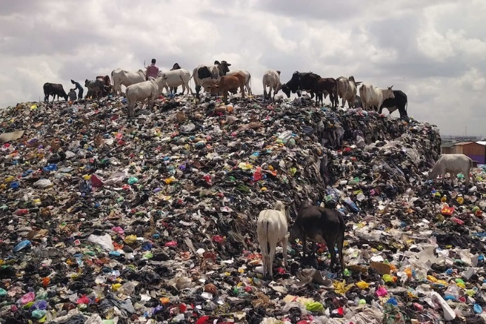  Link to image | 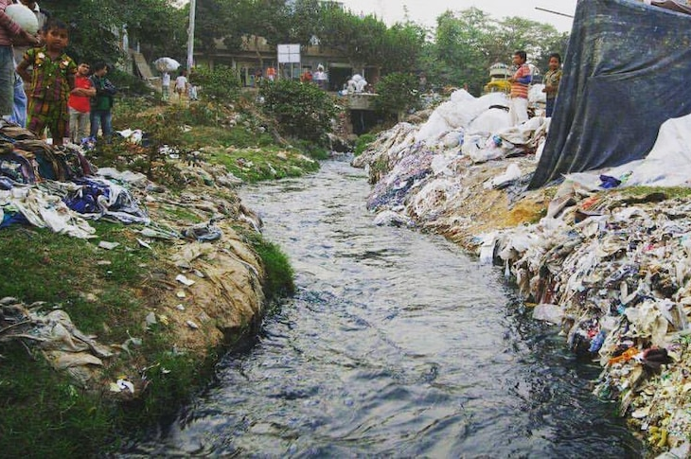  Link to image
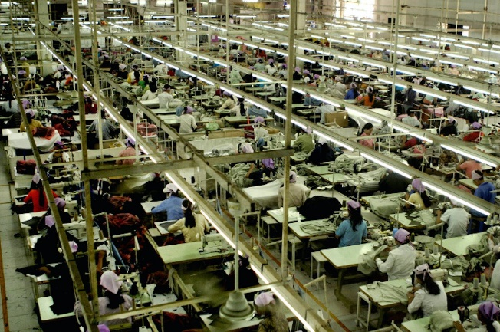  Link to image | 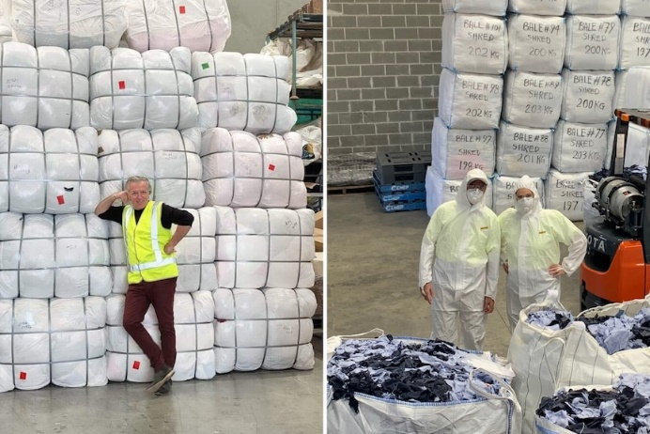  Link to image

Activity: TEDEd video
Consider the classic white t-shirt. Annually, we sell and buy 2 billion t-shirts globally, making it one of the most common garments in the world. But how and where is the average t-shirt made, and what’s its environmental impact?

As a class, watch this TEDEd video to learn more about the life cycle of a t-shirt. Students will then respond to one or more of the following questions.
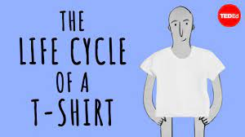
- How many t-shirts are made and sold each year globally?
- Where is cotton grown? Locate and highlight on a world map.
- How many litres of water is needed to produce enough cotton for one t-shirt?
- What negative impact does growing cotton have on the environment?
- How is organic cotton different to non-organic cotton?
TEDEd – The life cycle of a t-shirt

- List all the countries that may be involved in creating a t-shirt.

Activity: Where is my t-shirt made?
After watching the TedEd video students will choose one of their own t-shirts and investigate where it is made, what it is made from and who made it. Student will investigate where their clothes go when they throw them out and how they can reduce their impact on the environment.

Where is my t-shirt made? | Locate the ‘Made In’ label on one of your own t-shirts. Identify where your t-shirt is made. With your classmates locate and highlight each of the countries on a world map. What do you notice? Which countries are most popular for making your t-shirts?
What is my t-shirt made from? | Examine your t-shirt. Without looking at the labels what do you think it is made from? After you have made a prediction, examine the labels. Find out the following:  - What materials are used to make the t-shirt?  - Where do the materials come from?  - Where is the t-shirt made?  - Is the t-shirt and the materials used to make the t-shirt made in the same country?  - What else do you want to learn about your t-shirt? Investigate and record your findings.  Compare your findings with your classmates.
Who made my t-shirt? | Find out the brand of your t-shirt and conduct further investigation. Use the following to guide your investigation:  - What is the brand of your t-shirt? Does the company use sustainable materials? Explain.  - Who made your t-shirt? Find out more about the person who made your t-shirt. Consider contacting the brand to ask them who made your t-shirt.
How can I curb my t-shirt consumption? | Think of all the t-shirts you’ve owned in your life and then respond to the following questions:  - How many t-shirts do you own?  - What’s your favourite t-shirt?  - What do you do with t-shirts you no longer want? Find out what happens to your clothes when you throw them away.  - What can you do with your old t-shirt to avoid it going to landfill? Brainstorm ways you can upcycle your t-shirts. Use the internet to find out what other people are doing to upcycle their t-shirts.

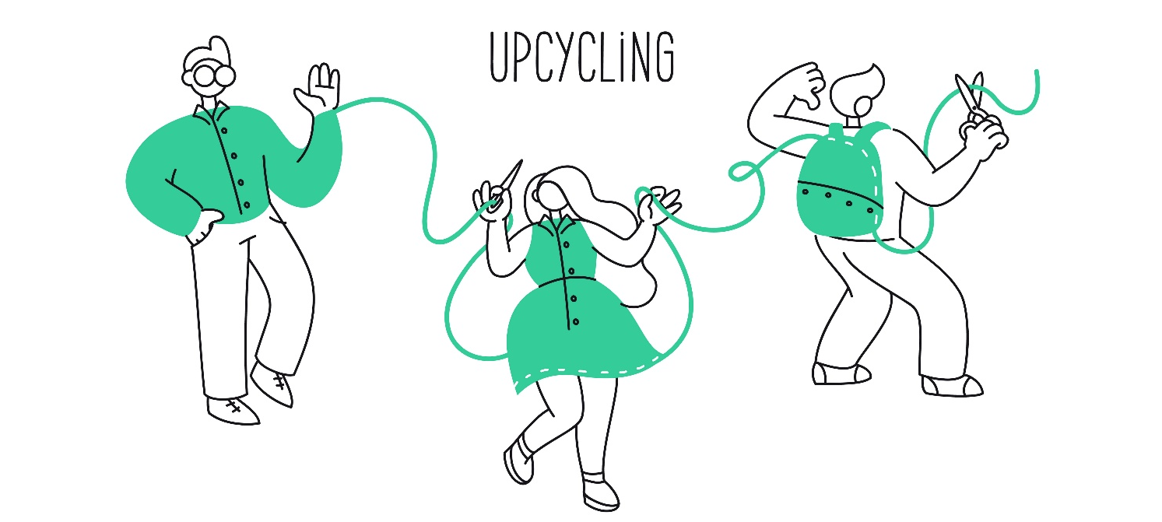

Useful Websites
- Big W and David Jones pledge cash to tackle waste, as rest of fashion industry told to follow – ABC News
- Seamless Scheme – Australian Fashion Council
- Fashion Waste – Newsbreak
- Fast Fashion – BTN
- Fashion Waste – BTN
- Why is fashion a BIG problem for the environment? – Newsround
- Sustainable fashion: How to be fashionable without harming the planet – Newsround

