

First Fleet
- When is Australia Day?
- Complete the following sentence: The day marks the anniversary of...
- Describe life in Britain in the 1700s.
- Why were prisoners transported to the colonies?
- What sorts of crimes were committed by people who were transported?
- How many ships transported convicts in the First Fleet?
- What do you think life would have been like on board the ships in the First Fleet?
- New _______________ was the name given to mainland Australia.
- Who was the commander chosen to lead the colony?
- Name three facts you learnt watching the BTN First Fleet story.

Federation
- Discuss the BTN Federation story with another student and record the main points of your discussion.
- Before Federation, Australia was divided into six separate ______________.
- Which other country might have been part of Australia?
- Who was Henry Parkes?
- What was his famous speech about?
- Why were initial attempts to become a Federation rejected?
- What role did Alfred Deakin play in Australia becoming a Federation?
- In what year did Australia become a nation?
- Who was Australia’s first Prime Minister?
- How did Federation impact on Indigenous people and Chinese migrants?

Constitution
- What is a constitution?
- What sorts of things are set out in Australia’s constitution?
- No other law can overrule the constitution. True or false?
- When was Australia’s constitution drawn up?
- Which group of people were discriminated against in the original constitution?
- What is a referendum?
- What two changes to the constitution that happened as a result of the referendum in 1967?
- Why do you think the constitution is described as the country’s birth certificate?
- Finish the following sentence: Australia’s constitution still doesn’t recognise Aboriginal and Torres Strait Islander people as...
- Should Australia’s constitution be changed? Give reasons for your answer.

Eureka Stockade
- When is the anniversary for the Eureka Stockade?
- Where was the Eureka Stockade? Locate using Google Maps.
- What is the Eureka Stockade? Explain what happened.
- What happens at Sovereign Hill?
- What was mined in Ballarat Victoria in the 1850s?
  - Copper
  - Diamonds
  - Gold
- Describe what life was like for the miners.
- What did the miners call themselves?
- What happened to the miners if they didn’t hold a license?
- How has the Eureka Stockade contributed to democracy in Australia?
- What does the Eureka flag look like and what does it symbolise?

Teacher Resource
First Fleet

Students will investigate what life was like in 18th century Britain, stories from the First Fleet and first contact with Aboriginal people.


HASS – Year 4
Stories of the First Fleet, including reasons for the journey, who travelled to Australia, and their experiences following arrival.

Pose questions to investigate people, events, places and issues.

Locate and collect information and data from different sources, including observations.

Present ideas, findings and conclusions in texts and modes that incorporate digital and non-digital representations and discipline-specific terms.

- When is Australia Day?
- Complete the following sentence: The day marks the anniversary of...
- Describe life in Britain in the 1700s.
- Why were prisoners transported to the colonies?
- What sorts of crimes were committed by people who were transported?
- How many ships transported convicts in the First Fleet?
- What do you think life would have been like on board the ships in the First Fleet?
- Complete the following sentence. New _______________ was the name given to mainland Australia.
- Who was the commander chosen to lead the colony?
- Name three facts you learnt watching the BTN First Fleet story.


Engage
After watching the BTN story hold a class discussion to find out what students know about the First Fleet. The following questions can help guide discussion:
- When did the First Fleet leave England?
- When did they arrive in Botany Bay?
- Why did the First Fleet travel to Australia?
- Who was transported?
- What were the conditions like on the ships?

Working in pairs, students create a glossary of historical terms related to the First Fleet. Follow up this activity with a class discussion to ensure students understand the terms.
Penal | Transportation | Navigation
Colony | Colonisation | Fleet
Convict | Free Settler | Prison hulk
Larceny | Settlement | Rations

Ask students to present the glossary in an interesting way, for example:
- Wordle word cloud http://www.wordle.net/
- A poster
- Use the words to form your own sentences.
- Illustrate the terms in an interesting way.

Explore – England in the 1700s
Students will explore what life was like in England in the 1700s and research the events that led to the transportation of convicts to Australia. Things to consider include:

- Changes to farming practices in England
- America becoming independent from Britain
- English cities becoming overcrowded
- Rates of petty crime
- Overcrowding in prisons

Brainstorm a list of words that describe what life was like at this time. Students create an artwork that depicts life in England in the 1700s.

Explore – Stories from the First Fleet
Students will research a prisoner on the First Fleet and tell their story. The following website will provide a starting point for their research http://www.convictrecords.com.au/timeline/1787

Students will write a journal entry in the first person using present tense. Students can then present their journal entry as a podcast or an oral presentation.

Refer to the NSW State Library website for Journals from the First Fleet. The State Library holds the world's largest collection of original First Fleet journals and correspondence. https://www.sl.nsw.gov.au/journals-first-fleet

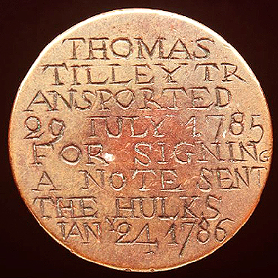
Explore – Convict love tokens
Love tokens were made by convicts while they were waiting to be transported. They were made of copper coins and given to people they were leaving behind.

Students will visit the National Museum Australia website to find out more about these tokens http://www.nma.gov.au/collections/highlights/convict-tokens
Hold a class discussion.
- What was the purpose of the love tokens?
A convict love token that belonged to Thomas Tilley, a convict on the First Fleet.
Source: Powerhouse Museum
- What sort of information was included on the love tokens?
- How were they made?

Students design their own convict love token that has a message to a
loved one. They could base their design on an original convict love token.

Explain – Life on board the ships
What was life on board the ships like? Students will research what daily life was like for the convicts on board the First Fleet. Students will create an artwork or write a letter to their family home in England describing the conditions and how they’re feeling.
http://www.portcities.org.uk/london/server/show/ConNarrative.56/chapterId/429/Prison-hulks-on-the-River-Thames.html

Research questions
- What was a typical day on board the ships?
http://members.iinet.net.au/~perthdps/convicts/ships.html
- What were the daily routines on board convict ships?
- What do the routines tell us about conditions on board the ships?
- What was the source of the information? Whose point of view is being given?

Students will reconstruct the voyage of the First Fleet using the information in the BTN story and the following website http://firstfleet.uow.edu.au/s_chrono.html

Students will show the journey including places and dates by either hand drawing or using an online mapping tool like Google maps http://maps.google.com or Scribble maps http://scribblemaps.com/

First Contact
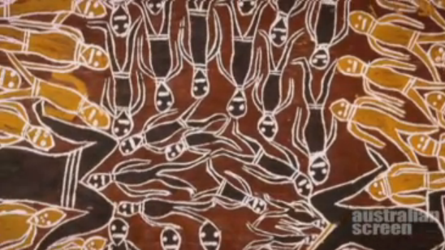
Students will explore the nature of the contact between First Fleet settlers and Aboriginal people in the early days of colonisation.

Ask students to watch the following videos. The first clip explains Indigenous life before contact .http://aso.gov.au/titles/documentaries/first-australians-episode-1/clip1/

- What did the video tell you about Indigenous life before European settlement?

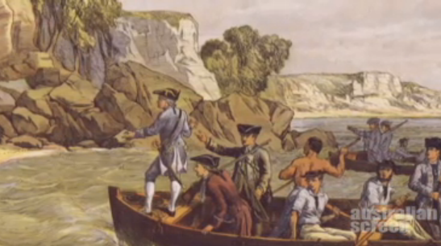
The second clip gives an Indigenous perspective of the First Fleet arriving http://aso.gov.au/titles/documentaries/first-australians-episode-1/clip2/

- How is the landing of the First Fleet described in the video?
- What do the videos tell you about contact between the First Fleet settlers and Aboriginal people?

Evaluate
Ask students to reflect on their learning
- I learned that...
- I enjoyed/did not enjoy...
- I want to know more about...
- I was surprised to discover that...

ABC My Place – First Fleet
http://www.myplace.edu.au/decades_timeline/1780/decade_landing_22.html?tabRank=2
A Convict Story – Interactive
https://fuse.education.vic.gov.au/Resource/LandingPage?ObjectId=0c1152ff-209e-47fb-9462-63b1ebb59898&SearchScope=Teacher
Sydney Living Museums – Why were convicts transported to Australia?
https://sydneylivingmuseums.com.au/stories/why-were-convicts-transported-australia

Teacher Resource
Federation
Students will examine key dates and people that led to Australia’s Federation. They will also investigate reasons for and against Federation and the choice of Canberra as the nation’s capital.

HASS – Year 6
Key figures, events and ideas that led to Australia’s Federation and Constitution.

The contribution of individuals and groups to the development of Australian society since Federation.

Develop appropriate questions to guide an inquiry about people, events, developments, places, systems and challenges.

Locate and collect relevant information and data from primary sources and secondary sources.

Examine different viewpoints on actions, events, issues and phenomena in the past and present.
- Discuss the BTN Federation story with another student and record the main points of your discussion.
- Before Federation, Australia was divided into six separate ______________.
- Which other country might have been part of Australia?
- Who was Henry Parkes?
- What was his famous speech about?
- Why were initial attempts to become a Federation rejected?
- What role did Alfred Deakin play in Australia becoming a Federation?
- In what year did Australia become a nation?
- Who was Australia’s first Prime Minister?
- How did Federation impact on Indigenous people and Chinese migrants?

Discussion
Discuss the BTN Federation story with students and clarify any questions they have. Students can choose one or more of the following activities.

Use key Federation words to create a game of bingo using Bingo Baker https://bingobaker.com/

Words to include:
Federation | Colony | Henry Parkes
Alfred Deakin | Federate | Immigration
Convention | Tariffs | Referendum
Representative | Constitution | Secret Ballot
Commonwealth | Free trade | White Australia
Students can then research what each word means in the context of Federation.

Key dates in Federation
Students make a timeline of key events leading to Australia’s Federation. They need to include the date, event, a brief description of what happened and an image (if available). Students can create their timeline in any way they choose. An interactive timeline creator is available at the Read Write Think website http://www.readwritethink.org/classroom-resources/student-interactives/timeline-30007.html

Federation Timeline
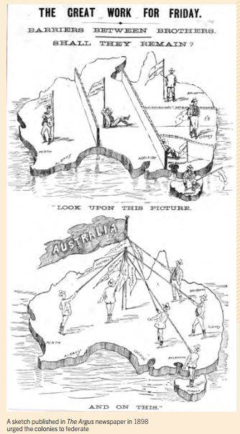
What is the message in this image?

Reasons for and against Federation
Students will investigate the reasons for and against Federation using
a T-chart.

Reasons for Federation | Reasons against Federation
- Better transport between the colonies | - New South Wales and Victoria were more powerful than the other colonies
To investigate the topic further, students consider the following question:
What would Australia be like if Federation had never happened?

Significant people in Federation
Students choose a key person in Federation history and research the answers to the questions.
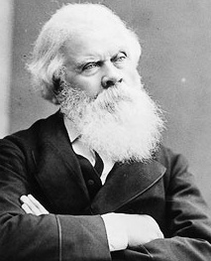
Henry Parkes (1815 – 1895)
- Why was Henry Parks known as the `Father of Federation’?
- What was his famous speech `The Tenterfield Address’ about?
- What is significant about the date of Parkes’ death?
- Why do you think Parkes is referred to as one of the most significant politicians in Australian history?

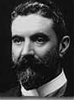
Alfred Deakin (1856-1919)
- Who was Alfred Deakin? Give a brief summary.
- Where was he born?
- What were Alfred Deakin’s views about Federation?
- What significant things happened when Deakin was Prime Minister?

Edmund Barton (1849-1920)
- Edmund Barton was Australia’s first...
- What contribution did Barton make to Federation?
- What is an interesting fact about Edmund Barton?

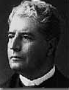
The Nation’s Capital
A point that couldn’t be agreed on by the six colonies was the location of the nation’s capital. Both Melbourne and Sydney claimed the right to be the capital. A compromise was reached where a separate capital city would be created.

Research Questions
- Which city was the temporary capital until a new city was established?
- What historical events led to the decision to create a new city as a capital?
- How was the location selected?
- What other locations were considered?
- What are the advantages and disadvantages of Canberra being chosen as the nation’s capital?

Further Investigation

The Commonwealth of Australia was declared on 1 January 1901. A week of celebrations took place around the nation. Create a collage of images that show Federation celebrations.

Investigate what life was like around the time of Federation for Indigenous people and Chinese migrants. How did the key people involved in Federation view immigration?

Behind the News – Constitution
http://www.abc.net.au/BTN/story/s3939299.htm
Australia.gov – Australia’s Federation
https://www.australia.gov.au/about-government/how-government-works/federation
Parliamentary Education Office - Federation
http://www.peo.gov.au/learning/fact-sheets/federation.html
ABC Education – Federation of Australia
https://education.abc.net.au/home#!/media/1957410/federation-of-australia
Australian Dictionary of Biography – Henry Parkes
http://adb.anu.edu.au/biography/parkes-sir-henry-4366
Civics and Citizenship Education – Alfred Deakin
http://www.civicsandcitizenship.edu.au/cce/deakin,9127.html
Civics and Citizenship Education – Henry Parkes
http://www.civicsandcitizenship.edu.au/cce/parkes,9158.html
Civics and Citizenship Education – Edmund Barton
http://www.civicsandcitizenship.edu.au/cce/barton,9076.html

Teacher Resource
Constitution
Students will develop a deeper understanding of the events that led to Federation what a referendum is.

HASS – Year 5
Examine different viewpoints on actions, events, issues and phenomena in the past and present.

HASS – Year 6
Key figures, events and ideas that led to Australia’s Federation and Constitution.

The contribution of individuals and groups to the development of Australian society since Federation.

Develop appropriate questions to guide an inquiry about people, events, developments, places, systems and challenges.

Locate and collect relevant information and data from primary sources and secondary sources.

Examine different viewpoints on actions, events, issues and phenomena in the past and present.

- What is a constitution?
- What sorts of things are set out in Australia’s constitution?
- No other law can overrule the constitution. True or false?
- When was Australia’s constitution drawn up?
- Which group of people were discriminated against in the original constitution?
- What is a referendum?
- What two changes to the constitution happened as a result of the referendum in 1967?
- Why do you think the constitution is described as the country’s birth certificate?
- Finish the following sentence: Australia’s constitution still doesn’t recognise Aboriginal and Torres Strait Islander people as...
- Should Australia’s constitution be changed? Give reasons for your answer.

Discussion
Clarify students’ understanding of the information in the BTN Constitution story. In pairs, students discuss the meaning of the following words:
- Constitution
- Referendum
- Colonies
- Federation

Students then report back to the class to share their understandings.

Research
Students will research why and how Australia became a nation. The following questions will help guide students’ research.
- What is Federation?
- When did it happen?
- What significant events led to Federation?
- What are some reasons for and against Federation?
- What would Australia be like if Federation didn’t occur?

Presenting your learning
- Create a timeline that shows significant events that led to Federation.
- On a map, show Australia before and after Federation
- Use Prezi to share your research http://prezi.com/

What is a referendum?
A referendum is a vote by the people. Every citizen who is eligible to vote has the right to vote on a given issue. Voters can accept or reject a government proposal put directly to them. Students will find out more about what a referendum is.

Research questions
- What is another word for referendum?
- How does a referendum work?
- When was the last referendum held?
- Are referendums important? Why or why not?
- Is it compulsory to vote in a referendum? Explain why?

The BTN story focussed on whether the constitution should be changed to recognise Aboriginal and Torres Strait Islander people. Develop an argument for or against holding a referendum.
Further investigation: Conduct research into the history of referendums that have been held in Australia and then create a timeline of successful and unsuccessful referendums.

Behind the News – Republic
http://www.abc.net.au/BTN/story/s3775972.htm
Recognise
http://www.recognise.org.au/
Parliamentary Education Office - The Australian Constitution
http://www.peo.gov.au/learning/closer-look/the-australian-constitution.html
Parliament of Australia – The Australian Constitution
http://www.aph.gov.au/About_Parliament/Senate/Powers_practice_n_procedures/Constitution
Australian Electoral Commission – Referendums
http://www.aec.gov.au/Elections/referendums/
Creative Spirits – 1967 Referendum
http://www.creativespirits.info/aboriginalculture/history/australian-1967-referendum
Australian Human Rights Commission - Constitutional Reform Fact Sheet
https://www.humanrights.gov.au/publications/constitutional-reform-fact-sheet-recognising-aboriginal-torres-strait-islander-people
National Archives of Australia – 1967 Referendum
https://www.naa.gov.au/explore-collection/first-australians/other-resources-about-first-australians/1967-referendum

Teacher Resource
Eureka Stockade
Students will learn about the impact of the Eureka Stockade on Australian democracy.

HASS – Year 5
Examine different viewpoints on actions, events, issues and phenomena in the past and present.

The impact of a significant development or event on an Australian colony.

Reasons (economic, political and social) for the establishment of British colonies in Australia after 1800.

HASS – Year 6
Develop appropriate questions to guide an inquiry about people, events, developments, places, systems and challenges.

Locate and collect relevant information and data from primary sources and secondary sources.

Examine different viewpoints on actions, events, issues and phenomena in the past and present.

- When is the anniversary for the Eureka Stockade?
- Where was the Eureka Stockade? Locate using Google Maps.
- What is the Eureka Stockade? Explain what happened.
- What happens at Sovereign Hill?
- What was mined in Ballarat Victoria in the 1850s?
  - Copper
  - Diamonds
  - Gold
- Describe what life was like for the miners.
- What did the miners call themselves?
- What happened to the miners if they didn’t hold a license?
- How has the Eureka Stockade contributed to democracy in Australia?
- What does the Eureka flag look like and what does it symbolise?

Remember and understand
After watching the BTN Eureka Stockade story encourage students to participate in and contribute to a class discussion about the Eureka Stockade. Find out what your students know about the event, what they learnt from the story and what questions they have about Eureka Stockade.

Discussion questions
- When did the Eureka Stockade occur?
- Where was it located?
- Who was involved?
- What made the miners feel that they were being treated unfairly?
- How were they treated by the police?
- What were the conditions of the mining license?
- Why were the Victorian police so disliked?

Working individually or in pairs students can investigate their own questions or some of the following. Encourage students to share their research with the class in an interesting way.

Inquiry questions
- What do we know about the lives of people in Australia’s colonial past and how do we know?
- How did an Australian colony develop over time and why?
- How did colonial settlement change the environment?
- What were the significant events and who were the significant people that shaped Australian colonies?

Primary and secondary sources
Students will identify the origin and purpose of primary and secondary sources and share their findings with the class. As a class brainstorm examples of primary and secondary sources.

Primary Source
- Definition – Primary sources are from the time the people lived and are made by the people involved. Primary sources are facts from someone that was present at the time it happened.
- Examples – diaries, letters, paintings, maps, drawings.

Secondary Source
- Definition – Secondary sources are records that were made by others, like a person talking about something they didn’t see themselves and textbooks.
- Examples – newspaper articles, accounts from the internet.

Activity – are these primary or secondary sources?
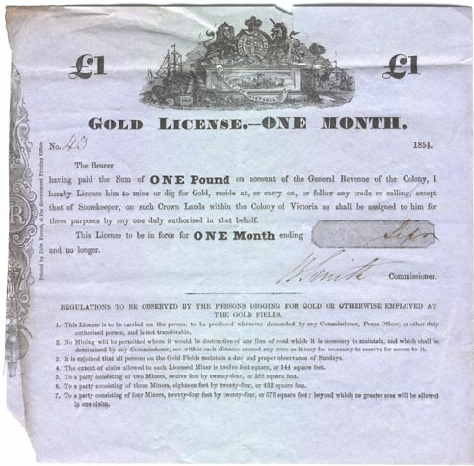
Public Record Office Victoria – Eureka Stockade: Gold License No. 43
http://wiki.prov.vic.gov.au/index.php/Eureka_Stockade:Gold_License_No.43

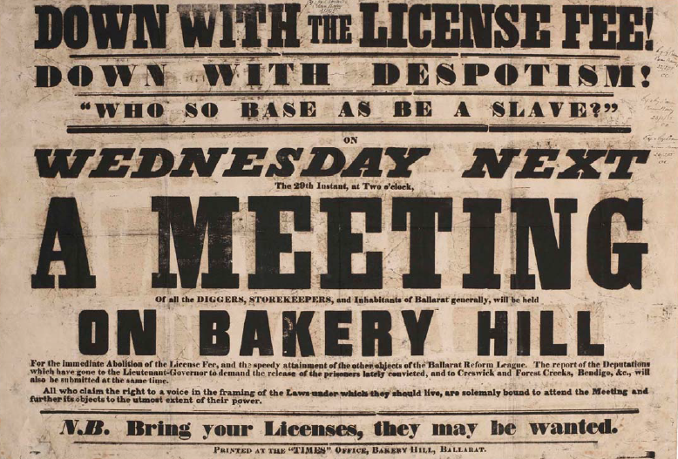
Public Record Office Victoria – Eureka Stockade: Bakery Hill Meeting Poster
http://wiki.prov.vic.gov.au/index.php/Eureka_Stockade:Bakery_Hill_Meeting_Poster

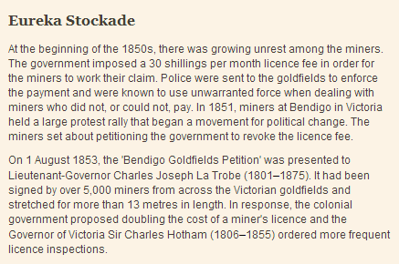
My Place – Australia in the 1850s: Eureka Stockade
http://www.myplace.edu.au/decades_timeline/1850/decade_landing_15_1.html?tabRank=2&subTabRank=2

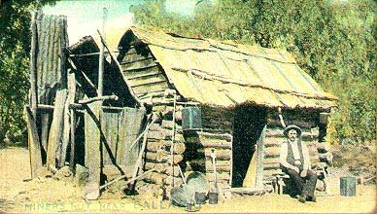
Sovereign Hill Education – Historic photo gallery: A miner’s hut near Ballarat
http://education.sovereignhill.com.au/index878a.html?id=historicphotogallery

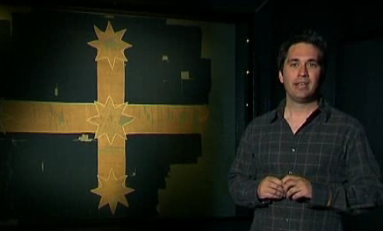
National Treasures – Eureka Flag (video)
http://www.nfsa.gov.au/digitallearning/heritage/eureka.html

Further research
Students will use their research on primary and secondary resources to tell the story of the Eureka Stockade.

- Learn more about digital storytelling
Digital storytelling is a great way to research historical events and to tell a story using images. A digital story is made up of images and narratives synchronized to convey thoughts, information and perspectives on a moment in time.

- Visit Sovereign Hill’s historic photo gallery
The photographs are presented by courtesy of the Ballarat Historical Society Inc. Collection jointly housed by the Gold Museum, Ballarat and the Ballarat Library. They are early photographs depicting aspects of the Victorian gold rushes.

After analysing the photographs answer the following questions. http://education.sovereignhill.com.au/index878a.html?id=historicphotogallery
  - What is going on here?
  - How do we know?
  - What else is going on?

- Eureka on Trial
The Eureka Stockade was an eruption of suppressed anger on the Ballarat goldfields in 1854 and remains an ongoing symbol of popular protest.

Take a look at one of the nine focus areas to explore the Eureka story further. Public Record Office Victoria – http://prov.vic.gov.au/whats-on/exhibitions/eureka-on-trial

Biography
Students will develop a biography on Peter Lalor or another significant individual that has helped shaped Australia’s history in the 1850s. What sort of information is included in a biography? What does a biography tell us about a person?

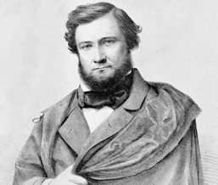
Research questions
- Who is Peter Lalor?
- Where is he from? Find it on a map.
- What did he achieve?
- What were his challenges?
- Did he help of hinder the miners in their endeavour to find gold?
- How was he responsible for the Eureka Stockade?
- Create a ‘what if’ scenario by constructing different outcomes for a key event, for example ‘What if Peter Lalor had encouraged gold miners to pay rather than resist licence fees?’

The following plan provides a guide for students when writing a biography.
- Research
- Set a direction for your biography
- Create a plan
- Start writing
- Edit

Encourage students to present their research using maps, timelines, drawings and photographs in an interesting way, for example using:
- Prezi http://prezi.com
- Glogster http://www.glogster.com/
- Bio Cube Creator http://www.readwritethink.org/files/resources/interactives/cube_creator/

Remind students that they will need to cite all references in a bibliography at the end of their biography.

English
Choose one or more of the following English activities to explore with your class.

- Write a letter to the editor of a newspaper in which you express your thoughts and feelings about the diggers’ plight and the way in which the authorities handled the situation.

- Describe what you think this poem by Timothy Hayes would have meant to the diggers:
‘On to the field, our doom is sealed
To conquer or be slaves:
The sun shall see our country free
Or set upon our graves.’

- Divide the class into half, one half diggers, and the other half Gold Commissioners or authorities. Organise for students to argue the case for and against the licence hunts.

Visit the Public Record Office Victoria classroom ideas for more education activities for students in
years 5-8. http://prov.vic.gov.au/education/eureka-stockade/classroom-ideas

- Imagine you are the editor of the Ballarat Times. Create the front page of your newspaper for the 4th of December 1854. What would it say?

Timeline
An historical snapshot of Australia in the 1850s
December 1854
Battle takes place at Ballarat between miners and government troops at the Eureka Stockade. South Head
1851-1852
Migrants from Europe, the USA and Asia flooded the goldfields in Australia.

January 1858
A telephone line opened between Sydney GPO and South Head

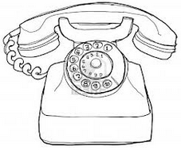
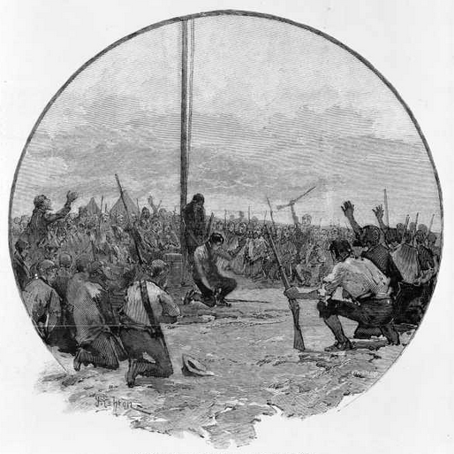
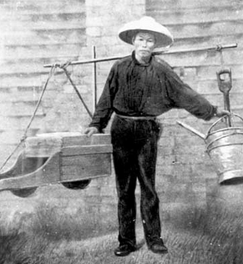

Provide students with the opportunity to create a timeline of significant Australian historical events that occurred during the 1850s including the events that led to the Eureka Stockade battle in 1854. Consider adding photos and video. Refer to the My Place website for more information. http://bit.ly/18AlnvV

Democracy
Students will choose one of the following inquiry questions to investigate and report back to the class.

- What is democracy?
- Some historians say that democracy was ‘born’ at Eureka. What does this mean?
- Do you think the battle at Eureka was influenced by the miners’ desire for democracy?
- Did the struggle at Eureka contribute to the establishment of democracy in Australia?
- What does the Eureka flag symbolise? Illustrate.

Visit the Museum of Australian Democracy at Eureka (M.A.D.E) to learn more about the impact that the Eureka Stockade had on Australian democracy.
http://www.made.org/

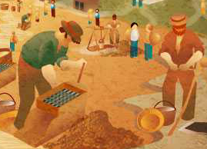
Further Investigation
Gold Rush – Flash Interactive! Does the sight of gold make your palms itchy? Give them a scratch by mining for gold in the Ballarat goldfields of 1865. For 8-12-year old’s. http://www.nma.gov.au/education-kids/classroom_learning/multimedia/interactives/gold-rush

Australian Government – Eureka Stockade
https://www.nma.gov.au/defining-moments/resources/eureka-stockade

Sovereign Hill – Education
https://sovereignhill.com.au/education-programs

Museum of Australian Democracy Eureka – Home
http://www.made.org/

State Library of Victoria – Eureka Stockade
http://ergo.slv.vic.gov.au/explore-history/golden-victoria/impact-society/eureka-stockade

Department of the Environment – National Heritage Places: Eureka Stockade Gardens
http://www.environment.gov.au/heritage/places/national/eureka-stockade/

Museum of Australian Democracy Eureka – Eureka Flag
http://www.made.org/Explore/EurekaFlag.aspx

Australian Screen – Riot or Revolution?
http://aso.gov.au/titles/documentaries/riot-or-revolution/clip3/

My Place – Australia in the 1850s: Eureka Stockade
http://www.myplace.edu.au/decades_timeline/1850/decade_landing_15_1.html?tabRank=2&subTabRank=2

