
EPISODE 14
26 May 2026

KEY LEARNING
Students will learn about key events in Australia’s reconciliation history and explore the Reconciliation Week theme.

CURRICULUM
HASS – Year 3
Significant events, symbols and emblems that are important to Australia’s identity and diversity, and how they are celebrated, commemorated or recognised in Australia, including Australia Day, Anzac Day, NAIDOC Week, National Sorry Day, Easter, Christmas, and other religious and cultural festivals.

HASS – Year 4
The diversity of First Nations Australians, their social organisation and their continuous connection to Country/Place.

HASS – Year 5 and 6
Develop appropriate questions to guide an inquiry about people, events, developments, places, systems and challenges.

HASS – Year 6
Changes in Australia's political system and to Australian citizenship after Federation and throughout the 20th century that impacted First Nations Australians, migrants, women and children.

This document contains the names and images of Aboriginal and Torres Strait Islander people now deceased. It also contains links to sites that may use images of Aboriginal and Torres Strait Islander people now deceased.

  - Teacher Resource

Reconciliation Week

Focus Questions
Discuss the BTN stories as a class and record the main points of the discussion. Students will then respond to the following:

Reconciliation Week
- In your own words, explain what reconciliation is.
- Reconciliation Week is held between two important anniversaries. What are they?
- What does the theme for Reconciliation Week, All In, mean to you?
- What is another important milestone for reconciliation in Australia?
- How does your school celebrate Reconciliation Week or support reconciliation?

Reconciliation Action Plan Kids
- Briefly summarise the BTN Reconciliation Action Plan Kids story.
- What does RAP stand for?
- What are the students doing to work towards reconciliation?
- How do the students use the bush tucker garden?
- What did you learn watching the BTN story?

Activity: Class Discussion
After watching the BTN Reconciliation Week story, students will respond to the following questions:
- What is reconciliation?
- Why is reconciliation important in Australia?
- What values are important to reconciliation?
- Why do we have special days or weeks like Reconciliation Week, Sorry Day, Mabo Day and NAIDOC Week?
- How does your class and/or school support reconciliation?

Activity: Reconciliation Week Theme
Reconciliation Australia’s theme for 2026 is All in for Reconciliation, which calls for all Australians to commit wholeheartedly to reconciliation every single day.

National Reconciliation Week (NRW) is a time for all Australians to learn about our shared histories, cultures, and achievements, and to explore how each of us can contribute to achieving reconciliation in Australia.

Class Discussion
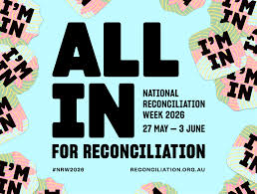
Discuss the theme as a class, using the following questions to get the discussion started:
- What does the theme ‘All In’ mean to you?
- Why do you think reconciliation involves everyone not just Aboriginal and Torres Strait Islander peoples?
- What actions does your school take to help support reconciliation? (For example, Acknowledgement of Country, celebrate Reconciliation Week with school activities).

Practical Action
Design a practical action that shows what being “ALL IN” could look like at your school. For example:
- Create an Indigenous garden space that includes edible bush tucker plants. Use these native ingredients in school cooking classes.
- Write an Acknowledgement of Country to give at your school assembly. Consider including a section about your own sense of belonging and connection to Australia. Include a positive message about community, respect or inclusion.
- Design signage around your school that uses local Indigenous language words.
- Create a display of books in your library written by First Nations authors. Include books that talk about reconciliation.
- Fly or display two flags representing the Aboriginal peoples and Torres Strait Islander peoples. Talk with the local Aboriginal and Torres Strait Islander community about how the flags should be flown or displayed at your school.

School Plan
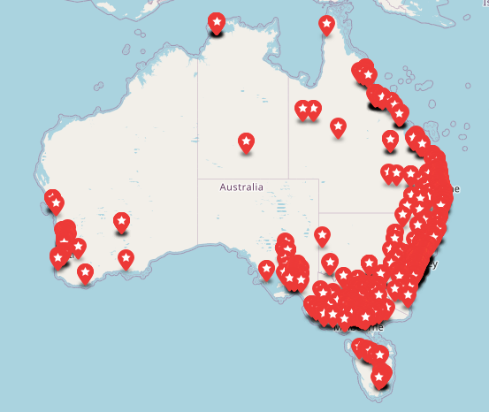
A Reconciliation Action Plan (RAP) gives your school a framework to contribute to the reconciliation movement.

Who has a Reconciliation Action Plan (RAP)? Use the RAP map to search for schools with a published RAP.

Explore a range of RAP actions which are important for strengthening relationships, respect and opportunities in the classroom, around the school, and with the community.
Reconciliation Australia: What is a RAP?

Activity: Key moments in reconciliation
In this activity students will analyse images which show key moments in Australia’s history where Indigenous and non-Indigenous people have come together for reconciliation. Students will choose one or more of the images below and respond to the following:
- What is happening in the image?
- How does the image make you feel?
- What does the image tell you about reconciliation?
- Why is it a key moment in reconciliation in Australia?

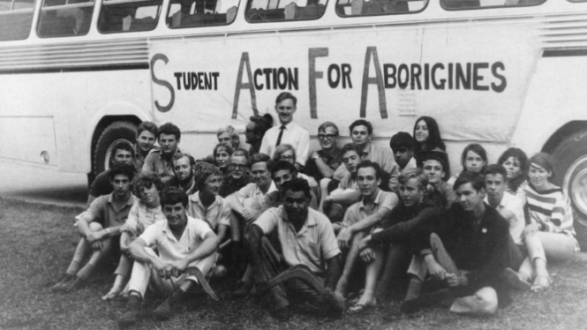  Freedom Ride | 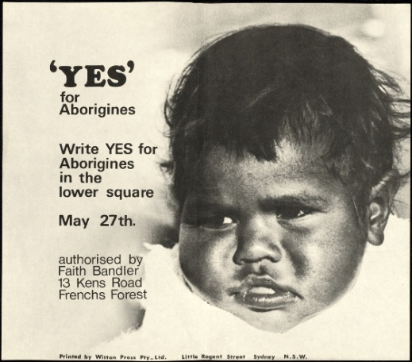  1967 Referendum
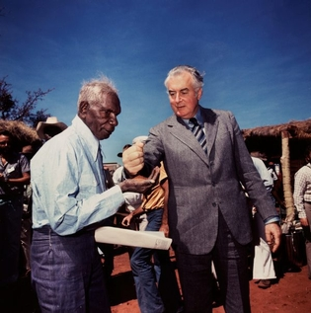  Wave Hill | 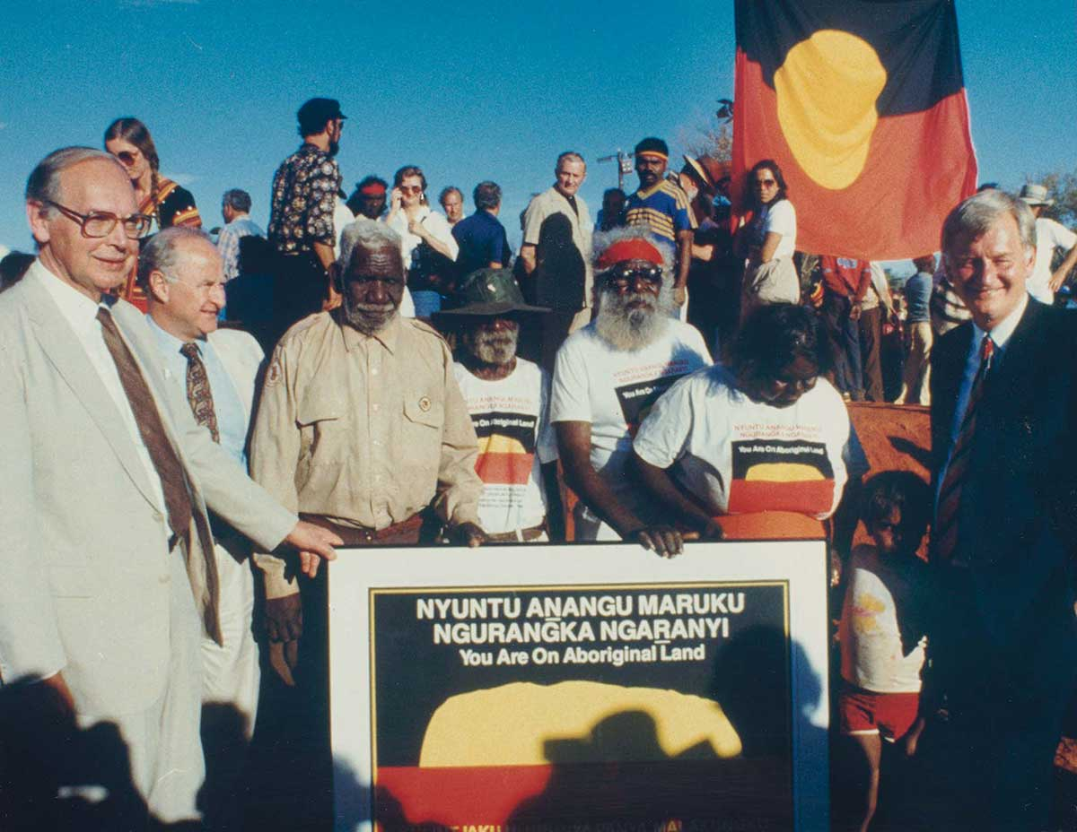Uluru Handback
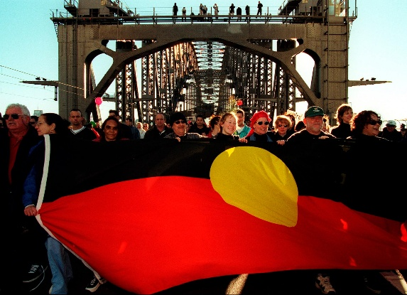  Walk for Reconciliation |   National Apology to the Stolen Generations

Further Investigation
Students choose one key event to explore in more detail and write a summary, which answers the 5 W’s – Who, What, Where, When and Why?
- What is the event? Describe.
- When did the event occur?
- Where did it happen?
- Who was involved in the event?
- Why is it significant?
- How does it recognise Aboriginal and Torres Strait Islander peoples?
- Is there a special day to commemorate or celebrate the event? What happens on this day.
- Include 2-3 images which are related to the event. Include captions.

To help with their research, students can explore the following BTN stories which look at significant events that have helped move Australia towards reconciliation. Students will then present their findings to the class.

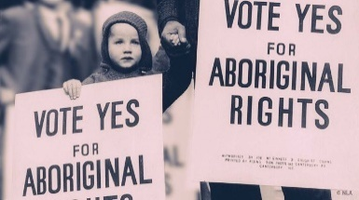  1967 Referendum | 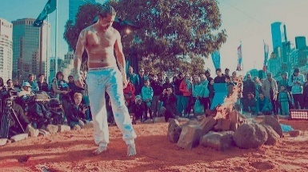  What is a treaty? |   Mabo Legacy
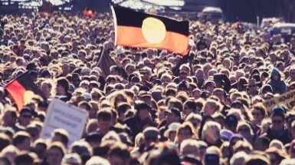  Bridge Walk Anniversary | 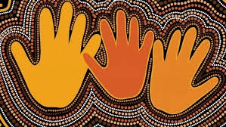  Apology Anniversary | 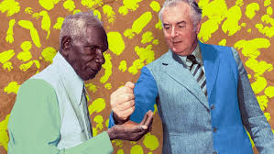  Vincent Lingiari

Activity: Bush Tucker Garden
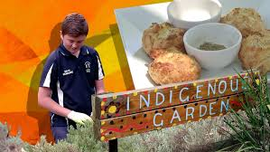
Create your own bush tucker garden Students create their own garden at school or home. Watch the BTN Bush Tucker Garden story for inspiration. Brainstorm possible garden designs and locations. Things to consider when designing a garden include position, type of soil and how much water the plants will need, then find edible plants that are native to the area. Students will need to consider how easy the plants are to obtain and the size of the plants – how large will they grow (how much space is available for the garden). Think about signage for the garden or an information brochure.

Explore cooking with native ingredients! The students in the BTN story made lemon myrtle biscuits. Students can have a go at making their own biscuits following this recipe.

Activity: First Nations Perspectives
Visit your school or community library to find a book written by a First Nations author. Find a book (fiction or non-fiction) that is age-appropriate that your students will connect with and you can read aloud as a class. It is a great way to share First Nations perspectives with your class and develop understanding of Aboriginal and Torres Strait Islander people, cultures and histories. Students will reflect on the story and respond to one or more of the following questions.
- Who is the author and/or illustrator of the book?
- What traditional lands are they from?
- What parts of the story could you relate to personally?
- What First Nations voices are heard in the story?
- What did you learn about First Nations experiences or culture?
- Are there Indigenous language words you learnt in the book?
- Were there cultural practices or traditions mentioned in the book?
- Were there historical events or references included in the book?

Build other reconciliation activities around the book you have read!

Activity: Listening, Learning and Sharing
Students will learn about First Nations cultures through storytelling, language and listening. Students will partner with younger students (buddy classes) to listen to an episode of the ABC’s Little Yarns.
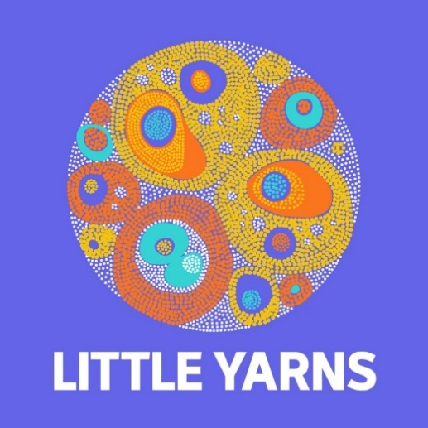
- Together with your buddy listen to an episode of Little Yarns. You may want to pause the episode to help explain new words or ideas.
- After listening to the episode complete these sentence starters together.
  - I learned…
  - I felt…
  - My favourite part was….
- What new Indigenous language words did you learn? Choose one new word and learn the correct pronunciation. What does the word mean?
- Draw a picture that shows something your learned or found interesting from the story.
- Share one thing you learned with the class.

BTN First Nations collection

Visit BTN’s collection of stories which focus on First Nations. Look for BTN stories with the pencil icon to find supporting teacher resources all linked to the Australian Curriculum. BTN – First Nations Collection

Useful Websites
- Reconciliation Action Plans – Reconciliation Australia
- Curriculum Resources – Reconciliation Australia
- Bush Tucker Garden – BTN
- Ngani Café – BTN
- Planting Indigenous Foods – Australian Museum
- Deep Time – BTN (video and teacher resource)

