KEY LEARNING
Students will view a range of BTN stories and use comprehension skills to respond to a series of focus questions.

CURRICULUM
English – Year 4
Use comprehension strategies to build literal and inferred meaning to expand content knowledge, integrating and linking ideas and analysing and evaluating texts.

English – Year 5
Use comprehension strategies to analyse information, integrating and linking ideas from a variety of print and digital sources.

English – Year 6
Use comprehension strategies to interpret and analyse information and ideas, comparing content from a variety of textual sources including media and digital texts.

English – Year 7
Use comprehension strategies to interpret, analyse and synthesise ideas and information, critiquing ideas and issues from a variety of textual sources.
  - Teacher Resource

Focus Questions
As a class, discuss the stories featured in the episode of BTN Classroom and record the main points of the discussion. Students will then respond to the following focus questions.

Pitjantjatjara Book
- Where does Kellis live? Find on an Indigenous map of Australia.
- What Aboriginal language is the book written in?
- What animal is an anumara?
- How does Kellis feel about the book?
- Why is it important for Pitjantjatjara kids to have a book in their language?

NAIDOC Week 2023
- Who are the traditional owners of the land you live on?
- What is an elder? Why are elders important in Aboriginal and Torres Strait Islander communities?
- Give an example of a story shared by an elder in the BTN story.
- What advice do the elders in the story give?
- What did you learn watching the BTN story?

Reviving Indigenous Languages
- Kaurna Warra is the language of the First Nations people of what area?
- What has been created to help protect Kaurna language?
- What has happened to many First Nations languages since European colonisation?
- Why is it important to protect Indigenous languages?
- Find the words for `hello’ and `goodbye’ in the Indigenous language local to your area.

KEY LEARNING
Students will learn about the Pitjantjatjara people and the importance of storytelling. Students will work collaboratively to write and illustrate a children’s picture book.

CURRICULUM
English – Year 4
Discuss how authors and illustrators make stories exciting, moving and absorbing and hold readers’ interest by using various techniques, for example character development and plot tension.

HASS – Year 4
The diversity of Australia's first peoples and the long and continuous connection of Aboriginal and Torres Strait Islander Peoples to Country/Place.

English – Year 5
Create literary texts that experiment with structures, ideas and stylistic features of selected authors.

HASS – Year 5
The influence of people, including Aboriginal and Torres Strait Islander Peoples, on the environmental characteristics of Australian places.

English – Year 6
Create literary texts that adapt or combine aspects of texts students have experienced in innovative ways.

HASS – Year 6
Experiences of Australian democracy and citizenship, including the status and rights of Aboriginal and Torres Strait Islander Peoples, migrants, women and children.
  - Teacher Resource

Pitjantjatjara Book

Activity: What do you see, think and wonder?
Students will watch the BTN Pitjantjatjara Book story, then respond to the following questions:
- What did you SEE in this video?
- What does this story make you WONDER?
- What did you LEARN from this story?
- What did you LIKE about this story?

Activity: Class Discussion
Discuss the BTN Pitjantjatjara Book story in small groups or as a class.
- What is the language of the Pitjantjatjara people?
- Where is Pitjantjatjara country?
- Explore the Indigenous Map of Australia to learn more about the language, social or nation groups of Aboriginal Australia.
- What questions do you have?

What questions do you have about the story?
What did you learn from the story?

Activity: Indigenous Perspectives
There are a range of children’s picture books which help us understand Aboriginal and Torres Strait Islander histories and cultures. Introduce your students to Aboriginal perspectives by reading one of the following picture books and then discuss the themes in the books.

- Young Dark Emu by Bruce Pascoe
- Took the Children Away by Archie Roach
- Hello, Hello by Children from the Spinifex Writing Camp
- Freedom Day: Vincent Lingiari and the Story of the Wave Hill Walk-Off by Thomas Mayor and Rosie Smiler
- Stolen Girl by Trina Saffioti
- Little Bird’s Day by Sally Morgan

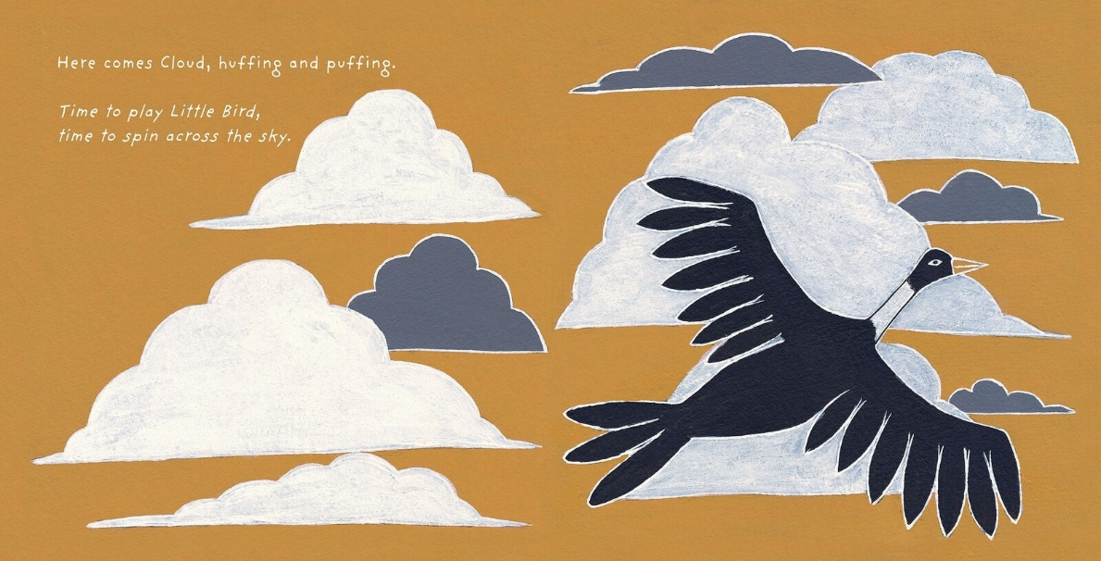
Little Bird’s Day by Sally Morgan, illustrated by Johnny Warrkatja Malibirr

Watch this video as a class to hear illustrator, Johnny Warrkatja Malibirr, read his Little Bird's Day book to 'Bapi' class at Gapuwiyak School. Watch this video to hear Johnny talk about his illustrations that he made for the Little Bird’s Day story.

After reading one of the books listed above, students will respond to the following:
- Who is the author and illustrator of the book?
- What traditional lands are they from?
- What is the theme of the book?
- What techniques does the author use to create suspense in the story? Think about the words and sounds that are used.
- What words or imagery are used in the book to convey feeling and emotion?
- What is the message of the book?
- Write down three things you would like to learn more about after having read the book.

Activity: How to build stories
Visual storytelling and understanding the importance of narrative is key in the making of a successful picture book. Start this activity by asking your students what they think a picture book is, recording their ideas during the discussion. Talk to students about the elements and techniques of effective storytelling. In pairs, students will make a list of useful tips for story writing, including tips on how to build character development, plot tension and narrative.

In pairs students will discuss what their favourite picture book is and why, using these questions to guide the discussion.
- What is your favourite picture book? Why?
- How did the illustrator and author make the story interesting or exciting?
- What did you like about the words and the pictures?
- Could the pictures tell the story without the words?
- What techniques does the illustrator use?

Resources
Use these FUSE teacher resources to help guide your students as they Make a Picture Storybook, Write a Picture Storybook, Illustrate a Picture Storybook, and Create a Storyboard.

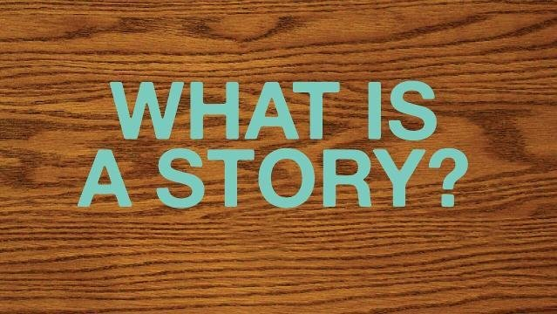
Use the ABC Education’s Digibook How to build Stories, which explains how to build your own stories, using tricks to create exciting characters, plots, settings, genres and language.

Activity: Pitjantjatjara Culture
After watching the BTN Pitjantjatjara Book story students will explore the culture and traditions of the Pitjantjatjara people. Students will develop their own question for inquiry or select one of the questions below.
- What is the language of the Pitjantjatjara people? Learn some common Pitjantjatjara words. How do you say ‘hello’?
- Where is Pitjantjatjara country? Mark the approximate boundaries on a map. What are some special sites in the area?
- Learn more about the Pitjantjatjara seasons and the plants and animals that are important to the Pitjantjatjara people. Learn more about the Indigenous Seasonal Calendar on the CSIRO website.

Further investigation
Students will explore the cultural diversity of Aboriginal and Torres Strait Islander peoples. Individually or in small groups, students will learn about the Indigenous group where they live and present what they have learnt to the class. Students will learn about the geographic location, language, culture, traditions, and histories.

Activity: Indigenous Language
What do your students know about Indigenous languages? As a class explore Gambay, the first Australian map that allows Aboriginal and Torres Strait Islander communities control over the way their languages are publicly represented. It showcases over 780 traditional languages.

While exploring the map, students will investigate the following (either as a class or in small groups):
- On the Gambay map type in the area where your school is situated.
- What is the local Indigenous language in your area?
- Do your own research to learn more about the local language. Find out the local language words for hello and goodbye.
- Look for stories by Aboriginal and Torres Strait Islander peoples valuing their oral traditions. Can you find stories told through dance, song and other art forms as well as through text?

Teachers Notes to support teachers in teaching about Aboriginal and Torres Strait Islander Languages.
The ABC offers a range of videos and podcasts which encourage students to explore the diversity of Indigenous culture and languages.

ABC – Indigenous Languages

Little J and Big Cuz  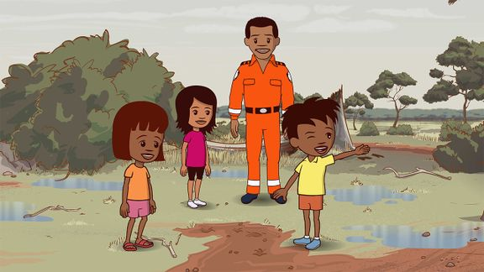 | Watch an episode of the ABC’s Little J and Big Cuz which are spoken in the Indigenous languages of Gija, Noongar, Torres Strait Creole, Palawa Kani, Warlpiri and Djambarrpuyngu. Find an episode in an Indigenous language local to your area. Link to iView videos
Education Good Mornings  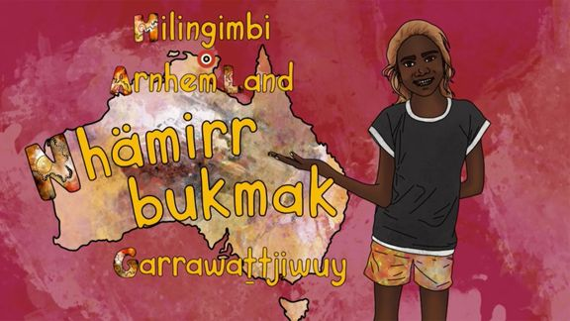 | How would you greet someone in the language of the land on which you live? In these ABC Education videos, children from around Australia encourage you to join them as they share greetings in their Indigenous languages.  Meet Garrawattjiwuy and learn how to say hello in the local language in Arnhem Land.  Link to iView videos
Little Yarns | Listen to the diverse languages, stories and Countries of Indigenous Australia in these Little Yarns audio resources. Teachers can check out the Educator Notes for ideas to get the most out of the Little Yarns podcast series.

Activity: Exquisite Corpse
Exquisite corpse is the most famous of all the surrealist games and was invented by Andre Breton and the surrealists in the 1920s. The surrealists were a group of artists and poets who loved breaking the rules of art and finding new ways to look at the world.

Exquisite corpse is a method by which a collection of words or images is collectively assembled. Each collaborator adds to a composition in sequence, either by following a rule, or by being allowed to see only the end of what the previous person contributed.

Exquisite (adjective)
Early 15c., "carefully selected," from Latin exquisitus "choice," literally "carefully sought out"
Corpse (noun)
Late 13century “body”, from Old French cors “body; person; corpse; life.

FOLDING STORY BASED ON THE EXQUISITE CORPSE
Exquisite corpse is a method by which a collection of words is collectively assembled. Each collaborator adds to a composition in sequence, either by following a rule, or by being allowed to see only the end of what the previous person contributed.

The instructions provide outline details for writing a narrative, but it could also be used for writing a poem. If writing a narrative, students will write a beginning, middle (with a complication) and an ending (with a resolution). Students will work in groups of three to create their folding story, using the following steps.

How to: | - Fold an A4 piece of paper into three equal parts.  - The first person begins writing the beginning of the story on the first section of the paper. The last word they are going to write should be written onto the next section.  - The second person uses the word that is written as the start of the second section (middle) of the story – it should include a complication. The last word they are going to write should be written onto the next section.  - The third person uses the word that is written as the start of the third section (ending) of the story – it should include a resolution for the story.  - NOW – SHARE!
Reflect | Reflect on the activity by responding to the following questions:  - What did you enjoy about this investigation?  - What did you find surprising?

Useful Websites
- APY Lands school student illustrates picture book to boost First Nation language literacy among remote kids – ABC News
- Anangu Language – Parks Australia
- Anangu Culture – Parks Australia
- Map of Indigenous Australia – AIATSIS
- Indigenous Culture (curriculum subject stories) – BTN
- School Libraries – BTN
- History of Libraries – BTN
- Young Author – BTN
- Writing Club – BTN
- Teen Novelist – BTN

KEY LEARNING
Students will learn more about the local Indigenous languages where they live.

CURRICULUM
English – Year 3
Understanding that languages have different written and visual communication systems, different oral traditions and different ways of constructing meaning.

English – Year 4
Understand that Standard Australian English is one of many social dialects used in Australia, and that while it originated in England it has been influeced by many other languages.
English – Year 6
Understand that different social and geographical dialects or accents are used in Australia in addition to Standard Australian English.

History – Year 3
The importance of Country/Place to Aboriginal and/or Torres Strait Islander Peoples who belong to a local area.
  - Teacher Resource

Reviving Indigenous Languages

Activity: See, think and wonder
After watching the BTN Reviving Indigenous Languages story hold a class discussion, using the following as discussion starters:
- What do you THINK about what you saw in the BTN story?
- What does this video make you WONDER about Indigenous languages?
- Think of three QUESTIONS you have about the story.
- What did you LEARN from the BTN story?

Activity: Class Discussion
Continue the class discussion, asking students to respond to the following questions:
- What language/s do you speak? Write a list of all the languages students speak in your class.
- What do you know about Indigenous languages?
- What Indigenous languages are spoken where you live?
- Why do you think it’s important to keep Indigenous languages alive?
- Why is preserving Indigenous languages difficult?
- What are the benefits of learning an Indigenous language?

Further Learning
Students research their own cultural heritage and the languages in their family history. Ask students if they think it’s important to celebrate cultural heritage and to know their family's languages and histories?

Activity: Local Indigenous Languages
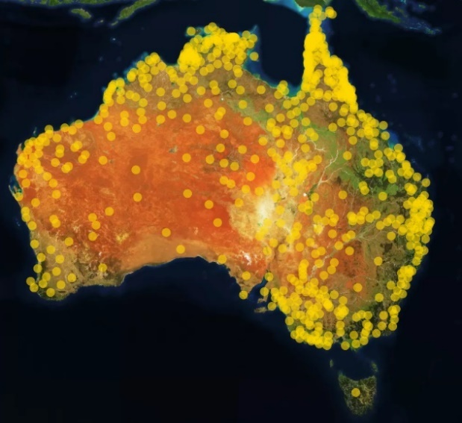
Who are the traditional custodians of the land where you live and what languages do they speak?

Students will learn more about their local Indigenous languages by exploring the Gambay – First Languages Map. Enter the place they live to find out the Indigenous languages in their area. Many of the Indigenous languages have videos or resources to support students to learn more about the language.
Learn words in your local Indigenous language! The 50 Words Project provides words in Indigenous languages. Use the map to search the local language and learn 50 words. All words have audio recordings provided by language speakers.

Further Learning
Invite an Indigenous language speaker to your school to learn more about the local languages.

Activity: Learn First Languages through song
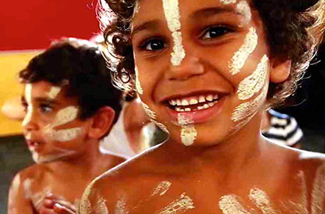
The Marrin Gamu song was created to introduce people to the diversity of Australia’s first languages. The song incorporates words from several different Indigenous language groups within Australia. Follow the instructions to get involved in creating and sharing your song.
- Watch the song and translate it into your local Indigenous language.
- Learn the song in your local language.
- Record a film clip of your song.
- Upload the video.

Activity: Learning our First Words on Country
Listen to the diverse languages, stories and Countries of Indigenous Australia in these Little Yarns audio resources. Teachers can check out the educators notes for ideas to get the most out of the Little Yarns podcast series.

Activity: This Place
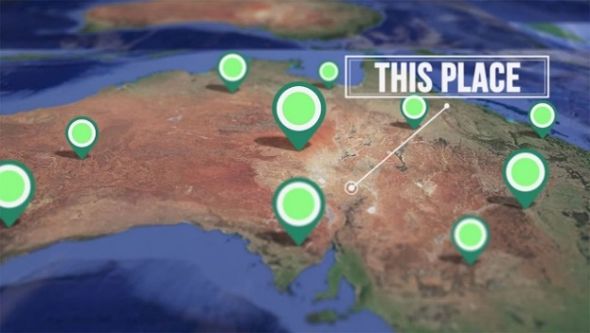
Around Australia, many places are known by their Aboriginal and Torres Strait Islander names. Indigenous communities share the stories behind place names of their country in the This Place series. Do you know the meaning of the place names where you live?

Students can explore the place names where they live using the Gambay interactive map.
Check out ABC Education’s English resources that explore Aboriginal and Torres Strait Islander culture. Learn about language conventions while discovering various Australian Indigenous languages and cultures.

BTN Indigenous Language Stories
Students can watch one or more of the BTN stories below to learn more about Indigenous languages.
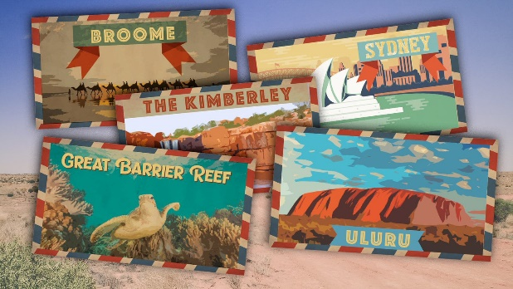  Indigenous Place Names | 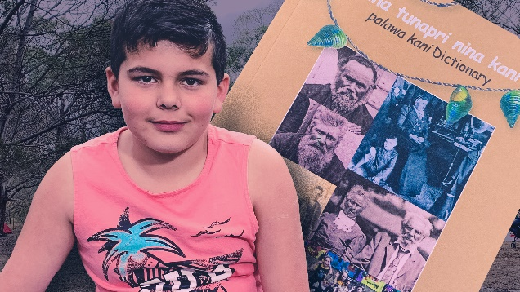  Palawa Kani
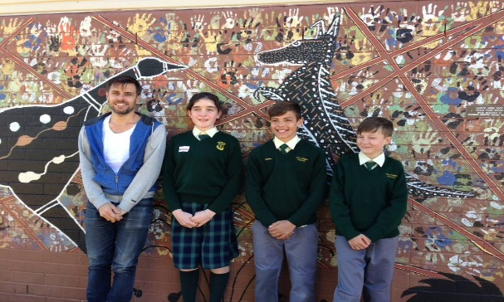  Indigenous Art and Language | 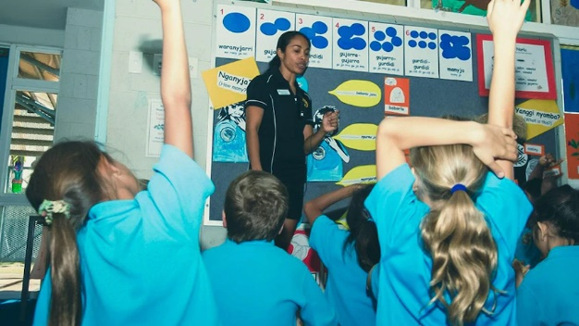  Indigenous Language Lessons

Useful Websites
- Kaurna Warra, the language of the people of the Adelaide Plains – Kaurna Warra
- Kaurna for Kids – YouTube
- Gambay – First Languages Map - First Languages Australia
- 50 Words Project – University of Melbourne
- Little Yarns – ABC Listen
- Marrin Gamu – First Languages Song

