EPISODE 6
9th March 2021

KEY LEARNING
Students will view a range of BTN stories and use comprehension skills to respond to a series of focus questions.

CURRICULUM
English – Year 4
Use comprehension strategies to build literal and inferred meaning to expand content knowledge, integrating and linking ideas and analysing and evaluating texts.

English – Year 5
Use comprehension strategies to analyse information, integrating and linking ideas from a variety of print and digital sources.

English – Year 6
Use comprehension strategies to interpret and analyse information and ideas, comparing content from a variety of textual sources including media and digital texts.

English – Year 7
Use comprehension strategies to interpret, analyse and synthesise ideas and information, critiquing ideas and issues from a variety of textual sources.
  - Teacher Resource

Focus Questions
As a class, discuss the stories featured in the episode of BTN Classroom and record the main points of the discussion. Students will then respond to the following focus questions.

Climate Change Court Battle
- What was the main point of the BTN story?
- Why have a group of teenagers taken the Federal government to court?
- They are hoping the court action will restrict the Environment Minister from approving an extension to the ____________mine.
- What does the government say are the benefits of the coal mine?
- Why don’t Izzy and Tom want the extension of the coal mine to go ahead?
- What is a class action law suit?
- Who are the group of teenagers representing?
- Taking a government to court has become more common. True or false?
- Why do Tom and Izzy say it’s important for young people to take action?
- What do you understand more clearly since watching the BTN story?

Brisbane Olympic Bid
- Before you watch the BTN story, record what you know about the Olympic Games.
- Brisbane has bid to host the Olympics in…
  - 2024
  - 2028
  - 2032
- If Brisbane’s Olympic bid is successful, it will be the first time Australia has hosted the games since _______.
- Why hasn’t there been as much competition to host the Olympic Games in recent years?
- What are some negatives about hosting the Olympic Games?
- What has the International Olympic Committee done to address these negatives?
- Why is Brisbane in a good position to host the Olympics?
- About how much would the Brisbane Olympic Games cost?
- Where are they hoping the money for the Olympics will come from?
- What was surprising about this story?

Check out the Brisbane Olympic Bid resource on the Teachers page.

Pompeii Discoveries
- What did the Pompeii Discoveries story explain?
- Where is Pompeii? Locate on a map.
- Which volcano erupted in 79AD near the city of Pompeii?
- Which Roman author gave a first hand account of the eruption of Mt Vesuvius?
- Pompeii was buried in ash which _______________the city for centuries.
- What have archaeologists discovered at Pompeii?
- Describe the chariot that was discovered recently.
- Why are illegal dig sites at Pompeii a problem?
- Why do you think Pompeii is considered an important archaeological site?
- Name three facts you learnt about Pompeii.

Check out the Pompeii Discoveries resource on the Teachers page.

Clean Up Australia
- What did the kids in the BTN story find when they were cleaning up their school yard?
- How long has Clean Up Australia been going for?
- Why did Ian Kiernan start Clean Up Australia day?
- How many Australians have been involved in the day since it began?
- What are some common types of rubbish found?
- Why do the kids in the BTN story like getting involved in Schools Clean Up Day?
- Every year, the waste we generate is growing at ___________the rate of the population.
- What changes can people make to reduce the amount of waste being produced?
- Why has the pandemic made the waste problem worse?
- What changes will you make to help reduce waste?

Arts Recovery
- In pairs, discuss the BTN story. Record the main points of the discussion.
- What is the name of the festival featured in the BTN story?
  - Melbourne Comedy Festival
  - Adelaide Fringe Festival
  - WOMADelaide Music Festival
- What do the kids in the BTN story like about the Fringe festival?
- Which artist are they performing with?
- What impact has the pandemic had on the arts industry?
- What sort of theatre is Ben involved in?
- What is the name of the show that Ben recently got a part in?
- How does Ben feel about theatre coming back?
- What are organisers doing to keep events COVID safe?
- How did this story make you feel?

EPISODE 6
9th March 2021

KEY LEARNING
Students will explore the history of the Olympic Games. Students will host their own class mini-Olympics.

CURRICULUM
HASS – Year 5 & 6
Sequence information about people’s lives, events, developments and phenomena using a variety of methods including timelines.

HASS – Year 7
Sequence information about events, developments, periods and phenomena using a variety of discipline-appropriate formats and conventions including chronological frameworks that use dating conventions.

History – Year 7
Sequence historical events, developments and periods.

Health and PE – Year 5 & 6
Participate positively in groups and teams by encouraging others and negotiating roles and responsibilities.

Health and PE – Year 7 & 8
Practise and apply personal and social skills when undertaking a range of roles in physical activities.
  - Teacher Resource

Brisbane Olympic Bid

Focus Questions
Discuss the BTN story as a class and record the main points of the discussion. Students will then respond to the following:
- Before you watch the BTN story, record what you know about the Olympic Games.
- Brisbane has bid to host the Olympics in…
  - 2024
  - 2028
  - 2032
- If Brisbane’s Olympic bid is successful, it will be the first time Australia has hosted the games since _______.
- Why hasn’t there been as much competition to host the Olympic Games in recent years?
- What are some negatives about hosting the Olympic Games?
- What has the International Olympic Committee done to address these negatives?
- Why is Brisbane in a good position to host the Olympics?
- About how much would the Brisbane Olympic Games cost?
- Where are they hoping the money for the Olympics will come from?
- What was surprising about this story?

Activity: Class Discussion
Discuss the information raised in the BTN Brisbane Olympic Bid story. Ask students to record what they know about the Olympics on a mind map. What questions do students have? Use the following questions to guide discussion:
- What do you know about the Olympic Games?
- When were the Olympic Games last held in Australia?
- Why does it cost a lot for countries to host the Olympic Games?
- What words or symbols do you associate with the Olympic Games?

Activity: KWLH
What questions were raised in the discussion about the Olympic Games and what are the gaps in their knowledge? The following KWLH organiser provides students with a framework to explore their knowledge on this topic and consider what they would like to know and learn.
What do I know? | What do I want to know? | What have I learnt? | How will I find out?

Research questions for Inquiry
- Why do we have the Olympic Games?
- What are the Olympic rings? Who created it? Think about the symbols and meanings of the rings. Think of a creative way to display your findings.
- Is it important that we have the Olympic Games? Give reasons.
- Who is Pierre de Coubertin? He said, “The most important thing in the Olympic Games is not to win but to take part”. What does this quote mean? Explain using your own words. Imagine you could interview Pierre de Coubertin, what questions would you ask him?
- Why are the Olympic Games held every 4 years?
- How do new sports get added to the Olympic Games? Choose one new sport that will be added during the Tokyo 2021 Olympic Games and explain why it was added.
- Do the Olympic Games unite the world? Explain using your own words.

Activity: Persuasive text
Students will develop a persuasive text convincing the International Olympic Committee (IOC) to add a new sport to the Olympic Games. Students will explore the following as part of their research:
- What are the benefits of adding the sport to the Olympic Games?
- How could you gain public support?
- Think about what your campaign would include.

Alternatively, students may want to write a persuasive text convincing the IOC to choose their city as the host of the Olympic Games. Students can use the information recorded during the class discussion and their own research to help develop their argument. Encourage students to use a range of sources. Provide students with the following structure to follow when completing this activity.

Introduction
- What is the point you are trying to argue? Construct an introductory paragraph which states the issue or topic.
- Introduce the arguments that will be developed in the body of the text.

Body
- Construct arguments that support your point of view.
- Each paragraph starts with a topic sentence which introduces each point.
- The rest of the paragraph gives more reasons.
- Arguments can be ordered from strongest to weakest.

Conclusion
- Restate your position on the argument.
- Construct a concluding paragraph that provides a summary of your arguments and a call to action.
Tips
- Who is your audience? For example, are you directing your argument at kids, teachers or politicians?
- Explore how language choices can have a big impact on persuading your audience.
- Which language devices give the report credibility and authority?
- Which are designed to create an emotional response in the listener?
- Provide facts and evidence to support your argument.
- Write in the present tense.
- Check your spelling and punctuation.

Activity: Timeline of events
Students will create a timeline to sequence the history of the Olympic Games, including the beginning of the Olympic Games in Ancient Greece until the modern Olympics which we know today. Students will work in small groups and work through the following questions to build on their understanding of the history of the Olympics. Students will find and collect images, photographs, illustrations and video as part of their research.
- When were the Olympic Games first held?
- Who is the founder of the Olympic Games?
- When did women first compete in the Olympic Games?
- When were the first Olympic Winter Games held?
- When were the Paralympic Games first held?
- What sports did athletes compete in during the ancient Olympic Games?
- How have the Olympic Games changed throughout time? Choose one aspect to explore in more detail and compare.
- What controversies have surrounded the Olympics over the years? Choose one to explore in more detail.
- How many countries have hosted the Olympics? Plot each country on a world map and incorporate into your timeline project.

Activity: Choose a project
Individually or in small groups, students will choose one of the following projects to work on and then present their findings to the class.
Scandals and controversies
Choose one scandal or controversy that occurred during the Olympic Games and write your own news report about the event.

Uniform design
Take a look back at some of the Australian team's past Olympic Games uniforms. Design a new uniform for the Australian team for 2032. Think about climate, durability, comfort, colour and symbols.

School Olympic Games
Plan and host your own class mini-Olympic Games. Plan a schedule of activities. Each student can represent a different country. Hold an opening ceremony and then let the games begin!

Opening ceremony
Plan the opening ceremony for the Brisbane 2032 Olympic Games. What will be included in the ceremony? Think about welcome speeches, the parade of athletes and artistic aspects.

Activity: Olympic Sports
Students will create a report about their favourite Olympic Games sport. They can develop their own key questions to investigate or respond to one or more of the questions below.

- Why is it your favourite Olympic Games sport?
- Give a brief summary of the sport.
- Research the history of the sport at the Olympic Games.
- What equipment is needed to play the sport?
- Who won gold in the sport at the last Olympic Games? Imagine you could interview the sportsperson. Write a list of questions to ask the person.
- Write instructions explaining how to play the sport. Play the sport with your classmates using your instructions.

Activity: BTN Story
Watch the BTN Olympic History story to travel back in time and see where the Olympics first started. Students will then respond to the following discussion questions.

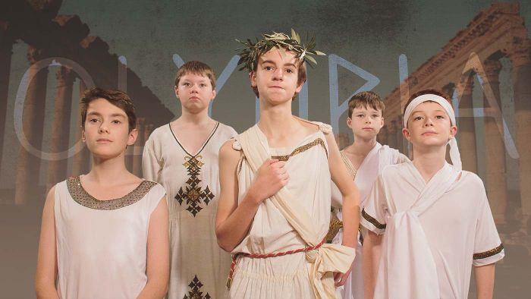
- Discuss the story in pairs and record your responses.
- When were the first Olympic Games held?
- Which god were the Olympic Games dedicated to?
- The only people who could compete were...
- Give an example of a sport included in the ancient Olympics.
- There was only one winner of the ancient Olympics. True or false?
- What did the winner receive?
- In which year was the first modern Olympic Games held?
- How are the ancient and modern Olympics similar?
- Name three facts you learnt watching the BTN Olympic History story.

Useful Websites
- What would a Brisbane Olympics look like and what events will be held outside the capital city? – ABC News
- Olympic History – BTN
- History and origin of the Games – International Olympic Committee
- History of the Olympics – National Geo Kids
- Australian Olympic Team

EPISODE 6
9th March 2021

KEY LEARNING
Students will develop their historical knowledge and understanding of Pompeii and ancient Roman society.

CURRICULUM
History – Year 7
How historians and archaeologists investigate history, including excavation and archival research.
The importance of conserving the remains of the ancient past, including the heritage of Aboriginal and Torres Strait Islander Peoples.
  - Teacher Resource

Pompeii Discoveries

Focus Questions
Discuss the BTN story as a class and record the main points of the discussion. Students will then respond to the following:
- What did the Pompeii Discoveries story explain?
- Where is Pompeii? Locate on a map.
- Which volcano erupted in 79 AD near the city of Pompeii?
- Which Roman author gave a first hand account of the eruption of Mt Vesuvius?
- Pompeii was buried in ash which _______________the city for centuries.
- What have archaeologists discovered at Pompeii?
- Describe the chariot that was discovered recently.
- Why are illegal dig sites at Pompeii a problem?
- Why do you think Pompeii is considered an important archaeological site?
- Name three facts you learnt about Pompeii.

Activity: Class Discussion
Before watching the BTN Pompeii Discoveries story hold a class discussion, using the following discussion starters. Brainstorm ideas in small groups and then students will report their group’s responses to the class.
- Where is Pompeii? Locate on a map.
- What happened to the ancient Roman city of Pompeii in 79 AD?
- Why is Pompeii considered an important archaeological site in the Roman world?
- Why is it important to conserve Pompeii?
- What can recent discoveries of artefacts tell us about Pompeii and Roman society?

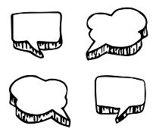
After watching the BTN story, students will respond to the following questions:
- What did you SEE in this video?
- What do you THINK about what you saw in this video?
- What did you LEARN from this story?
- What was SURPRISING about this story?

Activity: Glossary
Students will brainstorm a list of key words that relate to the BTN Pompeii Discoveries story. Here are some words to get them started.
CHARIOT | ARTEFACT | ANCIENT
MT VESUVIUS | PRESERVED | ARCHAEOLOGIST

Activity: Pompeii Research
After watching and discussing the BTN Pompeii Discoveries story, what questions do students have and what are the gaps in their knowledge? The following KWLH organiser provides students with a framework to explore their knowledge on this topic and consider what they would like to know and learn.

What do I know? | What do I want to know? | What have I learnt? | How will I find out?

Students will develop their own question/s to research or select one of the questions below.
- How has Pompeii helped us learn about life in ancient Rome and why is Pompeii important to us now?
- What was Pompeii like before Mount Vesuvius erupted in 79 AD? How do we know? What does the preservation of Pompeii tell us about the way of life at that time?
- Pliny the Younger was a witness to the eruption of Mt Vesuvius in 79 AD. Read his account in the letters he wrote to the historian Tacitus. What information did he give about the famous eruption? How reliable is Pliny the Younger as a witness? Give reasons for your answer.
- Investigate the rediscovery of the cities of Pompeii and Herculaneum. Why were the cities important to our understanding of ancient Roman society?

Activity: A Day in Pompeii
Students watch the animation that shows a recreation of Mount Vesuvius erupting.
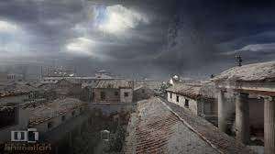
- What does the animation tell you about the day Mt Vesuvius erupted on 24 August 79 AD?
- Is the account a primary or secondary source?
- What questions do you have after watching the animation?
- If you could talk to an eyewitness, what would you ask them?

Activity: Roman House
The House of the Vine was a typical Roman house. Take a tour of the house and describe what you can see.
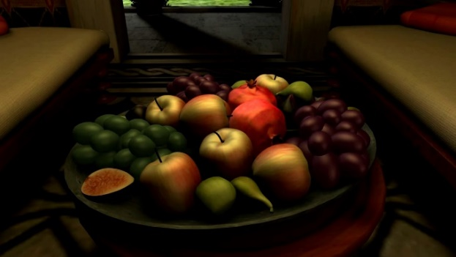
- What are your first impressions of a typical Roman house?
- What objects did you notice in the house?
- What do you think it would have been like to live in a Roman house?
- How does the house compare to yours?
- What was surprising about the house?

Activity: Amazing Artefacts
Students will look at the ancient objects that have been discovered at Pompeii and respond to the following questions:
- What is the object? Write a brief description.
- Who do you think the object belonged to? Why do you think that?
- What does the object tell us about Pompeian society?

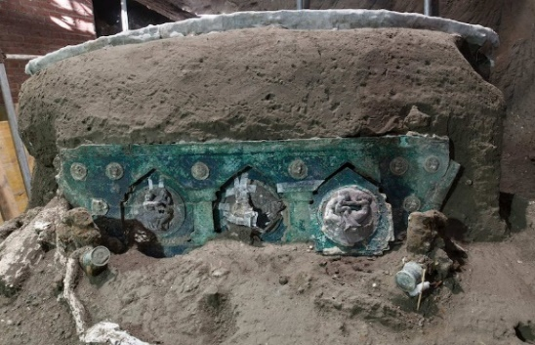  Ceremonial chariot | 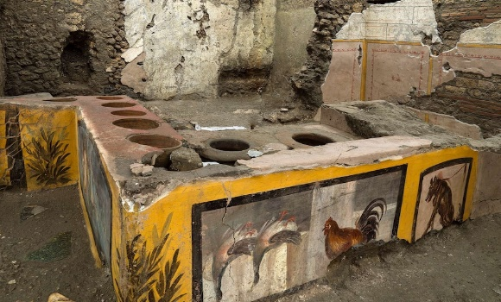  Fast food outlet
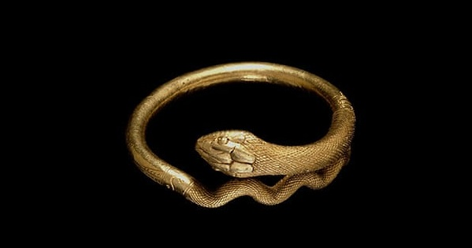  Gold bracelet | 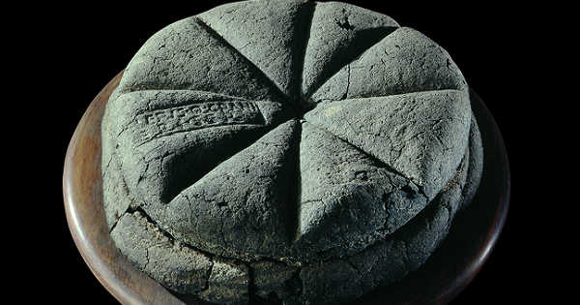  Carbonised bread
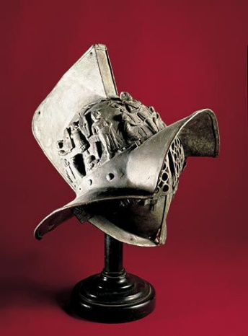  Gladiator helmet | 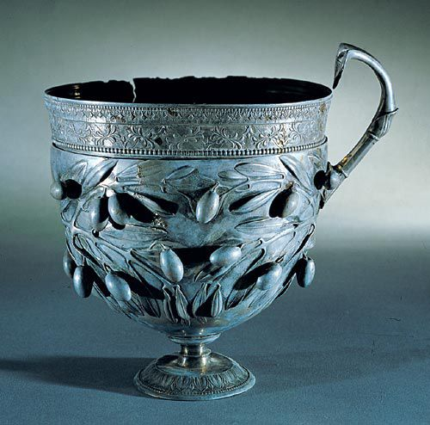  Silver goblet

Activity: Investigate Pompeii

What role did the public bath play in Pompeian society? What can this tell us about Roman society?

Take a tour of Pompeii.
What do the images tell you about the city and the people that lived there?

Pompeii is a UNESCO World Heritage site. Investigate what makes Pompeii special. Why is the site significant, are there any threats to the site and how is it being protected?

What was it like to be a slave in ancient Roman society? Watch this video to find out more.

Useful Websites
- Pompeii archaeologists find intact ceremonial chariot at site of illegal dig – ABC News
- Pompeii culinary tastes revealed by archaeologist after Italian excavation uncovers 2,000-year-old food shop – ABC News

  - Teacher Resource

BTN Transcript: Episode 6 - 9/3/2021

Hey, I’m Amelia Moseley and you’re watching BTN. Here's what's coming up. We learn about the pros and cons of hosting the Olympic Games, find out more about the ancient Roman city buried by a volcano and celebrate the reopening of the arts in Australia.
Climate Change Court Battle

Reporter: Cale Matthews

INTRO: But, first today to a court case that's just happened in Melbourne. It was started by a group of teenagers who were trying to stop the expansion of a coal mine. And as Cale found out, it's not the first time young people have gone to court over the potential effects of climate change. Take a look.

These teenagers are watching a court hearing. Sure, it's not your everyday after school activity, but they're the ones who started the case. These 7 teenagers have taken the Australian government to court, to try and stop the extension of a coal mine in New South Wales, but instead of hearing me talk about it. I figured I'd let them explain.
CALE: Hey Tom, Izzy, how are you guys? So why are you taking the Aussie government to court?
TOM: We're suing the federal environment minister, because we're arguing that she has a duty of care to protect all Australian children and young people from the impacts of climate change.
IZZY: Which is going to try and hopefully will restrict her from approving Vickery’s coal mine.
This is the Vickery Coal Mine near Tamworth. Last year the government approved a 600-million-dollar expansion to the mine, which it says will create hundreds of new jobs and bring in a ton of money to New South Wales, but Izzy and Tom see things differently.
IZZY: If the extension is approved over the next 25 years, it'll produce 168 million tons of coal. And that will be completely catastrophic for climate change.
They're seeking an injunction as part of something called a class action lawsuit, but before we go any further, let's get out the dictionary. A class action is when a small group of people represent a larger group of people in court, so in this case these guys are representing all the young people in Australia. And an injunction is a court order telling a person or a company not to do something, here it’s to stop the Environment minister from approving the expansion. Right, back to the story.
Taking the government to court is a pretty big deal, but it's becoming more common than you might think. In fact, around the world, there have been more than 1300 court cases over climate change since 1990. Back in 2015, the Dutch government was ordered to cut its carbon emissions by 25 per cent after a small group of protestors took them to court.
ADULT: I am extremely happy that the highest court in the Netherlands has confirmed that climate change is a real severe problem.
Then in 2018, Colombia's highest court ordered the government to do more to protect the Amazon rainforest.
TOM: We've seen huge social movements of young people over the past 12 to 24 months.
IZZY: People are realising that we actually can, that there are amazing lawyers around the world who do want to take this to court.
Australia's government says it is taking climate change seriously and it’s taking steps to cut carbon emissions while balancing the need to protect people’s jobs and the economy, but a lot of young people say we need to do more to protect the future. It'll be a little while before they find out the result of the case, but, even if they lose, Tom and Izzy say it won't be for nothing.
TOM: We will argue this case over and over and over if need be, and we will continue fighting to save our future from the catastrophic risk of climate change.
IZZY: I hope they listen to us, but I also hope they see how powerful we are together, and how strong and how resilient we are, and we will not let our voices go quiet.
News Quiz

Who is this very famous, classic children’s author? It’s Theodore Geisel, aka Dr Suess. His company has decided to stop printing a six of his books. They were written between the 30s and the 70s and some of the pictures are seen by many today as racist or culturally insensitive.

Can you name the cyclone that caused some damage in Far North Queensland last week? Was it Niran, Biran or Siran? It was Niran.

Can you name the space company behind this shiny new spacecraft, the Starship SN10? Is it Boeing, SpaceX or Virgin Galactic? It’s SpaceX, Elon Musk’s company. He was celebrating this test, because it was the first time the Starship managed to land in one piece. Until this happened. Oops. Looks like it needs a bit more work before they start putting people in there.

And Sydney’s Gay and Lesbian Mardi Gras went off with a bang on the weekend, but it was a little different this year. Where was it held? On Oxford Street, the Sydney Showground or the SCG? It was at the SCG. It usually rolls down Oxford street, but to keep things more COVID-safe organisers moved the Mardi Gras to the Cricket Ground and while crowds were smaller than usual, they seemed to be having a good time.

MARDI GRAS PARTICIPANT: We weren’t sure what it was going to be like, new venue, completely new experience, but oh my goodness.

Brisbane Olympic Bid

Reporter: Cale Matthews

INTRO: Now to Brisbane, where a lot of locals are excited about the prospect of hosting the 2032 Olympics. The city's been named as the frontrunner and, if it happens, it'll be the first Aussie games since 2000. Cale found out more about the pros and cons of being an Olympic city and why the competition isn't as fierce as it used to be.

The Olympics. Yeah, this isn't it, but for a lot of young athletes. The chance to be faster, higher, stronger than anybody in the world is the ultimate dream. Now imagine doing all that in your own backyard.
THOMAS BACH, PRESIDENT OF THE INTERNATIONAL OLYMPICS COMMITTEE: This Commission recommended to the executive board to enter into a targeted dialog with Brisbane 2032.
Yep, the International Olympic Committee has announced that Brisbane is its top choice to host the 2032 Olympic and Paralympic Games, and while it’s not a sure thing it is the only city to move to the next stage of the selection process. If it goes ahead, it'll be the first time Australia has hosted the games since the year 2000. While you're probably too young to remember it, and actually, so am I, this was a big deal for Australia. In fact, it was described by organisers as the best games ever and it brought in millions of tourists. So, it's not hard to see why countries go to great lengths to try and host the games. At least they used to.
Lately the competition to host the games has cooled down and one big reason is the cost. In the past countries have spent billions of dollars on the Olympics. Sydney's cost 6.9 billion while in 2014 Russia forked out more than 60. Whoa. It's not just new stadiums that need to be built. There's transport, accommodation, and basically giving the town a makeover. Which in some cases has led to governments booting locals out of their homes. Around the world many Olympic facilities have been left empty and abandoned. This ski resort in South Korea, used to host the last Winter Olympics, is now a ghost town.
It’s why a couple of years ago the International Olympic Committee decided to make some changes to try and make the games cheaper and more sustainable, and it’s exactly these changes that have put Brisbane in the box seat.
ANNASTACIA PALASZCZUK, QUEENSLAND PREMIER: We don't have to build huge stadiums that are not going to be used in the future.
After hosting the Commonwealth Games only 2 years ago, Brisbane already has 14 venues ready to rock and roll. It’s also planning to host other sports in cities like the Gold Coast or even Sydney and Melbourne. If Brisbane gets the nod it’s estimated the games will cost about 5 billion dollars, but Aussie officials are hoping that money will come from the IOC, ticket sales and sponsors.
JOHN COATES, PRESIDENT OF THE AUSTRALIAN OLYMPIC COMMITTEE: That's enough then to pay for both the Olympics and the Paralympic Games without any call on the state or federal or local government.
So who knows, fast forward 12 years from now and I might just be cheering some of you guys on from the sidelines as you go for gold.
Quiz

How many times has Australia hosted the Olympics? Once, twice or three times? We've hosted the Olympics twice. There was Sydney in 2000 and Melbourne hosted the games way back in 1956.

Ask a Reporter

If you want to know more about the Olympics, well, you can ask me live on Ask a Reporter this Friday. Just head to our website for all the details.

Pompeii Discoveries

Reporter: Nat Kelly

INTRO: Now, we're going to Italy, where archaeologists have made an exciting find. It's a chariot which was unearthed in the ancient Roman city of Pompeii. It's been the site of lots of big finds over the years all because of a disaster that happened there nearly 2,000 years ago. Nat can tell you more.
JOE: Hey mate, how's it going?
NAT: Hey good thanks, just enjoying the beautiful view of Mount Vesuvius from my luxury mansion here in Pompeii.
JOE: It sure is good to be a Roman.
NAT: Oh, it sure is. A rich Roman at that, yeah sorry. Oooh, smoke. I love it when it does that.
JOE: Does it look a little big to you?
Alright, let me tell you all about Pompeii. It was a city in what's today known as Italy. But a couple of millennia ago, the Roman Empire was in charge, and lots of rich Romans had holiday homes there. They also had slaves, but yeah. Pompeii was full of luxury villas, bustling taverns and amazing art. And the reason we know so much about it is because of something that happened almost 2,000 years ago.
JOE: Woah.
NAT: It's okay, I'm sure it’s nothing. Here, have some grapes.
You see, Pompeii and the nearby city of Herculaneum were built in the shadow of Mount Vesuvius, part of a chain of volcanoes that runs along between the African and Eurasian tectonic plates. Previous eruptions had made the soil here fertile and perfect for farming, which is why Pompeii was so rich. In fact, they even thought of the volcano as sacred. But in the year 79 AD, Mount Vesuvius started to erupt, spewing out tonnes of volcanic ash and rock. It's an event that's been retold in many books, movies and TV shows. We also have a first-hand account from a famous roman author, Pliny the Younger.
PLINY: A dreadful black cloud was torn by gushing flames and great tongues of fire much-magnified like lightning.
NAT: It’s fine don’t worry about it. This happens all the time.
BLAKE: Alright I'm outta here, boys.
JOE: Fair.
While some people escaped, thousands died as Pompeii and Herculaneum were covered in metres of ash. While it did destroy the cities, the ash also preserved them for centuries, and when archaeologists started digging into the ruins of Pompeii back in the 1700s, they came across buildings and artworks that had been preserved in amazing detail. They also found the remains of people. The ash had covered their bodies and hardened to create a natural mould, allowing us to see their last moments in amazing and creepy detail.
Over the years, the discoveries have kept coming, and Pompeii and Herculaneum have taught us heaps about life in ancient Rome. And last month, archaeologists came across another exciting find. It's a chariot. It's the first of its kind to be found in one piece. Experts reckon that back in the day, it was used for special ceremonies, or parades. It was actually discovered at an illegal dig site. That's a bit of a problem for archaeologists around here, locals wanting to find their own treasures, who risk damaging important sites. They say there's still heaps more waiting to be discovered here, and more that we can learn about this lost world.

Clean Up Australia

Reporter: Amal Wehbe

INTRO: On the weekend you might have seen some people out and about picking up rubbish. You might've even been one of them. It was Clean Up Australia Day, the biggest community event in the country. Amal found out how it started and why it's still important.
AMAL, REPORTER: Last week, you might've found yourself like these guys, going for a hunt. Under playgrounds, behind bushes, in the trees. All to find, this.
KID 1: Ew yuck.
Yep, rubbish. The thing you really don't enjoy finding but always seems to be hiding around the schoolyard.
AMAL: So, did you guys find a lot?
KID 2: Yeah, we found quite a lot.
KID 3: Lots of chip wrappers.

KID 2: We also found some pink netting.
AMAL: Okay, what do you think that was for?
KID 2: I think it’s from arts and crafts. We also found lots of ice block wrappers and food wrappers.
Heaps of schools around the country took part in School Clean Up Day which is part of Clean Up Australia Day.
PIP KIERNAN, CLEAN UP AUSTRALIA CHAIR: Clean Up Australia Day was launched by my father Ian Kiernan over 31 years ago.
Ian described himself as an average Aussie bloke who loved hanging out on his boat. But one day when he was out on the sea, he noticed heaps and heaps of rubbish floating by in the water. He was horrified, so he decided to do something about it. He organised a community event to get people picking up rubbish and the idea took off.
IAN KIERNAN: Sydney Harbor belongs to the people, we want to lift the public awareness.
Ever since, Aussies have been arming themselves with bags and gloves and hats and picking up rubbish every Clean Up Australia Day. Since 1990, they reckon volunteers have taken 380,000 ute loads of rubbish off the streets and shores of Australia. The most common thing on the ground? Cigarette butts, plastic wrappers and glass, followed by lids and bottle caps, and plastic bags.
KID 1: My class has been working with our buddy classes to help clean out rubbish and make our school a better place.
KID 2: I just like helping the environment, and it's nice picking up rubbish.
KID 3: It just makes me feel really proud that I'm doing good stuff for the environment.
KID 4: If we litter then when it rains, it can go into our drains, and go into the oceans, which can kill sea animals, because they could think it's another animal, and maybe eat it and die.
Over the years, we Aussies have been getting better at doing the right thing. But we still make a lot of waste, like, a lot. Every year, the waste we generate is growing at twice the rate of the population.

AMAL: Which is why as well as picking up the rubbish, Clean Up Australia wants us to focus on making less of it in the first place.

This year, the organisers are asking us to make some simple changes to cut back on our waste.
PIP KIERNAN: Whether that's saying no to a single use plastic water bottle, taking a reusable coffee cup, saying no to single use plastic packaging where you can, just simple pledges that together have a really huge impact on the environment.
Pip says the pandemic has made our waste problem even worse. For starters, we've been using a lot of these and during lockdown, a lot of us ate a lot of takeaway food.
PIP KIERNAN: We've moved away from some of those better habits that we'd started adopting like using less plastic and taking on reusable products rather than single use products.
Pip says Clean Up Australia Day was a good reminder to get back into those good habits.
KID 1: I pledge to use net bags instead of plastic fruit and veg bags.

KID 2: I pledge to use food containers and not plastic bags.
KID 3: I pledge to use beeswax wrap instead of cling wrap.

Sport
It was a thrilling All-Star weekend for the NBA. Steph Curry pulled off a nail-biting win in the 3-point comp while Anfernee Simons won the dunk contest with this spectacular display. As for the big game, Team LeBron beat Team Durant 170 to 150, with Giannis Antetokounmpo named MVP.
New Zealand has won the Constellation Cup. The Australians went down 45 to 43 in Christchurch, with the silver ferns taking out the series 3 to 1. It's the first time Australia's lost the cup in nine years, and the New Zealand team couldn't be happier to come away with the trophy.

SILVER FERNS PLAYER: I’ve never touched it so I’m so excited.
The signs weren't good for the West Coast Eagles before Sunday's AFLW derby had even started. Their mascot Aussie, who’s an actual eagle, went rogue, flying around the stadium. After a brief delay, he was apprehended, and Fremantle absolutely destroyed the Eagles 75 to 8. Thanks a lot Aussie.
Arts Recovery

Reporter: Olivia Mason

INTRO: Finally, today, we're going to get a dose of the arts. And for a lot of us that's been a long time coming. After a year of lockdowns and cancellations theatres are open and festivals are in full swing. Liv's been to the Adelaide Fringe to find out what it's like for artists being back on stage and how they're keeping things COVID-safe. Check it out.

Here in the Festival State, the Adelaide Fringe is in full swing.
KID 2: This year, we're doing a Peter Combe show. We're doing Fix the Fence with Sticky Tape. It's singing and dancing.
KID 3: I honestly love the Fringe because I love that you can see all these different shows with different people exposing their talents. And also, I love the rides.
KID 4: It's really exciting. Because I've only done one other like live show recently. And it was very small.
For performers like these guys, this festival is particularly special.
HEATHER CROALL, FRINGE FESTIVAL DIRECTOR: Many artists haven't even performed since Adelaide Fringe 2020. This is their first time back on stage.
KID 4: It was tough because a lot of shows were cancelled. People weren't making enough money to what they usually are. And a lot of them were going out of business. And that was really sad for them.
It's not just here in Adelaide that the arts are making a comeback.
BEN: Well, moving on from online musicals to normal musicals on stage. I recently got a part in Hairspray, and I'm one of the nicest kids in town. And this is my brother who also got into Hairspray. Good morning BTN.
As you might be able to tell, Ben is a bit of a musical theatre fan so he's pretty excited to see Australia host big international shows again.
BEN: Oh yeah, we did see a show recently, what was it called again, it was called like, away from. Oh, wait, hold on. Yeah, Come from Away. It was really good. And we were the first people to see it, reopening worldwide. And the producers from America came here to thank us like, great job, Melbourne, you kept going, and you were the first people to open globally.
But of course, things aren't quite the same as pre-COVID.
BEN: We had to wear masks when we went to the theatre. And then we had to be socially distant. So like, if one person was sitting here, there'd be a seat in between, and then another person would be sitting there.
Here at the Fringe, organisers have tried to make things a bit more COVID-safe, with more outdoor shows and lots of these around the place.
KID 3: I think it's different because there's a lot of like COVID check-ins and hand sanitizers everywhere and less people are coming.
Of course, holding a big event like this in the middle of a pandemic is a risk, and as we've seen quite a few times now, things can change quickly when it comes to COVID. A lot of people around the world are watching Australia to see if we can safely pull off our big arts comeback. While we all wait for the world to get back to normal.
KID 1: I'm probably hoping for next year more people will come. Yeah, because I love performing and everything.
KID 2: I'm hoping that there's like less restrictions and that we can get more people to come to shows and that it's all back to normal hopefully.
KID 3: I'm kind of hoping that COVID kind of goes away so that we can do more live performances, because it's been a bit hard for especially professional artists. Because it's now like, all online.
KID 4: Hopefully this year, we can all get back to doing what we love.

Closer

Well, that's it for this week. Don't forget you can jump online any time to check out stories and specials and episodes of Newsbreak. And if you're 13 or over you can subscribe to our YouTube channel. Thanks for watching I’ll see you soon. Bye.

