EPISODE 28
11th October 2022

KEY LEARNING
Students will view a range of BTN stories and use comprehension skills to respond to a series of focus questions.

CURRICULUM
English – Year 4
Use comprehension strategies to build literal and inferred meaning to expand content knowledge, integrating and linking ideas and analysing and evaluating texts.

English – Year 5
Use comprehension strategies to analyse information, integrating and linking ideas from a variety of print and digital sources.

English – Year 6
Use comprehension strategies to interpret and analyse information and ideas, comparing content from a variety of textual sources including media and digital texts.

English – Year 7
Use comprehension strategies to interpret, analyse and synthesise ideas and information, critiquing ideas and issues from a variety of textual sources.
  - Teacher Resource

Focus Questions
As a class, discuss the stories featured in the episode of BTN Classroom and record the main points of the discussion. Students will then respond to the following focus questions.

Ukraine Update
- Which country is Ukraine at war with?
- What breakthrough did Ukrainian troops have recently?
- How have people in Russia reacted to young Russian men being called up to fight?
- Recently schools reopened for in-person learning. True or false?
- How did this story make you feel?

Optus Data Hack
- Explain the Optus data breach that happened recently.
- Approximately how many past and present customers had their personal information stolen?
- Why do cyber criminals want our personal data?
- What can people do to stay safe online?
- What did you learn watching this story?

Republic Debate
- Who is our head of state?
- What is a republic?
- Why do some people think Australia should become a republic?
- What is the process to change the constitution?
  - Plebiscite vote
  - Parliamentary vote
  - Referendum vote
- Do you think Australia should become a republic? Give reasons for your answer.

Check out the teacher resource on the Teachers page.

NASA DART Mission
- In your own words, describe NASA’s DART mission.
- What does DART stand for?
- What is the goal of the mission?
- Was the mission successful?
- What do you understand more clearly since watching the BTN story?

Check out the teacher resource on the Teachers page.

Young AFL Umpire
- How old is Emma?
- How did she get into umpiring?
- What are some of the challenges of umpiring AFL?
- Which does Emma prefer, playing football or umpiring?
- What questions do you have about the story?

EPISODE 28
11th October 2022

KEY LEARNING
Students will develop an argument for or against Australia becoming a republic.

CURRICULUM
HASS – Year 6
Key figures, events and ideas that led to Australia’s Federation and Constitution.

HASS – Year 7
Sequence information about events, developments, periods and phenomena using a variety of discipline-appropriate formats and conventions including chronological frameworks that use dating conventions.

Civics and Citizenship – Year 7
The process for constitutional change through a referendum.

English – Year 6
Plan, draft and publish imaginative, informative and persuasive texts, choosing and experimenting with text structures, language features, images and digital resources appropriate to purpose and audience.
  - Teacher Resource

Republic Debate

Focus Questions
Discuss the BTN story as a class and record the main points of the discussion. Students will then respond to the following:
- Who is our head of state?
- What is a republic?
- Why do some people think Australia should become a republic?
- What is the process to change the constitution?
  - Plebiscite vote
  - Parliamentary vote
  - Referendum vote
- Do you think Australia should become a republic? Give reasons for your answer.

Activity: Class Discussion
Students will discuss the BTN story in pairs and then share their thoughts with the class.
- Australia is a constitutional monarchy. What does that mean?
- Who is our head of state?
- What is a republic?
- How could Australia become a republic?
- What is a referendum?
- Why would some people vote against Australia becoming a republic?
- Do you think Australia should become a republic? Create a plus, minus and interesting chart.
- Who would you choose as our head of state? Give reasons for your choice.

What did you learn from the story?
What questions do you have about the story?

Activity: Glossary
Students will brainstorm a list of key words that relate to the BTN Republic Debate story. Here are some words to get them started.

MONARCHY | REPUBLIC | REFERENDUM
HEAD OF STATE | CONSTITUTION | GOVERNOR-GENERAL

Activity: KWLH
Discuss the information raised in the BTN Republic Debate story. What questions were raised in the discussion and what are the gaps in students’ knowledge? The following KWLH organiser provides students with a framework to explore their knowledge on this topic.

What do I know? | What do I want to know? | What have I learnt? | How will I find out?

Students will develop their own question/s to research or choose one or more of the questions below.

- What is the role of the King in Australia’s system of government?
- Why does Australia have a monarch as its head of state?
- What is a constitutional monarchy?
- Explore the reasons why some people want Australia to become a republic.
- What would change if Australia became a republic?
- What is a referendum? How do they work and when was a referendum last held in Australia?
Watch these BTN videos to help students understand more about Australia’s Constitution and referendums.
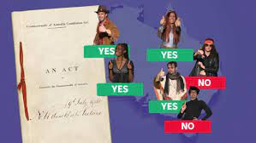

BTN – Australia’s Constitution BTN – 1967 Referendum

Activity: Understanding Referendums
Students will explore what a referendum is in more detail. They can use the following questions to guide their research.
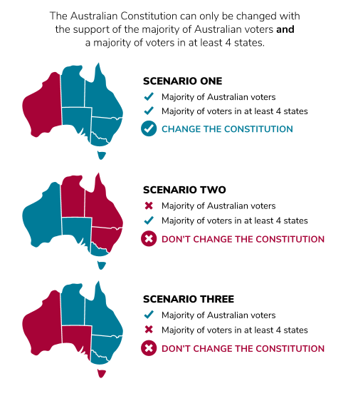
- What is a referendum?
- How does a referendum work?
- When was the last referendum held on becoming a republic?
- How many referendums have been held In Australia and how many of these have resulted in a change to the Constitution?
- Is it compulsory to vote in a referendum? Explain why.
- What other issues have Australians voted on in referendums?

Further investigation
Students can hold their own classroom referendum. This BTN Teacher Resource has more details.
Source: Parliamentary Education Office

Activity: Persuasive Text
Students will explore the issue of Australia becoming a republic and then develop a persuasive text for or against the following statement: `Australia should become a republic’. Students need to weigh up the pros and cons of the issue then write a short persuasive argument stating Australia should or should not become a republic.

Tips
- Who is your audience? For example, are you directing your argument at kids, teachers, or politicians?
- Explore how language choices can have a big impact on persuading your audience.
- Which language devices give the report credibility and authority?
- Which are designed to create an emotional response in the listener?
- Provide facts and evidence to support your argument.
- Write in the present tense.
- Check your spelling and punctuation.

Use this Read Write Think persuasion map to plan your exposition text.

Introduction
- What is the point you are trying to argue? Construct an introductory paragraph which states the issue or topic.
- Introduce the arguments that will be developed in the body of the text.

Body
- Construct arguments that support your point of view.
- Each paragraph starts with a topic sentence which introduces each point.
- The rest of the paragraph gives more reasons.
- Arguments can be ordered from strongest to weakest.

Conclusion
- Restate your position on the argument.
- Construct a concluding paragraph that provides a summary of your arguments and a call to action.
Reflection
- How difficult was it to think of points to support one side of the argument?
- Do you think you would have done a better job supporting the other side of the argument?
- Was I able to convince others of my opinion?
- Did my opinion change?
- What did you learn from this activity?

Activity: Quiz

- Who is Australia’s Head of State?  A. Anthony Albanese  B. David Hurley  C. King Charles III  - Australia is a…  A. Absolute monarchy  B. Constitutional monarchy  3. The Australian Constitution is a set of rules by which Australia is run.  A. True  B. False  Quiz Answers: 1C, 2B, 3A, 4C, 5C, 6A | 4. What is the process to change the Constitution?  A. Plebiscite vote  B. Parliamentary vote  C. Referendum vote  5. For a referendum to be successful, it needs to be agreed to…  A. By a majority of voters  B. By a majority of states  C. By a majority of voters and a majority of states  6. How many referendums have been successful in Australia?  A. 8  B. 16  A. 44

Useful Websites
- Republic movement unleashes campaign after mourning period for Queen – ABC News
- Queen’s Holiday Protests – BTN Newsbreak
- Referendums and plebiscites – Parliamentary Education Office
- The Constitution – Parliamentary Education Office
- Why are we a constitutional monarchy? – Parliamentary Education Office
- Referendums – Australian Electoral Commission
- Republic – BTN
- Australia’s Constitution – BTN
- The Queen in Australia - BTN
EPISODE 28
11th October 2022

KEY LEARNING
Students will learn more about asteroids and NASA’s space mission DART.

CURRICULUM
Science – Year 5
Scientific understandings, discoveries and inventions are used to solve problems that directly affect peoples’ lives.

The Earth is part of a system of planets orbiting around a star (the sun).

Science – Years 5 & 6
Scientific knowledge is used to solve problems and inform personal and community decisions.

Science – Year 7
Predictable phenomena on Earth, including seasons and eclipses, are caused by the relative positions of the sun, Earth and the moon.

Scientific knowledge has changed peoples’ understanding of the world and is refined as new evidence becomes available.

  - Teacher Resource

NASA DART Mission

Focus Questions
Discuss the BTN story as a class and record the main points of the discussion. Students will then respond to the following:
- In your own words, describe NASA’s DART mission.
- What does DART stand for?
- What is the goal of the mission?
- Was the mission successful?
- What do you understand more clearly since watching the BTN story?

Activity: Class Discussion
Hold a class discussion about the information raised in the BTN story. Clarify students’ understanding of terms such as asteroid, planetary defence, and asteroid redirection. Students will then discuss the story in pairs and share their thoughts with the class.
- What does DART stand for?
- What is the aim of the mission?
- Was the mission successful?
- Why is the DART mission important?
- What words would you use to describe the mission?
- What questions do you have about the story?

Activity: Questions and answers
Are you curious about space exploration? Students will make a list of questions they have about the story and space exploration that they would like to ask an astronomer. Students will use the internet to find answers to their questions.

Visit the following website to see which questions are answered.
Ask an Astronomer – http://curious.astro.cornell.edu/

Activity: Glossary
Students will watch the BTN NASA DART Mission story and summarise the story in their own words. Students will watch the story again and listen carefully, circling each of the following words as they hear them and recording any unfamiliar words.
ASTEROID | DART SPACECRAFT | DIMORPHOS
NASA | ORBIT | SPACE AGENCY
DIDYMOS | ASTEROID BELT | PLANETARY DEFENCE TEST MISSION

Ask students to write what they think is the meaning of each word (including unfamiliar words). They will swap definitions with a partner and ask them to add to or change the definition. Check these against the dictionary definition.

Further activities for students:
- Write your own sentences using the key words.
- Illustrate the difference between an asteroid, meteoroid and a comet.
- Draw a diagram which illustrates the scale of the Dimorphos asteroid, the DART spacecraft, Earth and various objects.
- Use the following words to write a summary about the NASA Dart Mission: DART, potential threat, Falcon 9, spacecraft, Dimorphos, orbit, space agency, planetary defence.

Activity: KWLH
Discuss the information raised in the BTN NASA DART Mission story. What questions were raised in the discussion and what are the gaps in students’ knowledge? The following KWLH organiser provides students with a framework to explore their knowledge on this topic.

What do I know? | What do I want to know? | What have I learnt? | How will I find out?

Students will develop their own question/s to research or choose one or more of the questions below. To start off their research get students to go to Google and search “DART Mission”. What do they discover?

- What is an asteroid?
- What is the DART mission?
- Who was involved in the DART mission? What is Australia’s involvement in the DART mission?
- What role did telescopes play in the DART mission?
- What’s the difference between comets, asteroids and meteors?
- What is the asteroid belt?
- How often do asteroids hit the Earth’s atmosphere?
- Is space exploration important? Why or why not?
- How has space exploration affected people’s lives?
- How has technology used in space exploration changed over time?

Activity: Create a Model
In this activity, students will think like engineers and build a model of the DART spacecraft (alternatively, students can build a model of their favourite spacecraft, for example, SpaceX Dragon, Apollo, ISS, Vostok 1, Soyuz, Discovery).
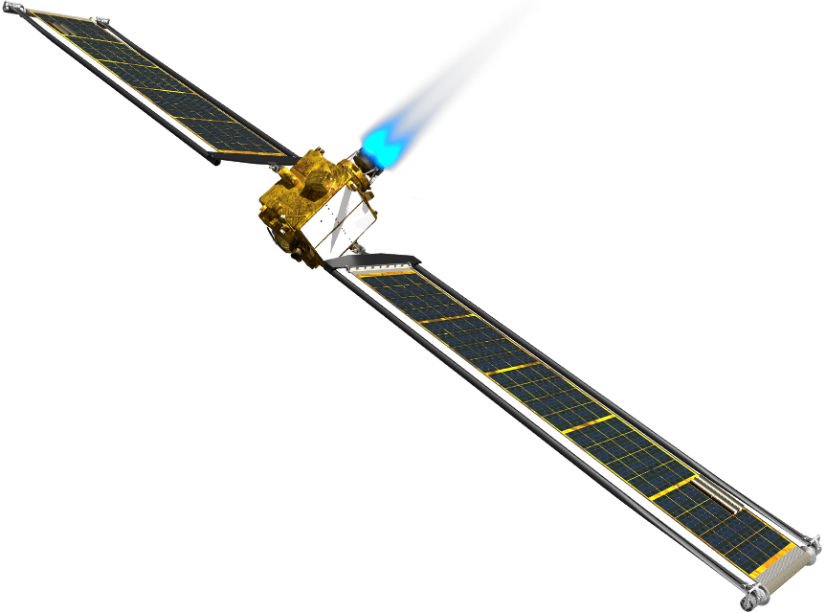
Before creating their models, students will respond to the following:
- Sketch a diagram of the DART spacecraft and label important features.
- What will the size and scale of your model be?
- What do the different parts of your spacecraft look like? Visit this NASA website to learn more about the parts of a spacecraft. For example, navigation, structures and antennas.
- What materials will you use to make your model spacecraft? Find recycled objects to construct your spacecraft.
- What tools will you need to build your spacecraft? Make a list.
- Will you be able to test the aerodynamics of your spacecraft? How?

Students will then create a model of the spacecraft using the materials they have collected and display them in the classroom. You may want to use a template which can be used to make scale spacecraft models.

Research project - Spacecraft
Students will explore the DART spacecraft in more detail and respond to the following research questions to create a profile on the spacecraft.
- Who created the spacecraft?
- When was it created?
- What size is it?
- What is the purpose of the spacecraft? Briefly summarise the mission
- Imagine you are the creator and write a paragraph explaining why you created the spacecraft.
- How has the spacecraft helped people and our understanding of space?
- Include photographs and diagrams in your research.

Activity: Quiz

- What do all asteroids orbit?  A. Earth  B. Sun  C. Moon  - What does DART stand for?  A. Double Asteroid Redirection Test  B. Double Asteroid Redirection Target  C. Dual Asteroid Redeployment Test  - How many asteroids are in the Didymos asteroid system?  A. 1  B. 2  C. 10  - What is the aim of the DART mission?  A. To change an asteroid’s motion  B. To break up an asteroid into pieces  C. To take a sample from an asteroid  - The asteroid that the DART mission targeted is NOT a threat to Earth.  A. True  B. False  - What is the diameter of the Dimorphos asteroid?  A. 17 metres  B. 170 metres  C. 1.7 kilometres  Quiz Answers:  1B, 2A, 3B, 4A, 5A, 6B, 7C, 8C, 9A, 10C, 11A | - What telescope was involved in the DART mission?  A. Hubble Space Telescope  B. James Webb Space Telescope  C. All of the above  - How far away from Earth was the Dimorphos asteroid when it was hit by the DART spacecraft?  A. 111 kilometres  B. 1 million kilometres  C. 11 million kilometres  - What is a rocky object that orbits the sun?  A. Asteroid  B. Comet  C. Meteor  - Where is the asteroid belt located?  A. Between Mercury and Venus  B. Between Pluto and Neptune  C. Between Mars and Jupiter  - What species was wiped out by an asteroid 65 million years ago?  A. Dinosaur  B. Woolly mammoth  C. Tasmanian tiger

Activity – Choose a project
Individually or in small groups, students will choose one of the following projects to work on and then present their findings to the class.

3D Model
Create a model of the DART spacecraft using recycled materials. Display your model in the classroom.
Reporter for the Day
Investigate the NASA DART Mission and write a newspaper article or online news report for kids.
True or False?
Create a true or false quiz about asteroids and test your classmates. Alternatively, create a word find or crossword.
Make a Crater
Design and make your own crater in your classroom using these step by step NASA instructions (YouTube).

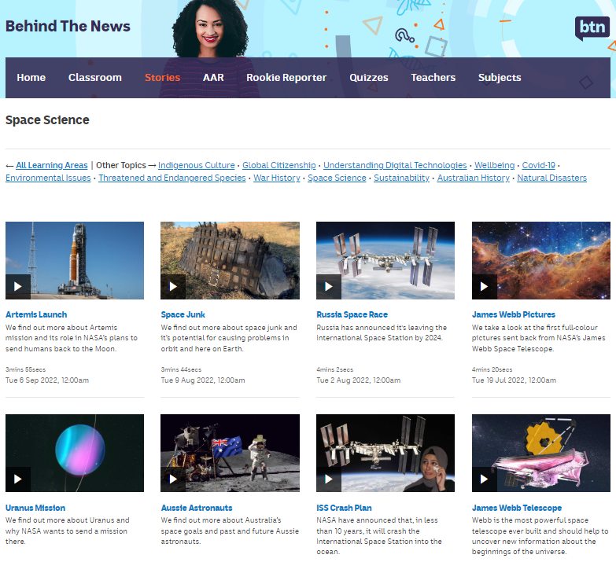
BTN Space Science stories
Visit BTN’s collection of stories which focus on space science and space exploration. After watching any one of the BTN videos ask students to respond to the discussion questions (to find the discussion questions and teacher resources go to the related BTN Classroom Episode and download the Episode Package).
Link to collection of BTN Space Science stories

Useful Websites
- NASA releases detailed views of DART mission smashing into asteroid from James Webb, Hubble telescopes – ABC News
- Double Asteroid Redirection Test (DART) – NASA
- DART Fact Sheet – NASA
- NASA's 'Double Asteroid Redirection Test', or DART, has made impact with an asteroid. Here's what you need to know – ABC News
- Nasa launches world’s first planetary defence mission – Newsround
- Nasa: US space agency crashes spacecraft into asteroid – Newsround
- What is the difference between a meteor, a meteorite, an asteroid and a comet? – Newsround
- Dr Karl discusses mining asteroids – ABC Education
- Meteors and Meteorites – Australian Museum
- Asteroids – NASA

  - Teacher Resource

BTN Transcript: Episode 28- 11/10/2022

Hey everyone, I'm Amelia Moseley and you’re watching BTN. Welcome back to a whole new term. I hope you had a really good break. Let's find out what's coming up on today's show. We look at the hack that exposed the personal information of millions of Aussies, find out what happened when NASA crashed a spaceship into an asteroid and meet the youngest elite-level umpire in AFL history.

Ukraine Update

Reporter: Amelia Moseley

INTRO: But first today we're going to Ukraine where there've been a lot of things happening lately. As you probably know, the country is at war with Russia which invaded back in February. But the Ukrainians are fighting back and have managed to take back some big areas. Let’s find out more.
It's been more than 200 days since Russia invaded Ukraine. Millions of Ukrainians have left everything behind to escape the war. While others have stayed and lived through the destruction caused by Russian missiles.
UKRAINIAN KID 1: (ENGLISH TRANSLATION) War is very bad because people are dying.
UKRANIAN KID 2: (ENGLISH TRANSLATION) I remember that when we woke up, I heard some sounds. I thought something was right next to my ear. I heard the sirens. It was horrific. My mother took me under her arm. Then I looked after my little brother and sister.
Russia is much bigger and more powerful than Ukraine and has a much bigger military. But Ukraine’s been getting support from other big countries like the United States that have sent weapons and other equipment to help out, and over the past few months Ukrainian troops have fought back, more effectively than many expected. They've managed to take back parts of the country, cutting off supplies to Russian troops and forcing them to retreat. In fact, Ukraine just made its biggest breakthrough in the South since the war began. It took back towns and villages in two key regions. Ukrainian soldiers celebrated and took down Russian signs and flags, replacing them with their own.
UKRAINIAN SOLDIER: We are going to win. I feel very good, very great.
It's a big blow to Russian President Vladimir Putin. Just hours before, he'd held this huge event to celebrate annexing, or claiming, those Ukrainian regions and two others as what he said would be "Russian territory forever". Russia's government says it held referendums or votes asking people living in the regions to say yes or no to becoming part of Russia and that in some cases more than 99 percent voted yes. But Ukraine and its allies have called the vote a "sham" and illegal.
JENS STOLTENBERG, NATO SECRETARY GENERAL: This represents the most serious escalation since the start of the war.
Young Russian men have also been called up to fight in the war, even though many of them don't have any experience, and that's lead to protests and lines of people trying to leave Russia. People in parts of Ukraine are trying to get back to some kind of normal life. Last month, some schools like this one in Kyiv reopened for in-person learning again. But every Ukrainian school has to have access to a bomb shelter and students are being prepared.
UKRAINIAN KID 3: (ENGLISH TRANSLATION) I want the war to end because it's terrible. I want everything back as before.
UKRAINIAN KID 4: (ENGLISH TRANSLATION) I want the war to end, so we can live and go to school like we used to before.

And while it seems the war is still far from over, many Ukrainians and supporters around the world are hoping for good news soon.
News Quiz

People in the US state of Florida are cleaning up after one of the most powerful hurricanes ever to hit the US. Do you know its name? It was Hurricane Ian and was a category 4 when it hit Florida, ripping apart homes and roads and killing more than 60 people.

FLORIDA RESIDENT: This is such a big storm, it brought so much water that you’re having basically what’s been a 500 year flood event.

Speaking of wild weather, 2022 is now the wettest year in recorded history for which Aussie capital city? Sydney, Melbourne or Brisbane? It’s Sydney. It broke the 164-year record last Thursday and the rain didn’t stop there. It’s filled up rivers and dams across New South Wales which were already full to bursting and caused serious floods in several towns and cities.

And Kim Kardashian has been fined more than a million US dollars for promoting a product on Instagram and not making it clear it was an ad. Do you know what she was promoting? Was it a luxury car, a make-up brand or a cryptocurrency? It was a cryptocurrency. While Kim K did include a hashtag ad, the US securities and exchange commission decided that wasn’t enough and she should have made it clear that she was paid more than $300 thousand to promote the product.

Optus Data Hack

Reporter: Amal Wehbe

INTRO: Now to another big story you might have heard about over the holidays involving one of the biggest cybercrimes in Aussie history. The personal details of millions of Optus customers were stolen by hackers, and some were even published online. Amal found out how that happened and how we can all stay safe.

DETECTIVE: I've acquired the target's address. Birthday is October 7th, and her favourite cake is vanilla. I'm getting a look at her credit card details.
AMAL, REPORTER: Yeah, it used to be that finding someone's personal information took a lot of sneaky work.
DEVON: Um, excuse me.
DETECTIVE: I've been burnt, abort mission, abort mission.
But things have changed a lot. Now we share a lot of information online. And while some of it's public. Some of it really needs be kept private. Like bank details, our medical records, or details that could help people track us down in the real world. If that information got in the wrong hands, well, that would be bad.
REPORTER 1: A cyber-attack against telecommunications giant Optus.
REPORTER 2: Optus is in meltdown tonight.
REPORTER 3: Millions of Australians are being warned they could face a higher risk of online scams.
Over the break, you probably heard about the Optus data breach. Someone hacked into the company’s network and stole information about almost 10 million past and present customers. That included names, birthdays, phone numbers, emails, home addresses, plus personal ID numbers, for licenses, passports and Medicare cards. The hackers demanded 1 million US dollars and posted information on more than 10,000 customers. But then they backed down and even said sorry for the whole thing. Yeah, some reckon they weren't exactly criminal masterminds, but they sure did a lot of damage.
JULIE INMAN GRANT, AUSTRALIA'S eSAFETY COMMISSIONER: Cyber criminals want our personal data to help them commit crimes.
This is Julie, Australia's eSafety Commissioner a position set up to fight cybercrime and other online nasties. She says there are a few ways that the stolen information could be misused. The first is something called a phishing scam. That's where a cybercriminal tricks you into sharing personal information by pretending to be a legitimate business or organisation.
JULIE INMAN GRANT, AUSTRALIA'S eSAFETY COMMISSIONER: They have your name. And so, they'll say “hi, Julie, hi, Amal”. And they will have your email address, they may even fool you into thinking that they have your password, or they may have your password.
The other big worry is identity theft. That's where cyber criminals use people's personal information to impersonate them.
JULIE INMAN GRANT, AUSTRALIA'S eSAFETY COMMISSIONER: People can use identity theft, to buy cars, to commit crimes, using your identity.
Optus says it's been working with government and agencies, to figure out exactly what happened. And they've contacted the 1.2 million customers who had their current ID and personal information stolen.
KELLY BAYER ROSMARIN, OPTUS CEO: The team at Optus is doing everything that we possibly can to ensure that no harm comes to our customers.
They've been told to replace their passports, and licenses, and be on the lookout for scams. Meanwhile the Australian Federal Police are doing their own investigation and the government says it'll look into how we can stop this from happening again.
ANTHONY ALBANESE, AUSTRALIAN PRIME MINISTER: Clearly, we need better national laws.
Experts say it's also a good reminder to all of us to stay safe online. That means having good passwords and updating them regularly. Being careful with what you click and what you share. And being on the lookout for scams.
JULIE INMAN GRANT, AUSTRALIA'S eSAFETY COMMISSIONER: You need to question everything you see or are told online. So, if something looks uncharacteristic to you, like you know, your best friend saying that you smell like a bologna sandwich, you know, you should question that.
Quiz

What should you do if you get an email or a text that you think could be a phishing attempt? A. Check the logos to make sure it looks legit? B. Click on any links to see where they lead? Or C. Delete the email immediately. It’s C, you should never open an email or follow a link if you think it could be a phishing scam. A good thing to do before you open an email is to hover the mouse over it and look at the sender’s address. If it looks a bit suspect, delete it and report it straight away.

Republic Debate

Reporter: Jack Evans

INTRO: The recent death of Queen Elizabeth the Second was a sad time for many people. But for some Aussies it was also a reminder of how Indigenous people suffered under British colonisation. Now that the time of mourning is over, some people reckon it's time to talk about whether Australia should move forward without the monarchy. Here's Jack.

On the 22nd of September people around the country stopped to commemorate the death of Queen Elizabeth the Second.
ANTHONY ALBANESE, AUSTRALIAN PRIME MINISTER: We gather today, here and around our nation to offer Australia's thanks for an extraordinary life dedicated to service, faith, country and Commonwealth.
But as many took a moment to be silent, others took the opportunity to have their voices heard. For a lot of Aboriginal and Torres Strait Islander people, the death of Queen Elizabeth the Second has been a reminder of the ongoing struggles First Nations people have faced since British colonisation.
VOXIE 1: It was important that we show up today, as a form of resistance to the settler, colonial nation state that is Australia and to remind the world that not everyone's mourning the Queen’s death.
VOXIE 2: I think that the government should consider more about what goes on in Aboriginal communities and give us some representation.
It's also raised the question for many, about whether it's time to leave the British monarchy and the Commonwealth behind and become a republic. A republic is a form of government where there is no king, queen or other monarch. Instead, someone is chosen to represent the country as it's head of state.
VOXIE 3: We're a country of many nations, we're a country of many religions at the moment and that we've got to get to stage where we create a republic, where the republic is based on fairness and responsibility.
It's certainly not a new idea and it's not just people here who have been talking about it. For a while now the Australian Republic Movement has been campaigning to replace our head of state with an Aussie. They say it doesn't make sense to have someone on the other side of the world representing Australia.
AUSTRALIAN REPUBLIC MOVEMENT AD: Not one of us, not voted for by us, not accountable to us in any way.
But becoming a republic wouldn't be easy. For starters we'd need to change the Constitution which, as you might already know, requires a big public vote called a referendum. That actually happened back in 1999 when Aussies voted on whether or not to become a republic. Spoiler alert, the no vote won. So, would things be any different now? Well, there are plenty of people who are in favour of a republic, but there are still many who think we should keep things as they are. Some reckon it would be too expensive and some say the royals have been a big part of Australia's history and we should keep them around. So, what do you think?
KID 1: Overall, I think the monarchy is a good thing, just maybe not so much for Australia.
KID 2: I think the Queen was a really good leader, I know a lot of people really liked her.
KID 3: It's a bit uncertain on how things will pan out with a new king. So, this could be a crucial step towards deciding if Australia would be a republic or not.
KID 1: I think that it might help as well with the First Nations people feeling like they really are having their country back because it was the British people who came and took it from them.
KID 4: We're a separate country, and we're no longer a colony. So, we should be independent, and be able to run ourselves independently.
Quiz

Which former Australian Prime Minister led the campaign to become a republic back in 1999? It was Malcolm Turnbull. He's always been strongly in favour of becoming a republic, although he said he was also a big personal fan of Queen Elizabeth the Second.

NASA DART Mission

Reporter: Jack Evans

INTRO: Imagine finding out that an asteroid was heading straight for Earth. Don't worry, it isn't. But if that did happen, NASA has a plan which it has just tested out and Jack found out all about it.

DART CAPTAIN: If there's one thing, I've learnt from watching sci-fi films, it's that I should be terrified that an asteroid will fall out of the sky and hit me on the head.

DART CAPTAIN: Oh, curse you asteroids.

DART CAPTAIN: But never fear, because I've come up with DART, Destroying Asteroids (before they) Ruin Things. A group of like-minded people dedicated to destroying all asteroids.
DART CAPTAIN: Okay team, here's what I've come up with. We tell the asteroid to back off in a real stern voice, yeah? Oh, okay, well we could try catching the asteroid with a really big net, yeah? Well, what if we tried smashing a rocket into the asteroid in order to change its orbit so it's no longer a threat. Yeah, that could work.
Guess what, it did work.
DART CAPTAIN: What, who said that? Was it an asteroid?
But it had absolutely nothing to do with these guys. Yep, believe it or not, NASA has been worried about an asteroid hitting Earth. No need to be alarmed, there are none headed for us at the moment. But it's definitely something that has happened before. For example, some 66 million years ago, a huge asteroid smashed into Earth and experts believe it caused widespread fires and a massive tsunami, which scientists have just mapped. Not to mention a giant dust cloud leading to massive changes in the climate and eventually causing the dinosaurs to go extinct. So, yeah, NASA wants to be prepared in case we ever found ourselves facing a similar situation.
ANDREA RILEY, NASA: We're constantly looking in the skies for potential new asteroids and threats. And so, this test will help give us confidence that we do have a mitigation strategy should a threat ever be identified.
And that's where DART comes in.
DART CAPTAIN: Yeah, we’re still here.
No, the real DART.

DART CAPTAIN: Oh.
NASA's DART stands for Double Asteroid Redirection Test. It's a multi-million dollar mission that the space agency launched last year. The goal, smash into this bad boy, an asteroid called Dimorphos. It orbits a bigger asteroid called Didymos in the asteroid belt between Mars and Jupiter.
NANCY CHABOT, NASA: Dimorphos is such a perfect target for this first planetary defence test mission, because it's the size that you're most concerned about for planetary defence.
So did it work? You bet ya. On the 27th of September DART’s spacecraft successfully smashed into Dimorphos at about 22,000 kays an hour.
NANCY CHABOT: The test went spectacularly. It was really everything that we expected, and even, honestly, more. I think all of us had said it would be spectacular and it was.
The big question now is whether the collision managed to change the asteroid's orbit enough to make a difference if it were heading towards us and while scientists suspect it did, it'll take a bit more work to find out for sure. But at least we can rest assured knowing that someone's thinking up a plan for any potentially threatening asteroids in the future.
DART CAPTAIN: Yes, take that you silly little asteroid. Yeah, high five.

Sport

The wet weather in New South Wales made for a slippery start to a historic Bathurst 1000. Just 30 seconds into the race there was a massive crash, and it wasn't until the 10th lap that the cars went around without an incident. After a few more crashes, it was Shane Van Gisbergen and Garth Tander who took out the title in what was the final Bathurst race for Holden.
Over to F1 where Max Verstappen has just become world champion for the second time. He won the Japanese Grand Prix and with 4 races left in the season, well he’s going to finish on top.
And go. Oh, that was quick. This is Canberra's first arm-wrestling championship, open to anyone from 17 to 47.

ARM WRESTLER: I started watching arm wrestling online, I thought pretty interested, so I thought keep it going.

Organisers say it was a success with hopefully more to come.

ARM WRESTLING ORGANISER: We expected 15, 20 people, so to see this much of a turn out and see people coming down from Queensland and up from Victoria it’s been absolutely amazing.

Young AFL Umpire
Reporter: Amal Wehbe

INTRO: Finally, today, to this record breaking moment in sport. When Essendon took on Hawthorn in their round one AFLW game at Docklands Stadium, one of the umpires controlling the game was 16-year-old Emma Stark. She's the youngest person ever to umpire an AFL game at the highest level and Amal caught up with her to find out what it was like.
EMMA: My name is Emma Stark. I'm 16 years old and two weeks ago, I became the youngest person to debut in the AFL as an umpire.
AMAL: So, let's go back a bit. How did you even get into umpiring in the first place?
EMMA: So, I was 13 years old, and, in the offseason, I was playing football. I decided I would balance it out and umpire football as well, as my side job and as a little bit of extra fitness. And I actually started on this field right here. I started under twelves game, and I quickly came up the ranks. And from there, I got the call up in the offseason saying if I'd be interested in joining the list for the AFLW field umpires.
AMAL: What was going through your head when they called you?
EMMA: I was so over the moon. I cannot explain how excited I was, and I broke down into tears and once I hung up the phone, I just jumped to my closest friend gave her a huge hug. I debuted in round one with the Essendon/Hawthorn match at Marvel Stadium. When I walked on Marvel in my warm up gear, I was just I couldn't stop looking around at all the empty seats and thinking this is soon going to be absolutely packed and I'm gonna be umpiring on this field in front of just over 12 thousand people. It definitely hit me I was like tearing up as I was walking out thinking wow, is this actually real? And then same when I put the ball up for the first time to start the game. The crowd just let out this huge roar, it was so insane.
AMAL: Once the game started did you still have nerves going through or were you just focusing on the game, what was going through your head?
EMMA: In the first few minutes it was everything was still so surreal. But then as the game quickly got ahead it was just my supporting umpires, the ball, and the players. I really just focused on my task ahead of me.
AMAL: And because you love footy so much. Like were you seeing people play that you've just liked to watch play in the past?
EMMA: Oh, yeah, just some big names. Knowing that wow, I'm umpiring these very talented girls. Girls like Georgia Gee, Madison Prespakis.
AMAL: What is some stuff that you've learnt from being an umpire?
EMMA: The three components that I've learnt the most would be leadership, communication and being composed in a crazy situation. What may shock some people is how team based it actually is, so when you've got a really good team supporting you, I don't find that there are too many hard things to come by.
AMAL: What do you see for the future? Footy player? Umpire? What's the dream?
EMMA: I love them equally as much. I'm hoping to definitely stay at elite level and, and even maybe umpire the men's AFL but I'm not sure what path I want to go down yet. So, I guess I'll see what happens in the future and just go with the flow.
Closer

What a legend Emma. Well, that's all we’ve got for today, but we’ll be back before you know it and, in the meantime, you can jump onto our website and of course Newsbreak will be right here in the studio every weeknight to keep you up to date. Have a great week. And I’ll see you next time, bye.

