EPISODE 28
12th October 2021

KEY LEARNING
Students will use mathematical formulas to create a scale drawing of their dream future school. Students will look at ways to reflect and celebrate Aboriginal and Torres Strait Islander culture in the school community.

CURRICULUM
Mathematics – Year 5
Calculate perimeter and area of rectangles using familiar metric units.

Choose appropriate units of measurement for length, area, volume, capacity and mass.

Mathematics – Year 6
Solve problems involving the comparison of lengths and areas using appropriate units.

Mathematics – Year 7
Establish the formulas for areas of rectangles, triangles and parallelograms, and use these in problem-solving.

Draw different views of prisms and solids formed from combinations of prisms.

Classify triangles according to their side and angle properties and describe quadrilaterals.

Geography – Year 4
The custodial responsibility Aboriginal and Torres Strait Islander Peoples have for Country/Place, and how this influences their past and present views about the use of resources.

  - Teacher Resource

Minecraft Education Challenge

Focus Questions
Discuss the BTN story as a class and record the main points of the discussion. Students will then respond to the following:
- Summarise the Minecraft Education Challenge story.
- What was the brief for this year’s challenge?
- Describe some of the features of the student’s design.
- What did the students learn from participating in the Minecraft competition?
- How does your school reflect and celebrate First Nations culture?

Activity: Class discussion
As a class discuss the BTN Minecraft Education Challenge story using the following questions as a guide. Record the main points of discussion on a mind map.
- What do you think about what you saw in this story?
- What skills did the students use to design and create their school in Minecraft? Give examples of when they have used creativity, maths, programming skills, teamwork, problem-solving and project management.
- How did the students celebrate First Nations culture in their designs?
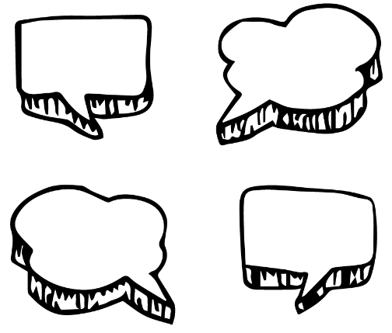
- How did the students make their designs sustainable?
- What question/s would you like to ask the kids in the BTN story?
- If you could improve your school using Minecraft, what would it look like?

Activity: Glossary
Students will brainstorm a list of key words that relate to the BTN Minecraft Education Challenge story. Students may want to use pictures and diagrams to illustrate the meaning and create their own glossary. Here are some words to get them started.

PERIMETER | AREA | RATIO
LENGTH | LANGUAGE | ABORIGINAL COUNTRY
CULTURAL KNOWLEDGE | DIMENSIONS | FUTURE
MEASUREMENTS | SUSTAINABLE | CREATIVITY

Activity: Winner - Best Minecraft World
Students will watch the Salisbury North Primary students’ video and then respond to the following questions. Click here to watch the video of the 2021 WINNER - Best Minecraft World (Year 7 to Year 10) Salisbury North Primary School, SA.

- What Aboriginal Country is Salisbury North on?
- What shapes did the students use in their design?
- Which building is inspired by a yarning circle? Describe.
- Why did they choose to make it in the shape of a yarning circle?
- What are the benefits of the glasshouse? Give two examples.
- What is the purpose of the cultural burning and fire station?
- What flags did you see in the design?
- What animals did the kids feature in their design?
- Why did the students’ put sheep in their school?
- What did you like about the student’s design?

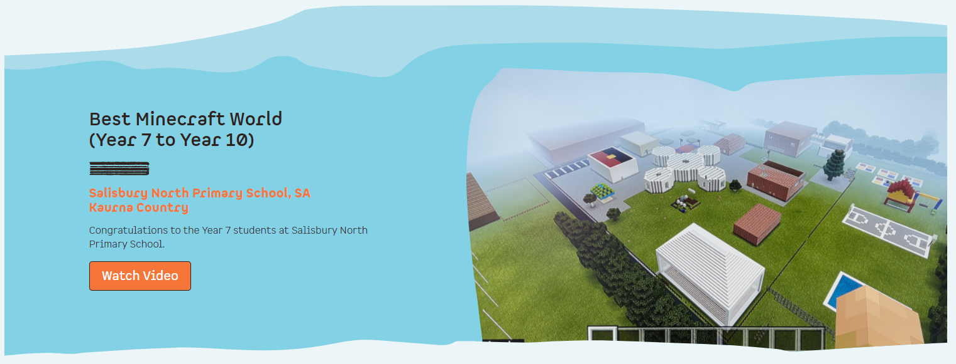
Minecraft Challenge Winners – Indigital

Activity: How does your school reflect First Nations culture?
Facilitate a class discussion to explore Aboriginal and Torres Strait Islander cultural knowledge, histories and languages. Students will look at how their school already reflects Aboriginal and Torres Strait Islander culture and what it can do further to celebrate it.

Use the following questions to start a class discussion to engage your students and find out what they already know and what they want to learn.
- What do you see when you walk into your school? Think about the artwork, the gardens, and buildings around your school.
- How does your school reflect and celebrate Aboriginal and Torres Strait Islander culture? For example, your school may fly the Aboriginal and Torres Strait Islander flags and hold ceremonies and events that include Welcome to Country or Acknowledgement of Country.
- How is your school environmentally sustainable? Do any of your school’s sustainability practises embrace Aboriginal and Torres Strait Islander cultural knowledge?
- What are some ways that your school could reflect and celebrate Aboriginal and Torres Strait Islander culture? Look at one or more of the following: Language, arts and crafts, land management, ceremony and astronomy.
- What does your dream future school look like? Brainstorm some ideas in pairs and then share your thoughts.

Activity: Choose a project
Individually or in small groups, students will choose one of the following projects to work on and then present their findings to the class.
Language
Who are the traditional custodians of the land where you live and what languages do they speak? Learn some everyday words and record them in a book. Label areas in your school using your local Indigenous language.

Bush tucker garden
Create a bush food trail/Indigenous garden in your school. Find out if you have an Indigenous food trail near your school that you could visit for inspiration.

Aboriginal Dreamtime
Learn more about the dreaming trails in your local area. Use the internet to find out if there are any dreaming trails in your area that explain the creation theories of the traditional owners of the land.
Reconciliation
Create a reconciliation wall that uses images to represent reconciliation. This could be done in conjunction with an Indigenous artist in residence.

Activity: Create your future school in Minecraft
In this activity students will imagine and create their dream future school. Use the following as a guide. Students may work individually or collaborate in small groups.

Before students begin to measure and draw their school discuss what they know about area and perimeter, using the following questions to guide the discussion.
- What mathematical formulas will you use to draw a scale plan of your school? (Discuss area, perimeter, ratio, unit).
  - How is perimeter different to area? Give examples.
  - What formula is used to calculate perimeter?
  - What formula is used to measure area?
- What is a floor plan? Have you seen a floor plan before? Why are floor plans useful? Who draws and uses floor plans?
- What tools will you use to measure your school? Make a list.
- Why is scale important when drawing plans? How will you draw your school to scale?

Plan | - Explore your school, do you think there will be any challenges when you measure your school? Explain.  - How will you measure your school? What tools and materials will you need to measure your school? Make a list (E.g., trundle wheel, measuring tape, pencil, ruler, graph paper).  - What shapes will you find when drawing a plan of your school? How will you measure and calculate the area and perimeter of these shapes?
Measure | - Measure your school using the method you have written.  - Sketch a rough plan of the school and write notes as your measure your school.  - Collect as much data as you can and record what you find. Measure the perimeter of your school. You will need to include gates, driveways, buildings, play areas, and any other features that you come across.
Draw and calculate | - Draw a floor plan of your school, including as much detail as possible.  - What scale will you use? Each square on your graph paper needs to represent a unit of measurement so your drawing is to scale. For example, 1 square on your graph paper represents 1 square metre. Include a scale and dimensions on your drawing.  - Use mathematical formulas, to calculate the area and perimeter of the school. Show your workings.  - What shapes can you see in your drawing other than rectangles? How would you calculate the area for each of these shapes?
Improvements | - What elements would you like to improve or add to the design of your school? Think about ways that you can improve your school’s sustainability and connection to Aboriginal culture.  - Incorporate these designs into your drawings.
Reflect | Students will reflect on the investigation by responding to one or more of the following questions:  - What did you enjoy about this investigation?  - What did you find surprising?  - What would you do differently next time?

Challenge
Challenge your students by giving them the opportunity to create a diorama of their school or a virtual tour of their school using Minecraft. Alternatively, they may want to design and create one of the following using Minecraft:
- A new community playground
- Your dream house
- A habitat for a native animal

Useful Websites
- Minecraft School Tours – BTN
- Minecraft Playground – BTN
- Minecrafting Parks – BTN
- Minecraft Education Challenge – InDigital
- Aboriginal students take out top tech prize, using Minecraft to `Heal Country’ and build school of their dreams – ABC News
- Ideas for Using Minecraft in the Classroom – Edutopia

