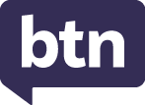
KEY LEARNING
Students will view a range of BTN stories and use comprehension skills to respond to a series of focus questions.

CURRICULUM
English – Year 4
Use comprehension strategies to build literal and inferred meaning to expand content knowledge, integrating and linking ideas and analysing and evaluating texts.

English – Year 5
Use comprehension strategies to analyse information, integrating and linking ideas from a variety of print and digital sources.

English – Year 6
Use comprehension strategies to interpret and analyse information and ideas, comparing content from a variety of textual sources including media and digital texts.

English – Year 7
Use comprehension strategies to interpret, analyse and synthesise ideas and information, critiquing ideas and issues from a variety of textual sources.
  - Teacher Resource

Focus Questions
As a class, discuss the stories featured in the BTN Special and record the main points of the discussion. Students will then respond to the following focus questions.

Interest Rate Cut
- Summarise the BTN story in three sentences. Share your summary with another student.
- Which bank decides whether to increase or decrease interest rates?
- Who is affected by interest rate cuts?
- What is inflation?
- What questions do you have about this story?

Cyclone Insurance
- Before watching the BTN story, in pairs discuss what you know about insurance. Record the main points of your discussion.
- Give examples of items people insure.
- The regular fee an insurance company charges to insure items is called a…
  - Debit
  - Premium
  - Surcharge
- What impact do experts say climate change is having on the cost of insurance?
- What did you learn watching this story?

Minimum Wage
- What was the main point of the BTN story?
- When was the minimum wage first introduced in Australia?
  - 1850s
  - 1890s
  - 1990s
- Why does the government want to increase the minimum wage?
- Why are some people against the idea?
- What do you understand more clearly since watching the BTN story?

KEY LEARNING
Students will develop their understanding of interest rates and inflation.

CURRICULUM
Mathematics – Year 5
Construct displays, including column graphs, dot plots and tables, appropriate for data type, with and without the use of digital technologies.

Mathematics – Year 6
Interpret and compare a range of data displays, including side-by-side column graphs for two categorical variables.

Mathematics – Year 7
Find percentages of quantities and express one quantity as a percentage of another, with and without digital technologies.

Investigate, interpret and analyse graphs from authentic data.

Identify and investigate issues involving numerical data collected from primary and secondary sources.

Economics & Business – Year 7
Gather relevant data and information from a range of digital, online and print sources.

Present evidence-based conclusions using economics and business language and concepts in a range of appropriate formats, and reflect on the consequences of alternative actions

Interpret data and information displayed in different formats to identify relationships and trends.
  - Teacher Resource

Interest Rates

Activity: Class discussion

Before watching
Before watching the BTN story students will discuss in small groups what they already know about interest rates and what they think this BTN story will be about.
What do you know about interest rates?

After watching
Students will respond to one or more of the following questions after watching the BTN story:
- What did you learn from the BTN story?

- What do you THINK about what you saw in the BTN story?
- Who are affected by interest rates?
- Think of three questions you have about the story.
- Write a summary of the BTN story.
- What is the key vocabulary from the BTN story? Make a list.

Activity: Glossary
Students will brainstorm a list of key words that relate to the BTN story. Students may want to use pictures and diagrams to illustrate the meaning and create their own glossary. Here are some words to get students started.

INTEREST RATES | RBA | LOAN
INFLATION | ECONOMY | DEBT

Activity: Borrowing Money
Students will explore what it means to borrow money and will look at the reasons why people borrow money. Have a class discussion to explore and investigate these concepts further, using the following questions to get the discussion started.

- Have you ever borrowed money from someone? What did you borrow the money for? Explain.
- How did you pay the money back? What sort of agreement did you have to pay the money back? Were you able to pay the money back in time?
- Alternatively, have you ever lent money to someone else? How did they pay you back and did you have an agreement to make sure the loan was paid back in time?
- As a class discuss the concept of interest and how it relates to borrowing and lending money. What sort of maths would you need to use to calculate interest?

Calculating interest
Explain to students they will be calculating the amount of interest they will need to pay on a loan from the bank to buy a new home. Students will need to determine the following:
- How much money will you need to borrow from the bank to buy your new home?
- What is the interest rate for your loan? For example, the interest on your loan may be 4%. This means that every year 4% of the money you haven’t repaid yet is added to your debt.
- How long will you need to repay the full amount of the loan? This is called the ‘length of the loan’ and normally is set at about 25 or 30 years.

Students can then use this Money Smart mortgage calculator to find out how much interest they will pay on a home loan. Students will then respond to the following focus questions:
- How much will your repayments be?
- How much interest will you pay in total?
- What happens if your interest rate increases or decreases?
- What happens if you change your repayment frequency?

Explain to students that if they encounter simple interest on short term loans, they can use the following formula to calculate the amount of interest.

Loan amount X Interest rate (decimal) X Number of years = Total interest paid
Example - Sally has borrowed $2,000 from her parents to buy a car. The interest on this loan is 5% and Sally must pay the loan back to her parents in 5 years. In total, Sally will need to pay $500 in interest.

$2,000 x 0.05 x 5 = $500

Activity: My five cents explainer
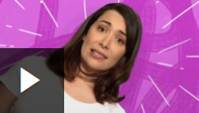
Watch this ABC Education explainer to learn how interest rates and fees affect the money you borrow, and why they may be more expensive in the long run.

Watch more of the ABC Education’s My Five Cent’s series to learn about other important financial concepts.
ABC Education – My Five Cents: Why borrowing can cost you more

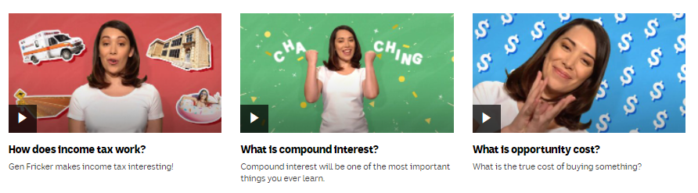

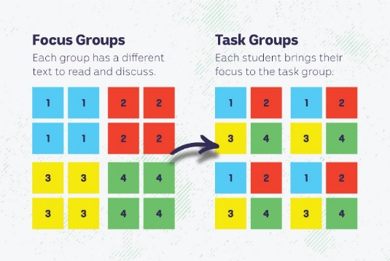
Activity: Jigsaw learning activity
In this activity students will work cooperatively to learn more about inflation, an increase in the cost of goods and services over time.

As a class, decide what time periods you will be researching as part of the jigsaw activity. For example:
- Current year compared to 50 years ago
- Current year compared to 100 years ago
- Current year compared to 20 years ago, 15 years ago, 10 years ago, and 5 years ago.

Form groups | Divide the class into 4 x Focus Groups. Each Focus Group will be assigned a different type of goods or service to investigate and become experts. Some areas of research could include: the average cost of a new home, food (choose one type of food like a loaf of bread or a sausage roll), average wage, and the average cost of a new car. Each group will need to decide how they will collect and communicate the information they find during their research.
Research | Each Focus Group will respond to the following questions to become experts:  - Find out the average cost of the goods or service in each time period you are investigating. Where and how will you find your information? Consider having a conversation with your parents or grandparents to find out more about the cost of living.  - Plot the information you have found on a bar graph. What do the axes represent? What is the graph trying to communicate? What has changed over time?  - What do you notice about your findings?  - What do you wonder about your findings?  Challenge: Use the RBA’s formula to calculate the rate of inflation:  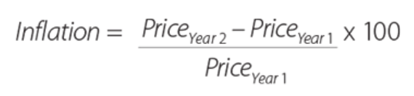
Share | Mix the Focus Groups to form Task Groups (Tasks Groups include one student from each of the Focus Groups) to share the information they have collected. Students will share the information they have collected and learn from one another. Compare and contrasts your findings.
Reflect | Students will reflect on the activity by responding to one or more of the following questions:  - What did you enjoy about this investigation?  - What did you find surprising?

Useful Websites
- Interest Rate Cut – BTN
- Interest Rates – BTN
- Inflation – BTN
- Inflation: Why are things getting more expensive? – BBC Newsround
- What it used to cost – State Library of Victoria

