Episode 30

27th October 2020



**COVID Normal**

1. What did the BTN *COVID Normal* story explain?
2. What did the Victorian government announce regarding the easing of restrictions?
3. Finish the following sentence: For the first time since June, Victoria had its first day of….
4. What does it mean to go on a ‘bubble’ holiday?
5. Parts of Australia have agreed to open up borders to which country?
6. Why is that country not letting Aussies in yet?
7. International travel is unlikely to happen until when?
8. The Australian government has announced all state borders will be ready to open by Christmas, except for:
   1. New South Wales
   2. Victoria
   3. Western Australia
9. What is it important for people to continue to do to stop the spread of the virus?
10. What do you understand more clearly since watching the BTN story?

**Spotting Deepfake Videos**

1. Before you watch the BTN story, record what you know about deepfake videos.
2. Discuss the BTN *Spotting Deepfake Videos* story as a class and record the main points of the discussion.
3. What is a deepfake video?
4. Complete the following sentence. Deepfake videos use ______________ intelligence software.
5. Facebook challenged coders to develop an algorithm to automatically detect a deepfake. What was the best success rate for detecting one?
   1. 45%
   2. 65%
   3. 85%
6. What is the aim of project Fake Out?
7. Why are experts worried about people not being able to spot deepfake videos?
8. What questions do people need to ask themselves about spotting a deepfake video?
9. Have you ever spotted a deepfake video? Explain your answer.
10. What did you learn watching this story?

**History of the UN**

1. Where are the headquarters of the United Nations?
2. What anniversary did the United Nations recently celebrate?
3. When and why was the United Nations created?
4. What sorts of things does the United Nations Charter cover?
5. How many countries are part of the UN?
6. What does the UN Security Council do?
7. What happens at the General Assembly?
8. What is the name of the UN organisation that helps improve the lives of kids?
9. What do critics of the UN say about the organisation?
10. What questions do you have about the UN?

Check out the [History of the UN resource](https://www.abc.net.au/btn/teachers/) on the Teachers page.

**Mt Resilience AR App**

1. Discuss the *Mt Resilience AR App* story with another student and record the main points.
2. Australia has always had severe weather. True or false?
3. Finish the following sentence: In more recent decades, Australia is getting longer and more intense…
4. Is Australia experiencing more or fewer floods in recent years?
5. What has the ABC created to look at how we can adapt to a changing climate?
6. Briefly explain what Mt Resilience is.
7. Mt Resilience explains what sorts of things can be done to adapt to a changing climate. Give some examples.
8. What do you think it means to be disaster resilient?
9. What was surprising about this story?
10. What do you understand more clearly since watching the BTN story?

Check out the [Mt Resilience resource](http://www.abc.net.au/btn/teachers.htm) on the Teachers page.

**Fiver for a Farmer**

1. What was the main point of the BTN story?
2. How old is Jack?
3. What is ‘Fiver for a Farmer’?
4. What inspired Jack to start ‘Fiver for a Farmer’?
5. Describe the success of ‘Fiver for a Farmer’ when it first began.
6. How did Jack change his fundraising during COVID?
7. How much money has ‘Fiver for a Farmer’ raised?
   1. $80,000
   2. $180,000
   3. $1.8 million
8. What project did Jack work with Lego on?
9. What advice does Jack give about how to make a difference?
10. How did this story make you feel?

Teacher Resource

Episode 30

27th October 2020

**History of the UN**



Students will learn more about the United Nations, why it was created and its role in the world today.



**HASS – Years 5 and 6**

Work in groups to generate responses to issues and challenges.

Locate and collect relevant information and data from primary sources and secondary sources.

Sequence information about people’s lives, events, developments and phenomena using a variety of methods including timelines.

Present ideas, findings, viewpoints and conclusions in a range of texts and modes that incorporate source materials, digital and non-digital representations and discipline-specific terms and conventions.

**HASS – Year 7**

Collaborate to generate alternatives in response to an issue or challenge and compare the potential costs and benefits of each.

Apply a methodology to locate and collect relevant information and data from a range of primary sources and secondary sources.

Sequence information about events, developments, periods and phenomena using a variety of discipline-appropriate formats and conventions including chronological frameworks that use dating conventions.

Present ideas, findings, viewpoints, explanations and conclusions in a range of texts and modes that incorporate source materials, citations, graphic representations and discipline-specific terms, conventions and concepts.



1. Where are the headquarters of the United Nations?
2. What anniversary did the United Nations recently celebrate?
3. When and why was the United Nations created?
4. What sorts of things does the United Nations Charter cover?
5. How many countries are part of the UN?
6. What does the UN Security Council do?
7. What happens at the General Assembly?
8. What is the name of the UN organisation that helps improve the lives of kids?
9. What do critics of the UN say about the organisation?
10. What questions do you have about the UN?



**Class Dis****cussion**

After watching the BTN *History of the UN* story, students will respond to the following questions:

* What did you SEE in this video?
* What do you THINK about what you saw in this video?
* What does this video make your WONDER?
* What did you LEARN from this story?
* What was SURPRISING about this story?



**Class Discussion**

As a class discuss the BTN *History of the UN* story, using the following questions as a guide. Record the main points of the discussion.

* When and why was the United Nations formed?



* What is the purpose of the United Nations?
* Think of 5 words which best describe the United Nations.
* Is it important to have the United Nations? Why or why not?



**KWLH**

The KWLH organiser provides students with a framework to explore their knowledge of the United Nations and consider what they would like to know and learn.

|  |  |  |  |
| --- | --- | --- | --- |
| ***What do I know?*** | ***What do I want to know?*** | ***What have I learnt?*** | ***How will I find out?*** |
|  |  |  |  |

**Research questions for inquiry**

Students will determine a focus for their inquiry and develop a key question to guide their inquiry (below are some examples). Students will collect and record information from a wide variety of sources.

* Why was the United Nations created? Explore the history of the United Nations highlighting your findings on a timeline. Find and collect images, photographs, illustrations and video as part of your research.
* What is the role of the United Nations? Research the 4 most important goals of the United Nations and present your findings to the class.
* How many countries are members of the United Nations? Find out how a country becomes a member of the United Nations. When did Australia become a member of the UN and what is its role?
* What are some things the United Nations is involved in today? Choose one project and research in more detail.
* What is the UN Security Council? How many countries are permanently on the UN Security Council and what can they do?



**Youth addressing the UN**

As a class watch one or more of the following videos to learn more about young people who have addressed the United Nations on a range of issues.

|  |  |
| --- | --- |
| [BTN “Raise the Age"](https://www.abc.net.au/btn/classroom/raise-the-age/12507078) Meet Dujuan, an Arrernte/Garrwa boy who’s passionate about the issue of raising the age of kids put in detention who, last year, took his argument to the United Nations.  [Dujuan addressing the UN Human Rights Council, YouTube](https://www.youtube.com/watch?v=b8JpUUWYumw) | [BTN Newsbreak - Greta's passionate UN speech](https://www.abc.net.au/btn/newsbreak/gretas-un-speech/11542200) 16-year-old environmental campaigner Greta Thunberg delivers a powerful message to world leaders. |

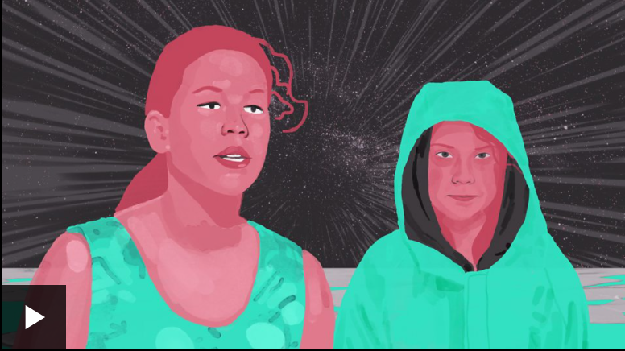

[Severn Cullis-Suzuki’s speech at Rio Summit 1992, YouTube](https://www.youtube.com/watch?v=oJJGuIZVfLM).

Watch this animated BBC video called “[The child who tried to save the world…in 1992](https://www.bbc.co.uk/ideas/videos/the-child-who-tried-to-save-the-world-in-1992/p07zxlwx?playlist=sustainable-thinking)”. In 1992, when she was just 12, Severn Cullis-Suzuki warned the world about the environmental crisis. Here she tells her story.

After watching one or more of the videos students will respond to the following questions:

* What issue did they talk about in their address to the United Nations?
* Why do you think they wanted to address the United Nations?
* What impact did their speech have?
* How did the speech make you feel?
* What part of the speech (1-2 sentences) had the most impact on you? Why?
* Why is it important for young people to voice their concerns about global issues?

**Further challenge – Be a diplomat**

In this activity students will play the role of diplomats and prepare a speech about an issue they are passionate about. Students will then imagine they are delivering their speech to world leaders at a United Nations Summit (and deliver their speech to the class).



**Jigsaw learning activity**

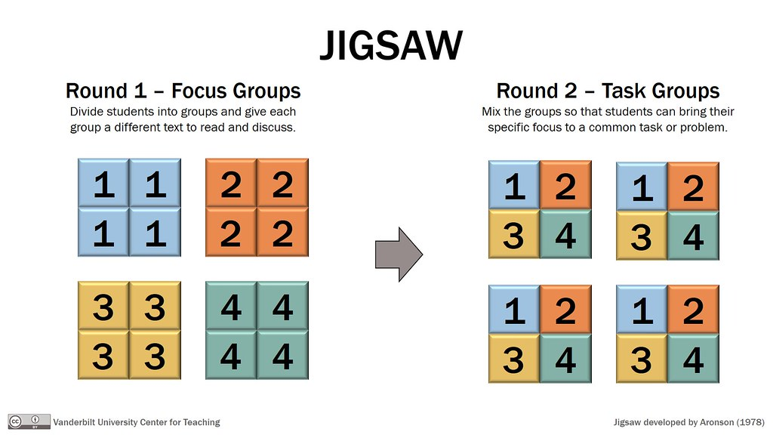

In this activity students will work cooperatively to learn more about United Nations’ International Days. Each group will become experts and then share what they have learnt with other students.

|  |  |
| --- | --- |
| **Form groups** | Divide the class into 6 x Focus Groups. Each Focus Group will be assigned a different United Nations International Day to investigate and become experts (for example World Oceans Day, World Food Safety Day, World Bee Day, World Malaria Day, World Health Day, International Day of Happiness, World Refugee Day plus many [more](https://www.un.org/en/sections/observances/international-days/)). Each group will need to decide how they will collect and communicate the information they find during their research. |
| **Research** | Each Focus Group will respond to the following questions to become experts:   * When is the day observed? * What is the day celebrating or observing? * What is the aim of the day? * What is the theme of the day for 2020? * What are some achievements that have been made in this area? * What are some issues of concern? * What does the day mean to you? * Think of an interesting way to create awareness about the day in your school community. |
| **Share** | Mix the Focus Groups to form Task Groups (Tasks Groups include one student from each of the Focus Groups) to share the information they have collected. Students will share the information they have collected and learn from one another. |
| **Reflect** | Students will reflect on the activity by responding to one or more of the following questions:   * What did you enjoy about this investigation? * What did you find surprising? |



**Choose a project**

Individually or in small groups, students will choose one of the following projects to work on and then present their findings to the class.



**FAQ or Crossword**

Compile your own FAQ (Frequently Asked Questions) or quick crossword about the United Nations. Test your classmate’s knowledge!

**UNICEF drawing challenge**

Do you love drawing? Do you want to change the world? Pick a cause that matters to you and create an original illustration that shows the world you want to build. Be a part of [UNICEF’s drawing challenge](https://www.voicesofyouth.org/world-childrens-day-challenge) here!

**Public speaking**

Choose a current event that is important to you. Write a speech about the topic and deliver it to your class. Your aim is to raise awareness about the issue and practice your public speaking skills.

**World Children’s Day**

Design a poster to celebrate World Children’s Day (20th of November 2020). Write a letter to members of the UN expressing your hopes and dreams for young Australians now and into the future.



**BTN Stories**

Watch the [BTN Peace Games story](https://www.abc.net.au/btn/classroom/peace-games/11506050) to learn more about a board game developed to prove that kids can make great diplomats.

1. Discuss the BTN *Peace Games* story as a class and record the main points of discussion.

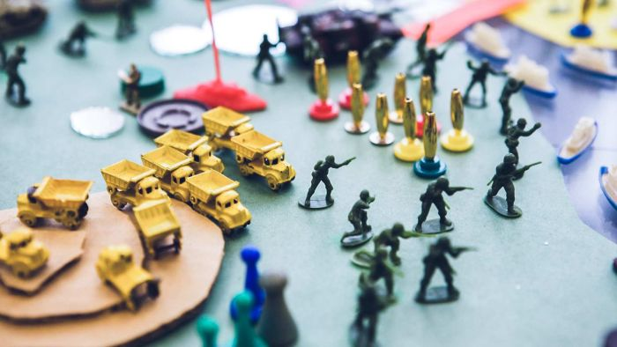

1. Who invented the World Peace Game?
2. How would you describe the World Peace Game?
3. What is the aim of the World Pease Game?
4. What type of roles are assigned to people playing the World Peace Game?
5. Complete the following sentence. At the beginning each country is given a __________.
6. Give an example of an issue that needs to be solved during the game.
7. What did the kids in the BTN story learn from playing the World Peace Game?
8. What world issues are most important to you? List your top 3.
9. What did you like about this story?



History of the United Nations – UN

<https://www.un.org/en/sections/history/history-united-nations/index.html>

Peace Games – BTN

<https://www.abc.net.au/btn/classroom/peace-games/11506050>

What is the United Nations? – CNNC Newsround

<https://www.bbc.co.uk/newsround/41159389>

Voices of Youth – Unicef

<https://www.voicesofyouth.org/>

UN Matters teaching pack – UNA-UK

<https://www.una.org.uk/get-involved/learn-and-teach/un-matters-teaching-pack>

Teacher Resource

Episode 30

27th October 2020

**Mt Resilience AR App**



Students will learn more about adapting and responding to extreme weather events.

**Geography – Year 5**



The impact of bushfires or floods on environments and communities, and how people can respond.

**Science – Year 6**

Scientific understandings, discoveries and inventions are used to solve problems that directly affect peoples' lives.

The growth and survival of living things are affected by physical conditions of their environment.

Sudden geological changes and extreme weather events can affect Earth’s surface.



1. Discuss the *Mt Resilience AR App* story with another student and record the main points.
2. Australia has always had severe weather. True or false?
3. Finish the following sentence: In more recent decades, Australia is getting longer and more intense…
4. Is Australia experiencing more or fewer floods in recent years?
5. What has the ABC created to look at how we can adapt to a changing climate?
6. Briefly explain what Mt Resilience is.
7. Mt Resilience explains what sorts of things can be done to adapt to a changing climate. Give some examples.
8. What do you think it means to be disaster resilient?
9. What was surprising about this story?
10. What do you understand more clearly since watching the BTN story?



**Class Discussion**

As a class discuss the BTN *Mt Resilience AR App* story, using the following questions as a guide. Record students’ responses.



* What extreme weather does Australia experience? Give examples.
* What impact can extreme weather have on people and the environment?
* What does it mean to be resilient?
* What does it mean to be disaster resilient?
* What did you learn from the BTN *Mt Resilience AR App* story?
* Think of three questions you have about the story.



**Key Words**

Students will brainstorm a list of key words that relate to the BTN *Mt Resilience AR App* story. Here are some words to get you started.

|  |  |  |
| --- | --- | --- |
| **Resilience** | **Natural disaster** | **Cultural burning** |
| **Extreme weather** | **Predict** | **Prepare** |
| **Fire resilient** | **Adapt** | **Climate** |



**Mt Resilience**

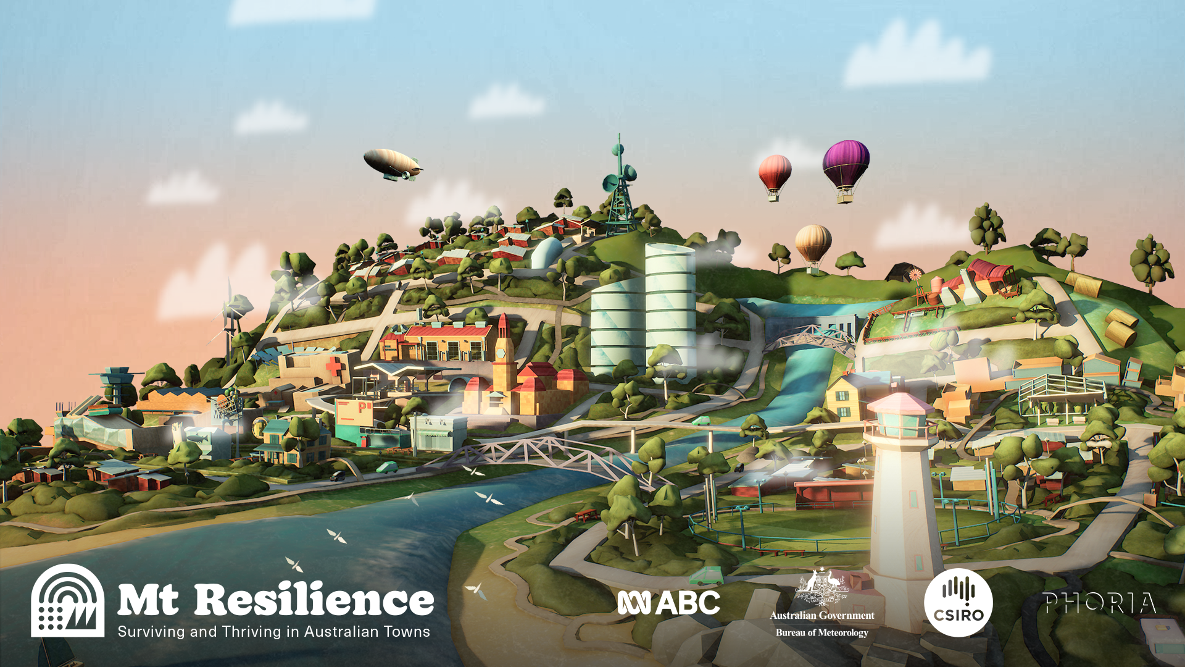

Students will visit Mt Resilience – an augmented reality experience that allows students to explore a town that’s been designed around climate and disaster preparedness.

The app works on both phones and tablets. Get the app [here](https://www.mtresilience.com/). Go [here](https://help.abc.net.au/hc/en-us/articles/360002034456-How-can-I-try-Mt-Resilience-the-ABC-s-new-Augmented-Reality-experience-) to find out more about the technical specifications for the app.

**Explore the features of Mt Resilience**

Working in pairs, look around Mt Resilience. Practise navigating your way around the town by zooming and rotating. Respond to the following:

* Mt Resilience is a town that’s built to adapt to our changing…
* As you look around the town, what do you notice?

Tap each of the four information icons - Community Centre, Communication, Medical Centre and Wildlife.

* **Community Centre** – Why are community centres important when preparing for and recovering from a disaster?
* **Communication** – Why is communication essential during a disaster?
* **Green zone** – Mt Resilience is surrounded by a green zone. Why is a green zone important?
* **Emergency Plans** – Residents of Mt Resilience have their own emergency plan. What do they do to get their plan together?
* **Wildlife –** How do the people of Mt Resilience value and protect wildlife?
* **Government** – How does the council work with local residents in Mt Resilience?

There are two play arrows. They will take to you to the **Fire Resilient House** and **Cultural Burning**

**Fire Resilient House**

* How do Sam and Ayla prepare their property for bushfires?
* Explain their power set up.
* What is their bushfire evacuation plan?
* Explore the features of Sam and Ayla’s house by tapping on the information icons.

Research examples of bushfire resilient buildings (homes and schools) and gardens. Design a bushfire resilient house or garden. What are the features that make it bushfire resilient?

**Cultural Burning**

* What is cultural burning?
* What do rangers consider when they do a low intensity cultural burn?
* What do practices like cultural burning promote?
* Record what you know about the importance of Country to Aboriginal and Torres Strait Islander people.
* How can we learn from Aboriginal and Torres Strait Islander people about looking after Country?
* Explore each information icon in the cultural burning area.

To learn more about cultural burning, go to the [Firesticks website](https://www.firesticks.org.au/about/cultural-burning/). This [Traditional burning video](https://www.sbs.com.au/news/traditional-burning-reviving-indigenous-cultural-burns-for-bushfire-management)

explores bushfire management practices in more detail.

**Mt Resilience – Bushfire Scenario**

Tap on the fire icon at the bottom of the screen and listen to the bushfire scenario.

* How did the residents of Mt Resilience prepare for the bushfires?
* How did the community respond to the bushfire?
* Why do you think a bushfire recovery plan is important?



**Disaster Resilience Resources**

Below is a collection of resources that support both teachers and students learn more about disaster resilience and preparedness.

|  |  |
| --- | --- |
| ABC Education [Big Weather resources](https://education.abc.net.au/home/#!/topic/3710253/big-weather-and-how-to-survive-it) | [Disaster Resilience Teaching Resources](https://disasterresiliencetas.com.au/) |
| [Project Firestorm](https://www.projectfirestorm.com.au/) | [Survive and Thrive in a Bushfire](https://youtu.be/NC9ELky49gE) |



**BTN stories**

These BTN stories look at the impact extreme weather and natural disasters have on people and the environment. After watching any one of the BTN videos ask students to respond to the discussion questions (to find the teacher resources go to the related BTN Classroom Episode and download the Episode Package).

|  |  |  |
| --- | --- | --- |
| [Extreme Weather](https://www.abc.net.au/btn/classroom/extreme-weather/10790694) | [Fire Preparations](https://www.abc.net.au/btn/classroom/fire-preparations/10525718) | [Black Summer Bushfire Special](https://www.abc.net.au/btn/classroom/20200204-ep1-btn/11911010) |
| [Heatwaves](https://www.abc.net.au/btn/classroom/heatwaves/10521882) | [Burn off Season](https://www.abc.net.au/btn/classroom/burn-off-season/10522544) | [Bushfire Plan](https://www.abc.net.au/btn/classroom/bushfire-plan/10529444) |



Mt Resilience AR App – ABC

<https://www.mtresilience.com/>

Big Weather (and how to survive it) – ABC iView

<https://iview.abc.net.au/show/big-weather-and-how-to-survive-it>

Big Weather Resources – ABC Education  
<https://education.abc.net.au/home#!/topic/3710253/big-weather-and-how-to-survive-it>

Teaching Resources – Australian Institute for Disaster Resilience

<https://www.schools.aidr.org.au/disaster-resilience-education/teaching-resources/#/>

Extreme Weather – BTN

<https://www.abc.net.au/btn/classroom/extreme-weather/10790694>

Black Summer Bushfire Special - BTN

<https://www.abc.net.au/btn/classroom/20200204-ep1-btn/11911010>

**BTN Transcript: Episode 30 – 27/10/20**

Yaama I’m Jack and you're watching BTN. Here's what's coming up. We find out the best way to spot a deepfake, how Australian towns are changing to cope with extreme weather and we meet a young Aussie who's raised millions to help our farmers.

COVID Normal

Reporter: Cale Matthews

*INTRO: For the first time since early June Victoria has had a day with no new cases of coronavirus. It's great news, but the virus itself isn't going anywhere. The Australian government says it could still take up to 12 months to roll out a vaccine and until that happens, we'll have to get used to living in a world with COVID-19.*  
Life is slowly getting back to normal for many Aussies but with coronavirus still around, it's a very different version of normal and nowhere else in the country understands that better than Melbourne. It’s the announcement every Melbournian has been waiting for.  
  
DAN ANDREWS, VICTORIAN PREMIER: I am very pleased to be able to announce that from 11:59pm Tuesday October 27, all retail will open. Restaurants, hotels, cafe’s, and bars, they will reopen as well.  
  
And that's not all. Outdoor sport will restart for under 18s and people will be able to leave their house for whatever reason they want, as long as they stay within 25 kilometres.  
  
DAN ANDREWS, VICTORIAN PREMIER: Now is the time to open up, now is the time to congratulate every single Victorian for staying the course.  
  
The announcement comes after Victoria recorded zero, naught, not even one coronavirus case or death on Monday.  
  
CALE, REPORTER: And that’s something many people are calling donut day and that's something I'm totally on board with.  
  
Then on Sunday more restrictions will be lifted and people will be able travel anywhere in the state they want.   
  
CALE: If you're like me, you could probably do with a holiday right about now. But like a lot of things holidays are gonna be a bit different. So, what is travel gonna look like in this COVID normal world?  
  
Yep, if you're going anywhere soon, you're going bubble style. That means quarantine free travel but only to particular areas or countries. Parts of Australia have agreed to open up borders to New Zealand but keep them closed to everyone else. And just last week, we got our first batch of New Zealand arrivals. At the moment it’s only a one-way bubble. New Zealand isn't letting Aussies in, well not yet anyway.   
  
JACINDA ARDERN, NZ PRIME MINISTER: The reason for that decision for us is safety. In our view we are not ready to have quarantine free travel with Australia.  
  
As for heading further abroad, well don't get your hopes up. The government says that without a vaccine, international travel is off the cards until at least late next year. If you are looking for a little getaway this summer, it’s probably gonna be in your own backyard I mean not literally, but you can if you want. The Aussie government has said they want all state borders open by Christmas, except for Western Australia. Tasmania, South Australia, Queensland, and the Northern Territory are all open to visitors providing they aren't coming from a COVID-19 hotspot. While the Western Australian government say they're still gonna keep their borders shut. One thing that isn’t going to change is that we still need to be doing the right things to keep COVID safe. Living with the virus for the foreseeable future means doing many of the things we've all been working on this year, even if there aren't many or any cases where we are.   
  
DAVID NABARRO, WORLD HEALTH ORGANISATION: We are saying don't just let this virus go and infect whoever it wants to infect. Keep defending against it using proper what we call public health techniques and personal precautions.  
  
This means keep doing physical distancing where possible, all the proper hygiene stuff and make sure we get tested if we have any COVID symptoms. Because until we have a vaccine that's just our new COVID normal.

News Quiz

Which tech giant has been taken to court by the US government? Apple, Google or Facebook? It's Google. The US government says people have been forced to use Google's search engine and that's unfair. The government says the company is abusing its power. Google doesn't agree.  
  
NASA enjoyed some socially distanced celebrations this week after a successful mission by its OSIRIS-Rex spacecraft. Did it land on the Moon, reach Mars or land on an asteroid? It landed on an asteroid. The craft collected samples of its surface to bring back to Earth.  
Donald Trump and Joe Biden faced off the in the final US presidential debate. What big change did organisers make this time around after the first debate got a bit heated? The option to mute microphones.  
  
What colour do you think these shoes are? Pink and white or mint green and white? Billie Eilish recently asked her followers that exact question and it divided the internet. She says it's just an optical illusion and mint green is definitely the answer.

Spotting Deepfake Videos

Reporter: Cale Matthews

*INTRO: You've probably seen, or at least heard of deepfake videos. They use artificial intelligence to fake a person's likeness sometimes for fun, but sometimes not. So, for Media Literacy Week, let's take a close look at how you can spot the real deal from the fake.*

These kids are taking a test to see if they can spot the difference between a real video and a deepfake.  
  
KID: It Looks like the face matches the body quite well.  
  
KID: I'm not sure the skin tones a bit weird.

KID: I don’t know do you reckon that face matches the body though?

KID: I don’t know, but I honestly don’t even know.

KID: it didn’t kook as weird as the other one.

Wait this one. It looks more like pixelated.

KID: Yeah but the facial expression looks more bland in this one.  
  
CALE, REPORTER: If you haven't been on the internet or you're still wondering if Home Stallone was an actual blockbuster, a deepfake uses artificial intelligence to basically swap out one person’s face for another, often to make them say or do things that are completely out of character.

And even though a lot of these videos are obviously ridiculous in others the line between what's real and what isn't is becoming rather pixelated. Last year Facebook challenged coders to develop an algorithm to automatically detect a deepfake. Of the thousands of algorithms submitted the best had a success rate of about 65 percent.  
  
DR. SIMON CROPPER, UNIVERSITY OF MELBOURNE: Really, 65 percent of the time is actually not that much better than guessing, which is not good enough for something that's supposed to automatically detect fakes.  
  
CALE: It's why researchers like Simon here have launched a project called Fake Out. He wants to know whether us regular humans with our regular human eyes can sort the fact from the fake better than a computer.  
  
SIMON CROPPER, UNIVERSITY OF MELBOURNE: So, we took a selection of those videos, put them into a survey, and we basically just asked people to look at the video, only once, and make a judgement whether it is real, or whether it is fake and we found on average the performance across everybody is exactly the same as the code. So basically, on average we're really not that good at it.  
  
CALE: Yeah, turns out while some deepfakes are kind of easy to spot, others can leave us stumped.  
  
KID: I have no idea.

KID: I think, umm.  
  
A lot of experts are worried that if we struggle to separate fact from the video based fiction, clips similar to this can be used to spread fake news.  
  
MARK ZUCKERBERG, FACEBOOK: We just want to predict your future behaviours.  
  
CALE: At the start of the year Facebook announced that it would take down any deepfakes that were deliberately aimed to mislead people, but back in April President Trump re-tweeted a fake video of Joe Biden and more recently this doctored footage of the presidential candidate went viral.  
  
SIMON CROPPER, UNIVERSITY OF MELBOURNE: That's a real issue, because that can potentially change someone's mind about who they're going to vote for, for one of the most powerful people in the world.  
  
While there is software out there that can recognise deepfakes, a lot of experts say it's also up to us to really think and question what we see. Where is the video coming from? Can you trust it? Are other news sources talking about it? And don't forget a good pinch of common sense.  
  
SIMON CROPPER, UNIVERSITY OF MELBOURNE: If you have that sense of all that doesn't feel right, believe in that because there's a good chance it probably doesn't feel right for a good reason.

KID: Yeah, I’m not completely confident that it’s fake, but we can go fake.

Ask a Reporter

If you wanted to know more about deepfakes and Media Literacy in general, you can ask me live on Ask a Reporter this Friday. Just head to our website for the details.

History of the UN

Reporter: Olivia Mason

*INTRO: The United Nations has just celebrated its 75th birthday. The organisation is made up of 193 countries who have all agreed to work together to make the world a safer and better place. Let's take a look at the UN's history, and the important role it still has today.*

In one of the busiest cities in the world, between iconic buildings and hot dog stands, sits the headquarters of an international organisation with one mission, world peace. I'm talking of course about the United Nations or the UN for short. You've probably heard of it before. The UN first became a thing in 1945, just after the Second World War. The big allied four wanted to prevent another huge war from ever happening again, so they formed a new organisation designed to do just that.

NEWS REPORTER: San Francisco California, a momentous conference begins. Here leaders of the United Nations representing all, but a fraction of the Earth’s population are laying the foundations of international security in the post war world.   
  
On the 25th of April 1945, 850 representatives from 50 countries met in what was, at the time, the largest international gathering ever. The end result was this, the United Nations Charter. It's a legally binding contract between all the countries involved and includes all the things the UN wants to achieve, like getting rid of poverty and disease, providing food and aid to those who need it, improving health services, disaster relief, protecting humans rights and making sure countries follow international laws. On the 24th of July 1945, after a bunch of revisions, it was agreed upon and signed by all the countries involved. And a couple of months later on the 24th of October it came into force, the date we now mark as the UN's birthday.   
  
Today the United Nations consists of 193 countries and has accomplished a lot of the things it first set out to do. It's managed by the Security Council, which is made up by five permanent members France, Britain, the United States, China and Russia. They're in charge of helping countries resolve conflicts. To help make any decisions the UN holds a General Assembly. Which is overseen by this guy, Antonio Guterres, the UN Secretary General. It's held every year in September at New York headquarters. A lot of people are invited to speak there, and it's given many people, not just politicians, a platform to have their voice heard. Even Beyonce has belted out a ballad for the assembly. You sure were Beyonce, you sure were. The United Nations now has a bunch of specialised agencies, like the World Health Organisation and UNICEF, which helps to improve the lives of kids especially those in disadvantaged areas.  
  
While it all sounds pretty good, the organisation has some critics who say the United Nations isn't as effective as it should be, that it favours some countries over others and that it spends way too much money to operate. But over the weekend, as the UN turned 75, lots of people helped celebrate what it has accomplished and what it can still achieve.

Quiz

Which of these is not an organisation run by the United Nations? Is it the World Health Organisation, Red Cross or the International Monetary Fund? It's the Red Cross. The humanitarian organisation dates all the way back to 1863. Officially called the International Red Cross and Red Crescent Movement it has 97 million volunteers around the world.

Mt Resilience AR App

Reporter: Jack Evans

*INTRO: Bushfires and big storms are part of Australian life. But what if they keep getting bigger and happen more often? The ABC's just launched a new augmented reality experience giving us a sneak peek into the ways our towns and cities will have to adapt.*

Australia is home to some pretty wild weather, and it feels like we've seen a lot of it lately. Someone who knows all about that is ABC weather guru Nate Byrne.   
  
JACK: Hi Nate, how's the weather?   
  
NATE BYRNE, ABC NEWS BREAKFAST: Jack the weather is the most interesting thing there is.   
  
JACK: It's fair to say Australia's got some pretty wild weather, yeah?   
  
NATE: We do. Australia's a really, really big country you know. We have parts of Australia that are well up into the tropics up in Darwin and Cairns. And then places right down south that are, well, not that far away from getting into the arctic. Like the bottom of Tassie can get pretty chilly down there. So with all of that space and all of the different weather that can move through an area that big means that we pretty much get it all.  
  
JACK: In recent years we've seen everything from droughts, fires, floods. Are natural disasters becoming more common?   
  
NATE: Some are becoming more common, some aren't. It really depends on what you're looking at. So, Australia's always had severe weather and a wide range of severe weather and we always will. But in recent decades certain things are becoming a little bit more likely to happen. Like we're getting longer and more intense droughts and heat waves as well and that means more bushfire weather. But things like cyclones we're not really getting any more of them. They're likely to get a bit more intense, on average, but they're not really anymore in number. We are getting more floods when we're lucky enough to get rain though and that's all thanks to climate change.   
  
So how do we prepare for these types of big weather? Well that's something the ABC's been looking at in its Big Weather (and how to survive it) TV series. And now, you can get a hands-on look at how we might need to adapt. The ABC's teamed up with the CSIRO and the Bureau of Meteorology to create an augmented reality experience of an Australian town in the future.   
  
NATE: Mt Resilience is all about showing people that there is a way for us to survive what's coming and to do it well and to thrive all the while. So it's a bit of a good news story and maybe gives you a hint about what the future might look like.  
  
That includes things like buildings that can withstand strong winds and storms, flood plains that can absorb water during a flood and traditional Indigenous practices like cool burns. When small fires are burnt across large areas on purpose to avoid bigger bushfires in the future.  
  
JACK: And hey in the meantime we can always check in with you for all our weather updates.  
  
NATE: I do weather every day and even if I wasn't a weather presenter on television I would still have my head in it because it's my science and I love it. Thanks Jack.

Did You Know?

Did you know that hurricanes, typhoons and cyclones are all the same thing: tropical storms? But they're known by different names in different locations.

Sport

It's been a weekend of wins for Melbourne footy fans with the Richmond Tigers and the Melbourne Storm taking the premierships in the AFL and NRL grand finals.  
  
Tensions were high during the NRL Final and for Melbourne Storm coach Craig Bellamy it got a little too much but by the end of the match, it’s safe to say he'd cooled down.  
  
In the NRLW Grand Final the Brisbane Broncos continued their absolute domination of the comp with their 3rd title in a row.   
In the AFL Grand Final, it was a massive cat fight as the Tigers faced off against Geelong. There was plenty to celebrate. Richmond won their 3rd flag in 4 years and Dustin Martin became the first player in history to win 3 Grand Final Best on Ground medals. There was also a touching send off for AFL legend Gary Ablett who hung up his boots after the game. For the Tigers fans that came from all over the country it was well worth the trip. And for the team, well.

Fiver for a Farmer

Rookie Reporter: Jack

*INTRO: Finally, today we're going to hear from 12-year-old Jack Berne. He's raised nearly two million dollars to help farmers around the country who are struggling with drought. Now, he's been chosen to represent Australia in Lego form as part of a global campaign.*

JACK BERNE: Hi BTN. I'm Jack Berne. I live in Sydney. I'm 12 years old and I started a Fiver for a Farmer.  
  
Well Fiver for a Farmer is a charity I started about 3 years ago to help farmers in drought all over just watching a BTN clip and just seeing how in need the farmers were just really burnt that fire in my belly.  
  
KID 1: It's dry. The whole property is dry. There's no green at all.  
  
JACK: So, I went home to mum and I said there's a massive problem. There's a drought. And she didn't really know what I was talking about so I did some more research and then I decided to write an email to anyone who would listen about my idea: A Fiver for a Farmer, to help Aussies in drought by dressing up and bringing in five dollars.  
  
Well, Fiver for a Farmer's first event was kind of a small one, you know, we were just trying to figure out things and then out of nowhere 1200 schools registered, over 600 pre-schools, 500 workplaces, all to do with my idea. And we raised 20,000 dollars in 13 hours.   
  
KID 2: Thank you farmers.

KID 3: Thank you farmers for all our food.  
  
JACK: Our last big event with COVID, which is just a bit of a handful, I decided to take a slight pivot, and not just constantly donating but buying Aussie produce because that's like one of the main direct ways we could get back to our farmers. And so that was what the whole year was about was still dressing up and raising awareness but bringing in an all Aussie lunch.  
  
Hey guys, now we're just popping into my little cousins Harry and Max just to make sure they're eating an all Australian produce lunch. Alright let’s go. So now we're just checking with Max what he's got for his lunch and recess. Yummy oranges. Who doesn't love an orange? And that's probably a product of Australia.  
  
I definitely did not think Fiver for a Farmer would get this big. It's crazy that three years ago I wanted to raise a thousand dollars and I've raised 1.8 million dollars. It's just so cool and I'm so grateful that this all happened to me and I've made such a big effect on so many peoples' lives and it's awesome.  
  
SCOTT MORRISON, PRIME MINISTER: Can you believe it was a year ago that we went up to Dalby.  
  
JACK: I met the Prime Minister, which not many people get to meet and I got to go on his private plane, and go out to the country and meet so many amazing people.  
  
I've got to work with Lego and about rebuilding the world. And the question was, how would I rebuild the world. So, this is the crops up the front, the water stream, and a rainbow to show hope and diversity. You got your windmill for power, and your little farmer Jack. My creation, Farming Hope is all the way over in Denmark on this four-metre globe and I cannot believe that really happened.   
  
My advice for other kids to make a difference is, I guess, just be bold. Don't always hide and just come out with your idea, because there's so many amazing people in the world today and they will listen. So just be bold and be brave and have a great idea.

Closer

Well that's it for today, but thanks for watching. We’ll see you next week and, in the meantime, you can head to our website to check out more stories and quizzes and specials and all kinds of things. See you then.