
EPISODE 19
25th July 2023

KEY LEARNING
Students will view a range of BTN stories and use comprehension skills to respond to a series of focus questions.

CURRICULUM
English – Year 4
Use comprehension strategies to build literal and inferred meaning to expand content knowledge, integrating and linking ideas and analysing and evaluating texts.

English – Year 5
Use comprehension strategies to analyse information, integrating and linking ideas from a variety of print and digital sources.

English – Year 6
Use comprehension strategies to interpret and analyse information and ideas, comparing content from a variety of textual sources including media and digital texts.

English – Year 7
Use comprehension strategies to interpret, analyse and synthesise ideas and information, critiquing ideas and issues from a variety of textual sources.
  - Teacher Resource

Focus Questions
As a class, discuss the stories featured in the episode of BTN Classroom and record the main points of the discussion. Students will then respond to the following focus questions.

Northern Hemisphere Heatwave
- Name some of the countries in the Northern Hemisphere that have been affected by recent heatwaves. Find on a map.
- What affect are heatwaves having on the environment and on people?
- What natural weather phenomena is partly to blame for heatwaves in the Northern Hemisphere?
  - El Nino
  - La Nina
- What is the definition of a heatwave?
- What factors can contribute to a heatwave?

Check out the teacher resource on the Archives page.

Hollywood Strike
- Summarise the BTN Hollywood Strike story using your own words.
- Who is currently on strike in Hollywood?
  - Actors and writers
  - Producers and directors
  - Extras and crew
- Why are they going on strike in Hollywood?
- How have the strikes in Hollywood impacted on productions in Australia?
- What questions do you have about the story?

Women’s World Cup
- Who is hosting the 2023 Women’s World Cup?
- When was the Women’s World Cup officially recognised by FIFA?
  - 1976
  - 1991
  - 2023
- What is the name of the Australian women’s soccer team?
- Women playing A-League soccer receive less money as men for the same achievement. True or false?
- Who do you think will win the Women’s World Cup?

Check out the teacher resource on the Archives page.

Europe Trade Names
- Why does the EU want to restrict Australia from using food names like feta or Edam?
- What does GI stand for?
  - Geographical Indications
  - Geographical Index
  - Geographical Import
- What does feta mean in Greek?
- Which country does Edam cheese come from?
- What did you learn watching the BTN story?

Skateboard 720 Trick
- How old was Arisa when she started skateboarding?
- What is the 720 skateboarding trick? Describe.
- What was the crowd’s reaction when Arisa landed the trick?
- Who was the first person to land the 720 trick?
  - Tony Hawk
  - Arisa Trew
  - Nyjah Huston
- What advice does Arisa give to those that want to try skateboarding?

EPISODE 19
25th July 2023

KEY LEARNING
Students will investigate what heatwaves are, what causes them and how they impact people and places.

CURRICULUM
Geography – Year 5
The impact of bushfires or floods on environments and communities, and how people can respond.

Geography – Year 7
Evaluate sources for their reliability and usefulness and select, collect and record relevant geographical data and information, using ethical protocols, from appropriate primary and secondary sources.

Interpret geographical data and other information using qualitative and quantitative methods, and digital and spatial technologies as appropriate, to identify and propose explanations for spatial distributions, patterns and trends, and infer relationships.

Science – Year 6
Scientific understandings, discoveries and inventions are used to solve problems that directly affect peoples' lives.

The growth and survival of living things are affected by physical conditions of their environment.

Sudden geological changes and extreme weather events can affect Earth’s surface.

  - Teacher Resource

Northern Hemisphere Heatwave

Focus Questions
Discuss the BTN story as a class and record the main points of the discussion. Students will then respond to the following:
- Name some of the countries in the Northern Hemisphere that have been affected by recent heatwaves. Find on a map.
- What affect are heatwaves having on the environment and on people?
- What natural weather phenomena is partly to blame for the heatwave?
  - El Nino
  - La Nina
- What is the definition of a heatwave?
- What can cause a heatwave?

Activity: Class Discussion
After watching the BTN Northern Hemisphere Heatwave story, facilitate a class discussion, using the following questions to get the discussion started. Use a mind map to record your student’s responses.
- What words would you use to describe a heatwave? Use a mind map to record your responses.
- Why causes heatwaves?
- What impact do heatwaves have on people and places?
- How can we protect ourselves from heatwaves?
- Have you ever experienced a heatwave? Describe how it affected you.
- What do you want to learn about heatwaves?



Activity: Glossary
Ask students to think of words they associate with the word HEATWAVE. Record students’ ideas on a mind map with the word HEATWAVE in the middle. Below are some suggested words.

HEATWAVE | EXTREME WEATHER | METEOROLOGIST
AIR PRESSURE | TEMPERATURE | EL NINO

Ask students to clarify their understanding of the key words by writing down what they think the word means. Swap definitions with a partner and ask them to add to or change the definition. Check them using a dictionary or other source.

Activity: Research project
Discuss the information raised in the BTN Northern Hemisphere Heatwave story. What questions were raised in the discussion and what are the gaps in students’ knowledge? The following KWLH organiser provides students with a framework to explore their knowledge on this topic.

What do I know? | What do I want to know? | What have I learnt? | How will I find out?

Students will develop their own question/s to research or select one of the questions below.
- What extreme weather are people experiencing in the Northern Hemisphere? What impact are the heatwaves having on people and the environment?
- What is a heatwave? Use scientific words to help explain this extreme weather event.
- How are heatwaves in Australia and other parts of the world similar or different?
- How do experts predict when a heatwave is going to occur?
- How are heatwaves dangerous?
- How are heatwaves measured?
- How can we prepare for heatwave conditions and reduce the impact of heat stress? Create a public awareness campaign that targets people living in heatwave prone areas.
- Which areas in Australia do you think would be most at risk of experiencing a heatwave? Highlight on a map.
- What is the difference between La Nina and El Nino and when they occur? Define the terms La Nina and El Nino and explain using your own words.

Activity: Six Hat Thinking
As a class, use Edward De Bono’s Six Hat Thinking to explore the issues raised in the BTN Northern Hemisphere Heatwave story. Make your own coloured hat cut outs and place on the floor. Students will take it in turns answering questions in relation to what they already know about the issue, what they have learned from the story and what they want to learn further about the topic. Ask students to respond to the following questions:


- How did the BTN Northern Hemisphere Heatwave story make you feel?
- What do you know about heatwaves?
- What have you learnt from the story?
- Were there any positives from the story? If so, what were they?
- What are some of the negatives or challenges that you learnt from the story?
- Why is it important to find out more about heatwaves and staying safe and healthy during a heatwave?
- What questions were raised during this activity?
- What do you want to learn further about this topic?

Activity: How hot is your school?
The ABC’s Craig Reucassel visits a school in Western Sydney where the classrooms get very hot in the summer months. The students conduct an investigation to measure the temperatures in different locations around the school, and they think about solutions to cool down their learning environment.

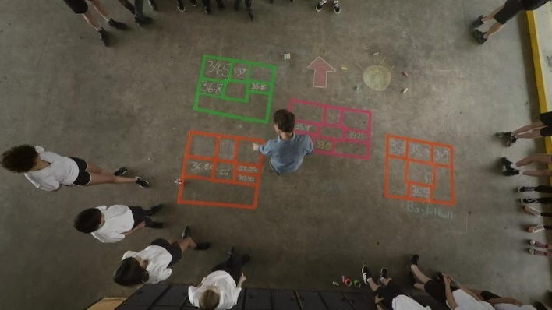
As a class watch the Big Weather: How Hot is Your School? video and then students will respond to the following.
- When was the last time you experienced extreme heat? Describe some of the ways your body reacts to extreme heat.
- What are some of the solutions to keep classroom temperatures down proposed by the students and Dr Sebastian Pfaustch?
- How would you describe the heating and cooling systems in your own learning environment? What impact do you think the temperature has on your ability to learn?
- Visit the CSIRO website to learn more about Australia's changing climate and extreme heat.

Activity: Act Like a Meteorologist
Students will start to think like a meteorologist and analyse the map below, which was produced by the Bureau of Meteorology. Students will then respond to the following questions:

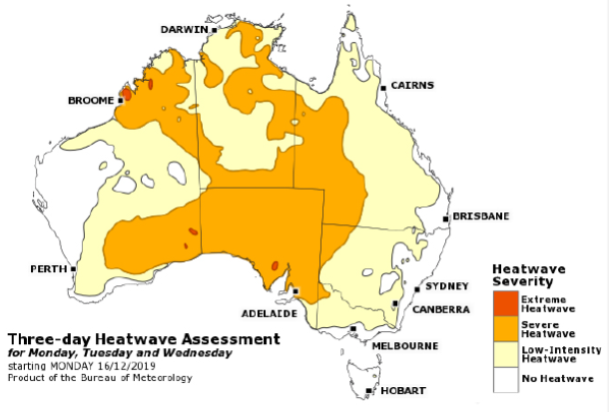
- What features do you see on this map? Make a list.
- What does the map tell us?
- What does it measure?
- What does the colour coding tell us?
- What area does it cover?
- What period of time does this map cover?
- What is the purpose of this map?
BOM Map: Example of a heatwave assessment map and text

Further investigation
- What is a heatwave? How does the Bureau of Meteorology define a heatwave?
- How is a heatwave measured? Who measures heatwaves? What instruments are used to measure heatwaves?
- How is a heatwave assessment map different to a heatwave forecast map? Explain using your own words.

Activity: BTN stories
These BTN stories look at the impact extreme weather has on people and the environment. After watching any one of the BTN videos ask students to respond to the discussion questions (to find the teacher resources go to the related BTN Classroom Episode and download the Episode Package).
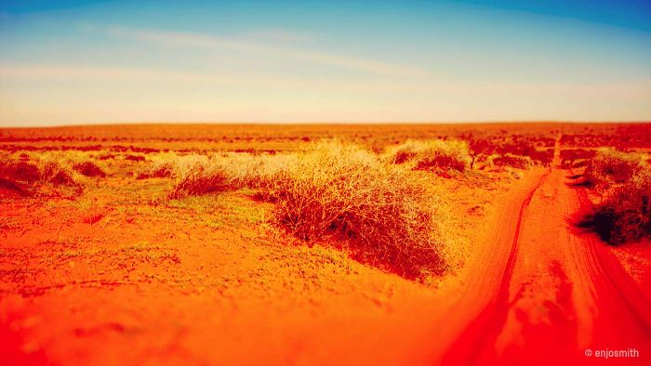  Heatwaves | 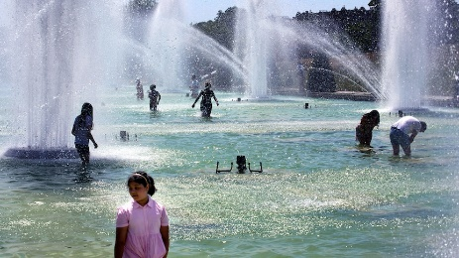  Europe Heatwave | 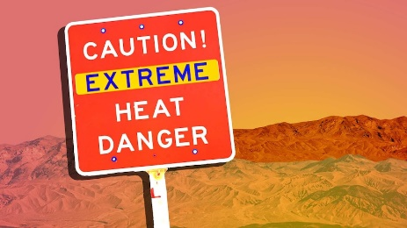  American Heatwave
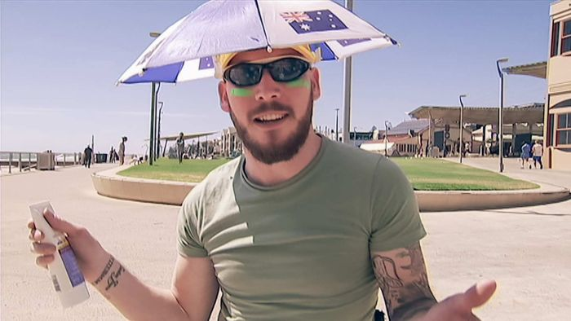  Extreme Weather | 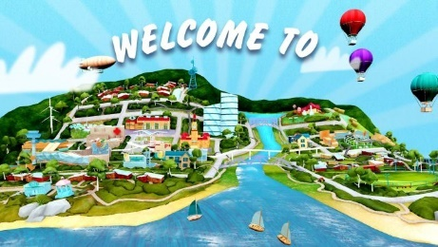  Mt Resilience AR App | 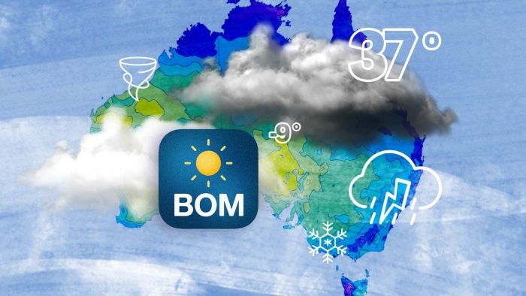  Weather Science

Useful Websites
- Extreme heat sweeps the world from Europe to the US and Japan – ABC News
- The World’s Hottest Day – BTN Newsbreak
- 'Unbearable' Cerberus heatwave sweeps across Europe – CBBC Newsround
- El Nino – National Geographic
- What is El Niño and how does it impact Australia? – Bureau of Meteorology
- American Heatwave – BTN
- Heatwave Knowledge Centre – Bureau of Meteorology
- Why heatwaves happen and where they come from – ABC News
- How hot is your school? – ABC Education
- What is El Nino? – BTN
- How to survive a heatwave – ABC Education
- Weather Science – BTN

EPISODE 19
25th July 2023

KEY LEARNING
Students will deepen their understanding of the Women’s World Cup and explore its significance in promoting women's sports.

CURRICULUM
Health & PE – Year 7/8
Investigate the benefits to individuals and communities of valuing diversity and promoting inclusivity.

Health & PE – Year 5/6
Identify how valuing diversity positively influences the wellbeing of the community.

HASS – Year 3 and 4
Pose questions to investigate people, events, places and issues.

Locate and collect information and data from different sources, including observations.

HASS – Year 5 and 6
Develop appropriate questions to guide an inquiry about people, events, developments, places, systems and challenges.

Locate and collect relevant information and data from primary sources and secondary sources.

HASS – Year 7
Construct significant questions and propositions to guide investigations about people, events, developments, places, systems and challenges.

  - Teacher Resource

Women’s World Cup

Focus Questions
Discuss the BTN story as a class and record the main points of the discussion. Students will then respond to the following:
- Who is hosting the 2023 Women’s World Cup?
- When was the Women’s World Cup officially recognised by FIFA?
  - 1976
  - 1991
  - 2023
- What is the name of the Australian women’s soccer team?
- Women playing A-League soccer receive less money as men for the same achievement. True or false?
- Who do you think will win the Women’s World Cup?

Activity: Class Discussion
After watching the BTN Women’s World Cup story, hold a class discussion using the following discussion starters.
- What do you know about the Women’s World Cup?
- How often is the Women’s World Cup?
- Why do you think the Women's World Cup is important?
- Can you identify any challenges women in soccer face?
- How does the Women’s World Cup help contribute to gender equality in sports?
- How did you feel after watching the story?
- What surprised you about the story?
- What did the video make you wonder?
- Think of three questions you have about the BTN story.


What do you know about the Women’s World Cup?


What questions do you have?

Freedom

Activity: The Role of Mascots
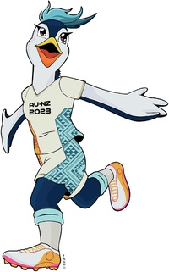
In this activity students will explore the significance and role of mascots in sporting events. Begin the activity with a discussion about the significance of sports events and ask students if they know about any sports mascots and their role in the events.

Students will look at pictures and watch a video of Tazuni, the mascot of the 2023 Women's World Cup. Students will learn about its design, symbolism, and the message it conveys. Tazuni – Official Mascot of FIFA Women’s World Cup

After learning about Tazuni, students will respond to the following:
- What is Tazuni?
- Where does the name Tazuni come from?
- What 3 words would you use to describe Tazuni?
- What qualities and characteristics should a good mascot have?
- Explore previous FIFA Women’s World Cup mascots. Research each mascots origin.

Students will then design and sketch a new mascot for the next Women’s World Cup. Students will respond to the following and create a poster with an illustration of their design.
- What qualities and characteristics do you think the new mascot should possess? Make a list.
- What values should it represent?
- How can it celebrate the diversity of women's soccer?

Activity: Write a Feature Story
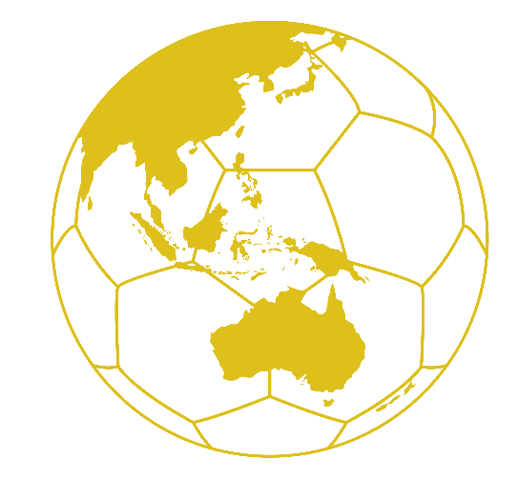
Students will imagine they are sports journalists covering the Women's World Cup. Students will choose one aspect of the sporting event that they are interested in writing about. Some possible topics include:
- A star player
- Match report
- The sporting event’s mascot
- Challenges faced by women in soccer.
- A history of the Women’s World Cup.
- A team making their first appearance at the World Cup.

Students can use the following to guide them throughout the research and writing process:
- Research as much as you can about the topic.
- Include statistics, quotes from players or experts, and any other significant details.
- Add visuals, such as images or infographics.
- Could you interview someone, like a player or expert? Write some interview questions.
- Write a feature story – find out what makes a good feature story here. Share your story with the class.
Rookie Reporter Training assets
Visit BTN’s Rookie Reporter Training to learn more about how to make a news story. The How to Make News video also gives some useful tips for making your own news story. Watch this BTN Explainer as a class to learn more about filming tips, like how to frame your shots and what the rule of thirds is.

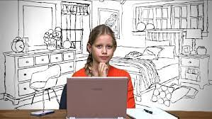  Rookie Reporter Training |   Becoming a journalist

Activity: Significant Australian Sports Women
In this activity students will learn more about significant Australian sportswomen, their accomplishments, and their impact on sport in Australia. Students will choose one Australian sports woman that they find inspiring and would like to learn more about. Students may want to explore the ABC’s Fierce Girls, a podcast that tells the stories of some of Australia's most extraordinary women, including many significant sports women.

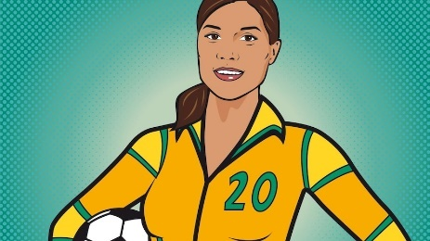  ABC Fierce Girls – Sam Kerr | 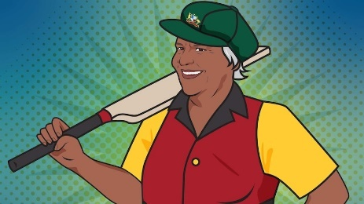  ABC Fierce Girls – Faith Thomas | 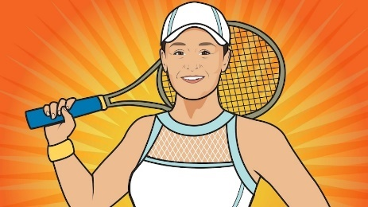  ABC Fierce Girls – Ash Barty
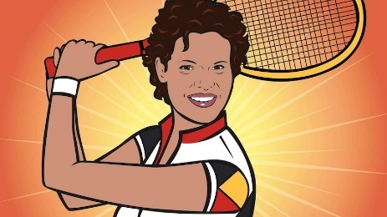  ABC Fierce Girls – Evonne Goolagong Cawley | 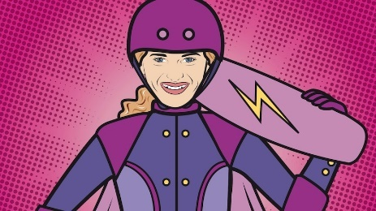  ABC Fierce Girls – Sabre Norris | 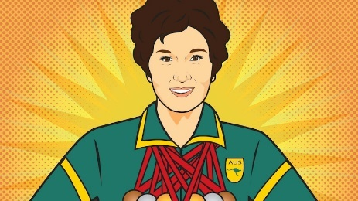  ABC Fierce Girls – Daphne Hilton (Ceeney)
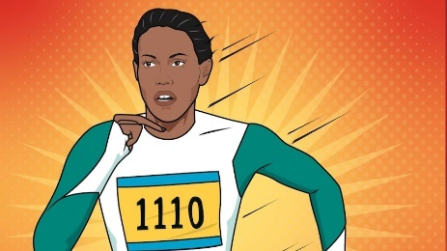  ABC Fierce Girls – Cathy Freeman | 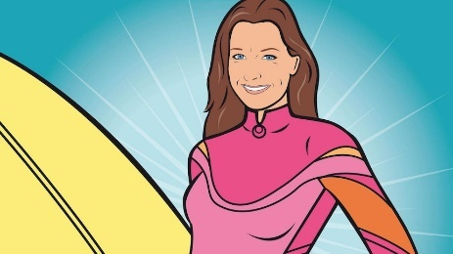  ABC Fierce Girls – Layne Beachley | 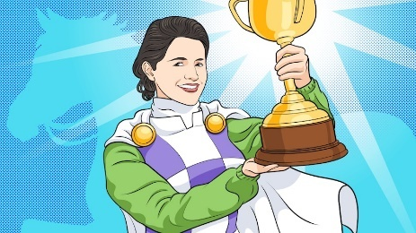  ABC Fierce Girls – Michelle Payne

Activity: Biography
Before students begin to construct their biographies, hold a class discussion to find out what they already know about biographical writing. Discuss what type of information is included in a biography and what they tell us about a person. The Civics and Citizenship website has some examples of biographies for students to look at.

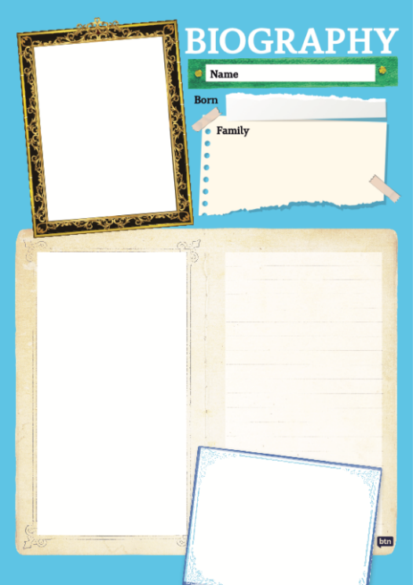
Class Discussion
Use the questions below to get a class discussion started with your students about biographical writing.

- What does a biography tell us about a person?
- Where can you look to find information for your biographical writing? It could include the internet, newspaper articles, magazine articles and interviews, other biographies, historical books or television interviews. Why is it important to use more than one source of information?
- What makes a biography interesting? For example, key information and facts, a timeline of events, photographs, illustrations and quotes.

Create A Biography
Using the biography worksheet at the end of this activity, students will research and record information about a significant Australia sports woman. Some possible areas of research include:

- When and where was she born? Describe her family life growing up.
- What are some of her achievements? Choose one to explore in more detail.
- What inspired or motivated them?
- What were some challenges that she faced?
- How did she make an impact on people’s lives?
- What do you admire about her?

Further Investigations
- Create a timeline of important events in her life.
- What are some of the key events in her life? Write a summary for one key event, which answers the 5 W’s – Who, What, Where, When and Why?
- How do primary sources (for example photos, letters, diaries, and official documents) help us understand what might have happened at a place in time? Find 1 or 2 primary sources that help you learn more about the person’s life.
- Make a Did You Know for other students.
- Plan and create a portrait of the person. Think about the expressions, symbolism, and colours that reflect the person, their values, and their impact. Explore and experiment with different techniques and mediums to produce a portrait. Present your portrait to the class, introducing who the person is, the impact they have had and then explain your portrait and what each of the elements in the portrait mean.

Activity: Choose a project
Students choose one of the following projects to work on and then present their work to a partner, small group, or the class.

Play Soccer
Organise a mini soccer match or penalty shootout to experience the excitement and teamwork associated with soccer.

Quiz
Create a quiz about the Women’s World Cup! Use a range of question types (true or false, multiple choice, fill in the blank, matching the pair). Test your classmates’ knowledge.
Letter writing
What significant Australian sports woman inspires you? Write a letter thanking her for her achievements and the impact she has had on Australia and sport.
Celebrate IWD
As a class celebrate the achievements of sports women in Australia. Go to the UN International Women’s Day website for more information.

.

Useful Websites
- FIFA Women’s World Cup
- Matildas Call for Equal Prize Money – BTN Newsbreak
- The Team – Matildas
- With the Women's World Cup fast approaching, the pressure is on the Matildas like never before – ABC News
- Matildas call on FIFA, A-Leagues to further support women's football in pre-Women's World Cup video – ABC News
- Sports Pay Gap – BTN

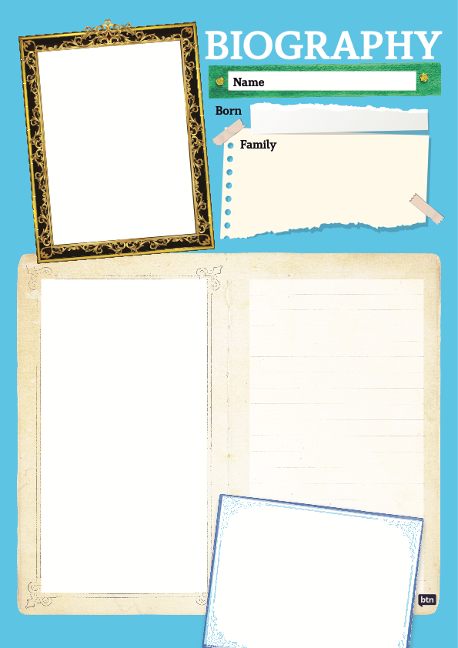

  - Teacher Resource

BTN Transcript: Episode 19 – 25/7/2023

Hey. I'm Amelia Moseley, you're watching BTN. Thanks for joining us for the first episode of term 3. Hope you enjoyed your holidays, let's jump into it. Here's what's coming up. Why you might have to wait longer for new seasons of your favourite TV shows. How this crumbly block of cheese could get a name change. And meet skater, Arisa, who's become the first female ever to pull off the 720 in a competition.

Northern Hemisphere Heatwave

Reporter: Jack Evans

INTRO: All that soon. But first, let's head somewhere a little warmer. For the past few weeks, we've been seeing record breaking temperatures around the Northern hemisphere. But in some places, heatwaves are causing big problems like wildfires. Here's Jack.

BELGIUM TOURIST: It's really, really hot.
DANISH TOURIST: It's so hot. The sweat is also, we're not used to the sweat in Denmark.
PARK VISITOR: it's burning, burning sensation.
This is Death Valley in the US and if you haven't worked it out yet, it's a pretty hot place. In fact, last week it got so close to breaking the record for hottest temperature ever recorded.
MATTHEW LAMAR, PARK RANGER: If you experience the top temperatures here, you're maybe experiencing that world record, which is really exciting for many folks.
Exciting as a world record is this sort of weather can be really dangerous.
BELGIUM TOURIST: You can maximum stay out like 10 minutes, 15 minutes.
It's not just here at Death Valley where people are feeling the heat. For the past few weeks most of the US, Europe and well a lot of countries in the Northern Hemisphere have been experiencing some pretty extreme heatwaves. As a result, we've seen massive wildfires, collapsing guards and people doing whatever they can to stay cool. To find out what's going on, I decided to call mine and everyone else's favourite weather guy Nate Byrne.
NATE: Hi Jack.
JACK: What's going on in the Northern Hemisphere?
NATE: Right so in the Northern Hemisphere right now, it is summer. But we've also got heatwave conditions going on. Essentially, a heatwave is when you have temperatures well above average for several days, and they're really, really dangerous, particularly when it doesn't cool down overnight.
Nate says there are a couple things contributing to the heatwaves, including a high pressure system.
NATE: when you see the weather on like the telly or something like that, you'll see the H's and Ls, what they are talking about is pressure, right. So, a high pressure system is where there is a lot of air trying to pack into a space.
When there is a high pressure system there is a good chance of clear skies and no rain. which sounds like a lovely day out, but as we've seen it can heat things up pretty quickly.
NATE: Those high pressure systems are getting stuck in places. So that air at the ground remains really slow moving under those clear skies and just heats up and heats up and heats up. There's no cold air moving in to get rid of it. It just stays in place and causes these heatwave conditions.
JACK: Is climate change also playing its part here, are we seeing that happened as well?
NATE: Yeah, we've had globally warmer oceans than we've ever seen before since around about mid-March. And oceans are actually a big part of what contributes to heat. So, if the water is warm all the time, day and night, that can really heat up the air above it. And that's contributing to this.
While the BOM hasn't officially announced it yet, Nate reckons that the natural whether phenomena El Nino is also contributing to the heat.
NATE: With an El Nino versus La Nina, which we've seen in the last few years and seeing lots of wet weather in the east of the country, for us in Australia, it actually ends up with warmer, drier conditions in the east of the nation.
During an El Nino weather event there is less moist air around, which means fewer storms and less rain but higher chances of drought. And experts reckon that what is happening in the Northern Hemisphere right now, could be a sign of what's to come later in the year for us here in Australia.
NATE: Australia's summer is likely at this stage not guaranteed depends on El Nino. But it looks likely to be warmer and drier than average. Since we've had years and years of la Nina, generally, it's looking pretty moist out there, most of our dams are relatively full, lots of our rivers are flowing, and lots of our soils have some moisture in there. So, we're likely to have a warm, dry summer, but probably not as bad as it could be because there's so much water in the system still, but it won't take much or long for summer to dry us out. And then we could be in some pretty dire straits.

News Quiz

Which Aussie state will be hosting the 2026 Commonwealth Games? If you said Victoria you’d be, wrong.

DANIEL ANDREWS, VICTORIAN PREMIER: The Games will not proceed in Victoria in 2026.

The state government scrapped its plans to host the Games in regional Victoria after the costs blew out from 2.5 to more than 6 billion dollars.

DANIEL ANDREWS, VICTORIAN PREMIER: I will not take money from schools and hospitals to host game that will be 3 times as expensive.

It’s left a lot of people disappointed and the opposition fuming. The other states have said they won’t be hosting either which means for the time being the games are without a home.

This strange object washed up on the shore in Western Australia. What do experts think it might be? Part of a submarine, part of an alien spaceship or part of a rocket? They think it’s part of a rocket. But because they’re not sure they were treating it pretty carefully, I mean you never know, could be aliens, right?

What’s unusual about the recording of this song? If you said it’s got something to do with artificial intelligence, you’d be right.

K-pop artist, MIDNATT, who’s signed to the same label as BTS has just launched this song in Korean. But his teams’ used AI to create 6 different language versions by combining his voice with the native speakers of five other languages.

Hollywood Strike

Reporter: Jack Evans

INTRO: Next up, to Hollywood, where thousands of actors have joined writers in walking off the job. It's the biggest strike the film industry has experienced in six decades and it could lead to some big consequences at the cinema and at home. Here's Jack.

Right now, there's a lot of drama going on in Hollywood, and while the place is famous for it, this isn't exactly the drama we're used to seeing from Tinsel Town. Recently more than 160,000 actors and performers went on strike across the United States, joining the more than 11,500 writers who have already been on strike since May. Some actors even left halfway through a movie premier to take part. So, what's going on?
FRAN DRESCHER, SAG-AFTRA PRESIDENT: We are the victims here. We are being victimised by a very greedy entity. I am shocked by the way the people that we have been in business with are treating us.
JACK: This is Fran Drescher. She has style, she has flare, and she was there at the picket lines because she's an actor as well as the president of SAG-AFTRA.
That stands for the Screen Actors Guild and American Federation of Television and Radio Artists. It's a union group that fights for better working conditions for actors and radio stars. SAG-AFTRA and WGA, which is the writers’ union, have been trying to negotiate new agreements between the big film studios and the actors and the writers. But as the strike would suggest, things haven't gone that well. So, what do the actors and writers want and when do they want it?
JACK: Well for starters the writers would like better pay for their work. Because while you might not necessarily see them in the movies and tv shows, writers play a really important role. Without them, oh hang on, there's nothing written on here for me to say?
Without writers the shows and movies we love wouldn't exist.
JACK: Oh well, yeah, what he said.
The actors say that they also want more money, because while you might think actors are so fancy shmancy and earn a ton of cash only a small percentage of them actually do.
DAWSON BLOOM, ACTOR: A lot of actors have to have second or third or even fourth jobs in order to just make a decent living.
JACK: In the past actors would make a lot of their money from something called residuals which was a small share of the profits when their work was broadcast on TV or sold on DVDs. Except the way we watch things has changed and streaming services don't offer as much money in residuals, so actors are making less.
They are also calling for better protections for writers and actors against Artificial Intelligence after some film studios proposed the idea of using AI to help write scripts and even replace actors.
DUNCAN CRABTREE-IRELAND, SAG-AFTRA CHIEF NEGOTIATOR: We're fighting for basic respect and protection for our members. That includes things like making sure that our members aren't abused by unfair provisions regarding artificial intelligence. They don't have their image and likeness and voice stolen from them through that method.
JACK: It would be like if they scanned me and used my AI image to create BTN stories. But that wouldn't happen. Huh, that's funny I don't remember filming that or that. Has AI been using my image? Oh well that I definitely remember filming. It was a very uncomfortable costume, don't recommend.
The last time a strike like this where both the writers and actors walked off the job was in 1960 and lasted several weeks and this one could have a big effect on what we watch.
JACK: While the strike is happening actors who are part of the union aren't allowed to act, audition or promote anything. which means a whole heap of films and tv shows have had their productions pushed back or put on pause.
It could mean you will have to wait a while for new releases. And it's not just in Hollywood feeling the effects. The strikes have put a pause on some big productions here in Australia. But many are hoping that the unions and productions companies can come to an agreement soon that sees everyone get a happy ending.

Trade Names

Reporter: Justina Ward

INTRO: What's this cheese called? It's feta. But if the European Union gets its way it won't be called that anymore if it's made in Australia. The same goes for a whole lot of products that the EU wants Aussie producers to rename.
CALE: Hello.
JUSTINA: Hey.
CALE: Can I try some feta please?
JUSTINA: Uh we don't have any feta.
CALE: What? It's just there.
JUSTINA: No, it's not.
CALE: What?
JUSTINA: Oh, you mean Bouncy Curd Bliss?
CALE: No. But can I try some Edam Holland then.
JUSTINA: Ah, you mean Red Wax Wheels?
CALE: What?
JUSTINA: Huh?
Can you imagine a world where feta can't be called feta anymore? Well in Australia this might soon become a reality, all because of a trade deal being negotiated between Australia and the EU.
You see, Australia wants to be able to export more things to the EU market like beef, lamb, sugar, and dairy products. But in return, the EU wants to restrict Aussie producers on the use of food names that originated in Europe. We're talking things like Gorgonzola, Edam Holland, and Feta. But cheesy names aren't the only thing on the table. There's a list of 166 food names and 234 alcoholic drinks that the EU want to restrict.

They call them GIs, or geographical indications, which basically means the name of the food is linked directly to the place it came from. Take Feta for example. In Greek it means slice or slab and it’s been made in Greece for a really long time. In fact, it even pops up in Homer's ancient Greek poem 'Odyssey' which was written around 700 BC. In the poem the cyclops Polyphemos was the first to discover how to make feta cheese.

Then there's Edam Holland, the name kind of says it all. It's a cheese named after the town of Edam in the Netherlands. The EU thinks because these foods are so much a part of the history and culture of the place, they come from only products that actually come from these regions should get their traditional names. It's about protecting local producers and making sure customers are getting exactly what they're paying for.

It's not the first time this sort of thing has happened. Australia has already recognised Europe's protection of the name "champagne" and no longer uses it. But lots of Aussie producers disagree. They say the name of the food feta for example, tell people what type of cheese it is, not where it comes from.
GIORGIO LINGUANTI, CHEESEMAKER: It would be like I need to change my own name from tomorrow everyone change your name, being called with another name, it’s really, really sad.
Aussie producers say that having to re-brand more of their products will affect their businesses, costing the industry about 95 million dollars. It'll be especially awkward for exporters who need to let their customers know exactly what sort of product they're buying. So, as you can see, we have a bit of stalemate.
MURRAY WATT, MINISTER FOR AGRICULTURE: It's a dud deal from the EU.
DAVID LITTLEPROUD, NATIONALS LEADER: If the EU doesn't want to sign up to our terms, then we should walk away.
FIONA SIMSON, NATIONAL FARMERS' FEDERATION PRESIDENT: It may just take a little bit longer to reach those important things.
Australia's trade minister is working hard to smooth things over with EU officials.
DON FARRELL, TRADE MINISTER: We're prepared to persevere and persist until we get the right result, both for Australia and for Europe.
And trade ministers from both sides will meet again next month to hopefully settle a deal.
JUSTINA: How about some Mouldy Blue Boulders?
CALE: It's just not the same is it? I’m Good.
JUSTINA: Eh, well I like the name.

Quiz

Can you match these three cheeses with their country of origin? We've got cheddar, gorgonzola, and gouda. Cheddar is from England, Gorgonzola is from Italy and Gouda is from the Netherlands
Women’s World Cup

Reporter: Justina Ward

INTRO: The Women's World Cup has kicked off in Australia and New Zealand. It's the first time the event's been hosted by two countries and the first time it's made its way to the Southern Hemisphere. Justina caught up with some young soccer players to see what it means to them.
Just like that, history was made. This Adelaide soccer team came together to be part of it, and they're pretty excited.
GIRL: I'm very very excited, very excited.
GIRLS: Stoked, so so excited.
You see, it's the first FIFA Women's World Cup to have more than one host nation; the first to be held in the Southern Hemisphere; plus the first time this tournament will have 32 teams. That's a lot of firsts. And the Matilda's line up is pretty epic, too.
GIRLS: They have Sam Kerr, Ellie Carpenter, Mary Fouler and a lot of other good players and they're gonna smash all the other teams.
GIRL: My favourite player's Sam Kerr because she scores all the goals and is just a legend in the game.
GIRLS: Sam Kerr then Charlie Grant, she signed one of my boots and it's on my shelf, displayed. Yes, in golden texta.
The FIFA Women's World Cup has been held every four years since 1991. Although it didn't start until 61 years after the men's first World Cup. The US has dominated lately and go in as defending champs. But who's gonna win this year?
GIRL: Australia's gonna win.
GIRLS: We love Matilda's, and they're gonna win the World Cup. Woo.
GIRLS: The Matilda’s are gonna win. They're definitely gonna win. We're certain. Yeah, they are gonna win. We can't be saying that though if they don't win.
But it's not just about winning.
THE MATILDA'S: We'll do everything we can to make the country proud when we take the field, and also to leave the shirt in a better place for those who follow in our footsteps.
Just days before their opening match the Matilda’s released a video calling on FIFA and the A-League to better support women's football.
THE MATILDA'S: We call on those in positions of power across football, business and politics to come on the journey with us to make women's football as big as it can be, here and around the world.
They called out things like unequal prize money between the men's and women's games.
THE MATILDA'S: FIFA will still only offer women one-quarter as much prize money as men for the same achievement.
A lack of full-time opportunities in the women's A-League and they say there need to be better standards of pay and playing conditions for all women's professional teams.
THE MATILDA'S: Those that came before us showed that being a Matilda means something. They showed us how to fight for recognition, validation, and respect. This is our legacy. This is our legacy.
And whatever happens this World Cup, these fans will be cheering them on.
GIRL: It means a lot to see female role models play.
GIRL: It's just everything, soccer is so fun, and you get to play with your friends.
GIRL: When I'm older I wanna be a Matilda and play for Adelaide United.
GIRL: I think it's really good that there's a women's world cup to see that um women can do just as much as men can do and that there's a chance for women to have a chance at playing a game, we all love.
Sport
Matilda’s World Cup opener last Thursday night was a nail biter. Scoring a one-nil victory over the Republic of Ireland. It was the biggest ever turn-out for a Matilda's match. With a record crowd of more than 75,000. Unfortunately, star player Sam Kerr had to sit this one out due to a calf injury. She'll also be missing Australia's next match against Nigeria this Thursday, and we don't know for sure when she'll be back yet. But despite some disappointment from fans hoping to see her play. The Matilda’s are united as ever and another win would guarantee them a place in the round of 16.
Australia has retained the Ashes. Thanks to some unrelenting rain washing out day five of the fourth Test at Old Trafford allowing Australia to salvage a draw.
FANS: We've come back here to get victory photos and look at it, here's an umbrella, I'm wearing a jacket, look at this guy. The rain saved us today. Big time.
England looked strong in the first innings, scoring 592 runs. For the Aussies it was all about hanging on until play was called off.
FAN 1: We're disappointed, we really fancied it today, we had the Aussies under the pump yesterday.
FAN 2: It's a bit of a hollow victory at this point.
The draw means that Australia takes their 2-1 lead into the final Test at the Oval on Thursday. Giving them a chance to win their first series in England in 22 years.
It's been a record breaking and gold winning start for the Aussies at the World Aquatics Championships in Japan. Ariarne Titmus produced a breathtaking performance to win the 400-metre freestyle, breaking a world record in the process. Sam Short also took out the gold in the Men’s 400-metre freestyle. Meanwhile the Australian women's 4 by 100 metre freestyle relay team snagged gold and another world record. Minutes later the men's relay quartet came home winners, too.
Skateboard 720 Trick

Reporter: Cale Matthews

INTRO: 13 year old Aussie skater, Arisa Trew, has just won gold at the X-Games. She also recently made history as the first female in the world to pull off one of skateboarding's most famous and difficult tricks in a competition, the 720. Cale caught up with her to find out what it was like.
CALE MATTHEWS, REPORTER: Hey Arisa, how are you going? Thanks for taking the time to have a have a chat.
ARISA TREW, SKATEBOARDER: Thank you, how are you?
CALE: I'm pretty good I'm pretty good, looks pretty nice where you are, where are you at the moment?
ARISA: I'm in San Diego, Clairmont, and it's really sunny around now.
CALE: First things first. Take me back to the start. How long have you been skating for?
ARISA: Well, I started skateboarding when I was eight years old, and I started because I used to surf a lot, and one year it got too cold in the water. So, we basically just went to land, and I started skateboarding and that was five years ago.
It's really fun to skateboard and I love doing it with my friends because we can all hang out and learn tricks together, and especially landing tricks and learning them. It's the best feeling like ever when you can land it.
I think the coolest thing that's happened is me landing the 720 in competition, because I've been working on it for a little bit, and it's a really hard trick, and I was just so happy to land it.
CALE: So let's talk about the 720, for those that don't know, what is a 720 in skateboarding?
ARISA: A 720 is when you come up the ramp backwards and spin two 360s in the air, and come back down forward on your board.
It was my first time landing it and it took 14 goes, which is pretty surprising.
I didn't really realize I landed it until I went to the other side, and I remember I literally said; "Did I just learn that?" and then I went to the other side of the ramp, and I came out and everybody was screaming, and the crowd was going wild. And all, like the skaters around me just came and hugged me and congratulated me. And it was like such an awesome feeling.
CALE: Now when you landed it, you know Tony Hawk, was there. The first person to ever land the trick. What was it like landing something like that in front of him?
ARISA: Well, it's pretty cool, because he was the first person to land it. And he also gave me some tips to land, because he told me I needed to duck my head more after the first rotation. Yeah, he's super cool and chill, and he's really nice, and he just comes in, like helps people. Like, if you need tips on a trick, he'll just tell you.
CALE: What's next for you in skating?
Well, I want to go to the Olympics and get a medal for park and I also want to win at X Games this year.
So I have the Ventura X Games in USA for park and vert. I'm hoping to get a medal in that. And then shortly after I have a world championship in Rome, which I also want to podium in.
CALE: What advice do you have for kids getting into skating?
ARISA: If you want to do it, obviously, just give it a go, because you never know what will happen, and I think like a helmet and like skate pads is a really good idea because it really brings your confidence level up.
If you like want something, you just have to go for it, because if you never try, you'll never know and like, if like, it means that much to you, then you just have to do it.

Closer

So impressive. Well, that's all we've got for you today. Don't forget to check out our website for more news and fun stuff. And teachers make sure you have a look at our classroom resources and follow our weekly stories on BTN High. Have a good week, I'll see you soon.

