Episode 8
2nd April 2019



Minimum Wage
- Discuss the Minimum Wage story as a class and record the main points of the discussion.
- What is the minimum hourly wage in Australia?
- Australia has the third highest minimum wage in the world after what countries?
- In what year did Australia introduce a minimum wage?
- Do you think Australia's minimum wage is enough? Why or why not?
- On average how much does it cost to live in Sydney per week?
- What is meant by the term living wage?
- How would a living wage be good for business?
- Why do some people disagree with introducing a living wage?
- What do you understand more clearly since watching the BTN story?

Online Trolls
- Briefly summarise the BTN Online Trolls story.
- What is an online troll?
- What is the difference between an online troll and a cyber bully?
- How did trolling make AFLW player Tayla Harris feel?
- It’s best to ignore online trolls. True or false?
- What advice does the expert in the BTN story give for dealing with trolls?
- How might online trolls affect people?
- What message would you give to people that troll?
- What did you learn watching the BTN story?
- What questions do you have about the BTN story?

Check out the Online Trolls resource on the Teachers page.

Gambling in Gaming
- What did the BTN Gambling in Gaming story explain?
- What is gambling? Give an example.
- What did a recent study by the Victorian Government find about gambling in gaming?
- What chemical does your brain release when you are happy?
- Why are some overseas countries banning games from using loot boxes and skins?
- The Victorian Government has launched a program to help parents understand the link between gaming and ___________. Complete this sentence.
- How do you feel when you win a game?
- Do you play any mobile or video games that use gambling features? Discuss in pairs.
- What do you think about games that use gambling features? Discuss as a class.
- What do you think are some solutions to the problem?

Exoplanets
- In pairs, discuss the Exoplanets story and record the main points of the discussion.
- An exoplanet sits within our Solar System. True or false?
- In what year was the first exoplanet discovered?
- Who discovered the exoplanet called 51 Pegasi b?
- Describe what they noticed about the way the exoplanet was orbiting its star.
- What is the Kepler?
  - An exoplanet
  - A star
  - A telescope
- The transit method is when a planet crosses in front of a ______. Complete this sentence.
- How many exoplanets have been discovered so far?
- What characteristics does an exoplanet need to be Earth-like?
- What was surprising about this story?

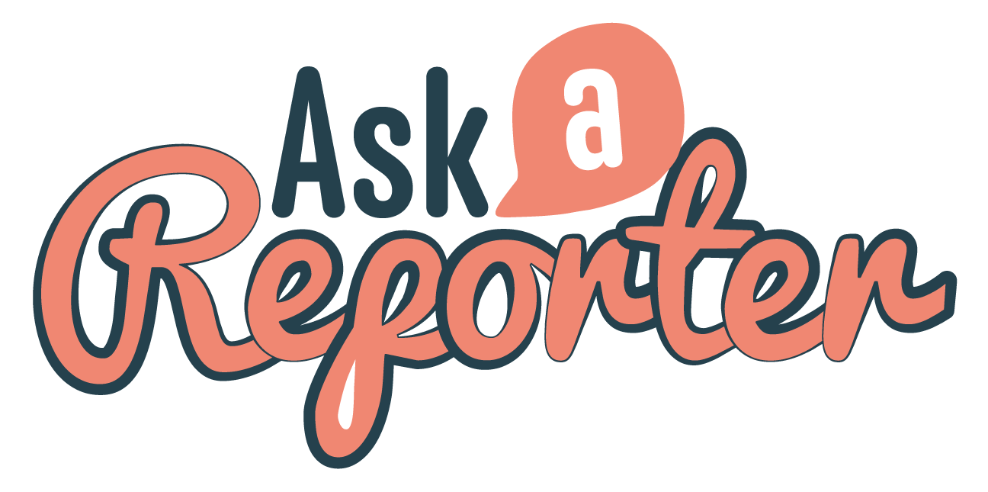
Check out the Exoplanets resource on the Teachers page. Get your class involved in BTN’s Ask A Reporter! This week’s topic is Exoplanets.

Lent
- Before watching the BTN Lent story discuss what you know about Lent.
- Who participates in Lent?
- Why do people often give something up during Lent?
- Give an example of something that people might give up during Lent.
- On what day of the week during Lent do people not fast and have a rest day?
- Complete this sentence. During Lent people don't eat ______ on Friday's.
- What food is eaten on Shrove Tuesday?
- What happens on Ash Wednesday?
- What does Good Friday represent?
- What do Easter eggs symbolise on Easter Sunday?

Teacher Resource
Episode 8
2nd April 2019

Online Trolls

Students will develop a deeper understanding of what online trolling is and how to respond to it.


Digital Technologies – Years 3 & 4
Plan, create and communicate ideas and information independently and with others, applying agreed ethical and social protocols.

Digital Technologies – Years 5 & 6
Plan, create and communicate ideas and information, including collaboratively online, applying agreed ethical, social and technical protocols.

Health and Physical Education Years 3,4 5 & 6
Identify, plan and practise strategies to promote health, safety and wellbeing.
- Briefly summarise the BTN Online Trolls story.
- What is an online troll?
- What is the difference between an online troll and a cyber bully?
- How did trolling make AFLW player Tayla Harris feel?
- It’s best to ignore online trolls. True or false?
- What advice does the expert in the BTN story give for dealing with trolls?
- How might online trolls affect people?
- What message would you give to people that troll?
- What did you learn watching the BTN story?
- What questions do you have about the BTN story?


Class Discussion

Discuss the issues raised in the BTN Online Trolls story. Ask students to record what they know about trolls and trolling on a mind map. What words do they associate with trolls? What questions do they have? Use the following questions to guide discussion:
- Who are trolls?
- What is trolling?
- What are some ways to deal with trolls?
- What is the difference between trolling and cyber bullying?

Glossary
Students will develop a glossary of words and terms that relate to trolling. Below are some words to get them started. Students will add words and meanings to their glossary as they come across unfamiliar words throughout their research. Students will then write their own sentence using each of the terms.

trolls | trolling | cyber safety
online behaviour | report | block
ignore | cyber bullying | privacy settings

Six Hat Thinking
Working in pairs, students use Edward De Bono’s Six Hat Thinking to explore the issues raised in the BTN Online Trolls story. Ask students to respond to the following questions:

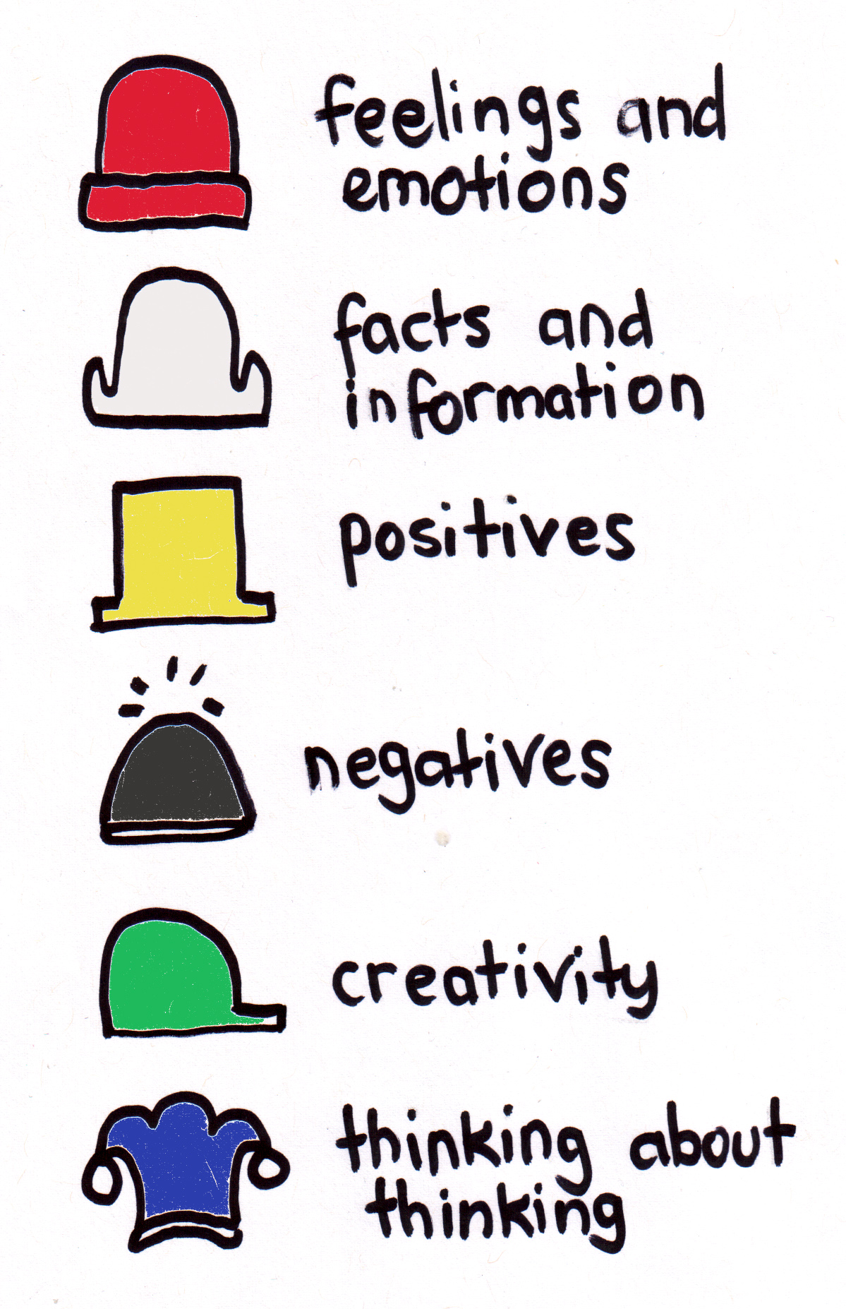 | How did the Online Trolls story make you feel?
What do you know about trolls and trolling?
What have you learnt from the story?
 | Were there any positives from the story? If so, what were they?
 | What are some of the negatives or challenges that you learnt from the story?
 | Why is it important to find out more about the issue?
What questions were raised during this activity?
What do you want to learn further about this topic?

Communicating online
Working in small groups, students share and record all the ways they communicate online. Encourage students to share the positive and negative feelings and experiences they have.

- What are your favourite websites and apps?
- List all the ways you use technology for communication.
- Do you use social media? If so, which ones?
- Who do you stay in touch with through your mobile phone and the internet?
- What do you think positive online communication means? Give some examples.
- What is negative online communication? Think of at least three verbs or adjectives that describe negative communication.
- What are some strategies to deal with negative online communication?

Raising Awareness
Students will design a campaign to help kids deal with trolling. To create a school awareness campaign, students will need to identify the following:
- What is trolling?
- How do you deal with it? For example: Ignore, block, report.
- How can you support friends who are being targeted?

Some questions to consider when designing your campaign:
- What is the campaign’s main aim?
- Do you have a slogan or message? What is it?
- Who is your target audience?
- What is the best way to communicate the message?

Discuss with students how they will get their message out there to help raise public awareness. Some possibilities include:
- Short film or animation
- Community service announcement (for television or radio).
- Press release (create posters to be put up around the school or pamphlets to give to all students).

Behind the News has covered a number of stories about staying safe online. Students can watch the stories and respond to the questions:


BTN Digital Footprint story
- How can a person’s movements be tracked?
- Why has online privacy been an issue in recent years.
- What sort of information are people sharing online?
- How can online activity be monitored?
- How can information footprints be useful?
- Give examples of how people can make smart choices online.


BTN Data Security story
- What is meant by the term ‘targeted advertising’?
- What websites and apps do you use?
- What is your digital footprint? Think about the information that you post online.
- Make a list of people or organisations that might track your online activity?
- How important is data security to you? Discuss as a class.
- What can you do to secure your data?


BTN Cyber Smart story
- What does cyberbullying mean?
- How is cyberbullying different to bullying someone face-to-face?
- Why do you think some people that bully online would never do it face-to-face?
- What is trolling?
- What are some strategies kids can use to help deal with cyberbullying?
- List some positive aspects of social media and communicating online.


ABC News – Tayla Harris AFLW photo could become landmark moment in Australian sport
https://www.abc.net.au/news/2019-03-21/tayla-harris-aflw-photo-could-be-landmark-moment-in-australia/10921892

BTN – Internet Trolls
http://www.abc.net.au/btn/classroom/internet-trolls/10527804
Newsround – Online trolls hiding behind a keyboard
https://www.bbc.co.uk/newsround/46157694

eSafety Commissioner – Cyber abuse
https://www.esafety.gov.au/esafety-information/esafety-issues/cyber-abuse

Teacher Resource
Episode 8
2nd April 2019

Exoplanets
Students will investigate the characteristics of an exoplanet. Students will explore how scientific knowledge is used to discover exoplanets.

Science - Year 5
The Earth is part of a system of planets orbiting around a star (the sun).

Scientific knowledge is used to solve problems and inform personal and community decisions.

Science – Years 5 & 6
With guidance, pose clarifying questions and make predictions about scientific investigations.

Science – Year 7
Scientific knowledge has changed peoples’ understanding of the world and is refined as new evidence becomes available.

- In pairs, discuss the Exoplanets story and record the main points of the discussion.
- An exoplanet sits within our Solar System. True or false?
- In what year was the first exoplanet discovered?
- Who discovered the exoplanet called 51 Pegasi b?
- Describe what they noticed about the way the exoplanet was orbiting its star.
- What is the Kepler?
  - An exoplanet
  - A star
  - A telescope
- The transit method is when a planet crosses in front of a ______. Complete this sentence.
- How many exoplanets have been discovered so far?
- What characteristics does an exoplanet need to be Earth-like?
- What was surprising about this story?

What do you see, think and wonder?
After watching the BTN Exoplanets story, respond to the following questions:

- What did you SEE in this video?
- What do you THINK about what you saw in this video?
- What did you LEARN from this story?
- What was SURPRISING about this story?

Glossary
Students will develop a glossary of words and terms that relate to exoplanets and our Solar System. Below are some words to get them started. Add words and meanings to your glossary as you come across unfamiliar words throughout your research. Consider using pictures and diagrams to illustrate meanings.
Planet | Exoplanet | Galaxy
Milky Way | Transit method | Universe
Solar System | Habitable zone | orbit
Research

Define: What do I want to know?
Key questions to research
Students can choose one or more of the following questions or come up with their own:
- What is an exoplanet?
- When was the first exoplanet discovered? Explore the exoplanet in more detail.
- How are exoplanets different from planets in our solar system?
- How do astronomers find exoplanets?
- How many exoplanets are like Earth? What makes them similar?
- What can we learn by studying exoplanets?
- How are exoplanets different and similar to planets in our Solar System?
- What makes a planet liveable? Think of three characteristics that would make a planet Earth-like.
Locate: Where do I find the information?
What resources will help answer my questions? (Internet, people, resource centre, organisations, print). Discuss with students what a reliable source is.

Select: What information is important for the investigation?
Students may need support to sort through and select relevant information.

Organise: How do I make sense of the information?
Students can organise their research by creating main headings from their questions. Write each heading on a separate piece of paper. Record the information found for each question.

Present: How do we let others know about this information?
Each group needs to discuss then decide on the best way to present the information. Possibilities could include:
- A `Did You Know’ Facts sheet
- Infographic
- Oral presentation
- Prezi presentation
- Create an infographic using Canva

Evaluate: What have we learnt?
Each group reflects on what they have learnt about exoplanets during their investigation. Students will reflect on their learning and respond to the following.
- What I learned...
- What I found surprising...
- What I would do differently next time…

Discover a new exoplanet
Students will imagine they have discovered a new exoplanet which has never been seen before. Use the following as a guide for this activity:
- Illustrate the new exoplanet using only a black felt-tip pen on a piece of A4 art paper – include as much detail as you can.
- Give the exoplanet a name.
- Describe what the exoplanet looks like – what are some of its physical characteristics?
- Does it have any interesting or unique features?

Daytime stargazing
Bring the stars to your students by using an online application to discover and explore stars, planets and constellations in the classroom. Before starting this activity download a free app like SkyView onto your classroom hand held device/s. This activity may need to be modified depending on the number of devices available to students.

- If possible dim the lights in the classroom to create the feeling that it is night time. Students will sit on the ground with SkyView open on their hand-held device.
- Students will point their device at the sky to locate and identify planets, stars and constellations. There is the option to turn on night mode. Students can learn more about what they find by selecting a celestial body and tapping on it. Give students time to explore the night sky.
- Hold a class discussion. What did your students discover?
- Students will choose one planet they want to learn more about. Students will develop their own question/s for inquiry, collecting and recording information from a wide variety of sources.
- Students will think of creative ways to display their findings.

BTN – Planet Nine
http://www.abc.net.au/btn/classroom/planet-nine/10523444?cachebusterTimestamp=1553577118035

https://www.zooniverse.org/projects/marckuchner/backyard-worlds-planet-9/

NASA – What is an exoplanet?
https://spaceplace.nasa.gov/all-about-exoplanets/en/

NASA – Five ways to find a planet
https://exoplanets.nasa.gov/5-ways-to-find-a-planet/

NASA – What is a planet?
https://solarsystem.nasa.gov/planets/in-depth/

ABC – How the sky works: A beginner’s guide to finding stars and planets
http://www.abc.net.au/news/science/2017-04-04/a-beginners-guide-to-finding-planets-and-constellations/8373718

BTN Transcript: Episode 8 – 2/4/19

Hey, I'm Amelia Moseley and you're watching BTN. Let's have a look at what's coming up today. We find out about the fight against online trolls, learn more about exoplanets and some kids fill us in on the story behind Lent.

Minimum Wage
Reporter: Martin Dougan

INTRO: But first up today. When you get a bit older you're probably gonna go out and get a job, right? Which means this next story could be important to you. Last week the federal Opposition announced its plans to raise Australia's minimum wage if it wins the election. Let's find out what all that means and why it’s controversial.

Alright, we know you might not be quite there yet but when you start working, how much do you think you'll be paid?

Kid 1: When I'm older I think I'll earn 1 million dollars because I'm going to be the best pro football player.

Kid 2: When I'm older I'm hoping to earn around two thousand dollars a week, because I want to be a doctor.

Kid 3: Well I don’t really know how much I'm going to earn, but I do want to become a basketballer when I'm older, and I think to start off with I'll probably not earn much but still a good amount.
Well, how much you earn will depend on quite a few important things like what job you do, your skills and your education. But in Australia, no matter what job you do, you'll get something called a minimum wage.

REPORTER, MARTIN: Alrighty, if you're 21 or over you'll earn at least $18.93 an hour, which adds up to around $719 a week and if you're in training, like an apprentice, it's a little bit less. But you've got to admit, it's not bad eh?

KID: It’s not that bad.

MARTIN: Wait.

KID: Thanks.
Australia has the third highest minimum wage in the world after Luxembourg and France and it was the second country ever to introduce a minimum wage, way back in 1896. Back then it only applied to certain jobs like bakers, who were all of a sudden guaranteed one shilling an hour, which is about ten cents in today's money. Boom shack lacka.

MARTIN: Since then Australia’s minimum wage has grown. But has it grown enough? Well that's the 18 dollar an hour question, isn't it? Well, let's put it to the kids. Do you think Australia's minimum wage is enough, but see before you that answer can I just have that money back because that other girl took it and she never…not her as well?

Kid 1: I think the minimum wage is way lower than it should be because there are people out there that need the money to feed their families and do things like insurance and electricity and water.

Kid 2: I don’t think that’s enough because people have to put food on the table for their families and pay for the rent and all this stuff.

Kid 3: Well with having to pay the rent and the water bills and all that kind of stuff I think it should be higher. I would like the minimum wage to go up because sometimes families struggle a bit more.
Experts say life’s getting pretty expensive, especially in big cities. On average it costs 719 dollars a week just for the basics. But in certain places it costs even more. In fact, some people think the minimum wage hasn’t kept up with the cost of living and some reckon that needs to change.
One idea is to bring in a living wage. That basically means businesses would have to make sure they're paying people at least what they need to live comfortably. The people who back this idea say it could actually help the economy, because if people have more money, then they can spend more, and that's good for business.

MARTIN: Not everyone agrees with this. You see, not every business makes lots of money and there are worries that if they had to pay more people more money they might go broke and they would stop employing as many people.
There are plenty of countries out there that don't have a minimum wage, or which have a much lower minimum than Australia and some reckon that if Australian workers are paid more, then more businesses will just go overseas and employ people who work for less money. It's a tricky question and it’s one that you might hear more about as the election gets closer.

This Week in News

There's going to be a lot of talk about the country's finances this week after the federal government delivers its budget. That's basically its plan for how it's going to spend the country's money over the next year and it's an important one because, of course, there's an election just around the corner. The government is pretty proud of this year's budget because it says there'll be a surplus which means more money is coming in than going out.

MINISTER FOR FINANCE, SENATOR THE HON MATHIAS CORMANN: The Coalition has been successful over the last five and half years in making the economy stronger, creating more jobs, driving the unemployment right down and indeed putting the budget on the stronger and improving trajectory for the future so that all of the essential services that Australians rely on can be funded.

Lights went out all around the world this weekend, but it wasn’t an electrical fault, it was the 13th Earth Hour. Big landmarks like the Eiffel Tower, the Colosseum and Christ the Redeemer in Brazil all went dark. And here in the Philippines, Star Wars fans took to the streets with lightsabers. Earth Hour’s all about making people think about how much energy they use and how it contributes to climate change. All up 180 countries and millions of people took part in the event which was actually started right here in Australia.

It's been almost 50 years since humans walked first on the moon, but we could be heading back up there again pretty soon. America's Vice-President Mike Pence says he wants to see NASA do it by 2024. We haven't set foot on the moon since 1972, because it's a very, very expensive thing to do and NASA decided to focus on other things once it had, you know, been there done that. The plan is to eventually build a base up there and use it to further explore our galaxy.

Speaking of space exploration, this burger has gone where very few burgers have gone before. All the way up to Earth's stratosphere. A guy in England decided it would be a great idea to attach it to a weather balloon with a go-pro, don't ask us why. After the burger returned to Earth, it was discovered by a local footy team on their training ground more than 160 kays away. As you can imagine, everyone was pretty confused by the unidentified frying object. But the owner soon came to claim his tasty experiment.

And that was actually a true story, unlike some of the others you might have seen yesterday. Like Victoria Zoo's announcement that it's brought dinosaurs back to life and another zoo that said it's going to open a bin chicken exhibit. Or there was this ad for a soda stream that turns your breath into fizzy water. Yep, it was April Fools’ Day and, as usual, lots of businesses and news outlets got in on the action. But we promise everything in this show is true.

Online Trolls
Reporter: Amelia Moseley

INTRO: Now to a story about trolls. No, not the ones that live under bridges, I mean online trolls. Let’s find out why they’ve been in the news and what we can do to fight them.

In fairy tales, the best way to get rid of a troll is to get yourself a really big goat to head-butt them off a bridge. In the real world, it's pretty much the same. Haha. Kidding. Dealing with real life trolls is a bit more complicated. I'm talking about internet trolls. That's anyone who writes comments online with the intention of causing as much trouble as possible; usually by saying something that they know will make people feel hurt or angry and might cause an argument.
REPORTER, AMELIA: And unlike cyber bullies who tend to deliberately attack someone they know trolls usually go after strangers, kinda like that guy under the bridge. It's fine, it's fine.
Recently, there's been a lot of talk about trolls after photos of two footy stars, Carlton AFLW player Tayla Harris and West Coast's Liam Ryan, attracted some nasty comments on social media. While sports stars cop criticism for the way they play all the time, Harris explained that rude, abusive comments are not the same and can have a real impact.
Tayla Harris, Carlton AFLW Player: Cause these people are behind screens now, but there's no one saying they aren't going to show up at the footy on the weekend and how do I identify if that was the person that made this vulgar comment directed at me? Cos now I’m uncomfortable in my work space.
AMELIA: While lots of social media sites are working on better ways to spot trolls and even mute their comments, the internet probably isn't going to be free of them anytime soon. So, I thought I'd better go and find out more about trolls and even how to deal with them. I'm gonna ask an expert.
AMELIA: So, what's the best way to deal with trolling?
Professor Barbara Spears, UNI SA: Well, trolls just like to cause chaos. They like to get in amongst it all and just throw bombs and see what happens. The best thing however is, don't feed the trolls. Just ignore them. By not giving them the information and the ammunition to see reactions, they will go away and try somewhere else. It's also important that we take a record of what we've seen of the original conversation, take a screenshot of it, look at your privacy settings, and then tell someone you trust that this is going on and this is happening.
In the case of Liam Ryan, West Coast rallied around him. It even tracked down one of the trolls and revoked his AFL club membership for two years. And Harris? Well, she turned some of the silly comments into a hilarious challenge.
Tayla Harris, Carlton AFLW Player: I’ve got a brand-new pair of NIKE footy boots, that I will sign and give away to anyone that can do the best impersonation of my kick.
So, what are your thoughts on trolls?
Cayleigh: There’s a fine line between trolling and bullying.
Sahib: The person being trolled might feel really ill, they might feel threatened and that can really hurt them, and it might affect their grades, their job.
Kaylan: To any trollers watching this, just watch the joke you're sending. Just think before you press send.

Gambling in Gaming
Reporter: Jack Evans

INTRO: Our next story is all about video games. But wait, before you get too excited it's not exactly good news. Recently, Victoria's government looked into some of Australia's most popular video games and it found that a lot of them had features similar to gambling. Take a look.

Have you ever been playing a game and then this happens? And so, you keep playing hoping to win again. While some say it's harmless fun, others say it's sort of like gambling. There are lots of types of gambling that are illegal for kids. Like betting on sport, scratchies, lottery tickets and poker machines. But there are some mobile and video games that use gambling features that are legal for kids to play and some reckon that's a problem. A recent study by the Victorian Government found that nearly half of the most popular video games in Australia included features that were considered gambling.
Lachlan: Some of the games I play have mini games in them where you can win prizes which then you can buy loot boxes with them.
Nisarg: In some of them they have wheels that you spin to get extra perks in the game.
The bigger prizes are usually harder to get and when you get them you feel really good. That's how some types of gambling works. People are rewarded a little and so they keep on playing hoping their next big win is just around the corner.

REPORTER, JACK: When you win something, your brain releases a chemical called dopamine. That's the chemical that makes us feel happy and it can be very addictive.
Lachlan: If you win a game then it feels really, you feel really accomplished.
Kavya: It feels like oh wow yeah, I win.
There are also worries about some online gambling websites that accept skins as currency.
Dr Alex Russell: So, these things that kids are winning in the games, some of them are worth quite a lot of money. They can be sold to other adults which opens up risks for kids and they can be used for gambling.
Some reckon these sorts of things could be leading kids to gambling habits in the future. And there are some countries overseas that have banned games from using loot boxes and skins, if they're targeting under 18's. That hasn't happened in Australia, but last week the Victorian Government launched a program that's trying to help parents understand the link between gaming and gambling, so they can guide their kids. But what do you think?
Ben: I think it is fine, but they need permission from their parents and like supervision.
Lachlan: I think that changing real money into currency isn't a great idea because some kids just use their parents credit cards and do it without asking.
Nisarg: Well first of all they shouldn't even play those games and if they do then don't spend money on it.
Did You Know?

Did you know that Tetris is still the best-selling game of all time? Almost 500 million copies of the puzzle game have been sold since it was released in 1984.

Exoplanets
Reporter: Jack Evans

INTRO: An oldy but a goody. Now, have you ever looked at the stars and wondered if there are other worlds out there. Well, it turns out there are a lot of them. Scientists have now discovered more than 4000 exoplanets. "What are they?", you ask? Well, Jack's about to take us all, including me, on a bit of a journey to find out.
Jack: Hi, hi, hello. Sorry you know how it is, meetings, meetings, hustle bustle.
Amelia: Is that you Jack?
Jack: Jake's the name intergalactic real estate's the game.
Amelia: Oh, sorry you look like someone I know.
Jack: Take a seat, take a seat.
Amelia: So, the ad said you had a great 2-bedroom apartment that was just out of this world.
Jack: Yes, the 2 bedroom with a cosy kitchen but a surprisingly big sink.
Amelia: Mmhmm.
Jack: Right. So that one is located just 41 light years away. 55 Cancri e, it's not the best name but it is a nice planet.
Amelia: What? Planet?
That's right 55 Cancri e is a planet, an exoplanet to be precise. That means it's a planet that doesn't sit in our Solar System. You know those bright shiny things in the sky? Stars. Well some of them have planets orbiting around them. And while we've been gazing up speculating about their existence for a long time. It wasn't until 1995 that the first one was discovered. 51 Pegasi b was spotted by two Swiss astronomers who noticed that the star it was orbiting had a sort of wobble caused by the planets gravitational pull.
In 2009 NASA launched the Kepler space telescope. Its mission was to find more alien planets using something called the transit method. That's when a planet crosses in front of a star blocking a little bit of the stars light. And it appears to be working because Kepler has found more than 2000 exoplanets and when you add those to the ones found using other methods the exoplanet count now comes to more than 4000.
Jack: Which is great, because I'm pretty sure I'm the only intergalactic real estate agent.
Amelia: Who are you talking to?
Jack: Oh, my mother.
Amelia: And I don’t actually want intergalactic real estate. I really just need a home here on Earth where I actually live.
Jack: Good to know, because 55 Cancri e isn't actually a habitable planet. The ground is lava. Like literally it's lava.
Amelia: What?
The exoplanets we've found come in all shapes and sizes. Some are rocky or gassy, some orbit two stars. On some a day lasts a year and on others a year can pass in just a couple of days. But the really big question is, is there anyone on those planets? Scientists think that the planets with the best chance of supporting life are the ones that are rocky like Earth and sit in just the right spot in relation to their star. Where it's not too hot and not too cold for liquid water to exist. And the exciting news is we've already found hundreds of exoplanets that fit that description. In fact, in 2017 Kepler found a whole bunch of Earth like planets orbiting a star called Trappist 1. But before you go planning a holiday they're 40 light years away, which means it would take about 700,000 years to reach in your average earthling space ship. Which might be a bit of a commute to work for Amelia.
Amelia: Look, that sounds really cool and all, but I really just need somewhere I can live right now.
Jack: Yeah fair enough.
Amelia: Jack, I knew it was you.

Ask a Reporter

If you want to know more about intergalactic real estate or exoplanets you can ask me live on Friday on ask a reporter. Just head to our website for all the details.

Quiz

What's the name given to the zone around a star where scientists think life could be possible? Is it the
Cinderella Zone
The Little Red Riding Hood Zone
or the Goldilocks Zone

It's the Goldilocks Zone. It's called that because it's not too hot and not to cold, a bit like the little bear's porridge in the Goldilocks fairy tale.
Sport

The Adelaide Crows have taken out their second AFLW premiership. A record crowd of 53 thousand fans packed into the Adelaide Oval on Sunday afternoon to watch the Crows take on the Carlton Blues. The home side dominated with a final score of 63 to 18. There was this bittersweet moment in the game, when Crows star Erin Phillips injured her knee and had to be stretchered out in the third quarter to a standing ovation from the crowd.

Aussie tennis star Ash Barty has scored the biggest singles titles win of her career beating Karolina Pliskova at the Miami Open to reach number 9 in the world. She's just the 2nd Aussie to crack the top 10 in the past decade. The victory just topped off an amazing week for the 2011 junior Wimbledon champion, who took a break from tennis in 2014 to play professional cricket for the Brisbane Heat.

Speaking of cricket, the Aussie men's team has pulled off a 5-nil clean sweep of Pakistan in the One-Day International series. Glenn Maxwell produced a true batting masterclass on Sunday in Dubai scoring 70 of 33 balls and helping the Aussies to a 20-run win. It’s the first time the Aussies have achieved a 5-nil series victory overseas since 2008.
Lent
Reporter: Martin Dougan

INTRO: Finally, today, we told you all about the Hindu festival of Holi last week and this week, we're going to find out about another religious event that's happening at the moment. It's called Lent and you're about to hear from some kids who can tell you all about it.
CHRISTIAN: Hi, my name's Christian.
ALYSA: My name is Alysa.
SAMMY: And my name's Sammy.
NARVADA: Hi my name is Narvada.
KIDS: And we're going to talk to you about Lent. Wooohooo.
Lent is a very important tradition for most Christian people. My family are Catholic. We go to a Catholic church and a catholic school. Lent goes for 40 days and comes just before Easter. Lent is the time when Jesus was tempted by the devil for 40 days. That's why for Lent, people often give things up. They might fast, which means to not eat very much. They might give up a type of food, like chocolate or coffee or even a habit, like watching TV or playing on your tablet. You could promise to consider others less fortunate than us. At our school we fundraise.
The idea of Lent is to become more closer to god. On Sundays, you don't have to fast, it's a rest day. In Lent people don't eat meat on Friday's, some people have fish instead. The day before Lent is Shrove Tuesday when you get to eat pancakes. Then there's Ash Wednesday. That's the day when the priest puts ashes on your head in the shape of crosses. The ashes come from special palms blessed by the priest the year before. The priest asks us to bring palms in to remember when Jesus was welcomed as a king. Ash Wednesday comes on different days every year but it's always 46 days before Easter.
We’re half way through Lent, and I've chosen to be kind to everyone. The last day of Lent is Holy Thursday, which reminds us of when Jesus had the last supper and washed the feet of his disciples. Then there's Good Friday. Good Friday is the most important holiday of the year for Christians, as that's when Jesus was crucified. We eat fish and there's a public holiday, so we don't have to go to school. Then on Sunday, there's a big celebration. We celebrate Easter Sunday because it reminds us of Jesus's resurrection. We eat Easter eggs and hot cross buns and we go to church. Easter eggs are important because they remind us of new life and we have a feast with our family. Hallelujah.
Closer

Ah, great work guys. Now that's about it from me until next week but if you miss us in the meantime, you can always head to our website and check out lots of fun, interesting stuff and that includes Newsbreak every weeknight. Have a good one. Bye for now.

