KEY LEARNING
Students will view a range of BTN stories and use comprehension skills to respond to a series of focus questions.

CURRICULUM
English – Year 4
Use comprehension strategies to build literal and inferred meaning to expand content knowledge, integrating and linking ideas and analysing and evaluating texts.

English – Year 5
Use comprehension strategies to analyse information, integrating and linking ideas from a variety of print and digital sources.

English – Year 6
Use comprehension strategies to interpret and analyse information and ideas, comparing content from a variety of textual sources including media and digital texts.

English – Year 7
Use comprehension strategies to interpret, analyse and synthesise ideas and information, critiquing ideas and issues from a variety of textual sources.
  - Teacher Resource

Focus Questions
As a class, discuss the stories featured in the episode of BTN Classroom and record the main points of the discussion. Students will then respond to the following focus questions.

Andy Warhol
- Who was Andy Warhol. Give three facts about him.
- What is pop art?
- In which decades did the pop art movement come about?
  - 1940s and 1950s
  - 1950s and 1960s
  - 1960s and 1970s
- What mediums did Warhol use to create his art?
- Do you like Warhol’s art? Why or why not?

Frida Exhibition
- Who was Frida Kahlo? Give three facts about her.
- What country is Frida Kahlo from?
- Complete the following sentence. Frida Kahlo created about 150 paintings, out of which 55 are ______- ___________.
- Describe Frida Kahlo’s art.
- Do you like Frida’s art? Why or why not?

Beep and Mort
- What are people who control puppets called?
- Name a TV show, other than Beep and Mort, that features puppets.
- Name a famous puppet.
- What is the name of the town where Beep and Mort live?
  - Mollyvale
  - Muppetvale
  - Pollyvale
- What are some different types of puppets? Give 2 examples.

KEY LEARNING
Students will learn more about pop artist, Andy Warhol and respond to his artwork. They will create a Warhol inspired artwork.

CURRICULUM
Visual Arts – Years 3 and 4
Explore where, why and how visual arts are created and/or presented across cultures, times, places and/or other contexts.

Use visual conventions, visual arts processes and materials to create artworks that communicate ideas, perspectives and/or meaning.

Share and/or display artworks and/or visual arts practice in informal settings.
Visual Arts – Years 5 and 6
Explore ways that visual conventions, visual arts processes and materials are combined to communicated ideas, perspectives and/or meaning in visual arts across cultures, times, places and/or other contexts.

Use visual conventions, visual arts processes and materials to plan and create artworks that communicate ideas, perspectives and/or meaning.

Select and present documentation of visual arts practice, and display artworks in informal and/or formal settings.
  - Teacher Resource

Andy Warhol

Activity: Class Discussion
Discuss the Andy Warhol story as a class using the following questions to guide discussion:
- Before watching the BTN story, had you heard of Andy Warhol? What did you know about him?
- What is pop art? Come up with a class definition.
- How would you describe Warhol’s style?
- What are the subjects of his art?
- What techniques did he use to create his art?
- Why is Warhol considered an influential artist? What impact has his art had?
What themes does Andy Warhol explore in his work?
What questions do you have about Andy Warhol and pop art?

Activity: Glossary
Students will brainstorm a list of key words that relate to the BTN Andy Warhol story. Here are some words to get them started.

POP ART | POPULAR CULTURE | REPETITION
TECHNIQUE | SCREEN PRINTING | ICON

Activity: Responding to Warhol
Students will select one or more of the Warhol artworks below or choose another pop art piece by searching on the internet. They will analyse and reflect on the artwork and then respond to the questions below.
- What is your first impression of the artwork?
- Why do you think Warhol chose to create art about everyday objects and celebrities?
- What techniques did he use?
- What effect does repeating an image over and over have on the viewer?
- What themes are present in Warhol’s artwork?
- What do you think Warhol’s art is trying to communicate?
- How does the artwork make you feel? What do you like about it?

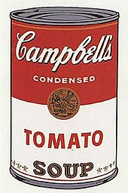  Campbell’s Soup | 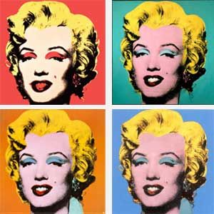  Shot Marilyns
Banana | 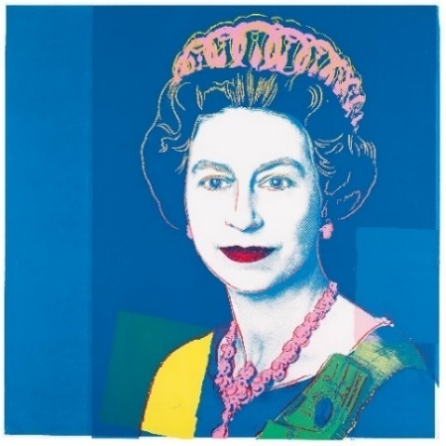  Queen Elizabeth II

Activity: Create a Warhol inspired artwork
Students will create an Andy Warhol inspired artwork or they can choose another pop artist such as Keith Haring or Roy Lichtenstein. Below are examples of their artwork.
- Begin by brainstorming some ideas for your artwork. What will be the subject of your artwork? Think about everyday objects (you could choose a soup can or piece of fruit) a popular culture icon or yourself as potential subjects. To create a pop art portrait, check out the NGV’s short video and teachers notes.
- What techniques will you use to create your artwork? (bright colours, repetition, bold lines). Think about taking a selfie or creating a self-portrait and repeating the image.

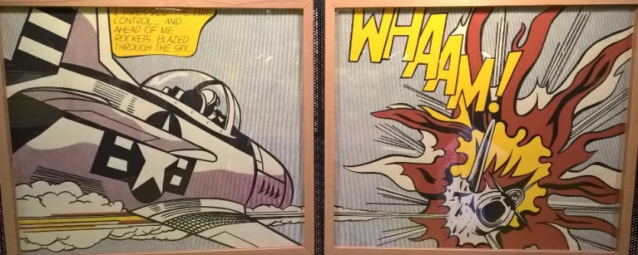
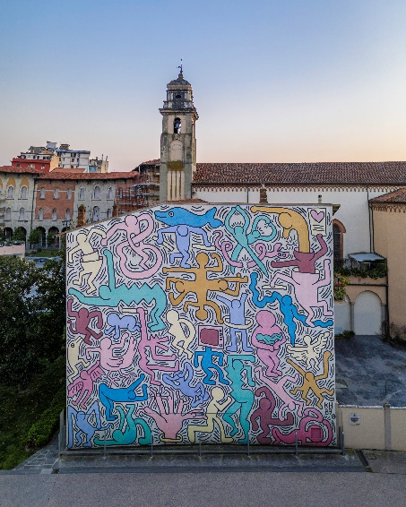

Whaam! – Roy Lichtenstein

Keith Haring
Pop Art Exhibition
Curate a class exhibition that showcases the students’ pop artwork. Invite students from other classes at your school to attend your exhibition. Consider holding your exhibition at your local library or local council.

Biography
Learn more about Andy Warhol’s life (or another pop artist) by creating a biography.
Your favourite pop art
Reflect on your favourite pop artwork. Give reasons why you like it.

Useful Websites
- Who is Andy Warhol? - Tate Kids
- Pop Art – Tate
- Andy Warhol Biography – The Warhol

KEY LEARNING
Students will learn more about the artist Frida Kahlo and respond to her artwork. Students will create a Frida Kahlo inspired artwork.

CURRICULUM
Visual Arts – Years 3 and 4
Explore where, why and how visual arts are created and/or presented across cultures, times, places and/or other contexts.

Share and/or display artworks and/or visual arts practice in informal settings.
Visual Arts – Years 5 and 6
Explore ways that visual conventions, visual arts processes and materials are combined to communicated ideas, perspectives and/or meaning in visual arts across cultures, times, places and/or other contexts.

Use visual conventions, visual arts processes and materials to plan and create artworks that communicate ideas, perspectives and/or meaning.

Select and present documentation of visual arts practice, and display artworks in informal and/or formal settings.

Visual Arts – Years 7 & 8
Experiment with visual arts conventions and techniques, including exploration of techniques used by Aboriginal and Torres Strait Islander artists, to represent a theme, concept or idea in their artwork.

Practise techniques and processes to enhance representation of ideas in their artmaking.

  - Teacher Resource

Frida Exhibition

Activity: Class Discussion
Discuss the BTN Frida Exhibition story as a class using the following questions to guide discussion:

- Before watching the BTN story, had you heard of Frida Kahlo? What did you know about her?
- What words would you use to describe her art?
- What are the subjects of her art?
- What techniques did she use to create her art?

What themes does Frida Kahlo explore in her work?
What questions do you have about Frida Kahlo?

Activity: Responding to Artwork
Students will select an example of Frida Kahlo’s artwork that inspires them (alternatively, they can choose one of the artworks below). Students will analyse and reflect on the artwork they have chosen and then respond to the questions below.

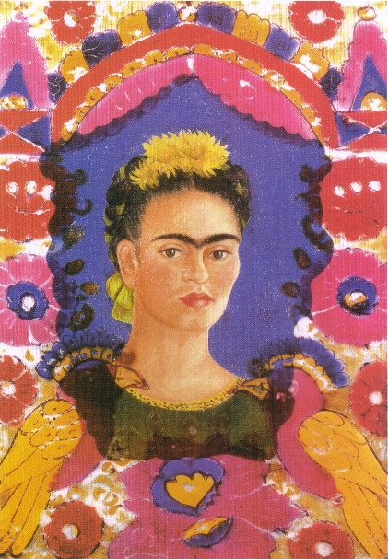 | 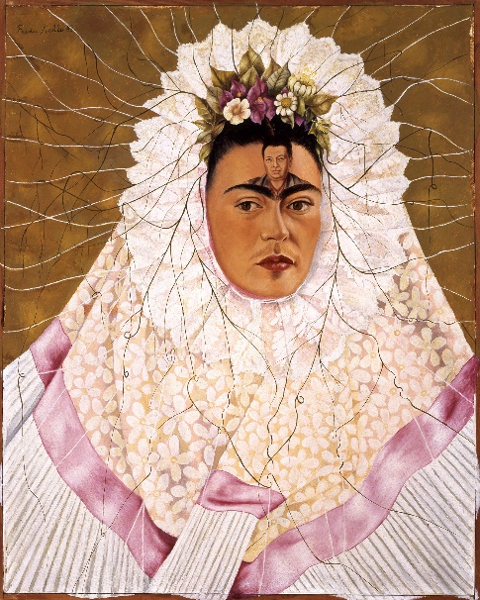 | 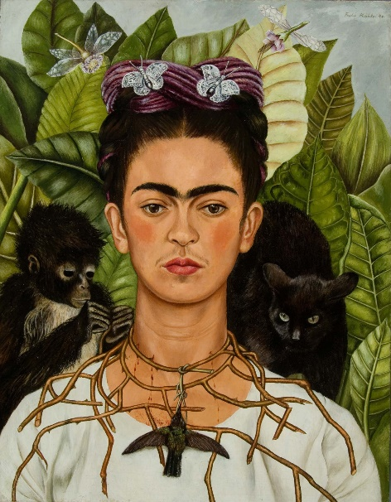

Questions to help guide students’ exploration:
- What is the title, artist, and date?
- Record as much information as you can about the artwork in 15 minutes. Record everything you see. The longer you look the more you will see. Consider looking at it from different angles, up close and far away.
- What shapes do you see? Do you notice any objects in the art work? What do these objects symbolise?
- What do you think the artist is trying to say through the artwork? What does it mean?
- What materials were used to make it? What techniques does the artist use?
- What themes are present in the artwork?
- What do you know about the artist?
- If there are people in the art work, what can you tell about their personality? What are they doing? Describe their facial expression and pose.
- What is the mood of the art work?
- Complete this sentence. Something that really caught my eye was….
- What do you like about this art work? Why did you choose it?
- How does the art work make you feel?
- What questions do you have about the artwork?

Further Challenge
- Create an artwork of your own which is inspired by the style of the artwork you have studied.
- Create a profile on the artist.

Activity: Exquisite Corpse
One of Frida Kahlo’s favourite games was Exquisite Corpse. Exquisite Corpse is the most famous of all the surrealist games and was invented by Andre Breton and the surrealists in the 1920s. The surrealists were a group of artists and poets who loved breaking the rules of art and finding new ways to look at the world.

Exquisite Corpse is a method by which a collection of images or words is collectively assembled. Participants play by taking it in turns drawing sections of a body on a sheet of paper. Each participant adds to a composition in sequence, either by following a rule, or by being allowed to see only the end of what the previous person contributed. The process of making an Exquisite Corpse encourages creativity and experimentation and often results in a strange and/or comical representation of the body.

Corpse (noun)
Late 13th century “body”, from Old French cors “body; person; corpse; life.
Exquisite (adjective)
Early 15c., "carefully selected," from Latin exquisitus "choice," literally "carefully sought out"
Drawing your Exquisite Corpse
Students will work in groups of three to create their Exquisite Corpse drawing, using the following steps. Before starting this activity establish procedures and expectations for collaborative work. Remind students that to be effective collaborators they need to be respectful and listen to each other.

Instructions
- Fold an A4 piece of paper into three equal parts, keeping the piece of paper in portrait mode.
- The first person begins the drawing in the top third of the piece of paper. Using a black felt tip pen, draw the head and neck of any creature – real or imagined. Extend the lines of your creature’s neck over the edge of the fold so that the next person will know how to connect their image to yours.
- Fold the paper to make sure the next person can’t see what has been drawn and pass it on to the next person.
- The second person draws a body – any kind of body – in the middle section of the piece of paper. Extend the lines of the creature’s body over the edge of the fold so that the next person will know how to connect their image to yours. Remember to fold the paper so the next person can’t see what has been drawn and pass it on to the next person.
- The third person draws the legs.
- Unfold your drawing together and discover your Exquisite Corpse.
- Repeat this process 3 times, so there are the same number of drawings as students in the class.
- Each student will take one of the drawings and decorate with coloured pencils.
Tips – Use a black felt tip pen when drawing each part of the creature. Include clothes on your creature!

Activity: Create a Self-Portrait
Who am I? Students will reflect on this question and explore their own identity through discussion, writing and art. Students will brainstorm and record how they see themselves, responding to the following reflective questions. Students will then take the information they have learnt about themselves and create a self-portrait.

Reflection
- Who are you?
- What words best describe you?
- What are you really passionate about?
- What are your most important values?
- What do you think is unique and special about you?
- What are your strengths?
- What are your challenges?
- How are you similar/different to other people? How do you feel about your differences?
- When do you feel most like yourself?
- How do you want people to see you?
- Why is it so important to be yourself?

Create
Students will create a self-portrait which represents how they see themselves. Looking at a mirror, students will experiment with poses, costumes and props and produce a self-portrait. Initially students can do some quick sketches of different features and then use these sketches to help create a final more detailed self-portrait. Students will write an artist's statement to go with their self-portrait.

Below are some guidelines for students as they create their self-portrait:
- Use colours that you feel reflect your mood or feelings.
- What style will you use to create your self-portrait? How will it help portray your identity?
- Where are you going to sit? Think about the background of your self-portrait. Is it real or imaginary?

Exhibition
Curate a class exhibition of your students’ self-portraits and choose a title for the exhibition. Invite students from other classes at your school to attend your exhibition. Consider holding your exhibition at your local library or local council.

Activity: Choose a project
Students choose one of the following projects to work on and then present their work to a partner, small group or the class.

Surrealism
How can you identify surrealism? Investigate the features of surrealist art. Reflect on your favourite example of surrealist artwork. Give reasons why you like it.
5 W’s
Choose one key event in Frida Kahlo’s life. Write a summary on the key event which answers the 5 W’s – Who, What, Where, When and Why?

True or False?
Create a true or false quiz about Frida Kahlo and test your classmates. Alternatively, create a word find or crossword.
Biography
Investigate the life and work of Frida Kahlo. Create a timeline of important events in Frida’s life. Present your findings in an interesting way.

Useful Websites
- Frida & Diego: Love & Revolution – Art Gallery SA
- Frida Kahlo: The woman behind the legend – TEDEd
- Frida Kahlo Museum
- Frida Kahlo – MoMA

