EPISODE 22
10th August 2021

KEY LEARNING
Students will view a range of BTN stories and use comprehension skills to respond to a series of focus questions.

CURRICULUM
English – Year 4
Use comprehension strategies to build literal and inferred meaning to expand content knowledge, integrating and linking ideas and analysing and evaluating texts.

English – Year 5
Use comprehension strategies to analyse information, integrating and linking ideas from a variety of print and digital sources.

English – Year 6
Use comprehension strategies to interpret and analyse information and ideas, comparing content from a variety of textual sources including media and digital texts.

English – Year 7
Use comprehension strategies to interpret, analyse and synthesise ideas and information, critiquing ideas and issues from a variety of textual sources.
  - Teacher Resource

Focus Questions

Vaccine Influencer Army
- In pairs, discuss the Vaccine Influencer Army story.
- What is the White House?
- Who is the `Influencer Army’?
- Why has the White House enlisted the help of social media influencers and celebrities?
- In the United States, teens and young adults have the lowest vaccination rates of any age group.
  - True
  - False
- In the US, people as young as ________ can get the COVID vaccine.
- What role is fake news and misinformation playing in the vaccine effort?
- Have you seen examples of misinformation and fake news about COVID? Give an example.
- What else is being done to encourage people to get vaccinated?
- What did you learn watching this story?

Feral Species Cost
- Before you watch the BTN story, make a list of the feral species you know.
- What is a feral species?
- About how much have invasive species cost Australia over the past 60 years?
  - 39 million
  - 39 billion
  - 390 billion
- Give an example of the damage an invasive species can cause to agriculture.
- Why are feral species particularly bad for Australia?
- Which feral animal is the most costly and dangerous in Australia?
- What other feral animals are a problem?
- How do biosecurity laws help to keep pests out of Australia?
- What impact can feral species have on native species?
- What questions do you have about the story?

Check out the Feral Species Cost resource on the Teachers page.
AIS History
- Discuss the BTN AIS History story as a class.
- How many gold medals did Australia win at the 1976 Olympic Games?
- What did experts recommend to the Australian government after the 1976 Montreal Olympic Games?
- What does AIS stand for?
- What year did the AIS open?
- How many gold medals did Australia win at the 1984 Los Angeles Olympic Games?
- How many sports did the AIS offer an intake for when it first opened?
- Why has the AIS had lots of international visitors since it began?
- What type of support does the AIS offer its athletes? Name two.
- What do you understand more clearly since watching the BTN story?

Check out the AIS History resource on the Teachers page.

Chess Champion
- Retell the BTN Chess Champion story.
- How old is Tani?
- What does Tani like about playing chess?
- Tani arrived in the United States as a refugee from which country?
  - Namibia
  - Nigeria
  - Sudan
- Where was Tani living when he started playing chess?
- Tani spends up to __________hours a day practising chess.
- Tani’s story has just been documented in a kids book. True or false?
- Which movie production company has bought the rights to his story?
  - Paramount Pictures
  - Universal Pictures
  - DreamWorks Pictures
- What is Tani’s ultimate dream?
- How did this story make you feel?

Do black holes suck in planets?
- What did the BTN story explain?
- A black hole is a point in space and time where _____________ is so intense that nothing can escape it.
- What is the most common way for a black hole to form?
- What is a supernova?
- What is the glowing part around a black hole called?
- Can a black hole suck in a planet? Explain your answer.
- How likely is it that a planet would fall into a black hole?
- Describe what the black hole looks like.
- What three facts did you learn watching this story?
- What was surprising about this story?
  - Teacher Resource

Feral Species Cost
EPISODE 22
10th August 2021

KEY LEARNING
Students will investigate the impact that invasive species have on the environment and economy.

CURRICULUM
Science – Years 5 & 6
Scientific knowledge is used to solve problems and inform personal and community decisions.
Science – Year 6
The growth and survival of living things are affected by physical conditions of their environment.
Science – Year 7
Interactions between organisms, including the effects of human activities can be represented by food chains and food webs.

Focus Questions
- Before you watch the BTN story, make a list of the feral species you know.
- What is a feral species?
- About how much have invasive species cost Australia over the past 60 years?
  - 39 million
  - 39 billion
  - 390 billion
- Give an example of the damage an invasive species can cause to agriculture.
- Why are feral species particularly bad for Australia?
- Which feral animal is the most costly and dangerous in Australia?
- What other feral animals are a problem?
- How do biosecurity laws help to keep pests out of Australia?
- What impact can feral species have on native species?
- What questions do you have about the story?

Activity: Class Discussion
Before watching the BTN Feral Species Cost story, ask students what they already know about invasive species. How many invasive plants and animals can they name? Make a list.
Hold a class discussion about the information in the BTN Feral Species Cost story. Use the following questions to guide discussion:
- What is an invasive species? Come up with a class definition.
- What are some examples of invasive species (plants and animals)?
- What impact do invasive species have native species and ecosystems?
- What is the economic impact of invasive species?
- What questions do you have about invasive species?

Activity: Glossary
Students will brainstorm a list of key words that relate to the BTN Feral Species Cost story. Below are some words to get them started.

INTRODUCED SPECIES | PEST | INVASIVE
POPULATION CONTROL | ERADICATE | ECOSYSTEM

Activity: Invasive Species Research
After watching and discussing the BTN Feral Species Cost story, what questions do students have? The following KWLH organiser provides students with a framework to explore their knowledge on this topic and consider what they would like to know and learn.
What do I know? | What do I want to know? | What have I learnt? | How will I find out?

Students will develop their own question/s to research or select one or more of the questions below.
- Investigate invasive species (plants and/or animals) that are found near where you live.
- What are the different pest threats (plant or animal) to farming and agriculture? Watch the BTN Mouse Plague story to learn more.
- How do we try to stop the spread of diseases and pest species (animals and plants) in Australia? (For example: not being allowed to take some food items across state borders, having bags checked at the airport, vaccinations for animals).
- Investigate ways of controlling invasive species.
- What is biosecurity? How does biosecurity help to keep Australian ecosystems healthy?
- Choose an invasive species and find out how it competes with native species.
- Investigate examples of native species becoming extinct because of invasive species.

Watch the BTN Calligrapha Beetle Business story to find out how some kids are helping to combat a serious environmental problem, while making a profit.
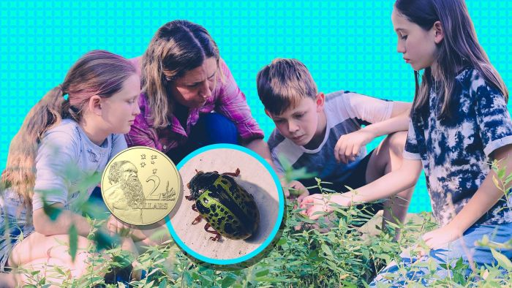
- How much do Jack and Kelly sell the beetles for?
- The beetles are native to which country?
- Why were the beetles introduced?
- Who is the Sida weed a big problem for?
- Sida weed is a problem, particularly in the dry season. True or false?
- Why is the Calligrapha beetle the perfect biological control?
- How many beetles have they sold so far?
- Explain the process of collecting the beetles.

Activity: Profile Invasive Species
Students will investigate the impact invasive species have on the environment and choose one to research in more detail. They may choose an invasive species that is found near them. Use the following template as a guide for their research.

Name of invasive species:
Which country did the species
come from?

When and how was the species
introduced to Australia?

Where in Australia is the species found?
Illustration/photo
What impact does the species have on the ecosystem?

Methods used to control or eradicate the species:

How successful has control or eradication been?

Further investigation
- Design a public education campaign to raise awareness about an invasive species in Australia. Think about your campaign’s aim, your target audience, and the value of raising awareness.
- Create a poster of Australia’s 10 most unwanted invasive species. Describe each species and the impact the species has on the environment.

Activity: Match the Invasive Species
Working in pairs, students match the invasive species to the clues provided.

Fire Ant  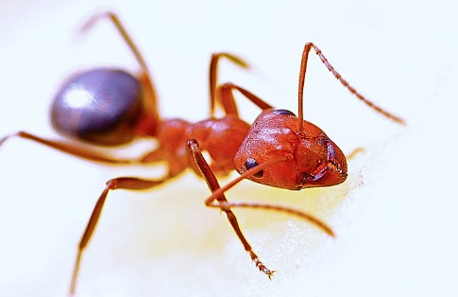 | A  I arrived in Australia with the First Fleet.  There are more 23 million of me across Australia.  I cause significant agricultural damage.
Feral pigs  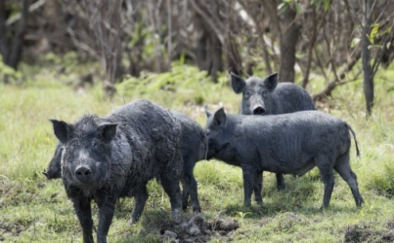 | B  I am native to Europe.  I am poisonous to grazing animals and invade native vegetation.
Ragwort  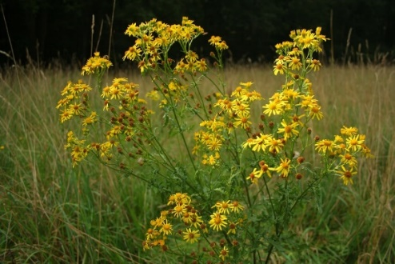 | C  I am spread mainly by fruit-eating birds and mammals.  More than 1400 native species are negatively affected by me including many endangered and threatened species.
Feral Cat  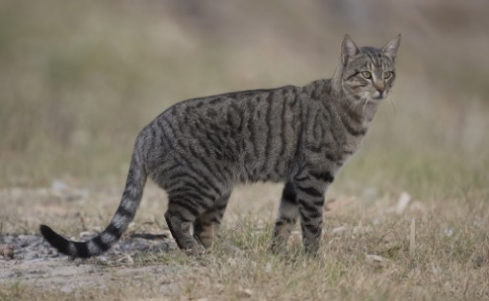 | D  I am native to South America.  I am the target of one of the biggest eradication programs in Australia.
Lantana  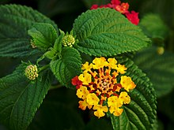 | E  I am responsible for killing around 1 billion native animals every year.  I have contributed to the extinction of more than 20 Australian mammals.

Answers: Fire Ant: D, Feral pig: A, Ragwort: B, Feral cat: E, Lantana: C.

Useful Websites
- Invasive species have cost Australia $390 billion in the past 60 years, study shows – ABC News
- Mouse Plague - BTN
- Calligrapha Beetle Business - BTN
- Fire Ants – BTN
- Controlling Carp – BTN

EPISODE 21
10th August 2021

KEY LEARNING
Students will learn more about the Australian Institute of Sport, why it was created and its role in Australia today.

CURRICULUM
HASS – Year 5-7
Develop appropriate questions to guide an inquiry about people, events, developments, places, systems and challenges.

Science – Year 5-6
Scientific knowledge is used to solve problems and inform personal and community decisions.

Science – Year 7
People use science understanding and skills in their occupations and these have influenced the development of practices in areas of human activity.

Health & PE – Years 3 & 4
Identify and practise strategies to promote health, safety and wellbeing.

Health & PE – Years 5 & 6
Plan and practise strategies to promote health, safety and wellbeing.

Propose and apply movement concepts and strategies with and without equipment.

Health & PE – Years 7 & 8
Investigate and select strategies to promote health, safety and wellbeing.

Practise, apply and transfer movement concepts and strategies with and without equipment.

  - Teacher Resource

AIS History

Focus Questions
Discuss the BTN story as a class and record the main points of the discussion. Students will then respond to the following:
- Discuss the BTN AIS History story as a class.
- How many gold medals did Australia win at the 1976 Olympic Games?
- What did experts recommend to the Australian government after the 1976 Montreal Olympic Games?
- What does AIS stand for?
- What year did the AIS open?
- How many gold medals did Australia win at the 1984 Los Angeles Olympic Games?
- How many sports did the AIS offer an intake for when it first opened?
- Why has the AIS had lots of international visitors since it began?
- What type of support does the AIS offer its athletes? Name two.
- What do you understand more clearly since watching the BTN story?

Activity: Class Discussion
Discuss the information raised in the BTN AIS History story. Ask students to record what they know and learnt about the AIS on a mind map. What questions do students have? Use the following questions to guide discussion:
- What does AIS stand for?
- What year was the AIS opened?
- Why was the AIS started?
- What is the purpose of the AIS?
- How does the AIS help Australian athletes?
- Is it important to have the AIS? Why or why not?
- What is sports science?
- How is sports science used to help athletes at the AIS? Give one example.

Activity: KWLH
Hold a class discussion about the information raised in the BTN AIS History story. What questions were raised in the discussion and what are the gaps in their knowledge? The following KWLH organiser provides students with a framework to explore their knowledge on this topic and consider what they would like to know and learn.

What do I know? | What do I want to know? | What have I learnt? | How will I find out?

Research questions for Inquiry
- Why was the Australian Institute of Sport (AIS) created? Explore the history of the AIS. Choose what you think are the 10 most important events that have happened in the history of the AIS and record your findings on a timeline. Find and collect images, photographs, and video as part of your research.
- What is the role of the Australian Institute of Sport (AIS)? Create a fact sheet highlighting your findings. Research the 3 most important goals of the AIS and present your findings to the class.
- What is sports science? Come up with a class definition.
- What are some of the key events in the history of the Australian Institute of Sport? Write a summary for one key event, which answers the 5 W’s – Who, What, Where, When and Why?
- Who works at the Australian Institute of Sport? Choose one role to explore in more detail. For example, physiotherapist, physiologist, psychologist, strengthening auditioning coach, bio mechanist, skill acquisition specialist or sports engineer.
- What sports are offered at the AIS? How does the AIS support athletes competing in this sport? Choose one to explore in more detail and present your findings in an interesting way.
- What athletes started their career at the AIS? Choose one to explore in more detail and create a biography on the athlete.
- How can you use science to improve sport? Give one example and explain using your own words.
- Choose one aspect of sports science that has helped athletes improve their performance, and research in more detail.

Activity: Visual literacy
Below are images of elite athletes and sports scientists at the Australian Institute of Sport. Students look at the image/s and then respond to the following questions:
- What do you see in this image?
- When do you think it was taken?
- Describe the setting and who is in the image.
- What do you think is happening?
- What questions do you have about what you see in the image?
- Create a caption for each image.

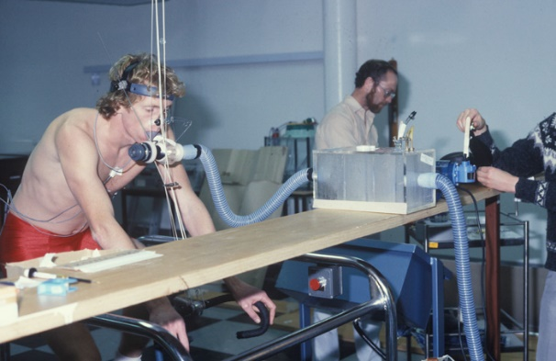  AIS Physiology 1989 - Ergometer Vo2 Tony Cox, Cycling | 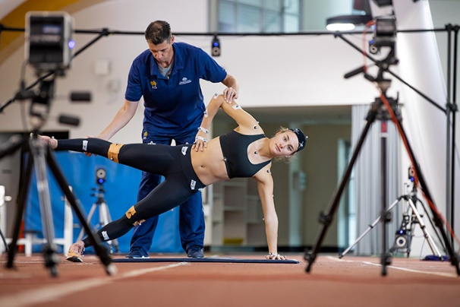  Athlete testing with strength and conditioning coach Aaron Holt in biomechanics lap 2019
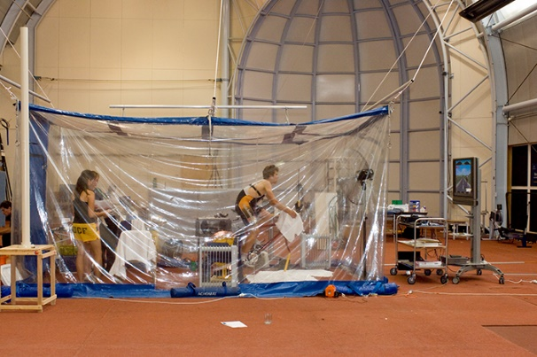  Ben King (athlete) cycling biomechanics testing 2008 | 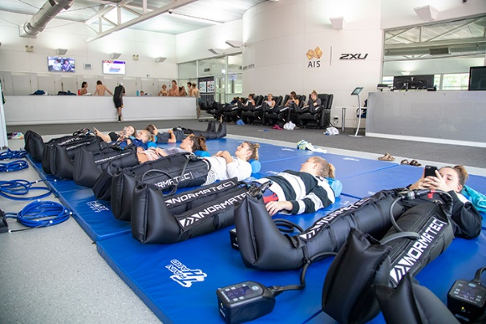  Athletes using recovery boots in the AIS recovery facility 2020

Activity: Imagine you’re a sports scientist
Students will imagine they are a sports scientist with the aim to help improve an athlete’s performance leading up to the Olympics. Students will choose an Olympian or Paralympian to focus on and write a day in the life of an athlete. Students can use the following to help guide their research.
- Goals – what are the athlete’s daily goals and how will they reach them?
- Practise – why is practise important? What would be a good training schedule for the athlete?
- Diet – what would be a healthy and nutritious diet for the athlete?
- Technology – what technology could help the athlete improve their performance?
- Pressure – how can you encourage the athlete to push themselves physically?
- Skill – how could you measure the athlete’s skills?
- Recovery – how could the athlete avoid or reduce injuries?
- Mentality – How could you help the athlete adopt a positive mentality even when facing challenges?
- Wellbeing – how can you help the athlete maintain a healthy wellbeing?

Activity: Future of sport
Before starting this activity, hold a class discussion, asking students what they think sports will look like in the future and how sports might evolve as new technologies become available. Think about safety, sustainability, convenience and innovation.

In small groups, students will imagine they are sports scientists, with the aim being to improve or adapt clothing to enhance athletic performance. Students will choose one sport to focus on and use the following as a guide during their research:

- How has the clothing evolved since the sport began? Create a timeline using images to show clothing from when the sport first began until now.
- How could the clothing be improved? For example, it could be more environmentally friendly, safer or improve performance.
- Write a brief for your design, using these headings as a guide: Background, Criteria, Your Challenge, Constraints.
- Sketch a drawing of the new clothing with labels to show its features – include annotated diagrams to show materials.
- How will it improve athletic performance?
- What new technologies will you incorporate in your design?
- What is unique about the design?

Presentation
Students will present their designs and share their ideas persuasively to the class. Encourage students to ask questions about their classmate’s designs. Challenge students to make any improvements they can to their designs.

Further learning
Students will make a prediction about how science and technology might improve sport in the future. Students will illustrate their prediction/s and provide an explanation. Below are some examples:
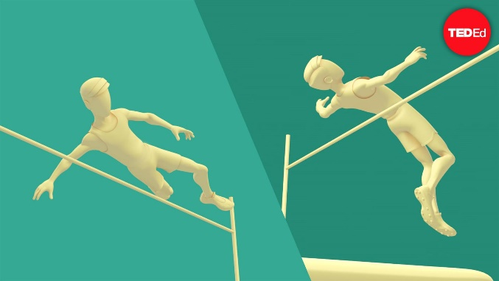
- Virtual reality – to allow spectators to watch the game.
- Augmented reality – to help athletes practise and improve their technique.
- Physics – to improve athletic performance. Watch this Ted-Ed animated video to learn more about a high jumper that changed their technique to jump higher.
TedEd – An athlete uses physics to shatter world record

Useful Websites
- AIS 40th Anniversary: Our History – AIS
- Australian Institute of Sport Special – BTN
- AIS Special Teacher Resource – BTN
- Australian Olympic Team – Tokyo 2020
- Sports Science – BTN

  - Teacher Resource

BTN Transcript: Episode 22 - 10/8/2021

Hey, Amelia Moseley here and you're watching BTN. Let’s check out what’s coming up. We count the cost of our country’s feral pests, find out how Australia got its winning Olympic edge and delve into the mysteries of black holes.

Vaccine Influencer Army

Reporter: Amelia Moseley

INTRO: But first today. With the COVID-19 Delta variant on the rise around the world, many countries are trying to convince as many people as possible to get vaccinated. In the US, the government has come up with a pretty interesting way to take the message to young people and fight the influence of misinformation. Take a look.

They've been enlisted by the President of the United States to fight fake news and tackle misinformation. Armed only with their phones and some specially purchased lighting and audio equipment. It's the US Influencer Army.

OK, that's what I imagine an influencer army looks like, but in reality, it's more like this. You see, a place that normally has quite a lot of influence recently realised it could use a little help you know influencing people. The White House.
WHITE HOUSE REPRESENTATIVE: So, I have a special guest with me today. Joining us in the briefing room is actress and multi-platform recording singer-songwriter Olivia Rodrigo.
OLIVIA RODRIGO, POP STAR: First I want to say I am beyond honoured and humbled to be here today to help spread the message about the importance of youth vaccination.
Yup, to encourage more young people to get vaccinated, the US government's recruited the biggest artist of 2021. Along with a so-called "army" of 50 TikTokers, Twitch streamers, YouTubers, and Instagrammers.
MIA FINNEY, TIK TOK INFLUENCER: One month ago, I got fully vaccinated.
TINX, TIKTOK INFLUENCER: You need to lock it up OK. I have a little bit of a sore throat. For the final time, I only protect against COVID.
Like many countries, the US is trying to get on a roll with its vaccine rollout. And while it is doing well, teens and young adults still have the lowest vaccination rates of any group, even though people as young as 13 can get the vaccine there. Experts say the vaccine effort is coming up against a powerful enemy online, fake news and misinformation. A problem that goes way beyond the US.
TRISHA: So, on social media I've seen a lot of people like put emphasis on the side effects and how bad they are after they receive the vaccine. Vaccines are known for having side effects after, that's just normal for vaccines for any disease.
ZAKI: I've seen that the vaccine is untested, isn't safe for people because it was developed in such a short time.
MITCHELL: I've seen lots of misinformation that the government's tracking you by giving you the vaccine, no one’s actually dying. It's all fake.
AMELIA: What do you think about those things?
ZAKI: Well, I think they're false because they wouldn't be testing out some experimental vaccine on people without getting it tested first.
While social media platforms have been trying to stop that kinda fake info spreading by flagging it and even slapping bans on people or organisations spreading it, the White House has decided to try this powerful weapon for good. It's asked influencers to spread positive messages and facts about COVID vaccinations. With the help of the President's chief medical advisor.
DR. ANTHONY FAUCI, CHIEF MEDICAL ADVISOR TO THE PRESIDENT: What's up dudes?
MATT & ABBY, TIK TOK INFLUENCERS: What's up Dr. Fauci.
DR. ANTHONY FAUCI, CHIEF MEDICAL ADVISOR TO THE PRESIDENT: There are multiple myths going on out there, from anything from aliens taking over your body to becoming magnetic. Thank you for what you’re doing, it’s really important.
Social media isn't the only thing countries around the world are using to encourage people to get the jab. There's also everything from ads.
SIGNAPORE VACCINE AD: Singapore. Don't wait and see. Better get your shot. Steady pom pi pi.
To cash prizes and music festivals tickets. So will it work?
ZAKI: I think encouraging people to get vaccinated is a great idea because they get to protect their loved ones and their school mates, teachers, family.
FENET: I think it's really good that they promote vaccines on social media, and incentives are a really good idea.
I guess it's up to these influencers to help fight on the social media frontlines. Wait, not these influencers. The real ones. Oh man. Well, you get the idea.
News Quiz

As you probably know, we’ve been hearing a lot from these people recently, state health officers. Can you match each of these with their states? There’s Doctor Jeannette Young, Doctor Brett Sutton and Doctor Kerry Chant. Jeanette Young is Queensland’s chief health officer, Brett Sutton is Victoria’s and Kerry Chant is New South Wales’. All three of them have at least part of their state in lockdown at the moment to try to stop the spread of the COVID Delta variant.

Which COVID-19 vaccine has just been approved for use in Australia? Johnson and Johnson, Moderna or Novavax. It’s Moderna. The first batch of doses are due to be delivered next month, and like Pfizer, it’s expected to eventually be given to kids as young as 12.

Devastating wildfires have burned near Olympia, the site of the ancient Olympics. What country is that in? It’s in Greece. Dozens of fires are burning through Greece, threatening homes and ancient sites. There are also really bad fires burning in Turkey and Italy and other nearby countries following an extreme heatwave in Europe.

How much will a local or national call from one of these things cost you now? 50 cents, $1.00 or nothing? The answer is nothing. Telstra’s decided to make its 15,000 payphones free. While that would have made kids in the 90s pretty excited, you guys probably don’t use them too often. But Telstra says about 11 million calls are made from its payphones every year, and in an emergency, they can save lives.

Feral Species Cost

Reporter: Natasha Thiele
INTRO: Now to a story about these guys, feral species. We all know they're a big problem here in Australia, but did you know they're also a really expensive problem? Here's Tash.

They're the pests menacing our country, invading our backyards, our farms and our national parks. They're the ferals. Yep, feral species are a big problem here in Australia. You're probably familiar with the usual suspects, but they're only a small part of the gang. In fact, you might be surrounded by ferals without even knowing it.
TASH: So, Corey, tell me a bit about this area.
PROFESSOR COREY BRADSHAW: Yeah, this is a classic bit of remnant bushland and it's mostly full of native species, but we've got a lot of weeds that have come in. Oh, this for example, this is capeweed. Here's another nasty one. It's a thistle, you know everyone will be familiar with the prickles.
TASH: They're very prickly those ones, yep.
COREY: Scottish national emblem, but we don't like them here. And, oh, of course, we've got wild pea here. This is a nasty one, this is a common grass called Kikuyu.
Professor Corey Bradshaw is an ecologist who's just published a paper about the cost of invasive species in Australia.
COREY: Not only the cost to damage ecological systems, but they cost our economies billions and billions and billions of dollars every year.
390 billion dollars in fact. That's how much Corey says these ferals have cost Australia over the past 60 years.
COREY: So that can be anything from damage to crops. For example, there's a fungal disease that attacks bananas in the Northern Territory or it can be say, like rats or mice eating grain from a grain store. Or it can be even things like the cost of taking weeds off of a property.
Corey says while feral species are a problem around the world, in Australia they're particularly bad news. And that's mostly because we're an island, a very old island, and for about a 100 million years or so plants and animals here got to evolve on their own paths relatively undisturbed by outsiders. That changed 200 years ago when European settlers came along bringing a whole host of ferals with them. Some by accident and some deliberately for farming or hunting or fishing or comfort.
COREY: It wasn't until, you know, farmers started to complain about, you know, weed x, y, z or we started to notice that populations of native species were going down the toilet.
So what are the worst feral offenders?
COREY: Feral cats aren't just costly from a price perspective; they are probably the most dangerous animal in Australia. Rabbits, European rabbits, are another big problem, especially for farmers across Australia. Other things like feral pigs. We have different types of grasses. In Queensland and things like the fire ants.
Over the years we've got a lot better at controlling what comes in and out the country and Australia now has some of the best biosecurity laws in the world.
COREY: If you’ve ever gone through the airport and you have to go through customs, you also come up to quarantine. And they say, have you brought any fruit in, or have you got any products, wood products and things like that.
Government’s also spend a lot of money trying to control feral plants and animals that are already here in all sorts of ways. It's a tough battle, but experts say it's one that we need to fight to keep our precious natives safe from the ferals.

Quiz

Which of these birds is introduced and considered a pest? Is it the Noisy Miner, the magpie or the blackbird? It's this one, the common blackbird.
AIS History

Reporter: Jack Evans

INTRO: Well, the Olympics have just wrapped up in Tokyo and the Aussies did really well. We've kinda come to expect big things of our elite athletes over the years and partly that's because of this place, the Australian Institute of Sport. Jack found out more about its place in Australia's Olympic history.

If there's one thing, we've learnt over the past two weeks it's that when it comes to sport, we Aussies have it in the bag or the hoop or the net or whatever, you get the point. But there was a time when, well, we weren't doing so well. In the 1976 Olympic Games in Montreal, Australia won no gold medals at all, none. No gold medals. It was pretty shocking. So much so that the government asked experts to look for a way to fix things.
JULIAN JONES, AIS: It was recommended that we started an institute, facility and environment to enhance the sports that we had in Australia.
That's Julian Jones, former Olympic weightlifter and Head of Performance Services at this place, the Australian Institute of Sport. Oh, and he was at it's opening.
JULIAN: 1981, Australia Day, January, was stinking hot day I was here myself actually. So there was 12 sports that started with the AIS all of them trained out of that facility, apart from swimming, which trained in the Deacon swimming pool, which didn't actually have a roof on it at the time when we started there.
The Australian Institute of Sport offered up and coming athletes intense training by the best coaches and gave a big boost to the growing field of sport science. Young athletes were given full time scholarships at the AIS where they could hone their skills and the hard work paid off. Because in the 1984 Los Angeles Olympics Australia took home 24 medals, four of them gold. The proof was in the pudding or the medals as it were. The government started spending money on all sorts of elite sports and the wins have kept coming. The success of the AIS became known all over the world and soon other countries started copying the AIS and setting up their own versions.
JULIAN: We've had lots of international visitors over the years since we've been set up. And a number of those countries have gone away and emulated what we've got here in whether it be with the buildings or whether it be with some of the systems. But fortunately, they haven't been able to replicate exactly what we've had here.
Of course, since then the AIS has changed a lot. Now every state and territory has its own sport organisation and professional teams have their own training programs and centres. But some of those are based at the AIS and it still plays a huge role in training athletes and in the science of sport.
JULIAN: I've got nutritionists, I've got psychologists, strengthening conditioning coaches, bio mechanists, skill acquisition specialists. Then we've got sports engineers. Then we've got artificial intelligence. We've got physio therapists. It's quite a moving feast and it's dynamic in nature as to where the best effect of them coming in and working with the athlete.
And if you spend any time around this place, you might just catch a glimpse of the Olympians of the future.
Ask a Reporter

Do you have a question about the AIS? Well, you can ask me live on Friday during Ask a Reporter. Just head to our website for all the details.

AIS Special Promo

That story is part of a special episode that we've put together from the AIS which you can find on our website. Now let’s have a look back at some Olympic highlights in this week's sport.

Sport

There were songs, parades and fireworks, as the Tokyo Olympics officially come to an end. These very different Olympic Games wrapped up on the weekend. The US topped the medal tally with 39 gold medals. China came in 2nd and Japan 3rd. As for us Aussie's, we did pretty well coming in 6th with 17 gold medals and 46 in total.

That was thanks to some very impressive Aussie athletes including swimming legend Emma McKeon. She's now the second woman in history to win 7 medals in a single Olympics. There were also some Aussie wins in new categories. BMX rider Logan Martin made history claiming the first Olympic gold in BMX freestyle, while Aussie Keegan Palmer won a skateboarding gold. The history making doesn't stop there. The Aussie men’s basketball team won their first ever medal at an Olympic Games and Andrew Hoy became Australia's oldest Olympic winner earning a silver in team eventing at 62.

As fierce as the competition was, there were plenty of feel good moments from this year’s Games, like when Italy and Qatar's high jumpers decided to share the gold after spending hours in a tie. Or when Simone Biles reminded us that winning isn't everything when she decided to pull out of some events but stayed on to cheer her team mates before collecting a bronze. Oh, and what would we have done without Tom Daley’s daily pool side knitting and if you're already missing the games don't worry cause the Paralympics are gonna start in a couple of weeks.
Chess Champion

Reporter: Amelia Moseley

INTRO: Now to a different sort of game, chess. You're about to meet a kid living in the US who's just become a chess master at 10-years-old and his amazing journey has been getting a lot of attention, it's even going to be turned into a movie. Check it out.
This is Tanitoluwa Adewumi. At 10 years old he's a chess wizard.
HARRY POTTER & THE PHILOSOPHER'S STONE, 2001: Check mate.
Ahh, not that kind of wizard. There's no magic here just serious skills and a love of the game.
TANI ADEWUMI, CHESS MASTER: Probably like the way like the pieces move, like the beautiful aspect of the game, I'd say.
Tani only started playing a few years ago after he and his family were forced to leave their home in Nigeria and come to the US as refugees. They ended up without anywhere to live and had to stay at a homeless shelter in New York for a while and that's when Tani first started making moves.
TANI ADEWUMI, CHESS MASTER: Like, there was nothing else to do. So, I was just like, why not go for it? And that time I was in the shelter, so I was just like, why not go for it?
And boy, did he go for it. Tani now spends up to 10 hours a day practising. He's won heaps of tournaments and now he's become a national chess master. For us non-chess champs, that means he's getting closer to being up there with the world's top junior players. Tani's amazing story has got a lot of attention, it's even been documented in a novel and a kids' book.
TANI ADEWUMI, CHESS MASTER: And over here, is the kids, you cannot forget about the kids, so this is 'Tani's New Home' over here.
There's also a movie in the works after Paramount Pictures bought the rights to his story. How cool is that? But this chess master's ultimate dream is to up his rating and become the youngest ever grandmaster. Although Tani says what really counts the most is just doing your best and having fun.
TANI ADEWUMI, CHESS MASTER: Rating is just outside, but it’s really inside of how you play the chess game. So, no underrating anybody and just play your best.

Quiz

What's this chess piece called? Is it a castle, a tower or a rook? It's a rook. It can move in a straight horizonal or vertical line.

BTN Investigates: Black Holes

Reporter: Jack Evans

INTRO: Finally, today, to BTN Investigates. It's a special segment where we answer your big questions. This one was sent in by year fours at Darcy Road Public School in Western Sydney, who want to know more about black holes.

SUHANA: Hi, I’m Suhana from Darcy Road Public School and I’m in year 4. My question is do black holes suck in planets?

JACK: Another day, another missing planet. Where do they keep going?
ROBOT: Beats me.
JACK: I wonder if it's got anything to do with this black hole? Like I always say, "black holes suck everything into them".
ROBOT: You do always say that.
JACK: I know.
ROBOT: But actually, they don't really suck everything in.
JACK: Ah, yes, they do.
Actually, that robot is right, kinda. Black holes aren't exactly giant vacuums sucking up every bit of space in sight. Although it's easy to understand why you would probably think that. More accurately a black hole is a point in space and time where gravity is so intense that nothing can escape it, not even light, hence the name.
They can form a couple of different ways. The most common way is when a big star reaches the end of its life and has burned up all of its fuel. The energy that once held the star together disappears and it collapses in on itself in a massive explosion called a supernova. As for all that stuff that made up the star, well it falls into an incredibly small, infinitely dense point, known as the singularity. The glowing part around the black hole is called the event horizon and anything that crosses the event horizon will never get out.
JACK: Ha, so they do suck. Which means it's probably responsible for all those missing planets.
ROBOT: Hold your horses.
JACK: Oh no, why? Do you think they could get sucked in too?
ROBOT: No. Why don't you give Sara a call?
JACK: Oh, that's a great idea, she knows all about this stuff.
JACK: Sara, Sara, come in, can you hear me?
SARA WEBB, ASTRONOMER: Hi Jack, black hole helpline. How can I help you?
JACK: I need help with a case, but more importantly I need help to prove somebody wrong. Can a black hole suck in a planet?
SARA: Theoretically, yes.
JACK: Uh huh.
SARA: So, if the planet that is being sucked into that black hole it would be spaghettified. So, once it crosses that event horizon, that magic line where light can no longer escape all of the atoms and the particles and the bits and bobs that make up that planet would start to be sucked in very slowly.
JACK: Well, there you go. Case closed. A black hole can suck in a planet.
SARA: But practically no.
JACK: Oh.
SARA: It's not like a cosmic vacuum going around and sucking things in. So, most of the time, if something comes close to a black hole, it will get sucked into an orbit around the black hole. The largest black holes that we see have these things called accretion disks, which is lots of gas and material just circling around the black hole. And it will occasionally eat a little bit of that when it gets close enough. But yeah, it's not like a big vacuum.
JACK: Oh.
SARA: The actual likelihood of planets falling into black holes is very, very slim.
JACK: Oh, well thank you, I spose.
SARA: I hope you find what's taking all of those planets.
JACK: Well, if it's not a black hole causing all those planets to disappear, then what is it?
ROBOT: Maybe it's a pesky planet destroying alien.
JACK: Oh yeah, sure. Like that's a thing.
Closer

If you have something you want us to investigate, then head to our website to submit your question. Well, that's it for this week, but next week we'll be bringing you a special episode for Science Week. In the meantime, BTN Newsbreak will keep you up to date every weeknight and there's heaps to see and do on our website and our YouTube channel if you're 13 or over. Have an awesome week. Stay safe and I’ll see you soon. Bye.

