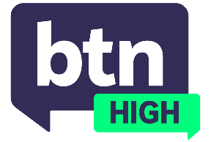
  EPISODE 65
  19th November 2025
  KEY LEARNING
  Students will discuss YouTube’s content and how it is expected to change with Australia’s social media ban.
  CURRICULUM
  English – Year 7 (v8.4)
  English – Year 7 (v9.0)
  Health and PE – Years 7 and 8 (v8.4)
  Health and PE – Years 7 and 8 (v9.0)
  Health and PE – Years 7 and 8 (v8.4)
  Economics and Business – Years 9 and10 (v8.4)
  Economics and Business – Year 8 (v9.0)
  Economics and Business – Year 9 (v8.4)
  Economics and Business – Year 9 (v9.0)
  Economics and Business – Year 10 (v8.4)
  - Teacher Resource

YouTube Content

Focus Questions
Discuss the BTN High story as a class and record the main points of discussion. Students will then respond to the following:
- Do you think YouTube exposes young people to harmful content? Explain.
- Do you think social media companies like YouTube have a responsibility to protect young people? Why or why not?
- Should there be tighter restrictions on YouTube’s content/ads once Australia’s social media ban comes in? Provide reasons for or against.
- Will the ban affect the way you use YouTube? Explain your answer.

Activities
- In small groups, discuss the content you’ve been exposed to on YouTube and how you felt about seeing it.
- Draft a letter or email to YouTube expressing your thoughts about the content on the social media platform. Are there concerns you want to raise? What restrictions would you like to see YouTube implement when the ban comes in?
- If you were in charge of Australia’s social media ban, design a business plan showing which social media platforms would be affected and what rules and restrictions would be enforced.

