Episode 33

17th November 2020



**COVID-19 Vaccine Trials**

1. Discuss the BTN story as a class. Record the main points raised in the discussion.
2. Working in pairs, record what you know about vaccines.
3. Creating a vaccine is a long process that usually takes years of research and three phases of testing. True or false?
4. Complete the following sentence. The vaccine is in the __________phase of human trials.
5. About how many people volunteered in the human trials of the vaccine?
6. Complete the following sentence. The vaccine seems to be effective more than ________% of the time.
7. Why are some experts and world leaders saying we shouldn’t get ahead of ourselves?
8. If the vaccine does get approved, when will it be released?
9. How many doses of COVID-19 vaccines has Australia signed up for?
10. How did the BTN story make you feel?

**High-Speed Hyperloop**

1. Discuss the BTN *High-Speed Hyperloop* story with another student.
2. What company built the Hyperloop?
3. The company is hoping that the Hyperloop will be able to go more than…
   1. 200 km per hour
   2. 1,200 km per hour
   3. 2,200 km per hour
4. How long would a trip from Melbourne to Sydney take?
5. The reason the Hyperloop can go so fast is the lack of friction. What does that mean?
6. What helps the capsule glide along in the tube?
7. Who came up with the idea of the Hyperloop?
8. What other new travel technology is being developed?
9. Illustrate an aspect of the *High-Speed Hyperloop* story.
10. What questions do you have about the story?

Check out the [High-Speed Hyperloop resource](http://www.abc.net.au/btn/teachers.htm) on the Teachers page.

**Charlie Perkins**

1. Where was Charlie Perkins born?
2. What sport did Charlie play?
3. He was one of the first Aboriginal people to be accepted at university. True or false?
4. What did Charlie become famous for while he was at university?
5. Complete the following sentence. Aboriginal people weren’t counted as Australian ___________in their own country.
6. What inspired the Freedom Ride in Australia?
7. What was the aim of the Freedom Ride?
8. What did they find out about the treatment of Aboriginal people?
9. What impact did Charlie have on Indigenous rights in Australia?
10. What did you learn watching this story?

Check out the [Charlie Perkins resource](https://www.abc.net.au/btn/teachers/) on the Teachers page.

**Food Safety Week**

1. In pairs, discuss the *Food Safety Week* story. Record the main points of the discussion.
2. Name a type of bacteria that can make us sick.
3. About how many Australians suffer from food poisoning every year?
4. What are some symptoms of food poisoning?
5. Where in the fridge should you keep chicken and eggs?
6. Should you wash raw chicken? Why or why not?
7. Why is it important to use different chopping boards when preparing raw meat and vegetables?
8. Why is hand washing important when handling food?
9. What other food safety tips does Alessia give? Name at least three.
10. What do you now know about safe food handling since watching the BTN story?

**School Therapy Dog**

1. What was the main point of the BTN story?
2. Apollo is a therapy dog. What does that mean?
3. How does he help the students at the school?
4. Why did the school decide to get a therapy dog?
5. Why has Apollo been especially important to students in 2020?
6. What does it mean when Apollo isn’t wearing a bandana?
   1. He’s working
   2. It’s lunchtime
   3. It’s playtime
7. What can’t you do when Apollo is working?
8. What does it mean when Apollo’s jacket is off?
9. What are the benefits of having a therapy dog in a school?
10. What was surprising about this story?

Teacher Resource

Episode 33

17th November 2020

**High-Speed Hyperloop**



Students will generate and communicate design ideas for future modes of transport. Students will design a mode of transport that has minimal impact on the environment.



**Design and Technologies – Years 3 and 4**

Recognise the role of people in design and technologies occupations and explore factors, including sustainability that impact on the design of products, services and environments to meet community needs.

Generate, develop, and communicate design ideas and decisions using appropriate technical terms and graphical representation techniques.

**Design and Technologies – Years 5 and 6**

Examine how people in design and technologies occupations address competing considerations, including sustainability in the design of products, services, and environments for current and future use.

Generate, develop and communicate design ideas and processes for audiences using appropriate technical terms and graphical representation techniques

**Design and Technologies – Years 7 and 8**

Generate, develop, test and communicate design ideas, plans and processes for various audiences using appropriate technical terms and technologies including graphical representation techniques.



1. Discuss the BTN *High-Speed Hyperloop* story with another student.
2. What company built the Hyperloop?
3. The company is hoping that the Hyperloop will be able to go more than…
   1. 200 km per hour
   2. 1,200 km per hour
   3. 2,200 km per hour
4. How long would a trip from Melbourne to Sydney take?
5. The reason the Hyperloop can go so fast is the lack of friction. What does that mean?
6. What helps the capsule glide along in the tube?
7. Who came up with the idea of the Hyperloop?
8. What other new travel technology is being developed?
9. Illustrate an aspect of the *High-Speed Hyperloop* story.
10. What questions do you have about the story?



**What do you see, think and wonder?**

After watching the BTN *High-Speed Hyperloop* story hold a class discussion, using the following as discussion starters:

* What do you THINK about what you saw in the BTN *High-Speed Hyperloop* story?
* What does this video make you WONDER about the future of transport?
* Think of three QUESTIONS you have about the story.
* What did you LEARN from the BTN story?



**Class Discussion**

After watching the BTN *High-Speed Hyperloop* story, students will respond to the following questions:

* What is the Hyperloop?
* How does it work?
* What type of energy is used to power the Hyperloop?
* How is it different to traditional rail travel?
* What are the benefits of the Hyperloop?
* When do they predict it will be operating?



**Inquiry**

Discuss the story as a class and ask students to pose questions about current transport and the future of transport. They can develop their own key questions to investigate or respond to one or more of the questions below. Students can complete the following KWLH organiser to explore their knowledge and consider what they would like to know and learn. Below are some possible questions for students to research.

|  |  |  |  |
| --- | --- | --- | --- |
| ***What do I know?*** | ***What do I want to know?*** | ***What have I learnt?*** | ***How will I find out?*** |
|  |  |  |  |

* How has transport changed over time in Australia? Research the history of transport and present your findings on a timeline.
* What are some of the fuels that vehicles use? Which fuels cause the most and the least amount of pollution? What is the best fuel for the environment?
* How do planes fly? Investigate what parts of the design help it to fly. Make your own paper plane or glider and experiment with wing shape to help it fly.
* What are the pros and cons of electric cars? Think of ways that electric cars can help people, the environment and/or the economy.
* How have cars changed since their invention? Explore the history of cars in more detail and create a timeline of significant events. Alternatively, choose another mode of transport to explore in more detail and plot your findings on a historical timeline.
* What is sustainable travel? Think of ways that you can be sustainable while travelling.
* Make a prediction about how transport will change in the future. Illustrate your predictions.



**Drawing activity**

Exquisite corpse is the most famous of all the surrealist games and was invented by Andre Breton and the surrealists in the 1920s. The surrealists were a group of artists and poets who loved breaking the rules of art and finding new ways to look at the world. Exquisite corpse is a method by which a collection of words or images is collectively assembled. Each collaborator adds to a composition in sequence, either by following a rule, or by being allowed to see only the end of what the previous person contributed.

In this activity students will use their imagination to illustrate a futuristic mode of transport using the exquisite corpse game. Working in groups of three students will use the following instructions.

**How to:**



1. Fold an A4 piece of paper into three equal parts.
2. The first person begins the drawing in the top third piece of the paper. Using a black tip pen, draw the top of a mode of transport – you can be as creative as you like! When finished, fold over the piece of paper so only the very edge of the drawing can be seen. This will help the next person know where to start their drawing.
3. The second person will then draw in the middle part of the piece of paper. Draw the middle section of a mode of transport – real or imagined. Then fold the piece of paper so only the very edge of the drawing can be seen. Pass it on to the next person.
4. The third person will draw in the bottom section of the piece of paper. Draw the bottom of the mode of transport.
5. NOW – SHARE!

**Reflect**



Students will reflect on the activity by responding to the following questions:

* What did you enjoy about this activity?
* What did you find surprising?



**Future of Transport**

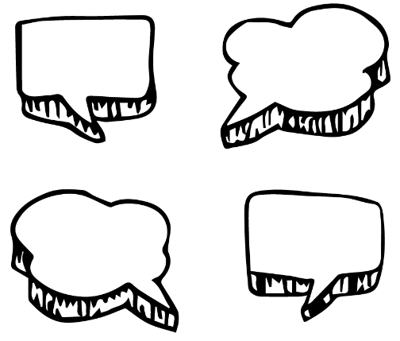

Before starting this activity, hold a class discussion, asking students what sort of transport they think they will be using in 50 years’ time? Think about safety, environmental impact, sustainability, power sources and innovation.

In small groups, students will imagine they are engineers and design a new mode of transport or make a modification to a current mode of transport (e.g. to improve the design or function of a car). Ask students to respond to the following:

* How can transport be improved? For example, it could be more environmentally friendly, or it could be safer. What’s the problem and what are some solutions to the problem?
* Write a brief for your design, using these headings as a guide: Background, Criteria, Your Challenge, Constraints.
* Sketch a drawing of the transport with labels to show its features – include a cross section and annotated diagrams to show materials.
* Choose a body size, engine size, fuel type and accessories.
* What is the source of power for the transport? Will it use green energy?
* What speed will the transport travel?
* What safety features does the transport have?
* What materials will be used to make the transport? Are they environmentally friendly?
* What are the interior and exterior features?
* What new technologies will you incorporate in your design?
* Who will use the transport?
* How will the transport benefit people?
* How will the transport benefit the environment?
* Why is your design the best one for your community?
* What is unique about the design?
* What inspired you to create your invention?

**Presentation**

Students will present their designs and share their ideas persuasively to the class. Encourage students to ask questions about their classmate’s designs. Challenge students to make any improvements they can to their designs, to reduce the cost of travel or make it more sustainable.



**Sustainable transport**

Students will think of ways they can improve transportation in their community. Students will look at how students get to and from school as a basis for their investigation. Before starting this activity, students will respond to the following questions (in small groups and then share their ideas with the class):

* What transportation in your community works well? How does it help people, the environment and/or the economy?
* What are some problems with transportation where you live?
* Look for inspiration in other places around the world. What do you like about the transport systems they use? Would it work where you live?
* How could you promote sustainable travel habits in your community?

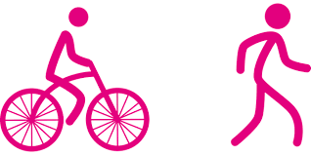

Students will make improvements to the transport available in their community. Students’ designs will need to include transport that uses alternative fuel sources, like solar energy and have an emphasis on pedestrians and bikes. Students may create a community where we can work, go to school and shop closer to where we live; create more bike lanes; have more people living closer together so they can support public transport and create safer streets to encourage walking and riding.

Watch this YouTube animation about [climate change, energy and action](https://www.youtube.com/watch?v=_s9dxc_jVlY&feature=related) to get your students inspired!

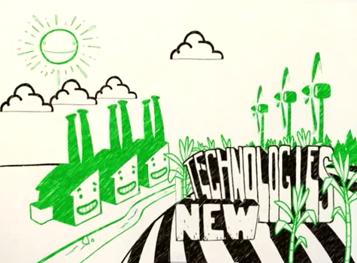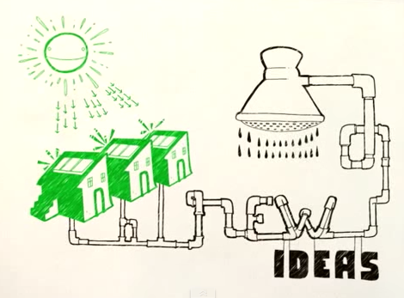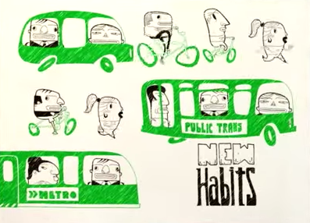

Virgin Hyperloop claims world’s first passenger ride on super high-speed system in Nevada

<https://www.abc.net.au/news/2020-11-09/hyperloop-virgin-first-passengers-on-high-speed-system/12865148>

Flying Cars – BTN

<https://www.abc.net.au/btn/classroom/flying-cars/12625704>

Driverless Cars – BTN

<https://www.abc.net.au/btn/classroom/driverless-cars/10522100>

Could supersonic ‘Hyperloop’ be our future transport? – Newsround

<https://www.bbc.co.uk/newsround/23678271>

Transport – ABC Education

<https://education.abc.net.au/home#!/topic/1773359/transport>

Teacher Resource

Episode 33

17th November 2020

**Charlie Perkins**



Students will learn about the life and achievements of Charles Perkins. They will also investigate the changing rights and freedoms of Indigenous Australians.



**HASS – Year 4**

Sequence information about people’s lives and events.

**Civics and Citizenship – Year 5**How laws affect the lives of citizens, including experiences of Aboriginal and Torres Strait Islander Peoples.

**History – Year 6**

Experiences of Australian democracy and citizenship, including the status and rights of Aboriginal and Torres Strait Islander Peoples, migrants, women, and children.

The contribution of individuals and groups, including Aboriginal and Torres Strait Islander people and migrants, to the development of Australian society, for example in areas such as the economy, education, science, the arts, sport.



1. Where was Charlie Perkins born?
2. What sport did Charlie play?
3. He was one of the first Aboriginal people to be accepted at university. True or false?
4. What did Charlie become famous for while he was at university?
5. Complete the following sentence. Aboriginal people weren’t counted as Australian ___________in their own country.
6. What inspired the Freedom Ride in Australia?
7. What was the aim of the Freedom Ride?
8. What did they find out about the treatment of Aboriginal people?
9. What impact did Charlie have on Indigenous rights in Australia?
10. Choose 3 words to describe Charlie Perkins.

**Aboriginal and Torres Strait Islander people please note that this document contains images of people who have died.**



**Personal Response**

Students will write a personal response to the BTN *Charlie Perkins* story. Ask students to finish one or more of the following incomplete sentences:

* Charlie Perkins was a significant Indigenous person because…
* Five words that I would use to describe Charlie Perkins are…
* The Freedom Ride was an important event because…
* It was interesting to learn…
* It was surprising to learn that...



**Class Discussion**

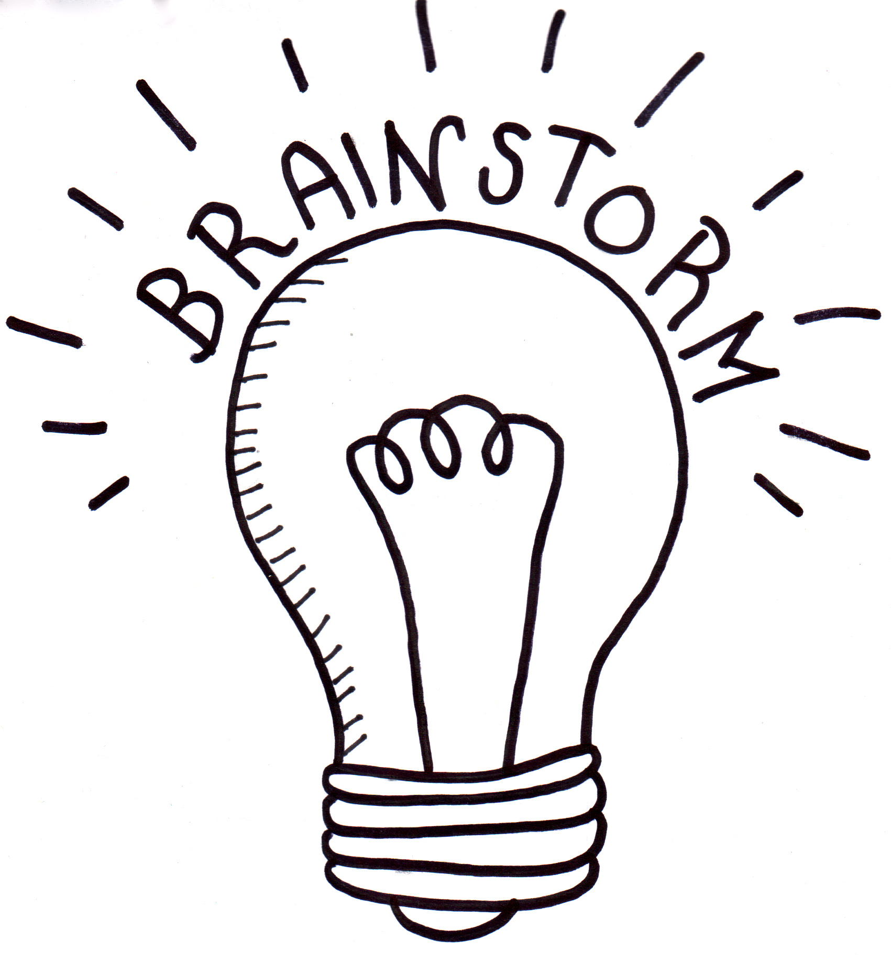

After watching the BTN *Charlie Perkins* story hold a class discussion. Here are some discussion starters:

* Who was Charlie Perkins?
* Where was Charlie Perkins from?
* What were some of Charlie Perkins’ achievements?
* What was the Freedom Ride?
* What did the Freedom Ride achieve?
* What questions do you have after watching the BTN Charlie Perkins story?



**Key Words**

Students will develop a glossary of words and terms that relate to the BTN *Charlie Perkins* story. Below are some words to get them started. Students will add words and meanings to their glossary as they come across unfamiliar words throughout their research.

|  |  |  |
| --- | --- | --- |
| **Activist** | **Referendum** | **Segregation** |
| **Civil Rights** | **Protest** | **Discrimination** |



**Charlie Perkins - Biography**

Before students begin to construct their biographies, hold a class discussion to find out what they already know about biographical writing. Below are some discussion starters:

* What does a biography tell us about a person?
* Where can you look to find information for your biographical writing? It could include the internet, newspaper articles, magazine articles and interviews, other biographies, historical books or television interviews. Why is it important to use more than one source of information?
* What makes a biography interesting? For example, key information and facts, a timeline of events, photographs, illustrations and quotes.

Using the biography worksheet at the end of this activity, students will research and record information about Charlie Perkins. Some possible areas of research include:

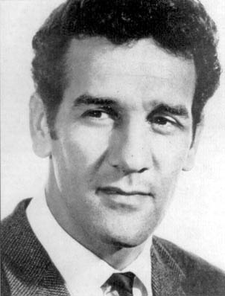

* Where was Charlie Perkins from? Locate using Google Maps.
* When was he born? Describe his life growing up. Watch [this interview](https://fadlmedia.s3.amazonaws.com/austbiog/clips/perkinst_bb.mp4) with Charlie where he describes what life was like growing up in institutions.
* What were some of Charlie Perkins’ achievements? Choose one to explore in more detail.
* How do we recognise his achievements?
* What were some of the challenges he faced?
* How has Charlie Perkins made an impact on Indigenous people’s lives?
* What do you admire about Charlie Perkins?

Further investigation

* Imagine you could sit down and talk to Charlie Perkins. What questions would you ask about his life and achievements?
* Create a timeline of significant events in Charlie Perkins' life.



**Freedom Ride**

In 1965, Charlie Perkins led a group of students from the University of Sydney on a bus journey through regional New South Wales. Students will research in detail the Freedom Ride and the role he played in it. Here are some useful resources to help students with their research:

[Freedom Ride - BTN](https://www.abc.net.au/btn/classroom/freedom-ride/10527008)  
[1965 Freedom Ride - AIATSIS](https://aiatsis.gov.au/explore/articles/1965-freedom-ride)

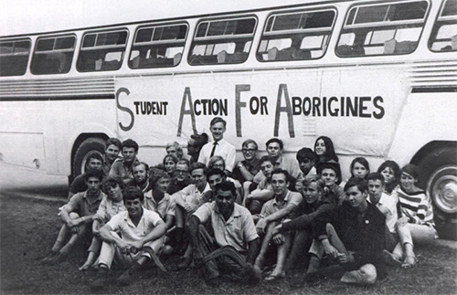

[Freedom Ride 1965 – National Museum Australia](https://www.nma.gov.au/explore/features/indigenous-rights/civil-rights/freedom-ride)

[Charles Perkins in Moree – ABC Education](https://education.abc.net.au/home#!/media/3334221/charles-perkins-in-moree)

* What was the purpose of the Freedom Ride?
* Where did the Freedom Ride go? Show on a map.
* What role did Charlie Perkins play in the Freedom Ride?
* What inspired the Freedom Ride in Australia?
* What did they find out about the treatment of Aboriginal people?
* What instances of racism did they find?
* What is segregation? Give an example.
* What important event happened on the Freedom Ride in Moree?
* How did their trip make a difference to Indigenous rights?

Students will imagine they are a student travelling on the Freedom Ride and write a journal describing their experiences and feelings about it. [Ann Curthoy’s diary](https://aiatsis.gov.au/collection/featured-collections/ann-curthoys-diaries) gives a great insight into what it was like being a student on the Freedom Ride. The questions below may help students to structure their journal.

* Why did you want to be a part of the Freedom Ride?
* What does the community think about it?
* How do you feel on the bus with the other students?
* What are some of the challenges?
* What do you hope Freedom Ride will achieve?

**BTN Indigenous Rights stories**

Watch these BTN stories to learn more about significant events for Aboriginal and Torres Strait Islander people.

|  |  |
| --- | --- |
| [BTN 1967 Referendum story](https://www.abc.net.au/btn/classroom/1967-referendum/10523010) | [Teacher Resource](https://www.abc.net.au/btn/resources/teacher/episode/20170523-1967referendum.pdf) | [BTN Wave Hill story](https://www.abc.net.au/btn/classroom/wave-hill/10525958) | [Teacher Resource](https://www.abc.net.au/btn/resources/teacher/episode/20150825-wavehill.pdf) |
| [BTN Stolen Generations story](https://www.abc.net.au/btn/classroom/stolen-generations/10542138) | [BTN Mabo Legacy story](https://www.abc.net.au/btn/classroom/mabo-legacy/11143302) [| Teacher Resource](https://www.abc.net.au/cm/lb/11154220/data/mabo-legacy---teacher-resource-%28pdf%29-data.pdf) |



**Visual Literacy – Indigenous Rights**

* What do you see in this image?
* What significant moment or event does the image relate to?
* What do you think is happening?
* If there are people in the image who do you think they are? How do you think they might be feeling?
* What question/s would you like to ask the people in the image?
* Create a caption for each image.

|  |  |
| --- | --- |
| [Link to image](https://upload.wikimedia.org/wikipedia/commons/thumb/b/b4/Whitlam_Lingiari_Image_3.jpg/220px-Whitlam_Lingiari_Image_3.jpg) | [Link to image](https://www.nma.gov.au/defining-moments/resources/day-of-mourning) |
| [Link to image](https://aiatsis.gov.au/sites/default/files/2020-08/a5605027h.jpg) | [Link to image](https://www.sl.nsw.gov.au/blogs/commemorating-50th-anniversary-1967-referendum-aboriginal-rights) |



Charlies Perkins – National Museum Australia

<https://www.nma.gov.au/explore/features/indigenous-rights/people/charles-perkins>

Freedom Ride – BTN

<https://www.abc.net.au/btn/classroom/freedom-ride/10527008>

Charles Perkins fights for racial equality – ABC Education

<https://education.abc.net.au/home#!/media/1264423/charles-perkins-fights-for-racial-equality>

Charles Perkins campaigns for Aboriginal rights – ABC Education

<https://education.abc.net.au/home#!/media/1264445/charles-perkins-campaigns-for-aboriginal-rights>

Freedom Ride, 1965 – National Museum Australia

<https://www.nma.gov.au/explore/features/indigenous-rights/civil-rights/freedom-ride>

1965 Freedom Ride - AIATSIS

<https://aiatsis.gov.au/explore/articles/1965-freedom-ride>

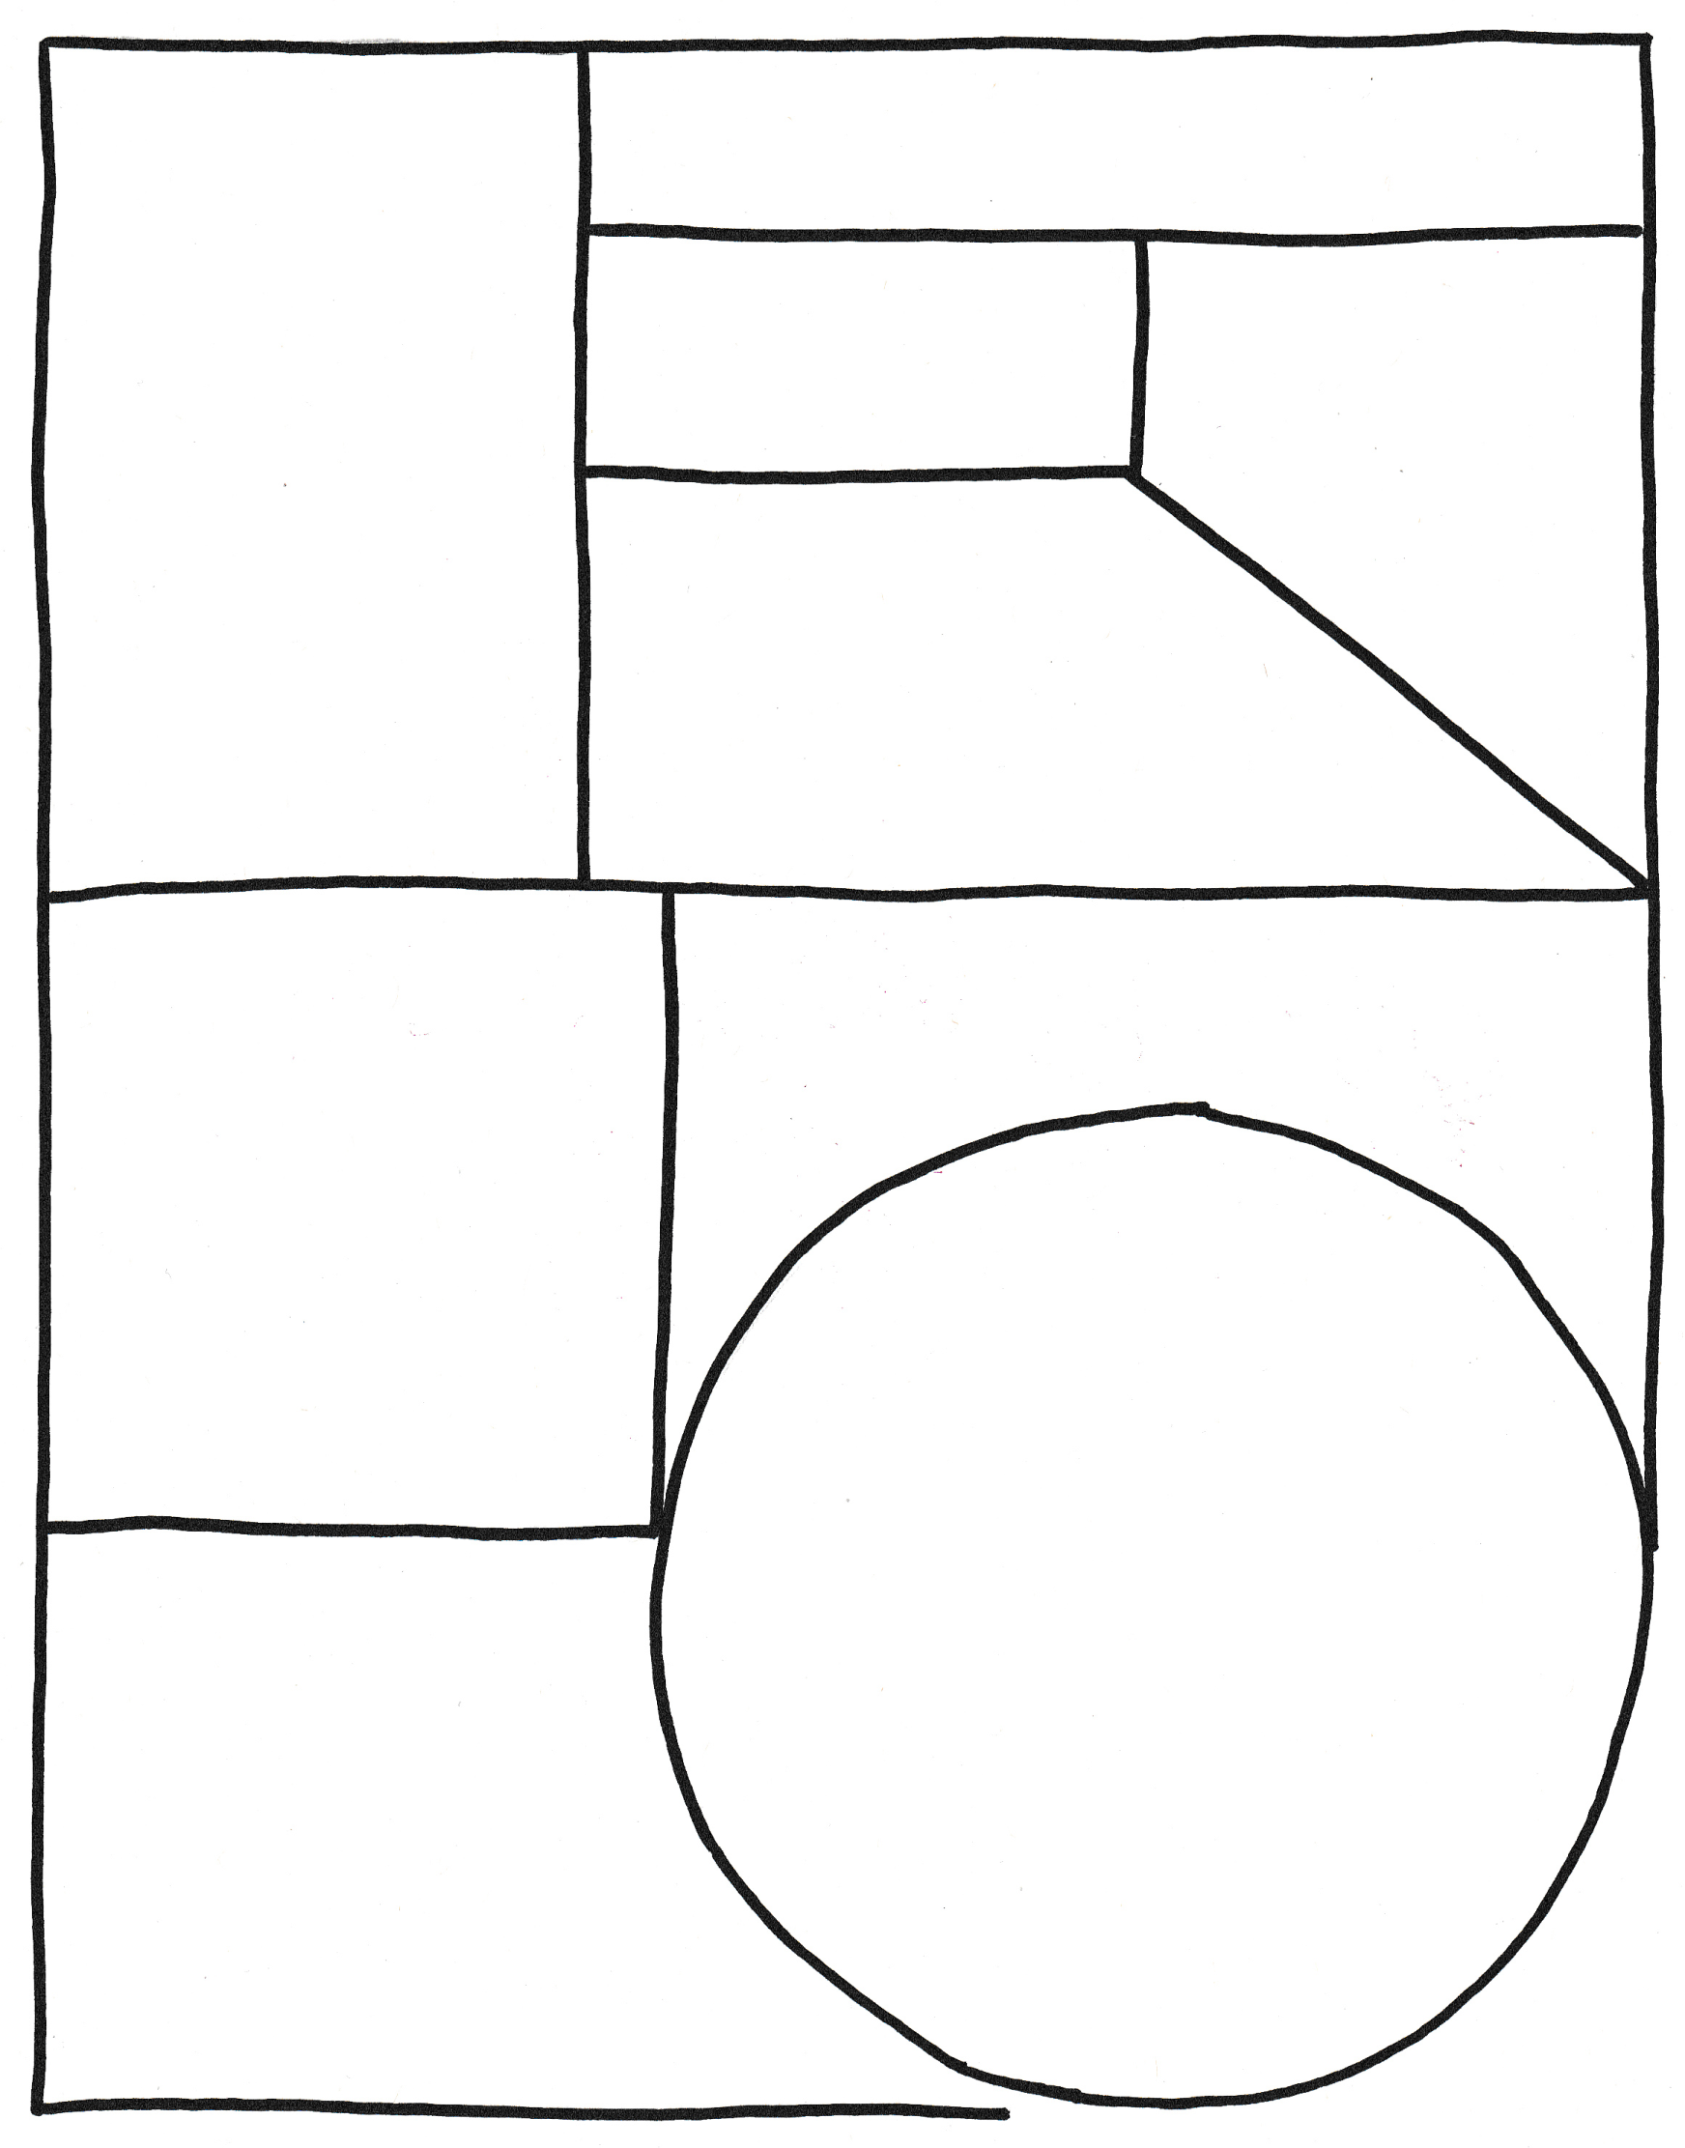

Full name

Portrait of Charlie

Important contributions Charlie made…

**Biography – Charlie Perkins**

Interesting things about Charlie…

Achievements

Born

Family

**BTN Transcript: Episode 33 – 17/11/20**

Hey. I'm Amelia Moseley and you're watching BTN. Here's what's coming up. We learn more about the life and legacy of Charlie Perkins, zoom into the future of high-speed transport and find out how your kitchen can make you sick.

COVID-19 Vaccine Trials

Reporter: Amelia Moseley

*INTRO: But, first today to some exciting news that we got last week. A pharmaceutical company is in the final stage of human trials for its COVID-19 vaccine and it says the results so far are looking pretty good. While it's not the end of the pandemic, it could be to be a step in the right direction. Check it out.*

DR. FRANKENSTEINISH: I've done it. I've finally done it.  
  
ASSISTANT: What?  
  
DR FRANKENSTEINISH: I've created the thing we've all been waiting for my most perfect achievement yet.  
  
ASSISTANT: Oh, that guy?   
  
MONSTER: Aaarrrrggghhh.  
  
DR FRANKENSTEINISH: No, no, no no. Between you and me that was a big mistake. Huge. No, no, no. I’ve created this, the COVID-19 vaccine.  
  
OK that's not exactly how things work in the real scientific world, but actual scientists across the globe have been getting excited about the news that we might finally have a vaccine to protect people from COVID-19.   
  
Dr Albert Bourla, Pfizer Chairman and CEO: It's such a great day for science and humanity. You know I've never felt professionally such a moment of joy to put an end to this dreadful pandemic.   
  
Prof. Jonathan Van-Tam, Deputy Chief Medical Officer for England: I have to say this is really a very important scientific breakthrough. I am certain of that.  
  
You might already know that a vaccine works by teaching our bodies how to fight against a disease which then helps to protect us from that disease the next time we encounter it. But creating a vaccine is a long process that usually takes years of research and three big phases of testing, on humans, that is.  
  
MONSTER: Huh?  
  
To make sure it’s both safe and effective. Now, in record time this company says it’s in the final phase of human trials on a COVID-19 vaccine. Its human trials involved more than 43 thousand volunteers across a few different countries, and it says people who had the vaccine had no serious side effects and were much less likely to get COVID-19. In fact, it says the vaccine seems to be effective more than 90% of the time. While that sounds like great news, some experts and world leaders say we shouldn't be like these two and get ahead of ourselves.   
  
BORIS JOHNSON, UK PRIME MINISTER: We cannot let our enthusiasm tonight run away with us, folks. It's more vital than ever now that we follow the basics, that we wait and see whether this vaccine lives up to its promise.   
  
JOE BIDEN, US PRESIDENT-ELECT: For the foreseeable future a mask remains the most potent weapon against the virus.

The results of the trial haven't all been released yet, and they haven't been reviewed by other people in the scientific community. Plus, there's the issue of getting the vaccine out there to billions of people. This vaccine uses some pretty new technology which means it has to be stored and transported at the really low temperature of minus 80 degrees.But if the vaccine does get approved the company says it'll put 1.3 billion doses out there by the end of 2021. And Australia's government has signed up to get ten million doses of the vaccine and a few other vaccines that are in the works.  
  
SCOTT MORRISON, AUSTRALIAN PRIME MINISTER: These results are very promising and I'm optimistic and hopeful about next year.  
  
So, while it's definitely not the end of this scientific journey, it's certainly a step in the right direction. And preferably a big step away from whatever these guys are doing.  
  
MONSTER: Umm excuse me, but has this vaccine been peer reviewed by the scientific community?  
  
DR FRANKENSTEINISH: I didn't understand a word it said, did you?  
  
ASSISTANT: No, no.

News Quiz

Which state has had a COVID setback with a spike in cases over the weekend? It’s South Australia. It’s the first outbreak there in months. Adelaide’s now been declared a COVID hotspot by several other states.

What line of the Australian National Anthem has New South Wales Premier Gladys Berejiklian suggested changing? We are young and free, our home is girt by sea or we’ve golden soil and wealth for toil? She reckons "we are young and free" should be changed to "we are one and free" to recognise Australia's 60,000 years of Indigenous history.

GLADYS BEREJIKLIAN, PREMIER NSW: I think if we say we’re one and free it acknowledges that we’re not really young as a continent. We’re tens of thousands of years old when it comes to human inhabitants.

QANTAS turned 100 on Monday. The flying kangaroo has been, well, flying since November 16th, 1920. Do you know what its name stands for? I’ll give you a hint. It’s first routes were in Queensland and Northern Territory. QANTAS stands for Queensland and Northern Territory Aerial Services and did you know it’s actually the third oldest airline in the world? Way to go Qantas.

People in India and around the world have celebrated Diwali, which is known as the Indian festival of what? Lights, colour or food? Diwali is the festival of lights.

High-Speed Hyperloop

Reporter: Nat Kelly

*INTRO: Now, imagine travelling overland from Sydney to Melbourne, in one hour. Well that could be the high-speed future of transport. Last week we saw the first human test of an Hyperloop, a super-speedy levitating train in a tube. Here's Nat to tell you all about it.*  
1820s JOSEPH: I wonder what the future of transport will be like?  
  
1820s NAT: Oh well have you heard of those fan dangled new things called trains?

1920s JOSEPH: I wonder what transport will be like in a hundred years.   
  
1920s NAT: Oh well have you heard of those fan dangled new things called planes?

2020s JOSEPH: Do you ever think about what transport will be like in a hundred years.   
  
2020s NAT: Hmm, well have you heard of those new fan dangled Hyperloops?   
  
Yep, welcome to the brave new world of high-speed travel. These two brave Virgin execs strapped themselves in to be the world's first passengers of an Hyperloop. On this trip they only clocked about 172 kays an hour, but this thing can travel at more than double that. And with some development they're hoping it'll be able to do over 1200 kays an hour. Yep, you heard that right, 1,200 kays an hour. That'd mean a trip from Melbourne to Sydney would only take 45 minutes. Or a trip from Darwin to Adelaide, 2 and a half hours.   
  
The reason it can go so fast is the lack of friction, that's the force that slows things down when one thing rubs against another, like wheels on tracks or roads, even moving through the air creates friction. But inside the Hyperloop there's very little air, don't worry though, there's air in the capsule so they can breathe. There are also no wheels. Special magnets are used to help the capsule glide along the tube, kind of floating just above the tracks.  
  
The idea for the Hyperloop came from none other than Elon Musk. Yep, that's the guy who started Tesla, and SpaceX. But Elon did something a little unusual, he released his plans for the Hyperloop as open source for anyone to use. Which means lots of companies are working on their own versions.

And it's not the only newfangled contraption that could take us zooming around the world in the future. Several companies are working on supersonic passenger planes, that is planes that fly faster than the speed of sound which is 1,234 kays and hour. While that's something we've been able to do for a while, they're working on making them cheaper, safer, more efficient, and solving the problem of the loud boom that usually comes from breaking the sound barrier. There are even companies working on hypersonic planes, which can travel faster than Mach 5, that’s more than 6000 kays an hour. But that's also a way off yet.  
  
Back on Earth, Virgin are working on making their Hyperloop faster and cheaper, and importantly, making sure it's safe before it can become a reality.   
  
JOSH GIEGEL, VIRGIN HYPERLOOP CO-FOUNDER: For us, the steps moving forward are really to continue to showcase that this technology not only works but is actually cost effective. And then in the second piece is really to make sure that we can actually have the full length to get up to the speeds that we like.  
  
Countries like India and Saudi Arabia are already trying to figure out ways to bring Hyperloop to their cities. But whether or not it's the future of transport, well, we'll have to wait and see.  
  
2120s JOSEPH: I wonder what the future of transport will be like.   
  
2120s NAT: Oh well, spoilers.

Quiz

Do you know the name of the world's first supersonic passenger plane? It was the Concorde. The planes, which could travel faster than the speed of sound, first took passengers between London and Paris in 1976 but the last one was retired in 2003.

Ask a Reporter

If you wanna know more about the future of high-speed travel you can ask me live on Friday. Check the website for details.

Charlie Perkins

Reporter: Nat Kelly

*INTRO: Last week during NAIDOC Week Sydney University paid tribute to one of its most famous graduates, the late Charlie Perkins. He was an activist, sportsman and public servant who helped to pave the way for a more equal Australia. Let’s find out more about him.*On the 19th of February 1965, these kids went for a swim in their local pool. And while it might not seem like a big deal, at the time, it was. This was an act of defiance, which changed the way Australia, and the world, saw the treatment of Aboriginal people. And this was the man behind it. Dr Charles Perkins. He was born in Alice Springs in 1936. His grandmother on his mum's side was an Arrernte woman, his grandma on his dad's side, a Kalkadoon woman. He was a gifted soccer player, and played professionally for the English club, Everton. He was also one of the first Aboriginal people to be accepted at a university, and it was during his time at Sydney Uni that Charles became famous as a mover and shaker in the world of Aboriginal rights.   
  
You see, at the time, Aboriginal people didn't have the same rights as other Australians. In fact, they weren't counted as Australian citizens in their own country. Charlie wanted to find a way to draw people's attention to racism in Australia, and he found inspiration from the USA. During the 1960s Black Americans were fighting to change racist laws, which denied them the same opportunities as white Americans and kept them separate in schools, bathrooms, restaurants, theatres and on buses.  
  
The Freedom Riders were civil rights activists who travelled in buses around the southern states to challenge segregation laws. Charlie, with the help of some fellow students, decided to organise their own Freedom Rides. At midnight on the 12th of February 1965, a big group of university students joined Charlie on a bus trip across New South Wales. They wanted to see how Aboriginal people were being treated, and to call attention to any segregation or discrimination they saw. And they saw a lot.  
  
Which brings us back to those kids in the pool. It was in a small town called Moree, in northern New South Wales, that the local council had banned Aboriginal people from swimming in the pool. Charlie and his group stood at the gate and refused to let anyone else in until they were let in too. There were similar scenes in other towns. These images got a lot of attention in the Australian media, and attitudes began to change. In 1967, Australians voted to change the Constitution, to include Aboriginal people in the census. In towns like Moree, racist laws were lifted.  
  
DR CHARLES PERKINS: In the times that I've been back there, there has been a change of attitude. And it’s a better relationship. It's not perfect, but it's better.  
  
Charles spent the rest of his life fighting for the rights of Aboriginal people as a policy maker and a leader. It's been 20 years since Charlie Perkins died, and last week Sydney Uni celebrated his legacy with the Charlie Perkins oration, where awards were given to the next generation of Indigenous leaders. As the fight for Indigenous rights continues, Charlie's message to Australians is as important today as ever.  
  
DR CHARLIE PERKINS: What we've got to do in this country is bring ourselves together, whites and blacks, live in a harmonious situation. Lessen the conflicts, learn to understand each other, and cooperate with each other. And that's got to be our future.

Food Safety Week

Reporter: Charlotte Batty

*INTRO: Now, I hope you've had your breakfast already because this next story could put you off. It's all about how food can make us sick if we're not careful, that is. It's Food Safety Week so Charlotte found out more about how to stay safe in the kitchen.*  
CALE: Do you wanna lick?  
  
We can sometimes do some pretty gross things when it comes to food.

NAT: August. This year, you reckon. That’s alright.

LEELA: Look Charlotte I found a floor donut.  
  
CHARLOTTE: Is that mould?  
  
But that moment of delicious goodness can leave us feeling, well, pretty average. You see our food can be a magnet for bacteria, and while some of these tiny little, microscopic critters are good for us, there are a few like salmonella, E. coli and listeria that can make us really sick. In fact, more than 4 million Aussies suffer from food poisoning every year, which can mean nausea, vomiting, diarrhea and sometimes even a trip to hospital. Now if that's totally put you off your lunch, never fear. Experts say we can all save ourselves from a world of pain if we know how to handle food safely.

CHARLOTTE BATTY, REPORTER: Alright Alessia, come have a suss of the kitchen.

So, to find out how I’m doing on that front I spoke to Alessia. She usually inspects restaurants to make sure all their hygiene is up to scratch. But today it’s my kitchen on the chopping block.

CHARLOTTE: Shall we check out the fridge?

ALESSIA, ENVIRONMENTAL HEALTH OFFICER: Ordinarily what we would say is let’s move your chicken and your eggs and put them down lower. Give them some space because they’re raw they’ve got the opportunity to drip fluids and juices and contaminate. And this chicken here, I'd suggest we'd put some cover on it.  
  
CHARLOTTE: Alright, so I'm making some chicken and salad for lunch, I'm just going to wash the chicken first.  
  
ALESSIA: Oh no, no, no, no. No, No, not a good idea to wash chicken because chicken actually contains microbes, so when you’re washing that chicken all you're doing is spreading microbes everywhere.  
  
CHARLOTTE: Is that like bacteria everywhere? Eurgh that's nasty. Alright, well I'll just.  
  
ALESSIA: Wash your hands however, that’s probably a good idea.

CHARLOTTE: Oh, wash my hands. Of course. Alrighty, so chicken's all chopped, I'm ready for my veggies. Should I just wipe this down?  
  
ALESSIA: Nope. Not a good idea. No, because what we've just done here is we've handled raw meat. So, pop that into the dishwasher with your knife. Wash your hands and start afresh with a new board and knife.   
  
Alessia says bacteria also loves to party at room temperature, so keep meats nice and cool in the fridge or with an ice block in your lunchbox, and make sure they're well cooked. As for some of those naughty habits we've developed over the years, well Alessia has some bad news.  
  
CHARLOTTE: Making a cake, what's the deal with licking the spoon?  
  
ALESSIA: I know it tastes great, but not a good idea. It contains raw eggs and raw eggs have microbes on them.   
  
CHARLOTTE: Aww. Alright what about the 5 second rule?  
  
ALESSIA: Probably not a good idea. Either leave it there for one of the pets to pick up or put it straight in the bin.  
  
CHARLOTTE: And what about all those double dippers out there, you know who you are.

ALESSIA: If you're sharing a dip with family and friends don't do it. Keep your germs to yourself.  
  
So remember keep it cool, cook it through, watch that raw meat and most importantly wash your hands, so what you cook doesn't make you crook.

Sport

The conditions were wet and slippery, but that wasn't going to superstar Lewis Hamilton winning the Turkish Grand Prix which was, get this, his 94th career win and his seventh Formula One championship title. Michael Schumacher is the only other person in history to do it that many times.  
  
The Mighty Maroons have taken out their first Women's State of Origin. After a nail-biting first half which ended in a 6 to 6 deadlock, Queensland surged ahead and fought off a late fightback by New South Wales to clinch a 24 to 18 win.

And US golfer Dustin Johnson got a brand-new jacket from his mate Tiger Woods.

DUSTIN JOHNSON, US GOLFER: Obviously having Tiger put it on was awesome and unbelievable.

Famously you get the jacket if you win the Masters. And he won. With a record score of 20 under par.

DUSTIN JOHNSON, US GOLFER: Since I’ve played my first masters it’s been, the tournament I’ve wanted to win the most.

School Therapy Dog

Reporter: Amelia Moseley

*INTRO: Now we all get a little stressed out at times and this year's been more stressful than most. But you're about to meet some kids who've had a bit of help of the adorable, four-legged variety. Check it out.*

Meet Apollo. He's not your average classmate. For starters, he's quite hairy and he doesn't say much, but he's a really good listener.  
  
NATALIE: I like stroking Apollo and talking to him. He's just so cute, it lets the worries just melt away.  
  
KANI: So whenever we have friendship problems, we can go to Apollo we can pat him, talk to him and it calms us down.  
  
You see, Apollo isn't just your regular pooch, he's a therapy dog. Which means he's here to help.  
  
EMMA: He helps students be comfortable around their surroundings and if we have a problem we go to Apollo.  
  
KANI: We've got some children with severe multiple needs, so Apollo goes into the learning centre regularly.  
  
AMELIA, REPORTER: So, Miss Amanda, why did you decide to get Apollo at your school?   
  
AMANDA WALKER, ASSISTANT PRINCIPAL: So, we've done a bit of research around the effects that dogs have on kids and their wellbeing and their mental health and we discovered that around the world it's becoming more of a trend to have dogs in nursing homes, in schools and in other settings so we started looking into it and we contacted guide dogs and then we just went from there.  
  
Apollo has been especially important to these guys in 2020.  
  
KANI: Kids have been stressed out a lot, so we can just go to Apollo and talk about it and stroke him.  
  
Luckily Kani, Emma and Natalie say he's the right dog for the job.  
  
EMMA: He's very happy around people.  
  
NATALIE: He won't get up and walk away like other dogs. He'll just sit there and listen to you.  
  
But since this little guy has been specially trained, there are some rules to follow.  
  
NATALIE: When he hasn't got the bandana on it means he's working and that he needs to concentrate, so you can't go up to him and give him pats.  
  
EMMA: You can't order him around because then he doesn't learn to just listen to Miss Amanda.

But when his jacket's off, it's playtime.  
  
KANI: If we've achieved something that we're proud of or been on good behaviour we can take him to the hall and play fetch and he loves it.  
  
AMANDA WALKER, ASSISTANT PRINCIPAL: People sometimes worry does he get enough rest time? The minute the school bell goes his jacket's off and he's running around the halls playing fetch, so he's loving life.

AMELIA: Aw, what a good boy.   
  
AMANDA WALKER, ASSISTANT PRINCIPAL: He is a good boy.  
  
And a popular boy to boot.  
  
NATALIE: Oh, Apollo is a very popular dog. Everyone, when they know Miss Amanda is coming around to classes they'll always go "Is Apollo coming?".  
  
KANI: It's made us more happier and more focused to learn and dedicated to our work.  
  
EMMA: I think other schools should get a dog like Apollo because it makes the school a better place.

Closer

Thanks so much for that guys. Well, that’s about it for now but don't forget to head online and fill out our 2020 Happiness Survey. We'll bring you some early results next week so make sure you have your say as soon as possible. Have a great week and I’ll see you next time. Bye.