EPISODE 8
28th March 2023

KEY LEARNING
Students will view a range of BTN stories and use comprehension skills to respond to a series of focus questions.

CURRICULUM
English – Year 4
Use comprehension strategies to build literal and inferred meaning to expand content knowledge, integrating and linking ideas and analysing and evaluating texts.

English – Year 5
Use comprehension strategies to analyse information, integrating and linking ideas from a variety of print and digital sources.

English – Year 6
Use comprehension strategies to interpret and analyse information and ideas, comparing content from a variety of textual sources including media and digital texts.

English – Year 7
Use comprehension strategies to interpret, analyse and synthesise ideas and information, critiquing ideas and issues from a variety of textual sources.
  - Teacher Resource

Focus Questions
As a class, discuss the stories featured in the episode of BTN Classroom and record the main points of the discussion. Students will then respond to the following focus questions.

International Criminal Court
- How have children in Ukraine been impacted by the war?
- When was the International Criminal Court (ICC) set up?
- Which country has been investigated by the ICC for possible war crimes?
- Which countries have not signed the Rome Statute? Name two.
- How did this story make you feel? Discuss as a class.

Darling River Fish Deaths
- Where is Menindee? Find on a globe, wall map or digital application such as Google Earth.
- What are the causes of hypoxic blackwater?
- What impact has the fish deaths had on the quality of drinking water?
- How have the fish deaths impacted farmers?
- What did you learn from this story?

Check out the teacher resource on the Archives page.

Kangaroo Leather Debate
- Which companies have announced they are phasing out kangaroo leather in their soccer boots?
  - Adidas and Converse
  - Puma and Nike
  - Umbro and New Balance
- Why have animal rights activists been campaigning against the killing of kangaroos for commercial purposes?
- Kangaroos are wild animals. True or false?
- What do you think about the issue? Share your thoughts with the class.
- What was surprising about the BTN story?

World Happiness Survey
- Briefly summarise the BTN World Happiness Survey story.
- Who started the World Happiness report?
- What country has been named the happiest country on earth?
- Where did Australia rank in World Happiness Report?
- What factors contribute to a country’s happiness? List three.

Check out the teacher resource on the Archives page.

The Crochet Guy
- When did Jorden learn to crochet?
- What is crochet? Describe using your own words.
- What can be made using crochet?
- Why does Jorden keep the first piece of crochet he made on his desk?
- What did you like about the BTN story?

EPISODE 8
28th March 2023

KEY LEARNING
Students will investigate how changing conditions for fish populations in the Murray-Darling river system impacts their growth and survival. They will also learn more about a native fish species.

CURRICULUM
Science – Year 4
Living things depend on each other and the environment to survive.

Science knowledge helps people to understand the effect of their actions.

Science – Year 6
The growth and survival of living things are affected by the physical conditions of their environment.

Geography – Year 5
The influence of people, including Aboriginal and Torres Strait Islander Peoples, on the environmental characteristics of Australian places.

The environmental and human influences on the location and characteristics of a place and the management of spaces within them.
  - Teacher Resource

Darling River Fish Deaths

Focus Questions
Discuss the BTN story as a class and record the main points of the discussion. Students will then respond to the following:
- Where is Menindee? Find on a globe, wall map or digital application such as Google Earth.
- What are the causes of hypoxic blackwater?
- What impact has the fish deaths had on the quality of drinking water?
- How have the fish deaths impacted farmers?
- What did you learn from this story?

Activity: Personal Response
After watching the BTN Darling River Fish Deaths story, ask students to finish one or more of the following incomplete sentences:
- Learning about the fish deaths made me feel…
- This story made me wonder…
- BTN did a story about fish deaths because…

What did you learn from the story?
What questions do you have about the story?

Activity: Class Discussion
Discuss the information raised in the BTN Darling River Fish Deaths story. Use the questions below to guide the discussion.
- What do you know about the Murray-Darling river system?
- Who do you think depends on the river system?
- Whose responsibility is it to look after the Murray-Darling river system?
- Why is the health of the Murray-Darling important?
- Why have a large number of fish died in the Darling River recently?

Activity: Glossary
Students will brainstorm a list of key words that relate to the BTN Darling River Fish Deaths story. Here are some words to get them started.

SPECIES | OXYGEN | MURRAY-DARLING BASIN
FLOODWATERS | BLACKWATER | BACTERIA

Further investigation: What is hypoxic blackwater? Write a short explanation of what it is and how it affects fish populations.

Activity: Research project
Discuss the information raised in the BTN Darling River Fish Deaths story. What questions were raised in the discussion and what are the gaps in students’ knowledge? The following KWLH organiser provides students with a framework to explore their knowledge on this topic.

What do I know? | What do I want to know? | What have I learnt? | How will I find out?

Students will develop their own question/s to research or choose one or more of the questions below.

- Who relies on the Murray-Darling river system? How do they use or rely on it?
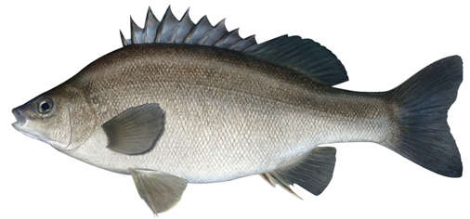
- How has people’s use of the Murray-Darling river system changed over time? Record the information on a timeline.
- What is blackwater? What causes it and what impact does it have on people and animals? Watch this video to learn more.
- What is being done to prevent fish deaths? Include both long and short term actions.
- How is River Country important to First Nations people?
- What impact might the poor health of the Murray-Darling river system have on the traditional owners?
- How were communities along the Murray River affected by the floods in recent months? Watch this BTN story to learn more.

Activity: Native Fish profile
Students will research and write a profile of a native fish species found in the Murray-Darling river system. Students can use the animal profile worksheet at the end of this activity to record their findings. Encourage students to use a range of sources to find their information.

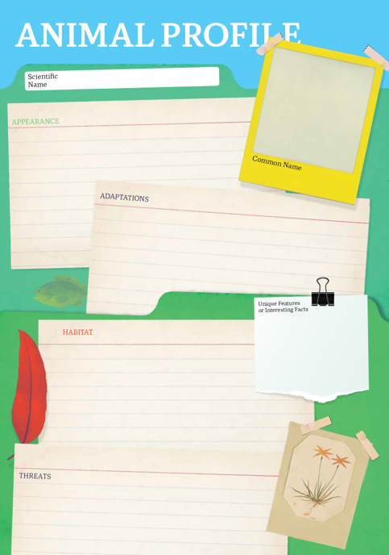
Research
Students will research and create a profile of a native fish species. Students can use the Animal Profile at the end of this activity.

- Illustration or photo
- Scientific and common name
- Appearance
- Habitat
- Feeding and diet
- Behaviours and adaptations
- Predators/threats
- Interesting facts

Activity: The Murray-Darling river system
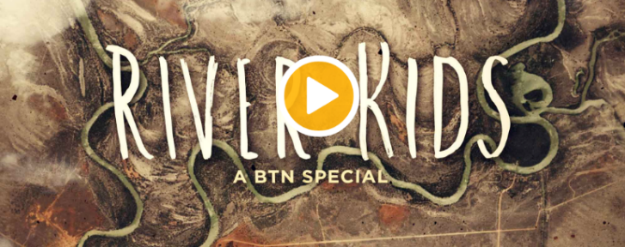
BTN River Kids is a documentary that looks at life along Australia's largest river system, the Murray-Darling river system. It's narrated by Tyrone, a Ngarrindjeri boy, who introduces us to people who depend on it. The documentary highlights the importance of Australians working together to look after the Murray-Darling river system and how the river system supports people, wildlife, and the economy.

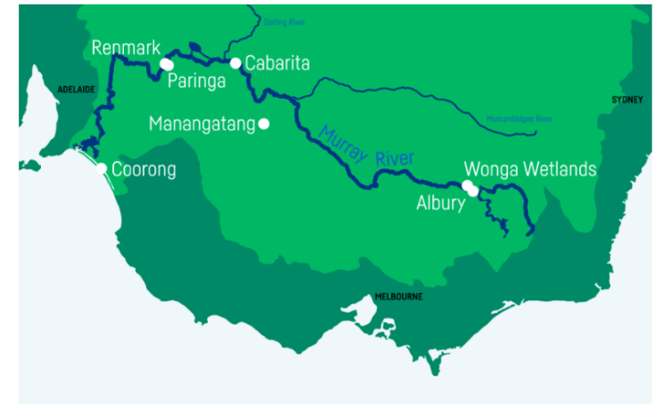
The River Kids documentary features some kids that live along the Murray-Darling river system. As you meet the kids in the documentary, think about how they all depend on the river system for different reasons.

Class discussion:
- How has the health of the Murray-Darling river system changed since the documentary was made?
- Brainstorm a list of reasons why.
- Why is the health of the Murray-Darling river system important?

Activity: Aboriginal Dreaming
Water has an important place in Dreaming stories in Aboriginal and Torres Strait Islander culture. Dreaming stories pass on important knowledge, cultural values, and belief systems to later generations. Many sites of Dreaming significance are located along the Murray River.

Students will develop a deeper understanding of the connection Indigenous people have to water and the Murray River. Students will develop their own question/s to research or choose one of the questions below.

- How has the Murray River changed over time? Watch this BTN River Kids story to learn more. Explain in your own words why the Murray River is important to Ngarrindjeri people and how the Murray River has changed.
- What does Ngurunderi Dreaming explain? Students will practise their storytelling skills by taking it in turns to read the Ngurunderi Dreaming story aloud to the class.
- How was the Murray River made? Listen to this Bangerang story about how the Murray River was made. Find the Bangerang words for Murray River and water. Illustrate an aspect of this Dreaming story to present to the class.
- What Aboriginal Dreaming stories teach us about the importance of water? For example, the Rainbow Serpent, Ponde or Tiddalick. Compare and contrast these stories. Choose one to research in more detail and present your findings in an interesting way.

Activity: Run the River
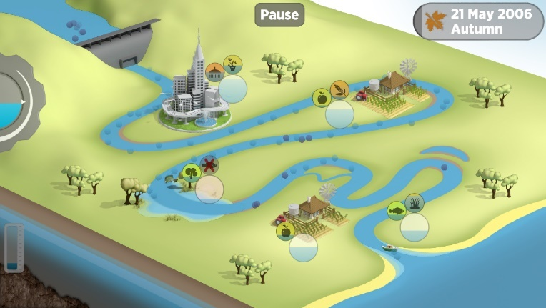
Run the River – A Water Sharing Challenge is a game where students learn about the challenges of balancing water use and also learn more about the natural water cycle.

Lesson notes and game guide for teachers

Useful Websites
- Dead Fish in NSW – BTN Newsbreak
- Fish deaths – Murray-Darling Basin Authority
- The Menindee fish kills – Australian Museum
- Fish kill clean-up finally underway at Menindee, a week after creatures began clogging up river – ABC News
- Murray-Darling Warning – BTN

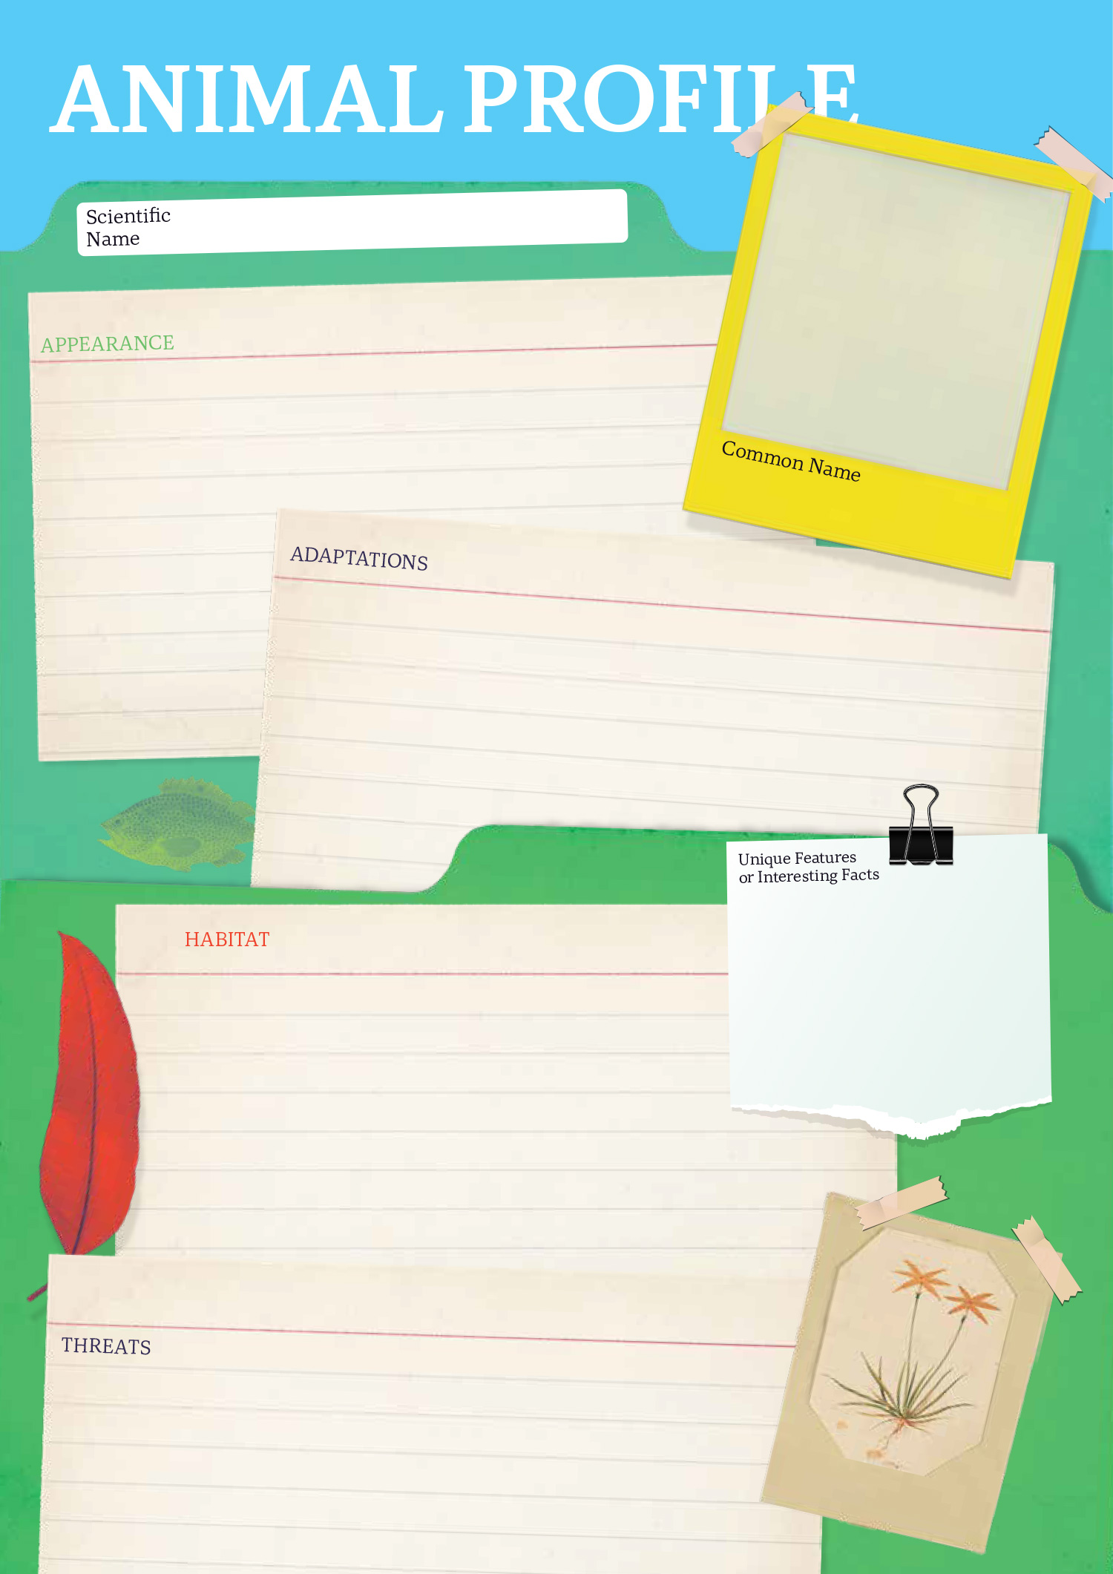

EPISODE 8
28th March 2023

KEY LEARNING
Students will learn more about and celebrate International Happiness Day. Students will explore the variables that influence happiness.

CURRICULUM
HASS – Years 5-6
Locate and collect relevant information and data from primary sources and secondary sources.

HASS – Year 7
Apply a methodology to locate and collect relevant information and data from a range of primary sources and secondary sources.

HASS – Year 7
Factors that influence the decisions people make about where to live and their perceptions of the liveability of places.

The influence of environmental quality on the liveability of places.

Strategies used to enhance the liveability of places, especially for young people, including examples from Australia and Europe.

Health and PE – Years 3-4
Investigate how emotional responses vary in depth and strength.

Health and PE - Years 5-6
Examine the influence of emotional responses on behaviour and relationships.
Investigate the role of preventive health in promoting and maintaining health, safety and wellbeing for individuals and their communities.

  - Teacher Resource

World Happiness Survey

Focus Questions
Discuss the BTN story as a class and record the main points of the discussion. Students will then respond to the following:
- Briefly summarise the BTN World Happiness Survey story.
- Who started the World Happiness report?
- What country has been named the happiest country on earth?
- Where did Australia rank in World Happiness Report?
- What factors contribute to a country’s happiness? List three.

Activity: Class Discussion
Before watching the BTN World Happiness Survey story, explain to students what the purpose of the World Happiness Report is (learn more about it here). Ask students to make some predictions, using the following questions to help guide discussion:
- Which countries do you think made the top 10 happiest countries in the world in 2023? Look at a globe, wall map or digital application such as Google Earth.
- What type of questions do you think the UN would ask to measure a country’s happiness? (Think about variables like health, freedom, social support, income, and education).
- How would you define happiness?

After watching the BTN World Happiness Survey story, hold a class discussion, using the following discussion starters.
- What are the 10 top happiest countries in the world? Find on a map.
- What makes Finland the happiest country in the world?
- What makes you happy where you live?
- How did the story make you feel?
- What was surprising about this story?

Activity: What makes kids happy?
Discuss the BTN World Happiness Survey story as a class. Create a class mind map with HAPPINESS in the middle. Use the following questions to guide discussion. Brainstorm ideas in small groups and then students will report their group’s responses to the class.
- Find a definition for happiness.
- What makes you happy? Think about the happiness within yourself and within your community.
- What makes you happy where you live?
- What do I need to be safe?
- Name something that makes you worried, angry, or sad. What can kids do if they are feeling worried, angry, or sad?
- Why does it matter to be happy?

Survey – What makes kids happy?
Survey students in your school about what makes them happy. Think about ways to record students’ responses – written, audio or video. Ask students to think of creative ways to share the results with the school community.

Activity: Celebrate International Day of Happiness
Since 2013, the United Nations has celebrated the International Day of Happiness as a way to recognise the importance of happiness in the lives of people around the world. Students will learn more about the UN International Day of Happiness and then respond to one or more of the following:
- What is the International Day of Happiness? When is it and why is it important?
- What is the World Happiness Report?
- Why do we mark international days?
- What can your school do to celebrate International Day of Happiness? Brainstorm some ideas as a class. Make a photo album which captures the happiness in your class or school. Visit the UN photo album to see their collection of photos.

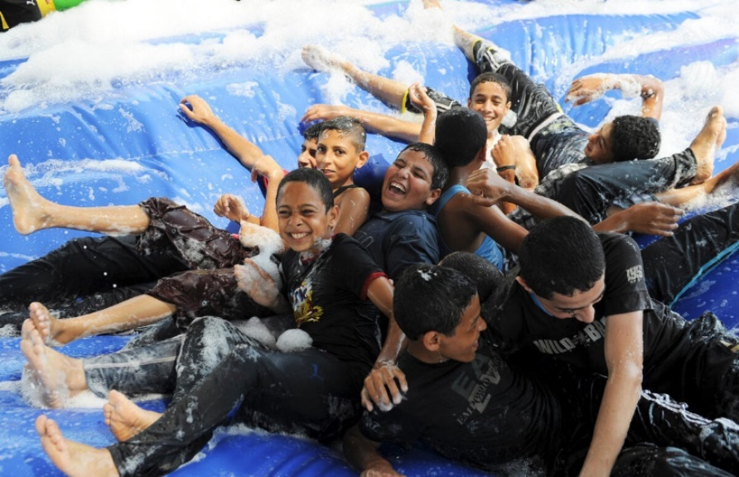
UN photographers capture people smiling, celebrating, playing, and laughing in this special collection for the International Day of Happiness.

Activity: Country profile
Finland has topped a list of the world's happiest nations for the sixth successive year. The northern European nation was judged to be the happiest, according to the World Happiness Report 2023.

Students will research and develop a profile of Finland and gain a deeper understanding of the country. Working in pairs, ask students to brainstorm what they know about Finland and record their responses. Using the `Who, what, why, when, where and how’ framework, ask students to write questions that they would like to find the answers to. Students share their questions with the rest of the class. Discuss how students could find answers to the questions they generate.

Research
Students will learn more about Finland and create a profile.
- Population and area size.
- Government and politics – who is the leader of the country and how is the country run?
- Economy – work, trade, industries, and products.
- Education
- Geography – capital city, physical features of the country, climate, environment. Who are its neighbours? Show on a map.
- The people, language, culture, customs, and beliefs.
- Interesting facts.

Presentation
Discuss with students how they are going to present their profile of Finland.

Possibilities include:
- Create a postcard using Canva to share some of the things you have learnt about Finland.
- A short oral presentation.
- Compare Finland to Australia using a Venn diagram.

Further investigation
Students will explore what makes some countries happier than others. Below is a range of variables which can contribute to someone’s level of happiness. Students will investigate the factors that make Finland the happiest place on earth.

Social support
Politics
Freedom
Health
Income
Education
Nature
Generosity

Activity – Choose a Project
Individually or in small groups, students will choose one of the following projects to work on and then present their findings to the class.

Design a poster!
Design a poster to celebrate International Day of Happiness (20th of March). Write a letter to your local MP or members of the UN expressing your hopes and dreams for young Australians now and into the future.

Summary
Write a summary of the story. What does the story explain? Explain in your own words what happiness means to you and why we have the UN International Day of Happiness.

UNICEF drawing challenge.
Do you love drawing? Do you want to change the world? Pick a cause that matters to you and create an original illustration that shows the world you want to build. Be a part of UNICEF’s drawing challenge here!
Tips and Exercises
Make a list of tips and exercises to help you find joy and happiness in every day. Keep a journal of things that make you happy every day.

Useful Websites
- What is the World's Happiest Country? – Newsround
- World Happiness Report – BTN
- World Happiness Report 2023 – World Happiness Report
- The 2023 World Happiness Report has been released. Where does Australia rank and what makes a country 'happy'? – ABC News
- Happiness Survey 2020 – BTN

  - Teacher Resource

BTN Transcript: Episode 8 - 28/3/2023

Hey, I'm Amelia Moseley and you're watching BTN. Thanks for hanging out with us again, here’s what’s coming up on today’s show. The debate over kangaroo leather, we find out the happiest country in the world and how you can make crochet art.

International Criminal Court

Reporter: Michelle Wakim

INTRO: All that soon, but first. The International Criminal Court has put out an arrest warrant for Russian President, Vladimir Putin. The court says he's responsible for the illegal transfer of thousands of kids from Ukraine to Russia. Michelle finds out more about the ICC and what this means for the war in Ukraine.

A lot of kids in Ukraine have been impacted by the war. Some have had to leave their homes or stop school, and now it's been discovered that Russian officials have been moving some children from Ukraine into Russia.
Prof. Donald Rothwell, International Law ANU: Once the children were transferred and taken to Russia, two things happen to them. The first was that they were allocated to Russian families, and secondly, they’ve been made Russian citizens. This is really a terrible thing. They've lost their Ukrainian identity by becoming Russian citizens.
We don't know the exact number of kids, but Ukraine says it could be as many as 16,000.

MICHELLE, REPORTER: This is illegal, so wouldn't it be great if there was some kind of group that could do something about this? Well, actually there is. It's an organisation called the International Criminal Court.

The ICC is an independent organisation that was set up in 2003. You'll find it here, in The Hague in the Netherlands.
Prof. Donald Rothwell, International Law ANU: It's a special court because it's both global, and also its focus is on crimes that result from war or armed conflict.
Since March 2022, the ICC has been investigating possible war crimes committed by Russia after its invasion of Ukraine. And moving children is one of those crimes.
Judge Piotr Hofmanski, ICC President: It is forbidden by international law for occupying powers to transfer civilians from the territory they live in, to other territories. Children enjoy special protection.
The thing about war crimes is, you can only charge individuals not entire countries. So, who's the individual in this case? Vladimir Putin, the Russian president leading the invasion of Ukraine.

MICHELLE: So, it's sorted right. The ICC has enough evidence to arrest Putin so they can just pop over to Russia and, well, actually that can’t because Russia isn't a part of the ICC.

You see, the ICC was built on a treaty called the Rome Statute and signing this treaty wasn't compulsory. While there are 123 countries who did, including Australia, some key players, like Russia, the US, and China are not part of the treaty.
Prof. Donald Rothwell, International Law ANU: They don't think it is a proper court for the purposes of bringing charges against their citizens, or arresting their citizens and putting their citizens on trial. Some countries say, ‘well, if we have war criminals in our own country, we should be able to prosecute them and put them on trial before our own courts.’
So, if a country doesn't support the ICC, an arrest warrant doesn't really mean anything.
Prof. Donald Rothwell, International Law ANU: Russia's response is really quite simple and they say, ‘Well, we certainly don't recognise that any arrest warrant issued against President Putin has any legal validity, so we're just going to ignore it.
MICHELLE: So, let's recap. The ICC have issued an arrest warrant for Putin, but they can't actually arrest him. You might be wondering, what's the point of all this?

Well, now Putin can't step foot in any country that supports the ICC without being arrested by that country's authorities, so that rules out two-thirds of the countries on earth.

MICHELLE: This action from the ICC also means a lot symbolically, and it sends a message that there will be consequences for how people in Ukraine have been treated.
Prof. Donald Rothwell, International Law ANU: Well, it certainly means something because it is true that it may take some time before President Putin or indeed any other Russians may appear before an International Criminal Court in The Hague. But the processes have started. These are all very positive developments, but we'll just have to be patient.
Now, If you're feeling worried or upset about that story or anything else you've seen in the news, make sure you talk to someone about it. You can also call kids helpline on 1800 55 1800 or check out our website, where we've got some resources up there on how to deal with upsetting news.

News Quiz

Prime Minister Anthony Albanese has made an important announcement about the Indigenous Voice to Parliament. What has the Prime Minister told Australians? The date of the referendum, the proposed referendum question or the person who’ll represent the Voice to Parliament? It’s the referendum question. Australians will now be asked: A Proposed Law: to alter the Constitution to recognise the First Peoples of Australia by establishing an Aboriginal and Torres Strait Islander Voice. Do you approve this proposed alteration? But the wording's not set in stone. All of parliament will vote on it in June ahead of the referendum later in the year.

Meanwhile, South Australia has become the first state in the country to create a First Nations Voice to Parliament. Thousands of people gathered outside state parliament in Adelaide to witness the passing of the bill to establish the First Nations Voice. Representatives for the South Australian Voice will be elected in coming months, with the body expected to be running before the end of the year.

PAT DODSON, SPECIAL ENVOY FOR RECONCILIATION: This requires all Australians. We need your help.

PROF. MEGAN DAVIS, REFERENDUM WORKING GROUP: We implore all Australians to unite behind us.

PROF. MARCIA LANGTON, REFERENDUM WORKING GROUP: We’re here to draw a line in the sand and say this has to change, people’s lives have to improve, and we know from the evidence that what improves people’s lives is when they get a say.

Meanwhile, South Australia has become the first state in the country to create a First Nations Voice to Parliament. Thousands of people gathered outside state parliament in Adelaide to witness the passing of the bill to establish the First Nations Voice.

SOUTH AUSTRALIAN: I think it’s a great day for the country. It’s a great day for the state. I think it’s something that all South Australians should be proud of.

Representatives for the South Australian Voice will be elected in the coming months with the body expected to be running before the end of the year.

New South Wales had an election on the weekend. Who will be the new Premier of the state? It’s Labor leader, Chris Minns.

CHRIS MINNS, NSW PREMIER-ELECT: I’m deeply, deeply grateful that the people of New South Wales entrusted Labor with this challenge, and we’re going to meet that challenge.

His party defeated the Coalition government although there’s still some counting going on.

And many Aussies have marked the beginning of Ramadan. It's a sacred month in the religion of Islam where billions of Muslims from around the world will fast from dawn to dusk.

KID 1: We kind of just celebrate by being together, having little family talks.

KID 2: We celebrate it by fasting.

How long does Ramadan last? Approximately 4 weeks, 30 days, or 60 days? It’s about 30 days, but the exact dates change every year based on lunar cycles.

Darling River Fish Deaths

Reporter: Jack Evans

INTRO: People in Menindee in New South Wales have started cleaning up the millions of dead fish which have been flowing down the Darling River and many are worried it could take years for the river to recover. Let's hear from some kids there about what it's like and why it happened.

GRAEME McCRABB, MENINDEE RESIDENT: We’ve had horrific scenes today in Menindee. We're just by main weir, probably 20 kays down, it's just fish from one side of the river to the other.
CAMERON LAY, NSW FISHERIES: It's quite devastating out there at the moment, we’ve been sort of keeping an eye on this over the last couple of months really.
For the residents of Menindee in New South Wales, it's been a devastating past week. Millions of dead fish have filled the Darling river.
BRYCE: The fish are dying. It smelt rotten and stink.
JAS: It's putrid and it's so disgusting. It feels like when you get sick, it's the smell that makes you feel sick in your tummy.
JAN DENYING, MENINDEE RESIDENT: It's pretty hard to comprehend really. You're smelling this putrid smell, and it's a terrible smell and a horrible to see all those dead fish.
Experts say it's because of something called hypoxic blackwater caused by receding floodwaters and a recent heatwave that has caused the spread of bacteria which has taken all the oxygen out of the water, something fish need to survive.
STEVEN HOWES, MENINDEE RESIDENT: There'd have to be a million fish dead within, what, a kilometre of the river. It's not pleasant, it's a shame the camera can't pick up on the smell.
It's actually not the first time this has happened. Most recently in 2018 and 2019 the area was going through a massive drought which caused a similar thing to happen.
GRAEME McCRABB, MENINDEE RESIDENT: It's just staggering compared to 18-19, you think you could never see anything like that again and we have eclipsed that this time.
It's not just the awful sight and smell that people have to deal with, many rely on the river for their household water.
STEVEN HOWES, MENINDEE RESIDENT: There’s plenty of people along here that actually don’t have the bore water, and they rely on this water for everything in their house. Washing, showering, how would you like to shower in that water at the moment, ugh.
KAREN PAGE, MENINDEE RESIDENT: Other than rain water, we 100 percent rely on that river for our household domestic use.
There are also concerns about the impact this will have on the area. The Darling River is part of the Murray-Darling system which stretches all the way from Queensland down to South Australia and Victoria. It's really important to agriculture in Australia and there are lots of farmers who rely on the river to irrigate their properties.
CAMERON LAY, NSW FISHERIES: We do have some concerns with that volume of fish sinking to the bottom of the river, that it might actually negatively impact water quality even further by sort of, by sucking more and more oxygen out of the water.
Experts say it could take years for the river and the species that call it home to recover and that more needs to be done to prevent this sort of thing from happening again. Like restricting how much water can be taken out of the Murray-Darling system and making sure the river flow doesn't get too low. Meanwhile, authorities have begun a clean-up operation and say they'll be trucking in fresh water, something residents say, should have been done sooner to keep this river healthy for all those that depend on it.

JAS: They’re trying to move all the fish out and I don’t think there’s anything else being done about it.

ERIN: They’re trying to wash the fish out downstream.

KAREN PAGE, MENINDEE RESIDENT: As soon as they seen what was happening, they should’ve had that equipment here, they should’ve already been cleaning this out.
Kangaroo Leather Debate

Reporter: Lyeba Khan

INTRO: Sporting brand giants Nike and Puma have announced they're phasing out kangaroo leather in their soccer boots. It's a move that animal rights groups have welcomed, but some here in Australia say it could actually do more harm than good. Lyeba explains.
LYEBA, REPORTER: You might not have thought about it before, but all of these things are made from leather and often that leather comes from the skin of cows and sheep. But did you know that sometimes these products are made from kangaroos?

For a long time, kangaroo leather's been used in soccer boots by some of the biggest sports gear companies in the world. But now two of them, Puma, and Nike, have announced they'll stop using kangaroo products by the end of this year. It comes after the introduction of a bill in the US state of Oregon, where Nike has its headquarters, that would ban the sale of "any part of a dead kangaroo or any product containing a part of a dead kangaroo". Other US states as well as federal lawmakers have also tried to ban the sale of kangaroo products recently. And long before that in the 1970s California banned them, too. But why?
Well, animal rights activists in Australia and overseas have been campaigning against the killing of kangaroos for commercial purposes. These groups say that kangaroo leather, or k-leather, is bad because native species should not be killed, and it could threaten the kangaroo population.

LYEBA, REPORTER: The Commonwealth government estimates there're around 40 million kangaroos hopping around. That's more than a kangaroo per person.

In some areas, kangaroo populations are culled because there's too many of them. Too many kangaroos means that when a drought happens, population numbers become unsustainable, and masses of kangaroos can die because there's not enough for them to eat and drink. It's not the only issue. Farmers have long complained about the damage roos cause to their properties.
LEIGH COLLINS, FARMER: My main concern is the pasture they eat. Like if there's 60 kangaroos there, they could consume the grass, you know. I paid a lot of money for that land. I'd say potentially it could be worth about 10,000 a year annually.
Each year, more than a million kangaroos around the country are killed for their skin and meat. Kangaroos aren't farmed, they're wild animals. And hunters say that the recent move from Nike and Puma will hurt their business and may not stop the animals being killed anyway. Animal welfare groups say the killings are inhumane. Joeys are often killed, too. They also say kangaroo culling, if it has to happen, should be based on the population and environment, not profit.
REBEKAH EYERS, RSPCA: Nobody wants to see roos starving to death during a boom and bust cycle. And nobody wants to see enormous amounts of damage being done to the landscape by kangaroos. But they should be the trigger points for a control program. Not an industry that is commodifying the kangaroos.
Nike and Puma have announced they are switching to using a synthetic leather for the boots instead. And the end product will actually be better. But what do you think about the issue?
KID 1: If it's banned to kill kangaroos for their leather and meat, it'll put a lot of people out of a job.
KID 2: And they might have to resort to other things instead, which might be difficult, especially if they're in regional Australia.
KID 3: I think instead of throwing away the leather using as much of the kangaroo as possible is more sustainable.

KID 4: I think synthetic options are pretty good.

KID 5: We should continue to ship kangaroo leather overseas because it could keep our economy up. But limit it, maybe.

Quiz

Which of these is not a species of kangaroo? Is it the eastern grey kangaroo, western grey kangaroo, or the southern grey kangaroo? The southern grey is the odd one out, it doesn't exist. The eastern grey is the most common one you'll see in Australia.

World Happiness Survey

Reporter: Jack Evans

INTRO: For the sixth year in a row, Finland has been named the world's happiest country by the United Nations, while Australia didn't quite crack the top ten. Jack looks at the lessons we can learn from the happiest people on earth.

JACK: Oh, yeah, no, I love the new song by Hairy Steels.

VOICE ON TELEPHONE: [unclear voice]

JACK: What? Harry Styles? Uh, great. Ah, it’s a prop.

It's moments like these, I wish I could just escape to my happy place. Finland, everything is great in Finland. There's snow and trees and the night sky does this whacky light thing. And while I might have only ever been to Finland in my head, I do hear it's a pretty happy place to be. So much so that, for the 6th year in a row, Finland has topped the list of the World Happiness Report.
What’s that? Well, every year for the past 10 years the United nations has asked thousands of people from 137 different countries a whole bunch of questions to find out what makes them happy about where they live, focusing on these key areas. Once all the answers have been collected the UN puts out a report that includes a list, ranking the countries in order of which has the happiest and most content citizens.
JACK: Finland might have taken out the number 1 spot, but what about Australia? Where did we place? Well, I'm happy to announce that we came in at number 12. What? We didn’t even make the top 10. Well, that makes me so, oh, happy. Yeah, no, it makes me really happy. It's all good. It's just a number.
Sitting close behind Finland were quite a few of its European neighbours.
JACK: Oh well, looky here, New Zealand made the top 10. Well, good on you New Zealand.
So, what exactly makes Finland the happiest place to live? Is it the breath taking scenery? The spectacular northern lights? Or could it be the fact that Finland has more than 2 million saunas and the most amount of heavy metal bands anywhere in the world?
JACK: While they're all good points, surely there's more to being happy than just being able rock out and look at natural phenomena.
There is. The UN says there are a number of things that contribute to any country being a pleasant place to live. Like having a healthy economy; a government that is trustful; takes care of its people; and allows them the freedom to make their own life choices. In addition to that, Finland is also known for having lower crime rates as well as really good education and health care systems.
Of course, the list doesn't just include the happiest places. It also tells us the countries where people feel less content. Right at the bottom of the list is Afghanistan. Almost two years ago the country was taken over by the extremist Islamic group the Taliban. It's had a massive impact on the lives of many people who live there, especially women and girls who have lost many of their freedoms.
The UN says the report is all about looking at the inequalities between countries and how that effects a person's happiness and wellbeing. It's also about drawing attention to countries, like Finland, who are doing well overall. In the hopes that other countries will take note and work towards making their people a little happier.
JACK: And that makes me pretty happy. Just not as happy as I would be if I were in Finland.

Sport

First up, over to the Sheffield Shield cricket final where Western Australia have secured their 17th Shield defeating Victoria by nine wickets. Teague Wyllie and Cameron Bancroft wasted no time steering the team to victory making it the first time in almost 25 years the hosts have become back-to-back champions.
Now to basketball and the Townsville Fire have won the WNBL championship. They defeated the Southside Flyers 82 to 69 in Melbourne to sweep their best of three grand finals series. Steph Reid and Tianna Hawkins led Townsville's late-game charge, picking up the title after a 16-game winning streak.
And finally, to the Women's World Curling Championship in Sweden. Switzerland defeated Norway 6 to 3 successfully defending their top spot as world champs. It's marks the 35th time in a row that the team have secured the title and the fourth win for leader Silvana Tirinzoni. Well done team.
The Crochet Guy

Rookie Reporter: Jorden

INTRO: Takeover Melbourne winner, Jorden, developed a love of crochet during COVID-19 lockdowns. Now, at school, he's known as "The Crochet Guy" and has started a club to get others involved. Check it out.

JORDEN: It was two years ago when I stumbled across this cute dinosaur photo. We were in a lockdown, and the endless stream of bad news was crazy. But that photo really brightened my day and I thought, you know what, I'm going to learn how to crochet. I like to describe crochet as art with yarn. You make it by looping yarn, usually wool, with a hooked needle. Once I finished making my own dinosaur, I felt really proud, and the process made me feel calm and relaxed. Crochet ignited a creative spark in me, and once I started, I just couldn't stop. I've now created around 70 pieces.
From amigurumi, which is the Japanese art of making soft toys, to blankets, scarves, bags, clothes, and hats. I've made lots and lots of hats. It's ridiculous. The completion of each new creation drove me to seek out more challenging and difficult projects like making a whole outfit from crochet. Currently, I'm about halfway through a two metre blanket. I crochet every chance I get. Even out in public. Everyone at school knows me as The Crochet Guy. I also have a group of friends at school who like to crochet as well. We even started the craft club. About 10 to 15 of us meet once a week during lunch at the library. It's a great place to unwind.
Making crochet is my happy place. It's where I can re-centre and create something beautiful and unique at the same time. Most people learn crochet from others, but for me, it's been one of the first things I've learnt by myself. And I keep that dinosaur on my desk as a daily reminder of how far I've come in my crochet journey.
Closer

Aw, love your work Jorden, keep it up. Well, that's us done for another week. But before you go, don't forget to check out our website. You'll find heaps more stories and things to do. And while you're there, why not also check out BTN High. Have a lovely week and I’ll see you very soon. Bye.

