

**KEY LEARNING**

Students will view a range of BTN stories and use comprehension skills to respond to a series of focus questions.

**CURRICULUM**

**English – Year 4**Use comprehension strategies to build literal and inferred meaning to expand content knowledge, integrating and linking ideas and analysing and evaluating texts.

**English – Year 5**

Use comprehension strategies to analyse information, integrating and linking ideas from a variety of print and digital sources.

**English – Year 6**

Use comprehension strategies to interpret and analyse information and ideas, comparing content from a variety of textual sources including media and digital texts.

**English – Year 7**

Use comprehension strategies to interpret, analyse and synthesise ideas and information, critiquing ideas and issues from a variety of textual sources.

Teacher Resource

**Focus Questions**

# Parliament House Tour

1. Name three interesting facts about the foyer of Parliament House.
2. What colour is the House of Representatives?
3. What object symbolises the authority of the House of Representatives?
4. How many seats are there in the Senate?
5. What did you learn watching the tour of Parliament House?

# Passing a Bill

1. What is a bill?
2. If a bill is passed in parliament, it becomes…
3. Describe what happens when a bill is introduced in the House of Representatives.
4. If the bill is passed in the House of Reps, where does it go next?
5. What part does the Governor-General play?

# Levels of Government

1. What are the three levels of government in Australia?
2. What does local government look after?
3. State and territory governments are responsible for...
4. What is the federal government responsible for? Give three examples.
5. Why do you think we need three levels of government in Australia?



**KEY LEARNING**

Students will learn more about the history of parliament in Australia.

**CURRICULUM**

**Civics and Citizenship – Year 6**

The key institutions of Australia’s democratic system of government and how it is based on the Westminster system.

**History – Year 6**

Key figures, events and ideas that led to Australia’s Federation and Constitution.

Teacher Resource

**Parliament House**

# Activity: What do you see, think and wonder?

After watching the BTN Parliament Anniversary story, respond to the following questions:

* A picture containing text, vector graphics

  Description automatically generatedWhat did you SEE in this video?
* What do you THINK about what you saw in this video?
* What did you LEARN from this story?
* What was SURPRISING about this story?

# Activity: Glossary

Students will develop a glossary of terms that relate to the history of parliament in Australia. Below are some key words to get them started:

|  |  |  |
| --- | --- | --- |
| FEDERATION | CONSTITUTION | SENATE |
| HOUSE OF REPRESENTATIVES | WESTMINSTER SYSTEM | PARLIAMENT |

# Activity: History of Parliament House

Students will investigate the history of Parliament House using the questions below to help guide their research.

* How and when did Canberra come to be Australia’s capital city?
* When and where did Australia’s Federal Parliament first meet?
* When was Australia’s ‘new’ Parliament House built?
* Where is it located?
* Who officially opened the building?
* Who designed the building and how long did it take to construct?

# Activity: Organise history through pictures

Students will find and collect images, photographs and illustrations that represent the history of Australia’s Parliament House. Students may want to organise and sequence their pictures in the form of a timeline.

Refer to the following websites for sources of information.

* [The National Archives of Australia](http://www.naa.gov.au/)
* [Parliament of Australia](http://www.aph.gov.au/Visit_Parliament/Photo_gallery)
* [Parliamentary Education Office](https://www.peo.gov.au/learning/closer-look/short-history/the-first-parliament.html)

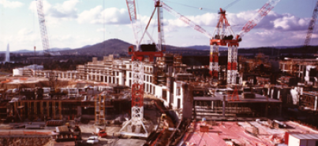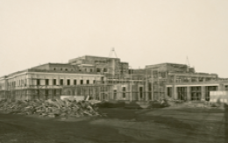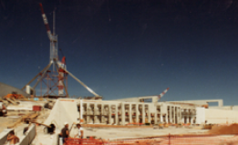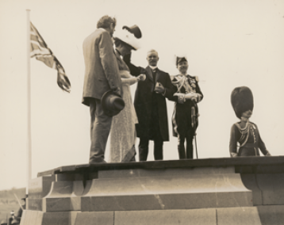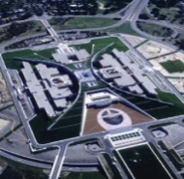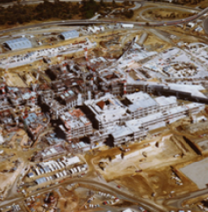

Images: Parliamentary Education Office

# Activity: The Nation’s Capital

A point that couldn’t be agreed on by the six colonies was the location of the nation’s capital. Both Melbourne and Sydney claimed the right to be the capital. A compromise was reached where a separate capital city would be created. Ask students to research and respond to the following questions:

* Which city was the temporary capital until a new city was established?
* What historical events led to the decision to create a new city as a capital?
* How was the location selected?
* What other locations were considered?
* What are the advantages and disadvantages of Canberra being chosen as the nation’s capital?

# Activity: BTN Federation story

Students will watch the [BTN Federation story](http://www.abc.net.au/btn/classroom/federation/10528704) and answer the questions below.

1. Before Federation, Australia was divided into six separate ______________.
2. Which other country might have been part of Australia?
3. Who was Henry Parkes?
4. A group of men posing for a photo

   Description automatically generatedWhat was his famous speech about?
5. Why were initial attempts to become a Federation rejected?
6. What role did Alfred Deakin play in Australia becoming a Federation?
7. In what year did Australia become a nation?
8. Who was Australia’s first Prime Minister?

# Useful Websites

* [The First Parliament](https://www.peo.gov.au/learning/closer-look/short-history/the-first-parliament.html) – PEO
* History of Parliament House - Parliament of Australia
* [Parliament House](http://www.abc.net.au/btn/classroom/parliament-house/10529908) – BTN
* [Federation](http://www.abc.net.au/btn/classroom/federation/10528704) – BTN
* [Parliament](https://explore.moadoph.gov.au/timelines/parliament?_ga=2.149307829.202059.1556604572-1296603443.1556604572) - Museum of Democracy Old Parliament House



**KEY LEARNING**

Students will develop a deeper understanding of the roles and responsibilities of the three levels of government

**CURRICULUM**

**Civics and Citizenship – Year 6**

The roles and responsibilities of Australia’s three levels of government.

The responsibilities of electors and representatives in Australia’s democracy.

Teacher Resource

**Levels of Government**

# Activity: Class Discussion

Discuss the BTN Levels of Government story as a class. What questions were raised in the discussion (what are the gaps in their knowledge)? Some questions to help guide discussion include:

* A picture containing text, vector graphics

  Description automatically generatedWhat is democracy?
* Why do we need governments?
* What is a representative democracy?
* What are the three levels of government?
* Why do we have three levels of government?
* Name some responsibilities of each level of government?

# Activity: Glossary

Students will develop a glossary of terms that relate to the three levels of government. Below are some key words to get them started:

|  |  |  |
| --- | --- | --- |
| GOVERNMENT | REPRESENTATIVE DEMOCRACY | PRIME MINISTER |
| MAYOR | COUNCILLOR | PREMIER |

# Activity: Investigating the Three Levels of Government

Students will research responses to the following questions:

**Federal government**

* 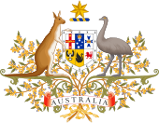What is the decision making body of federal government?
* What are the two houses of parliament?
* What is the leader of the federal government called?
* How often are elections held?
* What are the representatives of each house of parliament called?
* Give three examples of federal government responsibilities.

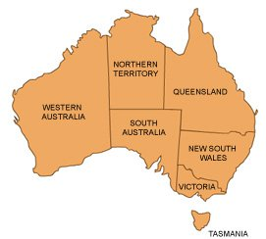**State and territory government**

* What is the decision making body of state government?
* Are all states made up of two houses?
* What is the leader of the state government called?
* What is the leader of each territory government called?
* Give three examples of state government responsibilities.

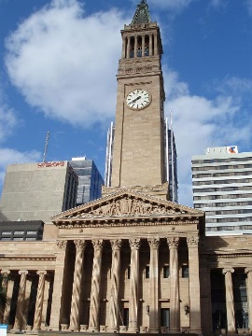**Local government**

* What is the decision making body of local government?
* What are the representatives called?
* What is the head of the council called?
* Give three examples of local government responsibilities.

# Activity: Who Represents You?

Students will find out more about who represents them in local, state and federal government. Ask them to record what they already know about their representatives then research the gaps in their knowledge.

**Federal government**

* Which electorate do you live in? Go to the *Australian Electoral Commission* website to [find your electorate](https://electorate.aec.gov.au/).
* Who is the current member for this electorate?
* Which political party do they represent?

**State government**

* Which electorate do you live in? Go to the *Electoral Commission* website in your state to find your electorate.
* Who is the current member for this electorate?
* Which political party do they represent?

**Local government**

* Which council area do you live in?
* Who is the councillor/s that represent you?
* Who is the Mayor or Shire President?
* What special features or facilities does your council area have?
* What improvements would you like to see in your local area and who would you contact to make those improvements?

# Activity: Shared and Separate Responsibilities

Working in pairs, students will investigate the shared and separate responsibilities of the three levels of government. They can display their information using a Venn diagram with three circles. Record shared responsibilities in the overlapping areas. Ask students to consider why there are some responsibilities that are shared between the different levels of government.

Federal

State

Local

# Activity: Which level of government is responsible?

Students will look at the following issues and tick which level of government is responsible. Ask students to think of three of their own examples, one for each level of government.

|  |  |  |  |
| --- | --- | --- | --- |
|  | **Level of Government** | | |
| **Issue** | **Local** | **State** | **Federal** |
| *A railway line needs to be fixed* |  |  |  |
| *I want to make a Medicare claim* |  |  |  |
| *I lost my passport* |  |  |  |
| *My rubbish bin wasn’t collected* |  |  |  |
| *I want to submit plans to build an extension on my home* |  |  |  |
| *The footpath in front of my house is unsafe and needs to be repaired* |  |  |  |
| *I want improvements made to public transport in my area* |  |  |  |
| *I have family from overseas who want to live in Australia* |  |  |  |
| *A mine is being planned near the town where I live, and I’d like to know more about it* |  |  |  |

Students can test their knowledge of the three levels of government in this fun interactive game [Play now](https://peo.gov.au/sub-site/three-levels-of-government-game/index.html)

# Activity: BTN State Laws

The BTN [State Laws](http://www.abc.net.au/btn/story/s3875892.htm) story explains the differences between state and federal laws. After watching the story, students will respond to the following questions:

1. A picture containing text, fabric

   Description automatically generatedIn the BTN story, what law was passed by the State Government in the Australian Capital Territory?
2. Why might this law not be accepted by the Federal Government?
3. List Australia’s states and territories.
4. Each of the states has their own parliaments, their own leaders and their own laws. True or false?
5. List some areas that the state government gets to look after.
6. List some areas that the federal government gets to look after.
7. Give an example from the 1980s when the federal government overturned a state government decision.
8. Where are legal fights between the levels of government settled?
   1. Supreme Court
   2. State Court
   3. High Court
9. Do you think the federal government should be allowed to overturn state government decisions?
10. What was surprising about this story?

# Useful Websites

* [What is Democracy?](http://www.abc.net.au/btn/story/s4460249.htm) – BTN
* [History of Voting](http://www.abc.net.au/btn/story/s4464749.htm) – BTN
* [State Laws](http://www.abc.net.au/btn/story/s3875892.htm) – BTN
* [Everyone’s Parliament: Three Levels of Government](https://www.parliament.qld.gov.au/documents/explore/education/factsheets/Factsheet_1.1_ThreeLevelsOfGovt.pdf) - Queensland Parliament
* [Snapshots: Three Levels of Government](http://www.peo.gov.au/multimedia/videos/snapshots-three-levels-of-government.html) - Parliamentary Education Office
* [Three Levels of Government](http://education.aec.gov.au/teacher-resources/three-levels.html) - Australian Electoral Commission