EPISODE 25
31st August 2021

KEY LEARNING
Students will view a range of BTN stories and use comprehension skills to respond to a series of focus questions.

CURRICULUM
English – Year 4
Use comprehension strategies to build literal and inferred meaning to expand content knowledge, integrating and linking ideas and analysing and evaluating texts.

English – Year 5
Use comprehension strategies to analyse information, integrating and linking ideas from a variety of print and digital sources.

English – Year 6
Use comprehension strategies to interpret and analyse information and ideas, comparing content from a variety of textual sources including media and digital texts.

English – Year 7
Use comprehension strategies to interpret, analyse and synthesise ideas and information, critiquing ideas and issues from a variety of textual sources.
  - Teacher Resource

Focus Questions

Refugees in Australia
- In pairs, discuss the Refugees in Australia story. Record the main points of your discussion.
- Why did Muhammad and his family leave Syria?
- When did they come to Australia?
- Why do people leave their country as refugees?
- When did Australia start accepting refugees?
- Who started the United Nations High Commissioner for Refugees?
- How many Afghan refugees is Australia taking?
  - 3,000
  - 13,500
  - 20,000
- Why did the Australian government have to abandon its rescue mission in Kabul?
- What questions do you have about the story?
- What do you think would be one of the most difficult things about moving to another country?

Paralympics – We the 15
- What did the BTN Paralympics – We the 15 story explain?
- What does the ‘We the 15’ campaign hope to raise awareness about?
- Why is it called ‘We the 15’?
- What sport does Katelin play?
- Katelin wants to compete in the 2024 Paralympics. True or false?
- What sport does Ellie Cole compete in?
- What message does Paralympian Kurt Fearnley give in the campaign?
- What did organisers do for the launch of the ‘We the 15’ campaign?
- What is the global colour for disability?
- What did you learn watching this story?

Fossil Emblem
- Before watching the BTN story, can you name any of your state’s emblems?
- Which Australian state is looking for a new emblem?
- Name one of the animals that has been nominated to become the state’s fossil emblem.
- What are some of New South Wales’s state emblems?
  - Waratah and platypus
  - Sturt desert pea and wombat
  - Kangaroo paw and black swan
- What is Victoria’s state bird?
- What is Victoria’s state mineral?
- What year did Western Australia choose the Gogo fish to be its fossil emblem?
- Which state has the oldest fossil as its emblem?
- Complete the following sentence. Dermot hopes that the fossil emblem vote will encourage people to consider a career in _______________.
- Illustrate an aspect of the Fossil Emblems story.

Check out the Fossil Emblem resource on the Teachers page.

Street Art
- Summarise the Street Art story using your own words.
- What is street art?
- Where can you see street art? Give an example.
- What did street art evolve from?
- Banksy’s identity is unknown. True or false?
- What is the theme of Banksy’s street art?
- Describe one of the artworks included in Banksy’s Great British Spraycation.
- Why is Banksy’s street art controversial?
- When is street art legal?
- What did you like about the BTN Street Art story?

Check out the Street Art resource on the Teachers page.

  - Teacher Resource
EPISODE 25
31st August 2021

KEY LEARNING
Students will learn about how fossils are formed and the different types of fossils. Students will explore the fossil emblems shortlisted for Victoria.

CURRICULUM
Science – Year 4
Earth’s surface changes over time as a result of natural processes and human activity.

Science – Year 5
Living things have structural features and adaptations that help them to survive in their environment.

Science – Years 5 & 6
Scientific knowledge is used to solve problems and inform personal and community decisions.

Science – Year 6
Scientific knowledge has changed peoples’ understanding of the world and is refined as new evidence becomes available.

Fossil Emblems

Focus Questions
- Before watching the BTN story, can you name any of your state’s emblems?
- Which Australian state is looking for a new emblem?
- Name one of the animals that has been nominated to become the state’s fossil emblem.
- What are some of New South Wales’s state emblems?
  - Waratah and platypus
  - Sturt desert pea and wombat
  - Kangaroo paw and black swan
- What is Victoria’s state bird?
- What is Victoria’s state mineral?
- What year did Western Australia choose the Gogo fish to be its fossil emblem?
- Which state has the oldest fossil as its emblem?
- Complete the following sentence. Dermot hopes that the fossil emblem vote will encourage people to consider a career in _______________.
- Illustrate an aspect of the Fossil Emblems story.

Activity: Pre-viewing questions
Before watching the BTN Fossil Emblem story, students will discuss the following and record their responses on an A3 piece of paper.
- What do you think the BTN story will be about?
- Have you ever seen a fossil? Where did you see it and what did it look like?
- Do you know where fossils come from? Describe.
- What else do you know about fossils?
Did you know that the word fossil comes from the Latin word fossus, which means ‘dug up’?

Activity: Class Discussion
Hold a class discussion about the information in the BTN Fossil Emblem story. Use the following questions to guide discussion:
- What is a state emblem and why do we have them?
- What are the emblems for the state where you live?
- What are fossils?
- What is a fossil emblem?
Activity: Glossary
Students will brainstorm a list of key words that relate to the BTN Fossil Emblem story. Students may want to use pictures and diagrams to illustrate the meaning and create their own glossary. Here are some words to get your students started.

Fossil | Emblem | Organism
Extinct | Palaeontology | Geology

Activity: Research
After watching and discussing the BTN Fossil Emblem story, what questions do students have? The following KWLH organiser provides students with a framework to explore their knowledge on this topic and consider what they would like to know and learn.
What do I know? | What do I want to know? | What have I learnt? | How will I find out?

Students will develop their own question/s to research or select one or more of the questions below.
- How are fossils formed? Use illustrations to help describe the process.
- How does finding fossils help scientists learn about the past?
- What are trace fossils? What are some examples?
- What is a coprolite? What can we learn from coprolites?
- How do the layers of the Earth help us to work out the age of fossils?
- What are the different types of fossils? Create a graphic that explains each type.
- What is the role of a palaeontologist? What are the different parts to the job of a palaeontologist and what skills do they need to have? Present your information in a creative way.

How are dinosaur fossils formed?
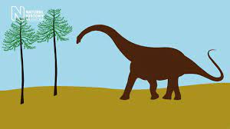
Watch this video that explains the process of how dinosaur fossils formed. Give a short presentation to another student describing the process and include any interesting facts.
Further investigation
Students can understand how impression fossils are formed by making their own fossil using clay. Follow the instructions on the Australian Museum website.

Activity: Meet the fossils
Students will learn more about the fossils shortlisted for Victoria’s fossil emblem. Play the short `Meet the Fossil’ video then respond to the following:
- Describe the plant or animal.
- Give reasons why it should it be chosen as Victoria’s fossil emblem
- Fun Fact
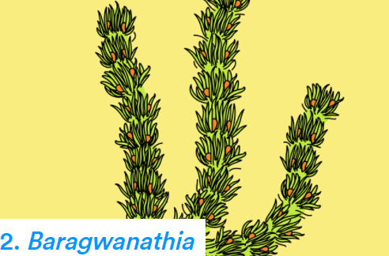
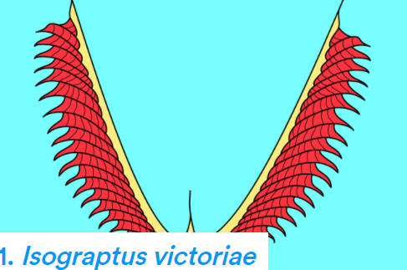
Meet the fossil Meet the fossil
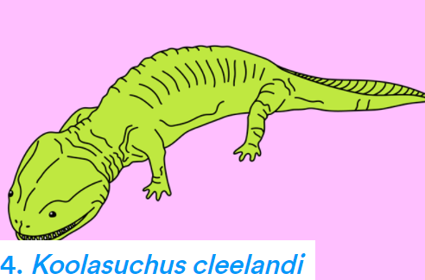
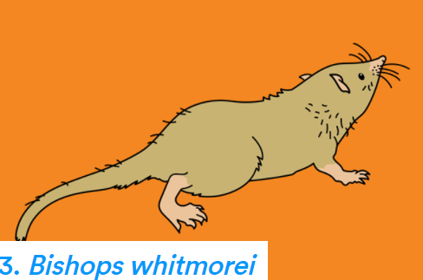

Meet the fossil Meet the fossil
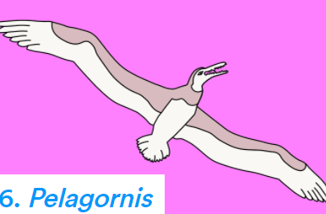
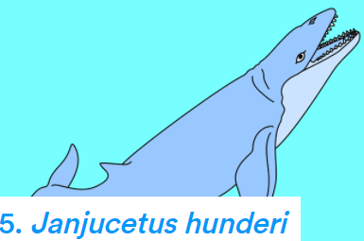
Meet the fossil Meet the fossil

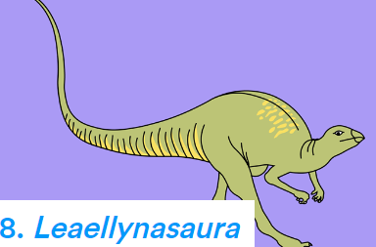
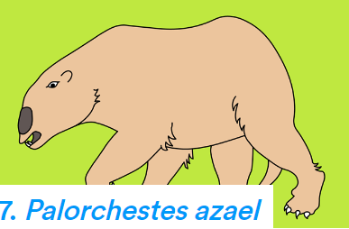

Meet the fossil Meet the fossil

Activity: Quiz

- The word fossil comes from the  Latin word fossus which means…  A. Old skeleton  B. Old Bones  C. Dug up  - Scientists who study fossils are  called…  A. Archaeologists  B. Botanists  C. Palaeontologists  - Fossils are found in mostly which  type of rock?  A. Sedimentary  B. Metamorphic  C. Igneous | - Fossils can be preserved in…  A. Rock  B. Soil  C. Amber  D. All of the above  - What is fossilised poo called?  A. Trilobites  B. Coprolites  C. Ammonites  - The oldest known fossil was  found in Western Australia.  A. True  B. False
Quiz Answers: 1C, 2C, 3A, 4D, 5B, 6A

Useful Websites
- Nominations for Victoria’s fossil emblem - Melbourne Museum
- What are fossils? – Australian Museum
- How are fossils formed? – Australian Museum
- Should a `mysterious marsupial’ or a giant, round-headed amphibian be Victoria’s state fossil? – ABC News

EPISODE 25
31st August 2021

KEY LEARNING
Students will create their own street art which connects with their community.

CURRICULUM
Visual Arts – Years 3 & 4
Identify intended purposes and meanings of artworks using visual arts terminology to compare artworks, starting with visual artworks in Australia including visual artworks of Aboriginal and Torres Strait Islander Peoples.

Visual Arts – Years 5 & 6
Explain how visual arts conventions communicate meaning by comparing artworks from different social, cultural and historical contexts, including Aboriginal and Torres Strait Islander artworks.

Visual Arts – Years 7 & 8
Analyse how artists use visual conventions in artworks.

  - Teacher Resource

Street Art

Focus Questions
Discuss the BTN story as a class and record the main points of the discussion. Students will then respond to the following:
- Summarise the Street Art story using your own words.
- What is street art?
- Where can you see street art? Give an example.
- What did street art evolve from?
- Banksy’s identity is unknown. True or false?
- What is the theme of Banksy’s street art?
- Describe one of the artworks included in Banksy’s Great British Spraycation.
- Why is Banksy’s street art controversial?
- When is street art legal?
- What did you like about the BTN Street Art story?

Activity: Class Discussion
Before watching the BTN Street Art story, ask students what they already know about street art. Here are some discussion starters:
- What is street art?
- Have you seen street art? Where? Describe the street art you have seen.
- How do think street art benefits society?
- What do you think is the difference between graffiti and street art?

After watching the BTN story as a class, respond to the following questions:

- What did you SEE in this video?
- What do you THINK about what you saw in this video?
- What does this video make your WONDER?
- What did you LEARN from this story?

Activity: KWLH
Hold a class discussion about the information raised in the BTN Street Art story. What questions were raised in the discussion, and what are the gaps in their knowledge? The following KWLH organiser provides students with a framework to explore their knowledge on this topic and consider what they would like to know and learn.

What do I know? | What do I want to know? | What have I learnt? | How will I find out?

Research questions for Inquiry
- What was the first form of street art?
- What is the history of street art? Create a timeline to illustrate your findings.
- What are some different types of street art? Explore the different techniques used in street art (e.g., graffiti artwork, stencil graffiti, sticker art, street poster art, video projection, guerrilla art, flash mobbing and street installations). Give examples.
- Is street art legal? When is street art not legal? Explore the similarities and differences between graffiti and street art.
- Why do some street artists stay anonymous? Explore the works of Banksy and other street artists who hide their identity.
- What is Banksy’s style? Who was Banksy influenced by? Find artists with similar artistic styles and techniques to that of Banksy.

Activity: Analyse street art
As a class, view a variety of street art, near to your school, around Australia and around the world. Students will select an example of street art that interests them. Students will analyse and reflect on the street art and then respond to the questions below.

ABC News – (Getty: William West) | 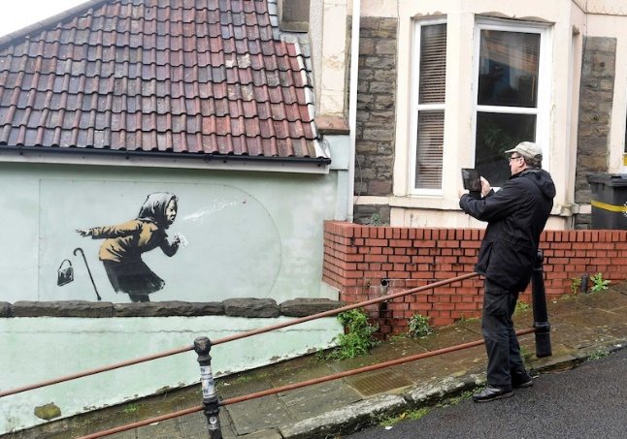  ABC News – (Reuters: Rebecca Naden)
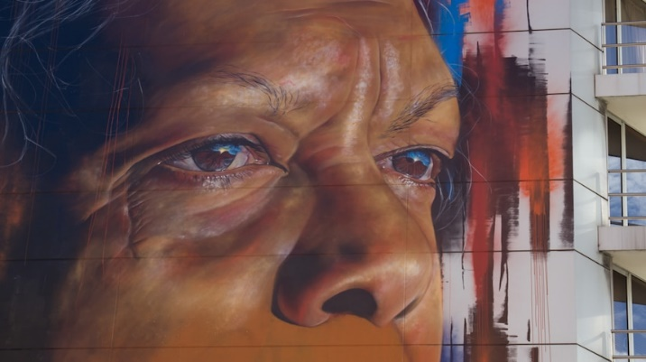  ABC News – (702 ABC Sydney: Amanda Hoh) | 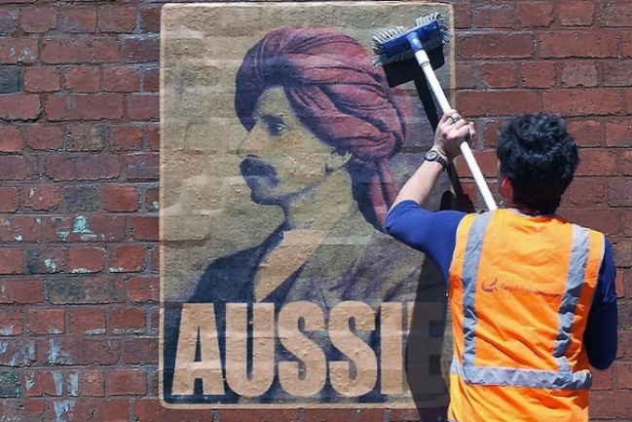  ABC News – (Supplied: Peter Drew)

Questions to help guide students’ exploration:
- Record as much information as you can about the street art in 15 minutes. Record everything you see. The longer you look the more you will see. Consider looking at it from different angles, up close and far away.
- If there are people in the art work, what can you tell about their personality? What are they doing? Describe their facial expression and pose.
- What is the mood of the art work?
- Do you notice any objects in the art work? What do these objects symbolise?
- What do you think the artist is trying to say through the street art? What does it mean?
- What materials were used to make it?
- What techniques does the artist use?
- What do you know about the artist?
- What do you like about this art work? Why did you choose it? How does the art work make you feel?
- What questions do you have about the artwork?

Activity: Create your own street art
Students will create their own artwork that is inspired by their favourite street artist. Students will create a sketch of their artwork on paper or cardboard, using the following to guide their design:
- What is your message? Think of a positive message that you want to convey in your art work.
- Does your artwork tell a story, promote an idea, illustrate a culture, make the viewer think, or create an experience?
- How will your street art connect with your community?
- What images, symbols, words, and colours will you use?
- Where would your street art appear? (e.g., exterior of a building, under a bridge, footpath).
- Is the location a public or privately owned building? Who would give you permission for your design?

Activity: Explore street art in your community
In this activity, students will explore a range of street art in their community. As a class you may want to visit street art out in the community or take a virtual street art tour.

Explore | Go on a tour of your town or city, taking photos and drawings of what you find. Find out as much as you can about the street art.  - What street art is in your community? Make a list.  - Where is the street art located? E.g., on electricity poles, the exterior of buildings, chalk street art, murals, mosaics.
Research | Choose an example of street art in your community to explore in more detail.  - Who is the artist?  - Where is the street art located?  - When was the street art created?  - Describe the street art including: the elements, colours and materials used.  - What is the message? What symbols and themes do you notice in the artwork?  - How does the street art connect with the community?  - Could you interview the artist for extra content? What questions would you ask?
Design & create | Design a tour of the street art in your community. Take a look at these street art guides for inspiration. Wonderwall Outdoor Gallery SA, Melbourne Street Art Walk, Every Banksy remaining in London.  - Identity the artworks that you will include in your street art tour.  - Will there be a common theme in your tour?  - What order should the artworks be visited?  - Who is the tour for? Is it for families? Is it accessible?  - How will you present the information in your map? E.g., grid system or numbered.  - Will your tour and map be digital or a printout?  Sketch a map and include grid lines which you can use to reference the street art on your tour.  - List each of the places and artworks on your tour.  - Who is the artist? Include a bit of information on each piece of art.  - What extra information will you include, e.g., photographs, QR codes, legend, scale, distance and time of tour, nearby attractions, public transport.

Useful Websites
- Banksy: Who is the famous graffiti artist? – BBC Newsround
- Banksy: Who is Banksy? – Newsround
- Banksy claims responsibility for new Great British Spraycation artworks in English seaside towns – ABC News
- https://www.abc.net.au/news/2021-08-14/banksy-artwork-in-english-seaside-towns/100377542
- The Birth of Street Art – Saatchi Art

  - Teacher Resource

BTN Transcript: Episode 25 - 31/8/2021

Hey, I’m Amelia Moseley and you're watching BTN. Here’s what’s coming up. We hunt for Victoria's new fossil emblem, get on the trail of a mysterious street art superstar, and hear the important message behind this year's Paralympics.

Refugees in Australia

Reporter: Jack Evans

INTRO: All that soon. But first up today, we're going to find out more about what it means to be a refugee. Right now, many people who have fled the Taliban in Afghanistan are making new homes in countries around the world, including Australia. They're amongst the thousands of refugees that come here every year to escape violence and persecution. Jack found out more.

For the past 5 years Muhammad and Zain have been living in Adelaide and enjoying all the things other Aussie kids do. But they can still remember a time before they came to Australia, when things were very different.
MUHAMMAD: I remember when it was on my birthday, I found a bullet in my window, my room window. And we barely even heard it. Yeah, that I remembered that. And they used to throw like, tear gas bombs and that. Yeah.
The brothers came here as refugees.
MUHAMMAD: My family left Syria because there was war in 2010 and 2011. And we thought we couldn’t survive there if we stayed. Around Australia there are hundreds of thousands of former refugees like Muhammad and Zain. They come from many different countries. But all were forced to leave because their life has been threatened by war, violence, or bad treatment, often because of their race, gender, or beliefs.
Australia started accepting refugees after the Second World War, when the United Nations set up a special agency, The United Nations High Commissioner for Refugees. Many countries, including Australia, agreed to help by giving money or aid to the UN's refugee program. As well as taking in refugees to give them a safe place to live.
Australia's first refugees were from European countries that had been badly affected by the war. And then in the 70s Australia resettled more than 55,000 Vietnamese people who were displaced because of the Vietnam War, which Australia had a played a role in. Many have compared what happened then to the situation in Afghanistan that's happening right now. And human rights and refugee advocacy groups have called on Australia to help.

SCOTT MORRISON, AUSTRALIAN PRIME MINISTER: There are many women and children that we’ve been able to get out of Afghanistan.
Our Prime Minister, Scott Morrison, has said Australia will offer 3,000 refugee visas to Afghans with priority given to people with family already in Australia, as well as women and children. That will come from the existing 13,750 visas that Australia offers every year to refugees from around the world. Other countries involved in the war in Afghanistan, like the UK and Canada, have agreed to take in 20,000 Afghan people and some would like to see Australia do the same. But the Government says the situation is complicated because of COVID and because of how dangerous things are in Afghanistan. Last week the Government had to abandon its rescue mission, for now, after a deadly attack at Kabul's airport. Meanwhile some Afghans have already arrived in Australia ready to start a new life and many are hoping those still stuck there will get to safety soon.
MUHAMMAD: I feel really bad for Afghanistan. And I don't think they should be treated like that.
ZAIN: I think the people that are killing off Afghanistan's should stop because like, really Afghanistan's didn't do anything to them.
MUHAMMAD: And they don't deserve it. They don't deserve being killed. It makes me feel really, really bad. And because I've been in that situation before, but luckily, I survived. And I hope they do too.
News Quiz

What’s the youngest you can be to get a COVID-19 vaccination in Australia? 12, 16 or 18? It’s now 12. The government has just added 12 to 15-year-olds to its vaccination rollout, although it’ll be up to the states to decide when you can actually get it.

KID 1: I think our age group should get the vaccine and I think it is a good idea.

KID 2: I think for the safety of us and others I think we should be getting the vaccine.
What cartoon movie was the Prime Minister referencing in this interview?

SCOTT MORRISON, AUSTRALIAN PRIME MINISTER: People wanted to stay in the cave, some wanted to stay in the cave, and that young girl, she wanted to go out and live again and deal with the challenges of living in a different world. Well, COVID is a new different world, and we need to get out there and live in it.

It’s the Croods, apparently a fave of the PM. He reckons, much like the movie characters, Australians need to learn to live with COVID and open up once we’ve got enough people vaccinated.
Scientists in Egypt have discovered a 43 million-year-old fossil of a walking whale that they’ve named Phiomicetus anubis. Anubis was the ancient Egyptian god of what? Youth, death or the Sun? Anubis was the god of death, and scientists reckon this guy would have been a pretty fearsome predator back in the day.
Some school kids in Queensland have been singing about their very, very big classroom. What’s the name of their famous school which was set up for kids in remote areas? It’s the School of the Air. These guys were doing distance learning way before it was trendy, and a musician from Toowoomba decided to write a song about their unique classroom.

KID 1: I was definitely a bit nervous before I went to record my voice.

KID 2: I felt super embarrassed and nervous and all that.

KID 1: And then when I actually did it, I was like, oh I want to do that again because it was really fun.

KID 3: It was really fun getting your own voice recorded.

KID 2: I’m sort of famous now, so yeah, it was good.
Do you know which high-ranking Aussie official this is? It’s the Governor General, Australia’s official head of state. Last week he and his wife got into the spirit of Book Week.

Paralympics – We the 15

Reporter: Amelia Moseley
INTRO: Now to Tokyo, where, as I'm sure you know, the Paralympics are in full swing. And in the lead-up to the games some of our top Paralympians helped to launch a campaign called We the 15. It's all about changing people's attitudes towards the 15 percent of the world's population who have a disability. Check it out.

For aspiring sports stars like Katelin here, the Paralympics is a chance to see some of their sporting idols in action.
KATELIN: I'm very excited for the Paralympics. I just love just watching everyone with similar abilities to me play sport and show me that they can do it and anything's possible.
But Katelin doesn't just wanna watch the games, she wants to compete.
KATELIN: I like wheelchair basketball cause it's a team sport and I've always loved playing as a team and just having each other's back and playing with others that have similar abilities to me. I really want to go to either the 2024 Paralympics or the 2028 Paralympics and hopefully win gold there.
But while our Paralympians are out there inspiring young athletes on the court or the track or in the pool, recently they turned their attention to spreading a really important message that goes way beyond sport.
#WETHE15 CAMPAIGN: You're a superhero. Really? Yeah, we're superheroes alright.
This is a worldwide campaign called We the 15. It's all about smashing stereotypes and changing people's attitudes about the 15 percent of the world's population that has a disability.
#WETHE15 CAMPAIGN: We pray five times a day and no, I'm not praying for a cure. I'm praying for a new handbag.
Yeah, it's a little bit cheeky and fun.
#WETHE15 CAMPAIGN: We get married. We met on a blind date.
And it's about helping to show that people with disabilities are just like everybody else and deserve to be treated with the same respect and given the same opportunities. It's a message lots of famous Paralympians are getting behind like Aussie wheelchair racer Kurt Fearnley and Aussie swimmer Ellie Cole.
Kurt Fearnley, Paralympian: We the 15 is about taking the voice of the people with disabilities to an international stage. They don't want to be seen as superhuman, they want to be seen as human, as equal, as being able to get a job, being able to access education.
Ellie Cole, Paralympian: Everyone wants to have the same opportunity as the person next to them and it shouldn't be based on how you were born or if you were in an accident.
#WETHE15 CAMPAIGN: We're not special, that's not what it's like and only when you see us as one of you, wonderfully ordinary, wonderfully human, will we break down the barriers that keep us apart.
We the 15s already getting a lot of love. When it launched more than 100 landmarks around the world lit up purple, the global colour for disability, and it featured at the Paralympics opening ceremony in Tokyo. During the games, you might even spot athletes wearing temporary tattoos of the campaign symbol, and it's hoped its important message will travel far and wide.
Ellie Cole, Paralympian: The thing that excites me the most about the We the 15 campaign is that it's finally going to create that conversation that the world really needs.
KATELIN: I just want people to understand that even though people may have a disability, that their abilities do change, but it doesn't stop them from achieving everything that an able-bodied person can do.
Fossil Emblem

Reporter: Natasha Thiele

INTRO: Now here's a question, do you know your state's emblems? They're animals and plants that are chosen to represent the states and territories and Victoria's looking for a new one and asking people to vote for their favourite. But there's a twist, all of the contenders have been dead for a really long time. Here's Tash to explain.

Coming to you live from Victoria where we have the contestants that prove you don't have to be alive to be the State's favourite fossil. First up, we have the 470-million-year-old marine animal, shaped like a V for Victoria or very handsome. It's Isograptus victoriae. Or coming at you from the Cretaceous, the very cool Koolasuchus cleelandi. Next, we have the adorable Bishops whitmorei. A pint-sized mammal that ran around the toes of dinosaurs. Or the youngest of the group Palorchestes azael, the mystery marsupial of the Ice Age. They're just four of the eight contestants nominated to become Victoria's new state fossil emblem.
You might be familiar with some state emblems. Animals and plants that have been chosen to represent their home like New South Wales’s Waratahs and platypuses or WA's kangaroo paw and numbats and in Victoria, the common Heath and the Leadbeater's possum. Aww how cute.
But the states and territories have other emblems that you might not know so well. For example, did you know that Victoria's state bird is the Helmeted Honeyeater. It's state marine animal is the Common Seadragon, and its state mineral is gold. Oh, and it's got a state tartan too. Oh, who knew. And now it's time to add one more.
DERMOT HENRY, HEAD OF SCIENCES AT MUSEUMS VICTORIA: We thought, Victoria has got fantastic fossil record internationally significant fossil sites, we should have a fossil emblem our fossils are as good as anything in the world. So, we'd like the people of Victoria to help us choose it.
Victoria won't be the first state to adopt an emblem that's a little less alive. Back in 1995, Western Australia adopted the Gogo fish as its fossil emblem. A little more recently, New South Wales chose the Devonian fish and last year, the ACT picked Batocara Mitchelli as its fossil emblem.
TASH: And while it wasn't chosen until 2017, South Australia's is the oldest. This wormy-looking thing called Spriggina floundersi is 550-million years old.
And now it's Victoria's turn. There were lots of fossils to choose from, but the team at Museums Victoria managed to get it down to just eight.
DERMOT HENRY: These were the ones that we felt on the international geological international stage, people would be aware of them, because of their, the unusual nature of them and the stories they tell about the evolution of life on our planet in general.
Dermot says fossils can tell us a lot about our past and he hopes that Victoria's fossil emblem vote might even encourage some of you guys to consider a career in paleontology.
DERMOT HENRY: Paleontology is a real gateway into science. It's a wonderful career, you're a time traveller going back 600 million years in Victoria, and great opportunities to see really bizarre, unusual critters that lived you know a long time ago.
So while we'll have to wait a little while before a winner is chosen, it won't be too long until we find out which of these dead gorgeous beauties will be deemed the winner.

Quiz

Which if these geological periods is the oldest? The Paleocene, the Jurassic or the Cambrian? It's the Cambrian period. It's also known as the Cambrian explosion because it's when heaps and heaps of complex, multicellular creatures started to appear which we have fossils of today.

Ask a Reporter

If you want to know more about fossils you can join us live on Friday for Ask a Reporter. Check our website for more details.

Street Art

Reporter: Jack Evans

INTRO: Now you've probably heard of the anonymous British street artist Banksy. He's just released a video showing that he was behind a whole bunch of new paintings which appeared around England's East Coast. Unfortunately, Jack couldn't track him down for an interview, but he did catch up with another street artist to find out how this kind of art's changed over the years. Take a look.

JACK: Ah yes, a bit more here and a touch more red there. Too much red. I think it’s finished, I'm a genius. Let me present, street art, art of a street.
LEELA: I don't think that's what street art is?
JACK: Oh really, because it's a street and it's art. So why would they call it street art?
LEELA: Because it's art in a street.
JACK: Oh, well that makes sense.
Street art if you haven't worked out yet is indeed a form of art that is displayed in public spaces. On streets, duh, as well as buildings and other publicly viewed surfaces. Most people reckon that street art evolved from graffiti. Which, fun fact, has been going on for thousands of years, look ancient graffiti. That doesn't mean it’s good. In fact, most people would agree that graffiti is a bit of an eye sore. But street art is another matter. Over the years some street artists like Jean-Michel Basquiat and Keith Haring have become famous for their work which started on public walls.
And then there's this guy or maybe this guy or is it this guy? I don't know. In fact, no one really knows who Banksy is. But everyone knows his work. Banksy started spraying his political themed pieces in the UK in the 90s and since then his work has appeared around the world, attracting thousands of tourists, and sometimes selling for a lot. Although you never know when this is going to happen.
Just last week Banksy published a video owning up to a bunch of new artworks which have appeared on England's east coast during what he called a Great Spraycation. Of course, the way he does his art can be controversial because, well, it's illegal. I mean you can't just go around spraying on walls guys. But there are a lot of other street artists who are making a name for themselves by painting on walls with permission. Like Leah. If you're from Adelaide you might recognise some of her murals.
LEAH: I was always fascinated by street art, and I was interested in it. But I kind of felt like I wasn't allowed to be because I didn't know how to practice with permission.
She said she started working with other artists to learn the tricks of the street art trade and now business is booming.
LEAH: We've come full circle, we had councils were trying to stop graffiti and strop street art. And now they're the ones that have the biggest budgets to create, and commission artists to come and add colour and vibrancy to the street.
She also runs workshops teaching aspiring artists some of her techniques, legally of course and she says thanks to the medium’s booming popularity there will be plenty of opportunity for the next generation of street artists.
LEAH: Every mural that I've done has led to the next mural, which has been really exciting and fun. It's publicly viewed, and it makes you see it in a different perspective, often from a scale that is just so much bigger than what you can do inside a gallery or inside on a canvas or paper.
JACK: There we go. Now it's street art.
LEELA: Uhmmmm.
JACK: It's art in a street.
LEELA: Yeah, I guess you're right.
Sport

The New South Wales Swifts are officially this year's Super Netball champions. The Swifts got off to an unbelievably strong start scoring the first 6 goals. While the Giants fought their way back into the game the Swifts were just too strong winning 63 to 59 and netting their 2nd championship in just 3 years.
The Paralympics are well underway over in Tokyo, where Aussie Madison de Rozario has taken home gold in the 800 metres T53. After her second lap, she broke away from the pack and took a massive lead holding on for the win. Meanwhile, Aussie swimmers Keira Stephens and Katja Dedekind added to our tally with a couple of bronzes. In the wheelchair rugby the Aussie Steelers dug deep for a 2-point win against France.
And Debbie Lee's made history by becoming the first woman to be inducted into Australian Football Hall of Fame. She's one of the greats of the VWFL and now works with the Western Bulldogs as General Manager of women's football. Dual Brownlow medal winner Chris Judd has also been inducted, as has Nathan Burke who played 323 games for the Saints.
Bushfire Heroes

Rookie Reporter: Paris

INTRO: Finally, today we're going to meet another winner of the ABC's Heywire competition. It gets kids from regional Australia to share stories about their lives and Paris is going to tell us what it was like when her home town, Yamba, was hit by bushfires back in September 2019. Check it out.

I remember when dad pulled up the car to pick me up from school. My guitar and all my belongings were on the backseat. I was like, `what’s going on?’. He said, `there’s embers in the backyard’. A crackling blaze was rampaging across the drought-stricken bushland, scorching hot and glowing like hell itself.

And it’s not even summer yet. We all flinched at the thought that the worst was yet to come. Earlier that day, it was eerie. The sky was orange. We’ve been watching the fires burn for weeks, our eyes glued to the `Fires near me’ website. The smouldering black leaves falling on our homes. The combination of high winds, scorching hot temperatures, and less than average rainfall simply fed the inferno. If only the tears cried by the hundreds of Australians who had lost homes and family members could extinguish the fires that ravaged our sunburnt country.

At my grandmother’s, lying in a strange bed, I stayed awake thinking about all the homes that were at risk, hoping that my friends would be safe. Mentally, I prepared for the worst, that the town would be no more the next time the sun came over the smoky horizon. All that stood between the fire and the town was a band of firefighters, some who left their own jobs to save our homes. Mother nature was against them. The fire jumped roads, but they kept fighting. Not one single home was lost, and we owe it all to our firefighters. Not all heroes wear capes. My heroes wear helmets.

Closer

Well, that's if for another week. But we'll be back with more before you know it and in the meantime there's heaps to see and do on our website. You can also subscribe to our YouTube channel if you're 13 or over and of course Newsbreak will be here every weeknight to keep you all up to date. Have a great week. Look after each-other and stay safe. Bye.

