EPISODE 11
3rd May 2022

KEY LEARNING
Students will view a range of BTN stories and use comprehension skills to respond to a series of focus questions.

CURRICULUM
English – Year 4
Use comprehension strategies to build literal and inferred meaning to expand content knowledge, integrating and linking ideas and analysing and evaluating texts.

English – Year 5
Use comprehension strategies to analyse information, integrating and linking ideas from a variety of print and digital sources.

English – Year 6
Use comprehension strategies to interpret and analyse information and ideas, comparing content from a variety of textual sources including media and digital texts.

English – Year 7
Use comprehension strategies to interpret, analyse and synthesise ideas and information, critiquing ideas and issues from a variety of textual sources.
  - Teacher Resource

Focus Questions
As a class, discuss the stories featured in the episode of BTN Classroom and record the main points of the discussion. Students will then respond to the following focus questions.

Solomon Islands Security
- How far are the Solomon Islands from Australia? Find on a map.
- Approximately, how many islands are there in the Solomon Islands?
- During what war were the Solomon Islands part of a major battleground?
- What country did the Solomon Islands sign a security agreement with?
  - Australia
  - China
  - Japan
- Why are some people concerned about the security agreement?

Palm Oil Ban
- What part of the palm tree does palm oil come from?
- What types of products contain palm oil? Give examples.
- Palm oil can sometimes appear on food labels as what?
- Why is Indonesia banning the export of palm oil?
- What is sustainable palm oil?

Check out the teacher resource on the Teachers page.

Voting Age
- What is the minimum voting age in Australia?
- For a long time in Australia, the minimum voting age was 21. True or false?
- Which country has NOT lowered the voting age to 16?
  - Brazil
  - Austria
  - England
- Why are some people against the idea of lowering the voting age?
- Do you think the voting age should be lowered to 16 in Australia? Why or why not?

Check out the teacher resource on the Teachers page.

Election Lingo - Parties
- What are the major political parties in Australia?
- To become Prime Minister your party has to win most of the seats in what house?
  - The lower house
  - The upper house
- Which party is part of the coalition with the Liberals?
- You have to be a politician to be a member of a party. True or false?
- How many members do you need to register a new political party?

Human Lifespan
- What year was Kane Tanaka born in?
- Where was Kane Tanaka from?
- What has increased the average lifespan in Australia?
  - Medicine
  - Nutrition
  - Living conditions
  - All of the above
- What causes ageing? Give some examples.
- What species can keep renewing themselves?

EPISODE 11
3rd May 2022

KEY LEARNING
Students will learn more about the impact palm oil production has on the habitat of orangutans. They will also investigate the use of palm oil in products and learn more about sustainable palm oil.

CURRICULUM
Science – Year 6
The growth and survival of living things are affected by physical conditions of their environment.

Science – Year 7
Interactions between organisms including the effects of human activities can be represented by food chains and food webs.

HASS – Year 6
The obligations citizens may consider they have beyond their own national borders as active and informed global citizens.

  - Teacher Resource

Palm Oil Ban

Focus Questions
Discuss the BTN story as a class and record the main points of the discussion. Students will then respond to the following:
- What part of the palm tree does palm oil come from?
- What types of products contain palm oil? Give examples.
- Palm oil can sometimes appear on food labels as what?
- Why is Indonesia banning the export of palm oil?
- What is sustainable palm oil?

Activity: Class Discussion
Discuss the BTN Palm Oil Ban story as a class. Create a class mind map with PALM OIL in the middle. Use the following questions to guide discussion: Ask students to record what they know about palm oil. What questions do they have? In small groups, ask students to brainstorm responses to the following questions:
- What do you know about palm oil?
- What impact does palm oil have on the environment?
- Give examples of products that contain palm oil.
- How are food products that contain palm oil labelled?
- What is sustainable palm oil?

Activity: Glossary
Students will brainstorm a list of key words that relate to the BTN Palm Oil Ban story. Here are some words to get them started.
 | DEFORESTATION | PALM OIL |  | ENDANGERED
 | HABITAT LOSS | PLANTATION |  | SUSTAINABLE PALM OIL

Activity: Palm Oil Research
Discuss the information raised in the BTN Palm Oil Ban story. What questions were raised in the discussion and what are the gaps in students’ knowledge? The following KWLH organiser provides students with a framework to explore their knowledge on this topic.

What do I know? | What do I want to know? | What have I learnt? | How will I find out?

Students will develop their own question/s to research or choose one or more of the questions below. Encourage students to collect and record information from a wide variety of sources and present the information they find in an interesting way.

- Where is palm oil produced? Highlight the countries on a world map.
- Why is palm oil considered a problem?
- How is palm oil important to the economies of Indonesia and Malaysia?
- What species have been impacted by the production of palm oil? Research how one of these species has been impacted by the clearing of tropical rainforests to make way for palm oil plantations.
- What is sustainable palm oil and how is it produced? Look for products that contain sustainable palm oil. How can the community be encouraged to make sustainable choices at the supermarket?
- What does it mean to shop sustainably? How can you make a difference as a consumer?
- Why should we protect orangutans and other endangered species affected by deforestation? Write a persuasive piece of writing explaining your reasons.
- Is boycotting palm oil the answer? Investigate the pros and cons of boycotting palm oil.

Activity: Orangutan Profile
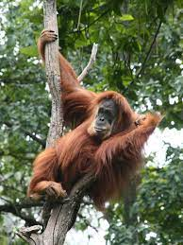
Students will research and write a profile about orangutans, or another endangered species affected by the production of palm oil. Students can use the animal profile worksheet at the end of this activity to record their findings. Encourage students to use a range of sources to find their information.

Students will research the following for their project:
- Common and scientific name
- Appearance - what are some of their physical characteristics?
- Habitat - where do orangutans live? Describe their habitat.
- Conservation status
- Threats - what are some of the threats to the survival of orangutans? What is being done to protect their habitat?
- Unique features
- Interesting facts

Activity: Peel back the label
Students will investigate the use of palm oil in grocery products. In this activity, students peel back the label and learn more about which products contain palm oil and why. Using information in the BTN story and their research, students respond to the following questions:

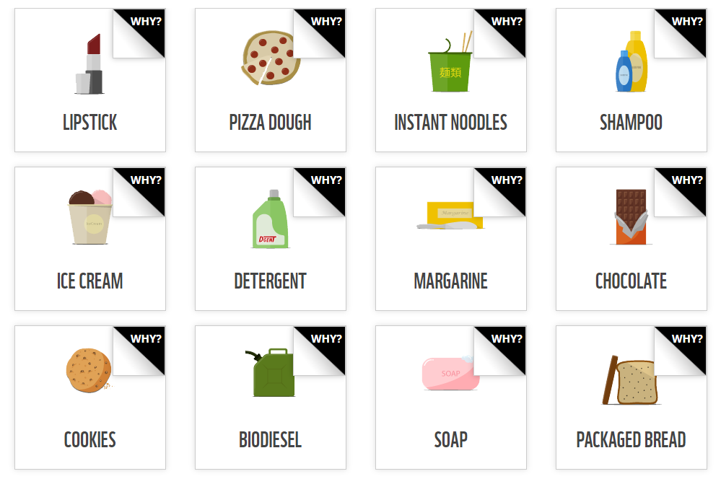
- Which products contain palm oil? List as many as you can.
- Many products that use palm oil aren’t clearly labelled. Palm oil can appear under many names. Give some examples.
- Which products do you use that contain palm oil? Do an audit of your pantry and make a list.
- What are some solutions to the palm oil problem?

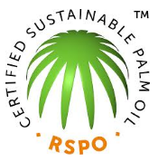
What is certified sustainable palm oil? Students use the following questions to guide their research:
- What is sustainability?
- What is sustainable palm oil?
- How is sustainable palm oil produced?
- Who would benefit from sustainable palm oil production?

Useful Websites
- Palm Oil Problem - BTN
- Palm Oil - BTN
- What is palm oil and why is it thought to be bad? – Newsround
- Palm Oil - WWF

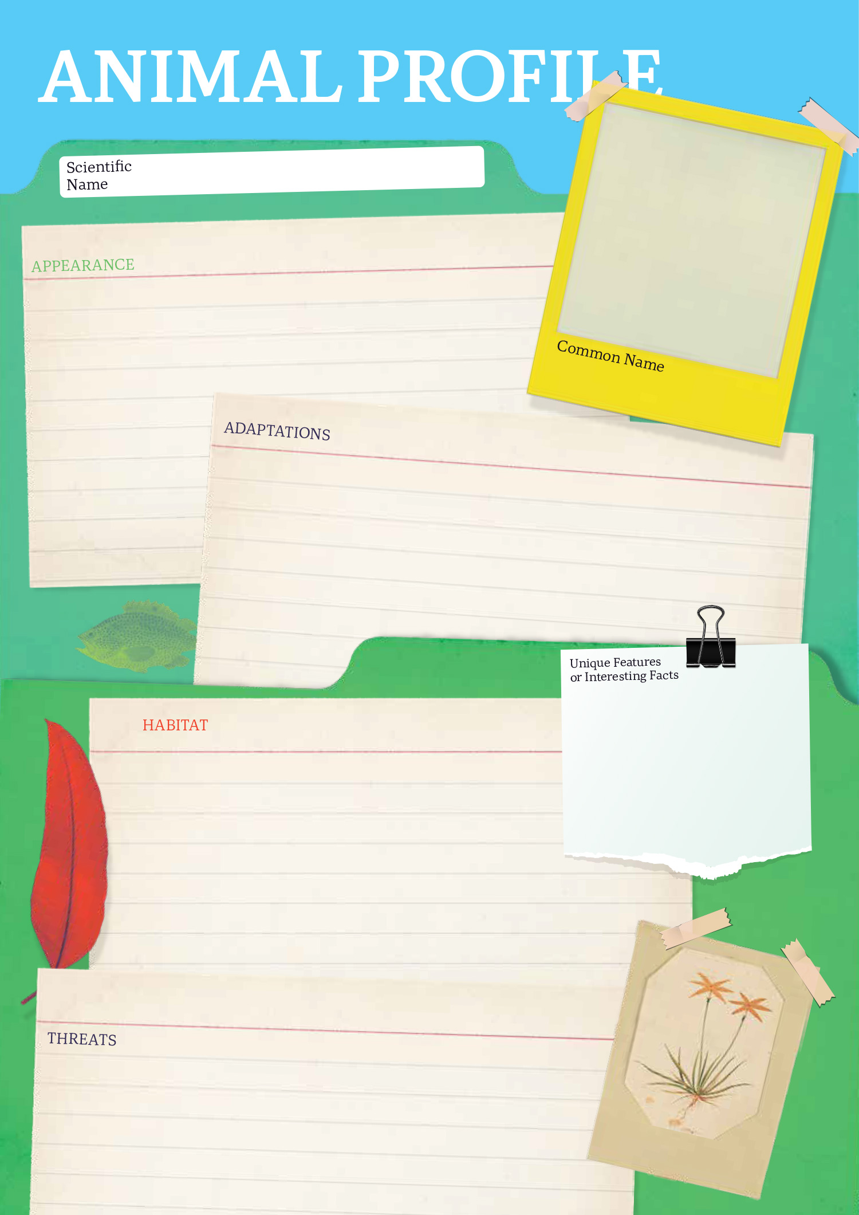

EPISODE 11
3rd May 2022

KEY LEARNING
Students will develop their understanding of the voting process. Students will develop a persuasive argument for or against lowering the voting age in Australia to 16.

CURRICULUM
HASS – Year 4
Sequence information about people’s lives, events, developments and phenomena using a variety of methods including timelines.

HASS – Year 5
The key features of the electoral process in Australia.

Sequence information about people’s lives, events, developments and phenomena using a variety of methods including timelines.

HASS – Year 6
The responsibilities of electors and representatives in Australia’s democracy.

Civics and Citizenship – Year 7
Reflect on their role as a citizen in Australia’s democracy.
  - Teacher Resource

Voting Age

Focus Questions
Discuss the BTN story as a class and record the main points of the discussion. Students will then respond to the following:
- What is the minimum voting age in Australia?
- For a long time in Australia, the minimum voting age was 21. True or false?
- Which country has NOT lowered the voting age to 16?
  - Brazil
  - Austria
  - England
- Why are some people against the idea of lowering the voting age?
- Do you think the voting age should be lowered to 16 in Australia? Why or why not?

Activity: Class discussion
Before watching the BTN Voting Age story record what students know about voting on a mind map. What questions do they have about voting and elections? Use the following questions to help guide discussion.
- Have you ever voted? Discuss in pairs.
- Who can vote at an election?
- How old do you have to be to vote in Australia?
- Do you think being able to vote is important? Why or why not?

After watching the BTN story ask students what they would like to know and learn about voting. Use the following framework to explore their knowledge on this topic.

What do I know? | What do I want to know? | What have I learnt? | How will I find out?

Activity: Glossary
Create your own classroom glossary about voting. Start by brainstorming words as a class using a mind map to record your responses. Add to your list of words by downloading the BTN Voting Age story transcript and highlighting all the words that relate to voting. Find definitions for each word. Here are some words to get students started.

BALLOT BOX | CAMPAIGN | ELECTORATE
POLITICAL PARTY | ELECTORAL ROLL | ELECTION

Activity: Class Vote
Ask your students if they have ever voted. Students will think of different situations where they have been able to have their vote. For example, in the classroom with hands-up voting, at home in family decisions or at clubs voting for new members. Does your school hold elections? Get Voting is everything you need to run a free and fair election for your class or school. Visit the Australian Electoral Commission to download step-by-step resources.

Further investigation
Individually or in small groups, students will choose one of the following projects to work on and then present their findings to the class.

Timeline
Research the history of voting in Australia and record significant events on a timeline. Which dates on the timeline do you think are especially significant? Why?

Quiz
Create a quiz about voting and the electoral process. Test your classmates. Alternatively, make a word search using voting and election lingo!
Flowchart
Create a flowchart which shows the steps in the voting system. You could use Australia’s federal voting system, or a voting system that your school might use.
Class Poll
Run a class poll to find out if your classmates would like to lower the voting age to 16. Alternatively, run a poll on another issue that interests you.

Activity: Opinion Poll
Students will conduct their own opinion poll on the issue of lowering the voting age. Working in groups, students will need to decide who their sample group will be and how many people will be polled.

- What method they will use to conduct the poll? (Face to face interviews or written responses).
- Ask students to graph the opinion poll results and display in the classroom. Students can reflect on how reliable they think the results were. What would they do differently next time?
- Students may want to film their interviews and then create a movie to present to other students.

Activity: Persuasive Text
Students will explore the issue of changing the voting age in Australia and develop a persuasive text for or against the following statement: The voting age should be lowered to 16. Encourage students to research the issue using a range of sources. The following may help students to structure their argument.

Tips
- Who is your audience? For example, are you directing your argument at kids, teachers, or politicians?
- Explore how language choices can have a big impact on persuading your audience.
- Which language devices give the report credibility and authority?
- Which are designed to create an emotional response in the listener?
- Provide facts and evidence to support your argument.
- Write in the present tense.
- Check your spelling and punctuation.

Use this Read Write Think persuasion map to plan your exposition text.

Introduction
- What is the point you are trying to argue? Construct an introductory paragraph which states the issue or topic.
- Introduce the arguments that will be developed in the body of the text.

Body
- Construct arguments that support your point of view.
- Each paragraph starts with a topic sentence which introduces each point.
- The rest of the paragraph gives more reasons.
- Arguments can be ordered from strongest to weakest.

Conclusion
- Restate your position on the argument.
- Construct a concluding paragraph that provides a summary of your arguments and a call to action.

Reflection
- How difficult was it to think of points to support one side of the argument?
- Do you think you would have done a better job supporting the other side of the argument?
- Was I able to convince others of my opinion?
- Did my opinion change?
- What did you learn from this activity?

Useful Websites
- History of Voting – BTN
- Voting Age – BTN
- Voting Age Experiments – BTN
- Voting Age Experiment Results – BTN
- Democracy Rules – AEC
- Practise Voting – AEC
- Why do we enrol to vote? – BTN Newsbreak

  - Teacher Resource

BTN Transcript: Episode 11 - 3/5/2022

Hey, I'm Amelia Moseley and you're watching BTN. Thanks for hanging out with us again, let's see what's coming up in today’s show. We'll find out more about political parties and ask whether 16-year-olds should be able to vote, learn why palm oil is in the news and investigate the limits of human lifespans.

Solomon Islands Security

Reporter: Cale Matthews

INTRO: But first up today, let’s head to the Solomon Islands. That's a country in the Pacific and lately it's been a big topic of conversation here in Australia because of a deal between the Solomon Islands and China. Cale can tell you more.

CASSANDRA: Hi BTN. My name is Cassandra Saliga. I live in a small town of Honiara in the Solomon Islands.
About a 4 hour flight or 2,000 kays north east of Australia are the Solomon Islands. And when I say "islands" I mean about 900 of them, but 6 major ones.
CASSANDRA: Solomon Islands is a beautiful country. We enjoy our local seafood, such as fresh fish, vegetables, and fruits from our local markets. My favourite thing about Solomon Islands is the white sandy beaches and the warm weather.
But amongst the palm trees and below the crystal clear water are a few clues about the country's past. During World War 2 the Solomon Islands were a major battleground between the USA and Japan. Japan had plans to take over the South Pacific and set up military bases in the region. That made Australia super nervous because the Solomon Islands are right in the middle of a shipping route between the USA and us. Eventually, Japan left the area, but now almost 80 years later there are new tensions building in the Pacific.
This month the Prime Minister of the Solomon Islands, Manasseh Sogavare, signed a security agreement with China. No one’s really sure what’s in the deal but lots of people reckon it'll look a lot like this draft that was released in March. It says China can be asked to send police or the military to maintain social order in the country and allows Chinese ships to stopover in the country's ports. The Solomon Island’s PM says that’s nothing to worry about.
MANASSEH SOGAVARE, PRIME MINISTER OF THE SOLOMON ISLANDS: Our cooperation with China is about peace and wellbeing of Solomon Islands and the region.
But it’s got a lot of world leaders and experts a bit concerned.
DR. MALCOLM DAVIS, AUSTRALIAN STRATEGIC POLICY INSTITUTE : The Solomon Islands is a mere 2000 kilometres away from Australia and we worry about the prospect that another country like China could eventually establish a military base in the Solomon Islands from which they could then use military force against us in a war situation.
Some people in the Solomon Islands are also a bit unhappy about what they see as China's growing influence in the country and last year there were big protests. Back here in Australia it’s become a big election issue. Some reckon the government should have worked harder to build ties with the Solomon Islands and other countries in our Pacific neighbourhood, but the PM says it’s not his fault and after all the Solomon Islands are their own country and can make their own decisions.
DR. MALCOLM DAVIS, AUSTRALIAN STRATEGIC POLICY INSTITUTE: I think that we have taken the Pacific Island states and the Southwest Pacific for granted, they're far more concerned about things like climate change, and fisheries, resources.
Both parties say if they do win the election they’ll be really focussed on security in the area. For now, very little is set to change in the Solomon Islands themselves, but you can bet people in Australia are sure to keep a close eye on one of our closest neighbours.

News Quiz

Which of Australia’s major party leaders was out of action during the election campaign last week because of COVID? It was Anthony Albanese. The Labor leader had to take it easy at home. Not great timing, but he’s back out on the campaign trail.

Can you name the billionaire that just bought Twitter? It’s Elon Musk. The Tesla and SpaceX boss paid 44 billion US dollars for the social media company. He says he wants to give people more freedom to say what they want on Twitter, although that has some worried it could lead to more online nastiness.

And where did this team of private astronauts go last week? For a trip into orbit, a trip to the Moon or a trip to the ISS? They went to the ISS. The world-first team was made up of an ex-NASA astronaut and three billionaires who apparently paid around 71 million dollars for the experience. Ah, jealous.

Voting Age

Reporter: Gladys Serugga

INTRO: Now, to the election. There are less than 3 weeks left now until every Australian 18 and over gets a chance to vote for who they want to run the country. But some people reckon younger Aussies should also get a say. Gladys had a look at the debate over whether we should lower the voting age. Check it out.

Turning 16 comes with a lot of big responsibilities. You can learn to drive. You can also get a full-time job if you want and open your own bank account. So, should you also get a say in who runs the country?
GLADYS, REPORTER: Right now, in Australia the minimum voting age is 18. But it hasn't always been that way.

For a long time in Australia, the minimum voting age was 21. But after two World Wars and a war in Vietnam where some 20-year-olds were forced to go and fight many thought it wasn't right that young Aussies could die for their country but not vote. So, the voting age was lowered in 1973. The same thing happened in many other countries and now, 18 is a pretty common age for allowing citizens to vote. There are a few reasons for that.
GLADYS, REPORTER: Many reckon by 18 most of us are pretty mature and should be able to make informed decisions about who should run the country.
It's also an age at which many people leave school and maybe get a full-time job. You might also drive and live by yourself so you're likely to be affected by decisions that governments make. But some reckon younger Aussies also deserve to have a say.
SHANIA RICHARDS, YOUTH GOVERNOR: So, we've kind of seen like with stuff from strikes and protests of the young people that have been done for like the last two years even or even the whole COVID period, we can see that a lot of young people are very strongly passionate about the earth, the environment and also about allocating money properly to people that are in need and supporting everyone in the society.
This is Shania. She's the Youth Governor of South Australia and she's pretty passionate about reducing the voting age to 16.

SHANIA RICHARDS, YOUTH GOVERNOR: If you're allowed to participate in society at the age of 16 as a mature grown up or a young person growing up, then you should be old enough to also have a say and have an opinion about the world in which you're growing up in.
Shania's not the only one. Many other people have pushed to change the voting age to 16. Like Jordon Steele-John. He’s Australia’s youngest ever senator and a big advocate for giving young people a bigger say in who runs the country.
JORDON STEELE-JOHN, GREENS SENATOR: I found over this time that 16 and 17-year-olds are passionate and want to have their say in our politics, they are overwhelmingly in favour of lowering the voting age.
A few years ago, he introduced a bill to lower the voting age and while it didn’t become law the issue hasn’t gone away. And not just in Australia, in fact, several countries have now lowered their voting ages to 16 including Brazil, Scotland, Austria and Argentina. But not everyone’s convinced. In fact, surveys have shown that the majority of Aussies would rather leave the voting age as it is. Some say 16-year-olds just aren't interested enough in politics and would rather wait a couple more years. Others have suggested that if the voting age were to be lowered then it shouldn't be compulsory for 16 to 18-year-olds, so you'd only vote if you wanted to. But what do you think?
CHARLOTTE: I think that a lot of people, under the age of 18 do want to vote because it will definitely impact them going into Uni and being able to drive.
KORA: A lot of 16 year-olds that I know would love to be invested in politics and have their voice heard. But also, it should be voluntary, because a lot of 16-year-olds don’t have that maturity or know that much about politics. And I also believe that the parents should be involved a bit more in showing those younger people how to vote.

Election Lingo – Political Parties

Rookie Reporter: Tom

During an election you hear a lot about parties, but they're not your typical balloons, presents and cake sort of party. They're political parties. A political party is a group of people who all share a similar view on how a country should be run and they all work together to try and achieve that. Parties that you probably hear about the most about are the Labor and the Liberal Party. You probably know their leaders and their colours. Red is for Labor and blue is for Liberal. They're called major parties because they're the biggest and for the last 80 years all of our prime ministers have belonged to one of those two parties.

To be a prime minister your party has to win most of the seats in the lower house. Then there are the minor parties, like the National Party, which is part of a Coalition with the Liberals. That means they've agreed to always work together, and the Nationals can help the Liberals form a government. The other well-known minor party is the Greens. But the list doesn't stop there. There are heaps of other minor parties, some of them are kinda well known and others aren't so well known. Oh, and you don't have to be a politician to be a member of a party. Lots of ordinary people belong to political parties and you can even register a new one, as long as you have 1500 members. Which, at a regular party, would be a lot of people.

Palm Oil Ban

Reporter: Amelia Moseley

INTRO: Now to some big news about palm oil. It's a very common ingredient with a bit of a greasy reputation for leading to the destruction of animal habitats in some places and now Indonesia has decided to stop exporting it to other countries. But it’s not entirely for the reason you might think. Take a look.
Can you guess what an orangutan, a biscuit, an ice-cream and a bottle of detergent might have in common?
JACK, REPORTER: Oh, they're all delicious, yeah?
AMELIA, REPORTER: No, Jack. An orangutan and a bottle of detergent, really?
JACK, REPORTER: Oh, well, yeah, now that you say it out loud.
AMELIA, REPORTER: The answer is palm oil.
JACK, REPORTER: Oh, palm oil. Oh, well, I would’ve never got that one.
It's a type of, well, oil that comes from the fruit that grows on, you guessed it, palm trees. And it's found in a lot of stuff we use every day, not just here in Australia but around the world.
Jodie Sheridan, Adelaide Zoo Orangutan Program: Palm oil is in way more than just the ingredients at the supermarket, it can be used in plastics and fuels and even things like lubrication oils that are part of machinery, so this is why it can be hard to know where it is.
Palm oil isn't necessarily bad. In fact, you can get a lot more oil from these plants than some other oil crops like canola or sunflowers which means you don't need as much land to farm it. But the way it's sometimes produced can have a big effect on the environment, and that's where these big guys come in.
Amelia, Reporter: So, Jodie, you spent a lot of time with orangutans, can you tell me how might palm oil affect them?
Jodie Sheridan, Adelaide Zoo Orangutan Program: Yeah, so Amelia, I've worked with orangutans for like 16, 17 years now. I even used to live in Borneo where I worked with rescued orangutans over there. And so, sometimes palm oil causes big problems for orangutans because they actually chop down the forest to be able to plant the palm oil trees.
A lot of that deforestation happens in Indonesia where more than half of the world's palm oil supplies come from, but now the government there has done something it's never done before. It's banned exporting palm oil to other countries until further notice. But it's not entirely to do with saving orangutans. Droughts, and even the war in Ukraine, has left the world with a shortage of vegetable oils. So, Indonesia's government wants to keep the palm oil its producing in the country, so people here will have enough, and so it doesn't have to produce more, which could mean more deforestation, and more sad orangutans.
The ban could make some popular snacks and treats around the world, more expensive or harder to find. And it could be a real problem for people in developing countries who cook with palm oil and use it for fuel. Luckily for us, here in Australia we grow a lot of oil crops, and the ban could actually be a good thing for farmers. As for these guys, Jodie says you and I can help them by keeping an eye out for products that use sustainable palm oil which doesn't affect orangutan habitats.
Jodie Sheridan, Adelaide Zoo Orangutan Program: Generally companies that are using the good stuff will either have on their label saying certified sustainable palm oil or they'll have the letters RSPO which means the Roundtable for Sustainable Palm Oil which means they're part of the big organisation that's trying to make sure that palm oil doesn't cause these kind of problems for the forest and for the orangutans.
Amelia, Reporter: So, Jodie who's this little girl over here who's been watching us the whole time?
Jodie Sheridan, Adelaide Zoo Orangutan Program: Yeah, so this is our beautiful Sumatran orangutan. Her name's Puspah. So, would you believe she's 47 years old?
Amelia, Reporter: What? She doesn't look it.
Jodie Sheridan, Adelaide Zoo Orangutan Program: No, she doesn't look a day over 20.
Amelia, Reporter: You must really love orangutans?
Jodie Sheridan, Adelaide Zoo Orangutan Program: I really do. They're just so special. For me this is why I think that they're really worth saving cause we wanna have them around in the future.
Amelia, Reporter: Yeah, I totally agree.
Human Lifespan

Reporter: Gladys Serugga

INTRO: Last week, the world said goodbye to a Japanese woman named Kane Tanaka who died at the age of 119. At the time she was the oldest person in the world and the second-oldest person ever. And it got us thinking, just how long can people live? Gladys investigated.

Imagine what it was like to be Kane Tanaka. She was born in 1903, the year the Wright Brothers first did this. She grew up in a world with few cars and no TV, and over the years she saw two World Wars, a trip to the Moon, and events and inventions that she could’ve never imagined as a kid. She probably never imagined living to the age of 119 either.
See, when Kane was a kid, the average life expectancy in Japan was only around 38. Here in Australia, it was a little bit better. But people born at the same time as Kane were still pretty lucky if they lived past 60. Of course, now you can pretty safely expect to live until your eighties. Thanks to improvements in medicine, nutrition and living conditions. Which in general means, we live much healthier and safer lives than our great grandparents. So, will it keep getting better? Will you guys, all live to more than a hundred or even more?
GLADYS: How long would you like to live till?
Joseph: Eighty five.
GLADYS: And Hannah, how long do you want to live until?
Hannah: At least a hundred.
Toby: Maybe a round about a hundred.
Julian: Infinity hundred trillion.
GLADYS: Well, the good news for you kids of today, is some very smart scientists believe people born after 1970, could live up until 120. Wouldn’t that be nice? And you know what, scientists are trying to do even better than that.
The first step is understanding why we age, which is way more complicated than you might think. We know that overtime, things in the environment like sunlight, chemicals in the air and our food can damage our bodies and make us age faster. But scientists also think that our bodies have a kind of inbuilt clock that's controlled by our cells, the building blocks of all living things. You see, the cells that make up our body are constantly dividing, and old, dead cells are replaced by news ones. But eventually that cell division slows down and stops and the body starts to break down.

While most living things go through a similar aging journey, weirdly, there are a few creatures that don't. Like some species of jellyfish that have the ability to keep renewing themselves. Some scientists think by studying creatures like this we might one day figure out how to slow down or even stop the ageing process in humans. But that's a long way off and some think it'll never happen. In the meantime, researchers are working on ways to extend our lives, by finding better ways to diagnose and treat common diseases and even replace parts of our bodies if they're damaged or worn out.
They're also looking into fighting age-related diseases by manipulating our DNA, the genetic blueprints that make us who we are. Because of developments like these, some scientists think it won't be long until humans can live to 150. So, with all that time up your sleeve, who knows what sort of things you'll see in your lifetime.
Tamika: I'd like to see Port win a premiership. Yep.
Hudson: To see, do we have flying cars yet, or is time travel happening? I want to be able to just see how much things have changed from now to then.

Quiz

The oldest person who ever lived was a French woman named Jeanne Louise Calment who died in 1997. How old was she? 120, 122 or 125? She was 122 years and 164 days old. Wow.
Sport

Introducing the reigning AFL champions, Narrm. You might know them as Melbourne Demons, but the club decided to temporarily change its name for the 2022 AFL Sir Doug Nicholls Round. Narrm is the name of Melbourne in Woi Wurrung, the language spoken by the Wurundjeri people, Melbourne’s traditional owners.
Serbian number one, Novak Djokovic, just found out he will be going to Wimbledon, after the tournament confirmed you won't need a COVID vaccination to play, something that kept Djokovic out of the Aus Open.
And if you like dirt bikes and getting really, really dirty then you'll love Kamfari, the oldest and probably muddiest motorsport event in the NT. 33 competitors took on the four hour endurance race not always successfully. Darwin local Chris Warwick won the two wheel event but lost his goggles while Jason McArthur took out the four wheel division.
Savannah’s Black Belt

Rookie Reporter: Savannah

INTRO: Now let's meet another winner of the takeover Melbourne Competition. Every year it asks kids to share something interesting about themselves and their lives. So, here's Savannah, who wasn't going to let lockdown get in the way of her love of Taekwondo.

Taekwondo has not only taught me self-defence, but also resilience and determination, qualities that have helped me during these uncertain times. I started Taekwondo training when I was 9, and there was no doubt in my mind I wanted to earn my black belt. Gradually, I went from rank to rank, moving up through the belts, until I was ready.

SAVANNAH: The time had come for my black belt grading.

And then, COVID hit. The world dived into lockdown, and just like that, the grading was postponed. It felt like the world had paused. Outside activities like netball and cross country were cancelled. School and Taekwondo went online. Remote learning was a struggle, but I would give myself goals, like if you don’t finish your assignment there’s no Taekwondo tonight. We turned a room into a training space, and dad, who had no experience in martial arts, became my training partner. Grading was finally back on, but a little different. Everyone was ready. My instructors, the grand master, and even my family in Queensland were looking on. This is it. This is what it was all leading up to. I kicked, punched, chopped and flew through the air. Nothing could stop me. Not even COVID. The pressure was intense, but I ignored it. Then.

TAEKWONDO TRAINER: Savannah, congratulations, you’ve just become the first person from our club to grade online to black belt and I could not be prouder.

I did it. I became an 11-year-old black belt. I was overwhelmed with emotion. The world had thrown so many obstacles in my way, but Taekwondo training had given me the resilience and perseverance to get through. So, look out world, here I come.

Closer

Oh, awesome work Savannah. Well, that's it for this week. I hope you've enjoyed the show. Don’t worry, we’ll be back soon of course, and, in the meantime, you can jump online to check out more stories and quizzes and lots of other fun stuff. Plus, Newsbreak will be right here every weekday to keep you up to date. Have an awesome week and I’ll see you very soon. Bye.

