EPISODE 20
1st August 2023

KEY LEARNING
Students will view a range of BTN stories and use comprehension skills to respond to a series of focus questions.

CURRICULUM
English – Year 4
Use comprehension strategies to build literal and inferred meaning to expand content knowledge, integrating and linking ideas and analysing and evaluating texts.

English – Year 5
Use comprehension strategies to analyse information, integrating and linking ideas from a variety of print and digital sources.

English – Year 6
Use comprehension strategies to interpret and analyse information and ideas, comparing content from a variety of textual sources including media and digital texts.

English – Year 7
Use comprehension strategies to interpret, analyse and synthesise ideas and information, critiquing ideas and issues from a variety of textual sources.
  - Teacher Resource

Focus Questions
As a class, discuss the stories featured in the episode of BTN Classroom and record the main points of the discussion. Students will then respond to the following focus questions.

Antarctic Sea Ice
- Where is Antarctica? Find on a map.
- Why are scientists concerned about the sea ice surrounding Antarctica?
- Complete the following sentence. Sea ice helps to regulate the Earth’s _____________.
- What is ice-albedo feedback?
  - When sea ice reflects the sun’s heat back into space.
  - When sea ice absorbs the sun’s heat into the ocean.
- How will melting sea ice impact animals that live in Antarctica?

Check out the teacher resource on the Archives page.

Plastic Waste Problem
- Summarise the BTN Plastic Waste Problem story using your own words.
- How much plastic waste does the world produce each year?
  - 4 million tonnes
  - 40 million tonnes
  - 400 million tonnes
- What percentage of plastics are recycled in Australia?
- Why did REDcycle stop recycling soft plastics from supermarkets?
- What is the meaning of International Plastic Overshoot Day?

Check out the teacher resource on the Archives page.

Maralinga History
- During which war were nuclear weapons dropped over the Japanese cities of Hiroshima and Nagasaki?
- Where in Australia were nuclear tests conducted in the 1950s and 1960s?
  - Montebello Islands, WA
  - Emu Field, SA
  - Maralinga, SA
  - All of the above
- What is the aim of the Partial Nuclear Test Ban Treaty?
- What impact did nuclear testing in Australia have on people and the environment?
- What questions do you have about the story?

Australian Lab-Grown Meat
- What is another name for lab-grown meat?
- Why are scientists making lab-grown meat?
- Lab-grown meat is the same as plant-based meat. True or false?
- What are the benefits of lab-grown meat? Give one example.
- Would you eat lab-grown meat? Why or why not?

Soccer Star
- What soccer team does Melanie La Frentz play for?
  - Wynnum Wolves
  - Wynnum Wallabies
  - Wynnum Wombats
- Where in the world will Melanie go to train at the Borussia Dortmund club academy?
- How old was Melanie when she first started playing soccer?
- How often does Melanie do soccer training?
- What soccer team does Melanie want to play for in the future?

EPISODE 20
1st August 2023

KEY LEARNING
Students will investigate the impact of melting Antarctic sea ice on the environment.

CURRICULUM
Science – Year 5
Living things have structural features and adaptations that help them to survive in their environment.

Science – Year 6
Scientific understandings, discoveries and inventions are used to solve problems that directly affect peoples' lives.

The growth and survival of living things are affected by physical conditions of their environment.

Sudden geological changes and extreme weather events can affect Earth’s surface.

Science – Year 7
Science knowledge can develop through collaboration across the disciplines of science and the contributions of people from a range of cultures.

HASS – Year 4
Record, sort and represent data and the location of places and their characteristics in different formats, including simple graphs, tables and maps, using discipline-appropriate conventions.
  - Teacher Resource

Antarctic Sea Ice

Focus Questions
Discuss the BTN story as a class and record the main points of the discussion. Students will then respond to the following:
- Where is Antarctica? Find on a map.
- Why are scientists concerned about the sea ice surrounding Antarctica?
- Complete the following sentence. Sea ice helps to regulate the Earth’s _____________.
- What is ice-albedo feedback?
  - When sea ice reflects the sun’s heat back into space.
  - When sea ice absorbs the sun’s heat into the ocean.
- How will melting sea ice impact animals that live in Antarctica?

Activity: See, Think and Wonder?
After watching the BTN Antarctic Sea Ice story students will respond to the following:
- What did you SEE in this story?
- What did this story make you WONDER?
- How did this story make you FEEL?
- Think of three questions you have about the BTN story.

Activity: Questions and Answers
All scientific discoveries start with a question! As a class, come up with some questions you think scientists ask and solve in relation to Antarctica. As a class, make a list of questions that you would like to ask a scientist that works in Antarctica. Organise the questions into common themes. Use the internet to find answers to your class questions.
What scientific questions do you have about Antarctica?

In this BTN Antarctica Q&A video, a group of experts answer questions that kids had about Antarctica and the people and animals that live there.

Activity: Glossary
Students will brainstorm a list of key words that relate to the BTN Antarctic Sea Ice story. The glossary will help inform students while working through the activities in this resource. Below are some words to get them started.

SEA ICE | EXTREME WEATHER | LAND ICE
OCEANOGRAPHER | SOUTH POLE | ECOSYSTEMS

Further investigation:
- Ask students to clarify their understanding of the key words by writing down what they think the word means. Swap definitions with a partner and ask them to add to or change the definition. Check them using a dictionary or other source.
- Students will choose additional keywords and terms to add to their class glossary that are tricky. For example, ice shelf, ice sheet, glacier, snow melt, climate change, and ice–albedo feedback. Students will find a definition and add to their glossary.
- What is the difference between land ice and sea ice? Write a short explanation for each type of ice and make comparisons.

Activity: Research project
Discuss the information raised in the BTN Antarctic Sea Ice story. What questions were raised in the discussion and what are the gaps in students’ knowledge? The following KWLH organiser provides students with a framework to explore their knowledge on this topic.

What do I know? | What do I want to know? | What have I learnt? | How will I find out?

Students will develop their own question/s to research or select one of the questions below.
- What animals rely on sea ice to survive? Describe the sea ice habitat.
- Where is Antarctica? Find on a map. How far is Antarctica from where you live? Calculate the distance.
- How large is the Antarctic sea ice in winter? How large is the Antarctic sea ice in summer? Plot your findings on a bar graph.
- What marine animals live in Antarctica? Choose one species to explore in more detail. Create a 3D model of the animal and display in the classroom.
- Investigate some of the ways animals are affected by the extreme weather conditions in Antarctica. What behaviours and adaptations do they have for coping with such extreme conditions? For example, explain how emperor penguins' huddling behaviour helps to keep them warm, and effectively makes sure that no individual penguin is left to freeze on the outside of the huddle.
- Describe the landscape and weather conditions you would expect to see and experience on an expedition to Antarctica. Imagine you are an adventurer visiting Antarctica for the first time. What will you need to understand about Antarctica’s environment before embarking on your trip? What equipment and clothing will you need? What transport will you use? Plan an itinerary for your adventure. What challenges do you think you will face on your adventure?

Activity: Species profile
Students will imagine they are marine biologists and study a species that calls Antarctica its home. Students can use the animal profile worksheet at the end of this activity to record their findings. Encourage students to use a range of sources to find their information.

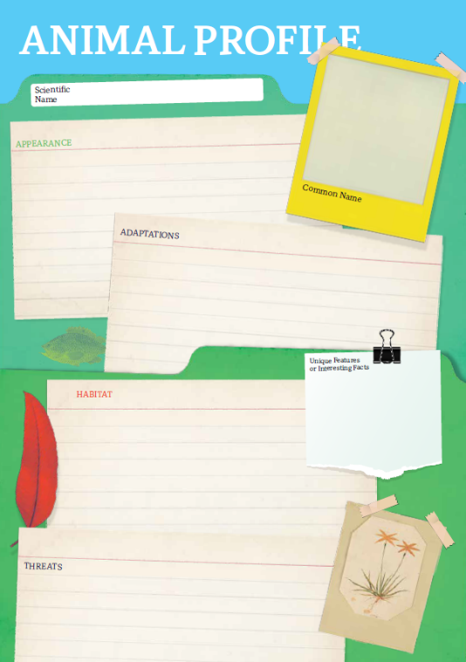
Research
Students will research the following and then share their research findings with the class or create a display in the classroom. Students can use the Animal Profile at the end of this activity.
- Name (common and scientific name)
- Biological illustration or photo
- Classification (class, family, genus)
- Description (size, colour, physical features)
- Habitat
- Diet
- Behaviours
- Adaptations
- Threats and conservation status

Share
- Share and compare your findings with your classmates.
- Present your research in an interesting way.
- Think of ways to raise awareness about the impact of melting ice in Antarctica.
Action
- What steps can you take to help protect the species?
- Email your local MP to voice your concern.
- Become a citizen scientist!

Further Investigation
Students will then choose one of the following activities to complete:
- Model – Create a 3D model of the species using upcycled materials. Display your model in the classroom.
- Diary – Write a diary of what might happen in the daily life of an Antarctic sea species.
- Haiku – Write a haiku poem about the species.
- Children’s book or comic – Write and illustrate either a children’s book or comic which tells the story of the species.
- True or false? – Find out as much as you can about Antarctica and the species that live there. Create a true or false quiz and test your classmates.
- Celebrate – Celebrate the Antarctic Treaty on the 1st of December. Think of a creative way to celebrate the day in your class.

Activity: BTN Antarctica Special
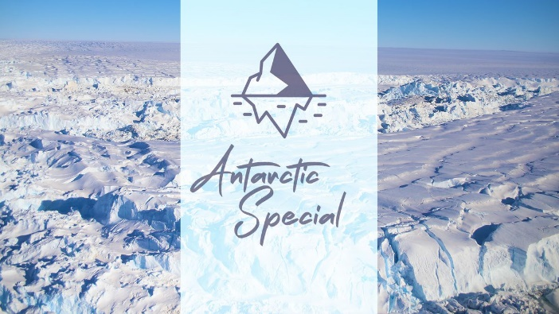
BTN reporter Emma went on a journey to one of the world’s most remote and amazing places - Antarctica! She’s met the people that live and work there, discovered why the frozen continent is so important to science and spotted some of the amazing animals that call it home. Check out the special here.

Take a look at this BTN video, where a group of experts answer questions that kids had about Antarctica and the people and animals that live there. What questions would they ask an expert about Antarctica?

Activity: Antarctica Q&A
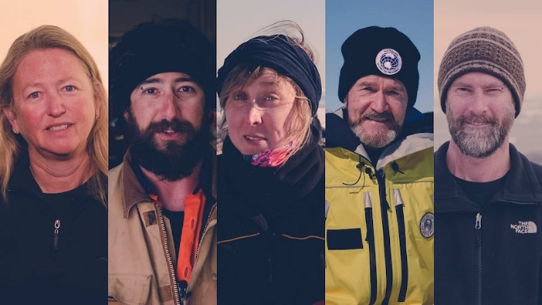
In this BTN video, a group of experts answer questions that kids had about Antarctica and the people and animals that live there. Respond to the following questions:

- What did you learn watching this video?
- What information was surprising?
- What question would you ask an expert about Antarctica?

Useful Websites
- Antarctic Sea Ice Concerns – BTN Newsbreak
- Antarctic sea ice levels dive in 'five-sigma event', as experts flag worsening consequences for planet – ABC News
- Sea Ice – Australian Antarctic Program
- Antarctic Special – BTN
- Antarctic Habitat – Antarctic and Southern Ocean Coalition

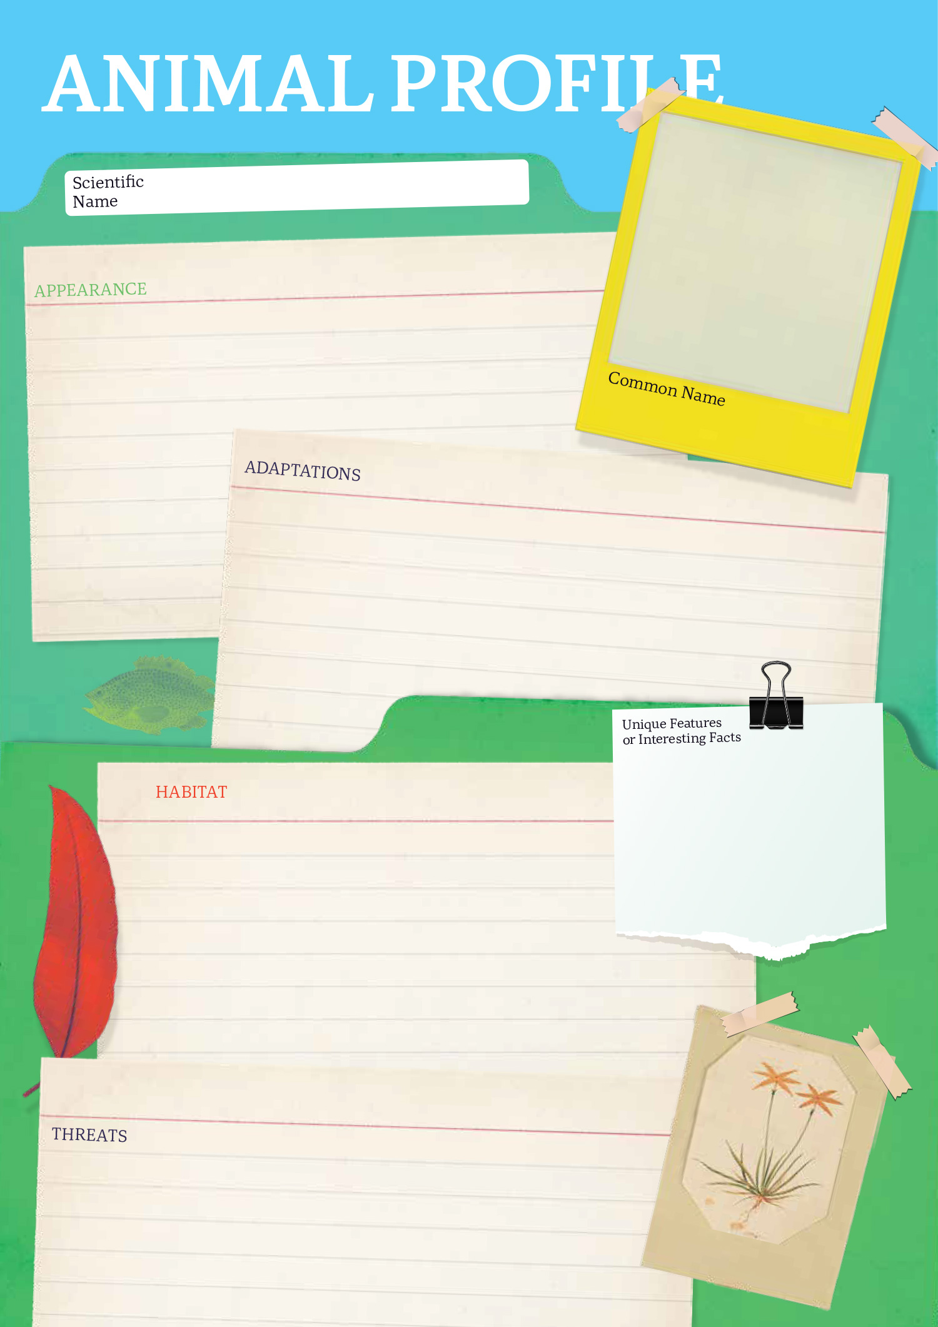

EPISODE 20
1st August 2023

KEY LEARNING
Students will investigate the plastic waste problem and take action to reduce their consumption of plastic.

CURRICULUM
Geography – Year 4
The use and management of natural resources and waste, and the different views on how to do this sustainably.

HASS – Year 4
Reflect on learning to propose actions in response to an issue or challenge and consider possible effects of proposed actions.

Science – Year 4
Science knowledge helps people to understand the effect of their actions.

Science – Years 5 & 6
Scientific knowledge is used to solve problems and inform personal and community decisions.

Science – Year 7
Scientific knowledge has changed peoples’ understanding of the world and is refined as new evidence becomes available.

  - Teacher Resource

Plastic Waste Problem

Focus Questions
Discuss the BTN story as a class and record the main points of the discussion. Students will then respond to the following:
- Summarise the BTN Plastic Waste Problem story using your own words.
- How much plastic waste does the world produce each year?
  - 4 million tonnes
  - 40 million tonnes
  - 400 million tonnes
- What percentage of plastics are recycled in Australia?
- Why did REDcycle stop recycling soft plastics from supermarkets?
- What is the meaning of International Plastic Overshoot Day?

Activity: What do you know?
Before watching the BTN Plastic Waste Problem story, use the following questions to guide a class discussion:
- What do you know about the plastic waste problem?
What questions do you have about the story?
- How much plastic waste does your household produce each week? Make an estimation.
- Have you got any soft plastics or other plastic packaging in your lunchbox? Record what you see.
- How could you reduce your plastic waste consumption?
- What questions do you have after watching the BTN story?

Language and Vocabulary
Single-use plastics, microplastics, landfill, short-life plastic, non-biodegradable, upcycling, recycling, sustainable packaging.

Activity: Six Hat Thinking
As a class, use Edward De Bono’s Six Hat Thinking to explore the issues raised in the BTN Plastic Waste Problem story. Make your own coloured hat cut outs and place on the floor. Students will take it in turns answering questions in relation to what they already know about the issue, what they have learned from the story and what they want to learn further about the topic. Ask students to respond to the following questions:

- How did the BTN Plastic Waste Problem story make you feel?
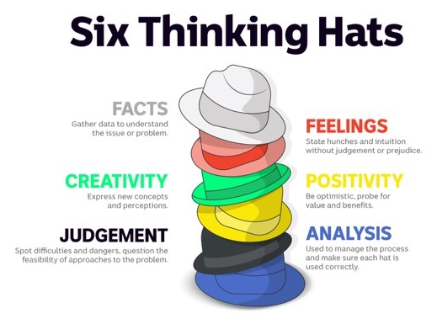
- What do you know about plastic waste?
- What have you learnt from the story?
- Were there any positives from the story? If so, what were they?
- What are some of the negatives or challenges that you learnt from the story?
- Why is it important to find out more about the plastic waste problem?
- What questions were raised during this activity? Think of three questions you would like to ask about the story.
- What do you want to learn further about this topic?

Reflection
After this activity, ask students to reflect on what they have learnt and the questions they have about the plastic waste problem. Students can include details about how their thinking on this issue has changed.

Activity: Research project
Discuss the information raised in the BTN Plastic Waste Problem story. What questions were raised in the discussion and what are the gaps in students’ knowledge? The following KWLH organiser provides students with a framework to explore their knowledge on this topic.

What do I know? | What do I want to know? | What have I learnt? | How will I find out?

Students will develop their own question/s to research or choose one or more of the questions below.
- What are some examples of soft plastics and other plastics that you use daily? Conduct a plastic waste bin audit over one week either at home or school.
- What percentage of plastic gets recycled in Australia? Investigate the percentage of recycling for other materials (e.g., metal, glass, paper, electronics). Plot your findings on a graph.
- What are recycling companies turning plastic waste into?
- What is the history of plastic? Explore the history and development of plastic and plot your findings on a timeline.
- Who invented plastic? Create a biography.
- What happens to the soft plastic you throw away? Explore the journey of soft plastic from production, to landfill and its impact on the environment.
- Why can’t soft plastics be put in your home recycling bin?
- Should there be incentives for people who reduce, reuse, and recycle? What do you think the incentives should be?
- How do you think our plastic consumption affects the environment?

Activity: Take Action
Discuss with students what their school already does to reduce waste. For example, their school might have recycling programs, rubbish audits, or clean up days. Does your school have an Environmental Management Plan or team? In small groups, ask students to brainstorm how their school could improve what it already does to reduce waste.
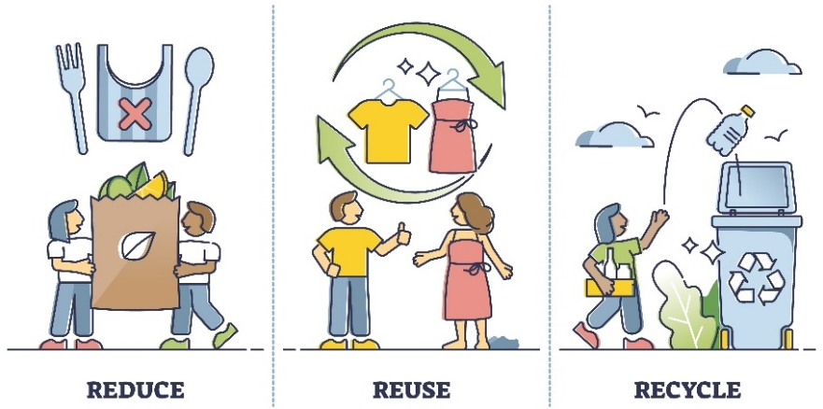
- Make a list of new ways that your school could reduce the amount of waste it creates and new ways that you can deal with the waste it creates.
- Share and compare your ideas with the class.
- Choose 1 of your ideas to present to your SRC or the school leadership team.

Here are some suggestions:
- Nude food days.
- Run a workshop to learn how to make reusable beeswax food wrappers.
- Audit rubbish created in one day. How much plastic waste is there?
- Contact your local council or other schools to find out what they are doing to reduce waste.
- Hold your own school’s clean-up day.
- Start a school compost or worm farm.
- Hold a zero-waste day.

Reflection
- What did you find interesting?
- What was challenging?
- What did you enjoy about this activity?
- What worked well and what would you do differently next time?

Activity: Visual literacy
In this activity students will analyse the image below which illustrates the soft plastics problem we are facing and the impact it has on our environment. Students will analyse the image and respond to the following:

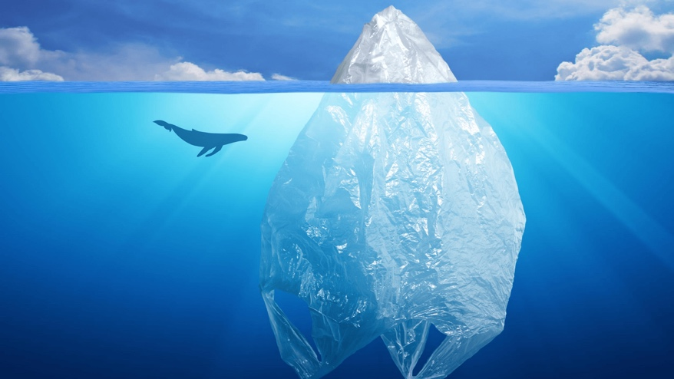
- What is happening in the image? Create a caption.
- What do you think the image is trying to tell us?
- What does the plastic bag represent?
- How does the image make you feel?
- What questions do you have about what you see in the image?
Clean Up Australia

Activity: Choose a project
Individually or in small groups, students will choose one of the following projects to work on and then present their findings to the class.

Persuasive writing
How can we convince people to reduce their plastic waste? Think of creative ways to raise awareness about the issues raised in the BTN story.
Plastic Waste Bin Audit
Do you know how much plastic you throw out each day? Think of all the times you used plastic in one day. How can you reduce your plastic waste?
Tips and tricks
How can we reduce our use of soft plastics? Write a list of tips and tricks to help people reduce their use of soft plastics. Think of a creative way to share your information.
Write a Letter
Write a letter to your local member of parliament, expressing your concerns about the plastic waste problem. What can local government do to help the problem?

Useful Websites
- Australia's plastic mismanagement to mount as researchers warn of ongoing pollution crisis – ABC News
- War on Waste – ABC iView
- Plastic Pact – BTN
- Soft Plastics Recycling – BTN

  - Teacher Resource

BTN Transcript: Episode 20 – 1/8/2023

Hey. I'm Amelia and you're watching BTN. Welcome back, thanks for joining us again, here's what's coming up on today’s show: the problem with plastic; would you eat lab-grown meat? And, meet the young soccer star who's about to head to Germany.

Antarctic Sea Ice

Reporter: Jack Evans

INTRO: We’ll get to all that soon but first up today we're heading to Antarctica, where Scientists say that sea ice levels are at the lowest they've ever seen. And if the ice keeps shrinking, the consequences for our planet are huge. Here's Jack.

How cool is ice? No really, that's its whole thing being cool. And somewhere you can usually find an abundance of ice is….
JACK: Ooo, Oooo, I know, the freezer. See!
ICE: Hi.
Oh yeah sure, the freezer. But I was actually going to say Antarctica.
JACK: Oh.
ICE: Oh.
Yeah see, ice. No really this is sea ice. More specifically it's ice that is in the sea surrounding Antarctica and it's constantly changing. Yep, just like the ice you put in your drink; sea ice also melts. It's actually considered one of the largest natural seasonal cycles on the planet. In summer it melts and then in winter it expands out again. But in recent years we've started to see less and less sea ice coming back and that's got experts worried, including Oceanographer Dr Edward Doddridge.
DR EDWARD DODDRIDGE, OCEANOGRAPHER: In 2016, we observed a sudden reduction in sea ice, so in the spring melt period it melted away much more rapidly and earlier than previously.
This line represents the average amount of ice that surrounds Antarctica throughout year. In 2016, 2017 and 2022 scientists noticed that sea ice was at all-time lows during summer and while the ice came back like normal during winter, this year that hasn't happened. In fact, it's at the lowest it's ever been during winter.
JACK: Now I know what you're probably thinking, who cares about sea ice Jack when I have this ice cube tray full of ice.
ICE: Yeah.
JACK: Well, sea ice plays an important role in keeping our oceans healthy and cool.
ICE: That's cool.
JACK: I know, that's why I said it.
Sea ice helps to regulate the Earth’s temperature through a process called ice-albedo feedback. That's when the ice reflects the sun’s heat back into space keeping the water below it nice and cool. That annual shrinking and growing of ice also plays a really important role in driving global currents that transport nutrient rich water into the rest of the ocean. Feeding ecosystems around the world, which is pretty important if you want a healthy ocean. Oh, and then there's the fact that sea ice is also a habitat for animals like seals and penguins.
DR EDWARD DODDRIDGE, OCEANOGRAPHER: For the ecosystems around Antarctica, it's a huge change. There are lots of species that depend on the sea ice for their lifecycle. If you take away the ice, all of those species will struggle to live as they currently live.
So, why is the ice melting? Is it because someone is drying their hair a little too close it?
ICE: Oh no, I'm melting.
JACK: Oh sorry.
While some experts say this could be a one off natural ice shrinking event and that next year the ice could come back as normal, others say that's unlikely. And that as the planet continues to heat up, less and less sea ice will become a reality in the future.
DR EDWARD DODDRIDGE, OCEANOGRAPHER: We know that this is what the world is gonna look like as it warms. It may be that next winter it'll come back. We can hope. I don't know that it will. If there's less ice than the sunlight that hits the ocean surface is absorbed instead of being reflected out into space. And so that accelerates the warming in that area. And that warmth then gets carried around to the rest of the world. So, it accelerates the warming associated with climate change.
Edward reckons that if the sea ice doesn't recover the effects could be catastrophic. Sea levels would rise, these guys would lose their habitats and global currents would change. To stop that from happening, Edward says that more needs to be done now to tackle things like climate change and protect sea ice from disappearing completely in the future.
DR EDWARD DODDRIDGE, OCEANOGRAPHER: We need to reduce our greenhouse gas emissions, we need to stop burning fossil fuels. That's the only way to save sea ice in Antarctica.

News Quiz

Scientists say July 2023 has set a record for something not so great, it was Earth’s hottest month in recorded history.

ANTONIO GUTERRES, UN SECRETARY-GENERAL: The era of global warming has ended, the era of global boiling has arrived.

The previous record was set back in July 2019. But when do some researchers reckon was the last time Earth was this hot? 12 years ago, 120,000 years ago or 12 million years ago? Some scientists reckon we have to go back 120,000 years to find similarly warm conditions.

Twitter owner Elon Musk has rebranded the social media platform. What is Twitter’s new name? Here’s a clue, it’s just one letter. Yes, Twitter is now called X. It’s also goodbye to the blue bird and hello to this new logo. It’s no coincidence that the news came not long after the launch of a similar style platform, Threads, created by Meta the company behind Instagram and Facebook.

Australia post is cracking down on people putting something in the mail. Is it notes and coins? Bugs and spiders or Barbies? It doesn’t want people posting bugs and spiders. While that might sound weird you can legally buy a whole bunch of invertebrate species online and some breeders use the post to get them to customers.

Plastic Waste Problem

Reporter: Justina Ward

INTRO: Next up, Australia has a plastic problem. We're predicted to use more than 1 million tonnes of short-life plastic by the end of 2023, and we're struggling to handle and process it all. Justina found out more.
BARBIE: Hey Ken
KEN: Hey Barbie
BARBIE: You know being plastic is kinda popular right?
KEN: You got that right Barbie.
BARBIE: But did you know the world produces around 400 million tonnes of plastic waste every year, and around 68,642,999 tons of that will end up in nature?
KEN: Woah that's a really big statistic Barbie.
JUSTINA, REPORTER: Yeah, we've got a bit of a plastic problem. Don't worry guys it's not just you.
It's also us, well, mostly us because we're the ones making way too much of it. You see, we each throw away 100 kilograms of plastic every year. And if you combine household, commercial, and industry waste, it adds up to 2.6 megatonnes of plastic.
JUSTINA: Yep. Plastic is everywhere and that's because it’s convenient and cheap to make. But if it can be recycled, why do we have such a waste problem?
Well, only 18 percent of plastics are recycled in Australia. With a lot of plastic ending up in landfill. And a lot of it has to do with cost and recycling companies not being able to keep up with the demand.
SARAH PERREARD, EA EARTH ACTION CO-CHIEF EXECUTIVE: The recycling capacity is in no way able to cope with the increase of plastic production. In fact, plastic production in the past 10 years has increased 20 times more rapidly than the recycling infrastructure.
We saw this happen with REDcycle. It ran one of Australia's largest soft plastics recycling programs. Collecting 336,000 tonnes of soft plastic, but only 4% of it was recycled because the company didn’t have a way of recycling all this material. And now, supermarkets are trying to work out what to do with it, which might involve sending it overseas.
JEFF ANGEL, BOOMERANG ALLIANCE: The fact that it’s going overseas to who knows what, incineration, possibly recycling or just landfill, is just another element of the ongoing disaster.
Globally things aren't looking too good either. July 28th marked International Plastic Overshoot Day. The point when the amount of plastic waste we generate, exceeds the world's capacity to manage it.
SARAH PERREARD, EA EARTH ACTION CO-CHIEF EXECUTIVE: It means that after that date, all of the plastic that we use, and that we consume, will end up in the environment and a portion of that in our oceans.
Back home people are trying to change things. We've seen states ban some single-use plastics. The federal government's working on stricter plastic packaging rules. And some local communities are taking recycling into their own hands.
HADI SAAB, KINGSTON MAYOR: There's been a huge uptake in the first four days of us doing this program, we had 11 skip bins full of soft plastics.
Some say more needs to be done.
JEFF ANGEL, BOOMERANG ALLIANCE: We're gonna have to get from government and business, binding commitments for recycle content.
SARAH PERREARD, EA EARTH ACTION CO-CHIEF EXECUTIVE: Solutions are there, but we just need to understand the scale of the issue. And the fact that we cannot recycle our way out of it.
JUSTINA: But are some things we can do too, like reusing what we have and saying no to plastics in our day to day life. She wanted to come shopping too.
Maralinga History

Reporter: Joseph Baronio

INTRO: This week marks the 60th anniversary of the signing of a big treaty around the partial banning of nuclear tests. It had a big impact on the world including here in Australia where the effect of nuclear testing is still being felt today. Joe looked into the history of one place in particular, the region of Maralinga in South Australia.
Outback Australia isn't exactly the busiest place but around 70 years ago there were some big things happening out here. And I mean big.
[Nuclear bomb explosion]
Yeah, I wasn't kidding. Back in the 1950s and 60s there were some massive nuclear weapons tests out there. See, after World War II in 1945, when the first nuclear weapons were dropped over the Japanese cities of Hiroshima and Nagasaki and the world was shown the true power of nuclear, everyone wanted a slice of the atomic pie. And so started the "atomic era".
Britain was one of those nuclear-hungry countries and their government needed some wide, open, spaces to develop their weapons. I wonder where has that? So, in 1950 the British PM, Clement Attlee, went to Aussie PM Robert Menzies and said, "Hello old chap, would you mind if we blow some things up in your desert? You know, for science." To which Menzies, who wanted to maintain a good relationship said, "Uh, sure, go ahead."
Britain conducted its first 3 tests in the Montebello Islands and Emu Field in 1952 and 1953 before moving to Maralinga in South Australia which from 1956 became the home of 7 more major tests and up to 600 smaller tests. These tests happened right up until 1963 when nuclear tensions around the world hit boiling point following the Cuban Missile crisis.
World leaders came together to sign the Partial Test Ban Treaty, which banned the testing of nuclear weapons under water, in the atmosphere, or outer space. As well as pledging to work towards an end to the nuclear arms race, welcoming a new era of world peace.
But, while the tests ended that wasn't the end of the Maralinga story. Some of the bombs tested in Maralinga caused mushroom clouds that reached more than 14 km into the sky. But in those clouds were a whole lot of radioactive particles, and winds blew those particles everywhere even as far as Townsville.
The Maralinga site and surrounding area was blanketed with dangerous radioactive material and too much radiation can cause major health problems including deadly diseases like cancer. But it was out in the middle of nowhere, what harm could it do?
Well, a lot, actually. There were around 16,000 on-site workers and many indigenous people in communities around the site, all of whom were exposed to dangerous levels of radiation. In 1967 British authorities tried to clean it all up. But, in 1984 Australian scientists found they hadn't done a very good job and major radioactive contamination was still there. The following year the Aussie government launched a royal commission into the tests, and it found that that very little effort was put in to protection and monitoring radiation levels.
Traditional owners were also not asked for permission to use the land and many Aboriginal people weren't warned of the danger or removed from the area, leaving them exposed to radioactive fallout, which they called "the black mist". It led to another massive clean-up effort costing around 101 million dollars and 13.5 million dollars in compensation for the indigenous people of Maralinga.
All of that didn't stop the long-term effects though.Veterans and indigenous people of the area suffer higher cancer rates than the rest of the population and many have ended up getting really sick and dying. 2012 and 2013 saw huge class-action lawsuits spearheaded by British and Aussie veterans against their governments, saying their human rights were violated.
GEOFF GATES: I love this country, I served this country, and now I feel I've been abandoned by the country.
Their argument was shut down though, as the UK Supreme court ruled that too much time had passed for them to prove that their illnesses were caused by the testing. In 2017 the Australian government agreed to provide better healthcare for both veterans and indigenous people of Maralinga, and today most of the site has been cleaned to a standard safe enough for people to go visit. But some areas still contaminated with plutonium-239 won't be habitable for more than 24,000 years. So, while the Maralinga nuclear tests disappear into the pages of history, their effects will live on long into the future.

Australian Lab-Grown Meat

Reporter: Lyeba Khan

INTRO: Would you eat a steak or a meatball that was made in a lab? Well, the US recently approved the sale of meat grown from animal cells and it might not be too long before similar products hit stores here. But are Aussies ready for a taste of lab-grown meat? Well, Lyeba finds out.

For lots of families, dumplings are a winter fave. But these dumplings are a little bit different. The meat inside them started right here as animal cells grown inside a nutrient tank.
PAUL BEVAN, MAGIC VALLEY CEO: We're taking a sample of cells from a living animal. Bring those into the lab, turn them into stem cells and grow them up into muscle and fat. Combine them together and create a real meat product.
It's called lab-grown meat. Or cultured meat. Scientists say they're making it because a lot of people like the taste of meat but don't like the idea of killing animals, or the impact that farming them can have on the environment. It's different to plant-based meat, which you'll have seen in shops already. The only place you can buy lab-grown meat right now is in Singapore. But that's about to change, because recently the US Food and Drug Administration gave it the green light for American customers. Now, Food Standards Australia New Zealand is working on it, too.
GLEN NEAL, FOOD STANDARDS AUSTRALIA NEW ZEALAND: We have received our first application. Pretty exciting after reading about these things for a number of years. We're busy working our way through that at the moment actually.
The application's from the company that created this. The Mammoth meatball. It's exactly what it looks and sounds like. They took cells from a long-dead woolly mammoth and created a meatball out of it. But no, they're not asking to start selling those. They're planning to sell lab-grown quail meat.
JAMES RYALL, VOW CHIEF SCIENTIFIC OFFICER: Quail is a really nice species because it's not something most consumers can immediately think about like “Oh, this doesn't taste like the quail I ate yesterday”.
There are definitely some questions, though. Like, does it taste like the real thing? Is it cheaper, is it better for the environment? And is it safe to eat?
LEIGH ACKLAND, DEAKIN UNIVERSITY: Well, I believe so, because it's so controlled. It's more controlled in the way it's produced than from an animal. It's not likely to be infected with any viruses or bacteria.
PAUL BEVAN: The animal that we take the sample of cells from goes on to continue living its normal natural life. We use a lot less land, a lot less water and produce a lot less greenhouse gas emissions than traditional animal agriculture. Look if I ate meat, this would be the meat that I would eat.
PROFESSOR PAUL WOOD, MOLECULAR BIOLOGIST, MONASH UNIVERSITY: This technology yes it works, but it's really expensive.
Food Standards Australia New Zealand is expected to make a decision on the first lab-grown meat product by March next year. So, what do you think?
KID 1: I think lab grown meat is a really cool alternative to meat.
KID 2: But I do think that it's going to be a little on, like, maybe more expensive. Since it's lab grown, it takes so much energy. But then again, it's really more sustainable than killing animals.
KID 3: I wouldn't eat lab grown meat because I still don’t, I don't really believe in eating animals.
KID 2: Yeah, I'm happy to try new things. And I think it will be great. Because some days I do have to go like I can't, I'm not allowed to eat meat.
KID 4: Yeah, I'll have a little bit, but I wouldn't, you know, keep on having it as, as a meat.
KID 1: I think a lot of people would want to try it. But I do think I think there would be some people who, like the original, like taste of meat better and like just how it's just like, it's not actually meat. So, how people just want their actual meat.
KID 5: Also, for people who are vegan or vegetarian, they'd probably try it.

Sport
AFL superstar Lance Buddy Franklin has announced his retirement effective immediately. It comes after he was subbed out of Sydney's match on Saturday with a calf injury. Over his 18 year career he played for both the Sydney Swans and the Hawks where he won premierships in 2008 and 2013. He's an 8 time All-Australian and 4 time Coleman Medalist and finishes his career as the fourth-leading goalkicker in AFL history after reaching the 1000-goal milestone last year.
The World Aquatic Champs have wrapped up in Japan with Aussies finishing at the top of the medal tally collecting 13 gold 7 silver and 5 bronze. The thirteenth gold came from the mixed freestyle relay team of Jack Cartwright, Kyle Chalmers, Shayna Jack and Mollie O'Callaghan. It's the first time Australia's topped the world champs since 2001.
Australia's had a pretty cruisy start to the Netball World Cup. The Diamonds got it done against the Fiji Pearls with a huge 101-32 victory. It's their straight win for the tournament and their largest win so far. They head through to the second preliminary stage at the top of their group.
Estonian athlete and three-time Slackline World Champion Jaan Roose has completed the world's longest single building slackline. On his first attempt he walked the 150-metre plus distance on a line just 2.5 centimetres wide.
JAAN ROOSE: To get to the other side, it feels great.
Soccer Star

Reporter: Justina Ward

INTRO: Finally, today, let's meet Melanie, a 14 year old from Brisbane, who's getting ready for the trip of a lifetime. She's a seriously talented soccer player and will head to Germany in November to train at one of the country's top clubs. Check it out.
MELANIE LA FRENTZ: My name's Melanie La Frentz and I play a left back, mid-field, and left wing.
Remember the name, because this 14 year old Brizzy whizz-kid is a star in the making. Melanie plays for a local football club called the Wynnum Wolves. And thanks to a new youth development partnership between her club and Germany's Borussia Dortmund. She'll be jetting off to Germany in November to train at the club academy for 2 weeks.
MELANIE: I was screaming and stuff of excitement.
COSI, DAD: The next minute their girls were screaming and then obviously had to pull over. Because I was in shock.
RABIEH KRAYEM, WYNNUM WOLVES PRESIDENT: Couldn't happen to a better person than Melanie in a World Cup year.
Her little sister wasn't shy with how she felt about it too.
MELANIE'S SISTER: It's not really fair. If I can't go.
She's the first player from the Wolves to be handpicked to go over there. And some of the sport's biggest stars have passed through Borussia Dortmund.
SURESH LETCHMANAN, BORUSSIA DORTMUND: We've seen a lot of young talented girls, as well as boys, and that transition to come and train and play in Germany is there for the taking.
MELANIE: I think it'll change how I'll play, like I'll get to know how they'll do their stuff, and maybe I can bring something back from there and do it in the game.
Melanie lives and breathes the game.
MELANIE: I've been playing soccer since I was 4 years old. I train every day. From the morning I wake up, like really early and catch the train and stuff to school, and depends on what day it is, I might have my school training, and then when I come home, I usually get ready for club training.
And she's already dreaming of her first international match.
MELANIE: I hope to like one day play for the Matilda's. I'll miss my mum, dad, little sister, and big brother
MELANIE'S SISTER: I don't really tell her that. I say I'm not gonna miss you, of course not.
MELANIE: I'm feeling nervous and excited that I have this opportunity to go over.
RABIEH KRAYEM, WYNNUM WOLVES PRESIDENT: Her ability will get her so far, but it's her determination and her will to succeed. And she's resilient. So, success will come for her just purely based on her resilience.
And just for the record, how many keepie uppie's can you do? Okay okay, a lot.

Closer

Well, that's it. This week's show is over. But if you can't get enough of BTN, make sure you head to our website, you'll find lots of learning resources, a huge archive of stories, and lots more fun stuff. Have the best week and I’ll see you soon.

