EPISODE 14
24th May 2022

KEY LEARNING
Students will view a range of BTN stories and use comprehension skills to respond to a series of focus questions.

CURRICULUM
English – Year 4
Use comprehension strategies to build literal and inferred meaning to expand content knowledge, integrating and linking ideas and analysing and evaluating texts.

English – Year 5
Use comprehension strategies to analyse information, integrating and linking ideas from a variety of print and digital sources.

English – Year 6
Use comprehension strategies to interpret and analyse information and ideas, comparing content from a variety of textual sources including media and digital texts.

English – Year 7
Use comprehension strategies to interpret, analyse and synthesise ideas and information, critiquing ideas and issues from a variety of textual sources.
  - Teacher Resource

Focus Questions
As a class, discuss the stories featured in the episode of BTN Classroom and record the main points of the discussion. Students will then respond to the following focus questions.

2022 Election Result
- Who is Australia’s new Prime Minister?
- Which party does he lead?
- Name three facts you learnt about Anthony Albanese.
- What promises did he make during the election campaign?
- Scott Morrison has stepped down as the leader of the Liberal Party. True or false?

Referendum Campaign
- To change the Constitution there needs to be a _______________.
- What did people vote on in the 1967 Referendum?
- How many successful referendums has Australia had?
  - 8
  - 18
  - 28
- What is the Uluru Statement from the Heart?
- What has the new Prime Minister, Anthony Albanese said about supporting the Uluru Statement from the Heart?

Check out the teacher resource on the Teachers page.

Flooded Farms
- Where do the kids in the BTN Flooded Farms story live? Locate on a map.
- How have the floods affected their farms?
- Describe the impact the flood has had on Travis’ bees.
- What happens to plants and animals when they get too much water?
- What impact have the floods had on the price of food?

Threatened Species App
- Explain what the Threatened Australians app does.
- What are some threats to native species?
- How can people take action to help save native species?
- Why is it important to protect and conserve species?
- What questions do you have about the BTN story?

Check out the teacher resource on the Teachers page.

24 Hour Musical
- What is the name of the show the kids are performing?
- How long have they got to produce the show?
- What are the different elements of the production?
- What were some of the challenges of doing the musical?
- What did you like about the BTN story?

EPISODE 14
24th May 2022

KEY LEARNING
Students will learn about the process of constitutional change through a referendum. They will explore the history of human rights for Aboriginal and Torres Strait Islander peoples.

CURRICULUM
HASS – Year 6
Key figures, events and ideas that led to Australia’s Federation and Constitution.

Experiences of Australian democracy and citizenship, including the status and rights of Aboriginal and Torres Strait Islander Peoples, migrants, women and children.

HASS – Year 7
Sequence information about events, developments, periods and phenomena using a variety of discipline-appropriate formats and conventions including chronological frameworks that use dating conventions.

Civics & Citizenship – Year 7
The process for constitutional change through a referendum.

  - Teacher Resource

Referendum Campaign

Focus Questions
Discuss the BTN story as a class and record the main points of the discussion. Students will then respond to the following:
- To change the Constitution there needs to be a _______________.
- What did people vote on in the 1967 Referendum?
- How many successful referendums has Australia had?
  - 8
  - 18
  - 28
- What is the Uluru Statement from the Heart?
- What has the new Prime Minister, Anthony Albanese said about supporting the Uluru Statement from the Heart?

Activity: Class Discussion
After watching the BTN Referendum Campaign story, hold a class discussion using the following discussion starters.

- What is a referendum?
- What needs to happen for a referendum to be passed?
- Why was a referendum held in 1967?
- What is the Constitution?
- When was the Australian Constitution written?
- How you think being left out of the Constitution affected Aboriginal people?
- What is the Uluru Statement from the Heart?

Activity: Glossary
Students will brainstorm a list of key words that relate to the BTN Referendum Campaign story. Here are some words to get them started.

 | REFERENDUM | CONSTITUTION |  | PARLIAMENT
 | CITIZENSHIP | RECOGNITION |  | REPRESENTATION

Activity: Referendum Research
Discuss the information raised in the BTN Referendum Campaign story. What questions were raised in the discussion and what are the gaps in students’ knowledge? The following KWLH organiser provides students with a framework to explore their knowledge on this topic.

What do I know? | What do I want to know? | What have I learnt? | How will I find out?

Students will develop their own question/s to research or choose one or more of the questions below. Encourage students to collect and record information from a wide variety of sources and present the information they find in an interesting way.

- What is the Australian Constitution? When and why was it written?
- Were Aboriginal and Torres Strait Islander peoples included in the process? Who wrote the Constitution? And who voted for it when it was first formed?
- What are the steps to change the Australian Constitution? Investigate what a referendum is and how it works. Use a timeline to highlight important referendums in Australia.
- What is meant by the term constitutional recognition? Explore the progress of constitutional recognition in Australia using a timeline to highlight important events.
- Why was the 1967 Referendum important in Australia’s human rights history? Use the term constitutional recognition in your explanation.
- How many Indigenous Australian politicians have been members of the federal, state or territory governments?
- Who was the first Indigenous politician? Create a biography.
- How many Indigenous politicians are in office at the moment? Which state has had the most Indigenous politicians?
- Why is Indigenous representation in parliament important?

Activity: What is Constitutional Recognition?
Constitutional recognition is something a lot of Indigenous people in Australia have been campaigning for, for a long time. But, what exactly is it and why is it such a big deal? Watch BTN’s Explainer on Constitutional Recognition as a class and hold a class discussion to clarify terms and meanings. Link to BTN Explainer

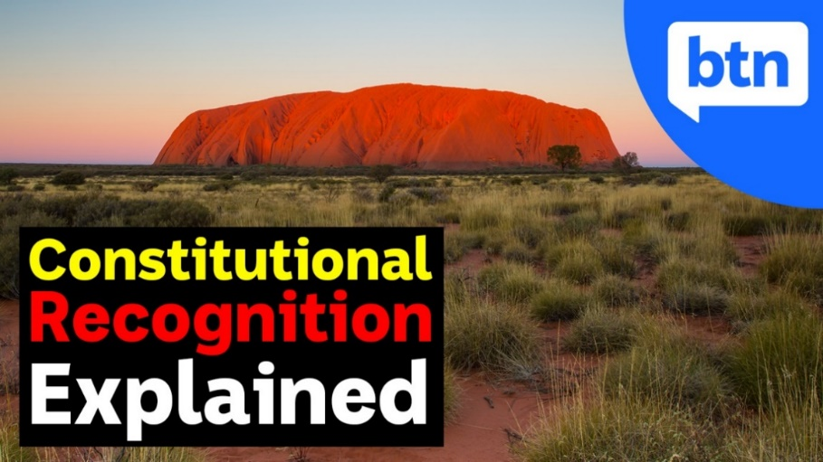

Activity: Uluru Statement from the Heart
Students will learn more about the Uluru Statement from the Heart and its calls for changes to the Australian Constitution. More information about the statement can be found here. Students respond to the following questions:
- What is the Uluru Statement from the Heart?
- What led up to the Uluru Statement from the Heart?
- The three main components of the Uluru Statement from the Heart are Voice Treaty Truth. Explain what is meant by each in relation to the statement.
- In the statement it says In 1967 we were counted, in 2017 we seek to be heard. Why is being heard and having a voice important?

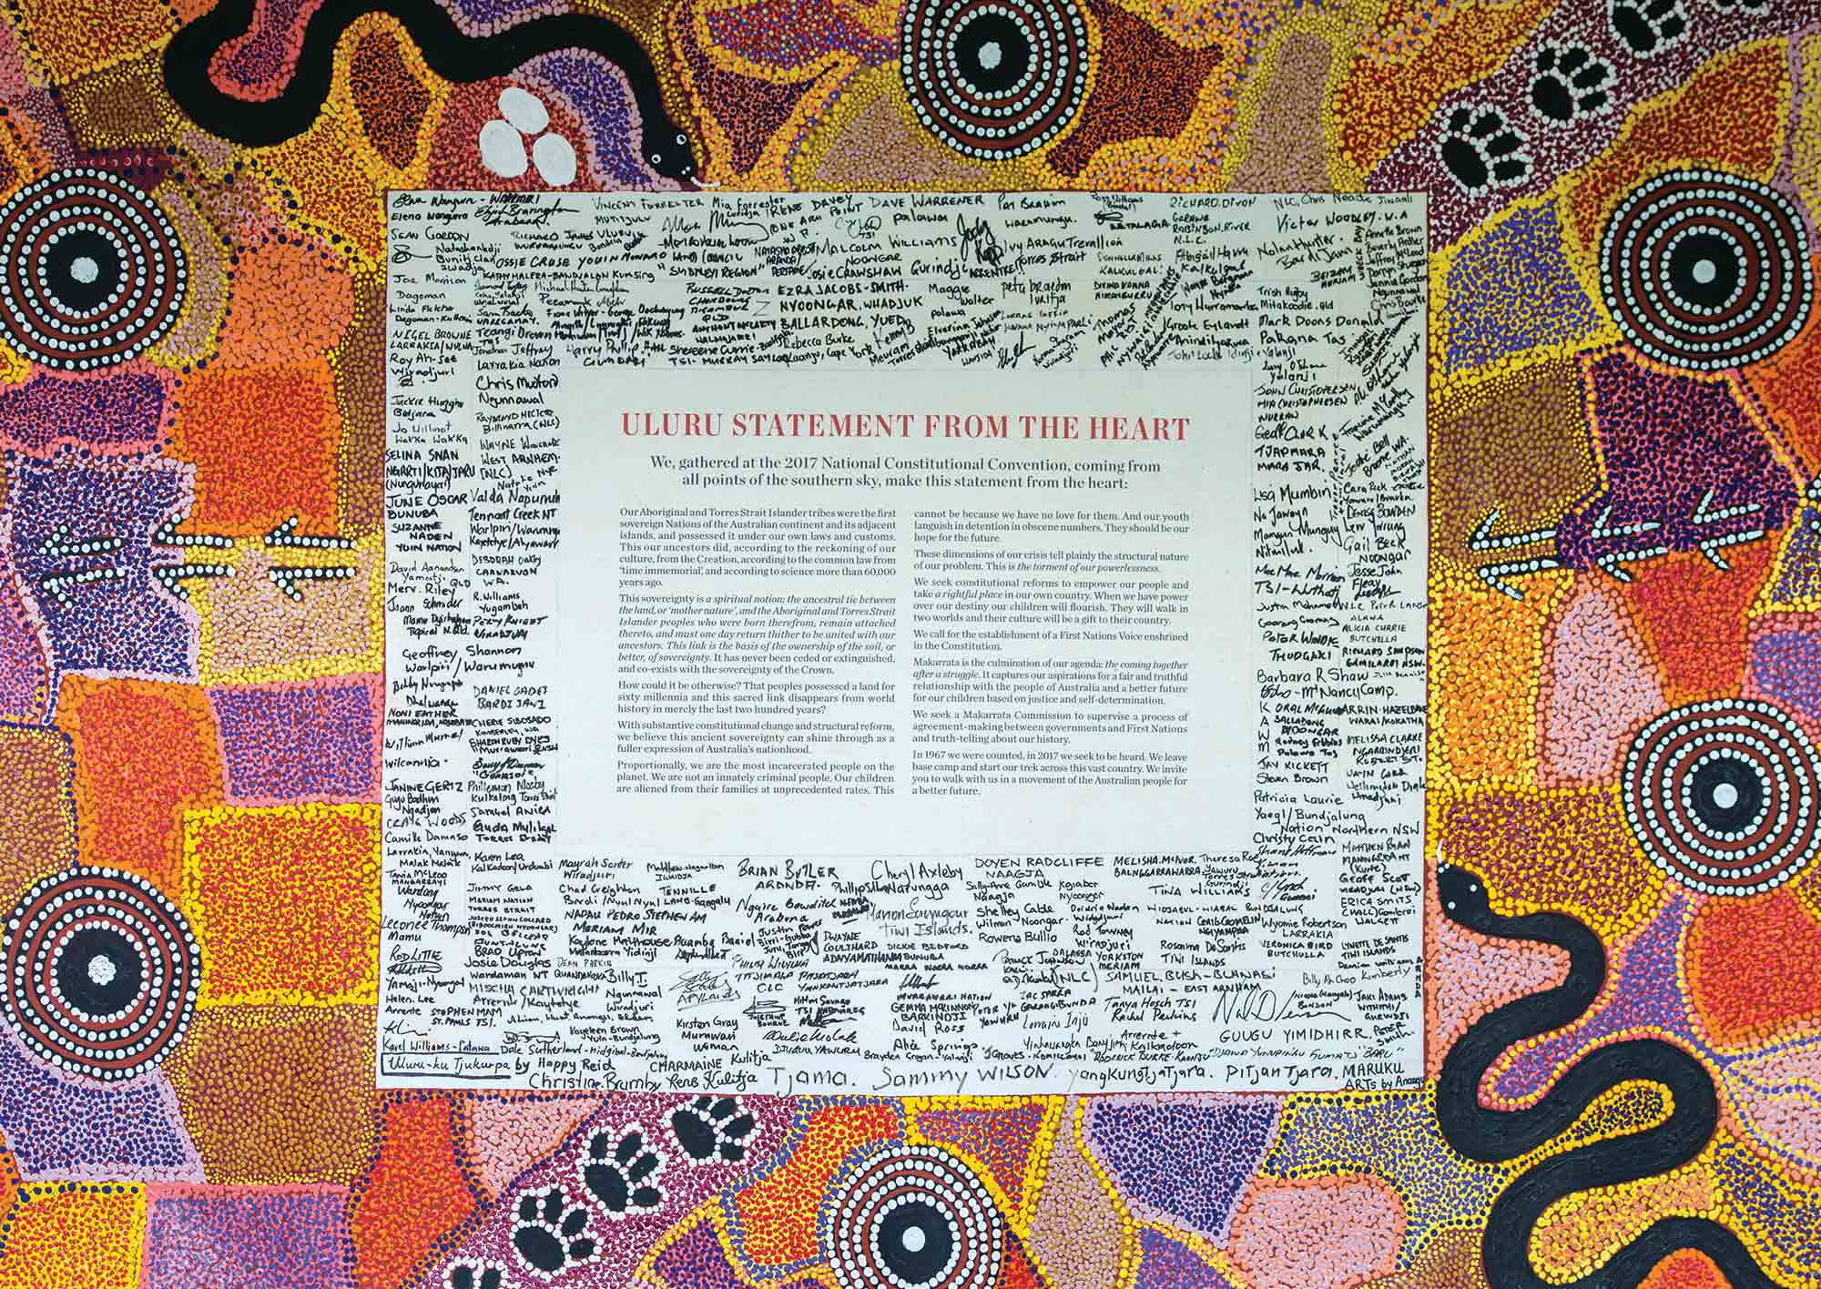

Activity: Visual Literacy
Below are photographs showing significant events in Australia’s history of Indigenous citizenship rights. Look at the images below and then respond to the following questions:
- What is happening in the image?
- Describe the mood of the photograph.
- What message comes across in the image?
- What question/s would you like to ask the people in the image?
- Create a caption for each image.

After you have responded to the above questions click on the link for each image to find out what is happening and compare to your responses.

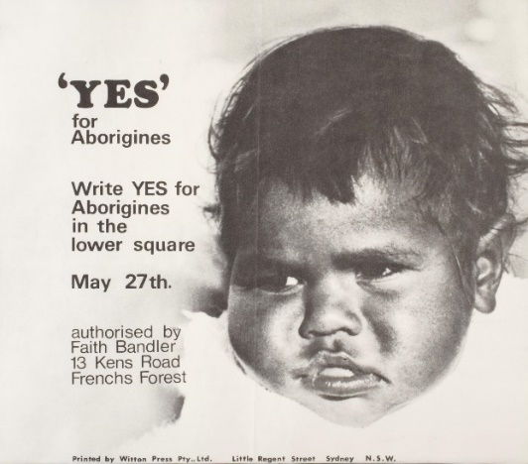  National Museum Australia | 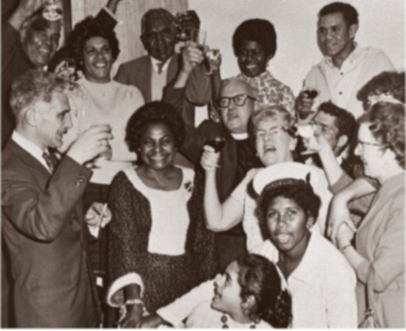  National Museum Australia
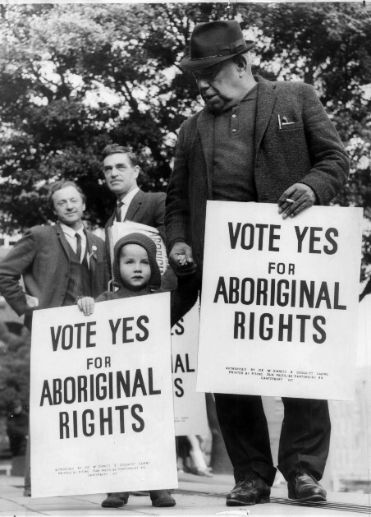
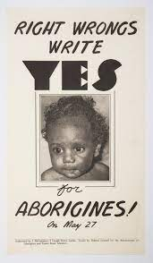

State Library NSW National Museum Australia

BTN Indigenous Rights Stories
Watch these BTN stories to learn about more about the fight for Indigenous rights and recognition.
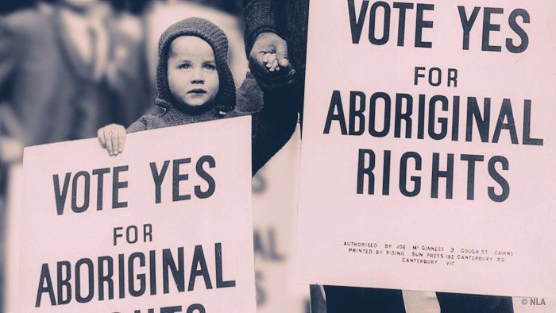
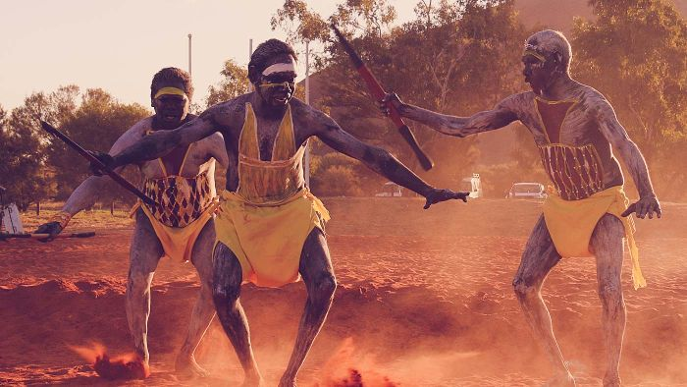

BTN 1967 Referendum BTN Indigenous Recognition

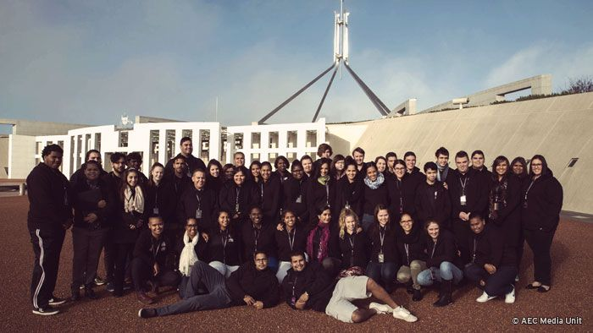
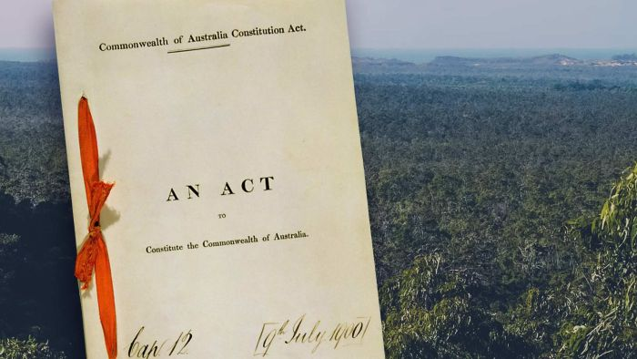

BTN Constitutional Recognition BTN Indigenous Parliament

Useful Websites
- Constitutional recognition – BTN
- What is constitutional recognition - Explainer – BTN
- 1967 Referendum – BTN
- Constitution - BTN
- Indigenous Parliament – BTN
- Referendums and Plebiscites - Parliamentary Education Office
- The 1967 Referendum – Reconciliation Australia
- Uluru Statement from the Heart – National Museum Australia

EPISODE 14
24th May 2022

KEY LEARNING
Students will develop a deeper understanding of the issues facing threatened species populations in Australia.

CURRICULUM
Science – Year 4
Living things have life cycles.

Living things depend on each other and the environment to survive.

Science – Year 5
Living things have structural features and adaptations that help them to survive in their environment.

Science – Year 6
The growth and survival of living things are affected by physical conditions of their environment.

Science – Year 7
Classification helps organise the diverse group of organisms.

  - Teacher Resource

Threatened Species App

Focus Questions
Discuss the BTN story as a class and record the main points of the discussion. Students will then respond to the following:
- Why was the Threatened Australians app created?
- What are some threats to native species?
- How can people take action to help save native species?
- Why is it important to protect and conserve species?
- What questions do you have about the BTN story?

Activity: Note taking
Students will practise their note-taking skills while watching the BTN Threatened Species App story. After watching the story, ask students to reflect on and organise the information into three categories. What information in the story was...?
- Positive
- Negative or
- Interesting

Activity: Class Discussion
Discuss the BTN story as a class. Ask students what they know about threatened species, recording their responses on a mind map. Use the Threatened Australians website to find out what species are threatened in your area. In small groups, ask students to brainstorm responses to the following questions:
- What did you learn?
- What was surprising about the results?
- What do you wonder?
- Why is it important to protect native species?

Activity: Research inquiry
The KWLH organiser provides students with a framework to explore their knowledge on the topic of threatened species and consider what they would like to know and learn.

What do I know? | What do I want to know? | What have I learnt? | How will I find out?

Questions to research
Students will develop their own question/s to research about threatened species. Students will collect and record information from a wide variety of sources. Students may develop their own question for inquiry or select one of the questions below.

- What are some threats to native species?
- Why is it important to protect and conserve living things?
- What is biodiversity and why is it important?
- What is causing species loss? Explore issues such as habitat loss, introduced species, pollution, population growth and overharvesting/hunting.
- Which species have become extinct in modern times? Choose a species to investigate in depth and create a news report explaining how the species became extinct.
- How are animal populations measured? Think of all the reasons why finding and counting animal species might be hard. Investigate what citizen science projects are happening to help count animal populations.
- Who do you think should be responsible for addressing the problem of species loss? List some of the responsibilities of individuals, communities and the government.
- What is citizen science and what are the benefits? Explore one of the following citizen science projects to learn more.

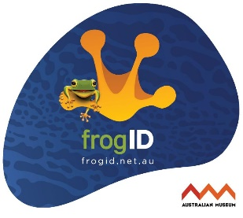  FrogID | 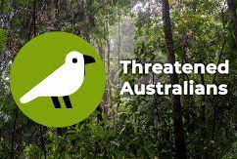  Threatened Australians | Virtual Reef Diver | 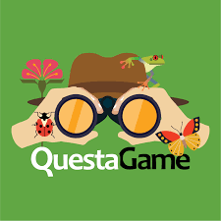  QuestaGame

Activity: Species profile
Students will choose an endangered species that is native to their local area. Use the Threatened Australians website to find a species to research in more detail.

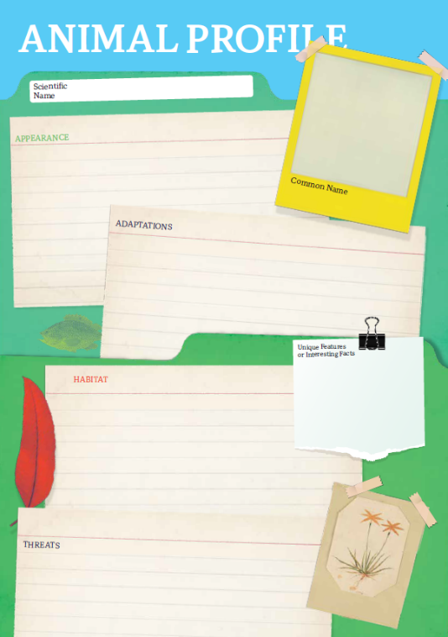
Research
Students will research the following and then share their research findings with the class or create a display in the classroom. Students can use the Animal Profile at the end of this activity.
- Illustration or photo
- Name (common and scientific name)
- Conservation status – why is this animal facing extinction in this area?
- Appearance
- Adaptations
- Habitat
- Threats
- Unique features

Share
- Share and compare your findings with your classmates.
- Present your research in an interesting way.
- Think of ways to raise awareness about threatened species in your area.

Action
- What steps can you take to help threatened species?
- Email your local MP to voice your concern. Find out what is being done to protect the species.
- Become a citizen scientist!

Activity: Biodiversity
Improve the biodiversity in your local environment
Students will work together to help and introduce a native animal species into their school yard. Ask them to consider the following:
- What kind of animals could you reintroduce into your school yard? E.g., birds, bees, frogs, butterflies. Research the species native to your local area. Contact a ranger at a park near your school or the local council to learn more about the local species.
- Do you have the right type of habitat in your school yard for the native animal species to survive? Describe the climate and identify the plants in your school yard.
- What are some threats to the species that are caused by humans? How can you reduce these threats in your school yard?
- What materials and tools will you need to build the habitat or introduce new species to your area? Consider writing a guide or procedure manual.
- Build the habitat as a class and present the habitat to your school community. Teach students in other classes about the new habitat and involve them in caring for the new habitat.
- Prepare a map of the habitat which highlights key features. Include information labels in the habitat (for example, QR codes) for other students to learn more about the habitat and the biodiversity of your school yard. Include scientific information about the species.

Watch these BTN stories to find out how kids are helping protect Australian species – Kangaroo Island Dunnarts, Threatened Flora, Koala Carer, Endangered Seeds & World Bee Day.

Activity: Choose a project
Individually or in small groups, students will choose one of the following projects to work on and then present their findings to the class.

Citizen Science
As a class choose a citizen science project to get involved in and make a difference in your community.
Children’s Book
Write and illustrate a children’s book or comic which tells the story of a threatened Australian species.
3D Model
Create a model of a threatened animal using recycled materials. Display your model in the classroom. Find a sound recording online to illustrate the sound that the animal makes.
What can your MP
do about it?
Write a class email to your local MP voicing your concern. How can you persuade them to help threatened species?

Useful Websites
- Which threatened species are found near me? – Threatened Australians
- Can this app for Australia’s biodiversity ‘crisis’ on the election agenda? – ABC News
- Atlas of Living Australia
- Threatened and Endangered Species stories – BTN
- Goldilocks Bird – BTN

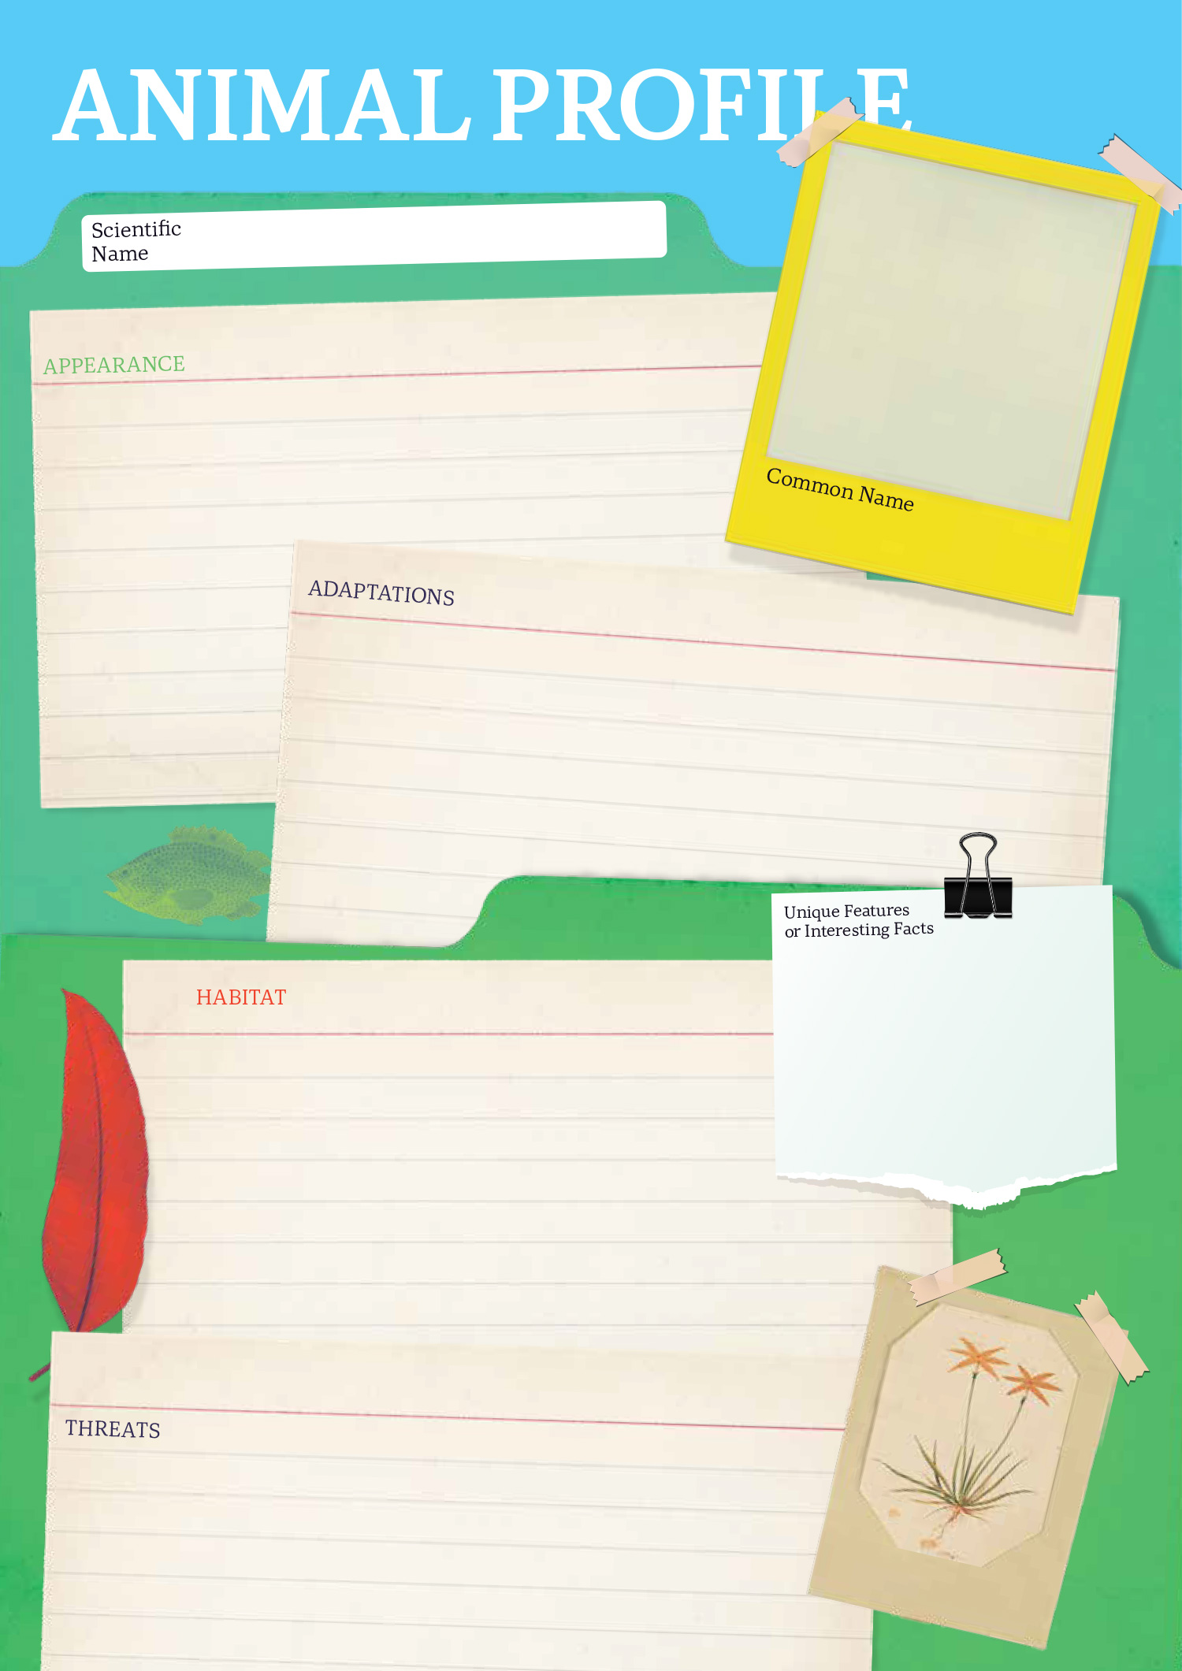

  - Teacher Resource

BTN Transcript: Episode 14 - 24/5/2022

Hey, I'm Amelia Moseley and you're watching BTN. Thanks for hanging out with us, let’s see what’s coming up in today’s show. We find out how farmers are coping after the floods, learn more about the threatened species in our neighborhood and see what it's like to put on a musical in 24 hours.

2022 Election Result

Reporter: Amelia Moseley

INTRO: All that soon, but first, it's the moment we've all been waiting for, the results of the federal election. After a big weekend of voting and counting all around the country, we finally know who our leaders will be for the next three years. Check it out.

So, there was this really big thing on the weekend. I can't remember if we told you it was coming up. Okay, yup, no we did. Now after weeks of hearing about the election and watching these guys do, well, just about anything to win votes. It's finally time to put your hands together for the winner of the 2022 Federal Election. The Labor Party. That means the party's leader Anthony Albanese will become the 31st Prime Minister of Australia. And he seems pretty stoked about it.
ANTHONY ALBANESE, PRIME MINISTER OF AUSTRALIA: Together we begin the work of building a better future.
Of course, the result wasn't what everyone expected or hoped for. Like probably not this guy, Liberal leader and former PM, Scott Morrison.

SCOTT MORRISON, FORMER PRIME OF MINISTER AUSTRALIA: And I congratulate Anthony Albanese and the Labor Party, and I wish him and his government all the very best.

But in the end a win's a win and democracy is democracy and democracy sausages are delicious. Wait, what was I saying? Oh yeah, so let's find out more about our new PM. Anthony Albanese is 59 years old, 173 centimetres tall and father to Nathan. Oh, and Toto, his cavoodle. His nickname is 'Albo', at least as far as we know let us know Albo. He grew up in Sydney with a single mum and without a lot of money. He was actually the first person in his family to finish high school. He says watching his family struggle inspired him to get involved with politics. When he was 12, he helped to organise a rent strike to stop the government housing he lived in from being sold to developers. Three years later he joined the Labor Party when he was just 15. Over the years, he's had the job of minister for transport and infrastructure, deputy prime minister for a little bit and opposition leader for the past few years. Oh, he's also into tennis and DJing. Yes, DJing.
But it wasn't an easy win for Mr Albanese, in fact, the Labor Party might not quite get the 76 seats it needs to form a government in its own right, but he'll get support from minor parties and independents. That is, candidates that don't belong to any party. A whole bunch of them were elected, many of them promising to fight climate change. The Greens did pretty well too, s o we could see a big focus on the environment from our new leaders.
So, what happens next? Mr Albanese has already been sworn in as Prime Minister, so he could set off for his first important overseas meeting in Japan, and when he gets back, he'll announce his new cabinet; basically, the people that'll help him run the country. As for Mr Morrison, he said he will step down as leader of the Liberal Party and let someone else take over. And as for me? Well, I'll just have to find some other news to tell you about, so many options. Skateboarding maybe, sharks, ooh sharks are cool. Donuts. Ooh kittens. Oh, kittens are great I love kittens.

News Quiz

What colour was used to describe the bunch of independents that won seats against some high-profile Liberal leaders. Were they the Aqua Independents, the Violet Independents or the Teal Independents? They were known as the Teal Independents, which was the colour they used for their campaign. They were supported by a group called Climate 200 and promised to fight against climate change and government corruption.

Which two countries have just applied to join NATO? It’s Finland and Sweden. It’s a big deal because the two countries have been neutral for a long time, that is, they try to stay away from military alliances like NATO, but Russia’s invasion of Ukraine changed a lot of people’s minds.

Speaking of Russia, which fast-food chain announced it would leave the country permanently? It’s McDonalds. The burger chain was the first American fast-food restaurant to set up shop in Russia back in 1990 but now it’s selling all 850 of its stores as a response to Russia’s invasion of Ukraine.

Which pop star was given an honorary doctorate by New York University last week. It was Taylor Swift. Tay Tay or Doctor Tay Tay, I spose, was honoured for her contribution to music and in return she gave a speech to the class of 22.
Referendum Campaign

Reporter: Jack Evans

INTRO: Now let’s talk about a different type of vote, a referendum. This Friday marks 55 years since Australia went to the polls to change the Constitution so Indigenous people would be counted as part of the population. And now many say it's time for another change. Here's Jack.

Vote yes and give them rights and freedoms just like me and you, vote yes for Aboriginies.
FAITH BANDLER, CAMPAIGN DIRECTOR: The referendum is on Saturday, and it is important that we should have the maximum vote because the eyes of the world are on Australia.
On the 27th of May 1967 Australians went to the polls, but it wasn't for an election. They were voting on whether or not Aboriginal and Torres Strait Islander people would be counted as citizens of their own country. You see back then Indigenous people didn't have the same rights as other Australians. They faced a lot of discrimination and Australia's Constitution said the government couldn't make laws for them or even count them as part of the population.
FAITH BANDLER, CAMPAIGN DIRECTOR: I feel that the time has come when Australia can no longer tolerate legal racial discrimination against its Indigenous people.
A lot of people, Indigenous and non-Indigenous, realised it was time to change that. But that would require changing the Constitution. The Constitution is a really important legal document that kinda acts like our nation’s rule book. It sets out how the government is set up and how laws are allowed to be made and enforced. Changing this thing isn't easy. You have to have a referendum which is basically a big public vote. For a change to pass more than half of the population, as well as more than half of the states and territories have to vote 'yes'. Out of the 44 referendums that we've had only 8 have been successful. Including the 1967 referendum, with 90 percent of Aussies voting 'yes'. It was seen as a huge win for all Australians, but for many it was just the beginning.
55 years later some say it's time for another referendum to recognise First Nations people and give them more of a say in the running of their country. It's something that many have been calling for, for a long time. In 2017 hundreds of Indigenous delegates met at Uluru and came up with this, the Uluru Statement from the Heart. It outlined a number of changes they wanted to see. Including the creation of a new group in federal parliament, the First Nations Body, whose job it would be advise the government on any laws and policies for Indigenous people. That would include things like high incarceration rates, underemployment, as well as access to better healthcare.
THOMAS MAYOR, ULURU PARTICIPANT: Everything that we struggle with, everything that we try and achieve all connects to the decisions made in Canberra by the federal government. All of these things are decided in Canberra with very little influence from Indigenous people.
But for a group like that to be formed there would need to be changes made to the Constitution. Which, as we all just found out, requires a referendum. Something the Prime Minister at the time, Malcolm Turnbull, rejected.
MALCOLM TURNBULL, FORMER PRIME MINISTER: I have to be honest with you about this. I don't think it's a good idea and if it were put up in a referendum, it would go down in flames.
It's now been 5 years and people are still waiting for something to happen. Last month the authors of the Uluru Statement reunited in North Queensland and are now calling on the next government of Australia to hold a referendum within the next two years.
NOLAN HUNTER, ULURU DIALOGUE: When will we ever be ready? How long in history have we gone? How long have Indigenous people in this country said the same thing over and over and over?
Now that a new government has been elected, advocates are hopeful that we will see changes happen soon.
ANTHONY ALBANESE: On behalf of the Australian Labor Party, I commit to the Uluru Statement from the Heart in full.
LUKE RUSSELL, GURAKI COMMITTEE: To have an Indigenous governing body advising our government on Indigenous issues instead of having them made for us. To me, that's the ultimate dream.

Flooded Farms

Reporter: Gladys Serugga

INTRO: Now, let’s head to Northern New South Wales and Southern Queensland where many farmers are still struggling after this year's floods. The wet weather hasn't really gone away and it's having a devastating impact on crops and livestock. Gladys spoke to some kids about how they've been affected. Take a look.

GAIA: Hi BTN, this is Thor, and my name's Gaia, this is Loki, over there is Xeia and Leia, they're the littlest.
Like many people here in New South Wales’s Northern Rivers, Gaia and her family are still recovering from February's devastating floods.
GAIA: When it flooded it went up to the rails, in a two storey house, that's where I live. I woke up and I came off my bed and I looked through the window and I saw the water rising every minute. 2 hours later the water was in the house.
THOR: And as well as the house, well, I'll just say we lost everything on the property, everything.
THOR: We had 23 acres, and the farm had microgreens, broccoli sprouts, salads and all those edible flowers, that got destroyed in the flood.
The floods had a huge effect on many farmers, washing away crops, destroying fences and machinery and killing livestock.
TRAVIS: Hi BTN my name is Travis and I live in Yamba with my mum and dad and my two brothers. We're bee keepers and we have three apiaries. When the floods were on, we were struggling because all our stuff went under water. We had a queen box and there was heaps of queens in there and unfortunately they all died which was a lot of money.
All up the floods did about 2 billion dollars’ worth of damage, making the natural disaster the most expensive in Australian history. And it's not over yet for many farmers. Since February the rain has come back again and again, making it hard for plants and animals to recover.
TRAVIS: It's been raining for the last four weeks, and well, bees need sunshine to work.
While plants need water to grow, too much can be really bad for them causing their roots to rot and diseases to spread. It can also suck nutrients out of the soil and encourage pests like slugs and snails. The wet weather can also make livestock sick and since the floods many cattle have died in New South Wales and Queensland. Even in the city we’re starting to see the effects of floods here in the supermarket. The price of some fresh fruit and veggies has gone up, along with meat, milk and other groceries. With the help of their communities, many families have started to rebuild.
THOR: We finally just got two sheds, one shed is one and a half built and one shed is fully built.
The government's given out grants to help farmers replace machinery and fences and salvage damaged crops and stock. But for many it's only a fraction of what they've lost. And the wet weather isn't over yet. Weather experts say, it could continue until late Autumn, and they're worried we could be in for another wet summer next year. But while this year has shown just how tough life on the land can be, these guys say they wouldn't swap it.
GAIA: The best things about living on a farm, you can have animals, as many as you want.
TRAVIS: My hopes are for the future, me and my dad can run our business and maybe one day I could take over the business. These are productive little fellas, aren’t they? Come move to the country, because you don't know what you're missing out on.

Threatened Species App

Reporter: Jack Evans

INTRO: Now we're going to find out about a new app that's been created by researchers at two Queensland universities which can tell you about the threatened species that live near you. They're hoping it'll help raise awareness about the problems Aussie plants and animals face and maybe even lead to better protection for them. Jack looked into it.

Australia is home to some pretty unique and even iconic critters. But, sadly, a lot of our Aussie species are under threat.
JACK: Oi you Koala, come down here and face me. Where are you animals? I just want to talk. Come back here so I can threaten you. There.
JOE: Jack. What are you doing?
JACK: Oh, well I'm just threatening species. I mean someone's got to.
JOE: What?
JACK: Well, this new app just came out and it tells you which animals need to be threatened.
JOE: Um, I think the app is about creating awareness around animals that are threatened. Not ones that need to be threatened. I don't think any animals need to be threatened.
JACK: What?
Okay, so maybe Joe is right. But to make sure, I thought I'd get in contact with one of the app creators.
JACK: Hello James.
JAMES: Oh, great hat.
JACK: Thank you. Now, a very quick question, that Threatened Australians App, it was designed to let people which animals need to be threatened, yes?
JAMES: That's, that's a terrible idea. Who would ever think that's a good idea?
JACK: Oh, oh yes. No well, I agree, yes. Quite silly. Well, while I've got you, what does the app do then?
JAMES: Yeah, so, it's an app to actually make you aware of all the threatened animals and plants in your district, your local community.
Let’s say I live in Adelaide, because well I do. If I put in that postcode, I get a list of all the threatened species in my area. Like the Southern Brown Bandicoot which is listed as endangered or the Australian Painted Snipe, sadly also endangered. The app then tells you why they are threatened.
JAMES: It could be foxes and cats, it could be fire, it could be land clearing, people chopping down trees, things that these species don't like, these animals and plants don't like.
JACK: And so, what can people do with this information?
JAMES: Once you have all that information, you can look down a bit more and work out what you can do to save these species. The good things that these animals like, like protecting their habitat and planting trees. But there are things that your mum and dad, or your adults around you want to do, such as writing to those politicians and those leaders that are responsible for the key decisions that make these species either rarer or commoner depending on the decisions they make.
James says that one of the best things we can do for our threatened and endangered species is looking after their habitat, and by telling those who can make big changes, AKA politicians, that more needs to be done now before it's too late.
JAMES: Australia is lucky to have more wildlife to just about any other country in the in the world. So, we have a chance to save these species now. But that means taking action. And that means standing up for these species that don't have a voice.
JACK: Oh, well, thanks for clarifying all of that James. But I've got to go, I've got some unfinished business. Hello, animals? It’s me. I just wanted to say I’m sorry about before, for being so threatening and rude. It was really inappropriate of me, and I’m sorry, okay.

Quiz

Which of these threatened species could you find near Perth? It's this one, the Chuditch or Western Quoll.

Sport

Dual Olympic goal medallist, Ariane Titmus, has broken the women's 400 metre world record at the Australian Swimming Championships. She beat the record, held by American Katie Ledecky, by just 0.06 seconds.

ARIANE TITMUS: I’ve just loved swimming the past six months and I think going to training with no pressure and just enjoying the sport I think it’s underrated like how important that is.
Manchester City have taken out their fourth Premier League title in five years, coming from two goals down to shatter Liverpool’s hopes at the Championship. City were trailing Aston Villa 2-0 before they scored 3 lightning quick goals in the last 15 minutes to secure the title. Ilkay Gundogan was the hero scoring two of the three goals.
Over the weekend, the AFL celebrated Indigenous players and culture in the Sir Doug Nicholls Round. The highlight was the pre-game ceremony ahead of the Dreamtime at the G' game between Richmond and Essendon and Richmond walked away with the win pretty comfortably.
24 Hour Musical

Rookie Reporters

INTRO: Finally, today we're going to meet some kids who've just starred in a musical. Now usually that would take weeks of rehearsing and learning lines and choreography. But these young superstars did it in just 24 hours and somehow amongst the chaos of it all, they managed to give us an inside look. Check it out.

KID 1: Hi, welcome to The Parks Youth Theatre 24 hour show. If it wasn't obvious enough by the title, we've only had 24 hours to produce this. So, for the first and only performance, here is The Sound of Music.
KID 2: So, the 24 hour show is basically a musical that is auditioned for, learned and performed in the span of 24 hours.
KID 3: So, the show that we will be performing, The Sound of Music.
KID 4: If I'm being honest, I haven't watched The Sound of Music and I feel pretty guilty about it and when they announced it I was like, what's going on?
KID 5: The Sound of Music is about someone called Maria who lives with like nuns in the Abbey, and she's just sort of like a rule breaker as such. And she likes going to the hills and just enjoying nature. And she gets told to look after some children at the Von Trapp’s.
KID 6: I'm auditioning for Kurt.
DIRECTOR: Alright, here we go.
KID 6: Yes. Well, that was surprising.
KID 7: I've never gotten a lead before and so now I've got the main character and so I'm shaking.
KID 5: What we have to accomplish for the 24 hours is learning our lines, music, costumes, set design, lighting. I guess it's sort of a little bit stressful, but also really fun.
KID 7: It's just like really chaotic. It's taught me how to learn lines very quickly. That's for sure.
KID 8: If you struggle with things such as lines, you are encouraged to try to cheat your way through. If that means having your lines inside of a hat or inside of your jacket, anything to try to make sure you can deliver your dialogue.
KID 2: I think it's going to be a really good show. The cast is amazing, the crew is amazing.
KID 6: It's happening, we're gonna mess up, we have to improvise. There's nothing left to do.
KID 9: It was so much fun, I loved it so much. I learnt how to work under pressure and get through things and work as a team. It’s really important to practice with everybody and get it down pat.
KID 10: Goodbye BTN. See you next week.
Closer

Well done everyone. Well, that's it for today's show. I hope you've had fun and maybe even learned something along the way. We'll be back next week with more but in the meantime there's heaps to see and do on our website, make sure you tell your teachers about our resources and, of course, Newsbreak will be right here in the studio every weekday to keep you up-to-date. Have an awesome week and I’ll see you soon. Bye.

