EPISODE 34
22nd November 2022

KEY LEARNING
Students will view a range of BTN stories and use comprehension skills to respond to a series of focus questions.

CURRICULUM
English – Year 4
Use comprehension strategies to build literal and inferred meaning to expand content knowledge, integrating and linking ideas and analysing and evaluating texts.

English – Year 5
Use comprehension strategies to analyse information, integrating and linking ideas from a variety of print and digital sources.

English – Year 6
Use comprehension strategies to interpret and analyse information and ideas, comparing content from a variety of textual sources including media and digital texts.

English – Year 7
Use comprehension strategies to interpret, analyse and synthesise ideas and information, critiquing ideas and issues from a variety of textual sources.
  - Teacher Resource

Focus Questions
As a class, discuss the stories featured in the episode of BTN Classroom and record the main points of the discussion. Students will then respond to the following focus questions.

Twitter Change
- Who bought Twitter recently?
  - Jeff Bezos
  - Elon Musk
  - Bill Gates
- What has happened at Twitter since the new CEO took over?
- What are his views on free speech?
- What is the ‘blue tick’ verification?
- Why are some people concerned about misinformation being spread on Twitter?

Soft Plastics Recycling
- Why have some big supermarkets stopped accepting soft plastics for recycling?
- What percentage of the soft plastics collected did REDcycle recycle last year?
- Give at least three examples of soft plastics.
- What can recycled soft plastics be made into?
- What are some solutions to the soft plastics problem?

Check out the teacher resource on the Archives page.

Art Protests
- Which famous art works were vandalised recently?
- What were climate activists trying to achieve by vandalising the art works?
- What is Laura’s opinion about the climate activist’s actions?
- How does Peter feel about what they have done?
- What do you think about the art protests?

Hay Fever Season
- How many Australians are affected by hay fever?
  - 1 in 5
  - 1 in 50
  - 1 in 100
- What are allergens? Give at least two examples.
- How does a person’s body react if they have hay fever?
- What are the symptoms of hay fever?
- What can people do to control hay fever?

Check out the teacher resource on the Archives page.

Therapy Horses
- What was the main point of the BTN Therapy Horses story?
- What is another name for horse therapy?
  - Bovine therapy
  - Canine therapy
  - Equine therapy
- How are the therapy horses helping kids?
- How can animals help people manage feelings of stress and anxiety?
- What was surprising about the BTN story?

EPISODE 34
22nd November 2022

KEY LEARNING
Students will investigate the soft plastics recycling problem and take action to reduce soft plastics waste.

CURRICULUM
Geography – Year 4
The use and management of natural resources and waste, and the different views on how to do this sustainably.

HASS – Year 4
Reflect on learning to propose actions in response to an issue or challenge and consider possible effects of proposed actions.

Science – Year 4
Science knowledge helps people to understand the effect of their actions.

Science – Years 5 & 6
Scientific knowledge is used to solve problems and inform personal and community decisions.

Science – Year 7
Scientific knowledge has changed peoples’ understanding of the world and is refined as new evidence becomes available.

  - Teacher Resource

Soft Plastics Recycling

Focus Questions
Discuss the BTN story as a class and record the main points of the discussion. Students will then respond to the following:
- Why have some big supermarkets stopped accepting soft plastics for recycling?
- What percentage of the soft plastics collected did REDcycle recycle last year?
- Give at least three examples of soft plastics.
- What can recycled soft plastics be made into?
- What are some solutions to the soft plastics problem?

Activity: What do you know?
Before watching the BTN Soft Plastics Recycling story, use the following questions to guide a class discussion:
- What are soft plastics? Give examples.
What do you know about soft plastics?
- Why do you think BTN is doing a story about soft plastics?
- Have you got any soft plastics in your lunchbox? Record what you see.
- How could you reduce the use of soft plastics in your lunchbox?

Activity: Note taking
Students will practise their note-taking skills while watching the BTN Soft Plastics Recycling story. After watching the story, ask students to reflect on and organise the information into three categories. What information in the story was...?
- Positive
- Negative or
- Interesting

Activity: Six Hat Thinking
As a class, use Edward De Bono’s Six Hat Thinking to explore the issues raised in the BTN Soft Plastics Recycling story. Make your own coloured hat cut outs and place on the floor. Students will take it in turns answering questions in relation to what they already know about the issue, what they have learned from the story and what they want to learn further about the topic. Ask students to respond to the following questions:

- How did the BTN Soft Plastics Recycling story make you feel?
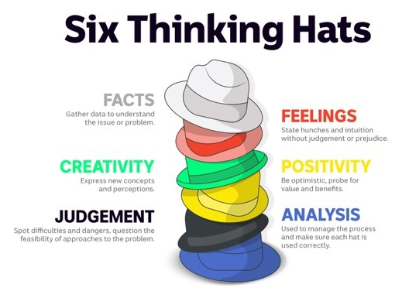
- What do you know about soft plastics?
- What have you learnt from the story?
- Were there any positives from the story? If so, what were they?
- What are some of the negatives or challenges that you learnt from the story?
- Why is it important to find out more about the soft plastics problem?
- What questions were raised during this activity? Think of three questions you would like to ask about the story.
- What do you want to learn further about this topic?

Reflection
After this activity, ask students to reflect on what they have learnt and what recycling means to them. Students can include details about how their thinking on this issue has changed.

Activity: Research project
Discuss the information raised in the BTN Soft Plastics Recycling story. What questions were raised in the discussion and what are the gaps in students’ knowledge? The following KWLH organiser provides students with a framework to explore their knowledge on this topic.

What do I know? | What do I want to know? | What have I learnt? | How will I find out?

Students will develop their own question/s to research or choose one or more of the questions below.
- Who invented soft plastic? Create a biography.
- What is the history of soft plastic? Explore the history and development of soft plastic and plot your findings on a timeline.
- What are some examples of soft plastics?
- What is the difference between soft plastic and other plastic?
- What are recycling companies turning soft plastics into?
- What percentage of soft plastics gets recycled in Australia? Investigate the percentage of recycling for other materials (e.g., plastic, metal, glass, paper, electronics). Plot your findings on a graph.
- What happens to the soft plastic you throw away? Explore the journey of soft plastic from production, to landfill and its impact on the environment.
- Why can’t soft plastics be put in your home recycling bin?
- Should there be incentives for people who reduce, reuse, and recycle? What do you think the incentives should be?

Activity: Take action
Discuss with students what their school already does to reduce waste. For example, their school might have recycling programs, rubbish audits, or clean up days. Does your school have an Environmental Management Plan or team? In small groups, ask students to brainstorm how their school could improve what it already does to reduce waste.
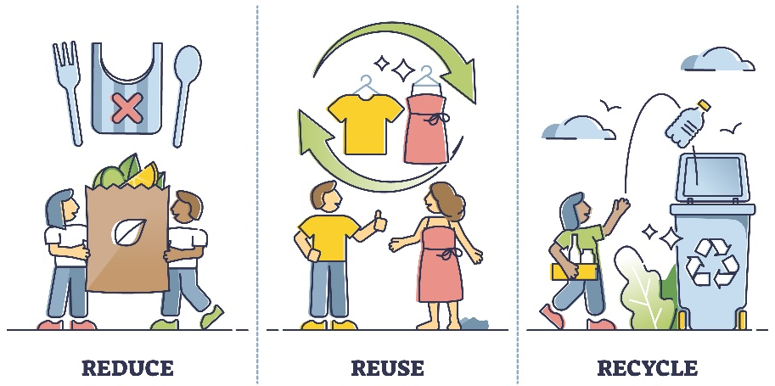
- Make a list of new ways that your school could reduce the amount of waste it creates and new ways that you can deal with the waste it creates.
- Share and compare your ideas with the class.
- Choose 1 of your ideas to present to your SRC or the school leadership team.

Here are some suggestions:
- Nude food days
- Run a workshop to learn how to make reusable beeswax food wrappers.
- Audit rubbish created in one day
- Contact your local council or other schools in your area to find out what they are doing to reduce waste.
- Hold your own school’s clean-up day
- Start a school compost or worm farm
- Hold a zero-waste day

Reflection
- What did you find interesting?
- What was challenging?
- What did you enjoy about this activity?
- What worked well and what would you do differently next time?

Activity: Visual literacy
In this activity students will analyse the image below which illustrates the soft plastics problem we are facing and the impact it has on our environment. Students will analyse the image and respond to the following:

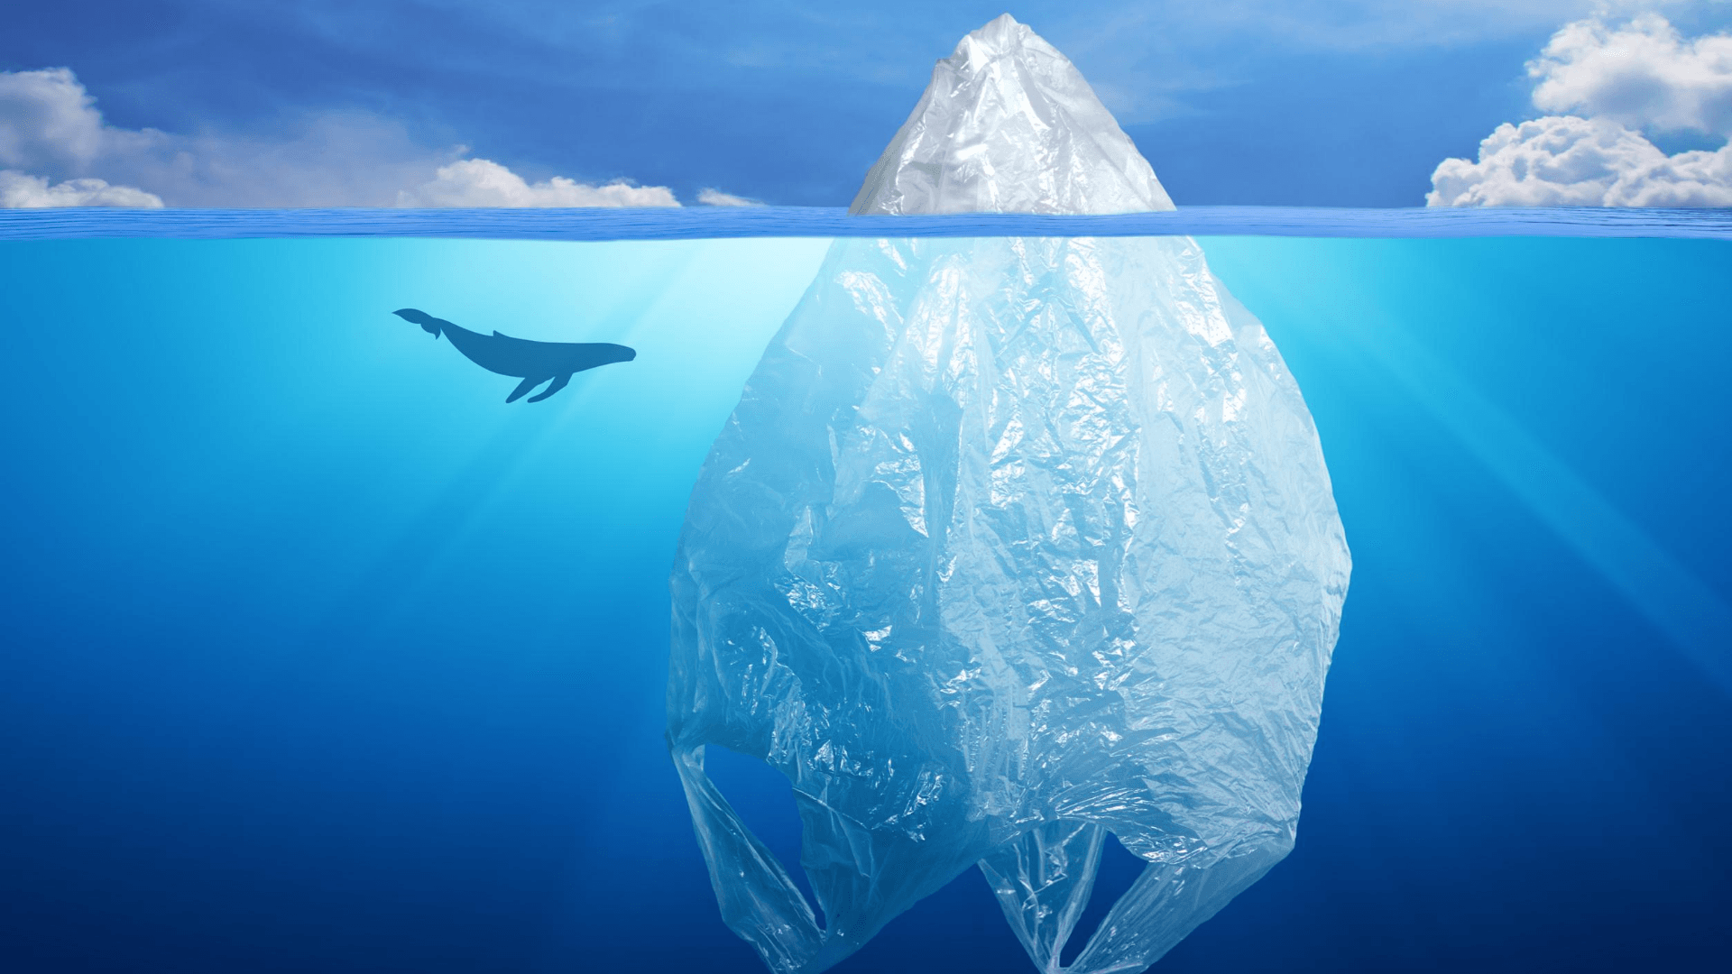
- What is happening in the image? Create a caption.
- What do you think the image is trying to tell us?
- What does the plastic bag represent?
- How does the image make you feel?
- What questions do you have about what you see in the image?
Clean Up Australia

Activity: Choose a project
Individually or in small groups, students will choose one of the following projects to work on and then present their findings to the class.

Tips and tricks
How can we reduce our use of soft plastics? Write a list of tips and tricks to help people reduce their use of soft plastics. Think of a creative way to share your information.
Persuasive writing
How can we convince people to reduce their use of soft plastics? Think of creative ways to raise awareness about the issues raised in the BTN story.
Soft plastics audit
Do you know how much soft plastic you use each day? Think of all the times you used soft plastics in one day. What could you have done to avoid using these soft plastics?
Write a letter
Write a letter to your local member of parliament, expressing your concerns about the soft plastics problem. What can local government do to help the problem?

Useful Websites
- Plastic Pact – BTN
- Single-use Plastic Ban – BTN
- Soft Plastics Recycling Paused – BTN Newsbreak
- Shoppers told to put plastic bags in the bin after suspension of REDcycle's soft plastics recycling scheme – ABC News
- Soft Plastics Recycling – Clean Up Australia
- Australian government pledges to recycle all plastics by 2040 – ABC News

EPISODE 34
22nd November 2022

KEY LEARNING
Students will learn more about the causes, symptoms, treatment, and prevention of hay fever.

CURRICULUM
Health and Physical Education – Year 3 and 4
Identify and practise strategies to promote health, safety, and wellbeing.
Describe strategies to make the classroom and playground healthy, safe and active places.
Health and Physical Education – Year 5 and 6
Plan and practise strategies to promote health, safety and wellbeing.
Health and Physical Education – Year 7 and 8
Practise and apply strategies to seek help for themselves or others.
Investigate and select strategies to promote health, safety and wellbeing.
Evaluate health information and communicate their own and others’ health concerns.
Plan and use health practices, behaviours and resources to enhance health, safety and wellbeing of their communities.

  - Teacher Resource

Hay Fever Season

Focus Questions
Discuss the BTN story as a class and record the main points of the discussion. Students will then respond to the following:
- How many Australians are affected by hay fever?
  - 1 in 5
  - 1 in 50
  - 1 in 100
- What are allergens? Give at least two examples.
- How does a person’s body react if they have hay fever?
- What are the symptoms of hay fever?
- What can people do to control hay fever?

Activity: Class Discussion
Before watching
Before watching the BTN Hay Fever Season story students will discuss in small groups what they already know about hay fever and how it impacts people.
What do you know about hay fever?

After watching
Students will respond to one or more of the following questions after watching the BTN story:
- What did you learn from the BTN story?
- What do you THINK about what you saw in the BTN Hay Fever Season story?
- Do you or someone you know suffer from hay fever?
- What are some of the signs and symptoms of hay fever?
- Think of three questions you have about the story.

Activity: Glossary
Students will brainstorm a list of key words that relate to the BTN Hay Fever Season story. Here are some words to get them started.

TRIGGER | HAY FEVER | ALLERGEN
SYMPTOM | IMMUNE SYSTEM | ALLERGIC REACTION

Activity: Research
What questions were raised in the discussion about the BTN Hay Fever Season story and what are the gaps in students’ knowledge? The following KWLH organiser provides students with a framework to explore their knowledge on this topic.

What do I know? | What do I want to know? | What have I learnt? | How will I find out?

Students will develop their own question/s to research or choose one or more of the questions below. Encourage students to collect and record information from a wide variety of sources and present the information they find in an interesting way.
- Why is hay fever called ‘hay fever’? Investigate when hay fever was discovered.
Create a flow chart to show the body’s reaction to hay fever. Include in the chart the antigen entering the body, the immune system’s reaction, and the physical symptoms.

- How does hay fever affect the body? Use the following scientific words in your description: symptom, allergens, immune system, and antibodies.
- What is the difference between an allergy and a cold? Create a Venn diagram to show the similarities and differences.
- How do you find out what is causing allergies?
- What impact has La Nina had on hay fever season this year?
- Why does pollen cause hay fever? Look at pollen under a microscope and record your findings. Investigate the pollen count in your area.
- What are histamines and what symptoms do they produce? How do antihistamines work?

Activity: Choose a project
Individually or in small groups, students will choose one of the following projects to work on and then present their findings to the class.

Summary
Write a summary of the hay fever story. Explain in your own words what hay fever is, what causes it, the symptoms and how it can be treated.
Quiz
Create a true or false quiz to test your classmate’s knowledge about hay fever.

Did you know?
Using the information in the BTN story and your own research, create a Did You Know fact sheet to show what you have learnt. Publish using Canva

Campaign
Design a public education campaign to raise awareness about allergies and how they can be treated and prevented.
Think about your campaign’s aim and target audience.

Activity: Hay Fever Quiz

1. An allergen is…  A. A substance that triggers an allergic reaction  B. Medicine used to treat an allergy  C. A symptom of an allergic reaction  2. Which of these allergens can trigger hay fever?  A. Pollen  B. Grass  C. Dust  D. All of the above  3. How many Aussies are affected by hay fever?  A. 1 in 5  B. 1 in 50  C. 1 in 100  Quiz Answers:  1A, 2D, 3A, 4A, 5B | 4. Australia has one of the highest rates of hay fever in the world.  A. True  B. False  5. What system in our body does hay fever mostly affect?  A. Digestive  B. Immune  C. Nervous

Useful Websites
- Hay Fever Problem - BTN
- Hay Fever – Raising Children
- Hay fever: Why seasonal allergies are peaking, and why climate change may make them worse – ABC News
- Hay fever – Queensland Health

  - Teacher Resource

BTN Transcript: Episode 34- 22/11/2022

Hey, I'm Amelia Moseley and you're watching BTN. Thanks for hanging out with us again, let’s see what’s coming up on today’s show. We find out about Australia's recycling problem, why climate change activists are vandalising art and Ella learns about horse therapy.

Twitter Changes

Reporter: Michelle Wakim

INTRO: Twitter has decided to once again let former US President Donald Trump tweet after 15 million users voted on the issue. It's the latest in some big changes to the social media platform that have come from its new owner billionaire Elon Musk. Michelle can tell you more.

He's the richest person in the world, known for electric cars and launching humans into space. But everyone's talking about Elon Musk right now because of his recent 67 billion dollar takeover of Twitter. In just the first few weeks of leading the company, half the staff have been fired.
TWITTER STAFF: We're all about to get fired.
Big name advertisers have left, and Twitter's reportedly losing millions of dollars a day.
MICHELLE, REPORTER: So, what is going on? Well, a lot.
Elon Musk says a big reason he wanted to buy Twitter, was to change it to a "digital town square" of free speech.

ELON MUSK: Twitter has become kind of the de facto town square.

While the platform has rules in place to help stop wrong and hurtful information being shared, he's criticised those rules for being too strict and, after talking about it for a long time, he's also lifted permanent bans for users like Donald Trump.
PROFESSOR TAMA LEAVER, CURTIN UNIVERSITY: We know Musk is a free-speech absolutist and I think this is a real sign that he's letting Twitter be a lot rawer and removing a lot of the safeties that have meant a lot of communities have felt that they can be a part of that platform.
MICHELLE, REPORTER: He's also tried to make money by selling Twitter's famous "blue tick" verification to users for about 12 dollars a month. You could make a few trips to the vending machine for that price.
These ticks used to be for politicians, famous people, journalists, and other public figures, so we'd know that the person or organisation using the account was the real deal.

MICHELLE, REPORTER: And since all this changed, Twitter has been, well, chaos.
After musk made his feelings clear about moderation and free speech, researchers say negativity and hate-speech on the platform has increased. Twitter also gets most of its money from advertisers, and a lot of big companies have frozen their ads because of what's been going on. And the blue tick thing went on to cause some unexpected problems. Two Twitter accounts posed as Eli Lily, an American pharmaceutical company, and shared fake tweets about free insulin, and because of the blue tick, people thought this was the real thing. Since then, Eli Lily has had a lot of backlash online, and they've lost a heap of money.
MICHELLE, REPORTER: For the moment, the blue tick subscription has been paused until it's made rock solid, whatever that means.
All of these events have raised questions about whether Twitter will be used to spread misinformation about things like politics, dangerous medical advice and deep fakes and impersonations. Many people aren't happy, and some big-name celebrities have now left the platform. A lot of it has got to do with how Elon Musk has handled the takeover and the changes keep on coming.
PROFESSOR TAMA LEAVER, CURTIN UNIVERSITY: What Twitter is I think is up for grabs today, but I think Elon Musk is literally making it up day by day.
News Quiz

The UN COP-27 climate summit has wrapped up in Egypt. So, what did countries decide? To phase out fossil fuels by 2025, to limit global warming by 1.5 degrees or to start a fund for developing countries? They agreed to start a “loss and damage fund” to help developing countries affected by climate change. It means richer countries will pay more to help those affected by events like storms and floods.

Former US President, Donald Trump made a big announcement last week. Does he plan to sue the United States Government, retire, or run for president in 2024? You guessed it. He wants another shot at being president.

DONALD TRUMP: It’s called the United States of America and it’s an incredible place.
It’s that time of year again when you’re probably going to start hearing a lot more of US singer Mariah Carey. Her name and this Christmas song go together like snowmen and carrots. Or beards and jovial, red-suited men. So, it’s probably no surprise that Mariah Carey recently tried to trademark a Christmassy name for herself. Is it Queen of Christmas, QOC or Princess Christmas? It’s a trick question, it’s all three. Unfortunately for her, a United States court has denied the application after someone opposed it. It would have given her the legal right to stop others from using the title on music and merchandise. Does that mean I can call myself the Queen of Christmas? Maybe.

Soft Plastics Recycling

Reporter: Joe Baronio

INTRO: The Federal Government has just committed to recycling or re-using 100 percent of Australia's plastic waste by 2040. It's a big announcement but it comes after news that a major soft plastics recycling scheme wasn't exactly working too well. Joe found out what it takes to tackle plastic pollution. Check it out.
They're soft, they're plastic-y, and they're causing plenty of problems beyond our bins. Yep, soft plastics are sparking a lot of chat right now. See, recently supermarket giants like Coles and Woolworths stopped accepting soft plastics for recycling, because the company responsible for doing the recycling wasn't doing the recycling. Last year, REDcycle collected 336,000 tonnes of soft plastics but only recycled 4 percent of that. Instead, it was actually stockpiling the plastics in warehouses, because of issues with its recycling centres and because it couldn't keep up with the demand. It's left many of us wondering.
Joe, reporter: What do we do about it? Well, let's take a look at what exactly soft plastics are. Everything you're seeing here is soft plastic. Food wrappers, bubble-wrap, shopping bags, basically, anything that's soft and made of plastic, obviously. When recycled, it can be used for things like garden edging, furniture, and even roads. But, unlike regular plastic, you can't put this in the normal kerbside bin.
That's because these floppy little menaces can easily get caught in the big conveyer belts inside recycling centres and have actually shut down whole systems in the past.
Joe, reporter: So, REDcycle's told Aussies to drop their soft plastics straight into the regular bin.
It's why some are now campaigning for big companies like manufacturers and supermarkets to change the way they operate, to use less plastic and more recycled materials. But, part of the problem is that it's just cheaper for those companies to create new plastic instead, and at the moment us consumers are the ones responsible for dealing with it.
Gayle Sloan, Waste Management Association: We can no longer pass it down the chain and expect someone else to solve it.
Jeff Angel, Total Environment Centre: We need a whole new raft of new policies, investment, targets, and action.
Coles and Woolworths both say they're committed to upping their recycling game and want to start buying back or funding recycled products. Now, the government's getting involved, too.
Tanya Plibersek, Environment Minister: If industry can't get this right on their own, then the Commonwealth and State and Territory governments will step in, and we will regulate.
It's joined a group of nations called the High Ambition Coalition to End Plastic Pollution, whose high ambition is to re-use or recycle all plastic waste by 2040. That's huge.
Tanya Plibersek, Environment Minister: We haven't got good recycling at the moment, we've got to do better, and by working in this global coalition, we're signalling that we're prepared to be held to account.
In 2020, just 16 percent of the country's plastic packaging was composted or recycled. So, there's still a lot of work to do. Experts say the best thing for us is to choose what products we use carefully and avoid plastics where we can.
Kid 1: We should be taking care of where we live and if we don't take care then no one else is going to take care.
KID 2: Nearly every animal on Earth is getting extinct from plastic.
KID 3: If we don't re-use plastics, um, more plastic will go to landfill which will turn into toxic waste.
KID 4: It's just, like, hurting ourselves and animals. Please recycle, you're hurting our Earth.

Art Protests

Reporter: Michelle Wakim

INTRO: Museums around the world have hit back after a bunch of attempts by climate activists to vandalise famous works of art. Activists say they want to draw attention to the state of our planet but what effect are they actually having? Michelle talked to some artists to find out what they think.
Cake on the Mona Lisa. Tomato soup on Van Gogh. Mashed potatoes on Monet. And hands on Warhol. These are just some of the attacks that have been made on famous art works in galleries and museums this year. And, they all have one thing in common. They've come from people who say they're climate activists. They say they're trying to prove that people are more outraged about a piece of art being destroyed, than they are about climate change. Let's take a breath. None of these famous pieces have actually been damaged yet, but their actions are designed to get people talking.
LAURA WILLS: If there's no planet, there's no art.
This is Laura Wills, an artist who creates work about the environment.
LAURA WILLS: I'm interested in how people connect to nature, and some of the themes that I've explored in my work are about food and where it comes from and how far it travels and how it should be accessible for everyone. Or plants, and threatened plants, animals.
MICHELLE, REPORTER: I think my favourite part are the two clips at the front, to hold back the hair.
We've met up at a gallery to chat about the recent protests.
LAURA: I think the activists have been successful in getting their message out there. It's drawn attention. They don't want to cause harm, but they feel so passionate about their issues, and they feel so passionate that things haven't been done and they want to get the word out there. I'm really grateful that people have a lot of courage to do what they do.
MICHELLE, REPORTER: I think, I take that back; I think these are my favourite.
I then went to meet another artist, Peter Drew.
MICHELLE, REPORTER: Hi Peter.
PETER DREW: Hello, nice to meet you.
MICHELLE, REPORTER: Great to meet you. Now, these are your works.

PETER DREW: Yes.

MICHELLE, REPORTER: Can you tell me a little bit about them and when you put them up?
PETER DREW: Well, I put these up a few weeks ago. These are photographs from the National Archive of Australia. They were excluded from being part of Australia, and my posters are a way of saying they should be a part of Australia.
Peter puts his work up in public places.
MICHELLE, REPORTER: Would you classify the work you do as vandalism?
PETER DREW: I guess technically it is. What I do is mostly illegal, but I try very hard to find places like this where I think that they will be appreciated. Well, this is a favourite spot of mine, but these posters were actually vandalised with some racist graffiti, and I came the next day and fixed them up. I think it's very good to be passionate about making the world a better place but what those activists are doing is really bullying, because they're picking on the most vulnerable thing there is, art is vulnerable. It's a miracle that these works have made their way through the dangers of history. So, I think encouraging people and asking questions and showing them a different way of thinking, giving them the power to decide, that's what works best.
In response to the vandalism, 93 museum directors from all around the world signed a statement that says the activists are really underestimating how fragile the artworks are. But what do you think?
JAY: The recent art vandalism attacks have been primarily just for publicity.
JOSH: I think we might be beyond the point now where any publicity is good publicity.
LUCY: I understand why they are protesting. But I think there are definitely better ways that they can go about it.
DEVON: Politicians, they're not going to take us seriously if all that we’re doing is defacing random things. They're gonna brush it off as like some random teens being teens.

Hay Fever Season

Reporter: Joe Baronio

INTRO: Spring has sprung and that means beautiful weather, blossoming plants and hay fever. Experts say this year is worse than usual and will last for a longer time. So, what can you do about it? Here's Joe.

RADIO: You're listening to Hay Fever FM emergency broadcast. Well, batten down the hatches everybody because it's spring outside. Authorities are trying to tell the public to get prepared for a hard.
JOE, REPORTER: Yep, you heard that right, spring. Normally the arrival of birds chirping, and sunshine and all these flowers blooming around you isn't a dire announcement. But for some people, it is.
Okay, so it might not be lock yourself up in an emergency bunker kind of dire, but allergic rhinitis, otherwise known as hay fever, can be pretty uncomfortable. It affects around one in five Australians and is triggered by your nose or eyes coming into contact with allergens. They are microscopic particles from grass, pollen, dust, mould, even pet fur, and they get trapped in tiny hairs and mucus in your nose that stop them from going into your lungs. But some people's bodies decide that those particles are dangerous and start an allergic reaction to try get rid of them. That means you might get a blocked or runny nose, itchy, stinging, or watery eyes, headaches, and.
KID 1: What it's like to have hay fever, it's very annoying. You know, watery eyes, sore throat, sometimes you can get lightheaded and stuff because of all the like pollen. It's just very annoying really.
KID 2: Waking up with watery eyes, always sneezing, it's just annoying and not normal.
KID 3: I've had it for a few months now. It's not that nice.
JOE, REPORTER: Now, allergens can affect us at any time but this time of year, spring, is when things are particularly spicy because of all the new plants popping up and spraying their particles everywhere.
And this year's spring is a bit different because of a little something called La Nina. You might already know that La Nina means a whole lot of rain, way more than usual for this time of year. Experts reckon that all the extra rainfall has caused the latest start to the pollen season ever, and has encouraged more grass to grow, which equals more pollen being released, especially when the rain eventually clears, and warm winds blow it around. In fact, experts say that grass pollen levels are about 4-and-a-half times higher than last year, and hay fever season could stick around later than usual into next year too.
KID 3: The worst thing would probably be watery eyes.
KID 1: Definitely watery eyes. Not being able to see sometimes, feel like you're crying, look like you are crying, it's terrible.
KID 4: Really annoying, especially when you're trying to do something that you're trying to concentrate on.
JOE, REPORTER: Luckily, though, there are ways to treat hay fever. One way is to just stay inside a nice comfy emergency bunker, or any indoor space really, on warm, windy days or when someone's mowing the lawn. But that's not all.
KID 3: I take a nasal spray or tablets.
KID 1: I do use like, Nurofen, like medicine and all that.
KID 4: Maybe have a shower or just wash my face.
KID 2: I don't have any tips and I don't treat it, I just deal with it, I've learnt to over the years.
You could also look up pollen counts online or on weather apps, keep a little extra space between you and your furry friends, check in with a doctor or pharmacist if you're not sure, wear a mask, or dress yourself in a full biohazard suit with a gas mask, sealing yourself off from the outside world. If you don't mind the odd look here and there.

Sport

The 2022 FIFA World Cup has begun. Host nation Qatar took on Ecuador in the opening match. Ecuador scored in the first 3 minutes until the ref decided it was actually offside. But Ecuador pushed through with captain Enner Valencia scoring two goals, making Qatar the first host nation in history to lose its opening game.
Over in Rugby League and Australia are the undisputed world champs. Starting in the women’s, the Jillaroo’s defeated New Zealand 54 to 4 to take home their third World Cup in a row. Meanwhile in the men’s, after a bit of an intense stare down the Kangaroos beat Samoa 30 to 10 in front of more than 67,000 fans. Aussie Captain James Tedesco scored 2 tries as Australia took home their 12th Rugby League World Cup. Geez, share it around guys.

Therapy Horses
Reporter: Ella Germein

INTRO: Now let's head to the Adelaide Hills to meet some very special horses. They've been helping kids deal with stress, anxiety, and issues like bullying. It's called horse therapy. Take a look.

Today we're lucky enough to be hanging out with some very special horses and their trainers who are helping kids in a unique kind of way.

SUZY, EQUINE THERAPIST: Just use your energy to move the horses into your space and remember we’re going to be calm and friendly when they move into the direction you would like them to go.

ZEL, SOCIAL WORKER: Keep your energy calm, but confident and steady. Be aware of what your body is doing.

For more than 7 years, Zel and Suzy have been running equine therapy sessions.

SUZY, EQUINE THERAPIST: I think when you're doing standard therapy it’s quite intense. You probably don't feel like talking very much. When you're with the horse, you don't need to talk, you just come and be with the horse. And the energy of the horse will help you relax and potentially what you need to say just starts to come out.

ELLA, REPORTER: So, guys right now we're here with beautiful Ricky who has a big personality, so you have to approach him in a special way.

ANGEL: You have to come up to him calmly because if you’re not really calm, he can get a little bit more frisky.

ZEL, SOCIAL WORKER: Sometimes you have to be calm but sometimes you have to be assertive with your body or if he is trying to barge on top of me, I might use my hand and tap him on the chest to get him to move away and move back.

ELLA, REPORTER: That’s awesome. So, would that work as well, say you’re in the classroom and maybe someone wasn’t being very nice or maybe you’re in a situation where someone was being a little bit bossy?

ANGEL: Yes, because horses are sort of like humans in lots of different ways.

SUZY, EQUINE THERAPIST: The student needs to learn to become self-confident in their posture, self-confident in their movement, self-confident in their body language. When they do that, other parts of their life will start to change.

ELLA, REPORTER: That looks absolutely beautiful, we’re down here with Ginger who is one of the horses and he’s your favourite horse, isn’t he Kensley? Tell me, what do you love about Ginger?

KENSLEY: It helps me be calm when I'm angry. I like decorating them and I like putting stuff in their hair.

ELLA, REPORTER: Ginger wants a few more bows, I reckon.

ZEL, SOCIAL WORKER: It's really great for building confidence, learning how to stand up for ourselves, whether it's bullies, or just our friends and being able to communicate our feelings, but also helping us regulate our emotions, if we're starting to feel upset, or frustrated, and how we can talk about that at school or at home. So, it might prevent meltdowns, or might prevent us feeling uncomfortable about ourselves.

SAMUEL: This is Mikey.

ELLA, REPORTER: He’s being very calm with you. What sort of energy are you giving him to make him so calm?

SAMUEL: I'm just not being too excited, not doing any sudden movements, just generally calm energy. He's easily worried and I remember I used to be easily worried so we just kind of have that similarity, just being able to easily relate which makes my life a lot easier at school because I have a lot of trouble at school sometimes, so it makes things a lot easier at school.

ELLA, REPORTER: Well, there's no doubt there’s so much we can learn from animals, and it’s been so special today to hang out with Zel, and her students to learn a little bit more about how horses can help us. And they say once you’ve gained the trust of a horse, you've got a mate for life, isn't that right Kensley.

Closer
Well, that's all for today, but we'll be back next week with the very last episode of BTN for 2022. It flew by. It's gonna be a fun one though, so make sure you tune in. I’ll catch you then. Bye.

