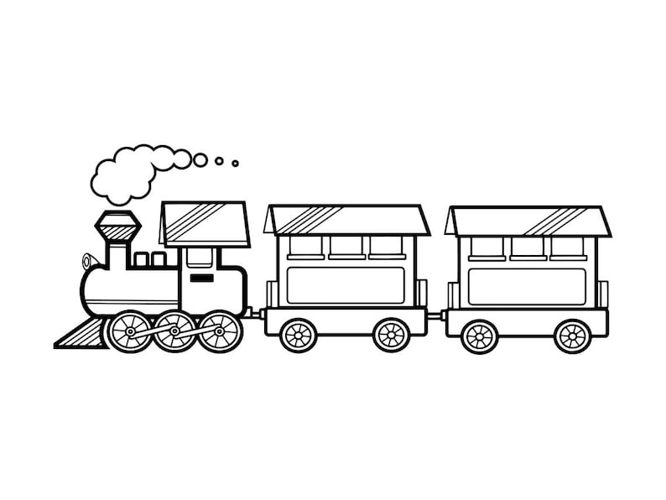
if is
Modify by Joins
f z
b g j p s y z
b c d g
o q s
i j p u v w y
m n r x
a h k l t
No Change
Change Letters
Don’t join from
Pointed Entries
Rounded Entries
Exits Only

