Episode 6
10th March 2020



Coronavirus Questions
- Discuss the BTN Coronavirus Questions story as a class and record the main points of the discussion.
- Where was the first coronavirus COVID-19 case recorded? Find using Google Maps.
- When was the first coronavirus COVID-19 case recorded?
- What animal do they think the virus originated from?
- What are the symptoms of the coronavirus COVID-19?
- Does wearing a face mask protect you from getting the coronavirus COVID-19?
- How long can the coronavirus COVID-19 live outside of the human body?
  - 9 seconds
  - 9 hours
  - 9 days
- Antibiotics can’t be used to treat the virus. True or false?
- What questions do you have after watching the BTN story?
- How did you feel watching the BTN Coronavirus Questions story?

Handwashing
- Before watching the BTN story discuss what you know about hand hygiene.
- What did the BTN Handwashing story explain?
- What year did Dr Semmelweis realise that handwashing was important for our health?
  - 1746
  - 1846
  - 1946
- What famous nurse supported Dr Semmelweis’ views about handwashing?
- What is another word for germs?
- What did the experiment in the BTN story show?
- How many seconds should you wash your hands for?
- What are good handwashing practices? Write step-by-step instructions.
- Why are countries releasing videos about hand hygiene?
- What did you learn from the BTN Handwashing story?

Check out the Handwashing Resource on the Teachers page.

Australian Associated Press
- Briefly summarise the BTN Australian Associated Press story.
- What year was the Australian Associated Press (AAP) founded?
- Who founded the AAP?
- A wire service is also known as a news…
  - Report
  - Agency
  - Station
- The AAP employs their own journalists and photographers to report on stories. True or false?
- Who does the AAP sell their stories to?
- Why is the AAP closing?
- Why do experts say we shouldn’t always rely on information we read online?
- Where do you get your news from?
- What will news look like in 10 years? Discuss in pairs.

School Libraries
- Before watching the BTN story discuss in pairs what you like about your school library.
- Briefly summarise the BTN School Libraries story.
- What is a Children’s Laureate?
- What per cent of Aussie schools think their libraries could be better?
  - 25%
  - 50%
  - 75%
- How have school libraries changed over time?
- Other than paper books what are many school libraries now offering?
- Why does Australia’s Children’s Laureate think paper books are really important? Give two reasons.
- What do you like about reading paper books?
- What is your favourite book at the moment? Discuss with another student.
- What do you think is the future of libraries?

Check out the School Libraries resource on the Teachers page.

Ballet Boy
- Discuss the BTN Ballet Boy story with another student.
- Where is Presley from? Find using Google Maps.
- What inspired Presley to start dancing?
- How has autism affected Presley’s dancing?
- Why did Presley start gymnastics?
- Complete the following sentence. Gymnastics and dance have helped improve Presley’s fine _______ skills.
- Why is Presley travelling to Brisbane?
- Who is the movie Mao’s Last Dancer based on?
- What are Presley’s goals?
- What did you like about the Ballet Boy story?

Teacher Resource
Episode 6
10th March 2020

Handwashing

Students will plan and practise strategies to promote good hand hygiene in their community.


Health – Year 3-4
Identify and practise strategies to promote health, safety and wellbeing.

Describe strategies to make the classroom and playground healthy, safe and active spaces.

Discuss and interpret health information and messages in the media and internet.

Health – Year 5-6
Plan and practise strategies to promote health, safety and wellbeing.

Investigate the role of preventive health in promoting and maintaining health, safety and wellbeing for individuals and their communities.

Health – Year 7-8
Investigate and select strategies to promote health, safety and wellbeing.

Plan and use health practices, behaviours and resources to enhance health, safety and wellbeing of their communities.


- Before watching the BTN story discuss what you know about hand hygiene.
- What did the BTN Handwashing story explain?
- What year did Dr Semmelweis realise that handwashing was important for our health?
- What famous nurse supported Dr Semmelweis’ views about handwashing?
- What is another word for germs?
- What did the experiment in the BTN story show?
- How many seconds should you wash your hands for?
- What are good handwashing practices? Write step-by-step instructions.
- Why are countries releasing videos about hand hygiene?
- What did you learn from the BTN Handwashing story?


What do you see, think and wonder?
After watching the BTN Handwashing story, students will respond to the following questions:

- What did you SEE in this video?
- What do you THINK about what you saw in this video?
- What did you LEARN from this story?
- What was SURPRISING about this story?
- What QUESTIONS do you have about this story?

Glossary
Students will brainstorm a list of key words and terms that relate to the BTN Handwashing story. Students may want to use pictures and diagrams to illustrate the meaning and create their own glossary. Here are some words to get you started.
Germs | Hygiene | Contagious
Virus | Bacteria | Preventative
Contamination | Public health | Infectious


Campaign
Students will design a public education campaign to raise awareness about good hand hygiene and the importance of handwashing. Students will need to think about their campaign’s aim, target audience, and the value of raising awareness at their school. Use Canva to design a poster to put up around your school and the wider community.

. To create a school awareness campaign, students will need to identify the following:
- When should you wash your hands? Make a list.
- What are good handwashing practices? Write step-by-step instructions.
- Why is handwashing so important?
- How can you teach other kids about good hand hygiene? Think of creative ways you can teach kids your message about handwashing.

Some questions to consider when designing your campaign:
- What is the campaign’s main aim?
- Do you have a slogan or message? What is it?
- Who is your target audience?
- What is the best way to communicate the message?

Discuss with students how they will get their message out there to help raise public awareness. Some possibilities include:
- Short film or animation
- Community service announcement (for television or radio).
- Press release (create posters to be put up around the school or pamphlets to give to all students).

Public service announcements
Because the coronavirus COVID-19 is a global concern, video PSAs (public service announcements) are emerging from all corners of the globe. As well as government productions, individuals including comedians, musicians and TikTokers, are making and sharing their own videos about handwashing.

Watch the following videos to see how people in other countries are communicating the message about good hygiene and handwashing.

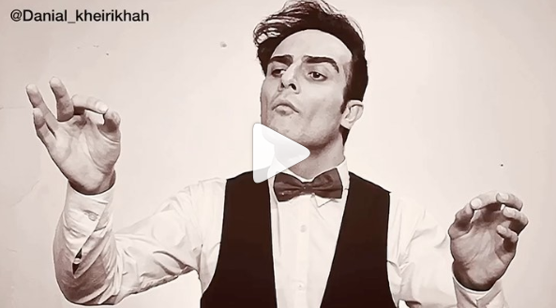  Instagram – Danial Kheirikhah from Iran | 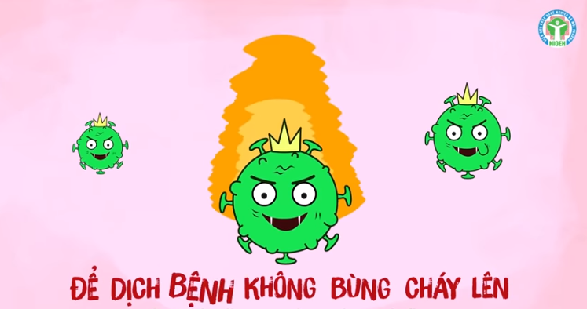  YouTube - Vietnam’s Ministry of Health
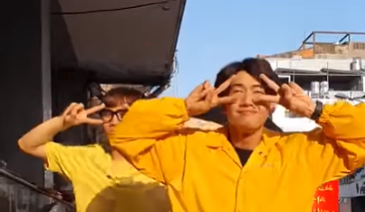  YouTube - Quang Đăng | 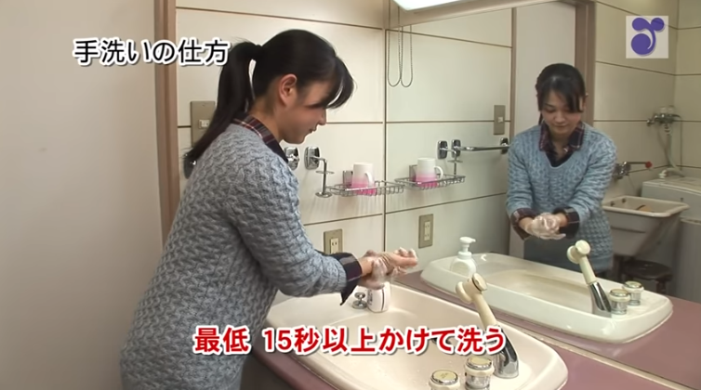  YouTube - Japan's Ministry of Health

After watching the videos hold a discussion about PSAs (public service announcements) and why they are important. Students will then respond to the following:
- What is a public service announcement?
- What was your favourite video about handwashing? Why?
- What video most effectively communicated good hand hygiene?
- Choose one of the videos and describe what is happening. What message does it communicate? What is the purpose of the video?
- In small groups create your own short video about handwashing and why it is important.


Handwashing – BTN
https://www.abc.net.au/btn/classroom/handwashing/10539976

Handwashing – Health Direct
https://www.healthdirect.gov.au/hand-washing

Global Handwashing Day
https://globalhandwashing.org/global-handwashing-day/

Handwashing: why it’s important – Better Health
https://www.betterhealth.vic.gov.au/health/ConditionsAndTreatments/handwashing-why-its-important

Coronavirus Explained – BTN
https://www.abc.net.au/btn/classroom/coronavirus-explained/11933838

Hands are important in containing coronavirus and now is the time to start good hygiene habits – ABC News
https://www.abc.net.au/news/health/2020-03-01/hand-washings-role-in-stopping-coronavirus-covid-19-spread/12014020

Teacher Resource
Episode 6
10th March 2020

School Libraries
Students will develop an argument about printed books versus ebooks. They will also write a review about a book of their choice.

English – Year 4
Discuss how authors and illustrators make stories exciting, moving and absorbing and hold readers’ interest by using various techniques, for example character development and plot tension.

Create literary texts by developing storylines, characters and settings.

English – Year 5
Create literary texts using realistic and fantasy settings and characters that draw on the worlds represented in texts students have experienced.

Create literary texts that experiment with structures, ideas and stylistic features of selected authors.

English – Year 6
Create literary texts that adapt or combine aspects of texts students have experienced in innovative ways.

Plan, draft and publish imaginative, informative and persuasive texts, choosing and experimenting with text structures, language features, images and digital resources appropriate to purpose and audience.

- Before watching the BTN story discuss in pairs what you like about your school library.
- Briefly summarise the BTN School Libraries story.
- What is a Children’s Laureate?
- What per cent of Aussie schools think their libraries could be better?
- How have school libraries changed over time?
- Other than paper books what are many school libraries now offering?
- Why does Australia’s Children’s Laureate think paper books are really important? Give two reasons.
- What do you like about reading paper books?
- What is your favourite book at the moment? Discuss with another student.
- What do you think is the future of libraries?

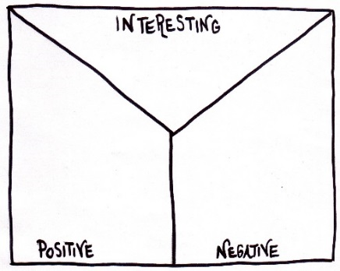
Note taking
Students will practise their note-taking while watching the BTN School Libraries story. After watching the story, ask students to reflect on and organise the information into three categories.
What information in the story was...?
- Positive
- Negative or
- Interesting

Class Discussion
Discuss the BTN School Libraries story as a class, using the following questions to guide the discussion.
- What sorts of books do you read?
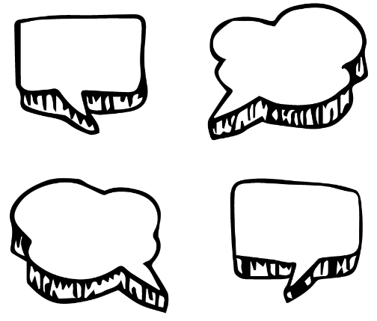
- Do you prefer printed books or ebooks? Why?
- What are the advantages and disadvantages of paper books?
- What are the advantages and disadvantages of ebooks?
- Do you think it’s important to read paper books? Explain why or why not.
- What do you think is the future of paper books?
- What do you think is the future of libraries?
Compare and contrast
Students will find similarities and differences between printed books and ebooks. Use the questions below to start a class discussion. Use a Venn diagram to help organise the information.

- What are the differences and similarities between paper books and digital books?
Printed books

E books

- What are the advantages and disadvantages of reading a paper book?
- What are the advantages and disadvantages of reading an ebook?

Persuasive text
Students will develop a persuasive text for or against the following statement: `Printed books are better than ebooks.’ Alternatively, students can develop their own statement about the topic. Students can use the information recorded during the class discussion and their own research to help develop their argument. Encourage students to use a range of sources. Provide students with the following structure to follow when completing this activity.

Structure
Introduction
- What is the point you are trying to argue? Construct an introductory paragraph which states the issue or topic.
- Introduce the arguments that will be developed in the body of the text.

Body
- Construct arguments that support your point of view.
- Each paragraph starts with a topic sentence which introduces each point.
- The rest of the paragraph gives more reasons.
- Arguments can be ordered from strongest to weakest.

Conclusion
- Restate your position on the argument.
- Construct a concluding paragraph that provides a summary of your arguments and a call to action.
Tips
- Who is your audience? For example, are you directing your argument at kids, teachers or politicians?
- Explore how language choices can have a big impact on persuading your audience.
- Which language devices give the report credibility and authority?
- Which are designed to create an emotional response in the listener?
- Provide facts and evidence to support your argument.
- Write in the present tense.
- Check your spelling and punctuation.

Responding to Books
Students will respond to a book by either writing a book review or reflecting on their favourite book.

Book Review
Students will choose a book they have read recently and then write their own book review. Students will respond to the following:
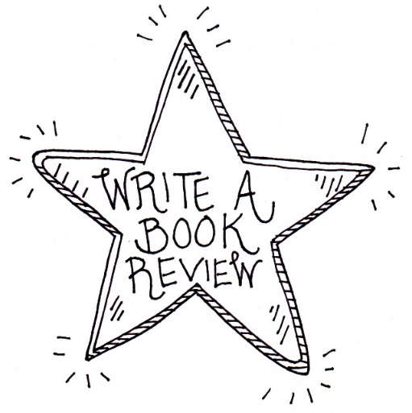
- Write a short description of the plot.
- Who are the main characters in the book?
- What are the themes in the book?
- What did you like or dislike about the book?
- Would you recommend the book to other kids your age? Why or why not?
- Include an illustration with your review. It could be a sketch of the front cover or one of the characters from the story.
- Write a letter to the author of the book explaining your views on the book and asking any questions you have about the book.

Favourite Book
Students will choose their favourite book and complete one of the following activities:
- Redesign the front cover of one of your favourite books. Explain why you chose the design.
- Create a poster that encourages people to read one of your favourite books.
- Rewrite the ending of your favourite book. Explain why you chose to end it the way you did.

BTN story and focus questions
Students watch the BTN History of Libraries story then respond to the following questions:

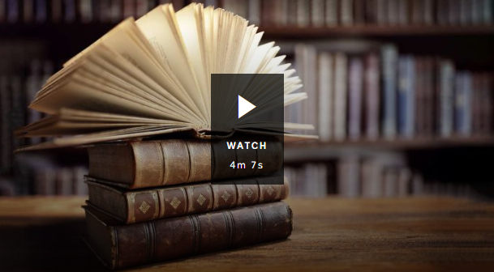
- What is your favourite book at the moment? Discuss with another student.
- How long have we had libraries?
- What were the books in the Library of Ashurbanipal made from?
- Where was the Library of Alexandria built? Find using Google Maps.
- What year was Australia’s first public library built?
- How have libraries changed over time?

Students watch the BTN Ebooks story then respond to the following questions:
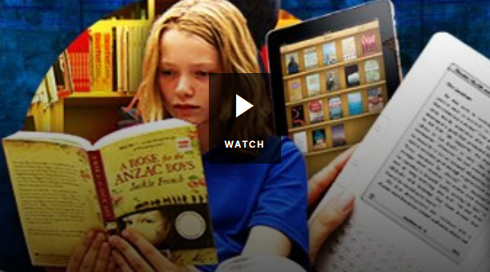
- What is an ebook?
- What sorts of devices can ebooks be read on?
- What is an ebook reader and what features do they have?
- What concerns do book publishers have about ebooks?
- How are ebooks being used in libraries?
- Would you rather read an ebook or a paper book?
- What do you think the future of paper books is?
History of Libraries – BTN
https://www.abc.net.au/btn/classroom/book-week-2019/11414458

Ebooks – BTN
https://www.abc.net.au/btn/classroom/ebooks/10536938

School libraries hit by the loss of a dying breed as teacher librarians enter `survival mode’ – ABC News
https://www.abc.net.au/news/2019-09-15/research-reveals-alarming-loss-in-teacher-librarians-in-schools/11494022

BTN Transcript: Episode 6 – 10/3/20

Hey. I'm Amelia Moseley and you're watching BTN. Here's what's coming up. Jack gets a lesson on washing his hands. We meet an Aussie author on a mission to share her love of libraries. And get to know a young dancer with a big future.

Coronavirus Questions
Reporter: Olivia Mason

INTRO: But by far the biggest news story in the world right now is coronavirus COVID-19. Overseas schools have been closed and big events cancelled. And here in Australia we're dealing with new travel restrictions and some empty supermarket shelves. It can all seem a bit worrying and confusing at times, so we thought we'd answer some of your coronavirus questions. Take a look.

KID 1: When and where was the first COVID-19 cases recorded?
The first cases of the virus were in Wuhan in China at the end of last year. Like other new coronaviruses it was almost certainly passed to a human from an animal, probably a bat.
KID 2: How does it affect the human body or make you sick?
The symptoms might include fever, cough, runny nose and shortness of breath. In more severe cases, it can cause pneumonia which is an infection of the lungs that it can make it difficult to breathe. But it's important to remember that most cases are mild and not much different to a common cold. In fact, some people who have tested positive for COVID-19 haven't had any symptoms at all.
KID 3: Can face masks protect you from the coronavirus?
While masks can stop people from spreading the disease, doctors say we shouldn't be wearing them if we're not sick.
DR NORMAN SWAN: Masks are pointless. Your chances of walking past a person with the illness or being on the same train or bus as them are not much higher than winning the lottery so by wearing masks you're unnecessarily using a resource that's needed for health workers who'll be directly exposed to infected patients and needed for people with the illness to cut the chances of them spreading it.
KID 4: What is the mortality rate of the coronavirus?
Wow. That's a good question. The mortality rate is the percentage of people who die when they get the virus. The World Health Organisation says it's about 3.4 per cent although it could be lower than that. While it’s still a fair bit more deadly than the seasonal flu, most people who get coronavirus have a really mild case and the good news for you guys is that kids are much less likely to get sick.
KID 4: How long can the coronavirus live outside of the human body?
While it passes much more easily from person to person, scientists reckon human coronavirus can live on surfaces for up to 9 days. The germs can be killed pretty easily though with common disinfectants.
KID 5: As an Australian, should I be concerned about the coronavirus spreading around Australia?
There are already cases in Australia and the government says it is likely to spread which is why they're getting ready.
SCOTT MORRISON, PRIME MINISTER AUSTRALIA: We've got ahead of this early, we intend to stay ahead of this.
Authorities are trying to limit the spread as much as possible by keeping close track of who's got the virus and who they've come into contact with.
KID 6: Are the government going to cancel school in Australia?
At the moment that's not really necessary because it hasn't spread that much in Australia. But it could happen. A few schools have already been closed in Sydney because students got the virus.
KID 7: Should I stock up on water, food and toilet paper?
Yeah so last week people got a little bit over the top with the toilet paper thing.
SENATE COMMUNITY AFFAIRS LEGISLATION COMMITTEE: Removing all of the lavatory paper from the shelves of supermarkets probably isn't a proportionate or sensible thing to do.
While experts say it's not a bad idea to have a couple of weeks’ worth of food in the cupboard just in case you need to quarantine yourself, we won't run out of food and there is no need to panic.
KID 8: How many people have the coronavirus?
That's a tricky one because it's changing all the time but around the world it's more than a hundred thousand. Although, heaps of those are now better.
KID 9: What should you do if you get the symptoms?
The government says if you think you might have COVID-19 you should talk to a doctor. But make sure you call first and let them know so everyone can take precautions and make sure you don't spread it. The government says you should also put a mask on before you see anyone.
KID 9: Will antibiotics help treat the virus?
No, antibiotics are used to kill bacteria and COVID-19 is a virus.
KID 10: Is there going to be any cure for the coronavirus?
Hopefully. All around the world scientists are working to find a vaccine and they've already had some breakthroughs. Researchers at the University of Queensland are testing a new vaccine on animals and there are also other tests going on. It will be a while before anything hits the shelves though so in the meantime the best advice is to stay calm, practice good hygiene and look after each other.

Handwashing
Reporter: Jack Evans

INTRO: Remember, if you're feeling worried about coronavirus make sure you talk to someone about it. We've also got some resources on our website with tips for dealing with upsetting news so you can always check that out. In the meantime, there's something we can all do right now to protect ourselves and it's way simpler than you might think. Here's Jack.

Across the globe a highly advanced weapon is being deployed to combat the spread of diseases, it's washing your hands.
JACK EVANS, REPORTER: What? Washing your hands? But I've been doing that forever. Like my mum always says, a washed hand gathers no moss. Wait, that doesn't sound right.
While washing our hands is something we do without thinking too much about it, it's actually quite a recent medical revolution. Up until 200 years ago people had no idea what germs were, and they thought that diseases could be spread in all sorts of whacky ways, like demons or witches or bad smells. It wasn't until 1846 that this guy, Dr Ignaz Philipp Semmelweis, realised that if doctors washed their hands in between touching sick people and delivering babies, new mums were less likely to get sick.
Unfortunately, not everyone believed him. In fact, Dr Semmelweis ended up in a mental institution. But he did have some fans like famous nurse Florence Nightingale, who made handwashing mandatory at the hospital she worked at. Eventually we realised what germs were and how they spread. But it wasn't until the end of the 20th century that experts around the world started getting serious about hand hygiene.
NICK BAKER, SA HEALTH: What handwashing can do is it can really remove a lot of those germs those nasty bacteria that can make us sick. Just by taking 30 - 40 seconds out of your day when you need to. It's a very easy and simple thing to do to keep yourself safe.
Nick here is a public health expert and knows a thing or two about washing your hands.
NICK BAKER, SA HEALTH: Sometimes your hands might not look dirty but they might actually have a lot of microbes or germs as we call the harmful ones.
Nick set up a little experiment to show just how dirty our hands get, involving some invisible gel.
NICK BAKER, SA HEALTH: Hands look very clean, pristine. But if we look with a torch it might tell a different story.
Now imagine the glowing bits are germs. See how easily they can be passed onto things we touch and if you think about all the things you touch in a day, you can imagine all the germs you can get on your hands. Which can easily end up on your face and that's why washing your hands is so important, as long as you're doing it properly.
JACK: OK, so what are the steps?
NICK BAKER, SA HEALTH: Have some good soap there, supply of running water. Rub your hands vigorously and get all that soap really worked up. Give it a scrub between your fingers, front and back, your thumbs, really good rub. Takes about 20 seconds. Think of a song that you might know in your head or time your favourite little tune which takes 20 -30 seconds. Some people use happy birthday and that takes about 10 seconds so you can do that in your head twice over and then by the time you've finished that you've done all that hand work then you know you've done about the right amount of scrubbing and cleaning you can wash your hands off in the sink. Dry them out nicely with some clean paper towel or clean material and you're good to go.
Experts reckon following these steps is one of the best things we can do to avoid getting coronavirus and it's why many countries have released videos like this reminding people about the importance of hand washing. They're also saying we should avoid touching our face as much as possible.
JACK: Alright shall we check that they're clean?
NICK BAKER, SA HEALTH: Let’s do it.
JACK: Alright hit the lights.
NICK BAKER, SA HEALTH: Looking good.
JACK: Alright well thanks Nick, now I know how to wash my hands properly.
NICK BAKER, SA HEALTH: No worries Jack that's much better, now you're a hand washing hero.
JACK: A handwashing hero. I like the sound of that. Hey, you wash your hands there buddy.
NAT: Yeah.
JACK: Yeah but did you really wash them?
NAT: What?
JACK: Come with me.
NAT: No.
JACK: Oh, well at least go and watch my story on handwashing, please.

Ask A Reporter
Do you have a question about washing your hands, well you can ask me live on Friday on Ask A Reporter. Just head to our website for all the details.

News Quiz

Alright time to test your knowledge with our weekly news quiz.
What household item was flying off the shelves so fast in Australia that one supermarket started restricting sales? Yep, it was toilet paper. Apparently, Aussies are worried about running out of it if they have to quarantine themselves.
MAN: I was shocked, I went into Woolies just then and the whole toilet roll aisle was empty, which wouldn't be a problem except I don't have any toilet paper.
German Chancellor Angela Merkel missed out on what at a meeting last week because of coronavirus? A cup of tea, a tissue or a handshake? Yep, a handshake. Some leaders have told people to avoid shaking hands, high-fiving or kissing to stop germs spreading, which could mean more creative ways of saying hello.
What has McDonalds promised to get rid of in Australia by the end of the year? Sugary drinks, plastic cutlery or Happy Meal toys? It's plastic cutlery. It was one of several companies that promised to cut down on single use plastics at Australia's first plastics summit which was held in Canberra last week.
SCOTT MORRISON, PRIME MINISTER: Every year 800 million tonnes of plastics ends up in our oceans.
This famous donkey is the logo for which US political party? It's the Democrats and last week, they held a massive vote called Super Tuesday to try to choose a candidate for the 2020 election. At the moment, the front runner is Joe Biden.
JOE BIDEN, DEMOCRATIC PRESIDENTIAL CANDIDATE: We want a nominee who will beat Donald Trump.
And this spectacular display of balloons filled the skies of which Aussie city? It's Canberra. Dozens of hot air balloons took part in the annual Balloon Spectacular including this giant dinosaur.
GRAB: What's your favourite balloon? The t-rex.

Australian Associated Press
Reporter: Amelia Moseley
INTRO: Now to a news story about the news or more specifically the people who help bring us the news. An Australian news company that's been around for 85 years has announced it's shutting down. It's called AAP or Australian Associated Press. Let’s find out more.
They were stories that changed history and behind many of those stories were three little letters AAP. If you're thinking "what's that?" I don't blame you, because for years these guys have been working quietly behind the scenes to help journalists get their news. AAP stands for Australian Associated Press and it was founded in 1935 by this guy, Sir Keith Murdoch; father of Rupert Murdoch founder of the Newscorp media empire.
He realised that it wasn't possible for each newspaper to get reporters to the scene of all of the big news stories, so he started what's known as a wire service. Wire services or news agencies have been used for almost 200 years by newspapers and later radio stations and TV networks.
They employ their own journalists and photographers to report on stories and then sell the words and pictures to newsrooms around the globe. You see, while lots of journalists wish they could be everywhere at once unfortunately they can't be. So, wire services give them instant access to stories, photos and information that's trustworthy. And that can give journalists more time to focus on their own reporting and investigating. Even we use wire services here at BTN. How else would we find out about chocolate fashion parades and llama racing?
Since most Australians stopped getting their news from these (newspapers), news wires like AAP started providing words, photos and videos to news websites too. But even online many news organisations have been struggling to make a profit. And in the past few years, hundreds of Australian journalists have lost their jobs.
Now, after 85 years, AAP has announced it's closing down for good. Part of the problem is there's so much news and information available online for free. But experts warn we shouldn't always rely on that information because of the spread of fake news, which has been known to make its way onto proper news sites and some reckon it could happen more often without wire services that check their facts. Whatever happens, it's the end of an era for Australian media and it's got many wondering what the future of news will look like.
Did You Know?
Did you know it's believed the world's first newspaper was printed in 1605? It was called the Relation. It was written in German and published in France by this man, Johann Carolus.

School Libraries
Reporter: Olivia Mason

INTRO: Now to the school library. It was always one of my favourite places to hang out and I'm sure some of you feel the same. But there are worries that not all school libraries are as great as they should be. This week Liv met a kids' author and found out why she's on a mission to share the library love.
Did you know there's a place in your school that can take you to different worlds? A place full of magic and spells and potions, or a fairyland with magical creatures, an underwater world with talking fish and mermaids, or maybe a daring adventure through the jungle. That place is the school library.
KID 1: At the school library we normally borrow books every Monday. I like it because it's interesting and I learn a lot from the books.
KID 2: I like coming to the library because it's fun and we learn different things every time and the librarians really help us with that.
KID 3: I like to read because most of the books I'd usually have to buy are at the library and it just saves a whole lot of money.
Nearly all Aussie schools have a library of some sort but there are some people who are worried that not all of them are getting the love they deserve. This is Ursula Dubosarsky. She's Australia's new Children's Laureate which is a position given to a kid’s author or illustrator every two years. She's been travelling around the country, teaching kids about writing and illustrating and she's also been using her new position to talk about her love of school libraries.
URSULA DUBOSARSKY, AUSTRALIAN CHILDREN'S LAUREATE: I can't imagine a school without a library and I think if we want our children to keep reading, and I think we all do, I don't think there's anyone out there who doesn't think it's important for our children to read, then I think we have to have libraries in the school that are open.
She says she's concerned that some school kids don't have access to libraries that are big, well-resourced and open all day, and she's not the only one. Studies have shown that more than half of Aussie schools think their libraries could be better and some experts are also worried about a drop in the number of professional school librarians who are trained to teach kids about literacy and research.
Of course libraries have changed over the years. While they used to be just about books, many now offer things like 3D printing, virtual reality, recording suites and e-books and some think that's a good thing. They say it's important for libraries to move with the times and help kids explore new technology and develop their IT skills. But others, like Ursula say it's important we don't forget the most important part of libraries, books.
URSULA DUBOSARSKY, AUSTRALIAN CHILDREN'S LAUREATE: Children want to actually hold a book in their hand and to open it up. Children are very tactile. They like holding things, touching things. They like to clutch the book to their chest. I think if you want children to read then you have to provide them with paper and cardboard books.
And it seems like these guys agree.
KID 4: I like to read paper books because you can read it and you don't have to look at a screen.
KID 5: I like reading hard cover books because they're a lot easier and you can have them in your hand.
These guys say libraries will always be an important place to learn and most importantly a place to explore new worlds.
URSULA DUBOSARSKY, AUSTRALIAN CHILDREN'S LAUREATE: Libraries are temples of the imagination. They're not just there to be useful when you need to know something. They're there to give you access to this world of the imagination.

Did You Know?
Did you know the biggest library in the world is in the US? It's called the Library of Congress and it has more than 168 million items including books, films, maps and sheet music.

Sport

Australia are the T20 World Cup champions after smashing India in the final match at the MCG. The crowd was the highest ever at a women's sporting event in Australia with more than 86,000 excited fans. Beth Mooney and Alyssa Healy got the Aussies off to a flyer doing what they do best. They set India a huge target of 185. But the Aussie bowlers ripped through the Indian attack and pretty soon it was party time.
Meanwhile some big sporting events around the world have been postponed or cancelled because of coronavirus including a major tennis tournament, two golf tournaments and two cycling races in Italy. The Italian soccer league is still going but some games have been postponed and some have gone ahead without fans. While it hasn't happened yet, the NBA has notified players that they could do the same which didn't go down too well with LeBron James.
LEBRON JAMES: We play games without the fans? Nah it's impossible. I ain’t playing.
Ballet Boy
Reporter: Jack Evans

INTRO: Finally, today we're going to meet Presley, a kid from Queensland who loves to dance. He's hoping to make it into a career one day and recently he got some tips from one of Australia's most famous ballet dancers. Check it out.

PRESLEY: Hi BTN my name is Presley and I love to dance. Well I first started seeing dancing in movies that I watched when I was younger and as I moved from towns to Magee I started getting more into dancing and I liked how I could be myself. I feel like I'm in my own world.
Going to ballet classes has helped me a lot with my confidence and balance. I have autism which can sometimes affect my coordination. My Mum saw that I was getting a little out of balance, so she started getting me to do some gymnastic stuff and because I wasn't doing it on the proper equipment, I started looking like I was doing a little bit more dancing. So, my mum started getting me to do more routines and dancing.
KYM, PRESLEY'S MUM: He didn't have his balance very well, so, to have his pediatrician just say that this is probably what it is. Doing team sports was never really good for him. But for dance and gymnastics and also swimming has been very good for those large and fine motor skills.
PRESLEY: Recently I was contacted by Queensland Ballet and invited to go to Brisbane for a workshop with their artistic director, Li Cunxin. I felt so excited, I was jumping out of my skin because I've seen all the dances that he's created and they're so good. Li is pretty famous in the ballet world. He's even had a movie created about his life. When he was younger, he moved from China to the US to join the Houston Ballet.
LI CUNXIN, QUEENSLAND BALLET: Well I can say ballet has given me the most incredible life a magical journey. You know ballet saved me from you know I could have possibly just faded away in my life doing mischief things in my life. But ballet taught me discipline and give me a purpose in life and help me to really focus on what I want to achieve in life and that is make a difference.
PRESLEY: Li says he like giving other kids like me the opportunity to learn about ballet and to train with the best dancers.
LI CUNXIN, QUEENSLAND BALLET: We want to take the ballet to as many people to as many communities as possible. So, we feel a sense of responsibility to share this beautiful art form with as many people around the world.
PRESLEY: Doing the workshop and meeting Li was such an awesome experience. I'm going to take what I have learnt and hopefully become a better dancer. Dancing is something I'd like to do as a career. I'm hoping to get into a few musicals, maybe a movie. I'm really excited for that if I do. No matter what I'm hope dance will always be in my life.

Closer

Way to go Presley. That's it for today. I hope you've enjoyed the show. We'll be back next week with another episode of BTN but until then you can always check out our website or our YouTube channel if you're 13 or over. You can also tune in to BTN Newsbreak every weeknight on ABC Me and online. I'll catch you soon. Bye.

