
EPISODE 7
17 March 2026

KEY LEARNING
Students will view a range of BTN stories and use comprehension skills to respond to a series of focus questions.

CURRICULUM
English – Year 4
Use comprehension strategies such as visualising, predicting, connecting, summarising, monitoring and questioning to build literal and inferred meaning, to expand topic knowledge and ideas, and evaluate texts.
English – Year 5
Use comprehension strategies such as visualising, predicting, connecting, summarising, monitoring and questioning to build literal and inferred meaning to evaluate information and ideas.

English – Year 6
Use comprehension strategies such as visualising, predicting, connecting, summarising, monitoring and questioning to build literal and inferred meaning, and to connect and compare content from a variety of sources.

  - Teacher Resource

Focus Questions
As a class, discuss the stories featured in the episode of BTN Classroom and record the main points of the discussion. Students will then respond to the following focus questions.

Oil Prices
- Summarise the BTN Oil Prices story in three sentences. Share your summary with another student. How did your summaries differ?
- Oil is a fossil fuel. True or false?
- What can oil be turned into? Give 2 examples.
- Name two countries that have oil reserves. Find and highlight these countries on a world map.
- How has the conflict in the Middle East impacted the price of petrol?

NT and QLD Floods
- Which parts of Australia have been impacted by heavy rainfall and flooding recently?
- Fill in the gaps. The Katherine River peaked at ____ metres, causing the towns worst flooding in nearly _____ years.
- What impact have the floods had on people and communities?
- What damage did the floods cause?
- What type of weather system caused the wet weather in northern Australia?

Check out the teacher resource on the Archives page.

Movie Sounds
- What does a Foley artist do?
- What type of sounds do Foley artists create? Give 2-3 examples.
- Where does the word ‘Foley’ come from?
- What films has Foley artist John Simpson worked on? Give 2 examples.
- What was surprising about this story?

F4 Driver
- What motorsport events has Joanne participated in?
- How did Joanne get started in motorsports?
- When was the last time a woman raced in the F1 Grand Prix?
  - 1976
  - 2006
  - 2026
- What advice does Joanne give to those who might want to pursue a career in motorsports?
- What did you like about the BTN story?

Women’s History Month – Margaret Tucker
- The Narrandera region is located on the traditional lands of the Wiradjuri people. Find the region on an Indigenous map of Australia.
- Who are the Stolen Generations?
- What protest did Margaret Tucker take part in on the 26th of January 1938?
- How did Margaret Tucker help First Nations people?
- What else did you learn about Margaret Tucker?

Check out the teacher resource on the Archives page.

EPISODE 7
17 March 2026

KEY LEARNING
Students will learn about how heavy rainfall and flooding can affect people and places in Australia.

CURRICULUM
Science – Year 6
Sudden geological changes and extreme weather events can affect Earth’s surface.

Science involves testing predictions by gathering data and using evidence to develop explanations of events and phenomena and reflects historical and cultural contributions.

Scientific knowledge is used to solve problems and inform personal and community decisions.

Geography – Year 5
The impact of bushfires or floods on environments and communities, and how people can respond.

Geography – Year 7
Causes, impacts and responses to an atmospheric or hydrological hazard.
.
  - Teacher Resource

NT and QLD Floods

Focus Questions
Discuss the BTN story as a class and record the main points of the discussion. Students will then respond to the following:
- Which parts of Australia have been impacted by heavy rainfall and flooding recently?
- Fill in the gaps. The Katherine River peaked at ____ metres, causing the towns worst flooding in nearly _____ years.
- What impact have the floods had on people and communities?
- What damage did the floods cause?
- What type of weather system caused the wet weather in northern Australia?

Activity: Class Discussion
Discuss the BTN NT and QLD Floods story as a class. Ask students what they know about floods. Use the following questions to guide discussion:
- What do you know about the recent floods in Australia?
- What has caused the floods?
- What impact have the floods had on people and communities?
- What questions do you have?

Activity: Comprehension
After watching the BTN NT and QLD Floods story students can answer one or more of the following comprehension questions, for example:

- What are some keywords from the BTN story?
- What did you learn from the story? Write a summary.
- What is the purpose of this news story? To entertain, persuade, inform, explain or describe?
- Why do you think BTN covered this story?

Activity: Key Words
Students will brainstorm a list of key words that relate to the BTN NT and QLD Floods story. Here are some words to get them started.
Tropics
Wet Season
Low Pressure
Severe Weather
Flood
Rainfall
Meteorologist
Evacuation

Ask students to write what they think is the meaning of each word (including unfamiliar words). They will swap definitions with a partner and ask them to add to or change the definition. Check these against the dictionary definition.

Activity: Visual Literacy
In this activity students will analyse a range of images which show the impact of floods on people and communities in Australia. Students will choose one or more of the images below and respond to the following:
- What is happening in the image? Create a caption for each image.
- How does the image make you feel?
- What does the image tell you about the impact that floods can have on a community?
- What questions do you have about what you see in the image?

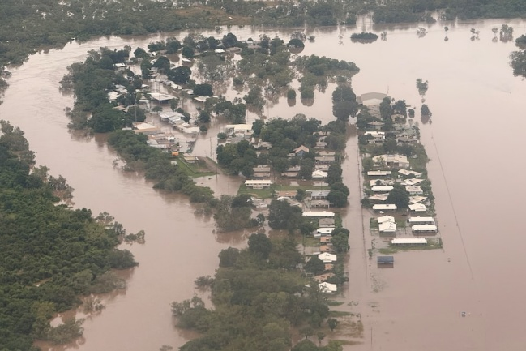  ABC News | 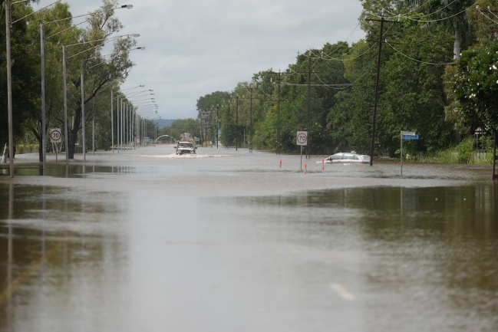  ABC News
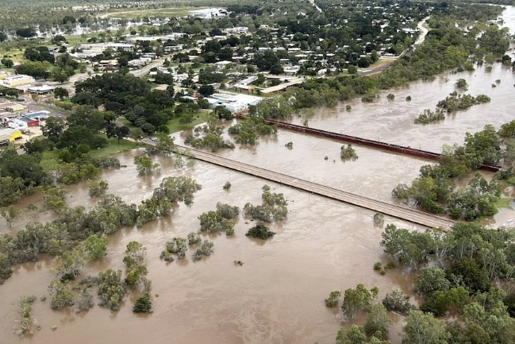  ABC News | 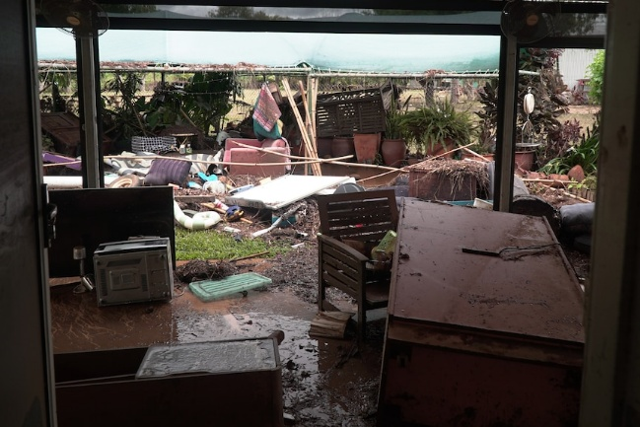  ABC News
Further Investigation
Students will then develop their own question/s to research or choose one or more of the questions below.
- How does the wet season affect people in northern Australia?
- What challenges can flooding create for communities?
- How does the wet season affect rivers, waterfalls and wetlands?
- How might the wet season impact transport and travel?
- How can communities stay safe during storms and heavy rain?

Activity: Understanding Rainfall
Students will start to think like a meteorologist and analyse this map of the Northern Territory produced by the Bureau of Meteorology. Students will then respond to the following questions:
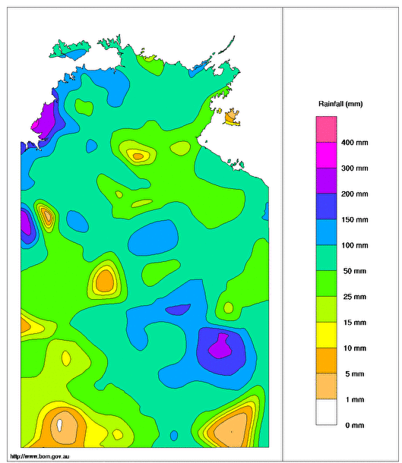
- What features do you see on this map? Make a list.
- What does the map tell us?
- What does it measure?
- What area does it cover?
- What period of time does this map cover?
- What is the purpose of this map?
- Find a map which shows the total rainfall for Northern Territory a week prior, and a week later and then compare. What are your findings?

Further investigation
- What is rainfall?
- How is rainfall measured? What instruments are used to measure rainfall?
Source: Bureau of Meteorology
- Who measures rainfall?
- What is a rain gauge? Investigate and then create
your own school rain gauge. Record the daily rainfall and calculate the average daily rainfall.

Activity: Australian Climate Zones
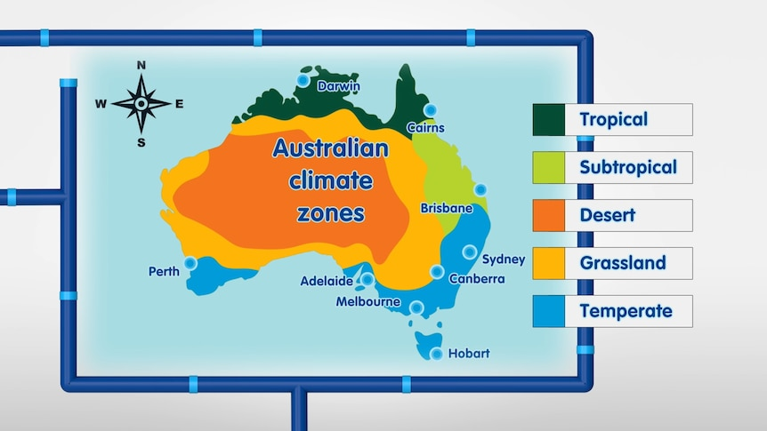
The amount of water in our environment is influenced by the climate. Across Australia, there are six broad climate zones. Climate is the average weather conditions of a place for a long period of time, while weather is the atmospheric conditions (e.g. a hot day, rain or cool conditions) for a brief period.

Watch this ABC Education video as a class to learn more about Australian climate zones and then respond to the following.
Acknowledgement: Melbourne Water in partnership with ABC Education.

Things to think about
- What climate zone do you live in, and how does it affect the weather where you live?
- What are the positives and negatives of floods?
- List the types of floods and droughts in Australia.
- What is the link between the water cycle and climate change?

Activities to do
- Create a picture diary of the different weather and seasons where you live. Your diary should include annotations explaining how the weather changes throughout a year.
- Using a map of Australia, mark and label where you live. Write down the climate zone. Then, using the Bureau of Meteorology website:
  - Find the average monthly temperature and rainfall data for your school or home.
  - Select a location from a different climate zone and collect its annual temperature and rainfall data.
  - Briefly describe any differences and similarities in rainfall and temperature. You can add pictures to your description.
- There's only a set amount of water on Earth. Investigate the different ways we can look after it and write a short report.

Useful Websites
- Water, weather and climate – ABC Education
- Floods – Geoscience Australia
- Things you can do before a flood – NSW SES
- Wet Season Signs – ABC Science
- Understanding Floods – Bureau of Meteorology

EPISODE 7
17 March 2026

KEY LEARNING
Students will recognise and celebrate Australian women who have made significant impact on society.

CURRICULUM
HASS – Year 3 and 4
Pose questions to investigate people, events, places and issues.

Locate and collect information and data from different sources, including observations.

HASS – Year 5 and 6
Develop appropriate questions to guide an inquiry about people, events, developments, places, systems and challenges.

Locate and collect relevant information and data from primary sources and secondary sources.

History – Year 6
The contribution of individuals and groups to the development of Australian society since Federation.

HASS – Year 7
Construct significant questions and propositions to guide investigations about people, events, developments, places, systems and challenges.

This document contains the names and images of Aboriginal and Torres Strait Islander people now deceased. It also contains links to sites that may use images of Aboriginal and Torres Strait Islander people now deceased.

  - Teacher Resource

Women’s History Month – Margaret Tucker

Focus Questions
Discuss the BTN story as a class and record the main points of the discussion. Students will then respond to the following:
- The Narrandera region is located on the traditional lands of the Wiradjuri people. Find the region on an Indigenous map of Australia.
- Who are the Stolen Generations?
- What protest did Margaret Tucker take part in on the 26th of January 1938?
- How did Margaret Tucker help First Nations people?
- What else did you learn about Margaret Tucker?

Activity: Personal Response
Respond to the BTN Margaret Tucker story as a class. Students will complete one or more of the following incomplete sentences:
- Margaret Tucker is an important Australian because…
- It was interesting to learn…
- These are five words that I would use to describe Margaret Tucker…
- This story made me feel…
- It is important to celebrate Margaret Tucker because…

Activity: Class Discussion
After watching the BTN story, hold a class discussion using the following discussion starters.
- What did the BTN story tell you about the life of Margaret Tucker?
- Name at least one of her achievements.
- Why do you think Margaret Tucker became so well-known?
- What questions do you have about Margaret Tucker?
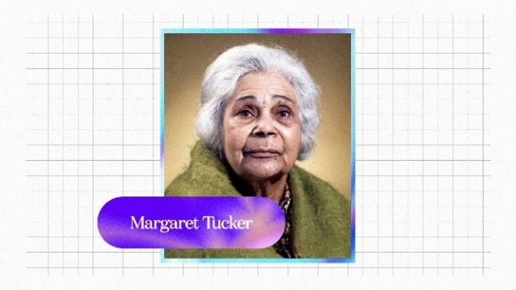

Activity: Vocabulary
Students will brainstorm a list of key words that relate to the BTN Margaret Tucker story. Below are some words to get them started. As a class discuss the meaning of each word/terminology and how it relates to Margaret Tucker and her story.

Autobiography
Trailblazer
Indigenous Rights
Equality
First Nations peoples
Stolen Generations
Activist
Day of Mourning

Further Investigation
- Who is an activist? What were some key achievements in Margaret’s activism?
- Margaret Tucker was one of many Indigenous children separated from their families. Take the time to learn what your students know about the Stolen Generations. As a class, find out more about Margaret Tucker’s story. Refer to this Educators Guide to the Stolen Generations (Healing Foundation) and the BTN Apology Anniversary story.

Activity: Timeline Poster
Students will research the life and achievements of Margaret Tucker and create a timeline poster and prepare an oral presentation summarising key events in Margaret’s life.
Timeline Poster
Your students’ task is to create a timeline poster, responding to the following areas of research.

Research
- Early Life - When and where was Margaret born? What was life like growing up on a mission? What significant event happened when she was 13 years old?
- What was Margaret’s life like as a domestic worker?
- What were Margaret’s achievements as an Aboriginal rights activist?
- When was Margaret’s autobiography If Everyone Cared released and why was it significant? Why was the book republished?
- What was Margaret’s legacy? - What event and/or action led to her becoming a significant person in Australia’s History? What impact has she had on the lives of others?
- 2 x ‘Interesting Facts’ and 2 x ‘Did You Know?’
- Include at least 4 photos with captions.
- Include a bibliography on the back of your poster.

Oral Presentation
Students will prepare a short oral presentation, speaking in ‘first person’. They will speak about their life, their family, character, the decisions they made and why, and their impact and influence on society.
Further Research
Students will choose one of the activities to further investigate their significant person.

Interview
Imagine you could sit down and talk to Margaret Tucker.
What questions would you ask about her life and achievements?
Find answers to your questions.

Portrait
Create a portrait of Margaret Tucker.
Explore and experiment with different techniques and mediums to produce a portrait.

Activity: Research Project
In this activity students will recognise and celebrate Australian women who have made significant positive changes in society and understand the importance of their contributions. Ask students to brainstorm and list the names of individuals they know or have heard of who have made significant positive changes in society. Encourage them to think about different areas such as civil rights, environmental conservation, science, and more.

Start a class discussion using the following questions:
- Can you think of women, past or present, who have made a positive change in society? Think of people that inspire you or are your role models.
- What qualities make this person special?
- How did their actions make a difference?
- What are some common characteristics and actions of people that are changemakers?
- Who inspires you? Why?

Direct your students to the BTN website to find stories of trailblazing Australian women who’ve made an extraordinary contribution to society, including:
- Dame Nellie Melba – Opera Singer
- Pearl Gibbs – First Nations activist
- Mum Shirl – First Nations advocate
- Vida Goldstein – Civil rights activist
- Nova Peris – Olympian and politician
- Dr Lowitja O'Donoghue – Indigenous rights advocate
- Elizabeth Kenny – Nurse who developed treatment for Polio
- Nancy Bird Walton – Aviation pioneer
- Dorothy Hill – Scientist
- Edith Cowan – Social reformer and politician
- Faith Bandler – Civil rights activist
- Evonne Goolagong Cawley – Tennis legend

Or visit the ABC Fierce Girls website to learn more about Australian women who dare to do things differently. From athletes to aviators, scientists to spies. From the deep blue sea to the dark, black skies.
Students will choose one trailblazing Australian woman they find inspiring and research and record information about the person. Some possible areas of research include:
- When and where were they born? Describe their family life growing up.
- What are some of their achievements? Choose one to explore in more detail.
- What inspired or motivated them?
- What are some of their values?
- What were some challenges they faced?
- How did they make an impact on people’s lives?
- What do you admire about them?

Useful Websites
- Margaret Tucker – First Peoples – State Relations
- Margaret Tucker Biography – The Australian National University

  - Teacher Resource

BTN Transcript: Episode 7- 17/3/2026

Hey, I'm Amelia Moseley and you're watching BTN. Thanks for hanging out with us again. Let's see what's coming up on today's show. We meet the man behind some big Hollywood sounds, chat with an upcoming motorsport star, and learn about the life of another trailblazing Australian woman.

Oil Prices

Reporter: Wren Gillett

INTRO: All that soon. But first today to something impacting people around the world. And that's the price of oil. The war in Iran has caused the biggest disruption in the supply of oil that the world has ever seen. Wren found out more.

CARTOON: I'm rich, I'm rich, I'm rich.
It's a slimy black substance that's been shaping the globe for more than a century.
TV SHOW: Oil, that is, black gold, Texas tea.
Driving economies, fuelling innovation, and sometimes causing conflict.

Oil is actually made from ancient living things, mostly tiny bits of plant-like bacteria. When they died, they sank to the seafloor, and over millions and millions of years, heat and pressure transformed them into the energy-rich liquid we call oil, and that's exactly why we call it a fossil fuel. While it's been used for millennia, the first commercial oil well was drilled in the US in 1859. Starting a revolution that changed the world.
You see, oil is really good at holding energy, and when it's burned that energy is released. Once it's refined and impurities are taken out, oil can be turned into petrol or diesel to power cars, trucks, trains, ships, aircraft and all sorts of other vehicles. Oil also lubricates machinery, keeping it moving smoothly, and it's turned into asphalt on roads. It contains chemicals that are used to make all sorts of things from artificial food flavours to makeup, and fertilisers to help crops grow. It's also what plastic is made from, so it's in pretty much everything.
WREN GILLETT, BTN REPORTER: If you look around you, chances are everything you see has either been made using oil or been transported using oil. Your computer, lunchbox, the stuff in your pencil case, your water bottle. Even your clothes. So, yeah, oil is pretty important, and so are the countries that have a lot of it.
These are all the countries with oil reserves. Venezuela has the most, but a lot of the world's oil comes from the Middle East, which is why when conflict breaks out there, the impact can be felt all around the globe.
NEWS: The price of crude oil has risen above 100 dollars a barrel.
NEWS: Filling up has become a lot more expensive.
NEWS: Stations across the country now rationing their fuels.
Iran is one of the world's biggest oil producers. It also borders the strait of Hormuz, a narrow body of water that roughly 20 per cent of the world's oil reserves travel through. But the conflict has disrupted that flow. That means less oil is being delivered to parts of the world that rely on it, including Australia.
WREN: In the past couple of weeks the price of petrol has gone up a lot, and it's having a big impact on a lot of people.
As well as costing your parents more to get you about, it's costing companies more to transport goods. It's also having a big impact on farmers, who need diesel to power their machines.
FARMER: We're below 500 litres, we've stopped all operations.
And if the situation continues to get worse, it could push up the price of all sorts of things. In response, some people have started stockpiling groceries and petrol.
ROWAN LEE, THE AUSTRALIAN CONVENIENCE AND PETROLEUM MARKETS ASSOCIATION: We've had up to a month's supply leave the system in a matter of a few days.
But the Government says we are not actually running out, and has asked people not to panic-buy.
CHRIS BOWEN, ENERGY MINISTER: I do want to say that Australia enters this period of great instability very well prepared, much better prepared than in previous crisis.
Like many countries, Australia keeps an emergency supply of fuel, and it's decided to release some of that and to allow lower quality fuel into the country to try to push down prices. Meanwhile some oil-producing countries say they'll boost production to help fill the gap. Some reckon the situation has highlighted the need to switch to renewable energy.
CHRIS BOWEN: The most secure form of energy for Australia is our renewable energy.
But in a world built around oil, our need for this ancient, slimy black substance won't be gone anytime soon.

Did you know?

Did you know, before the oil industry came about, a major source of oil for heating and lubricating machinery was whales. Whales were hunted for their blubber which was used in all sorts of things from soaps to paint and lamps, but crude oil was cheaper and easier to produce.

NT and Qld Floods

Reporter: Tatenda Chibika

INTRO: Now to Australia's Top End, where thousands of people have been impacted by devastating floods. Several rivers in the NT and Queensland have broken their banks after a huge amount of rain. Here's Tatenda to tell us more.

Tully: Recently, we've had the rains here in Katherine which have led to mass flooding.
LILY: That's the water line of how far it got.
These were the scenes facing many people in Australia's north as devasting and deadly floods hit the Northern Territory and Queensland.
TULLY: So, we can see there, that's our bridge level there it's at about 17 right now. This time last week it was about 7. My school, we've been in an evacuation centre, so I haven't been able to go to school for the past four days.
LILY: We went to the cinema, and we stayed at the highest floor, and we boiled the water so we can drink it.
In Katherine, the river peaked at 19.2 metres causing the towns worst flooding in nearly 30 years. The Daly River, which is 354 kilometres long and flows all the way out to the Timor Sea, peaked to a historic high of more than 15.5 metres, exceeding it's 1957 record. Three entire communities were evacuated as the flood water damaged roads and homes.

LIA FINOCCHIARO, NORTHERN TERRITORY CHIEF MINISTER: Their homes are inundated; there is not a building in Daly River that is not under water.

And because this is croc country, the extra water meant crocs in unexpected places.
PERSON: And over here, there's a big goanna here, I think that's a about close enough I reckon.
Queensland was also hit hard. The Burnett River swelled to 7.4 metres and even more people were forced to leave their homes as flood water took over.
PERSON: It's gut wrenching, it's absolutely gut wrenching. We've tried our hardest to get our stuff out as much as possible.
And as the week went on, the water moved inland to areas like Chinchilla and Longreach.
Tatenda, Reporter: Of course all of this is caused by lots and lots of rain but what causes the rain? Well, I'm not a meteorologist but, I happen to know someone who is. Hey Nate.
Nate Byrne, Weather Presenter: Hey Tatenda, well luckily, I'm always ready to accept your calls in times of weather emergency.
Nate Byrne: So, we've had several tropical lows, one after the other, and the thing is, it's how slow these ones have been moving that's really caused the problem.
As Nate explained, a tropical low-pressure system is a patch of hot rising air which pulls in moist air from the surrounding oceans, which then rises forming big rain clouds and a spinning weather system. He says they're fairly common up north at this time of year.
Nate Byrne: Because it's the wet season, essentially, we're warmer at this time of year than at any other. That means there's a lot more evaporation happening, a lot more moisture in the air, ready to be picked up by troughs and by weather systems to be dumped as heavy rainfall.
But because they've come so close together and stuck around all that rain has added up to record floods and it may not be over yet.
Nate Byrne: Tatenda, we've just got to look to the north again because we've got, believe it or not, yet another tropical low that's developing well off to the north-east of us at the moment. That's likely to cross the top of Cape York Peninsula, probably bringing more flooding with more heavy rainfall before then heading into the Top End. And that's not great news. The ground up that way is absolutely soaked.
In the meantime, people in flood hit parts of Australia are doing what they can to look after each other whether it's handing out sandbags or supplies or getting together to start the big job of cleaning up.
PERSON: We're locals and you know we've got to come together don't you in times like this.

… as Northern Australia waits for an end to this Big Wet.
News Quiz

David Littleproud has stepped down as the leader of which political party? Is it One Nation, The Nationals or the Greens? It’s the Nationals, they form part of the Liberal National Coalition that, right now, is Australia’s main opposition. Littleproud’s role has been taken over by Queensland Senator Matt Canavan.

MATT CANAVAN: I stood for this role because I think we are losing our country and we have to fight back for Australians.

More than 1.3 million kids had to pause their NAPLAN tests last week because of a major IT glitch. The only test that wasn’t affected was year 3 writing. Do you know why? It’s because year 3 writing is the only test that’s not completed online. Everyone else had to stop when the website stopped working about 5 minutes into the test. They were able to pick up where they left off when the tests were back online.

STEPHEN GNIEL, CEO ACARA: We do have those measures in place to ensure the students are not disadvantaged as a result of this technical issue.

NASA has announced a new target launch date for its manned mission around the moon. Do you know its name? Is it Apollo 2, Aramis 2 or Artemis 2? It’s Artemis 2. It was due to launch earlier this month and take a crew to orbit the moon, but it had to be set back because of a fuel leak in the SLS rocket. Now NASA says it’s aiming for the first of April.

LORI GLAZE, NASA SCIENTIST: It's a test flight, and it is not without risk. But our team and our hardware are ready.

And do you know which film won best animated feature at this year’s Oscars? Was it K-Pop Demon Hunters, Little Amelie or Elio? It was K-Pop Demon Hunters.

Movie Sounds

Reporter: Wren Gillett

INTRO: As you just heard, the Oscars have been handed out in Hollywood, which got us thinking about the movies and all of the talented people who make them, including some you might not know about. Wren went to meet someone who helps to create the sounds of some really big blockbusters. Check it out.

This might not look like the heart of Hollywood, but John's studio is where the sounds from some very famous blockbusters have been born. Think this…
THE TRUMAN SHOW: Truman.
This...
KING KONG: *Car smashes*
This...
THE LEGO MOVIE: Sorry, I wasn't listening, I've just been bat-mailing on my bat-phone.
This...
HAPPY FEET: Good morning Miss Viola.
JOHN SIMPSON, FOLEY ARTIST: There were a lot of penguins in happy feet. Make some nice snow. For the snow sound we just used wet sand.
John here is a Foley artist, a job that's all about creating sounds for film and TV. Whether that be human footsteps on carpet, concrete, in a puddle, horse gallops, tire skids, anything really.
JOHN: There's nothing like squishing a Zombie's head against a brick wall.
The art form started with this guy, Jack Foley, who worked at Universal Studios in the 1920s.
JOHN: Before, you know, you'd go to a cinema and there'd be a guy playing an organ in there and there'd just be titles with all the words there was no dialogue and then eventually dialogue came in on the movie Showboat.
SHOW BOAT: You have made me so happy.
JOHN: And yeah then they decided they wanted to hear footsteps and things and then it just increased from there.
These days, Foley is used in nearly all professional films and TV shows, and John has worked on quite a lot of them
WREN: Your job is pretty fun, do you love what you do?
JOHN: Look, I'm going to be honest, it's the most fun you can have. Getting to create sounds and get paid for it and no one complains about the noise is fantastic.
Honestly, it looks like so much fun that I just had to give it a go. First step? Record a movie with no sound. Yeah alright, it's not exactly Oscar worthy but work with me here. Next step, record the steps.
JOHN: So, the trick is when you're doing feet is to do heel-toe. So, start on the spot. That's it. And you can just follow me.
WREN: *Laughs*
JOHN: That's actually pretty impressive. Okay, you're hired.
WREN: Oh, great. Well, bye BTN.
JOHN: I need a backup.
Next, we focused on the bag, making the movement a bit bigger so the mic actually picks it up.
JOHN: Just don't hit me in the head with it, I'll stand out the way.
WREN: I'll try my best.
And finally, we recreated the sound of the door.
JOHN: That'll do me.
WREN: Yep, yep.
This was the end result.
WREN: So, the next time everyone goes to the movies or watches something on their TV at home, what's something cool they can sort of think about?
JOHN: Listen to the soundtrack. And you'll hear your feet, you'll hear birds, you'll start to hear things. Just listen.
WREN: Use these.
JOHN: Use your ears, yep.
F4 Driver

Reporter: Amelia Moseley

INTRO: Now lets meet a teenager who's living out her dreams of being a race car driver. Joanne Ciconte races Formula 4 and is about to star in the new season of the documentary series F1: The Academy and I got to have a chat with her.

JOANNE CICONTE, F1 Academy Driver: So, I'm Joanne Ciconte. I'm 17 years old. I'm a Formula 4 racing car driver. I participated in the F1 Academy season in 2025. So that's 20 of the best female drivers around the world. I was the youngest participant, one of two Australians in that.
F1 ACADEMY VIDEO: Tell me who's number one? Tell them you're number two now.
AMELIA MOSELEY, REPORTER: So, Joanne, what was it like being part of the TV show F1: The Academy?
Joanne: I never thought I'd be on Netflix. Like, it's insane. So, it's soon to be out, but having a bunch of cameras and having mics on you 24-7, even when you just get out of the car, it's quite challenging because I just like to be in my own space.

COMMENTATOR: Joanne Ciconte round the outside.

It's amazing because I never thought that I'd be on the show and to see myself on such a platform is a huge pinch me moment.
Amelia: How did you get started in motorsport?
Joanne: So, my brother, he's actually two years younger than me, and He got introduced to go-karts. I kind of had to beg my dad to give me that opportunity. It's a bit funny because six years ago there was no females in motorsport because it was so male dominated. My dad just thought I wouldn't enjoy it. So, he didn't really bother getting me into the sport. But I eventually convinced him and I think I annoyed him because I just was constantly so eager to have a drive.
Amelia: You really proved your dad wrong there.
Joanne: I know. He had to even start hiding the lap times from my brother so he wouldn't see I was faster.
AMELIA: Oh no, sibling rivalry goes to another level. Like, where is your head at when you're going to 240 kays?
JOANNE: Everything around you just kind of blurs, and you're just at one with yourself in the car. You're just so focused on what you need to do and how you can improve your lap time, how you can overtake here. It's quite intense, but I love it.
AMELIA: We haven't had a female driver start the F1 Grand Prix since 1976. How do you think we fix this?
JOANNE: There was no females when I started. I was competing in a field of 49 boys, and I was the only girl. It's amazing to see those kind of, like, more female-dominated brands out there involving themselves, because I think that it will bring more of a female audience. Really embracing female talent on social media will also help. Being a girl or boy, like when that helmet goes on, we're all equal out there. We're all equal as a driver and we all think differently and we have our own styles.
AMELIA: It is a bit of a trope, like every kid wants to be a race car driver. But what about for those, you know, kids and teens who are actually watching this and really do want to pursue it, even potentially as a hobby or even a career. What's your advice for them?
JOANNE: 100 percent get yourself in any shape or form of machinery because it's like a lifetime experience. The speeds, the competitiveness, even when you're out with your friends and you go go-karting, imagine something just slightly faster. Motorsport is so much fun, and I really want to see more people do it.
AMELIA: What do you want to be doing in the future? Like if I'm chatting to you in another like five years, what are you hoping?
JOANNE: So, even as a young girl, I always dreamed about being in Formula One. So, my ultimate dream is to be Australia's first female Formula One driver.
AMELIA: Yes. And then I can say "Hey, I interviewed her once on BTN". So, you've got to do it for me.
JOANNE: I will. For you, I will.
Quiz

How many women have officially competed in a Formula 1 Grand Prix? 2, 5 or 9? The answer is five, although only 2 have actually qualified and started a race. Maria Teresa de Filippis was the first to do it in the 50s then, in the 70s, Lella Lombardi became the first woman to score points in the F1 World Championship.

Sport

It's been an action packed 10 days at the Winter Paralympics in Milano-Cortina, Italy. In the end, Australia won 2 medals and tied for 21st place with Poland with snowboarder Ben Tudhope clinching both medals for Australia. Bronze for the Men's banked Slalom and silver for the men's snowboard cross. Meanwhile, at just 16 years old, Liana France made history as Australia's Youngest Winter Paralympian.
Oscar Piastri's F1 season is off to a rough start after crashing on his way to the grid last week in Melbourne, he didn't even make the start at the Chinese Grand Prix. Both Piastri and teammate Lando Norris couldn't race because of separate electrical problems with their McLarens.

COMMENTATOR: We're going to get an Italian driver winning here!

But it was full speed ahead for 19-year-old Kimi Antonelli from Italy who claimed his very first Formula One Victory.
Finally, Hannah Green has won the Women's Australian Open.

COMMENTATOR: And history at home for Hannah Green. She can now proudly call herself an Australian Open champion.

Just one shot separated Green from France's Agathe Laisné and fellow Aussie Cassie Porter, who tied for second place and the win marks Green's second victory of the season.

HANNAH GREEN: I kind of am a bit speechless, to be honest. I think the win in Singapore definitely helped with my nerves today.

Women’s History Month – Margaret Tucker

Rookie Reporter: Harriet

INTRO: Finally, today let's continue our series for Women's History Month learning about the lives of women who've helped to shape Australia. Today, Harriet will tell us about activist and writer, Margaret Tucker.

This is Margaret Tucker. She was born on the 28th of March 1904 at Warangesda Mission near Narrandera. Her father was Wiradjuri and her mother was from the Yorta Yorta nation. When Margaret was a teenager, she was taken from her family. It's a story shared by thousands of First Nations people who were part of the stolen generations. Many of these children were sent to orphanages, missions or to live with white foster families. Margaret was sent to the Cootamundra Domestic Training Home for Aboriginal Girls.
“I cannot forget the details of that moment. It stands out as if it were yesterday. It broke our hearts tearing us apart by taking us away to learn domestic work.”

After two years of training, Margaret moved to Sydney where she spent 11 years serving white households. Margaret was often treated badly and abused by the families she worked for.
By the 1930s, Margaret had had enough and moved to Melbourne where she and other First Nations people began campaigning for better treatment more rights and representation in parliament. This led to one of the country's first Aboriginal organisations, the Australian Aborigines League. On the 26th of January 1938 while the rest of the country was celebrating 150 years since the arrival of the First Fleet. Margaret and several other activists took part in the Day of Mourning Protest. It was the first demonstration of its kind and the beginnings of what we know today as NAIDOC week.
In her later years she continued to fight for equality along with her daughter Molly and in 1968 she was awarded the Member of the Order of the British Empire. In 1977 Margaret became one of the first Indigenous authors to publish an autobiography which helped to teach white Australians about what it was like to be an Indigenous person in a country that didn't treat its first people equally. Margaret died in 1996, but her activism and story of resilience and resistance became a part of Australia's story and continues to inspire many today.
Closer

Well, that's all we've got for today. But don't worry, we'll be back soon. And, as always, you can see more stories and specials and teachers' resources on our website. You can also watch BTN High or check out BTN Newsbreak right here in the studio every weeknight. Have a good week and I'll see you really soon. Bye!

