
KEY LEARNING
Students will view a range of BTN stories and use comprehension skills to respond to a series of focus questions.

CURRICULUM
English – Year 4
Use comprehension strategies to build literal and inferred meaning to expand content knowledge, integrating and linking ideas and analysing and evaluating texts.

English – Year 5
Use comprehension strategies to analyse information, integrating and linking ideas from a variety of print and digital sources.

English – Year 6
Use comprehension strategies to interpret and analyse information and ideas, comparing content from a variety of textual sources including media and digital texts.

English – Year 7
Use comprehension strategies to interpret, analyse and synthesise ideas and information, critiquing ideas and issues from a variety of textual sources.

  - Teacher Resource

First Nations History Special
As a class, discuss the stories featured in the BTN Special and record the main points of the discussion. Students will then respond to the following focus questions.

Pinjarra Massacre Apology
- What year did the Pinjarra Massacre happen?
- Where is Pinjarra located? Find on a map.
- What is the meaning of Frontier Wars?
- What questions do you have about the story?
- How did this story make you feel?

Deep Time
- How long have Aboriginal and Torres Strait Islander peoples occupied this land for?
- Where is the earliest evidence of humans in Australia?
  - Budj Bim cultural landscape
  - Madjedbebe rock shelter
  - Murujuga cultural landscape
- What evidence did archaeologists find there?
- What was the mega-continent that included mainland Australia, Tasmania and Papua New Guinea called?
- Reflect on your understanding of Deep Time since watching the BTN story. How has it changed?

Vincent Lingiari
- In which state or territory is Wave Hill located?
  - South Australia
  - Northern Territory
  - Western Australia
- Who were the traditional owners of the area?
- What year did Vincent Lingiari lead the Wave Hill walk-off?
- Why did the Gurindji people go on strike?
- What famous gesture symbolised the returning of land to the Gurindji people?

KEY LEARNING
Students will learn about the Frontier Wars in Australia and why learning about them is an important part of truth-telling.

CURRICULUM
HASS – Year 5
The impact of the development of British colonies in Australia on the lives of First Nations Australians, the colonists and convicts, and on the natural environment.

HASS – Year 9
The causes and effects of European contact and extension of settlement, including their impact on the First Nations Peoples of Australia.

  - Teacher Resource

Pinjarra Massacre Apology

This document may contain the names and images of Aboriginal and Torres Strait Islander people now deceased. It also contains links to sites that may use images of Aboriginal and Torres Strait Islander people now deceased.
It also contains some content that may be distressing.

Activity: Personal Response
After watching the BTN Pinjarra Massacre Apology story, ask students to finish one or more of the following incomplete sentences:
- It was interesting to learn that…
- Learning about the Frontiers Wars made me feel…
- It’s important to learn about the Frontier Wars because…



What questions do you have about the story?
What did you learn from the story?

Activity: Discuss
After watching the BTN Pinjarra Massacre Apology story students discuss the story in pairs, using the following questions to guide the discussion:
- Reflect on the apology by the Western Australian Governor. Why was it important? Watch the Governor’s apology.
- What were the Frontier Wars?
- What were the reasons for frontier violence?
- Why is truth-telling important?

Activity: Glossary
Students will brainstorm a list of key words that relate to the BTN Pinjarra Massacre Apology story. Here are some words to get them started.
MASSACRE | RESISTANCE | TRUTH-TELLING
COLONISATION | DISPOSSESED | RECONCILIATION

Activity: Researching Frontier Wars
Students will choose one or more of the questions below to explore in more detail or they can develop their own questions to research.

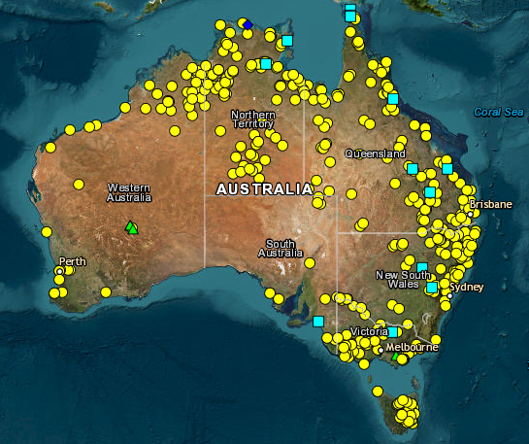
- What were the Frontier Wars and what was the cause of the violence?
- What happened in Myall Creek in 1838?
- What is truth-telling? Why is learning about the Frontier Wars an important part of truth-telling?
- How should these events be recognised or commemorated?
- Look at the map created for the Colonial Frontier Massacres Project. Why is it important to document these events? Use the interactive map to learn about sites that are near you.

Activity: Visual Literacy
Below are images that relate to the Frontier Wars. Students look at the image and then respond to the following questions:
- What do you see in this image?
- What does the image tell you about the Frontier Wars?
- How did the image make you feel?
- What question/s would you like to ask about the image?

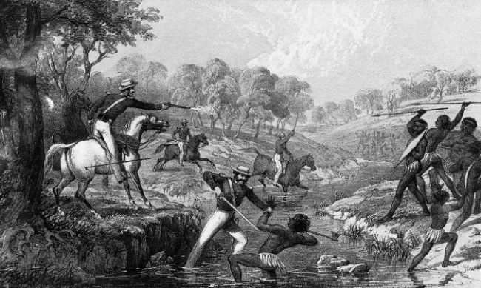  Waterloo Creek massacre | 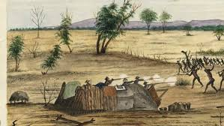  Bulla, Queensland 1861

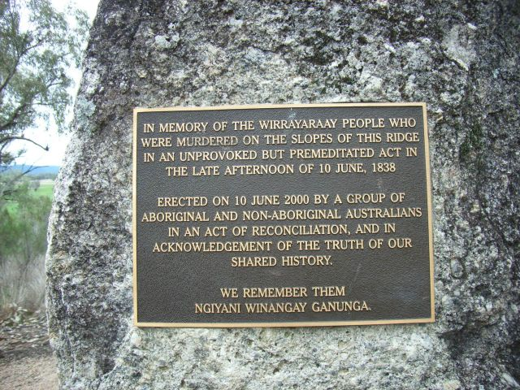  Myall Creek memorial plaque | Myall Creek Memorial  Working in pairs, students read the Myall Creek memorial plaque and respond to the following questions:  - Which groups worked together on the Myall Creek memorial?  - How is the Myall Creek remembered today?  - Why is the memorial important part of reconciliation?

Activity: BTN Stories
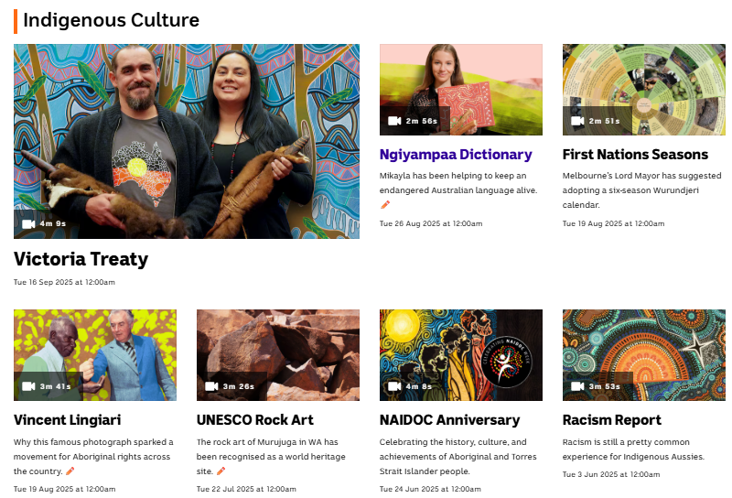
Visit BTN’s collection of stories which focus on Aboriginal and Torres Strait Islander peoples’ history, culture and issues.

After watching any one of the BTN videos ask students to respond to the discussion questions (to find the discussion questions and teacher resources go to the related BTN Classroom Episode and download the Episode Package).
Collection of BTN stories with a focus on First Nations

Useful Websites
- WA Governor Chris Dawson apologises to descendants of Pinjarra Massacre, almost 200 years later – ABC News
- Myall Creek Memorial a symbol of reconciliation as descendants of victims and perpetrators gather – ABC News

KEY LEARNING
Students will explore Australia's deep time history by investigating important archaeological sites and Indigenous creation stories.

CURRICULUM
HASS – Year 4
Pose questions to investigate people, events, places and issues.

HASS – Year 5 & 6
Develop appropriate questions to guide an inquiry about people, events, developments, places, systems and challenges.

Locate and collect relevant information and data from primary sources and secondary sources.

HASS – Year 7
Construct significant questions and propositions to guide investigations about people, events, developments, places, systems and challenges.

Apply a methodology to locate and collect relevant information and data from a range of primary sources and secondary sources.

How First Nations Australians are the world’s oldest continuing cultures, displaying evidence of both continuity and change over deep time.

How First Nations Australians have responded to environmental processes and changes over time.

The technological achievements of early First Nations Australians, and how these developed in different places and contributed to daily life, and land and water source management.

  - Teacher Resource

Deep Time

Aboriginal and Torres Strait Islander people should be aware that this document may contain images and names of deceased persons.

Activity: Class Discussion
Discuss the BTN Deep Time story in small groups or as a class. Ask students to record what they know about the ancient culture of Australia. What questions do they have? Use the following questions to help guide discussion:
- What do you already know about the history of First Nations people? Record your ideas on a mind map.
- How long have First Nations people been in Australia?
- How do we know this? (artefacts, rock art, footprints, Dreaming stories)
- What are some examples of the earliest evidence of people living in Australia?

What questions do you have?
What surprised you about this story?

Activity: Vocabulary
Students will brainstorm a list of key words that relate to the BTN Deep Time story. Here are some words to get them started.

DEEP TIME | FIRST NATIONS PEOPLE | CREATION STORY
ROCK ART | OLDEST LIVING CULTURE | SITES

Activity: KWLH research
The KWLH organiser provides students with a framework to explore their knowledge on the deep time history of Australia and consider what they would like to know and learn.

What do I know? | What do I want to know? | What have I learnt? | How will I find out?

Deep Time Inquiry
Students will collect and record information from a wide variety of sources. Students may develop their own question for inquiry or select one of the questions below.
- How long have Aboriginal people lived in Australia? Describe one recent discovery that shows this.
- What is the creation process known as? Find one dreaming story that explains the creation of the Australian landscape. Can you find a creation story from your local community to share?
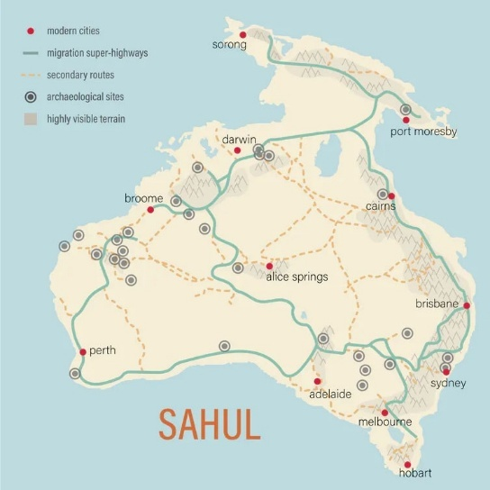
- What are some of the oldest archaeological sites in Australia? What do they tell us?
- What is Sahul? Investigate the ancient mega-continent of Sahul. Find a map of Sahul and make comparisons to present day Australia.
- How has Australia changed over the last 65,000 years? Make a timeline showing major environmental changes (sea levels rising, ice age, drought).
- What does the following sentence mean? Aboriginal cultures are the oldest continuous cultures on Earth.
ABC News

Activity: Time
Explore the Time interactive on the ABC Deep Time website as a class, following the timeline to explore the deep history of Aboriginal and Torres Strait Islander peoples.

To help understand how far back Australia’s history goes, the interactive uses a dot help represent a point in time, with each dot representing 250 years.


Follow the dot as it moves from the present day to the ancient past, recording key points in time. Continue through the interactive and click on the points of interest to learn more about specific events, cultural practices, and stories.
- What did you learn?
- What information was surprising?
- What questions do you have?
- Create a Did you know.

Journey back in time
This fun and interactive outdoor class activity will help students explore and visualise the deep history of Aboriginal and Torres Strait Islander peoples.

Take your classroom outside, using your school oval to make a giant timeline, to help students visualise the vast scale of history in Australia. First, students will decide on a scale (for example, 1 step equals 250 years in time) and calculate and record the distances using a spreadsheet. Students will walk back in time, counting steps according to their scale. At each key event they will place a marker and/or sign.

Key events to mark:
- 2,800 years ago – beginning of Ancient Greek civilisation
- 5,100 years ago – beginning of Ancient Egyptian civilisation
- 9,000 years ago – Sea levels rise dramatically
- 22,000 years ago – Ice age peaks
- 30,000 years ago – Great drought begins
- 37,000 years ago – Budj Bim volcano erupts
- 50,000 years ago – Megafauna live in Australia
- 65,000 years ago – Evidence of First Nations people in Australia

Further discussion
- What was surprising about this activity?
- What did you learn from doing this activity?
- What major environmental changes have First Nations Peoples survived throughout Australia’s 65,000-year history?
- Where do other civilisations fit onto your deep time timeline?
- Why is it important to learn about and share Australia’s deep time history?

Activity: Deep time stories near you

Go to the Place map on the Deep Time website. Choose a story near you to explore. Which location did you choose? What story is told there?
- What time-period does the story come from?
- How was the landscape and environment different in that story compared to today?
- What does the story tell you about how people used the land, water or sky?
- Why are the stories of the knowledge holders important?
- How did the story you chose make you feel?

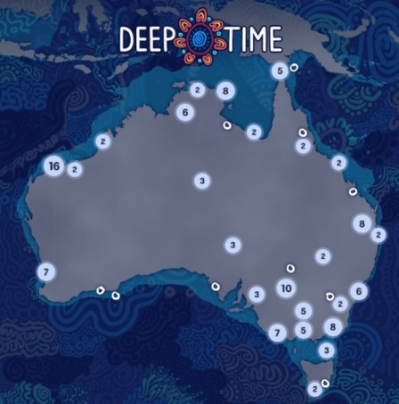
Further Investigation
Students will explore the cultural diversity of First Nations Australians. Individually or in small groups, students will learn about the Indigenous group where they live and present what they have learnt to the class. Students will learn about the geographic location, language, culture, traditions, and histories.
- Find one significant Aboriginal archaeological site in your local community. Why is it important to First Nations people?
- What is the Indigenous language in your local community? Learn some common everyday words and share with your class.
- Where is the Indigenous group located? Mark the approximate boundaries on a map. What are some special sites in the area?
- Learn more about the Indigenous seasons and the plants and animals that are important to Indigenous people. Learn more about the Indigenous Seasonal Calendar on the CSIRO website
- Look for stories by Indigenous peoples valuing their oral traditions. Can you find stories told through dance, song and other art forms as well as through text?

Activity: Dreaming stories
Dreaming stories pass on important knowledge, cultural values, and belief systems to later generations. Learn about Dharawal country through this Dharawal Dreaming story made by the National Museum of Australia.

One tells the origins of our animals …
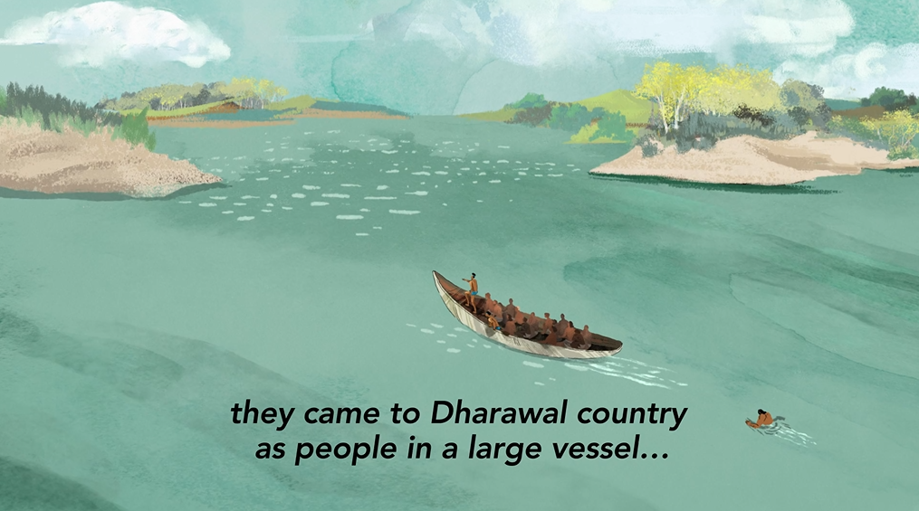 | 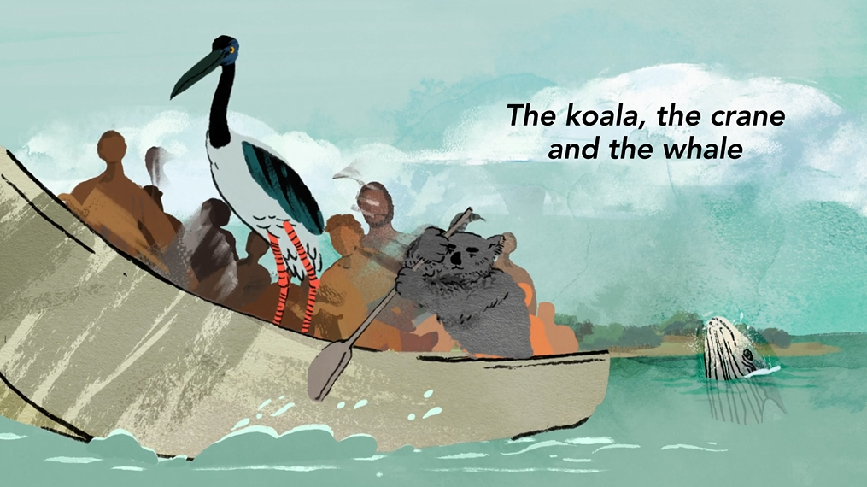

Another Dreaming story tells of how spirits of the dead returned in low lying cloud...
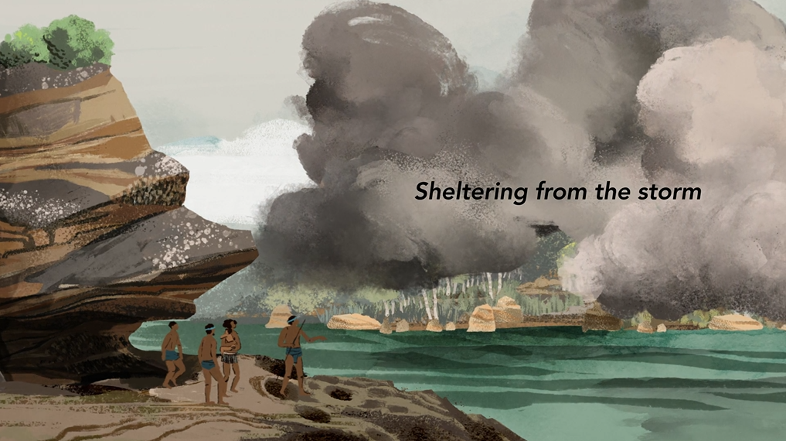 | 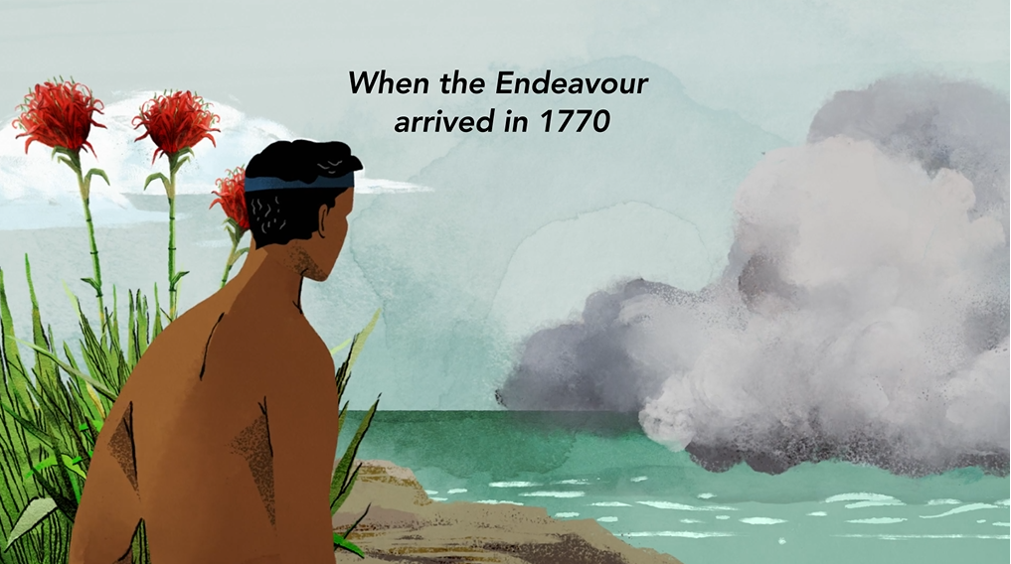
Dharawal Dreaming - Animation (National Museum Australia)

Spears have an important place in Dreaming stories in Aboriginal and Torres Strait Islander culture. Watch The Spear together as a class, a Yirritja story that is told in Dalabon language in Central Arnhem Land, Northern Territory.
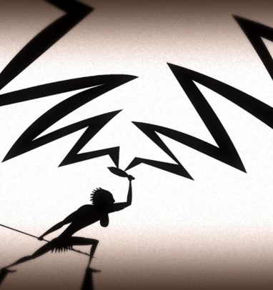
After watching the video students will respond to the following:
- What do you think the story is teaching us?
- What were your reactions or feelings during the story?

Follow-up activities
Teachers can download the ‘Dust Echoes’ study guide by ATOM for further follow-up activities.

The Spear, Dust Echoes - (ABC Education)

Activity: Meet the Megafauna
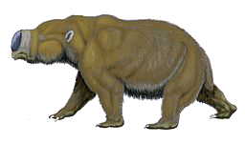
Students will explore the Megafauna stories on the Topics page of the Deep Time website and choose a species of megafauna to explore in more detail. What does the story tell you about First Nations people’s connection with megafauna? Students will then create a fact sheet including the following information:
- Common and scientific name
- What type of animal is it? (mammal, reptile, bird)
- Description – size, appearance, special features, adaptations
- Where did it live? Describe the habitat.
- What did it eat?
- When did it die out? What caused their extinction?
- What existing species is it similar to? Diprotodon
- Find evidence of megafauna in First Nations people’s culture. For example, in archaeological findings like rock art and the collection of fossils; or in creation stories.

Activity: Rock Art Investigation
Students visit the Art section on the Topics page to learn from knowledge holders about rock art. What do the stories tell you about rock art and its significance to First Nations peoples?
Students will explore one specific example in depth. Students will learn about petroglyphs (rock engravings) and pictographs (drawings) which are a key component of rock art. Below are some examples of rock art around Australia. Alternatively, students may want to find their own example of rock art to study.

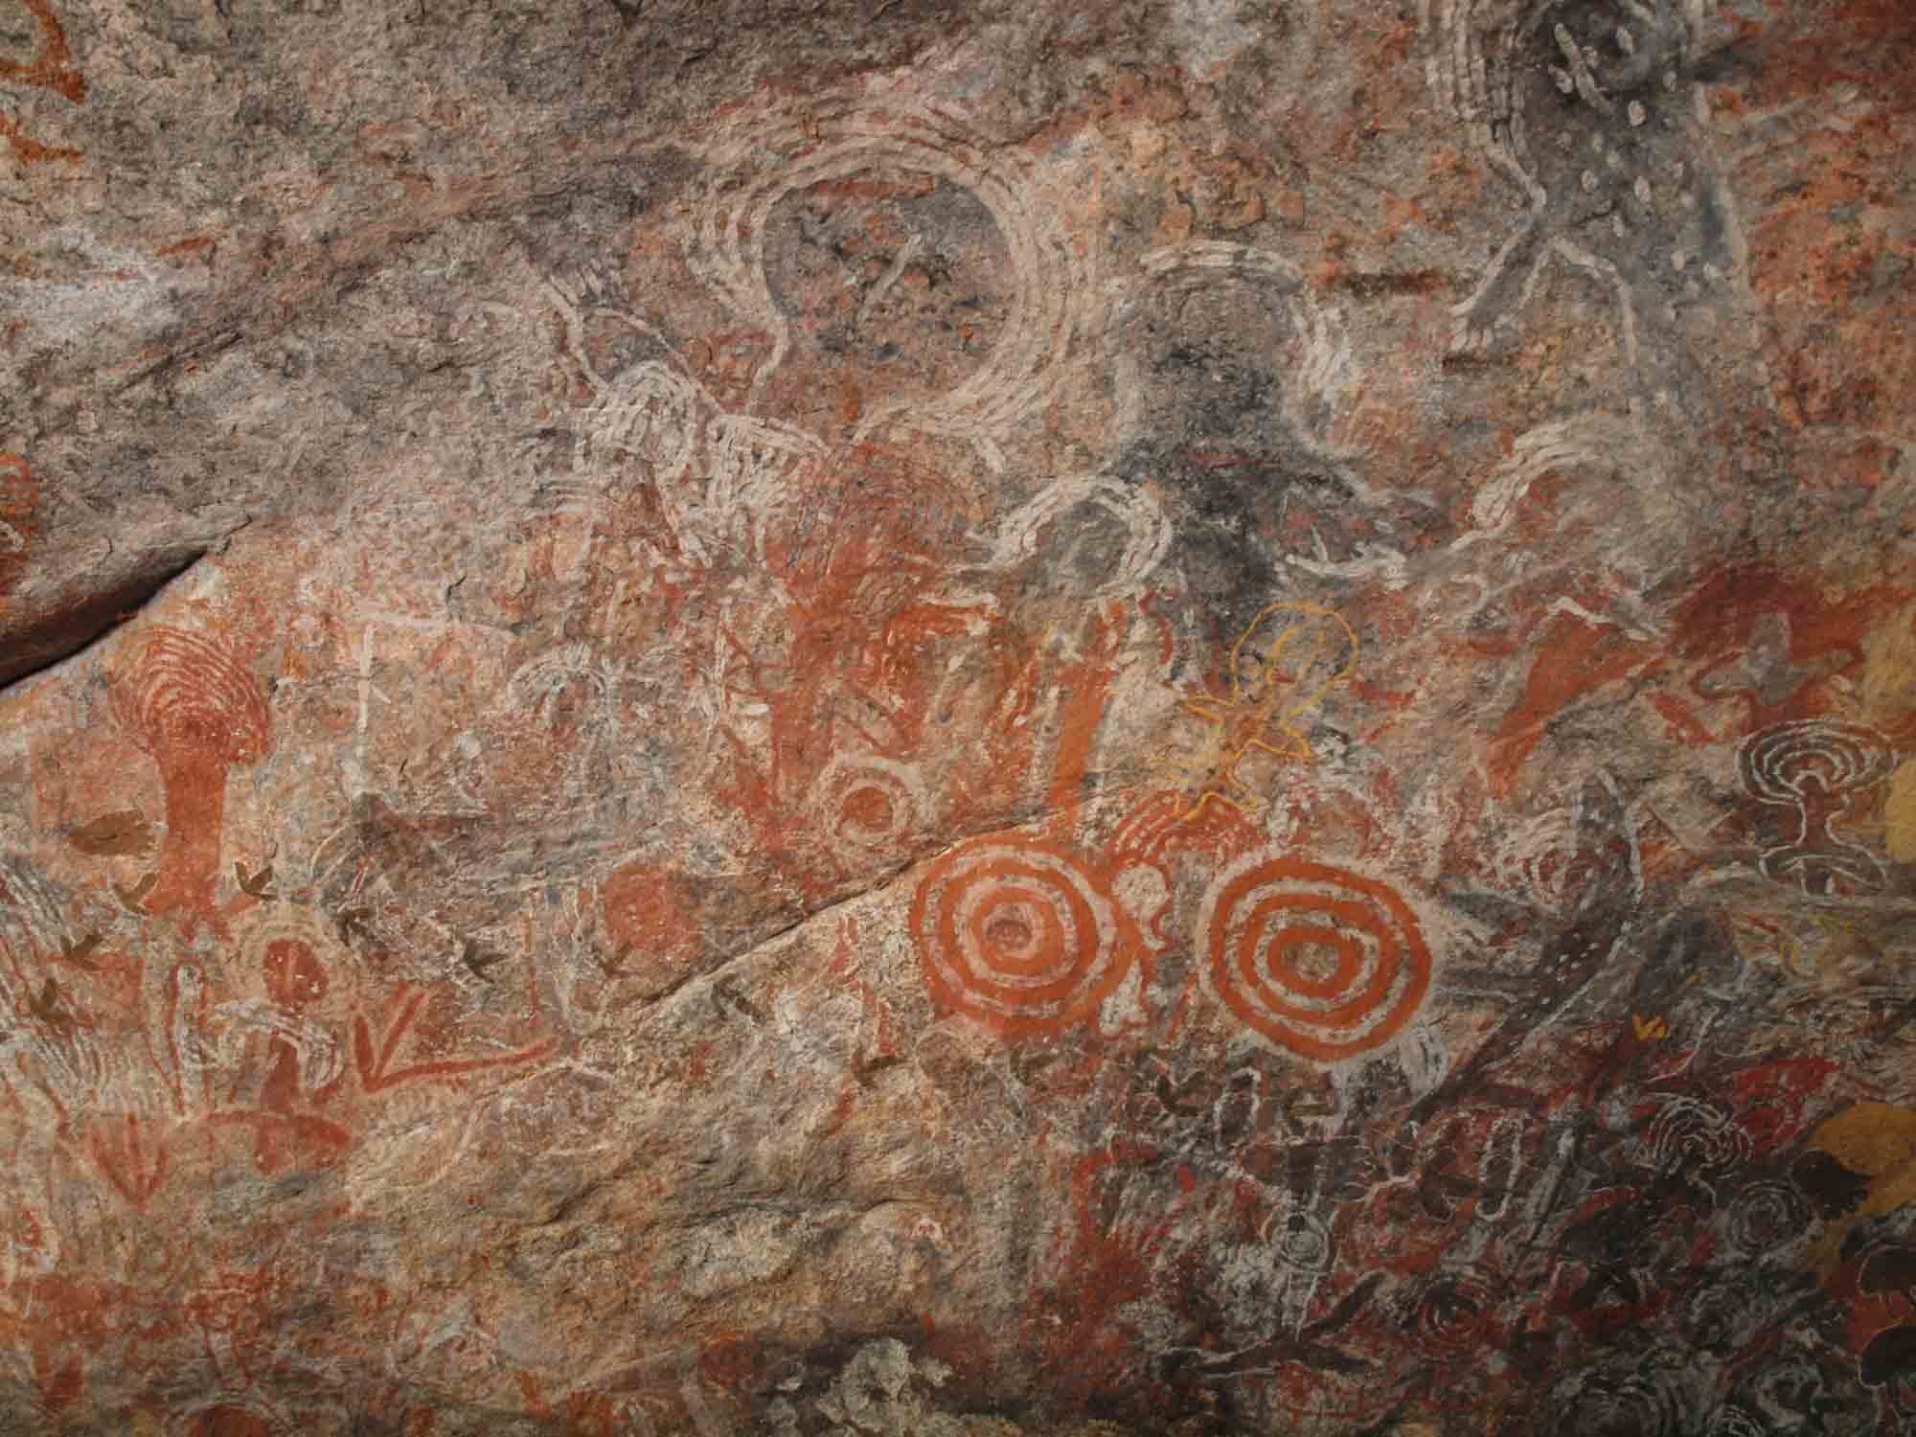  Walinynga (Source: National Museum Australia) | 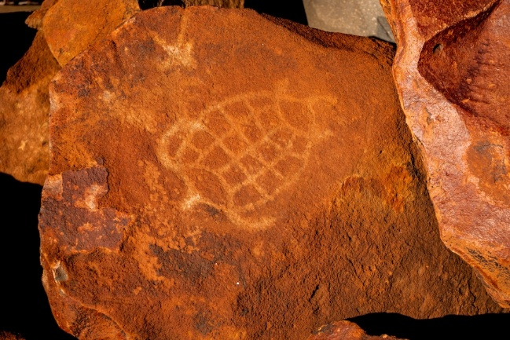  Murujuga rock art (Source: ABC)
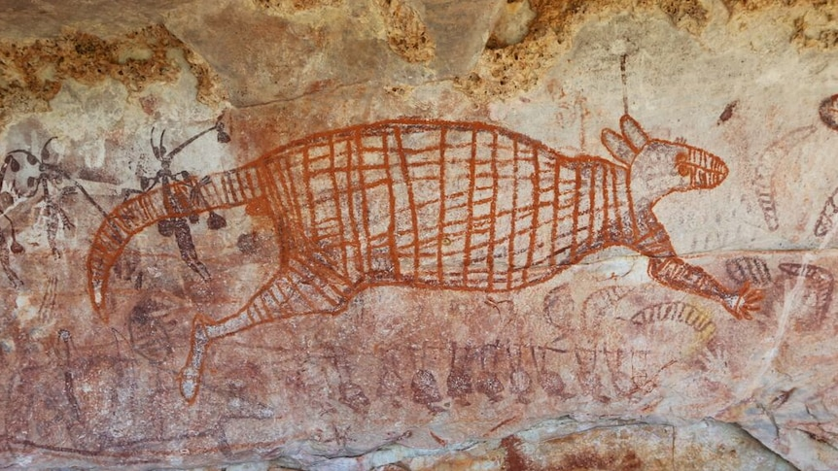  Rock art in the Kimberley. (Source: ABC News Supplied by Sven Ouzman) | 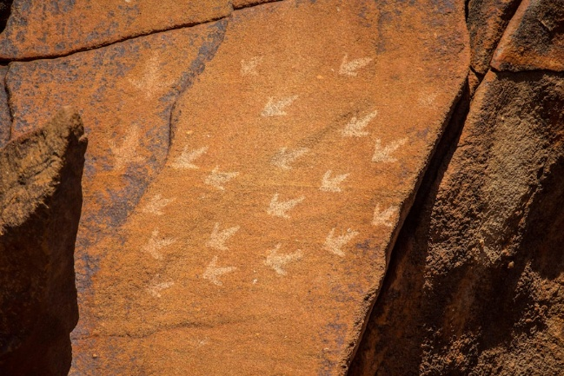  Murujuga rock art (Source: ABC)
Initial Observations
What do you notice?
- Describe the main features of the rock art. What sorts of colours, lines and shapes do you notice?
- What else do you notice? Can you see people, animals or spiritual figures in the art? Write as much as you can about what you see.
- What do you think the images are telling us?

Further Investigation
Students will respond to one or more of the following questions:
- Where is it located and how old is it? Locate on a map of Australia.
- What type of rock art is it? Is it a petroglyph or pictograph?
- Find the name of the place in both the Indigenous and English languages.
- What Indigenous language groups have connections to the land where the rock art is located?
- What story does the rock art tell? Is it a traditional Dreaming story? Explain what you know about the Aboriginal story.

Want to know more about where you live?
- Check out the Gambay language map to learn more about traditional languages spoken in your area.
- To learn whose Country you’re on, visit David Horton’s Map of Indigenous Australia on the AIATSIS site.
- Cross-reference with other sites, for example your local council or Aboriginal land council.

Activity: BTN Stories
Visit BTN’s collection of stories which focus on Aboriginal and Torres Strait Islander peoples’ history, culture and issues.

After watching any one of the BTN videos ask students to respond to the discussion questions (to find the discussion questions and teacher resources go to the related BTN Classroom Episode and download the Episode Package).

Collection of BTN stories with a focus on First Nations

Useful Websites
- Deep Time – ABC
- Deep time history of Australia – National Museum Australia
- Evidence of first peoples – National Museum Australia
- Deep time history of Australia resource – Australian Curriculum
- ‘We are from here’ – Digital Classroom: National Museum Australia
- The Human Revolution – ABC iView

KEY LEARNING
Students will learn about the Wave Hill walk-off and the contribution that Vincent Lingiari has made to Australian society.

CURRICULUM
HASS – Year 3 and 4
Pose questions to investigate people, events, places and issues.

Locate and collect information and data from different sources, including observations.

HASS – Year 4
the diversity of First Nations Australians, their social organisation and their continuous connection to Country/Place.

HASS – Year 5
the role of a significant individual or group, including First Nations Australians and those who migrated to Australia, in the development of events in an Australian colony.

the impact of the development of British colonies in Australia on the lives of First Nations Australians, the colonists and convicts, and on the natural environment.

HASS – Year 6
Experiences of Australian democracy and citizenship, including the status and rights of Aboriginal and Torres Strait Islander Peoples, migrants, women and children.

History – Year 7
the social organisation and cultural practices of early First Nations Australians, and their continuity and change over time.

  - Teacher Resource

Vincent Lingiari

This document contains the names and images of Aboriginal and Torres Strait Islander people now deceased. It also contains links to sites that may use images of Aboriginal and Torres Strait Islander people now deceased.

Activity: Personal Response
After watching the BTN Vincent Lingiari story students will complete one or more of the following incomplete sentences:
- Vincent Lingiari was important because…
- It was interesting to learn…
- These are five words that I would use to describe Vincent Lingiari.
- This story made me feel…
- It is important to remember Vincent Lingiari because …

Activity: Class Discussion

Discuss the BTN Vincent Lingiari story using the following discussion starters.
- Where is Wave Hill? Locate on a map.
- Who was Vincent Lingiari?
- Name one of his main achievements.
- Why was the Gurindji strike important?

Activity: Key words
Students will brainstorm a list of key words that relate to the BTN Vincent Lingiari story. Here are some words to get them started.
Indigenous rights
Recognition
Activist
Equality
Land rights
Native Title
First Nations peoples
Strike

Ask students to write what they think is the meaning of each word (including unfamiliar words). They will swap definitions with a partner and ask them to add to or change the definition. Check these against the dictionary definition.

Further Investigation
- What is advocacy? Ask students to give an example of when Vincent Lingiari was an advocate on Indigenous issues.
- In Australia, people speak up for Indigenous rights in many ways, like signing petitions, joining protests, going on strike, working in unions and taking action. What are some ways the Wave Hill walk-off showed these strategies?

Activity: Who was Vincent Lingiari?
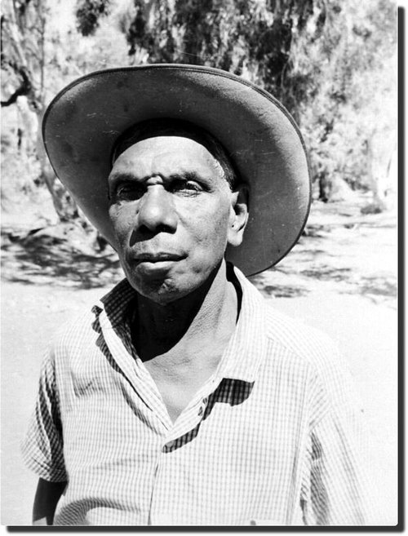
Students will develop a biography of Vincent Lingiari. Begin by discussing with students what a biography is. What information is included in a biography and what does it tell us about a person? Students can use the following questions to guide their research.
- When and where was Vincent Lingiari born?
- Who was his family?
- What was his occupation?
- How did he become a rights activist?
- What challenges did he face and how did he overcome them?
- What were his achievements?
- What is Vincent Lingiari’s legacy?
- What do you admire about him?

Further Investigation

Interview
Imagine you could sit down and talk to Vincent Lingiari. What questions would you ask about his life and achievements?
Portrait
Create a portrait of Vincent Lingiari. Explore and experiment with different techniques and mediums to produce a portrait.

Journal Entry
Imagine you are Vincent Lingiari. Choose a moment in your life to reflect on and write a journal entry.

Activity: Analysing a Source
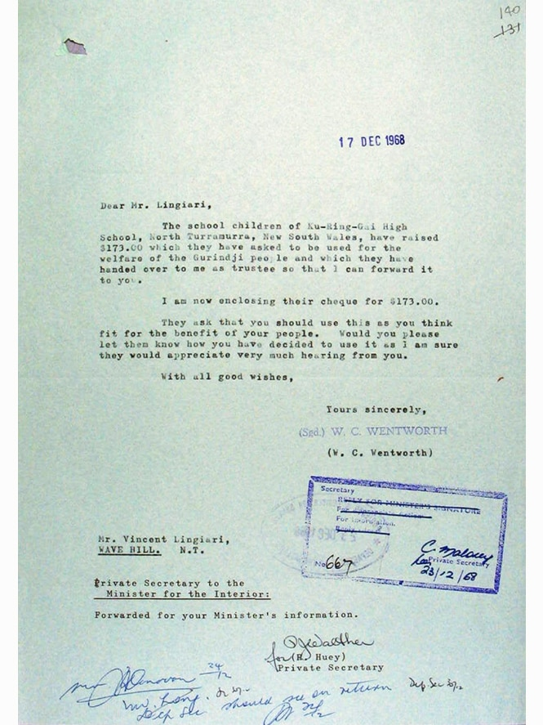
Below is a letter to Gurindji elder and strike leader Vincent Lingiari from school students to raise money to support the Gurindji Wave Hill walk-off, 1968. (Source: National Archives of Australia. A1734, NT1968/2509)

Students will read the letter and respond to the questions below.
- When was the letter written?
- Who wrote the letter? Who was the letter for?
- What information was included in the letter?
- Why did they write the letter? What was the aim of the letter?
- How do you think Vincent Lingiari felt as she read the letter? Give reasons for your answer.
- Is this letter a primary or secondary source? Explain your answer.

Letter to Vincent Lingiari (ABC Education)

Activity: Poetry
Poetry and lyrics – feel, think and wonder
As a class, listen to Paul Kelly’s song “From Little Things, Big Things Grow”. Alternatively take it in turns to read the song lyrics aloud.

In small groups respond to the following questions and then share your ideas with the class.
- Who are the main people and groups mentioned in the song?
- What events are being described? Why are they important?
- What emotions or messages do you think the artist wants to share?
- How does this song make you feel? Describe your emotions.
- Why is the meaning of the song title “From Little Things, Big Things Grow”? Write a short summary.

Further investigation
- Can you think of other songs that help us understand Australian history? Make a list.
- Choose one of the following songs, or choose one of your own, and conduct further research to find out what the song is about. Create a book of songs and background information to keep in your school library.

Song | Background
“Treaty”
By Yothu Yindi

“Took the Children Away”
By Archie Roach

“Beds Are Burning”
By Midnight Oil

Activity: Visual Literacy
Aboriginal land rights was an issue that Gough Whitlam tackled while he was Prime Minister. On August 16, 1975, Gough Whitlam returned traditional lands in the Northern Territory to the Gurindji people. This brought an end to their long struggle to reclaim their traditional country. The ceremony to officially hand back the land to the Gurindji people took place on August 16th, 1975, at Daguragu. Whitlam made a short speech before taking some sand and pouring it into the hands of Vincent Lingiari, the leader of the protest movement.
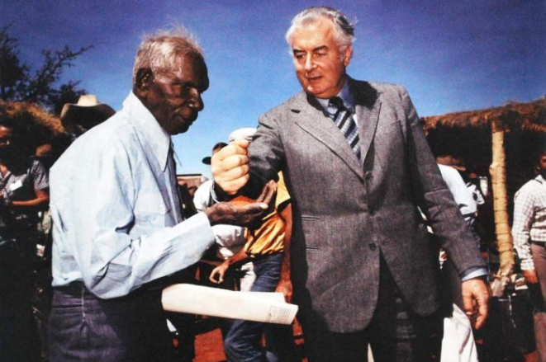
Show students the image of Prime Minister Gough Whitlam pouring soil into the hand of traditional landowner Vincent Lingiari. Hold a class discussion, responding to the following questions.
- What is happening in this photo?
- Why is this photograph symbolic? Consider that it is a reminder that all Australians share the same land and the same hopes.
- How does this image make you feel? Describe your emotions.

Learn more about land rights by watching BTN’s Mabo Day and Native Title stories.

Examine further images -
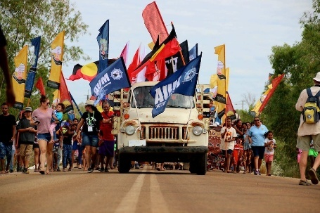  ABC News | 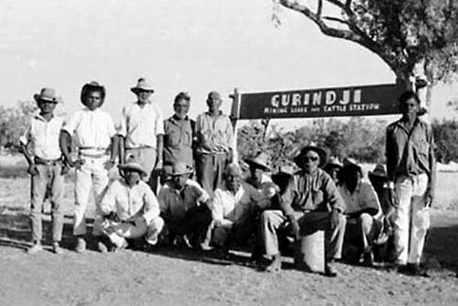  ABC News | 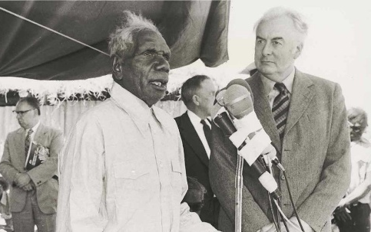  National Museum Australia

Useful Websites
- Vincent Lingiari the Leader – ABC Education
- Native Title – BTN
- Wave Hill Walk-Off – National Museum Australia
- Wave Hill Walk-Off (classroom resource) – National Museum Australia
- What’s special about Wave Hill? (learning module) – National Museum Australia
- This Day Tonight: Two years after the 1966 Wave Hill walk-off – ABC Education

