EPISODE 27
14th September 2021

KEY LEARNING
Students will view a range of BTN stories and use comprehension skills to respond to a series of focus questions.

CURRICULUM
English – Year 4
Use comprehension strategies to build literal and inferred meaning to expand content knowledge, integrating and linking ideas and analysing and evaluating texts.

English – Year 5
Use comprehension strategies to analyse information, integrating and linking ideas from a variety of print and digital sources.

English – Year 6
Use comprehension strategies to interpret and analyse information and ideas, comparing content from a variety of textual sources including media and digital texts.

English – Year 7
Use comprehension strategies to interpret, analyse and synthesise ideas and information, critiquing ideas and issues from a variety of textual sources.
  - Teacher Resource

Focus Questions

Zero Emissions
- What did the Zero Emissions story explain?
- What year do many countries want to reach net-zero carbon emissions by?
- What are fossil fuels? Give one example.
- What is it called when the sun’s heat gets trapped in the Earth’s atmosphere?
- What does it mean to be net zero or carbon neutral?
- What is a greener alternative to petrol cars?
- What gas do trees absorb?
- Name one country that has committed to net zero carbon emissions by 2050.
- Why has Australia been criticised by other countries about its commitment to becoming carbon neutral?
- What did you learn watching this story?

Check out the Zero Emissions resource on the Teachers page.

COVID Mental Health
- Discuss the COVID Mental Health story in pairs. Record the main points of the discussion.
- Dr Tegan says the most important thing we can all do right now is to talk about how we are ___________.
- Who can you talk to if you are feeling scared or sad?
- During a lockdown you should keep your normal sleep schedule. True or false?
- What routines are important to keep during a lockdown?
- How can you stay connected with friends and family during a lockdown?
- How has COVID made you feel? Discuss as a class.
- What have you been doing to look after your mental health?
- What questions do you have about this story?
- Write a letter to a friend or family member to stay connected.

China Gaming Curfew
- Summarise the China Gaming Curfew story.
- What organisation considers gaming addiction as an illness?
- What percentage of young online gamers in China are addicted?
  - 7%
  - 17%
  - 70%
- What is China’s online gaming curfew?
- Kids won't be able to play online games at all from Monday to Thursday. True or false?
- How are some young people getting around the rules?
- What technology are gaming companies using to find kids breaking the rules?
- What do people in China think about the curfew?
- Do you think there should be a gaming curfew in Australia? Why or why not?
- What was surprising about the BTN story?

History of Democracy
- Summarise the History of Democracy story.
- What ancient civilisation came up with the idea of democracy?
- What does democracy mean?
- What type of government was common during the Middle Ages?
  - Democracy
  - Monarchy
  - Anarchy
- What year was the Magna Carta created?
- How did the Magna Carta impact on England’s kings and queens?
- When did America become democratic?
- What is a constitution?
- What is the role of a politician?
- What questions do you have about this story?

Check out the History of Democracy resource on the Teachers page.

Songs of Support
- Retell the Songs of Support story using your own words.
- Where is Urbenville Public School? Find on a map.
- Where did the kids from Urbenville Public School put on a show when the pandemic first started?
- How did COVID impact on their show?
- What social media app did they use to help them perform their show?
- How is the show helping people around Australia?
- What big event is the school planning for?
- What music star is the school hoping will come and perform with them?
- How did the story make you feel?
- Illustrate and aspect of the story.

EPISODE 27
14th September 2021

KEY LEARNING
Students will investigate ways to reduce carbon emissions at home, school and in the community.

CURRICULUM
Geography – Year 4
The use and management of natural resources and waste, and the different views on how to do this sustainably.

HASS – Year 4
Reflect on learning to propose actions in response to an issue or challenge and consider possible effects of proposed actions.

HASS – Year 5 & 6
Reflect on learning to propose personal and/or collective action in response to an issue or challenge and predict the probable effects.

HASS – Year 7
Reflect on learning to propose personal and/or collective action in response to an issue or challenge, taking into account different perspectives, and describe the expected effects.

Science – Year 4
Science knowledge helps people to understand the effect of their actions.

Science – Years 5 & 6
Scientific knowledge is used to solve problems and inform personal and community decisions.

  - Teacher Resource

Zero Emissions

Focus Questions
Discuss the BTN story as a class and record the main points of the discussion. Students will then respond to the following:
- What did the Zero Emissions story explain?
- What year do many countries want to reach net-zero carbon emissions by?
- What are fossil fuels? Give one example.
- What is it called when the sun’s heat gets trapped in the Earth’s atmosphere?
- What does it mean to be net zero or carbon neutral?
- What is a greener alternative to petrol cars?
- What gas do trees absorb?
- Name one country that has committed to net zero carbon emissions by 2050.
- Why has Australia been criticised by other countries about its commitment to becoming carbon neutral?
- What did you learn watching this story?

Activity: Class Discussion
After watching the BTN Zero Emissions story students will reflect on the story and then respond to the following:
- What do you THINK about what you saw in the BTN story?
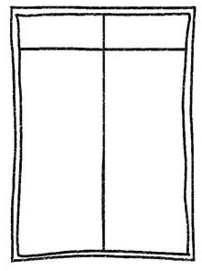
- What does it mean to have net zero emissions?
Positives Challenges
- What are some ways that we can achieve net zero carbon emissions by 2050?
- Think of three questions you have about the BTN story.
- What are the positives and challenges of trying to reach zero emissions? Create a T-chart.

Activity: Vocabulary
Students will brainstorm a list of keywords that relate to the BTN Zero Emissions story. Here are some words to get them started. Students will create their own class glossary of keywords and terms. Students can use illustrations and diagrams to help explain each keyword.
CARBON EMISSIONS | FOSSIL FUELS | RENEWABLE ENERGY
ATMOSPHERE | CLIMATE CHANGE | FOOTPRINT
GLOBAL WARMING | SUSTAINABILITY | GREENHOUSE GAS

Further investigation: Tricky Words
Students will choose additional keywords and terms to add to their class glossary that are tricky. For example, carbon offsetting, CFCs, emission trading scheme, Kyoto Protocol or greenhouse effect. Students will find a definition and explain to their classmates what the keywords mean.

Activity: Six Hat Thinking
As a class, use Edward De Bono’s Six Hat Thinking to explore the issues raised in the BTN Zero Emissions story. Make your own coloured hat cut-outs and place on the floor. Students will take it in turns answering questions in relation to what they already know about the issue, what they have learned from the story and what they want to learn further about the topic.

Reflection
After this activity, ask students to reflect on what they have learnt. Students can include details about how their thinking on this issue has changed.

How did the Zero Emissions story make you feel?

What do you know about the topic?
What have you learnt from the story?
Were there any positives from the story? If so, what were they?
What are some of the negatives or challenges that you learnt from the story?
Why is it important to find out more about the topic?
What questions were raised during this activity?
What do you want to learn further about this topic?

Activity: KWLH
Hold a class discussion about the information raised in the BTN Zero Emissions story. What questions were raised in the discussion and what are the gaps in their knowledge? The following KWLH organiser provides students with a framework to explore their knowledge on this topic and consider what they would like to know and learn.

What do I know? | What do I want to know? | What have I learnt? | How will I find out?

Research questions for Inquiry
Students will start to think like a scientist and develop their own question/s for inquiry, collecting and recording information from a wide variety of sources. Students may develop their own question for inquiry or select one or more of the questions below.

- What is carbon offsetting? Find a real life example of a company that is carbon offsetting and explain what they have committed to, to reduce their carbon footprint.
- What is the difference between weather and climate? Use meteorological terms in your explanation.
- What is currently being done to reduce our carbon footprint? Think about how your family, school, businesses and the government are trying to reduce their carbon footprint. Give examples.
- What is the difference between the Kyoto Protocol, the Paris Agreement and the Geneva Convention? How is Australia committing to these agreements?
- How can a city reach net zero carbon emissions? Design a sustainable community (think about transport, renewable energies, being water smart, recycling programs, growing food locally, changing habits) to represent your findings.
- What does climate change look like? Use images to show the impact of climate change in Australia. For example, bleaching of coral reefs in the Great Barrier Reef, dry lightning storms in Tasmanian World Heritage Forests or rising sea levels flooding mangroves.

Activity: Take action
Ask your students ‘What can we do and why is it important to get involved in tackling climate change?’ Facilitate a brainstorming session and record students’ responses on a mind map. Individually or in pairs, students will explore ways their school and home can reduce their carbon emissions and become more environmentally sustainable.

Students can undertake one or more of the following activities:
- School energy audit – track your school’s energy usage and calculate your carbon emissions. How can your school reduce its carbon emissions? For example, turn of lights when not in use, turn off computers at the end of the day, find alternatives to driving to school, buy locally sourced seasonal food and reduce your waste. Share your results with the school community.
- Does your school have solar panels? If not, conduct a study and present it to your school.
Research the benefits of using solar energy at your school. Does your school have a plan to reduce its carbon footprint? If so, find out what your school’s targets are in reducing its carbon emissions. Would installing solar panels reduce your schools carbon emissions? Explain.
- Write letters to local or federal politicians expressing your school’s views on greenhouse gas emissions and its impact on communities, plants and animals in your local area.
- Contribute a class article to the school newsletter sharing your research.
- Invite a scientist to visit your school to talk about the difference between weather and climate.
- Contact your local council and/or other schools in the area to find out how they are reducing their carbon footprint. Share ideas on how your community can reduce their greenhouse gas emissions.
- Design a special lesson to teach other kids at your school about why it’s important for people to take action against global emissions.
- Propose some goals (short-term and long-term) that your school could set to try and reduce their carbon footprint. Include a pact or plan of action in your proposal.

Activity: What is the Greenhouse Effect?
Working in pairs or small groups, ask students to discuss their understanding of the greenhouse effect. Use the following questions to guide discussion.
- What is the greenhouse effect?
- Why is it called the greenhouse effect?
- How is the earth a greenhouse? What are the similarities between earth’s atmosphere and a greenhouse that you would find in a garden?

In their pairs or groups, students will create a diagram/illustration to explain the greenhouse effect, including the following elements in their image: sun, earth, atmosphere, ozone layer and greenhouse gases.

What are the Consequences?
Ask the class to consider a range of consequences for not reducing greenhouse gas emissions. Rate the consequences on a scale of 1 to 10, where 1 is a low impact and 10 is severe impact.

Have students give their opinion on the likelihood of each consequence. Below are some suggested consequences:
- Rising temperatures
- Ice will melt
- Sea levels will rise
- Plants and animals at risk
- How are our natural ecosystems affected by climate change? (e.g., the Great Barrier Reef ecosystem)
- Health will be affected
- Extreme weather (heat waves, flooding, bushfires, drought)

Activity: What is climate change?
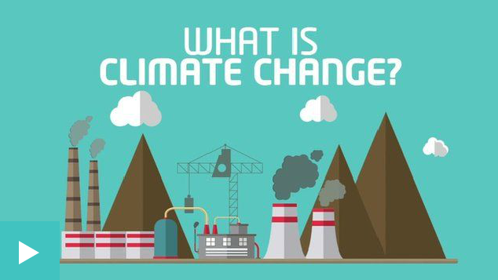
The following video explains what climate change is and the impact rising temperatures could have. Watch the Newsround video and answer the following questions:
- Pollution that causes climate change comes from what?
- Why is 2 degrees an important number?
- What are some of the effects of climate change?
- What can be done to reduce the impact of climate change?

Activity: BTN stories
Watch one of the following BTN stories to learn about hands-on projects that kids around Australia are working on at home, in the classroom and in the community to help the environment and reduce their carbon footprint. After watching any one of the BTN videos ask students to respond to the discussion questions (to find the teacher resources go to the related BTN Classroom Episode and download the Episode Package).

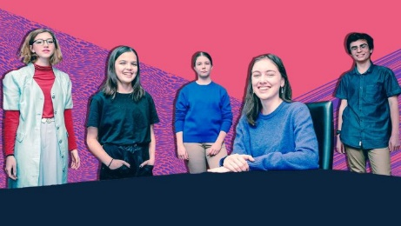  Climate Change Court Battle | 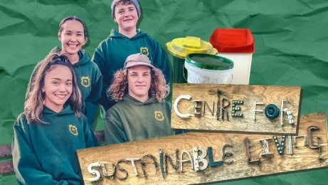  School Recycling Campaign | 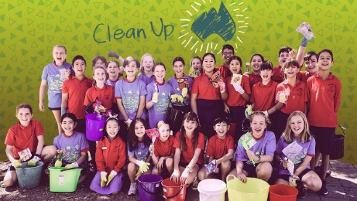  Clean Up Australia
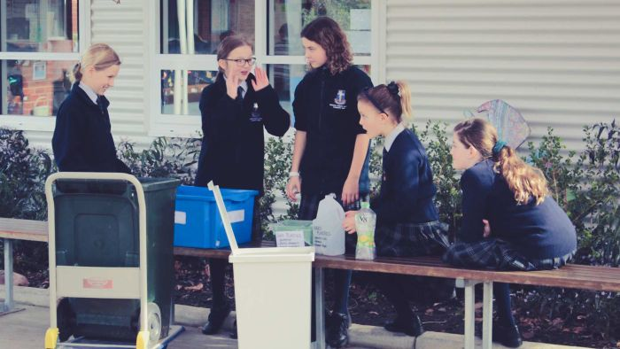  Recycling Solution | 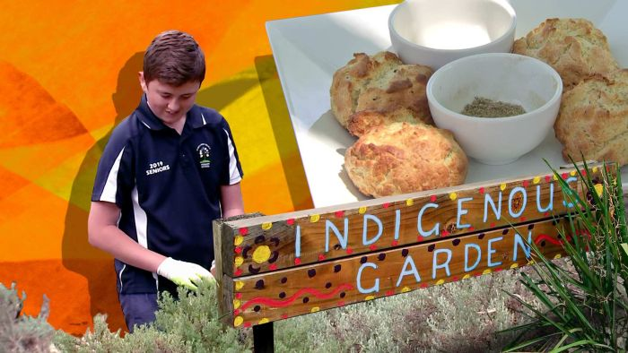  Bush Tucker Garden | 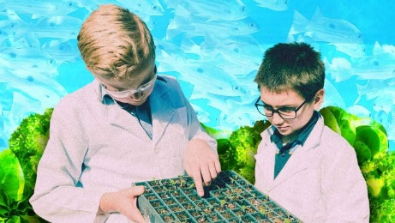  Aquaponics School
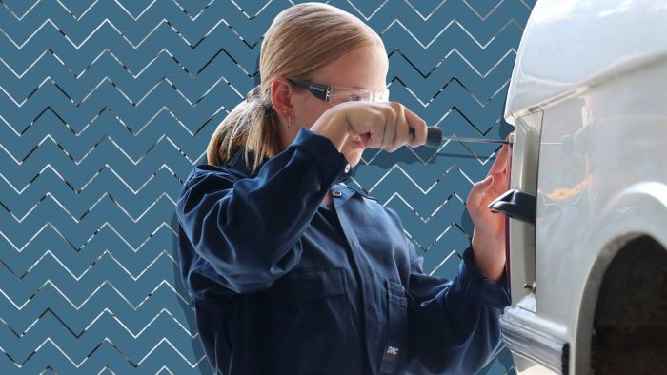  Electric Car Class | 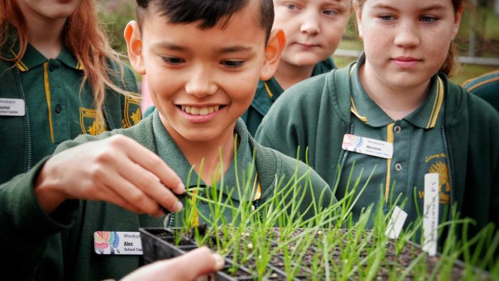  Endangered Seeds | 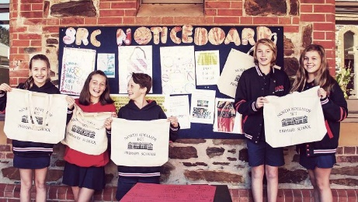  War on Waste School

Activity: Quiz
- What is the international treaty on climate change?  A. Paris Agreement  B. Kyoto Protocol  C. Geneva Convention  - Which of these is a greenhouse gas?  A. Carbon dioxide  B. Methane  C. Nitrous oxide  D. All of the above  - What is the chemical formula for carbon dioxide?  A. CO2  B. C2O  C. O2  - The Earth’s atmosphere is made up mostly of oxygen.  A. True  B. False  - What is NOT a fossil fuel?  A. Coal  B. Natural gas  C. Wood | - What does CFC stand for?  A. Carbon fluoro compound  B. Chloro fluoro carbon  C. Carbon fuel cycle  - What produces the MOST greenhouse gas emissions?  A. Electricity  B. Manufacturing  C. Transportation  - What is it called when there is a balance between emitting carbon and absorbing carbon from the atmosphere?  A. Global warming  B. Greenhouse effect  C. Net zero emissions  - What gas do trees absorb?  A. Methane  B. Carbon dioxide  C. Oxygen  - Which country has NOT yet committed to net-zero emissions by 2050?  A. Australia  B. Sweden  C. United Kingdom
Quiz Answers: 1A, 2D, 3A, 4B, 5C, 6B, 7A, 8C, 9B, 10A.

Useful Websites
- Understanding Climate Change – BTN
- Climate change: What is it and why is everyone talking about it? – Newsround
- Choose your climate future – WWF
- Net Zero Coalition – United Nations
- ‘No blank cheque’ on net zero carbon emissions target, PM says, as global ‘code red’ issued – ABC News
- Climate – WWF

  - Teacher Resource
EPISODE 27
14th September 2021

KEY LEARNING
Students will learn more about significant events in Australian democracy.

CURRICULUM
Civics and Citizenship – Year 5
The key values that underpin Australia’s democratic system of government.

Civics and Citizenship – Year 6
The key institutions of Australia’s democratic system of government and how it is based on the Westminster system.

The responsibilities of electors and representatives in Australia’s democracy.

History – Year 6
Key figures, events and ideas that led to Australia’s Federation and Constitution.

Experiences of Australian democracy and citizenship, including the status and rights of Aboriginal and Torres Strait Islander Peoples, migrants, women and children.

History of Democracy

Focus Questions
- Summarise the History of Democracy story.
- What ancient civilisation came up with the idea of democracy?
- What does democracy mean?
- What type of government was common during the Middle Ages?
  - Democracy
  - Monarchy
  - Anarchy
- What year was the Magna Carta created?
- How did the Magna Carta impact on England’s kings and queens?
- When did America become democratic?
- What is a constitution?
- What is the role of a politician?
- What questions do you have about this story?

Activity: Class Discussion
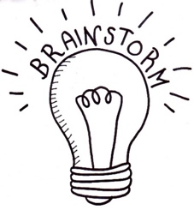
Discuss the BTN History of Democracy story as a class. Ask students to record what they know about democracy. What questions do they have? Use the following questions to guide discussion:
- Where does the word democracy come from?
- What is democracy? Come up with a class definition.
- Australia is a democratic society. What does this mean?
- How would our lives be different without democracy?

Activity: Glossary
Create your own glossary about democracy. Start by brainstorming words using a mind map to record your ideas. Add to your list of words by downloading the BTN History of Democracy story transcript and highlighting all the words that relate to democracy. Find definitions for each word.

DEMOCRACY | REPRESENTATIVE DEMOCRACY | MONARCHY
MAGNA CARTA | CONSTITUTIONAL DEMOCRACY | PARLIAMENT

Activity: Democracy Research
After watching and discussing the BTN History of Democracy story, what questions do students have? The following KWLH organiser provides students with a framework to explore their knowledge on this topic and consider what they would like to know and learn.

What do I know? | What do I want to know? | What have I learnt? | How will I find out?

- Compared to some parliaments around the world, Australia’s is quite young, but it is based on practices and ideals from parliaments in centuries past. Research the origins of parliament and present your findings in a timeline which highlights significant events. Find similarities and differences between ancient parliament and Australia’s parliament now.
- Magna Carta has become a powerful symbol of our rights and freedoms. Why was Magna Carta originally created? What would life be like if Magna Carta didn’t exist? This British Library video explains more.
- Investigate the key values that underpin Australia’s democratic system of government: freedom, equality, fairness and justice. What does each value mean to you? Why are these values important?
- What are the benefits of democracy? Is everyone’s experience of democracy the same?

Activity: Telling the story of Australian democracy
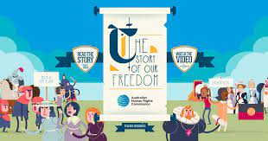
Take a look at this fun and engaging infographic, The Story of Our Freedom, to get a picture of the origins of democracy and how it has influenced our rights and freedoms today.

Students can then create their own timeline highlighting the main events that led to democracy in Australia. Research the origins of democracy and what democracy looks like in Australia today. Include three significant facts about each event. Reflect on ways in which people in ancient societies were represented and compare to Australia today.

Activity: Representative democracy
In Australia we have something called a representative democracy. That means that unlike in ancient Greece where everyone went to meet and vote on laws, we elect a representative to do that for us. They're our politicians and they represent us in parliament. It's their responsibility to keep in touch with their voters and make sure their voices are heard on a national level.
What makes a good representative?
Ask students to think about the following question: What do you think makes a good representative? Brainstorm and list what a good representative ‘is’, ‘does’, ‘does not’ and ‘says’. Record their ideas. Here are some examples:
- honest
- good at communicating
- confident
- has a positive attitude
- commitment
- creative
- inspiring

Run your own election
Running an election for your class provides the opportunity for students to participate in the democratic process of choosing representatives for a range of purposes. Students will run their own election and investigate how the preferential voting system works.

Watch BTN’s Preferential Voting story to find out why people’s preferences matter on election day. Visit the Australian Electoral Commission’s Get Voting website. Get voting is everything you need to run a free and fair election for your class.

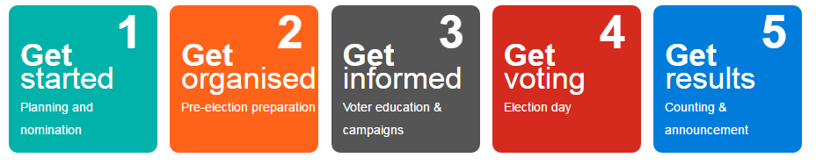

Activity: Visual literacy
In this activity students will examine, analyse and query a range of images which show significant moments in Australia’s history of democracy. Students will choose one or more of the images below and respond to the following:
- What is happening in the image? Create a caption for each image.
- How does the image make you feel?
- What does the image tell you about democracy in Australia?
- What questions do you have about what you see in the image?
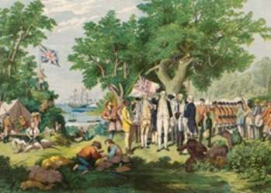  MoAD | 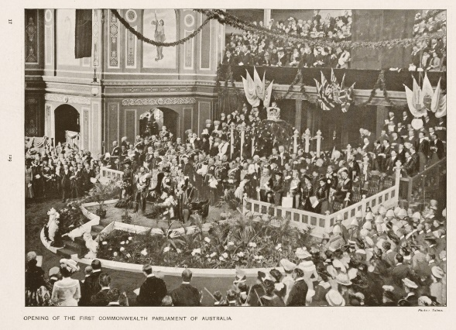  MoAD
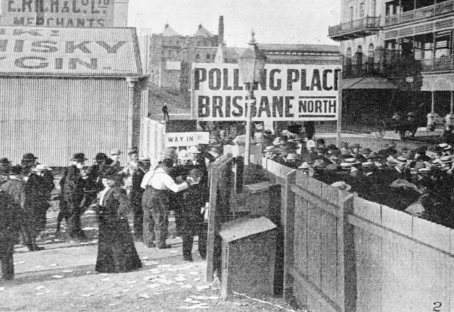  MoAD | 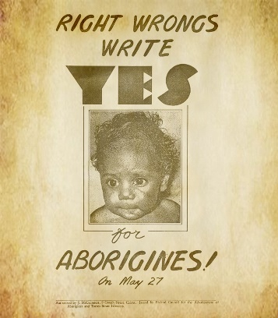  AIATSIS

Further investigation
Students can find and collect images, photographs and illustrations that represent the history of democracy in Australia. Students can organise and sequence their pictures in the form of a timeline.

Activity: Women in Politics Timeline
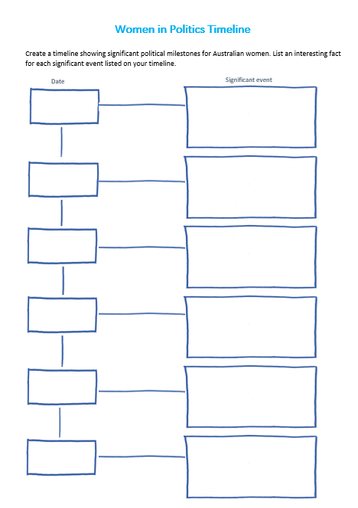
Students create a timeline showing significant political milestones for Australian women. Use the timeline template at the end of this activity to record key dates and milestones. Students can use the following questions to guide their research:

- When did women get the right to vote in Australia?
- Which state first gave women the right to vote?
- When were women first given the right to stand for Federal Parliament in Australia?
- When were Australian Aboriginal women given the right to vote?
- Who was the first woman to be elected to the House of Representatives?
- Who was the first woman to be elected in the Senate?
- Who was Australia’s first female Prime Minister?

Activity: 1967 Referendum
The BTN 1967 Referendum story explains how a majority of Australians voted to change our country’s laws to count Indigenous Australians as full citizens. Students watch the story and then respond to the following questions.

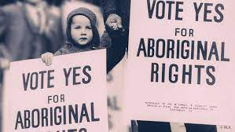
- Did Aboriginal people have equal rights to other Australians in the 1960s? Explain.
- In what year were Indigenous Australians given the right to vote in Federal Elections?
- To change the constitution there has to be a referendum. True or false?
- What is a referendum?
- In 1967 what percent of Australians voted ‘yes’ to change the constitution?
- Discuss why it is important to remember Australia’s 1967 referendum.
- How do you think being left out of the Constitution affected Aboriginal people?

Activity: Museum of Democracy Digital Excursion
The Museum of Australian Democracy’s Digital Excursions bring Old Parliament House directly into the classroom. These digital programs allow Museum Educators to connect with students in real time and guide them through the building to explore some key people and events in our democracy. Students participate in interactive activities and discussions to learn more about their role as active citizens and our democratic history. Find out more here

Activity: Democracy Quiz

- Who created the first form of democracy?  A. Ancient Greece  B. Ancient Rome  C. Ancient Egypt  - In which year did Federation  occur?  A. 1899  B. 1900  C. 1901  - In Australia, the public doesn’t  vote in a Prime Minister.  A. True  B. False  - In which city did parliament  first meet?  A. Canberra  B. Melbourne  C. Sydney  - Who does the Governor-General  represent in Australia?  A. Prime Minister  B. The people  C. The Queen | - How many levels of government  are there in Australia?  A. 1  B. 2  C. 3  - Voting in Australia is NOT  compulsory.  A. True  B. False  - At what age is it compulsory  for an Australian citizen to vote?  A. 16 years old  B. 18 years old  C. 21 years old  - When was a referendum  held to change the Constitution  so that Aboriginal and Torres Strait Islander people were counted in the census?  A. 1901  B. 1962  C. 1967  - Victoria was the first state to give women the right to vote.  A. True  B. False
Quiz Answers: 1A, 2C, 3A, 4B, 5C, 6C, 7B, 8B, 9C, 10B, South Australia was the first state to give women the vote.

Useful Websites
- Defining Democracy – Museum of Australian Democracy
- Democracy - Parliamentary Education Office
- Milestones in Australian democracy – MOAD
- What is Democracy? – BTN
- Magna Carta – BTN
- History of Voting – BTN
- Australian Women in Politics – BTN
- 1967 Referendum – BTN
- Federation – BTN
- The story of our freedom – Human Rights Commission

Women in Politics Timeline
Create a timeline showing significant political milestones for Australian women. List an interesting fact for each significant event listed on your timeline.

Date
Significant event

  - Teacher Resource

BTN Transcript: Episode 27 - 14/9/2021

Hey, I’m Amelia Moseley and you're watching BTN. Here’s what’s coming up. We go back in time to learn about the history of democracy, get tips on looking after ourselves during lockdown and meet some kids offering a bit of choral support to their community.

Zero Emissions

Reporter: Amelia Moseley

INTRO: All that soon. But first up, to a goal that the UN, some big countries and big businesses want the Aussie government to start aiming for. They want our politicians to commit to a zero emissions target in the next 30 years. So, what does that mean? Let's find out.
Over the past few years, many world leaders have been racing to set a goal, one that scientists say will help fight climate change. It's, oh, well I'll let them tell you.
JOE BIDEN, US PRESIDENT: Put our nation on the road to net zero emissions no later than 2050.
BORIS JOHNSON, UK PRIME MINISTER: To net zero carbon emissions by 2050.
JUSTIN TRUDEAU, CANADIAN PRIME MINISTER: And we will make it law to respect our new 2030 target and achieve net zero emissions by 2050.
Yup, net zero emissions by 2050. But what does that actually mean? Good question, Amelia. As you probably know every time we burn fossil fuels like coal, oil and gas, we're releasing greenhouse gases into the atmosphere which are trapping the sun's heat and causing our planet to warm up. But scientists say we can hit the brakes on global warming by balancing our emissions or getting to net zero or carbon neutral. That means the amount of gases we're putting into the atmosphere isn't more than the amount we're taking out. To get there, experts say we can do things like replace fossil fuels with greener energies, swap petrol cars for electric ones and plant more trees which absorb carbon dioxide.
DANIEL SWAIN, CLIMATE SCIENTIST: We still have our foot on the gas pedal of increasing carbon emissions, but as soon as we take our foot off that gas pedal, the climate system is still going to respond.
Many countries have already joined the race to net zero by 2050 including the US, UK, Canada and New Zealand, and a few like Finland, Germany and Sweden are aiming to get there even sooner.
BORIS JOHNSON, UK PRIME MINISTER: We'll no longer make any contribution whatsoever to the destruction of our precious planet.
But while Australia has set a goal to reduce emissions by 2030, we haven't set an official target for net zero.
SCOTT MORRISON, AUSTRALIAN PRIME MINISTER: It's not a question of if or even by when for net zero, but importantly how.
Australia's been criticised by the US and UK governments, the United Nations, and recently some big business leaders in Australia for being slow off the mark on climate action and not setting the same 2050 target as other wealthy countries.
Selwin Hart, Special Advisor to the UN Secretary-General on Climate Action: If the world does not rapidly face off coal, climate change will wreak havoc across the Australian economy from agriculture to tourism.
Of course, driving a whole country towards zero emissions isn't easy. Especially for a place like Australia which has big reserves of fossil fuels which have given us cheap fuel and helped to grow the economy and employ lots of people. It also costs money and takes time to make the switch to new technologies. But many big Aussie businesses, and some states, have decided it's worth a go and have set their own targets for, well you guessed it.
Mike Henry, BHP CEO: Our ambition is to be net zero by 2050.
We'll have to wait a few decades to see who makes it across the net zero finish line, but it's hoped the changes we humans make will help take our planet to a happier, healthier place.
Did You Know?

Bhutan in South Asia and Suriname in South America are the only countries that already absorb more greenhouse gases than they emit.
News Quiz

There have been big ceremonies in the US to mark the anniversary of the September 11 terrorist attacks. What year did they happen in? 2001, 2009 or 2011? They happened in 2001, 20 years ago.

Kids over 12 are now getting vaccinated in Australia. At the moment they’re able to get Pfizer but soon they’ll be able to get another vaccine made by what company? Moderna, AstraZeneca or Johnson & Johnson? It’s Moderna.

Which city will host this year’s AFL Grand Final? It’ll be in Perth for the first time ever and locals are pretty stoked. Last year it was in Brisbane because Melbourne was in lockdown and this year it’s happened again.

The NRL Grand Final has to move too for the first time in its history. Where will it be held? It’ll be in Brisbane, where all 16 teams have been based for the past 3 months. It’s usually held in Sydney but again, COVID.

To mark Threatened Species Day last week, the National Film and Sound Archive released this newly restored and colourised vision of the last Thylacine or Tasmanian Tiger who died on September 7th, 1936. Do you know what his name was? Teddy, Benjamin or Bilbo. His name was Benjamin.

And this hat, which is going up for auction in the UK, contains the DNA of a very famous French military and political leader. What was his name? Napoleon Bonaparte, Napoleon Perdis or Napoleon Dynamite? It was Napoleon Bonaparte. He was born in 1769 and led several successful military campaigns before being named emperor of the French in 1804.

COVID Mental Health

Reporter: Jack Evans
INTRO: Now I don't have to tell you that things are kinda tough right now. a big chunk of Australia’s population is in lockdown and that can have a pretty big impact on our mental health. So, this week we've spoken to some of you guys about how you're doing and asked an expert for advice on how we can look after ourselves and stay healthy. Check it out.
LIV: I hate that we've been in lockdown for so long it's been over 2 months of the same thing every day. The constantly rise in case numbers are definitely worrying. Right now, it feels like they're going to keep going up and not come down any time soon.
AMELIA: Most of the time is ok, but some days it is hard not knowing how long we're going to be in lockdown for. It does get frustrating.
ALICE: Honestly, it doesn't feel really good because I miss my family. I miss my friends. I even miss the normal routine of school. I'm also really worried about getting the COVID injection, because I really don't like needles, but I know I should get it but I'm worried about that.
BEN: Well, I really worry about my family catching it because they're family and I really worry because all these people, they're like gathering without masks and I'm like, you're gonna get COVID, you're gonna get COVID.
Yep, right now a lot of us are feeling all sorts of feelings. And, especially for those of us in lockdown, it's not always easy.
DR TEGAN CRUWYS: A situation like lockdown is, is a huge change. And it's also very uncertain. We can't go to school, and we can't go see our friends. We don't know when it's going to end, those are definitely times that we know really affect the way we feel and our wellbeing.
Dr Tegan Cruwys is a psychologist and lives in Canberra, so she knows what it's like to live in a lockdown. She's also been studying the impacts COVID-19 has had on people’s mental health.
DR TEGAN CRUWYS: One of the things that is particularly hard about lockdown as well is that we know that in normal times, something that keeps us healthy, is being in contact with our communities. So, seeing our friends having lots of different activities and groups that we're involved in, that's really good for our wellbeing. So, one of the things that can be really stressful about lockdown is it sort of forces us to not be in contact with those groups that are really meaningful.
TOM: I really miss playing soccer with my soccer team. It's a new one and I really miss that.
BEN: Things I really miss because we're lock down. I miss going to the movies, hanging out my friends. playing sport, doing the musicals I'm in, missing school, who would have thought I'd miss school, all that kind of stuff.
Dr Tegan says the most important thing we can all do right now is to talk about how we're feeling.
DR TEGAN CRUWYS: So, with our families and with our friends to say that we are feeling a bit scared or a bit sad, you know, there's nothing to be ashamed of in that.
Another tip is to stick to a routine.
DR TEGAN CRUWYS: Keeping our sleep schedule, the way it normally is, you know, the times we normally eat, the family activities we normally do, going for a walk every day, these kinds of routines kind of give our lives structure and it can be really helpful in keeping us on the rails.
Tip number three is stay connected to each other.
DR TEGAN CRUWYS: So, if lockdown means you can't see your friends face to face, it doesn't mean we can't stay connected with them. Maybe you can connect with them online, maybe you can connect with them, you know the old fashioned way, by writing messages through the mail.
Remember the bad times won't last forever and, in the meantime, we have to stick together, look after each other and do things that make us feel good.
LIV: I've been drawing, playing guitar and I also have zoom drama twice a week. It's a great way to relax and forget about COVID for a while.
ALICE: I like to escape to one of my books or I like to listen to music because that really helps me.
BEN: Well, I have a trampoline. So, I'll jump on that and just get all my worries out. Maybe play some video games and like lose focus and focus on the video game, or just put music to max volume in my room and then just dance, actually helps.
China Gaming Curfew

Reporter: Natasha Thiele

INTRO: One thing you might be doing a bit more during lockdown is playing video games. But that's something kids in China will be doing less of from now on. In fact, the government there has just limited them to three hours of gaming a week, to try to combat gaming addiction. Here's Tash to explain.

If you're into gaming, you'll know it can be pretty, well, fun. And also, kinda addictive.
KID 1: I think it's really addictive because it draws you into the next part of the game.
KID 2: I do it for 30 minutes, poof, it turns into three hours.
Gaming addiction is a serious problem around the world. In fact, a few years back the World Health Organisation recognised gaming addiction as an illness and one country that's decided to do something about it is China. It has a lot of gamers. 665 million in fact and they play a lot. Studies have found that around 17 percent of China's young online gamers were addicted, which is why back in 2019 the government brought in an online gaming curfew banning people under 18 from gaming between 10pm and 8am and limiting them to 90 minutes a day on weekdays and 3 hours on weekends and holidays.
TASH: What? That sounds ridiculous right? Actually, that's pretty reasonable. But wait for it the curfew just got even tighter.
Now kids won't be able to play online games at all from Monday to Thursday. They're only allowed three hours a week on Friday, Saturday, Sunday or public holidays and only between 8 and 9 at night.
TASH: Now, I know what you're thinking, how on earth can they enforce a ban? I mean, in the online gaming world. How do you even know who's who or even how old they are?
Well for a long time China's government has kept tight control of the internet and it keeps close tabs on what people do online. Of course, young people are pretty good at getting around rules like that, by using VPNs to disguise what country they're in, or fake logins to hide their age.
TASH: So, some of China's biggest gaming companies have come up with new technology like facial recognition and even an algorithm that identifies underage players based on things like how they play a game.
So, what do people think about the new rules? Well, as you can imagine some parents think it's a great idea. Although others think it's a bit harsh. Some experts reckon it could have a big effect on China's gaming industry, which brings in billions of dollars and it could seriously hold back esports. For these guys games are more than, well, games.
ZHANG KAIFENG, CHINESE GAMER: I insist on playing professionally because I want to get more people's recognition. It's a kind of motivation for me.
While it’s unlikely that Australia will see a similar ban any time soon, experts around the world are watching closely to see what effects China's new rules have on kids. So, what do you think?
KID 1: I think that maybe the parents should have a bit more control over it, but maybe it's the right thing to do.
KID 3: I think kids in China are feeling quite sad about it because they probably really enjoy gaming and then only three hours a week, that's really strict.
KID 4: Three hours it's not a lot of time but at least it's something.
History of Democracy

Reporter: Jack Evans

INTRO: September 15th is International Democracy Day, which was set up by the UN to celebrate the sort of government that we have right here in Australia. In fact, democracy is the most common form of government in the world. But it wasn't always that way. Here's Jack.
GREEK PERSON: Hey guys, guys, I've got a totally radical idea you're gonna love it. How about, you know, instead of those rulers making decisions, we the people vote and decide on issues that affect us? I know right, great idea.
Ok, so while it might not have gone exactly like that. But most people agree it was the Ancient Greeks who came up with the idea of democracy. In fact, democracy is the combination of two Greek words. Demos which means people and kratos meaning power or rule. Democracy meant everyone would be given a say on big issues, well almost everyone.
GREEK PERSON: Oh, except women shouldn't get to vote or slaves, obvs, and anyone who doesn't own land. You know poor people. They don't get to vote either.
Yeah, while it wasn't exactly perfect or fair, it was a pretty revolutionary idea for the time. When most nations were ruled by kings and pharaohs and dukes and alike, that were born into their jobs and didn't really give their subjects much of a say. In Greece's Democracy people could meet in front of rulers to vote on new laws and voice their opinions.
After the Greeks, the Romans had a go at their own type of democracy which lasted for a few hundred years. But As time went on new rulers took over, things changed and democracy kind of died out for a while. Fast forward to the Middle Ages and Monarchies were all the rage again. You know, that's where kings and queens rule and the people, well.
POOR PERSON: We don't get no say, nothing, nada, zilch.
GUARD: What was that.?
POOR PERSON: Oh nothing, I was just admiring the Monarchy sir. So lovely, so fair.
But in England in 1215, a document called Magna Carta came along.
POOR PERSON: What?
Magna Carta. It's a very important document that basically evened the playing field, a little bit. It meant that even English Kings and Queens had to follow the law. They couldn't just do whatever they wanted, and it gave a bit of power back to the people.
POOR PERSON: I'm practically a King now aren't I.
Ah, not that much power.
POOR PERSON: Oh.
Slowly over the next few hundred years the idea of democracy started to take hold again. In the 18th Century America had itself a revolution, drew up a constitution and declared themselves a democracy. And in the centuries that followed democracies of different types popped up all over the world.
Here in Australia, we have a Constitutional Democracy, which means we have a very important document, the constitution, which outlines how the country runs. We're also a Representative Democracy, which basically means that we don't meet to vote on laws. Instead, we elect a representative to do that for us. Yep, I'm talking about.
POLITICIAN: Did somebody say politician?
Ah I was about to.
POLITICIAN: Vote for me and you won't have to say anything at all. I'll say it for you.
Yep, politicians like, um, well not like this guy. But like these guys. They have the job of representing us in parliament, by listening to their voters and making sure their voices are heard. Today democracy's the most common form of government around the world and while it's not totally perfect a lot of people reckon it's something to celebrate.
POLITICIAN: Stop talking, that's my job. You just vote ok.
Sport

Dylan Alcott has made history winning the US Open Quad to complete his Golden Slam. That means he's won every major tennis tournament.
Meanwhile, the women's trophy went to 18 year old Brit Emma Raducanu. She was ranked 150th before the tournament and now she's the youngest women's major champion since 2004.
Lauren Jackson has become the first Aussie player to be inducted into the Naismith Memorial Basketball Hall of Fame. Jackson is a 3 time WNBA MVP, a 7 time all-star, 2 time champion and 4 time Olympic silver medal winner.
And it's official, it'll be an all Melbourne match in Perth's first AFL Grand Final. Melbourne beat the Cats on Friday night before the Bulldogs ended Port Adelaide's final hopes on Saturday.
And Daniel Riccardo has won a chaotic Italian Grand Prix. After a massive crash between Max Verstappen and Lewis Hamilton, Ricciardo cruised to victory in his first win since 2018.
Songs of Support

Reporter: Jack Evans

INTRO: Finally, today we're going to a town named Urbenville in New South Wales where a group of primary school kids are doing what they can to help people feel better with the power of song. Check it out.

At the tippity top of NSW there's a tiny town, with an even tinier school, that has a big voice or rather a bunch of big voices. Since the start of the pandemic students at Urbenville Public School decided to put on a show and spread some positively by singing to the residents at their local aged care home, from a COVID safe distance of course.
Welcome everyone and welcome to our show.
KID 1: We went up to the old care home and sang songs. Before we couldn't Anyway,
KID 2: It was really fun because we weren't allowed to go inside. We went outside and my Nanna, she's one of the people.
But as COVID-19 started to make its way across the state and restrictions started to get tighter, they had to come up with a creative way to keep the concerts going.
Chris Sifko, Principal: COVID was increasing, restrictions were being put in place and that restricted us from going up to the aged care home. So rather than prevent the kids from having that opportunity to perform, Facebook was the next logical step.
If you're feeling lonely, here is Callan to sing you a song. See you next Friday.
And the reviews are in. The Facebook concerts have been a big hit and not just for residents in the town. But right across the country reaching other kids who are in lockdown and letting them know they're not alone.
KID 3: They can feel down but someone will always be there for them
KID 4: Them can't see them friend, but them can see us.
KID 1: This is a song for you guys, because we can't you can't see us anymore.
KID 2: Some people that are like lockdown and Sydney and they haven't seen their family members since the start of the holidays,
KID 5: I hope that you're ok, lock downs going to end soon.
Now, the school is planning a big end of year spectacular.
Chris Sifko, Principal: That has sort of morphed into what we're hoping to hold at the end of this term, which is a little stars under the big stars concert. And we're hoping fingers crossed that Keith Urban might be out there. He's a big hit with the kids and the staff.
Yep, the school is hoping to get Aussie country music star Keith Urban to come and perform with them. Why?
KID 4: Keith Urban sounds like Urbenville
Oh, well apart from that.
KID 3: If he came it would lift our spirits and like Miss J was a fan.
KID 4: We love him so much and he's really good at playing the guitar.
KID 5: We don't have many people in Urbenville and everyone in lockdown and we hope you can come because you can help be in our video and tell everyone it's lockdown be done soon.
KID 5: It's pretty much a 50/50 chance.
Chris Sifko, Principal: Anything can happen. Fingers crossed, please Keith.
Closer

Awesome work guys. Well, that, I'm sorry to say, is our last show for the term. But don't worry we'll be back after the holidays and in the meantime, we'll still be bringing you BTN Newsbreak every weeknight. Plus, there are stories and specials and quizzes on our website and even more on our YouTube channel if you're 13 or over. Have a great, relaxing holiday. Stay safe, look after each other and we'll see you soon. Bye!

