EPISODE 16
7th June 2022

KEY LEARNING
Students will view a range of BTN stories and use comprehension skills to respond to a series of focus questions.

CURRICULUM
English – Year 4
Use comprehension strategies to build literal and inferred meaning to expand content knowledge, integrating and linking ideas and analysing and evaluating texts.

English – Year 5
Use comprehension strategies to analyse information, integrating and linking ideas from a variety of print and digital sources.

English – Year 6
Use comprehension strategies to interpret and analyse information and ideas, comparing content from a variety of textual sources including media and digital texts.

English – Year 7
Use comprehension strategies to interpret, analyse and synthesise ideas and information, critiquing ideas and issues from a variety of textual sources.
  - Teacher Resource

Focus Questions
As a class, discuss the stories featured in the episode of BTN Classroom and record the main points of the discussion. Students will then respond to the following focus questions.

Flu Season
- Summarise the BTN story using your own words.
- What is another name for the flu?
  - COVID-19
  - Influenza
  - Rhinovirus
- How can you catch the flu virus?
- What are some symptoms of the flu?
- How can you protect yourself from getting the flu?

Queen’s Platinum Jubilee
- How long has Queen Elizabeth II been the queen?
- How have people in the United Kingdom celebrated the Queen’s Platinum Jubilee?
- How did Queen Elizabeth become the queen?
- The Queen is the Head of State in Australia. True or false?
- Who is the Queen’s representative in Australia?

Check out the teacher resource on the Teachers page.

Imperial System Change
- What system do we use in Australia to measure things like length and weight?
- What is an imperial unit of measurement? Give an example.
- What is a metric unit of measurement? Give an example.
- What countries use the imperial system?
- Where does the term ‘imperial’ come from?

Indigenous Seasons
- How many seasons are on the Ngan'gi seasonal calendar?
- What is one of the most important plants in the seasonal calendar?
- What does the arrival of the dragonfly tell us?
  - the dry season is coming
  - the wet season is coming
- What do the kids in the story like about the dry season?
- What questions do you have about the story?

Check out the teacher resource on the Teachers page.

Pedal Prix
- What energy is used to power Pedal Prix cars?
- When did Pedal Prix first start in Australia?
- How do the kids prepare for Pedal Prix?
- What did you like about the Pedal Prix story?
- Design and sketch your own pedal prix car.

EPISODE 16
7th June 2022

KEY LEARNING
Students will investigate the role of the British Monarch and construct a biography of Queen Elizabeth II.

CURRICULUM
History – Year 5
Reasons (economic, political and social) for the establishment of British colonies in Australia after 1800.

Geography – Year 6
Differences in the economic, demographic and social characteristics of countries across the world.

Australia’s connections with other countries and how these change people and places.

  - Teacher Resource

Queen’s Platinum Jubilee

Focus Questions
Discuss the BTN story as a class and record the main points of the discussion. Students will then respond to the following:
- How long has Queen Elizabeth II been the queen?
- How have people in the United Kingdom celebrated the Queen’s Platinum Jubilee?
- How did Queen Elizabeth become the queen?
- The Queen is the Head of State in Australia. True or false?
- Who is the Queen’s representative in Australia?

Activity: Class discussion
Before watching
Before watching the BTN Queen’s Platinum Jubilee story students will discuss in small groups what they already know about the Queen and the monarchy and what they think this BTN story will be about.
What do you know about the Queen?

After watching
Students will respond to one or more of the following questions after watching the BTN story:
- What did you learn from the BTN story?
- What was SURPRISING?
- Think of three questions you have about the story.
- Write a summary of the BTN story.
- What are some key words from the BTN story? Make a list.

Activity: Glossary
Students will brainstorm a list of key words that relate to the BTN story. Students may want to use pictures and diagrams to illustrate the meaning and create their own glossary. Here are some words to get students started.

CONSTITUTIONAL  MONARCHY | JUBILEE | COMMONWEALTH
MONARCH | REIGN | HEAD OF STATE

Activity: Biography
Before students begin to construct their biographies, hold a class discussion to find out what they already know about biographical writing. Discuss what type of information is included in a biography and what they tell us about a person. The Civics and Citizenship website has some examples of biographies for students to look at.

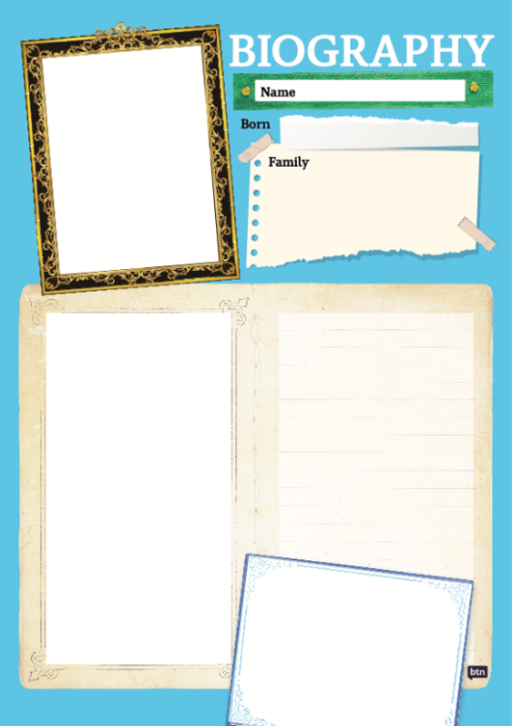
Class Discussion
Use the questions below to get a class discussion started with your students about biographical writing.

- What does a biography tell us about a person?
- Where can you look to find information for your biographical writing? It could include the internet, newspaper articles, magazine articles and interviews, other biographies, historical books or television interviews. Why is it important to use more than one source of information?
- What makes a biography interesting? For example, key information and facts, a timeline of events, photographs, illustrations and quotes.

Create your biography
Using the biography worksheet at the end of this activity, students will research and record information about Queen Elizabeth. Some possible areas of research include:
- When and where was Queen Elizabeth born? Describe her family life growing up.
- When did she become the Queen?
- What are some of her achievements? Choose one to explore in more detail.
- What inspires or motivates her?
- What are some challenges that she has faced?
- How has she made an impact on people’s lives?
- What do you admire about her?

Activity: Research inquiry
The KWLH organiser provides students with a framework to explore their knowledge and consider what they would like to know and learn.

What do I know? | What do I want to know? | What have I learnt? | How will I find out?

Questions to research
Students will develop their own question/s to research. Students will collect and record information from a wide variety of sources. Students may develop their own question for inquiry or select one of the questions below.

- What are the key moments in the history of Queen Elizabeth’s reign? Create a timeline of significant events in her life. How has the world changed over this time? Include key moments in history to include on your timeline. Learn more about Queen Elizabeth’s life in 92 facts!
- How has the royal family changed over time? How have they adapted to the times?
- What are some of the key events in Queen Elizabeth’s life? Write a summary for one key event, which answers the 5 W’s – Who, What, Where, When and Why?
- How do primary sources (for example photos, letters, diaries and official documents) help us understand what might have happened at a place in time? Find 1 or 2 primary sources that help you learn more about Queen Elizabeth’s life.
- Imagine you could sit down and talk to the Queen. What questions would you ask about her life and achievements?
- Why does the queen have two birthdays?
- Why does Australia have the Queen as its Head of State? Find out what a constitutional monarchy is and explore the reasons why some people want Australia to become a republic.
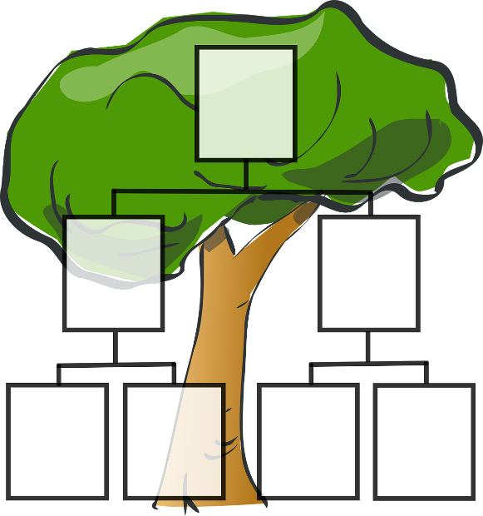
- Who is in the Royal Family? Create a family tree. How does succession work in the royal family? Explore this interactive guide to find out who’s who in the royal family.

Activity: Plus, minus or interesting
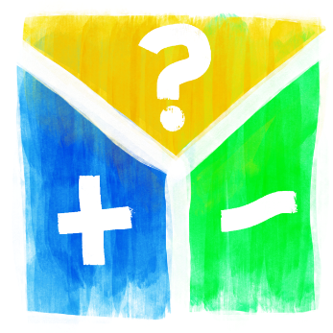
As a class discuss the concept of Australia becoming a republic. Students will identify and explain the values that a constitutional monarchy represents for Australians. Use the plus, minus, interesting chart to evaluate the issue, compare advantages and disadvantages and make decisions. In the plus column enter all the positive elements, in the minus column enter all the negative elements and in the third column enter the elements that cannot be classified. A scoring system can be added to this chart to inform decision-making.

Alternatively, students will conduct a classroom poll or debate on whether Australia should become a republic.

Activity: Choose a project
Individually or in small groups, students will choose one of the following projects to work on and then present their findings to the class.

Travel Brochure
Research some of the popular tourist attractions in the United Kingdom. Choose what you believe are the top 3 and create a tourism brochure.

Portrait
Sketch a portrait of Queen Elizabeth. Explore and experiment with different techniques and media to produce a portrait.
Pudding
Create a pudding in celebration of the Queen’s Platinum Jubilee. Look at recipes like the famous Eton Mess, Victoria sponge or trifle for your inspiration. Have a classroom high tea.
Poetry
Choose a word from your glossary and then create an acrostic poem. Alternatively, create a word search based on Queen Elizabeth II.

Useful Websites
- Queens Platinum Jubilee: What’s planned for the big day? – BBC Newsround
- The Queen's Platinum Jubilee: Take a look at the Queen's Jubilees through her reign – BBC Newsround
- Commonwealth for Kids – The Commonwealth
- Royal Responsibilities – BTN
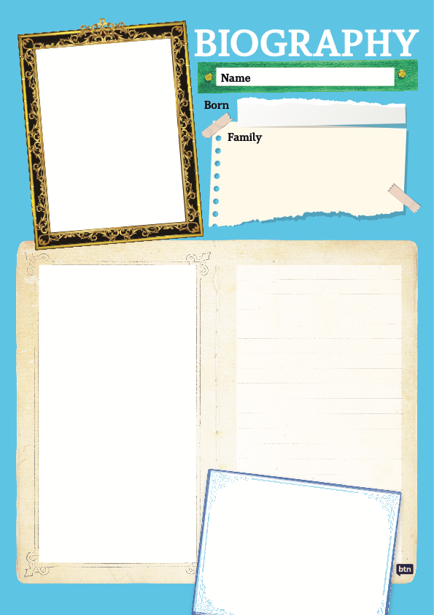

EPISODE 16
7th June 2022

KEY LEARNING
Students will investigate Indigenous seasonal calendars and learn more about the calendar in the area where they live.

CURRICULUM
Geography – Year 4
The custodial responsibility Aboriginal and Torres Strait Islander Peoples have for Country/Place, and how this influences views about sustainability.

Science – Year 7
Predictable phenomena on Earth, including seasons and eclipses, are caused by the relative positions of the sun, Earth and the moon.

  - Teacher Resource

Indigenous Seasons

Focus Questions
Discuss the BTN story as a class and record the main points of the discussion. Students will then respond to the following:
- How many seasons are on the Ngan'gi seasonal calendar?
- What is one of the most important plants in the seasonal calendar?
- What does the arrival of the dragonfly tell us?
  - the dry season is coming
  - the wet season is coming
- What do the kids in the story like about the dry season?
- What questions do you have about the story?

Activity: Personal Response
After watching the Indigenous Seasons story students will respond to the following:
- What do you THINK about what you saw in the story?
- What did this story make you WONDER?
- Think of three questions you have about the BTN story.
- What more do you want to learn about Indigenous Seasons?

Activity: Class Discussion
Discuss the BTN Indigenous Seasons story using the following discussion starters.
- How many Indigenous seasons can you name?
- Why might the ideas of the four seasons – spring, summer, autumn and winter not always be useful in northern Australia?
- How are Indigenous seasons similar or different to Australia’s European climate description?
- Australia’s climate is diverse. In your own words explain what this means.

Activity: Glossary
Students will brainstorm a list of key words that relate to the BTN Indigenous Seasons story. Here are some words to get them started.

SEASON | WEATHER | CLIMATE
INDICATOR | BUSH TUCKER | SEASONAL CALENDAR

Activity: Indigenous Weather Knowledge
Students will visit the Indigenous Weather Knowledge website and select the Indigenous community closest to where they live. Students will explore the Indigenous seasonal knowledge relevant to their area and respond to the questions below.

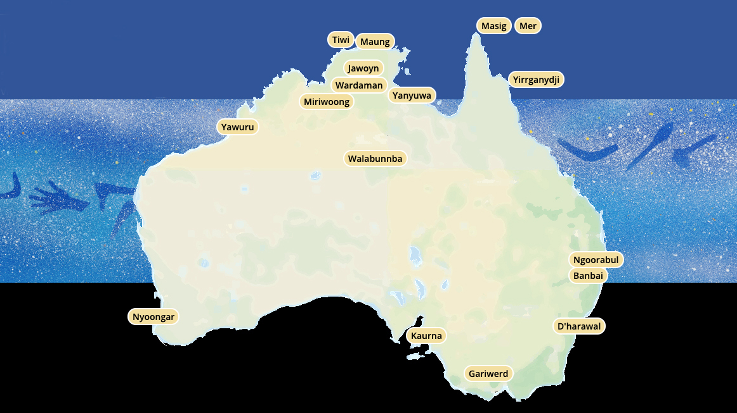

- Community name
- Name the distinct weather seasons in your area.
- How many seasons does your calendar have?
- Describe the weather periods in your area. What things mark a change of season? What changes in plants and animals have you noticed at certain times of the year?
- Interesting things about this seasonal cycle.
- Highlight the area on a map. What areas does it cover?
- Compare the calendar from your region to a calendar from another region.

Further Investigation
Invite a member of a local Indigenous community to your class to talk about the seasons in your area. Consider holding the information session in your school garden to help connect with the plants and animals local to your area.

Activity: Choose a project
Individually or in small groups, students will choose one of the following projects to work on and then present their findings to the class.
Bush Tucker Garden
Create a bush tucker garden at school or home. Consider the position of the garden, the type of soil and how much water the plants will need. Find edible plants that are native to the area.

Make an Explainer
Create a short film to explain the seasonal calendar in your region. Watch this BTN Explainer as a class to learn more about filming tips and visit BTN’s Rookie Reporter webpage for more training videos.
Venn Diagram
Investigate how Indigenous seasons are similar or different to Australia’s European climate description. Use a Venn diagram with two overlapping circles to record the similarities and differences.
Children’s Book
Write and illustrate a children’s book about Indigenous seasons.

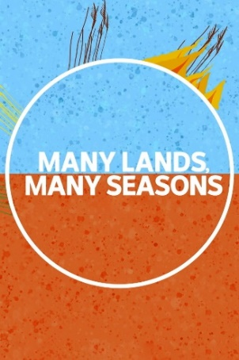
Watch the Many Lands, Many Seasons series which explores six Aboriginal seasonal calendars. Students can find out how unique knowledge helps the traditional owners hunt, fish and collect bush tucker. Learn more about the Indigenous Seasonal Calendar on the CSIRO website.

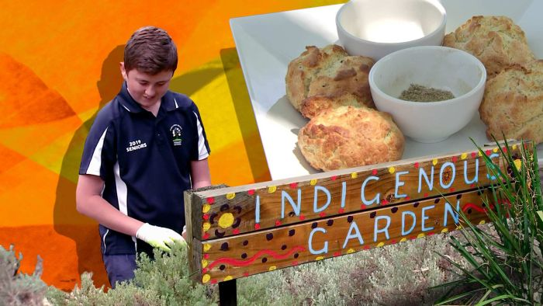
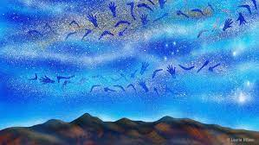

BTN Indigenous Seasons BTN Bush Tucker Garden

Useful Websites
- Indigenous Seasons – BTN
- Indigenous Seasonal Calendar - CSIRO
- Many Lands, Many Seasons – iView
- Indigenous Weather Knowledge – BOM
- Language, culture and environmental knowledge - BOM

  - Teacher Resource

BTN Transcript: Episode 16 - 7/6/2022

Hey, I'm Amelia Moseley and you're watching BTN. Thanks for hanging out with us, let’s see what’s coming up in today’s show. How people are celebrating Queen Elizabeth's Platinum Jubilee, why the UK might bring back pounds and ounces and Joe gets his hands or feet on a human powered vehicle.

Flu Season

Reporter: Michelle Wakim

INTRO: All that soon, but first to a virus you probably haven't been thinking about so much over the past few years and that's influenza. It's now flu season but health experts are worried we aren't as prepared as we used to be before COVID-19. So, state governments have started offering free flu shots to pretty much everyone. Michelle went to go and get hers and find out more.

For the past couple of years, we've got pretty good at protecting ourselves against one particular virus. But, while we've been busy focusing on stopping COVID-19, there’s another virus to worry about. It's back, and it’s as dangerous as ever. I'm talking about the flu.

ANTHONY TASSONE, Pharmacy Guild of Australia: We've seen cases rise really rapidly.
DR KERRY CHANT, NSW Chief Health Officer: Influenza spread in the community is high.
You've probably heard of the flu, or influenza. It's a virus you can catch through the spit or mucus of someone who is infected, mostly when they cough or sneeze. Ewww, disgusting. Flu symptoms are pretty similar to COVID symptoms, like a runny nose, a sore throat, headaches, and fever. And, like COVID, the flu can be really serious, especially for young kids, older people or those who are already sick. We haven't had to worry about it as much recently; with lockdowns, social distancing, and people just staying home more, influenza hasn't spread in the same way.
DR ANTHEA RHODES, Paediatrician: People are a bit vulnerable this year, particularly our children. Our immune systems haven't had that natural booster that we get when we are exposed to flu.
But now that winter's here, and we're all getting out and about, cases are going up really quickly. In the last two weeks of May, Australia recorded more than 26,000 cases of the flu. All of last year, there were just 598.
DR CHRIS MOY, VICE-PRESIDENT OF AUSTRALIAN MEDICAL ASSOCIATION: We are careering into our first proper flu season for three years, with, you know, 3,000 people in hospital with COVID at the same time. So, really, it’s a signal to everybody that, look, we’ve got to take this seriously.
So, how can we slow the spread down? Well, the message is pretty clear.
ANTHONY TASSONE: The best way that you can protect yourself, your family, and your community is to get vaccinated.
DR KERRY CHANT: So, I urge everyone to get vaccinated now.
So far, only about 28 percent of Australians have had this year's flu vaccine, and now State Governments have got involved to boost those numbers, and hopefully ease the pressure on our hospitals.
SA PREMIER PETER MALINAUSKAS: For the first time, ever, we will be providing the flu vaccination free.
WA PREMIER MARK MCGOWAN: For the month of June, we’ll have free flu vaccinations.
Queensland was the first state to announce free flu jabs until the end of June for anyone over the age of six months. Soon after, the other states jumped on board, and so far, it looks like, it's working.
MICHELLE: I've come in today to get my free flu vaccination, and I’m with David who's a pharmacist. Australians all around the country are rushing to get their flu vaccines, so these guys are in high demand. You might have to wait your turn.
DAVID: Do you have any questions, any concerns? Any allergies to anything?
MICHELLE: None, I think I'm good to go.
David: Good to go. Alright.
While you might have had a flu vaccine before, you have to get them every year for it to be effective, and often they change as new strains of influenza virus appear. The vaccine contains a little bit of the virus. It's not active so it can't actually give you the flu. Instead, it kind of trains your body to recognise the strain of influenza that might be around, so our bodies are prepared to fight it off.
DAVID: So, it not only prevents you from getting it, it also cuts down the duration and severity of the flu if you do happen to get it.
DAVID: And you are all done.
MICHELLE: Done, done. I feel good, done my part.
DAVID: Yes.
And don't forget about all the other stuff we've been doing since COVID.

News Quiz

Prime Minister Anthony Albanese’s new cabinet has been sworn in. They’re the ministers he’s chosen to take care of different areas of government. Like health, education, defence, transport, housing, foreign affairs, employment and you get the idea. This Aussie cabinet is a bit special, though. Do you know why? It has more women in it than ever before. 10 of the 23 cabinet positions are held by women.

On June 1st, New South Wales brought in a new ban on a certain type of single use plastic. But what type of plastic? Is it plastic bags, plastic straws or plastic plates and cutlery? It’s plastic bags. The rest will be banned from November 1st.

Scientists say they’ve discovered the world’s biggest plant off the coast of Western Australia. How long does it stretch? 500 metres, 18 kilometres or 180 kilometres? It’s 180 kilometres. The plant is known as ribbon weed and it’s about 4 and a half thousand years old. Scientists originally thought they were looking at a giant seagrass meadow but after genetic testing, discovered it’s a single big, ole plant.
Queen’s Platinum Jubilee

Reporter: Amelia Moseley

INTRO: Over the weekend lots of people around the world celebrated the reign of Queen Elizabeth the 2nd. She's been in the job for 70 years, so let's learn a bit more about her and how people have marked her Platinum Jubilee.

Crowns. Cakes. And corgis, in crowns, with cakes. It's a celebration fit for a queen.
CANADIAN PERSON: We are participating in the celebration of the Queen's 70th anniversary for her being on the throne. Her Jubilee. And Rosie said we had to come.
Yes, people and animals, around the United Kingdom and the world came out to celebrate Her Majesty's Platinum Jubilee, or ‘Platty Joobs’ if you prefer.

BRITISH PERSON: Well, we thought everybody was wearing fancy dress. We thought a sort of monarchy theme would be a good idea.

BRITISH PERSON: I’m a medieval princess from the Middle Ages.

BRITISH PERSON: I’m Jane Seymour. Daddy, I’m your wife.

BRITISH PERSON: We didn’t think this though.

In the UK, there was a four day long weekend. And lots of celebrations, including a big concert. The 70 year milestone makes Queen Elizabeth the 2nd, the longest reigning British monarch in history.
BRITISH PERSON: So, I live close by, but I've never actually seen the Queen before, so this is an opportunity I thought, I would come.
BRITISH PERSON: It's a big event, isn't it? I mean no one's gonna reign for that long again.
And here she is. On the balcony at Buckingham Palace. Oh, hang on. This is the Lego version. Here she is. The Queen is 96 years old, and she's seen a few jubilees in her time. After the first 25 years, they're celebrated mostly every ten years. But this one was obviously extra special. The Queen even had tea with another famous British icon just for the occasion.
PADDINGTON BEAR: Perhaps you would like a marmalade sandwich? I always keep one for emergencies.
QUEEN ELIZABETH II: So, do I. I keep mine in here.
PADDINGTON BEAR: Oh.
So, how did the Queen become Queen? Well, Elizabeth Alexandra Mary Windsor was born into the British royal family in 1926. And is the eldest of two sisters. She didn't actually think she'd ever sit on the throne, because her uncle was next in line. But in 1936, King Edward the 8th famously abdicated or gave up the throne. Making Elizabeth's dad the King instead. And when he died in 1952, Elizabeth became Queen at a pretty young age.
Officially, the Queen is the ruler of the United Kingdom and its territories and is Head of State in all commonwealth countries, including Australia. But in reality, that doesn't mean she gets to tell everyone what to do. Not when those countries are constitutional monarchies. That means you have an elected government that makes big decisions on behalf of the people. So, while the Queen stays out of politics, she's still considered a leader, and she and her kids and grandkids carry out about 2,000 official engagements a year in the UK and overseas. Of course, not everyone thinks the British monarchy should still have a place in modern society.
BRITISH PERSON: I don't really know that they do much to be honest.
JOURNALIST: Do you want to keep them around in the decades to come?
BRITISH PERSON: No, they can go.
But others are happy to celebrate this history making moment. You might've even seen Aussie monuments lit up in royal purple, just for the occasion. And now since she is the Queen, we should probably let her have the last word. Hmm, well said.

Imperial System Change

Reporter: Joe Baronio

INTRO: Now, how long is your standard school ruler? It’s 30 centimetres, right? But what if I asked you to answer in inches? That's a system of measurement known as imperial units and the UK is thinking about bringing it back. Joe explains why. Oh, and the answer is 12 inches, by the way.

HOST: Ladies and gentlemen, welcome to ‘Guess the Imperial’.
SHOPPER: Wait, what is this? I'm just trying to do my grocery shopping and be on my way.
HOST: What? No, no, no. That is far too easy. On this show, contestants must guess the amount of whatever it is they're buying.
SHOPPER: Those are apples.
HOST: In imperial units. Before the timer runs out. If they get it right, they can buy it. But if they get it wrong, they can't.
SHOPPER: Hold up, imperial? I didn't sign up for this.
HOST: Well, too bad.
Yeah, it'd be a bit of a shock to the system if one day your regular shopping became a guessing game. But that could be about to happen in the UK. The PM Boris Johnson says he wants people there to use the imperial system more in their day to day lives.
SHOPPER: Ugh, fine.
HOST: That's the spirit.
SHOPPER: Well, can you at least tell me what this imperial thing is?
Well, it's a different way to measure things. Here in Australia, we measure things like length in kilometres, metres and centimetres, and weight with things like kilograms and grams. It's called the metric system. But the imperial system measures length in feet and inches, and weight with pounds and ounces.
HOST: And here's the kicker: they’re not equal to each other.
SHOPPER: Ugh. Course they’re not.
Yeah, see, with the metric system everything is based on multiples of ten. For example, 1,000 grams equals 1 kilogram, and 100 centimetres equals 1 metre. But the imperial system is a little trickier. 16 ounces equals 1 pound, and 5,280 feet equals 1 mile, and in 1 kilogram there's 2.2 pounds, and 1.6 kilometres in a mile. If you're getting a bit confused then don't worry, you're not alone.
HOST: So, how much does that weigh?
SHOPPER: How much? Well, ah, 2.2 pounds equals 1 kilo.
HOST: Ooh you're out of time, sorry.
SHOPPER: This is confusing. Who even uses this?
Well, not many places anymore. In fact, it's only the US, Myanmar and Liberia that are still on the imperial bandwagon. But it isn't completely unfamiliar territory to the Brits. The imperial system was actually developed there in the 1800s but in the 2000s it was phased out across the European Union, which included the UK. You will still see some imperial units, though, like on the roads, where speed is measured in miles per hour and in some shops, alongside their metric cousins.
HOST: Quiz time. Did Australia use the imperial system: yes or no?
SHOPPER: Umm, yes?
HOST: That's correct. Don't get too excited, you don't win anything.
SHOPPER: Oh, so where did it go then?
HOST: Oh, we went to the metric system in the 70s, so much easier to understand.
SHOPPER: That's what I've been trying to say.
Since Brexit, when the UK left the European Union in 2020, the government has been planning to return to some of its older ways, including wider use of the imperial system. But it's controversial.
BRITISH SHOPPER: Imperial is ounces and pounds, right. Confusing. That's my view. I don't know much about this.
BRITISH SHOPPER: I don't understand why you want to go back. It doesn't make any sense.
BRITISH SHOPPER: Pounds and ounces is much better than the kilos.
BRITISH SHOPPER: Fantastic. It's just nice to keep our heritage. Keep it coming. Bring it all back. Whatever else you want to bring back, bring it back.
SHOPPER: Well, if 2.2 pounds is 1 kilo, then I’ve got half a kilo.
Host: Ooh, again. At this rate you'll end up with nothing.
Now, unlike this game, shoppers in the UK won't get their things taken away if they get the math’s wrong. But the world is watching to see if the UK inches towards this big change.
HOST: Inches. Ha, get it? That's from the imperial system too.

Indigenous Seasons

Reporter: Amelia Moseley

INTRO: Now, let's head to the Northern Territory to learn about Indigenous seasonal calendars. The different seasons are really important to different groups because they tell traditional owners the best times to hunt, fish and collect bush tucker. Now, the ABC's teamed up with the CSIRO in a new series to teach us more about it. Here's Rulla to tell you more.
You may have heard of spring, summer, autumn, and winter. But did you know Aboriginal and Torres Strait Islander people have their own names and times for their seasons? Our knowledge is unique to each community and their environment and has been passed down through generation to generation for over 65,000 years. We're heading to the community of Nauiyu, Daly River, in the Top End of the Northern Territory. There are 13 seasons on the Ngan'gi seasonal calendar. And the subtle changes observed by the traditional owners within these seasons tell them when to hunt, to fish, and when to pick the fruit off trees.
MIRIAM ROSE, ELDER: You’ve got to be aware of things, around you. The seasons, the plant, which way the winds blowing, animals, trees that flower at a certain time.

One of the most important plants in the seasonal calendar is spear grass.
MIRIAM ROSE, ELDER: The start of the seasonal cycle is when spear grass seeds begin to shoot, we call this season Wurr Bengin tyerrfal.
PATRICIA, ELDER: Then it’s Wudupuntyurrutu, when the wurrmuy are puffing open and when the river rises, it's a good time to collect fruit.
Not just fruit. Other bush tucker too.
MIRIAM ROSE, ELDER: We take this out from here, and we eat it. We call this cabbage, bush cabbage, yeah.
With so many bush tucker choices out there, it would be pretty hard to find a favourite.
JAYLIAH: My favourite bush tucker is turtle.
TIMENA: Barramundi, turtle and memelly.
FREDDIE: Turtle and crab.
KATHY ANNE: My favourite bush tucker is turtle, barramundi and plum.
PATRICIA, ELDER: It's now Wurr bengim miyerr, when the speargrass seeds start to fall. And that big black kangaroo Agurri, that lives in the hills, wakes with the arrival of the Ayiwisi.
The arrival of the dragonfly not only tells us the dry season is coming, it's also a great time to hunt for fish, especially barramundi.
JJ: After school today, we went to a little creek next to butterfly creek and we came here with our hand lines and rods, fishing, looking for barramundi and catching them.
After the barra fishing season is over, and the spear grass seeds have fallen, the electrical storms come and knock the plants down.

PATRICIA, ELDER: Wirirr Marrgu is the dry season and burning grass time.

The dry season is followed by monsoons, and the cycle starts again.
DARRYL: My favourite weather is the dry season because I like to hang out with friends, go fishing, go hunting, get goose, go swimming.
ALYSSA: In the dry season time we get python, and we cook it up on the fire and it's yum.
LARS: I love the dry season, I do flips, fishing, playing sport, that's it.
Sport

2.5 million dollars. That's how much Minjee Lee has pocketed for winning the US Open, the biggest individual prize in women's golf. Anyway, this is how she did it. Lee came into the last round 3 shots in front and never looked like losing. She’s now the first Aussie in more than 20 years to win the US Open.

MINJEE LEE: This is the one that I’ve always wanted to win since I was a little kid.
It’s safe to say Rafael Nadal is the King of the Clay. He's just won his 14th French Open title and a record extending 22nd Grand Slam title. Over in the women’s and world number 1, Iga Swiatek, took home her second French Open title, breezing past American Coco Gauff 6-3 6-1.
Aleix Espargaro was in 2nd place coming into the last lap of the Catalan Grand Prix. The trouble was.

COMMENTATOR: He thought the race was over.

After snapping back into race mode, the Spanish rider managed to scrape home for 5th place.
Pedal Prix

Reporter: Joe Baronio

INTRO: Alright, it's time to buckle up now, because we're going racing. Well, not me specifically but Joe is. We sent him out to Crafers Primary school in South Australia to learn more about Pedal Prix. Check it out.
JOE: Yep, Pedal Prix. Now I've got to be honest with you, I don't really know much, or anything, about Pedal Prix. But I want to become a racer, so I've come to talk to these guys.
This the Crafers Primary School pedal prix team and they know a thing or two about racing.
JOE: Now, Jasper, can you just fill me in on what is pedal prix?
KID: So, pedal prix is a sport where you lie down in one of these things and you pedal around a race track and it's a very fun experience.
JOE: Now, the first thing that strikes me about this is, it looks like a jellybean. Is that for any particular reason?
KID: Yeah, it's supposed to be aerodynamic, and it is, and it works, but yeah it does look like a jellybean, it really does.
Pedal Prix started way back in 1985 in South Australia and nowadays, it's a full on racing series with multiple events across the country designed to develop competitors' teamwork and technical skills. At their last major event the Crafers team came first in their class.
KID: Here is the favourite car, The Comet.
JOE: This one looks really small.
KID: Yeah, yeah it does but it is the most successful car here.
So, naturally that's the one I decided to try and get in.
JOE: Oh, wow look at that. It's like a bed with pedals. Will I fit?
JAPSER: Yes. Maybe.
JOE: Alright, you know what I gotta do.
It was at this moment that I realised I didn't really fit. But forget that for now because it's time to train.
JOE: So, what sort of exercises do you guys do to stay in shape, to be a proper pedal prix racer?
KID: We have to do lots of things to get our thighs ready for race day so that we can keep on pedalling.
And what's the best way to practice pedalling? Well, on a bike.
JOE: Turn it all the way up, let's go.
KID: You might regret that.
JOE: I might regret this, okay.
I did, in fact, regret it, and after a solid session on the bike I was pooped, but.
KIDS: Hey. We're not done yet.
Yeah, after another stint of shuttle runs and squats, it was finally over.
JOE: Well, now that the fitness is done. It's time to get in the cars.
Once I'd squeezed myself in and worked out the controls.
KID: Here's your horn and then your two brakes.
I was on my way.
JOE: Okay. Whoa, okay. We’re off, are we? Okay, let’s do this. Whoa, okay. We're going lightspeed now ladies and gentlemen. I tell you what, I reckon I'm pretty unstoppable. You know what, I need some challengers. Someone come race me.
And they did.
KIDS: 3, 2, 1, Go.
JOE: We're off.
Now, I didn't win but I did get the winner's welcome at the end.
JOE: Was I a success?
KIDS: Yeah.
My excellent skills aside, it’s a super fun time.

KID 1: It’s a very good sport and you learn a lot.

KID 2: Other kids should definitely get involved. It’s an absolutely brilliant experience.

KID 3: Yeah, I definitely think it would be a lot of fun so people should just give it a go.

Closer

Sounds like fun. Well, that's all we've got for you today, thanks so much for joining us again. But before you go, don't forget there are plenty more stories and things to do on our website and if you're a teacher, you'll like that, too. Make sure you also join us every weekday, right here in the studio for Newsbreak to stay up to date. I'll see you next week. Bye for now.

