
EPISODE 22
11 August 2026

KEY LEARNING
Students will view a range of BTN stories and use comprehension skills to respond to a series of focus questions.

CURRICULUM
English – Year 4
Use comprehension strategies such as visualising, predicting, connecting, summarising, monitoring and questioning to build literal and inferred meaning, to expand topic knowledge and ideas, and evaluate texts.
English – Year 5
Use comprehension strategies such as visualising, predicting, connecting, summarising, monitoring and questioning to build literal and inferred meaning to evaluate information and ideas.

English – Year 6
Use comprehension strategies such as visualising, predicting, connecting, summarising, monitoring and questioning to build literal and inferred meaning, and to connect and compare content from a variety of sources.

  - Teacher Resource

Focus Questions
As a class, discuss the stories featured in the episode of BTN Classroom and record the main points of the discussion. Students will then respond to the following focus questions.

Bird Flu Update
- How has bird flu impacted seabirds in Australia?
- How are chicken farmers protecting their birds? Give 2 examples.
- What rule has the Victorian Government put on chicken farms?
- The poultry exhibit at the upcoming Royal Adelaide Show has NOT been cancelled. True or false?
- What questions do you have about this story?

Space Junk
- Summarise the BTN Space Junk story in 3-4 sentences.
- What is space junk? Give a definition.
- How fast does space junk travel when it is orbiting in space?
- Who is responsible for space junk?
- What are some solutions that scientists are working on to reduce space junk? Give one example.

Check out the teacher resource on the Archives page.

Smart Glasses
- What can smart glasses do? List the main functions of smart glasses.
- How can smart glasses help people? Give 2-3 examples.
- What are some of the concerns around smart glasses?
- Is it legal to film people in public places?
- Do you think smart glasses should be banned? Why or why not?

Tuvalu Teens
- Where is Tuvalu? Find on a map. Calculate the distance from Australia to Tuvalu.
- Why have many Tuvaluans left Tuvalu?
- Some experts say Tuvalu could be inhabitable by the year 2100. True or false?
- How is Australia helping people in Tuvalu?
- What is a falekaupule and why are they important to Tuvaluan people?

Check out the teacher resource on the Archives page.

Musical Kids
- What type of performance are the kids appearing in?
  - Ballet
  - Circus
  - Musical
- What do the kids in the story like about performing arts?
- What did each round of the auditioning process involve?
- The kids in the BTN story all go to the same dance school. True or false?
- What did you like about the BTN story?

EPISODE 22
11 August 2026

KEY LEARNING
Students will explore the impact of space junk on Earth, the Moon and space exploration. Students will consider the challenges of space junk.

CURRICULUM
Science – Year 5
Scientific understandings, discoveries and inventions are used to solve problems that directly affect peoples’ lives.

The Earth is part of a system of planets orbiting around a star (the sun).

Science – Years 5 & 6
Scientific knowledge is used to solve problems and inform personal and community decisions.
With guidance, pose clarifying questions and make predictions about scientific investigations.
Science – Year 6
Describe the movement of Earth and other planets relative to the sun and model how Earth’s tilt, rotation on its axis and revolution around the sun relate to cyclic observable phenomena, including variable day and night length.

Science – Year 7
Model cyclic changes in the relative positions of the Earth, sun and Moon and explain how these cycles cause eclipses and influence predictable phenomena on Earth, including seasons and tides.

  - Teacher Resource

Space Junk

Focus Questions
Discuss the BTN story as a class and record the main points of the discussion. Students will then respond to the following:
- Summarise the BTN Space Junk story in 3-4 sentences.
- What is space junk? Give a definition.
- How fast does space junk travel when it is orbiting in space?
- Who is responsible for space junk?
- What are some solutions that scientists are working on to reduce space junk? Give one example.

Activity: Class Discussion
Before watching the story…
Before watching the BTN Space Junk story hold a class discussion about space junk using the following prompts.
- What do you think you will see in the BTN story?
- What do you already know about space junk? Brainstorm ideas as a class.

After watching the story…
After watching the BTN Space Junk story, students will respond to the following questions:

- What is space junk? Give some examples.
- How does space junk get into space?
What did you see, think and learn?
- How much space junk is there?
- Why is space junk a problem?
- What might happen if we don’t address the problem of space junk? What do you think space will look like in 30 years’ time? Make some predictions.

Activity: Key Words
Students will brainstorm a list of key words that relate to the BTN Space Junk story. Here are some words to get them started.
Satellite
Space Junk
Space exploration
Collision
Spacecraft eclipse
Rocket
Space Debris
Orbit

Ask students to write what they think is the meaning of each word (including unfamiliar words). They will swap definitions with a partner and ask them to add to or change the definition. Check these against the dictionary definition.

Further activities for students:
- Students will add to their glossary by downloading the transcript for the BTN Space Junk story and highlight all the words that relate to the topic. Additional words include fragments, atmosphere, lunar, Moon, crater, gravity, scientists, space station, robot, clean-up and impact.
- Where does the word debris come from? Explore the word’s origins and meaning.
- Why are satellites called satellites? Explore the origin and meaning of the word satellite.
- What is the history of Einstein Crater on the Moon? Explore its location, discovery and how it got its name.

Activity: Visual Literacy
Students will work individually or in small groups to find 3-4 images online that show the impact of space junk. Images may include:
- Actual photographs of space debris or damaged spacecraft
- Photographs showing satellites or objects in orbit
- Diagrams or visual presentations of orbital debris
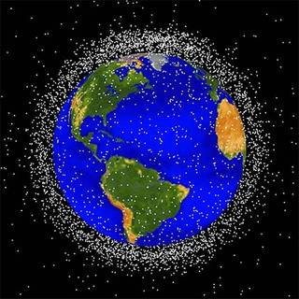
- An artist’s impression of space junk in space
- Artwork showing possible future impacts of space junk

Students will examine the image/s and respond to the following. Encourage students to use vocabulary from their list of keywords in their responses.
- What can you see? Write a short paragraph describing what you see in the image.
- What objects or details stand out?
- What do you think is happening in the image?
- What does the image tell you about space junk?
NASA
- How does the image make you feel? Identify what emotion you feel and what features of the image make you feel this way.
- Create a caption for each image.
- Record the source (website) for each image.

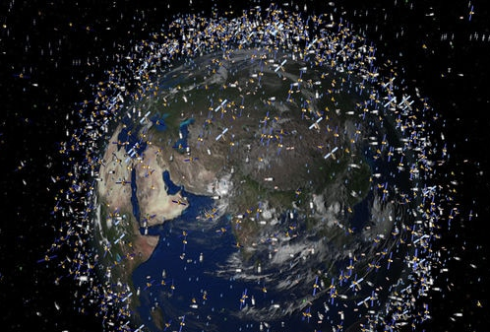  ABC News | 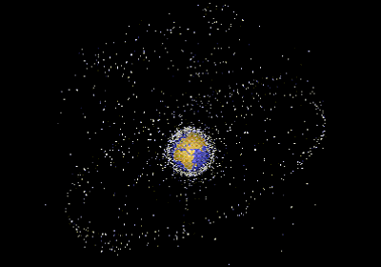  ESA Kids

Further investigation
- Imagine you are a scientist investigating the impact of space junk. Explain using scientific vocabulary and terms, explain why space junk exists and the impact it has on space and Earth.
- Could the problem of space junk have been avoided? Research the different ways scientists and organisations are working to prevent and reduce space junk.
- What are some of the strangest objects that humans have left in space? Visit the National Geographic Kids website to find out. Create a poster to illustrate your findings.

Activity: Six Hat Thinking
As a class, use Edward De Bono’s Six Hat Thinking to explore the issues raised in the BTN Space Junk story. Make your own coloured hat cut outs and place on the floor. Students will take it in turns answering questions in relation to what they already know about the issue, what they have learned from the story and what they want to learn further about the topic. Ask students to respond to the following questions:

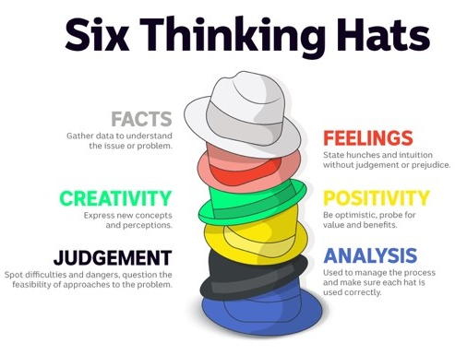
- How did the BTN Space Junk story make you feel?
- What do you know about space junk?
- What have you learnt from the story?
- Were there any positives from the story? If so, what were they?
- What are some of the negatives or challenges that you learnt from the story?
- Why is it important to learn about the issue?
- What questions were raised during this activity? Think of three questions you would like to ask about the story.
- What do you want to learn further about this topic?

Reflection
After this activity, ask students to reflect on what they have learnt. Students can include details about how their thinking on this issue has changed and why they think we should act.

Further investigation
In small groups, students will brainstorm innovative ways to clean up and reduce space junk. Encourage creativity during this activity and give students the time to explore their thinking and illustrate their ideas. Students will then share their ideas with the class, taking it in turns explaining how their creations will help reduce the amount of debris that is orbiting in space.

Encourage the class to ask questions about the other groups’ creations and then reflect on their own learning.
- What was challenging about this activity?
- What did you enjoy about this activity?

Useful Websites
- Moon Crash? – BTN Newsbreak
- Space Junk (2023) – BTN
- Is Space Junk Dangerous? – BTN High
- Space Junk (2022) – BTN
- Space junk: What is it and why is it a problem? – CBBC Newsround
- What is space junk and why is it a problem? – Natural History Museum
- Space Junk – ESA Kids
- Space Junk! 20 seriously strange things you’ll find in space – National Geographic Kids

EPISODE 22
11 August 2026

KEY LEARNING
Students will investigate the impact of climate change on the Pacific Islands.

CURRICULUM
Geography – Year 5
The geographical diversity and location of places in the Asia region, and its location in relation to Australia.

Australia’s interconnections
with other countries and how these change people and places.

Geography – Year 7
The causes and impacts of an atmospheric or hydrological hazard, and responses from communities and governments.

Factors that influence the decisions people make about where to live, including
perceptions of the liveability
of places and the influence of environmental quality.

  - Teacher Resource

Tuvalu Teens

Focus Questions
Discuss the BTN story as a class and record the main points of the discussion. Students will then respond to the following:
- Where is Tuvalu? Find on a map. Calculate the distance from Australia to Tuvalu.
- Why have many Tuvaluans left Tuvalu?
- Some experts say Tuvalu could be inhabitable by the year 2100. True or false?
- How is Australia helping people in Tuvalu?
- What is a falekaupule and why are they important to Tuvaluan people?

Activity: Comprehension
After watching the BTN Tuvalu Teens story students can answer one or more of the following questions:
- What are some keywords from the BTN story?
- What did you learn from the story? Write a summary.
- Why do you think BTN covered the story?

Activity: Class Discussion
After watching the BTN Tuvalu Teens story hold a class discussion, using the following questions to start the discussion:

- How are rising sea levels impacting the people and environment of Tuvalu?
- What are some of the challenges Tuvaluan families face moving to another country?
- Do you think larger countries like Australia have a responsibility to support climate vulnerable nations like Tuvalu? Explain your answer.


What did you learn from the story?
What questions do you have about the story?

Activity: Pacific Islands and Climate Change
Discuss the information raised in the BTN Tuvalu Teens story. What questions were raised in the discussion and what are the gaps in students’ knowledge? Students will develop their own question/s to research or choose one or more of the questions below.

Research Questions
- Why is Tuvalu particularly vulnerable to rising sea levels compared to other countries?
- If people are forced to leave their country because of climate change, what responsibilities do larger, wealthier countries like Australia have to help them?
- What is the Falepili Union? What does Falepili mean in Tuvaluan?
- What impact does rising sea levels in the Pacific Islands have on people, the environment, and the economy? Give one example for each.
- What is the highest point of Tuvalu? Compare to the highest points of other countries.
- What is an atoll? What’s the difference between an atoll and an island? Give examples.
- What connections do people in Australia have with the Pacific Islands? (for example, birth, family, heritage, food, holiday, celebrations).

Diary entry
Imagine you are living in the capital of Tuvalu, Funafuti. Your family has just been accepted into the Falepili Union program, and you are preparing to move to Australia next month.
Write a diary entry (150–200 words) exploring your feelings. Think about:
- What will you miss most about your island home?
- What are you excited or nervous about experiencing in Australia?
- How will you help your new Australian friends understand your Tuvaluan culture?

Activity: Visual Literacy
In this activity students will analyse a range photos that show the impact of rising sea levels in the Pacific Islands. Students will choose one or more of the images below and respond to the following questions:
- Describe what you see in the image. What stands out to you the most?
- What does this photo tell us about rising sea levels?
- How does this photo make you feel?
- What question/s would you like to ask about the image?
- Create a caption for each image.

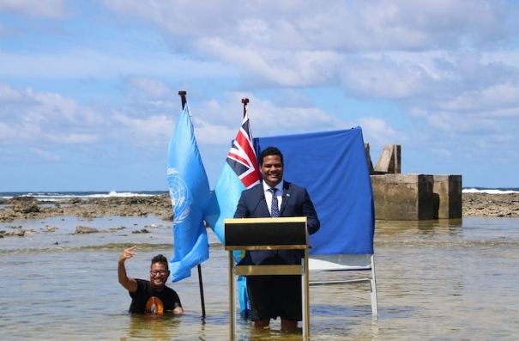  Source of image | 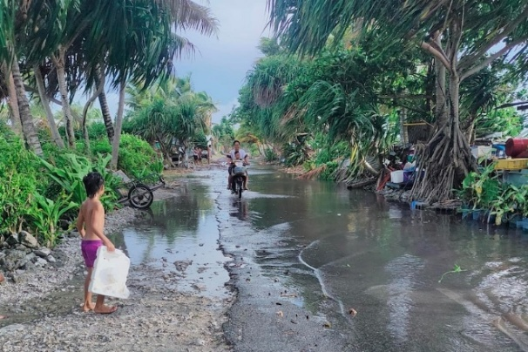  Source of image
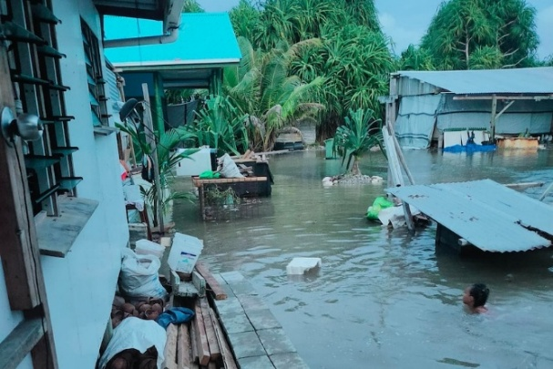  Source of image | 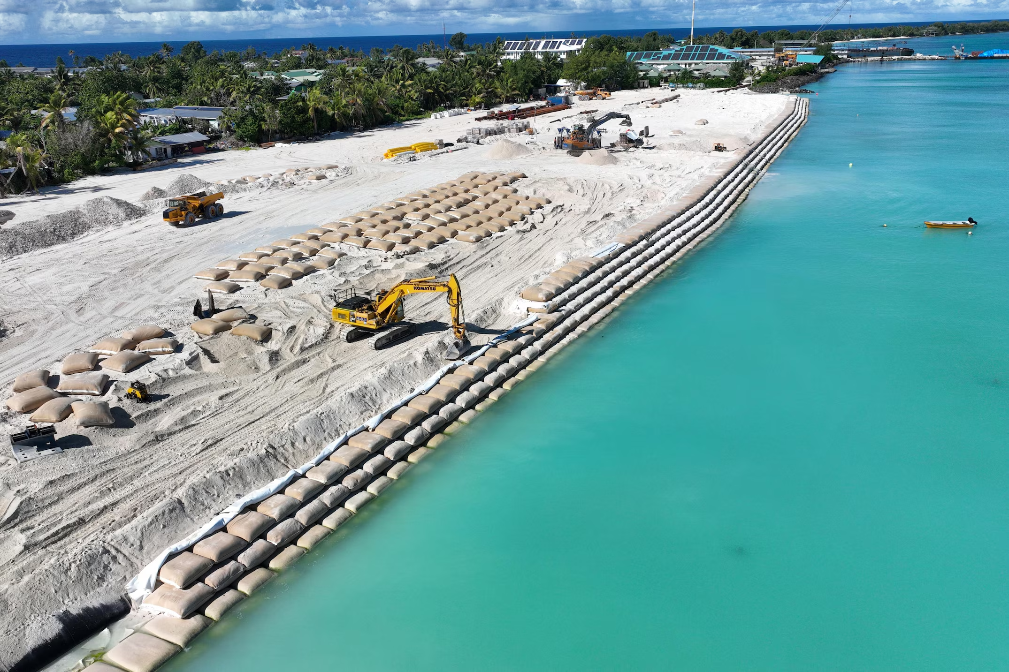  Source of image

Activity: Choose a Project
Individually or in small groups, students will choose one of the following projects to work on and then present their findings to the class.

Did you know?
Using the information in the BTN story and your own research, create a Did You Know fact sheet about Tuvalu.
Where is Tuvalu?
How far is Australia from Tuvalu? Locate and mark on a world map. Find other countries in the Pacific Islands that are affected by rising sea levels, including Kiribati and the Marshall Islands.

Summary
Write a summary of the Tuvalu story. What was the story about? Why did BTN cover this story?
Country Profile
Develop a profile of a country in the Pacific Islands that has been affected by rising sea levels. Create a postcard using Canva to share some of the things you have learnt.

Useful Websites
- Pacific Islands Climate Change – BTN
- Tuvalu Resettlement Deal – BTN
- Pacific Islands Forum – BTN
- The nation holding back the sea – ABC News
- Pacific Places – ABC

  - Teacher Resource

BTN Transcript: Episode 22- 11/8/2026

Hey. I'm Amelia Moseley and you're watching BTN. Thanks for hanging out with us again. Let's see what's coming up on today's show. We find out why a rocket crashed into the Moon, learn why these glasses are causing controversy and meet some kids who are starring in a musical.

Bird Flu Update

Reporter: Wren Gillett

INTRO: We'll get to all that soon, but first today to some bad news about Australia's birds. A whole lot more of them have tested positive for bird flu and authorities say there's no longer any way of stopping it from spreading. Wren found out how that's affecting farmers and wildlife and what people are doing to prepare. Take a look.

MAX, CHICKEN FARMER: I first started my little chook farm in 2024 with only 6 chooks. I started farming the eggs as a bit of a hobby and because I loved being around animals and livestock on the farm. It then developed into me having a passion for delivering a good quality product to the local community but also running the business side as well.
Max now owns around 70 chooks.
MAX: Chook chook chook.
But like most egg farmers, he's pretty worried about them.
MAX: Every new case makes me feel more and more worried, especially the closer they are getting to the region I live in. Knowing what it can do and how bad it can impact us, though, does frighten me lots.
See, since we last told you about bird flu, things have become much worse.
MURRAY WATT, FEDERAL ENVIRONMENT MINITSER: We now do have confirmation of the first mass mortality in native wildlife in Australia.
Big groups of seabirds have been found dead, and the virus has been detected in seagulls.
WREN GILLETT, REPORTER: And as you probably know, seagulls are everywhere, which means these guys could be superspreaders.
MURRAY WATT: The reality is you can't stop native and wild birds flying around, and you can't stop wild animals moving around, and that will mean more mass mortality events like the one we have now seen.
It's why farmers like Max are taking big steps to protect their animals.
MAX: These are putting roofs on all the areas that are possible, monitoring the birds as much as I can, and trying to limit the contact between them and wild birds.
On Friday, the Victorian Government put all chicken farms on lockdown.
7 NEWS: Strict new rules for Victorian farmers.
9 NEWS: Chicken farms across Victoria have been ordered into lockdown.
It means anyone with more than 50 chickens has to keep them undercover, and away from wild birds. So far no other states have followed, but South Australia has cancelled the poultry exhibit at the upcoming Royal Adelaide Show.
PERSON: All we can do is endeavour to stop it on our end, but we can't put a fence around this country.
See, chickens are particularly vulnerable to bird flu, and overseas, the strain has led to hundreds of millions dying either from the disease, or because they had to be culled to protect people and other animals.
PERSON: The closer you are, the more emotionally connected you are, the higher the impact on mental health.
Australia's poultry industry is worth billions of dollars, and many people's jobs rely on it.
MAX: Good girls.
There are also lots of people who just love their chickens.
MAX: At the moment, I haven't been affected by the bird flu, but the worry of it is definitely kicking in.
There are also serious concerns about our native birds, particularly endangered species, like the black swan. Conservationists are also really worried about little penguin populations like the one here on Phillip Island in Victoria.
WREN: And it's not just birds that can catch the virus, our native animals and our pets can become sick, too.
It's why experts say it's really important to keep animals and their food away from birds. You should also make sure you're keeping your distance as well.
MURRAY WATT: Avoid contact with birds and mammals that appear to be infected, record what you see and report that. That's the best way that we can work together to respond to what is a very serious event.
Right now, no one knows exactly how bad this bird flu outbreak is going to get, but it is something our Government has been preparing for, for a long time.
MURRAY WATT: I want to level with people, this is the beginning of what is likely to be a long, difficult journey in terms of the impacts on wildlife. But it is one that we are well prepared for.
MAX: I'm very hopeful for what the future holds and hope once this bird flu is gone, I, along with lots of other people, can keep expanding in our small businesses. My advice to other young farmers is just to stay calm in this situation and hope for a better future.

News Quiz

What is budget airline Jetstar going to start charging passengers for? Is it: Cups of water, carry-on luggage reclining seats? Jetstar will be charging for carry-on luggage that can’t fit under the seat from January next year. The airline says it’ll speed up boarding and help flights depart on time, but not everybody's happy about the idea.
PERSON: Charging for every single bit of the trip is just a bad model.
PERSON: Being charged to do overhead is just ridiculous.
PERSON: I'll definitely be looking for another airline.

Which super famous K-pop band says it’s boycotting the next Grammy awards over its new Asian Pop Music category? NewJeans, Blackpink or BTS? It’s BTS. The mega stars say they want their music to be appreciated "for what it is, rather than being divided by region or language".

And what’s this close-up video of? Honey on toast, the surface of the sun or the bird flu virus? It’s the surface of the sun. In fact, it’s the most detailed look at the red-hot, swirling surface we’ve ever had. The photos and videos were captured by the world’s biggest solar telescope in Hawaii, and they actually show a section of the sun a few thousand kays across, so around the size of Australia. Wow.

Space Junk

Reporter: Justina Ward

INTRO: Did you know the Moon has a new crater? Not a big one, but last week a part of an old rocket crashed into the surface and left a dent. It's a pretty exciting opportunity to study, well, what happens when a rocket crashes into the moon. But it also drew attention to the problem of space junk. Here's Justina.
COMMANDER: Object?
WREN: The upper stage of a SpaceX rocket.
COMMANDER: Location?
WREN: Impact point predicted at lunar latitude 19.461 N, longitude…
COMMANDER: In English.
WREN: The Einstein Crater. The shiny side.
COMMANDER: Oh. Speed?
WREN: It'll crash at about 8,700 km per hour.
COMMANDER: Great Scott, that's almost seven times the speed of sound.
WREN: OK. Impact on 3, 2, 1.
WREN: Yay!
REPORTER: While we didn't actually get to see the exact moment a rocket, or at least a part of a rocket, crashed into the moon, scientists have captured these piccies of the aftermath. That's before and after.
WREN: Come on, this is exciting.
MISSION CONTROL: Five...
The rocket was the top part of a Space X Falcon 9 rocket that launched back in Jan 2025. It was carrying a couple of lunar landers, which were safely sent on their way.
MISSION CONTROL: Separation confirmed.
But after the upper stage had completed its job, it was left to drift through space and eventually the moon's gravity pulled it into a collision course which some say is a pretty rare scientific opportunity.
SHANNON RYAN, DEAKIN UNIVERSITY: It's a little bit like a controlled experiment. So, that will allow them to learn a bit about how craters form on the moon, how big dust plumes form and things like that.
But it's also raised a big question.
COMMANDER: Who's gonna clean this up?
WREN: Umm.
Yeah, it's also drawn attention to the very big problem of all the other stuff that's floating around in space.
NEWSREADER: The countdown reaches zero.
Since the dawn of the space age in the 1950s, we've launched thousands of objects into space; rockets...
MISSION CONTROL: And lift-off!
...satellites...
MISSION CONTROL: Spartan is a free flyer once again.
...oh, and uh this. And a lot of those objects are still up there.
SHANNON RYAN, DEAKIN UNIVERSITY: Space junk is a broad term for anything that humans have put up there that doesn't work anymore. Might be an old satellite that ran out of fuel, or fragments of something that have exploded in the past.
Scientists say more than 25,000 objects larger than 10cm and 1.2 million objects between 1 and 10 cm are orbiting the earth, which is making space pretty dangerous, even the small stuff. In 2016 a fleck of paint took this chip out of some reinforced glass on the International Space Station.
PERSON: What is that?
And sometimes some of that space junk makes its way back to earth.
PERSON: Wowee!
While most of it burns up in the atmosphere some of it lands on farms, roads and the ocean. And Shannon says it could be an even bigger problem if humans do end up living on the moon.
SHANNON RYAN, DEAKIN UNIVERSITY: There's no protection at all for astronauts living on the surface of the moon. So, they're not as lucky as us where we have this atmosphere that protects us from most things.
COMMANDER: So, who is responsible for it hey? We can't have space junk hitting the moon, you, buildings.
WREN: Me?
NEWSREADER: Space junk from a rocket's launch vehicle...
If space junk did damage something on Earth, the country that launched it could theoretically be held responsible. As for the junk that's still in space, well no one's legally responsible for cleaning it up and some say that's a problem.
SHANNON RYAN, DEAKIN UNIVERSITY: We're putting more things into space today than we ever have before at a really, really fast rate. We can only do that for so long until it becomes very dangerous for anyone to do anything in space.
Scientists are working on solutions, like robots that could catch space junk. And many countries, including Australia, are working on limiting the amount of space junk that gets created, so that in the future there's enough space in space.
COMMANDER: So, what's the plan? Wren. These aren't even real notes.

Did you know?

Did you know, the most famous piece of space junk to hit Australia was NASA's first Space Station, Skylab. Part of it landed in the Western Australian outback in 1979, and the Shire of Esperance jokingly fined NASA $400 for littering. Not that they ever paid it.

Smart Glasses

Reporter: Wren Gillett

INTRO: Now, you might have seen ads around for smart glasses, or you might even know someone who has a pair. But they're really controversial, mainly because of the possibility that they can be used to film people without their knowledge. Here's Wren to tell us more.

WREN GILLETT, REPORTER: Hey Justina.
JUSTINA WARD, REPORTER: Hey Wren.
WREN: That was great. But just don't say my name this time.
JUSTINA: Hey?
WREN: That was great. We got it. We got it.
JUSTINA: (Humming)
WREN: Just a bit louder for me?
JUSTINA: Testing, oh that is loud.
Imagine being filmed without even knowing it.
WREN: Perfect. We got it. We got it!
JUSTINA: Ah WREN. How did you film this?
Well actually, you don't need to imagine anything, because this kinda tech is here, and has been for a hot minute.
EVEN REALITIES G2 AD: They might look like ordinary glasses, but the moment you wear them, everything changes.
Smart glasses have been around since the early twenty-tens, but they didn't really take off. Then in 2021, this collaboration between Ray-Ban and Meta attempted to make smart glasses more fashionable. And this year, that concept was taken to a whole new level.
KYLIE JENNER X META GLASSES AD: Hey Meta, take a picture.
Now, there are heaps of different versions of this technology out there, including this 89-dollar version from Kmart, which launched and sold-out last week. And many of them can do a lot more than just take videos.
KYLIE JENNER: My Meta glasses have my voice, so when you talk to Meta, it's me talking to you. So I've just been talking to myself.
They can respond to voice commands, play music, make calls. Some use AI to identify landmarks in real time, give you directions in your field of view, and translate foreign languages instantly.
EVEN REALITIES G2 AD: So that you can always connect.
For some, this sort of tech is life-changing, particularly people with vision or hearing impairments. For others, they make work and travel easier and are kinda fun.
WREN: But not everyone's the biggest fan.
JUSTINA: Can't believe you were filming the whole time.
TIKTOK: Stalker glasses, they're not just for stalkers anymore.
TIKTOK: These eyeglasses should have never been created.
Yeah, a lot of people think the idea of being discreetly filmed is pretty creepy. While many versions of these glasses have lights that indicate when they're recording, like this. Others don't. Some people are even buying patches to cover them or are paying people to remove them.
TIKTOK: Low-key, that's kind of creepy.
WREN: In Australia, you're generally allowed to film people in public places, like a beach or a sidewalk. But if you're on private property, you have to ask for permission.
And if you're in a place where people expect privacy, like a bathroom, changeroom, or bedroom, filming is illegal.
JUSTINA: I'm worthy. I'm calm. I am Justina. WRENNN!
WREN: Hey.
It's also illegal to film people inappropriately or record a private conversation. But while filming people without their knowledge isn't necessarily against the law, a lot of people say it's not ethical.
JUSTINA: C'mon, gimme.
In fact, some people are calling for our privacy laws to be updated, to take into account this sort of technology. And others have said these types of glasses should be banned altogether.
JUSTINA: Also, delete whatever this is.
WREN: Fair enough.

Tuvalu Teens

Reporter: Michelle Wakim

INTRO: Now we're going to meet some young people from Tuvalu. It's a country in the Pacific that's under threat because of climate change. In fact, many Tuvaluans are moving away to places like Australia. Poeva and Akesa told us what that's been like. Check it out.

POEVA: I grew up in Tuvalu, and I was also born there. Tuvalu is a very beautiful country.
AKESA: We have coconut trees. When it's hot, we like to go swimming, fishing.
POEVA: And cooking the traditional food, the language and the cultural dance, it's very important.
MICHELLE WAKIM, REPORTER: Poeva and Akesa are sisters from the small pacific nation of Tuvalu, which is around 4,000 kilometres north-east of Australia. It's made up of a group of nine small islands and is home to around 11,000 people. But despite their love for their home country, many Tuvaluans, like Poeva and Akesa, have made the tough decision to leave.
AKESA: Climate change and sea-level rise, and it's destroying our houses and the sea-level rise is flooding everywhere.
At its highest, Tuvalu is only about 4.5 metres above sea level so it's really vulnerable to climate change. It's predicted that by 2050, half of the capital, Funafuti, will be regularly flooded. On top of that, extreme weather events are eroding the Tuvaluan coasts, threatening homes and destroying crops. Some experts say the country could be uninhabitable by the year 2100.
In 2023 Australia pledged millions of dollars to help Tuvalu adapt to climate change.
ANTHONY ALBANESE, AUSTRALIAN PRIME MINISTER (2023): And that is precisely what we are doing.
It also created a new visa system, which allows a small number of Tuvaluans to migrate to Australia each year: 280 to be exact.
ANTHONY ALBANESE (2023): The most significant agreement between Australia and a Pacific Island nation ever.
Kausea NATANO, FORMER TUVALU PRIME MINSTER (2023): This partnership stands as a beacon of hope.
Last year, more than 8,000 Tuvaluans applied for visas to Australia. Pastor Manu was one of the first to be granted one. He now lives in Naracoorte, a regional town in South Australia, and while he is happy to be here, he says one of the things he and many other Tuvaluans worry about is how to maintain their culture in a new country.
MANU: Without culture, you cannot navigate in this life. That's in the perspective of a Tuvaluan person.
For many, Tuvaluan culture is centred around faith and family. On each Tuvaluan island there are communal meeting places called falekaupule houses. Here, people gather to listen to elders and learn about culture and traditions, and Manu says things like this aren't easy to replicate in Australia.
MANU: It's a special house for learning, so we learn things from there, not academic, but part of living, as it were, in the land.
Manu is trying to do what he can here in Australia to build a strong Tuvaluan community. In Naracoorte, there are about 30 Tuvaluan migrants, and he says this makes things easier.
MANU: It gives us opportunity to maintain our way of living.
Poeva and Akesa are part of this community, and both are still adjusting to life here.
POEVA: I miss the close community and the families, surrounded by family and culture.
POEVA: We strongly maintain our, our language and other traditional culture in like, in our house.

Did you know?

Did you know that there are so few flights to and from Tuvalu that the airport runway on Funafuti atoll doubles as a public sports ground and social gathering space.

Sport

COMMENTATOR: Season 11 at Marvel Stadium is go!
The 2026 AFLW season officially kicked off on Sunday with more than 20-thousand fans packing into Marvel Stadium for the Carlton and St Kilda clash. The Blues got off to a flying start with young gun Poppy Scholz kicking the first goal of the season.
COMMENTATOR: Bang! There's your opening goal for the season.

St Kilda were behind for most of the game but made an impressive comeback in the final quarter.
COMMENTATOR: A brilliant goal!

In the end Carlton held on coming out on top with a 26-point win.
Next up to France where Demi Vollering from the Netherlands has snatched her second Tour de France Femme's title.
DEMI VOLLERING, TOUR DE FRANCE FEMMES WINNER: It's the dream to live this life, to work hard together with people with a lot of passion. I think that's the whole dream, you know?

The 9th and final stage of the race stretched across 99.2-km of winding and mountainous terrain. And it was on the final climb that Vollering dropped her biggest rival and rode solo to victory.
Finally, to the World Athletics U20 Championships where 19-year-old Izobelle Louison-Roe cleared an incredible 1.95 metres in the women's high jump.
COMMENTATOR: Six out of six!
And that jump was enough to win her gold.
IZOBELLE LOUISON-ROE: It was just amazing to, like, get here, get the call. Like, I'm so happy. Over the moon!

Musical Kids

Reporter: Justina Ward

INTRO: For our last story today, let's meet some kids who have just landed roles in a big musical. So, what does it take to get to the big stage? Let's find out.

ISLA: Hello I'm Isla
ARIA: I'm Aria
DAISY: I'm Daisy
AUDREY: I'm Audrey and we're all appearing in Anastasia, the musical.
TOGETHER: Yay.
DAISY: I do performing arts because it's really fun.
ARIA: I just love to express myself and love performing in front of everyone and showing what I can really do.
ISLA: You can just be yourself and be as many characters as you want.
AUDREY: We work so hard, we do so many lessons a week, and it's still so fun, but there's a lot of dedication.

DIMITRI: We'll be rich!
VLADIMIR: We'll be rich!
DIMITRI: We'll be out!
VLADIMIR: We'll be out!
BOTH: And St Petersburg will have some more to talk about...

AUDREY: I watched the movie so many times, but I'd never seen the musical. I never really knew it was coming to Australia. It was in a ballet class. They were like, there's an audition going on, it's Anastasia.
DAISY: I didn't think I was gonna audition at first. And then my mum told me again, I was like, okay, I'll try. It was very hard because there were a lot of people there and they were all really good. And there were quite a few rounds.
ISLA: Think the first one was basically based on the look because most of the girls who got picked look like Anastasia and then the second one was on your vocal and your acting skills. And then the third one, you did the dance.
AUDREY: We had to sing it one by one and everyone was so good and I was like, uuuuuh.
DAISY: We found out a couple weeks after the callbacks.
AUDREY: It was a random Wednesday and I just got home from school and I was meant to go straight to a singing lesson and then I saw this big bouquet of flowers and I was like, Who gave you flowers, mum? And then she was like, It's not for me. And I was like, why? And then she was like, you, for Anastasia! And I was like, Oh. Yeah, so it was just a random Wednesday.
ARIA: I didn't think four of us from our dance school would get it they're all my best friends. Yeah, I love them so much.
ISLA: You get nervous, of course, because that means you care. But it's, of course, the best thing in the world.
ARIA: I think the secret is to be just trying your best, having fun with it.
AUDREY: I would say absolutely give it a shot. Even if you don't succeed and you don't do your best, that's okay because there's so many opportunities and you can just rise above because it's just such an amazing opportunity.

Closer

Oh, wow. I'd love to go and see it. Well done, guys. Well, that's it for now, but we'll be back next week with a Science Week special. And until then, you can jump online whenever you like to check out more stories or quizzes. There are also resources for your teachers up there and info on how you can take part in BTN Live this Friday where we'll answer your questions about robots. Have a great week and I'll see you soon. Bye!

