
EPISODE 33
18 November 2025

KEY LEARNING
Students will view a range of BTN stories and use comprehension skills to respond to a series of focus questions.

CURRICULUM
English – Year 4
Use comprehension strategies to build literal and inferred meaning to expand content knowledge, integrating and linking ideas and analysing and evaluating texts.

English – Year 5
Use comprehension strategies to analyse information, integrating and linking ideas from a variety of print and digital sources.

English – Year 6
Use comprehension strategies to interpret and analyse information and ideas, comparing content from a variety of textual sources including media and digital texts.

English – Year 7
Use comprehension strategies to interpret, analyse and synthesise ideas and information, critiquing ideas and issues from a variety of textual sources.
  - Teacher Resource

Focus Questions
As a class, discuss the stories featured in the episode of BTN Classroom and record the main points of the discussion. Students will then respond to the following focus questions.

COP30
- Where is COP30 being held? Find on a world map.
- What does COP stand for?
- What are the main issues leaders will be talking about at COP30? Name 2.
- What is the Paris Agreement?
- What message would you like to send to world leaders about fighting climate change?

Check out the teacher resource on the Archives page.

BBC Edited Interview
- What does it mean if a news story is balanced?
- Why is it important for journalists to think carefully about the shots and graphics they use in a news story?
- How was a BBC documentary about Donald Trump misleading?
- What is Donald Trump suing the BBC for?
  - Defamation
  - Negligence
  - Copyright infringement
- What was the main point of the BTN story?

Streaming Quotas
- Briefly summarise the BTN story.
- Free to air television is required to show a certain amount of Australian content each day. True or false?
- Why does the Australian government want streaming services to include more Australian content?
- If the new law passes, how much will streaming services have to spend on Australian content?
  - 1% of their budget
  - 10% of their budget
  - 50% of their budget
- Do you think it’s important for streaming services to show Australian content? Give reasons for your answer.

World Toilet Day
- Where was one of the oldest forms of a toilet invented?
  - Ancient Mesopotamia
  - Ancient Rome
  - Ancient Greece
- Who first invented sewer systems and public latrines?
- What is a garderobe?
- How many people in the world don’t have access to safe and clean toilets or clean soap and water to wash their hands?
- Why did the United Nations start World Toilet Day?

Hans Heysen
- What kinds of paintings is Hans Heysen best known for?
  - Landscape
  - Abstract
  - Portrait
- What landmarks in Australia are named after Hans Heysen? Name one.
- Where was Hans Heysen born and where did he grow up?
- What did you learn about Hans Heysen?
- What did you like about this BTN story?

Check out the teacher resource on the Archives page.

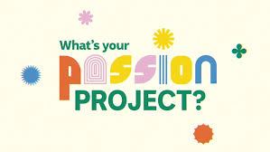
We're inviting schools around the country to tell us what their passion project is. Amazing artistic achievements? Super sporting success? Terrific technological triumphs? Enthusiastic environmental education! It could be anything but make sure it's something your whole class or school is buzzing about. We'll choose the best pitches and help you turn them into BTN stories to share with other kids around Australia.

EPISODE 33
18 November 2025

KEY LEARNING
Students will learn more about COP and the role young people can play to help fight climate change.

CURRICULUM
HASS – Year 4
Propose actions or responses to an issue or challenge that consider possible effects of actions

Science – Years 5 & 6
Investigate how scientific knowledge is used by individuals and communities to identify problems, consider responses and make decisions

Science – Year 7
Examine how proposed scientific responses to contemporary issues may impact on society and explore ethical, environmental, social and economic considerations

  - Teacher Resource

COP30

Focus Questions
Discuss the BTN story as a class and record the main points of the discussion. Students will then respond to the following:
- Where is COP30 being held? Find on a world map.
- What does COP stand for?
- What are the main issues leaders will be talking about at COP30? Name 2.
- What is the Paris Agreement?
- What message would you like to send to world leaders about fighting climate change?

Activity: Class Discussion
Discuss the BTN COP30 story as a class using the following questions to guide discussion:
- What is the aim of the COP30 meeting?
- Give examples of human activity that are causing the increase in carbon dioxide in the atmosphere.
- What is meant by net zero emissions?
- What are the consequences of not taking action on climate change?
- Do you think Australia is doing enough to address the problem of climate change?
- Why is it important for young people to be involved in events like COP?

- What message would you like to send to world leaders about fighting climate change?

Activity: Key words
Students will brainstorm a list of key words that relate to the BTN COP30 story. Here are some words to get them started.

GREENHOUSE EFFECT | NET ZERO | EMISSIONS
PARIS AGREEMENT | CLIMATE CHANGE | GLOBAL WARMING

Ask students to write what they think is the meaning of each word (including unfamiliar words). They will swap definitions with a partner and ask them to add to or change the definition. Check these against the dictionary definition.

Activity: Taking Action on Climate Change
Students will investigate ways that they can be part of the solution to reduce the effects of climate change. Discuss with the class ways to reduce the effects of climate change. What can be done on a global, national and local level? What changes can be made in our homes and schools to reduce emissions?

Reducing greenhouse gas emissions is the key to reducing the impact of climate change. This means getting most of our energy from a range of renewable energy sources instead of burning fossil fuels. Students can choose to research a clean energy technology in more detail and explain how it works and whether the technology is being used in Australia.

Ask your students ‘What can we do and why is it important to get involved in tackling pollution?’. Record students’ responses on a mind map. Ask students to think about ways their school and home can reduce energy demand, become more energy efficient and incorporate renewable energy sources.

Students can undertake one or more of the following activities:
- School energy audit – track your school’s energy usage and calculate your carbon emissions. How can your school reduce its carbon emissions? For example, turn of lights when not in use, turn off computers at the end of the day, find alternatives to driving to school, buy locally sourced seasonal food and reduce your waste. Share your results with the school community.
- Does your school have solar panels? If not, conduct a study and present it to your school.
Research the benefits of using solar energy at your school. Does your school have a plan to reduce its carbon footprint? If so, find out what your school’s targets are in reducing its carbon emissions. Would installing solar panels reduce your schools carbon emissions? Explain.
- Write letters to local or federal politicians expressing your school’s views on greenhouse gas emissions and its impact on communities, plants and animals in your local area.
- Invite a scientist to visit your school to talk about the effects of global emissions and ways the community can make a difference.
- Contact your local council and/or schools in your area to share ideas on how your community can reduce their greenhouse gas emissions.

Activity: BTN stories
Watch one of the following BTN stories to learn more about what young people are doing to help the environment. After watching any one of the BTN videos ask students to respond to the discussion questions (to find the teacher resources go to the related BTN Classroom Episode and download the Episode Package).

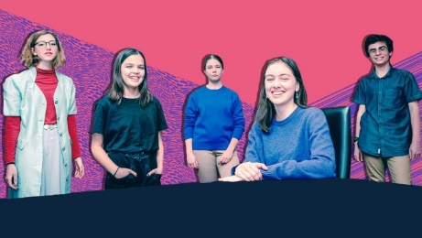  Climate Change Court Battle |   Teen Waste Recycler |   World Clean-up Day
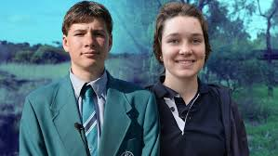  Young Conservationists | 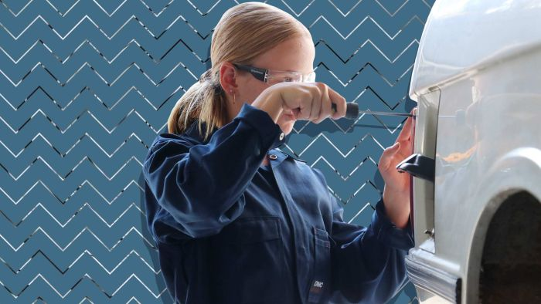  Electric Car Class | 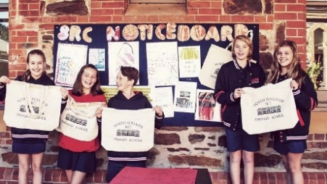  War on Waste School

Useful Websites
- Net Zero - BTN
- COP29 – BTN
- What can we expect from COP30? – Newsround
- Understanding Climate Change – BTN

EPISODE 33
18 November 2025

KEY LEARNING
Students will learn more about Australian artist Hans Heysen and respond to his artwork.

CURRICULUM
Visual Arts – Years 3 and 4
Explore where, why and how visual arts are created and/or presented across cultures, times, places and/or other contexts.

Use visual conventions, visual arts processes and materials to create artworks that communicate ideas, perspectives and/or meaning.

Share and/or display artworks and/or visual arts practice in informal settings.
Visual Arts – Years 5 and 6
Explore ways that visual conventions, visual arts processes and materials are combined to communicated ideas, perspectives and/or meaning in visual arts across cultures, times, places and/or other contexts.

Use visual conventions, visual arts processes and materials to plan and create artworks that communicate ideas, perspectives and/or meaning.

Select and present documentation of visual arts practice, and display artworks in informal and/or formal settings.

  - Teacher Resource

Hans Heysen

Focus Questions
Discuss the BTN story as a class and record the main points of the discussion. Students will then respond to the following:
- What kinds of paintings is Hans Heysen best known for?
  - Landscape
  - Abstract
  - Portrait
- What landmarks in Australia are named after Hans Heysen? Name one.
- Where was Hans Heysen born and where did he grow up?
- What did you learn about Hans Heysen?
- What did you like about this BTN story?

Activity: Class Discussion
Discuss the BTN Hans Heysen story as a class using the following questions to guide discussion:
- Before watching the BTN story, had you heard of Hans Heysen? What did you know about him?
- Where is Hans Heysen from and where did he grow up?
- How would you describe Hans Heysen’s art?

- What are the subjects of his art?
- What themes does Hans Heysen explore in his work?
- What are some interesting facts about Hans Heysen?
- What questions do you have about Hans Heysen?


What questions do you have?
Discuss the story as a class

Activity: Connection to Environment
In this activity students will explore the symbolism, importance and features of the eucalyptus tree in Hans Heysen’s paintings. Students will look at Heysen’s key artworks to understand how he communicates place, identity and connection to the environment.

Responding to art
Show 2-3 key pieces of Hans Heysen’s artworks to your class that feature the iconic eucalyptus landscapes. You may want to print out copies for your students or display them using your class whiteboard. Below are some examples.

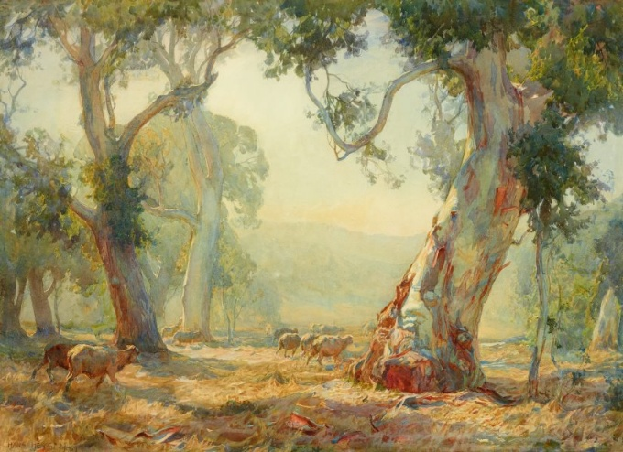  Art Gallery NSW  Hans Heysen, Summer | 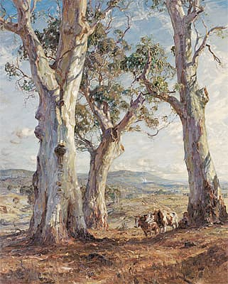  National Gallery of Australia  Hans Heysen, The three gums
Discuss why the eucalyptus tree is symbolic of the Australian landscape. Ask your students the following questions as they look at the artworks.
- What do you first notice in this painting?
- How does Hans Heysen use light and shade to make the trees feel peaceful?
- How do these images represent Australia?

Students will then work individually or in pairs to analyse one Hans Heysen artwork in more detail, responding to the following:
- What colours stand out?
- What mood does the painting create?
- What message or story do you think the artist is trying to convey?

Observing your natural environment
Move your class outside to observe the natural environment. It may be the environment of your school grounds or a park nearby. Students will take a pen and piece of paper with them to record their observations, responding to the following:
- Find a place in the environment to sit. Observe the shapes, shadows, textures and colours of the natural elements around you.
- Notice the light where you are, where is it brightest and where are there shadows.
- Write down what you see. Sketch 1-2 studies of a tree, leaf pattern or the shape of the landscape.
- How does being where you are, make you feel?
Create an artwork
Students will create an artwork inspired by their outdoor sketches. Students can base their artwork on one of the following:
- a tree that has meaning to them
- a small landscape scene of the school yard
- a symbolic drawing showing how they feel in nature.

Curate an art exhibition
Students will curate an art exhibition of their landscape artworks. As a class use the following questions to help plan your class exhibition:
- Where will it be? You could hold it at school and invite other classes to attend or consider another location in the local community.
- What are the dates of your exhibition?
- How will you label your artworks? Include the following information: a title, artist name, date and a description. Here is some more information about Exhibition labelling.
- Who will you invite to the exhibition opening?
- How will you let people know about your exhibition?
- How long will the exhibition run for?
- Are the artworks for sale?

Activity: Timeline Poster
Students will research the life and achievements of artist Hans Heysen and create a timeline poster and prepare an oral presentation summarising key events in Hans Heysen’s life. Alternatively, students can choose a different Australian landscape artist to investigate, for example, Albert Namatjira, Mary Tonkin, Tom Roberts, Frederick McCubbin, Arthur Streeton or Sidney Nolan.

Timeline Poster
Your students’ task is to create a timeline poster, responding to the following areas of research.

Research
- Early Life - Information about your significant person’s parents. When/where was your significant person born? What type of education did your significant person receive?
- Family - Personal information; Was your significant person married? Did they have children?
- Legacy - What event and/or action led to them becoming a significant person in Australia’s History? What did they do that had an impact on the lives of others?
- ‘Where are they now?’ If your significant person has died, you can outline where they are buried. If they are still alive you can outline what their life looks like now.
- 2 x ‘Interesting Facts’ and 2 x ‘Did You Know?’
- A minimum of 6 and a maximum of 10 photos with captions.
- Include a bibliography on the back of your poster.

Oral Presentation
Students will prepare a short oral presentation, speaking in ‘first person’. They will speak about their life, their family, character, the decisions they made and why, and their impact and influence on society.

Further Research
Students will choose one of the activities to further investigate their significant person.

Interview
- Imagine you could sit down and talk to the person.
- What questions would you ask about their life and achievements?
- Find answers to your questions.

5 w’s
- What are some of the key events in their life?
- Write a summary for one key event, which answers the 5 W’s – Who, What, Where, When and Why?

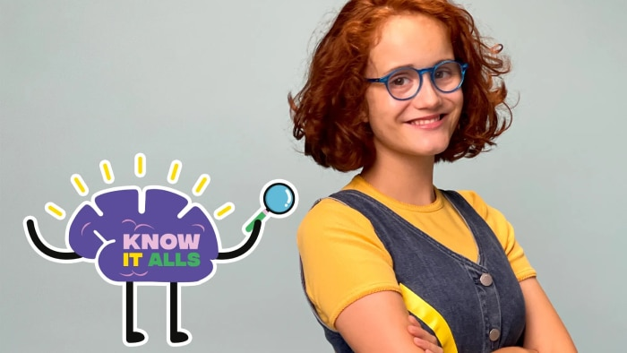
ABC iView
In this fun ABC series, one smart kid and one adequate adult embark on a fact-finding mission through all things “art”. Who will be declared the Know It All in the quiz: the kid or the adult?

ABC iView - Know It Alls: Visual Art


BTN The Arts collection
Visit BTN’s collection of stories which focus on the arts. After watching any one of the BTN videos ask students to respond to the discussion questions.

BTN - The Arts collection

Useful Websites
- Hans Heysen – Heysen the Cedars
- Hans Heysen – National Gallery of Australia
- Sir Hans Heysen – SA History Club
- Hans Heysen – Australian Dictionary of Biography
- Sewing (The Artist’s Wife) by Hans Heysen – National Museum Australia
- Hans and Nora Heysen: Two Generations of Australian Art – NGV

  - Teacher Resource

BTN Transcript: Episode 33 – 18/11/2025

Yaama. I'm Jack Evans and you're watching BTN. Here's what's coming up. We find out how an edit got the BBC into big trouble. Learn why streaming services are set to get a bit more Aussie. And take a trip through the fascinating history of toilets.

COP30

Reporter: Justina Ward

INTRO: But, first, we're going to Brazil, where world leaders have gathered for COP, the UN's annual climate conference. Justina found out what it's all about and met some young Aussies taking part.

JUSTINA WARD, REPORTER: Welcome to Belém, Brazil. A city in the heart of the Amazon rainforest which for the past week has hosted world leaders, royalty, and these guys.
NATASHA: Hi BTN. My names Natasha.
ISY: My name's Isy.
TJ: And I'm TJ, and we're from the Australia Youth Climate Coalition.
COP stands for 'Conference of the Parties'. It's the UN's annual global climate meeting and this is the 30th one.
JUSTINA: What does it feel like being there?
NATASHA: I think being next to the Amazon is pretty surreal. It's quite amazing to see the amount of indigenous groups coming out of the Amazon to COP30 and being represented here and making their voices heard.
TJ: Being in a rainforest area, you can kind of imagine the kind of weather that we're facing here. So, we're very hot ‘cause we had to run from one side of the venue to the other. But I guess that just goes to show, I guess the how large this conference is and just how important the stakes are because of how many countries are here to talk about I guess our future in this world.
Yeah, the world is facing some big problems, greenhouse gasses are climbing which is pushing up global temperatures and putting the planet at risk.
JUSTINA: So, what are the main issues this year at COP30?
ISY: This COP we're really discussing 'Just Transitions' and 'global climate finance'. So there’s talks of pulling together $1.3 trillion to finance developing countries when things like climate disaster strike their countries. So really preparing them for the future.
Some countries are particularly vulnerable to the effects of climate change for example the Philippines is considered one of the most disaster prone countries in the world they've recently seen 2 deadly typhoons in the span of a week.
NEWS REPORTER, ABC: It's the 21st typhoon to hit the Philippines this year.
NEWS REPORTER, CBS: fierce winds and heavy rain has displaced more than a million people.
Experts say unless we make some big changes, we're likely to see more frequent and more intense disasters like this.
ANTONIO GUTERRES, UN SECRETARY-GENERAL: The challenge is immense, but the choices are clear. No one can bargain with physics, but we can choose to lead or be left to ruin.
Ten years ago, 195 countries, including Australia, signed what's known as the Paris Agreement pledging to cut emissions to try to limit global warming to 1.5°C. But climate experts warn we're way off track and now the US one of the world's biggest greenhouse polluters has dropped out of the Paris Agreement.
SIMON STIELL, UNFCCC EXECUTIVE SECRETARY: The hole that was left by the U.S. contributed around 20% of our overall budget has been filled through philanthropy.
But despite the challenges people here at COP say there is some good news, for example, Brazil's leader says he's working together with other countries to protect and even replant the Amazon.
LUIZ INACIO LULA DA SILVA, BRAZILIAN PRESIDENT: In the global imagination, there is no greater symbol of the environmental cause than the Amazon rainforest.
Australia has put in a bid to host next year's COP, which these guys say could help to draw attention to environmental issues in our part of the world.
NATASHA: COP is a big opportunity in the Australian Pacific to actually get the public talking about climate again, and to actually increase the ambition of climate action for our own government.
TJ: I think it's important for all our futures to continue to engage with these conferences so that we can continue to hold the line and fight for the future for our young people that we that where no one gets left behind.

News Quiz

Dozens of schools in Australia and New Zealand have closed after a mineral called asbestos was found in what? It was coloured, decorative sand. Asbestos was found in the sand, which was sold at shops and used at many schools and childcare centres. Asbestos can make people sick if it’s inhaled, but authorities say that’s really unlikely.

JACQUELINE AGIUS, WORKSAFE ACT: The risk to our children and our community is low, according to the test results that we currently have.

As a precaution, some schools were closed or partially closed. People who bought it were told to seal it up and take it to be disposed of safely.

Which Aussie state has become the first to pass a treaty with First Nations people? It’s Victoria. Australia’s the only Commonwealth country that doesn’t have a treaty, or formal agreement, with its Indigenous people and that’s something many people have been trying to change.

PROTESTOR: What do we want?
CROWD: Treaty.
PROTESTOR: When do we want it?
CROWD: Now!

The Victorian treaty with give more powers to the state’s First Nations representative body which acts as a voice to parliament consult on laws and policies affecting Aboriginal Victorians.

NGARRA MURRAY: Today marks a turning point in our nation's history, a moment where old wounds can begin to heal.

America is back open. The USA’s longest ever shutdown has ended after how many days? 13 days, 23 days or 43 days? It was 43 days. Hundreds of thousands of government workers have gone without pay because America’s two main political parties couldn’t agree on a plan to spend the government’s money. The Democrats wanted the Republicans to agree to some changes designed to make health insurance more affordable. But last week a group of them decided enough was enough and the bill passed.

The sky lit up last week in parts of Australia with a display of Aurora Australis. What causes this colourful phenomenon? It is an exploding star, the moon moving in front of the sun or a solar storm. It’s a solar storm.

DR KIRSTEN BANKS, ASTROPHYSICIST: And they happen when the sun lets out a lot of charged particles towards the Earth, and those particles interact with our atmosphere and the particles in OUR atmosphere, making them get energised, which is the actual physics term for it. And then they release light and these beautiful colours.

BBC Edited Interview

Reporter: Wren Gillett

INTRO: Next to some trouble at the BBC. It's the UK's national broadcaster and last week its boss resigned over claims a current affairs show had unfairly edited together parts of a speech made by the US President. Wren found out why that's a journalism no-no.

So, you want to be a journalist, huh? I mean fair enough; it's a pretty good gig. You get to meet cool people, learn new things all the time, and act as an agent of the fourth estate speaking truth to power and safeguarding democracy. Ya ready?
POPPY, STUDENT JOURNALIST: Good afternoon, it's Poppy, reporting here from Prospect North Primary School, in the classroom of Ms Hideout.
KATHERINE RIDEOUT, TEACHER: Poppy, you've been in my class all year, it's Rideout.

WREN GILLETT, REPORTER: Wait, wait, wait. First things first, you need to get your facts straight.
NEWS GRABS: The US Capitol ... 7-5 ... over specific wording in the deal … Aukus submarine pact.
Names, numbers, dates, these have to be accurate. Otherwise, how's anyone supposed to believe anything else you say?
POPPY: Breaking news, we've had reports that Ms Rideout is failing students unfairly.
RYAN, STUDENT: It's so unfair, she gave me another F. My parents are gonna be so mad when I get home, they're gonna kill me.
POPPY: Poppy, reporting for PNTV.
WREN: Hang on. You're only interviewing one person?

POPPY: Yeah.
Yeah, journalists have to make sure they have clear evidence to support the stuff they say. This means looking at all the facts and considering different points of view.

STUDENT: Oh my gosh, I got an A.
STUDENT: She's the best, I love Ms Rideout.
You also have to be fair and give people a chance to defend themself.
POPPY: Today, I'm investigating the toilets here at Prospect North. Last night, cleaners found a big mess in there, and they're trying to figure out who did it.
KAT: Ummmm, why are you filming me?
WREN: Hang on. This is a bit misleading. It kinda makes it look like Ms Rideout made the mess.
KAT: Which I didn't.
You see, it's not just what we say that matters, what we show is important too. Journalists have to think carefully about the shots we use, what graphics we include, even the background music.

KAT: Why are you filming me?
WREN: We also have to think about what we include in a story and what we take out. Last year, the BBC aired a documentary which showed this clip of US President Donald Trump speaking outside the Capitol building on January 6th, 2021.
DONALD TRUMP, US PRESIDENT: We're gonna walk down to the Capitol. And I'll be there with you. And we fight. We fight like hell.
Except, it's not actually what he said:
DONALD TRUMP: We're gonna walk down to the capitol, and we're gonna cheer on our brave Senators and Congressmen and women.
The documentary took two parts of President Trump's speech and edited them together, making it seem like he was telling people to do this:

[NEWS CLIP OF JANUARY 6TH RIOTS]

While President Trump has been accused of encouraging the January 6th riots, the BBC admitted it had misled people by making it seem like he directly told them to do it. Last week, the head of the BBC and its Head of News quit. And President Trump said he would sue the BBC for defamation, which is when someone suffers because their reputation is harmed by the media. He's asking for up to 5 billion USD. The BBC says it won't be offering to pay him but it has apologised.
TIM DAVIE, FORMER BBC DIRECTOR-GENERAL: What I would say is these times are difficult for the BBC, but they get through them.
POPPY: (Sighs) This job's hard.
Yes, but it's worth it. You got this.
POPPY: Poppy, signing off for PNTV.

Quiz

What nickname does the BBC share with the ABC? Is it Uncle, Aunty or Grandpa? It's Aunty.

Streaming Quotas

Reporter: Jack Evans

INTRO: Now to a story about streaming services in Australia, which are set to get more Australian. The government is trying to pass laws that would make them create a certain amount of Aussie content. Take a look.

ACTOR: Romeo, Romeo, wherefore art thou Romeo?
DIRECTOR: Cut! Do you think you could try it a bit more Aussie? You know, a bit ocker, like, uh... Oh, yeah. Nah. Oh. Strike a light! I know! You know, that sort of thing.
ACTOR: Yeah alright.
DIRECTOR: Action.
ACTOR: Romeo, Romeo, wherefore art thou Romeo?
DIRECTOR: There's nothing like hearing an Aussie accent on the screen is there.
ACTOR: Deny thy father and refuse thy name.
DIRECTOR: So Soothing.
JACK EVANS, REPORTER: For as long as we've had TV in Australia, we've been seeing Australian stories, people and culture reflected on our screens. And since the 1960s we've had laws making sure that's the case. Today Australian commercial television stations have to show at least 55% Australian content between 6 am and midnight on primary channels and 1,460 hours Australian content between 6 am and midnight on their other channels.
But the way we watch tv has changed. A lot of us are now spending a lot of time and money on streaming services like these ones. But at the moment there is nothing forcing them to show Australian stuff and some reckon that could lead to fewer productions that are made in Australia, by Australian people, telling Australian stories.
ACTOR: Are you sure about all this? Romeo and Juliet was set in 14th Century Italy.
DIRECTOR: Oh yeah, yeah, don't over think it just put the hat on. Yeah, there we go.
It's why last week the Minister for the Arts, Tony Burke, introduced a piece of legislation that would, ah, you know what, I'll just let him tell you.
TONY BURKE, MINISTER FOR THE ARTS: Today the Albanese Labor government is legislating for streaming services to have guaranteed Australian content.
If it becomes law, it would mean streaming services that have at least a million Australian subscribers will have to Invest a minimum of 10% of all that they spend on programs available here in Australia on making Australian dramas, kids shows, docos, arts or educational programs.
TONY BURKE: Australian stories play an important role in shaping Australia's national identity, fostering social inclusion and encouraging cultural expression.
DR DAMIEN O'MEARA, LECTURER MEDIA & COMMUNICATIONS: If you are not from the kind of dominant represented class in Australia how do you get a sense of belonging? Part of that is in seeing yourself on screen.
DR ALEXA SCARLATA. SCHOLAR MEDIA & COMMUNICATIONS: Hearing your own accent and seeing your own kind of community and suburb and things that are kind of culturally significant and legible to you is really, really important.
As for the streaming services, well not all are on board with the idea and say that they already show a fair bit of Aussie content.
TONY BURKE: This legislation is not a criticism of the streaming businesses in Australia. This bill will guarantee Australians will have access to Australian stories, now and into the future. It will ensure that no matter which remote control you're holding, Australian stories will be at your fingertips.
DIRECTOR: Ok we've had a bit of a rewrite. Instead of Romeo his name is now Rocko and you're gonna be calling for him from the back of your ute.
ACTOR: Where are we gonna get a ute from?
DIRECTOR: Errr, we’ll fix it in post. And action!
ACTOR: Rocko, Rocko, wherefore art thou Rocko?
World Toilet Day

Reporter: Justina Ward

INTRO: Now, have you ever thought wow, toilets are a pretty amazing invention? Well, you wouldn't be wrong. It's why the UN created World Toilet Day on November 19th; to spread the message that toilets actually save lives by doing a messy but vital job. Here's Justina.

TRISH: (Screams)
WREN: (Screams) Sorry, I didn't... I didn't know you were in here, there.
TRISH: Oh, no, I wasn't. Name's Trish. Toilet time traveller.
WREN: Huh. I'll just use the other one. Wh-what are you doing? Pwoah. Where are we? Errr, was that what I think it was?
TRISH: Whoopsies I think we're inside a cesspit.
WREN: A cesspit?
TRISH: Yeah, a big hole that people do their business in. It's one of the oldest forms of toilets there is. A lot of people still use it today.

(FARTING NOISES)

Oh! Incoming!

Ah, Mesopotamia, 3000 BC. Already they were messing around with indoor toilets and clay pipes.
WREN: Oh, good I'm bust… uuuoooo
TRISH: Hawww, now, this is a toilet.
WREN: Where are we now?
TRISH: Ancient Rome. These guys had sewer systems and public latrines like this one, and a communal spongey stick to clean up afterwards.
WREN: Ooo, nahhh I’ll wait.
TRISH: Eh.
WREN: Wait, where are we now?
TRISH: Looks like a castle in the Middle Ages.
WREN: Eugh! What was that?
TRISH: Unlucky. We're right under a garderobe.
WREN: What's a garderobe? Do I even wanna to know?
TRISH: Well, it's a little room where you do what you got to do, and it all comes out of a little hole in the bottom. Or sometimes people did their biz in chamber pots and chucked it out the window. Lots of European cities had open drains or gutters that would carry all your pees and poos right down the street.
WREN: Didn't that make people sick?
TRISH: Sure did. But it got better. Here we are in the 19th century. We've got underground sewage pipes and flushing toilets like this beauty here. They'd actually been around for a couple of hundred years, but it took a while to catch on.
WREN: Great. Problem solved. Now I really, really, really, really need to go to the toilet.
TRISH: No, not problem not solved.
WREN: Whyyyy.

TRISH: While toilet technology has come a long way, and we've learned a lot about hygiene a lot of people still don't have access to them. The United Nations says around 3.4 billion people, which is nearly half the world's population, don't have access to safe and clean toilets or clean soap and water to wash their hands. And that's why every year we celebrate World Toilet Day. It was started by the UN to make people pay attention to how important it is to have one of these when you need it.
WREN: I do. I do. I really need the toilet. Oh, thank goodness for that. Arghhh.

Did you know?

Did you know the most expensive toilet ever built cost more than $30 million? And it's not this gold one or this diamond encrusted beauty. It's this one on the ISS.

Sport

Apparently good things come in threes, and that's definitely true for Carlton's Sophie McKay who kicked 3 massive goals against Hawthorn in the weekend’s AFLW semi-finals. And finished it off with this cheeky celebration.
COMMENTATOR: She's done the fake shoulder dislocation into the shimmy this time.
And with a 79-33 win secured, Carlton are off to the prelims and will take on the Brisbane Lions.
Over now to the Women's Big Bash league where the Sydney Sixers have secured a 24-run win over the Sydney Thunder.

COMMENTATOR: Chopped it on, she took a walk.

And also hitting the magic number, 16-year-old Caoimhe Bray stole the show and claimed a hat-trick.

COMMENTATOR: Absolutely brilliant. Who else?

Only, she didn't even know she'd done it…

COMMENTATOR: Yes, a hat-trick.

…until her teammates gave her this nice new hairdo.
CAOIMHE BRAY: It’s pretty crazy as you can tell by the reactions I didn't realise I had a hat-trick - it’s really exciting and I’m glad we away with a win.
Speaking of hat-tricks…

COMMENTATOR: Here comes Parrott.

striker Troy Parrott has kept Ireland's 2026 FIFA World Cup dreams alive. While the team trailed 2-1 to Hungary at the 80th minute in the World Cup qualifier match, Parrott scored his second and then his third goal to secure a 3-2 win...

COMMENTATOR: A dropping ball is touched home.
as well as Ireland's place in the playoffs for next year's tournament.

COMMENTATOR: A moment when dreams come true.

I told ya good things come in threes.
Hans Heysen

Rookie Reporters

INTRO: Finally today we've got another passion project, which is when you tell us what's important to you. Some students from East Adelaide Primary are going to tell us how they're sharing the story of a famous former pupil. Check it out.

AUDREY: My name is Audrey.
AMY: I'm Amy.
CHRYSTALLIA: And I'm Chrystallia.
AMY: And today, we'll be telling you about,
ALL: Hans Heysen.
AUDREY: His real name is really long, it's Sir Wilhelm Ernst Hans Franz Heysen OBE. That's really long.
CHRYSTALLIA: He's one of Australia's most famous landscape artists.
AMY: When you look at a Hans Heysen painting, you see gum trees, animals, flowers and lots of nature.
AUDREY: Even if you don't know his paintings, you might have heard his name. There's the Heysen Tunnel, the Heysen Trail. There's a community called Heysen. There's the Heysen Range.
AMY: Heysen was born on the 8th of October 1877, in Hamburg, Germany. And moved to Adelaide when he was 7.
CHRYSTALLIA: That was a time when a lot of other Germans were moving here. That's why we have a lot of German towns like Handorf.
AMY: Walking or driving into Handorf you can hear German music playing and see lots of German culture. When Heysen was young, he worked at his father's grocery store, painted at Norwood Arts School and went into the Hills often to collect stuff for his father’s business. He was fascinated by them and went and painted there for a long time.
CHRYSTALLIA: Hans Heysen went to Europe to study art, and then came back to live in Hahndorf where he thought it was very beautiful.
AUDREY: Before he was a famous artist, he was a conservationist and he protested to not, like, destroy the Ghana land and the trees. He showed that the land was really precious and beautiful with his paintings and his style of art. And guess what. He, Heysen, went to our school.
ALL: This is the Heysen building.
AUDREY: The Heysen building was built in 1885 and was the first building to be built at our school.
AMY: The Heysen was bult because Norwood and Walkerville primary schools were overflowing, so the government decided to build our school.
CHRYSTALLIA: This building has changed a lot over the past years, but this is where Hans Heysen would have had all his lessons.
AMY: He's inspired me to keep going through my art and try different types like still life, which is one of my favourites.
AUDREY: Our class, we believe it's important to preserve the history of our school so that we don't forget about it.
CHRYSTALLIA: Thanks for visiting our school.
AMY: And learning the story of Hans Heysen.
AUDREY: Bye BTN.
ALL: Bye.

Closer

Well, that's it for BTN this week but we'll be back before you know it. And if you miss us in the meantime, you can check out BTN Newsbreak every weeknight or jump on our website to check out all the good stuff we've got online. Have an awesome week and I'll see you next time. Bye.

