Episode 11
7th May 2019



Parliament Anniversary
- Discuss the Parliament Anniversary story as a class and record the main points of the discussion.
- Complete this sentence. Before Federation, Australia was divided into 6 different British __________.
- What year did Australia become the Commonwealth of Australia?
- Who is the Head of State in Australia?
- Who was Australia’s first prime minister?
- In which city was Australia’s first Parliament House opened?
- Where is Australia’s current Parliament House?
- What year was Australia’s current Parliament House opened?
- Describe what Parliament House looks like.
- What did you learn watching the BTN story?

Capital City Move
- Retell the BTN Capital City Move story using your own words.
- How many countries are there in the world?
- Canberra was built specifically to be Australia’s capital. True or false?
- What is the capital of the Netherlands?
- Which country doesn’t have a capital city?
- How many capital cities does South Africa have? Name one.
- What was the capital city of Russia before it became Moscow?
- Why did Brazil build a new capital city Brasilia to replace Rio De Janeiro?
- How much of Jakarta will be under water by 2050?
  - 15%
  - 59%
  - 95%
- What do you understand more clearly since watching the BTN story?

Check out the Capital City Move resource on the Teachers page.

History of Jazz
- Before watching the BTN story discuss in pairs what you know about jazz music.
- Briefly summarise the BTN History of Jazz story.
- What is scatting?
- Where did jazz music originate? Find using Google Maps.
- In what decade did jazz music become popular in the US?
- What influence did jazz music have on people?
- Name a jazz musician that featured in the BTN story.
- Which well-known jazz musician was in Sydney for International Jazz Day?
- Where in Australia did students recently take part in the Annual Generations of Jazz festival?

- What did you like about the BTN story?
Get your class involved in BTN’s Ask A Reporter! This week’s topic is the History of Jazz.
Kids’ News Service
- Discuss the BTN story with another student.
- Where in Australia does Jack go to school? Find using Google Maps.
- AC News only covers local issues. True or false?
- What year did the kids in the BTN story start their news service?
- What news story did AC News cover that was a bit of a shock to the community?
- How has the AC News website given more students the opportunity to get involved?
- When do the students get time to make bulletins for AC News?
- How will working on AC News help the students in the future?
- What was surprising about this story?
- If you were a reporter what would you report on?

Check out the Kids’ News Service resource on the Teachers page.

Teacher Resource
Episode 11
7th May 2019

History of Parliament

Students will learn more about the history of parliament in Australia.


Civics and Citizenship – Year 6
The key institutions of Australia’s democratic system of government and how it is based on the Westminster system.

History – Year 6
Key figures, events and ideas that led to Australia’s Federation and Constitution.
- Discuss the Parliament Anniversary story as a class and record the main points of the discussion.
- Complete this sentence. Before Federation, Australia was divided into 6 different British __________.
- What year did Australia become the Commonwealth of Australia?
- Who is the Head of State in Australia?
- Who was Australia’s first prime minister?
- In which city was Australia’s first Parliament House opened?
- Where is Australia’s current Parliament House?
- What year was Australia’s current Parliament House opened?
- Describe what Parliament House looks like.
- What did you learn watching the BTN story?


What do you see, think and wonder?
After watching the BTN Parliament Anniversary story, respond to the following questions:

- What did you SEE in this video?
- What do you THINK about what you saw in this video?
- What did you LEARN from this story?
- What was SURPRISING about this story?

Key Words
Students will develop a glossary of terms that relate to the history of parliament in Australia. Below are some key words to get them started:

Federation | Constitution | Senate
House of Representatives | Westminster System | Parliament
History of Parliament House
Students investigate the history of Parliament House using the questions below to help guide their research.

- How and when did Canberra come to be Australia’s capital city?
- When and where did Australia’s Federal Parliament first meet?
- When was Australia’s ‘new’ Parliament House built?
- Where is it located?
- Who officially opened the building?
- Who designed the building and how long did it take to construct?

Organise history through pictures
Find and collect images, photographs and illustrations that represent the history of Australia’s Parliament House. Students may want to organise and sequence their pictures in the form of a timeline.

Refer to the following websites for sources of information.
- The National Archives of Australia
- Parliament of Australia
- Parliamentary Education Office

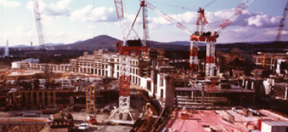
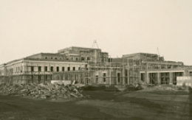
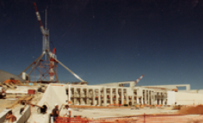
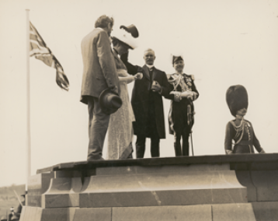
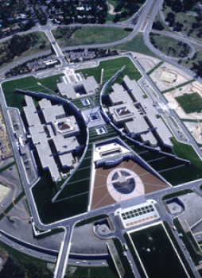
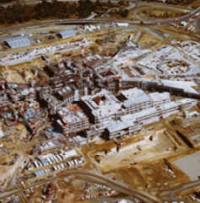

Images: Parliamentary Education Office

The Nation’s Capital
A point that couldn’t be agreed on by the six colonies was the location of the nation’s capital. Both Melbourne and Sydney claimed the right to be the capital. A compromise was reached where a separate capital city would be created. Ask students to research and respond to the following questions:

- Which city was the temporary capital until a new city was established?
- What historical events led to the decision to create a new city as a capital?
- How was the location selected?
- What other locations were considered
- What are the advantages and disadvantages of Canberra being chosen as the nation’s capital?
BTN Federation story
Watch the BTN Federation story and answer the questions below.

- Before Federation, Australia was divided into six separate ______________.
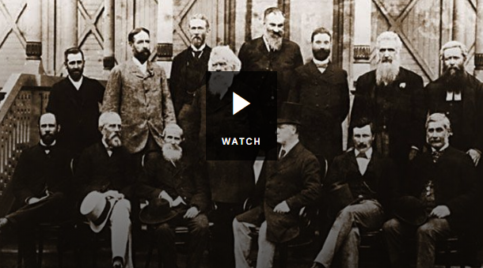
- Which other country might have been part of Australia?
- Who was Henry Parkes?
- What was his famous speech about?
- Why were initial attempts to become a Federation rejected?
- What role did Alfred Deakin play in Australia becoming a Federation?
- In what year did Australia become a nation?
- Who was Australia’s first Prime Minister?


PEO – The First Parliament
https://www.peo.gov.au/learning/closer-look/short-history/the-first-parliament.html
Parliament of Australia – History of Parliament House
https://www.aph.gov.au/Visit_Parliament/Things_to_Do/Take_in_some_history
BTN - Parliament House
http://www.abc.net.au/btn/classroom/parliament-house/10529908
BTN – Federation
http://www.abc.net.au/btn/classroom/federation/10528704
Museum of Democracy Old Parliament House – Parliament
https://explore.moadoph.gov.au/timelines/parliament?_ga=2.149307829.202059.1556604572-1296603443.1556604572

Teacher Resource
Episode 11
7th May 2019

Capital City Move
Students will explore the geographical diversity of cities around the world. Students will investigate the impact of rising sea levels on people and the environment.

HASS – Year 5
The environmental and human influences on the location and characteristics of a place and the management of spaces within them.

HASS – Year 6
The geographical diversity of the Asia region and the location of its major countries in relation to Australia.

Geography – Year 7
The quantity and variability of Australia’s water resources compared with other continents

Causes, impacts and responses to an atmospheric or hydrological hazard.

The influence of accessibility to services and facilities on the liveability of places.

Develop geographically significant questions and plan an inquiry, using appropriate geographical methodologies and concepts.

- Retell the BTN Capital City Move story using your own words.
- How many countries are there in the world?
- Canberra was built specifically to be Australia’s capital. True or false?
- What is the capital of the Netherlands?
- Which country doesn’t have a capital city?
- How many capital cities does South Africa have? Name one.
- What was the capital city of Russia before it became Moscow?
- Why did Brazil build a new capital city Brasilia to replace Rio De Janeiro?
- What percentage of Jakarta will be under water by 2050?
- What do you understand more clearly since watching the BTN story?

Class Discussion
Before watching the BTN Capital City Move story, ask students to make a list of as many capital cities as they can. Students will then discuss (in small groups) how they think capital cities are chosen, recording their responses. Students will compare and contrast their responses as a class. After watching the story discuss as a class using the following questions to guide discussion:

- What did you SEE in this video?
- What does this video make your WONDER?
- What did you LEARN from this story?
- How did this story make you FEEL?


Topic for inquiry
Students will develop their own question/s for inquiry, collecting and recording information from a wide variety of sources. Students may develop their own question for inquiry or select one or more of the questions below.
- Why does the Indonesian government want to change its capital city?
- What country do you think the Indonesian government should choose as its new capital city? Give reasons.
- Look at other countries that have changed their capital cities. Choose one to research in more detail and explain why its capital city was changed.

City profile
Students will explore Jakarta in more depth and use this template to record the information they find. Alternatively, students may choose any capital city in the world to explore in more detail and then compare and contrast their findings with their classmates.

Area - size

Latitude and longitude
Population

Map
Geography – physical features, climate, environment and population.
Government – who is the leader?
The people, language, culture, customs, beliefs and food.

Interesting facts about this city…
City Profile - Jakarta

Visual literacy
Below are images of different cities around the world that are vulnerable to rising sea levels. Students will observe, analyse and query the images and respond to the following questions.

- Write a short paragraph describing what you see in the image. Describe the environment.
- Where was the photo taken?
- What do you think is happening?
- How does the image make you feel?
- What does the image tell you about the impact of climate change on cities?
- Create a caption for each image.

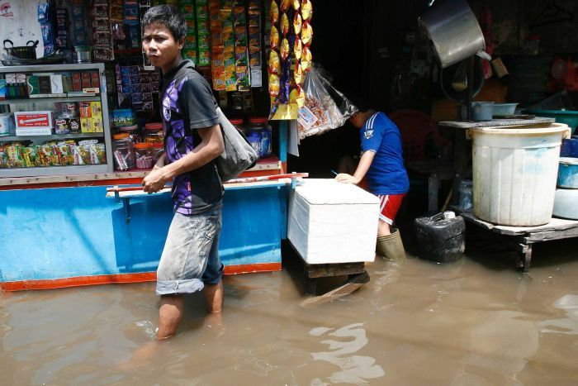  ABC News - Reuters: Supri Supri | 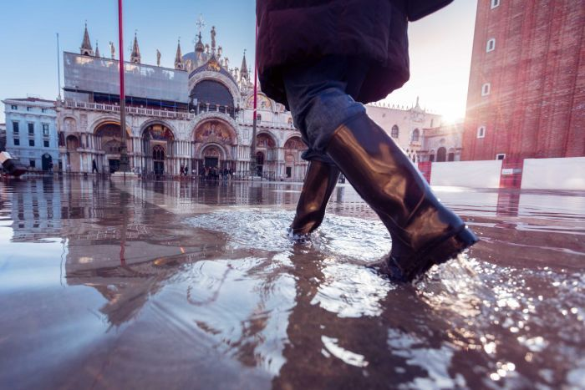  ABC News - Getty: Nullplus
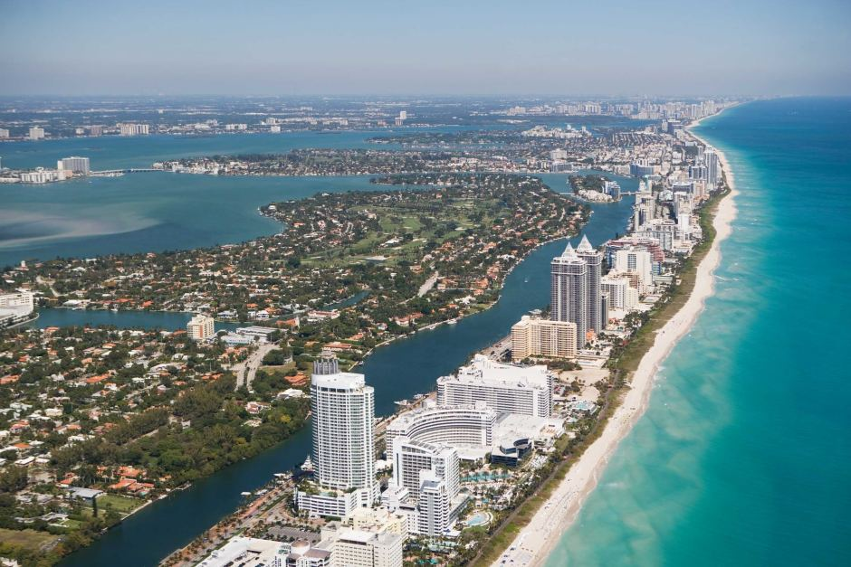  ABC News - Getty: Fotog | 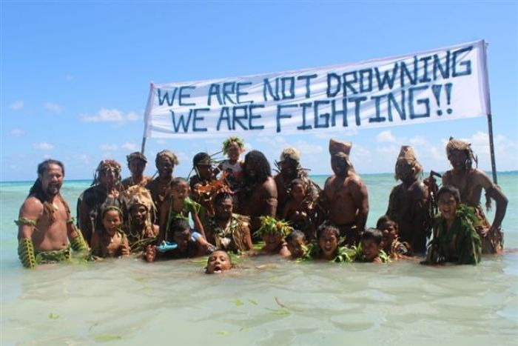  ABC News - Te Mana: Litia Maiava

Further investigation
- Imagine you are a scientist examining the impact of rising sea levels. Explain why sea levels are rising and the impact it has on people and the environment. In your description include the following terms: sea level rising, climate change, ocean temperature.
- Could rising sea levels have been avoided? Research the different ways people are preventing climate change and rising sea levels.

ABC News – Indonesia’s capital to be moved from Java, Planning Minister says
https://www.abc.net.au/news/2019-04-29/jakarta-to-no-longer-be-capital-of-indonesia-planning-minister/11056306

ABC News – Cities are sinking – and experts say we’re not doing enough to save them
https://www.abc.net.au/news/2018-11-17/cities-are-sinking-so-what-are-we-doing-about-it/10503924

Teacher Resource
Episode 11
7th May 2019

Kids’ News Service
Students will learn more about what makes a good news story and create their own news report.

English – Year 6
Use comprehension strategies to interpret and analyse information and ideas, comparing content from a variety of textual sources including media and digital texts.

Compare texts including media texts that represent ideas and events in different ways, explaining the effects of the different approaches.

Analyse how text structures and language features work together to meet the purpose of a text.

Media Arts – Years 5 & 6
Explore representations, characterisations and points of view of people in their community, including themselves, using settings, ideas, story principles and genre conventions in images, sounds and text.

Plan, produce and present media artworks for specific audiences and purposes using responsible media practice.
- Discuss the BTN story with another student.
- Where in Australia does Jack go to school? Find using Google Maps.
- AC News only covers local issues. True or false?
- What year did the kids in the BTN story start their news service?
- What news story did AC News cover that was a bit of a shock to the community?
- How has the AC News website given more students the opportunity to get involved?
- When do the students get time to make bulletins for AC News?
- How will working on AC News help the students in the future?
- What was surprising about this story?
- If you were a reporter what would you report on?

What makes a good news story?
Students will investigate what makes an event newsworthy. Brainstorm some ideas as a class. Watch the BTN story News Rules to find out what makes news.

Students will put together their own news program. Students will need to include a good balance of stories across different topics (for example: science, politics, world news, environment, arts, sport and human interest).

Respond to the following questions for each news story.
- Why did you choose this story?
- Summarise the main issue/message.
- Is the news story about a current local issue or an issue from the past?
- Where and when did it happen?
- What new information have you found about it?
- Who is affected by the issue?
- How are they affected by the issue?
- Why is it important for people to know about the issue?
- Why will people be interested in watching the news story?

Rookie Reporters
BTN encourages kids to tell their own stories about issues they are interested in or passionate about. Check out these BTN Rookie Reports.

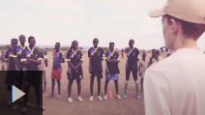


Storm Girl Barefoot to Boots




Young Carer Straw No More Campaign
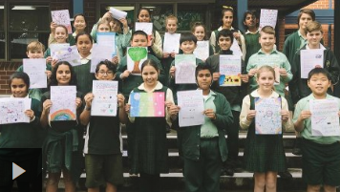
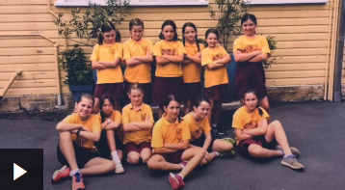

Operation Soy Sauce Letters to Refugees

Students will create a news report about an issue they feel strongly about or someone doing something interesting in their community. Ask students to think about the following:

- What is the story about?
- Why did you choose this story?
- What words would you use to describe this story?
- Describe the main issue/message in the story.
- What makes this story interesting?

Visit BTN’s Rookie Reporter Training to learn more about how to make a rookie reporter video. The How to Make News video also gives some useful tips for making your own news story.

Make a news podcast
Students can share their news stories by creating their own podcasts. Listen to BTN’s news podcast for inspiration.

Steps to create a podcast
- Make sure you have the required hardware and software – you will need a computer or Smartphone with a microphone and software such as the free Audacity (PC or Mac). Some Mac’s come with GarageBand which is well suited to making podcasts.
- Decide on your content and write your script. Who is your audience? How will you keep listeners engaged?
- Rehearse the content (practise speaking).
- Record. Create and save an audio file, usually in mp3 format.
- Publish. To make a podcast you will need to use a free service like PodOmatic, Buzzsprout or a paid service like Libsyn.
- Promote your podcast. Your school's website is a good place to start as well as their newsletter and social media sites.

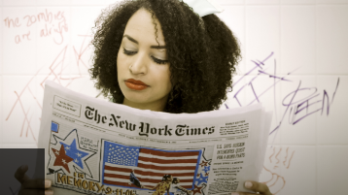
BTN’s Media Literacy Series
BTN has created a series of media literacy videos to help students understand and question news. Topics include; How to Spot Fake News, News Sources, What is News? How to Spot Bias, and Media Ethics. The videos will help students to critically analyse the news they see, hear or read. Please note – these videos are intended for secondary students.

BTN – Rookie Reporters
http://www.abc.net.au/btn/rookiereporter/

BTN – News Rules
http://www.abc.net.au/btn/classroom/news-rules/10533890

BTN – Signing the News
http://www.abc.net.au/btn/classroom/signing-the-news/10525786

Ararat College - AC News
http://acnews.cf/

BTN Transcript: Episode 11 – 7/5/19

Hey. I'm Amelia Moseley and you're watching BTN. Here's what's coming up today. We find out why Indonesia might need a new capital city. Jack gets jazzed up to learn about jazz and we meet some young reporters who are keeping their town informed.

Parliament Anniversary
Reporter: Martin Dougan

INTRO: Well, of course, the big story in Australia at the moment is the election. In just a couple of weeks we'll choose our next federal government. But did you know that this week is actually the anniversary of Australia's very first federal government sitting in Parliament for the first time? So instead of looking to the future of politics, Martin's stepped into Australia's political past.
Who will be the next prime minister? That's the question on everyone's lips right now.

KID 1: I don’t know Scott Morrison? I think he's a pretty cool dude.

KID 2: I don’t know who's in it. So, I don't know.

KID 3: I don't bother with politics.
Here's another timely question. Do you know who Australia's first prime minister was?

KID 1: No Idea.

KID 2: Umm no, that was too long ago.

KID 3: No clue.
MARTIN, REPORTER: Well, let me help you out with that. But first I need to travel back in time. So now we’re in the late 1800s which explains the clobber. Looking good, looking good. So, what is going on in politics? Shall we turn on the TV? No TV. Newspaper it is then.
Back then the hot political topic was Federation. At the time Australia wasn't a country, it was a continent divided into 6 different British colonies. They had their own leaders and different laws. But there were quite a few people who thought the colonies would be stronger together. After a few attempts, a lot of arguing and a lot of negotiating the leaders of the colonies finally agreed to get together and on the first of January 1901, the Commonwealth of Australia was born. They even filmed it which was pretty impressive for the time. Now the new country needed a government.

MARTIN: The constitution set out all the rules for how that would work. The queen or king of the UK would be Head of State represented by the Governor-General. The laws would be made in parliament made up of the Senate and House of Representatives.

It also said that members of parliament would be chosen by the people, although at first voting wasn't compulsory and, in most states, you had to be a male British citizen over the age of 21. By April the results of the election were in Australia had it's very first government. And its very first Prime Minister, Edmund Barton. Remember the name kids. Then, on the 9th of May 1901 there was a very fancy ceremony as Australia's federal parliament was opened in Melbourne. 26 years later there was another very fancy ceremony as Australia’s brand-new Parliament House was opened in its brand new capital, Canberra.
Over the years there were many more elections, many more governments and quite a few political firsts. Parliament grew and changed and in 1988, on the 9th of May again, Australia got another Parliament House, the one we know and love today.
MARTIN: Well guys, there you go. Turns out this Thursday is a pretty important day for Australian democracy. I tell you what I love that hat from the 1800s. Do you think that actually came back with me? I really like that.

And whilst the country prepares to decide how Australia will be run in the future, it’s always worth taking some time to think about how everything started.

Did You Know?

Did you know that Parliament House is full of fossils? They're in the black limestone floor of the marble foyer where you can see fossils of sea life that existed some 345 million years ago.

Election Q & A
Reporter: Annabel Crabb

INTRO: What, how cool is that? Well, now for some more interesting political facts. It's time to check out part two of our election special. The ABC's political whiz, Annabel Crabb, has come in to answer some questions you guys had about elections, politics and politicians. Check it out.

Why do you think people become politicians?
That is an awesome question and sometimes when politics gets really, really weird and shouty and bad, sometimes I think, why do they become politicians? I wouldn't like to do that job. And it can be hard, and it can be frustrating. If you're a politician too you’ve got to get used to people coming up to you in the street and saying you’re an idiot I don't like what you did. So, you’ve got to have a pretty thick skin. But most of the ones that I’ve met are in it because they want to use their abilities to make a difference. Sometimes people get involved in politics because they are a shopkeeper or a unionist or a campaigner for some cause or another or a doctor and they've seen things in their job that they want to be able to fix and so they run for politics to make a difference by making the laws that govern those situations and if you think about it that is a pretty good reason to go into politics because at its best politics can allow you to use your advocacy and your voice to make a difference for other people and to make life better for the country as it goes on and on through history and that's a pretty great motivation.
I wonder how much do politicians get paid?
Politicians get paid really well. So, how much is it exactly. It's like about 250 thousand dollars a year, I think. It changes all the time and they get more if they're a minister. Now that sounds like a huge amount of money and it is, it's heaps of money, but it also is a really demanding job and you have to hand over your whole life to it and often you don't really see your kids that much or your husband or your wife. One thing that is for certain though is that whatever politicians get paid everybody thinks it's too much so that’s a very, very constant theme because when someone is making decisions that you don't agree with the first thing you say is 'why am I paying you to make these terrible decisions that I hate so much?'. Anyway no one’s ever going to agree on this but yeah pretty well paid.
Do politicians work more hours during elections?
Oh, politicians totally work more hours in elections. In fact, I remember in the 20-13 election campaign, Tony Abbott remember him? The guy who ate the onion. He stayed up all night during the election campaign. And all of the journalists who were with him were falling asleep on the bus, and he was jogging on, he went and played a game of tennis at about 2 o’clock in the morning and then at 5 o’clock in the morning he went to the fish markets. He kept going all night. Nearly killed everybody, but he did it and he won the election so maybe that's the key I don't know. They do work really long hours in election campaigns. But I've got to say, from my experience politicians work pretty long hours the whole time. Anyone’s who is married to a politician or is the kid of a politician knows they work really long hours.
This Week in News

On Friday, many school students around Australia spoke up about an election issue that's important to them.
STUDENT: I'm here because I have a strong belief that politicians aren’t doing enough to address climate change.
There were protests like this around the country some outside of the offices of politicians. While most of these students can't vote yet they say they're hoping to make a difference.

STUDENT: We likely will have students at polling stations making sure people really know that they’re voting for climate and voting for our futures.

Japan has a new emperor. It might surprise you that they had an emperor at all in fact it's the only country in the world where someone has that title. It's a tradition that goes back 2600 years although these days the position is mostly ceremonial, and the Prime Minister makes the big decisions. Emperor Akihito decided to retire and pass the title on to his son Emperor Naruhito. To celebrate Japanese people now have 10 days off school or work.
And Marvel's Avengers Endgame has been smashing box office records with its mighty hammer. The film is now the second highest earning movie of all time and it's only been out for 2 weeks. It's just knocked Titanic out of second place and is only a few hundred million behind knocking Avatar off the top spot. Oh, and if you think being a star one of the biggest films ever has gone to Aussie Chris Hemsworth's head, here he is being a regular canteen dad at a school in Byron Bay. Aww.

Capital City Move
Reporter: Amelia Moseley

INTRO: Next up, imagine waking up and finding your country's capital city has changed to another city?
Well, that's what the people of Indonesia could be experiencing in a few years’ time. That is, if their government's plan to switch the capital city of Jakarta to another city goes ahead. Let's find out why on earth they'd want to do that and what capital cities are all about.

How many of the world's capital cities can you name?
OLIVIA: Paris?
ERIC: Rome.
MIKA: Tokyo.
ALEX: America, Washington DC.
ERIC: London.
ALEX: Obviously Canberra.
ERIC: Ahh Moscow?
AMELIA, REPORTER: Pretty good, guys. But considering there are about 195 countries in the world, I think you might've missed a few.
OLIVIA: Well, let's see you name them?
AMELIA: Fine.
ERIC: In alphabetical order.
AMELIA, REPORTER: Fine. There's Abu Dhabi in the UAE and then there’s Abuja, there’s Accra, there’s Addis Ababa, that's the capital of Ethiopia.
OK, even if you don't know all of the world's capitals, you’ve probably heard a lot of them before. Each one of these important places was picked by a country's government, or its states or counties, and it's usually written in a country's law or constitution.
While some really old cities like London were big, bustling places before getting their capital badge. Others were built specifically to be a nation's capital, like Canberra. That's because Sydney and Melbourne couldn't decide between them, so, compromise. Obviously, capitals aren't always the biggest, busiest, most famous cities in the country. Sorry, Canberra.
And while they're usually where the government and any kings and queens live and work, that's not always the case. Take Amsterdam. It's the official capital of the Netherlands, but the Dutch Parliament, Supreme Court and all those other super important things are located here in a city called The Hague. Vreemd. That's Dutch for strange. To make things even more confusing there's one country with no official capital, Nauru. While South Africa has three.

AMELIA: There’s Mexico City, there’s Minsk. Mogadishu, Monaco, Monrovia.
So clearly capitals are complicated and sometimes controversial, and they can also change. Russia switched capitals in 1919, going from St Petersburg to Moscow because it was harder for another country to invade. And in 1960, Brazil built a whole new city, Brasilia, to replace Rio de Janeiro as its capital because it was getting way too crowded.
Now Indonesia is considering switching its capital. At the moment that's Jakarta; Indonesia's busiest and biggest city. It's home to more 10 million people and that causes a huge amount of traffic and pollution. Oh, and it's also sinking. Jakarta's built on very swampy land near the coast and it's crisscrossed by 13 rivers, so floods are frequent and they're getting worse. Partly because of rising sea levels, but also because people are pumping out a lot of groundwater, causing the ground above to literally sink. Some experts reckon that by 2050, 95% of the north Jakarta will be under water.
Moving capitals would take time, effort and a lot of money and the government hasn't chosen a replacement yet, but it reckons it can pull it off. So, next time you're naming capitals of the world you might want to double check your list.
AMELIA: Yamoussoukro and there’s Yaoundé, Yerevan and Zagreb.
KIDS: Uhh, finally. You win.
AMELIA: Thanks. Well I think school's over. You probably better go.
KIDS: How did she remember that? That’s impossible.
AMELIA: Thanks, Jack. I think they were really impressed.
JACK: Great. That was weird.
Quiz

What's the capital city of New Zealand? Is it
Auckland
Wellington
or
Christchurch?
It's Wellington. It's been the capital since 1865, before that Auckland was the capital city.

History of Jazz
Reporter: Jack Evans

INTRO: Now to something a little more jazzy. Actually, a lot more jazzy. I'm talking about jazz music. That's because last Tuesday was International Jazz Day and on the weekend the Generations in Jazz festival was on in Mount Gambier in South Australia. So, what's with all that jazz? Here's Jack.

JACK EVANS, REPORTER: This is jazz and so is this. This is jazz, these are jazz hands, jazz-a-cise, that's my friend Jas. Wait I'm getting off track, right, jazz music. What is jazz music? Well, it uses propulsive syncopated rhythms, polyphonic ensemble playing and often deliberate distortions of pitch and timbre. Yeah don't worry, I don't know what any of that means either.

Jazz is kind of hard to define but you know it if you hear it. It's not as predictable as pop and there can be a lot improvisation where musicians get a chance to show off their skills. Oh, and you don't necessarily need an instrument. This is called scatting. It's a vocal technique singers use to make their voice sound like an instrument even Beyoncé approves.
Jazz music originated in the late 18th century in the African-American communities of New Orleans in the US. It's rooted in blues and ragtime music. But it also borrows from other styles. African drums, opera and marching bands were all really popular in New Orleans at the time. Musicians like Nick LaRocca and the Dixie Band and Buddy Bolden who are considered the OG Jazz Masters took elements of these styles of music and fused them together to get that distinct jazzy sound.
Fast forward to the 1920s and jazz really took off. It spread right around the US with cities like Chicago and New York becoming famous for their jazz scene. It influenced the way people dressed, the way people danced, and musicians became household names. Like Louis Armstrong, Ella Fitzgerald, Miles Davis, Nina Simone and Herbie Hancock.
Rhys Moore, Student: He is kind of a Master of Jazz.
These very lucky music students got to meet the jazz legend recently when he paid a visit to Sydney for International Jazz Day.
Herbie Hancock, Musician: Jazz is like famous for being the kind of music that really supports the people that are performing it. That's a good lesson as human beings, we need to learn.
The jazz didn't stop there, over the weekend more than 5,000 school students took part in the annual Generations in Jazz festival in South Australia. They got to watch some local masters at work and compete for serious prizes. And there was some serious talent on show; and for everyone who went it was just a chance to celebrate all that jazz.
Quiz

Which of these is a type of jazz dance? Is it
The Floss
The Black Bottom or
The Twist
It's the black bottom. A type of dance involving hip and shoulder movements that was really popular in the 1920s.

Ask a Reporter

Do you have a question about jazz? Ask me live on Friday during Ask A Reporter. You can head to our website for all the details.

Sport

Adelaide United star Ben Halloran has produced a stunning last-gasp, extra-time winner against Melbourne City to send his side into the A-League semi-finals. The game looked certain to go to penalties, but after 119 gruelling minutes Halloran sent fans wild with this goal. The Reds will now play Perth on Friday.

It was also a pretty exciting weekend of AFL. The Demons proved their season isn't over just yet when they beat the Hawks by 5 points in a nail biter. And Geelong cemented their spot at the top of the ladder with a 32-point win over Essendon.

And even legends can make mistakes as Steph Curry proved on the weekend. His team, the Golden State Warriors, was playing against Houston in game three of the NBA play-off series. The Rockets were up by five points in the last 20 seconds when Curry had a chance to cut the lead and missed. Houston ended up winning and are a game away from levelling the series.

Kids’ News Service
Reporter: Amelia Moseley

INTRO: Finally, today, you're going to meet some schoolkids who might just be doing my job in a few years.
Ararat College in Victoria has put together its own hard-hitting TV news team and they're covering everything from school news to national news. Take a look.
JACK: Welcome back to AC News, I'm Jack Ward.
Yes, this is Jack. He's in year 10. But as you can see, he's also an experienced television producer, presenter and all-round news enthusiast.
JACK: We cover school, local news and sometimes national news. We try and get content that’s curated to our local audience. So, if there's a national story that's going to interest or even international interest our audience then we'll work on that as well.
Jack goes to school in Ararat in regional Victoria. There is a local newspaper there, but the town doesn't have its own local TV news bulletin. So that's where this team comes in. Jack had the idea of creating a newsroom within his high school to give keen young reporters the opportunity to fill the news gap and get experience and luckily his school thought it was an awesome idea.
JACK: We've had AC News up and running since 2017, in 2017 we launched it and since then it’s just grown, our numbers have grown.

The students are super passionate about bringing people the news. And by all accounts they’re doing a really great job. They’ve even managed to break some big local stories.
JACK: Just recently we covered a story of the Ararat Eagles who were at crisis point, they were having a crisis meeting and the club was going to fold. And one of our media teachers here was involved with the club and suggested we do a story on it. So, we broke the news of the crisis meeting, which was kind of a shock to the community because not everyone expects that sort of thing.
Well Jack, I think the big news story here is how this newsroom has a cat but moving on. AC News now has its own news site, which gives more students the opportunity to get involved.
JACK: We launched our website at the start of this year, which has been broadened into writing as well. Which has been really exciting and allowed for more people to be involved, because not everyone wants to be in front of a camera and would rather be behind the keyboard. So now there's just lots of different areas going on and lots of students getting involved.
Jack says even though it’s fun making a bulletin isn't an easy job. Yeah, you’re telling me. These students take it really seriously, working at lunchtime and sometimes even pulling late shifts when there's big news going down, just like pro journalists. In fact, that's what some of these students are hoping to be in the future and I reckon they’re on the right track.
JACK: Going down the media path now, one of my friends she's looking at going into film and TV and I'm going to be heading to Channel 9 for work experience which is really exciting, so it's creating a lot of opportunities for young people as well, which is really exciting for the future.

Closer

Oh, good work team. Well that's it for today but we'll be back next week with more stories and quizzes and everything else. If you're craving more BTN in the meantime, you can jump online and check out our website. Oh, and don't forget you can watch Newsbreak every weeknight on ABC Me and online. I’ll see you next time. Bye.

