
EPISODE 10
28 April 2026

KEY LEARNING
Students will view a range of BTN stories and use comprehension skills to respond to a series of focus questions.

CURRICULUM
English – Year 4
Use comprehension strategies such as visualising, predicting, connecting, summarising, monitoring and questioning to build literal and inferred meaning, to expand topic knowledge and ideas, and evaluate texts.
English – Year 5
Use comprehension strategies such as visualising, predicting, connecting, summarising, monitoring and questioning to build literal and inferred meaning to evaluate information and ideas.

English – Year 6
Use comprehension strategies such as visualising, predicting, connecting, summarising, monitoring and questioning to build literal and inferred meaning, and to connect and compare content from a variety of sources.

  - Teacher Resource

Focus Questions
As a class, discuss the stories featured in the episode of BTN Classroom and record the main points of the discussion. Students will then respond to the following focus questions.

Fuel Shortage Impact
- What was the main point of the BTN story?
- How has the conflict in the Middle East impacted the price of fuel?
- What impact has the price of fuel had on businesses?
- How has the fuel shortage impacted your family?
- What do you understand more clearly since watching the BTN story?

Artemis II Mission
- What is the goal of the Artemis program?
- What was the purpose of the Artemis II mission?
- The mission achieved a number of `firsts’. Name one.
- What challenges did the crew face?
- Name three things you learnt watching the BTN story.

Check out the teacher resource on the Archives page.

Vietnamese Refugee Anniversary
- Why were North Vietnam and South Vietnam at war?
- Why did people flee Vietnam?
- What happened on the 26th of April 1976?
- What challenges did Vietnamese refugees face in Australia?
- How do Tamyen, Jackson and Kora feel about their families moving to Australia from Vietnam?

Shakespeare Day
- Why was William Shakespeare’s earlier life referred to as the “lost years”?
- What is the name of the theatre in London associated with William Shakespeare?
  - The Sphere
  - The Globe
  - The Orb
- Give three examples of words or phrases that Shakespeare invented.
- Name a film that is an adaptation of Shakespeare’s work.
- Do you think Shakespeare’s work is still relevant today? Give reasons for your answer.

Check out the teacher resource on the Archives page.

EPISODE 10
28 April 2026

KEY LEARNING
Students will learn more about the Artemis mission to the Moon.

CURRICULUM
Science – Year 5
Scientific understandings, discoveries and inventions are used to solve problems that directly affect peoples’ lives.

The Earth is part of a system of planets orbiting around a star (the sun).

Science – Years 5 & 6
Scientific knowledge is used to solve problems and inform personal and community decisions.
Science – Year 6
Describe the movement of Earth and other planets relative to the sun and model how Earth’s tilt, rotation on its axis and revolution around the sun relate to cyclic observable phenomena, including variable day and night length.

Science – Year 7
Model cyclic changes in the relative positions of the Earth, sun and Moon and explain how these cycles cause eclipses and influence predictable phenomena on Earth, including seasons and tides.

  - Teacher Resource

Artemis II Mission

Focus Questions
Discuss the BTN story as a class and record the main points of the discussion. Students will then respond to the following:
- What is the goal of the Artemis program?
- What was the purpose of the Artemis II mission?
- The mission achieved a number of `firsts’. Name one.
- What challenges did the crew face?
- Name three things you learnt watching the BTN story.

Activity: Comprehension
After watching the BTN Artemis II Mission story students can answer one or more of the following questions, for example:
- What are some keywords from the BTN story?
- What did you learn from the story? Write a summary.
- What is the purpose of this news story? To entertain, persuade, inform, explain or describe?
- Why do you think BTN covered the story?

Activity: Class Discussion
Discuss the information raised in the BTN Artemis II Mission story. Record the main points of the discussion. Here are some questions to guide the discussion:

- When was NASA’s last mission to the Moon?
- What was the aim of the Artemis II mission?
- Is space exploration important? Why or why not?
- What would you be most excited or nervous about if you were an astronaut on the mission?
- What questions do you have about the Artemis II Mission story?

Activity: Key Words
Students will brainstorm a list of key words that relate to the BTN Artemis II Mission story. Here are some words to get them started.
International Space Station
Astronaut
Re-entry
NASA
Solar eclipse
Gravity
Mission
Lunar

Ask students to write what they think is the meaning of each word (including unfamiliar words). They will swap definitions with a partner and ask them to add to or change the definition. Check these against the dictionary definition.

Activity: Moon and Mission Research
Discuss the information raised in the BTN Artemis II Mission story. What questions were raised in the discussion and what are the gaps in students’ knowledge? Students will develop their own question/s to research or choose one or more of the questions below.

- What was the purpose of the Artemis II mission? Why are humans going back to the Moon?
- What new technologies are being tested on Artemis II? Choose one to explore in detail.
- What challenges did the astronauts face during the mission?
- Create a profile of the Moon. Include the following information: distance from Earth, how long it takes to orbit Earth, the minimum/maximum temperatures of the Moon and geographical features of the Moon. Include any other interesting facts you find.
- What are the relationships between Earth, the Moon and the Sun? Draw a diagram showing the relative sizes and movement of Earth, the Moon and the Sun. In your description include words like orbit, revolution and axis.
- How does gravity affect the Moon? Investigate Earth’s gravitational pull on the Moon and explain why we only ever see one side of the Moon.
- What is it like living in microgravity? For example, eating, sleeping, having a shower and going to the toilet.
- What impact does microgravity have on the human body?
- What is Australia’s involvement in the Artemis mission?

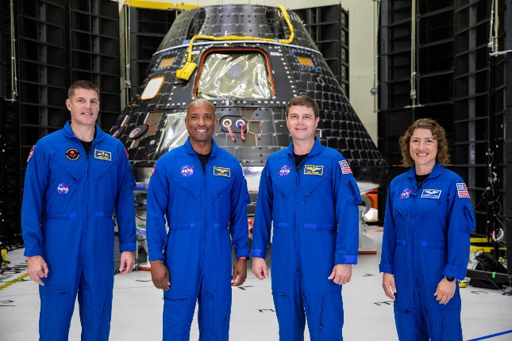
Further Investigation – Meet the astronauts
Who are the astronauts on the Artemis mission? Meet the Artemis crew. Watch this short video to learn more about them.
- What skills do you think you need to become an astronaut? What training do they do?
- Choose a crew member and write a short biography about them.
- What would you like to ask the astronauts? Think of three questions.

Activity: Images from the mission
Students look at the images that relate to the Artemis II mission, then respond to the following questions:
- Describe the image. What can you see?
- What does the image tell you about the mission and/or the Moon?
- If there are people in the image, what might they be thinking or feeling?
- What was surprising about the image?
- What questions do you have about it?
- How does the image make you feel?
- Create a caption for the image.

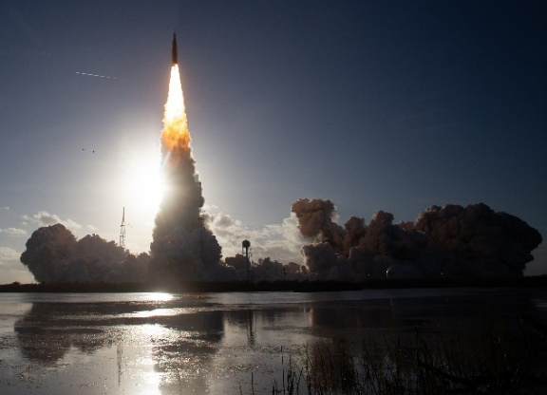  NASA |   NASA
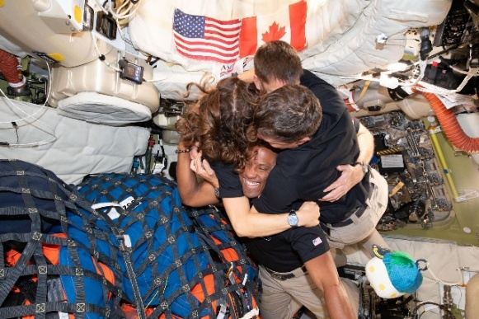  NASA | 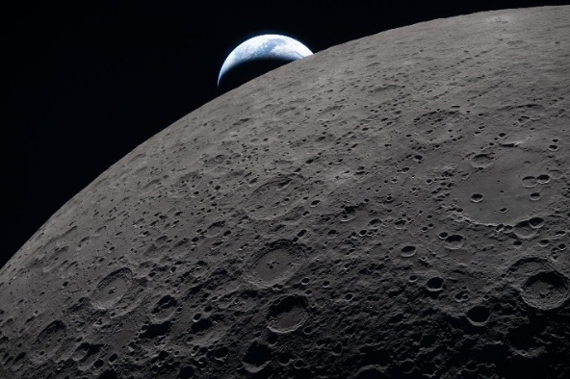  NASA

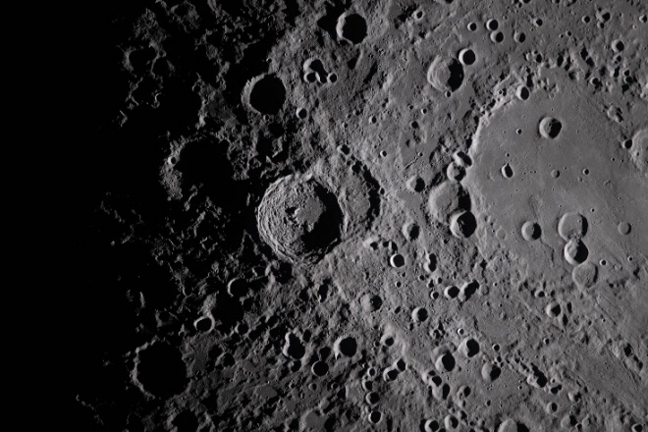  NASA  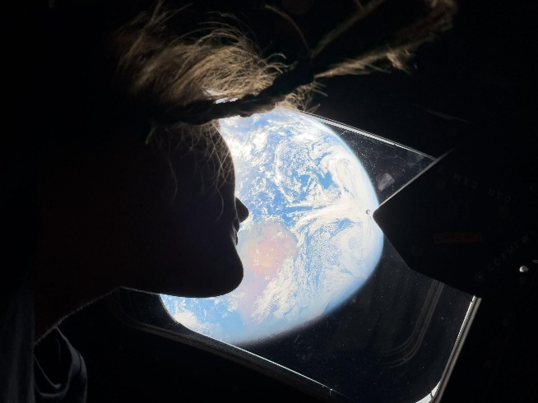 | 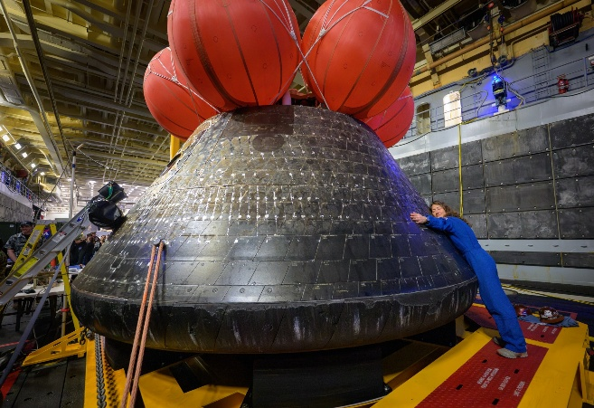  NASA  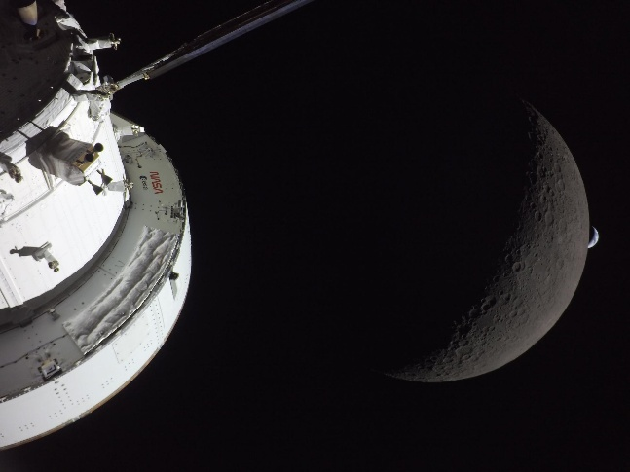
NASA | NASA

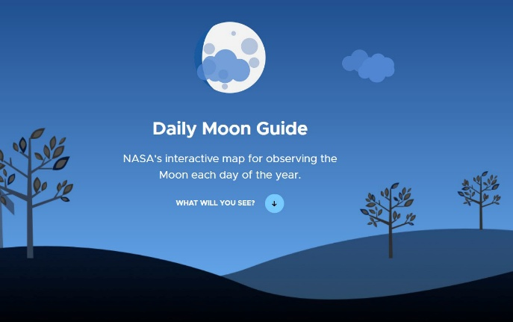
Activity: Daily Moon Guide
Learn more about the Moon! Explore NASA’s interactive map for observing the Moon, every day of the year.
Select the date, the hemisphere you are observing from and how you are observing the Moon (unaided eye, binoculars or telescope). Click on the features of the Moon to learn more about them. Keep an eye out for the `Sea of Tranquillity’ and learn about its significance.

Useful Websites
- Artemis 2 Launch - BTN
- Artemis Launch – BTN
- The Farthest People from Earth –Newsbreak
- Artemis II Crew Returns – BTN Newsbreak
- Artemis II – NASA
- 50th Moon Landing Anniversary Special – BTN

EPISODE 10
28 April 2026

KEY LEARNING
Students will learn about William Shakespeare’s life, work and legacy. Students will experiment with language by creating new words.

CURRICULUM
English – Year 5
Understand how to use knowledge of known words, base words, prefixes and suffixes, word origins, letter patterns and spelling generalisations to spell new words.

Explore less common plurals and understand how a suffix changes the meaning or grammatical form of a word.

English – Year 6
Understand how to use knowledge of known words, word origins including some Latin and Greek roots, base words, prefixes, suffixes, letter patterns and spelling generalisations to spell new words including technical words.

Identify the relationship between words, sounds, imagery and language patterns in narratives and poetry such as ballads, limericks and free verse.

English – Year 7
Understand how to use spelling rules and word origins, for example Greek and Latin roots, base words, suffixes, prefixes, spelling patterns and generalisations to learn new words and how to spell them.
  - Teacher Resource

Shakespeare Day

Focus Questions
Discuss the BTN story as a class and record the main points of the discussion. Students will then respond to the following:
- Why was William Shakespeare’s earlier life referred to as the “lost years”?
- What is the name of the theatre in London associated with William Shakespeare?
  - The Sphere
  - The Globe
  - The Orb
- Give three examples of words or phrases that Shakespeare invented.
- Name a film that is an adaptation of Shakespeare’s work.
- Do you think Shakespeare’s work is still relevant today? Give reasons for your answer.

Activity: Class Discussion

Discuss the BTN Shakespeare Day story as a class. Students will then respond to the following:
- What is one thing you learnt about William Shakespeaere?
- What is one thing you found interesting about him?
- What is one question you still have about Shakespeare?

Activity: Fun Facts!
After watching the BTN story students will write down their top 5 most fun facts about William Shakespeare. Students will share and compare their facts with the class.

Students will expand on their learning by finding 5 additional fun facts about William Shakespeare that aren’t included in the BTN story. They will compile their list of fun facts in an interesting way. Visit National Geographic Kids to learn all about William Shakespare.

Activity: Shakespeare’s life, work and legacy
Piecing together Shakespeare’s life
Students will work in small groups to put together a timeline of important events in William Shakespeare’s life. Provide cards with the following important events for students to create a timeline:
- Born in Stafford-Upon-Avon
- Marriage to Anne Hathaway
- Published poems with the Lord Chamberlain's Men
- The mystery of “The Lost Years”
- Acting and writing in London
- Performing at the Globe Theatre

An excerpt from ‘A Midsummer Night’s Dream’
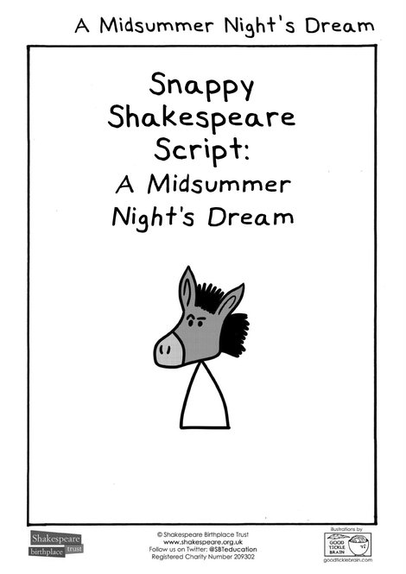
As a class read a short excerpt from one of Shakespeare’s plays. ‘A Midsummer Night's Dream' is the most popular of Shakespeare's plays with primary students. Download a copy of this reduced script from the Shakespeare Birthplace Trust.

Select a short passage to read aloud with your class. Students may want to take it in turns reading lines from the script. Encourage students to use emotion, actions or gestures as they read their lines.

Facilitate a class discussion after reading the script, using one or more of the following questions to guide the discussion:
- What is happening in the scene? Can you summarise it using your own words?
- Who are the main characters?
- Where is the scene set?
Source: Shakespeare Birthplace Trust
- What themes do you notice in the story?
- What part of the story did you enjoy the most? Why?
- Which character did you like the most? Why?
- How is the language different to how we speak today?
- Were there any words or phrases you didn’t understand? What do you think they mean?

Shakespeare today
As a class discuss how Shakespeare’s work still influences the world today. Explain to students what the word LEGACY means, and that Shakespeare’s legacy includes:
- Shakespeare’s stories – famous plays like Romeo and Juliet. Themes from his plays are still used today, like love, jealousy, power and revenge.
- The English Language – Shakespeare invented many words and phrases which are still used today. For example, “break the ice”, “wild goose chase” and “heart of gold”.
- His influence on entertainment – Many movies and songs have been inspired by his plays. For example, The Lion King and Gnomeo and Juliet.

Students will then design and create a poster that illustrates William Shakespeare’s legacy.

Activity: Playing with Language
This activity focuses on word-building and William Shakespeare’s creative use of language. Students will understand what prefixes, suffixes, compound words and verbification are and explore how William Shakespeare used these language features. Students will experiment with language and create their own new words.

Introduce the activity
Briefly explain to your students that Shakespeare experimented with language in creative ways.

He used prefixes like “un-” and suffixes such as “-ful” and “-less” to form new adjectives and nouns. He also created compound words by combining two words into one and often changed nouns into verbs (and vice-versa). In addition, he borrowed words from other languages, especially Italian, and modified existing English words by shortening or lengthening them.

Group activity
In small groups, present your students with a list of words that were invented by Shakespeare. Each of the words below are examples of prefixes and suffixes, compound words or verbification.

eyeball  eyelid  lacklustre  bittersweet  hotblooded  bloodthirsty  to shoulder | foul-mouthed  watchdog  cold-hearted  tongue-tied  bloodsucking  reword  to gossip | uncomfortable  uneducated  misquote  overblown  exhale  unreal  to elbow | misthink  frightful  fashionable  childish  gloomy  noiseless  to table

Students will organise the words into the following columns deciding whether they are a prefix, suffix, compound or verbification. Ask students to find meanings for 5 of the words, use each word in a sentence and then share with the class.

Prefixes and suffixes | Compound words | Verbification

Become a Wordsmith
Challenge students to invent their own words which they would like introduced into the English language. Encourage students to have fun inventing their new words!

Students will create:
- 1 word using a prefix
- 1 word using a suffix
- 1 compound word
- 1 verbified word

Choose a project
Students will find a creative way to use as many of the new words as they can.
- Write a short mini-Shakespeare style paragraph using your invented words.
- Create word search.
- Write a rap using your new words.
- Create an illustrated dictionary of your invented words.

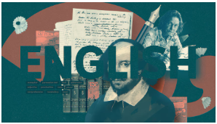
BTN English collection
Visit BTN’s collection of stories which focus on English. Look for BTN stories with the pencil icon to find supporting teacher resources all linked to the Australian Curriculum.

BTN – English Collection

Useful Websites
- William Shakespeare – BTN
- Shakespeare – BTN
- Modern Shakespeare – BTN
- Shakespeare in School – BTN
- Globe Theatre – BTN
- The History of English Shakespeare – YouTube
- Playground (interactive) – Shakespeare’s Globe
- Shakespeare's words and inventions – Bell Shakespeare
- New Words – BTN
- Shakespeare's Words – Shakespeare Birthplace Trust

  - Teacher Resource

BTN Transcript: Episode 10 - 28/4/2026

Hey, I'm Amelia Moseley, and welcome back to the first episode of BTN for term two. Hope you had the best holidays, but, hey, it's good to be back, right? Let's take a look at what's coming up on the show. We'll learn about the impacts of the Vietnam War, find out how NASA's second Artemis mission went, and celebrate the life and legacy of William Shakespeare.

Fuel Shortage Impact

Reporter: Aiden McNamara

INTRO: We'll get to all that soon, but first up to fuel. As you're probably aware, the ongoing conflict in Iran has seen fuel prices soar across the globe, including here in Australia. Aiden looked into the impact it's having and how the government, businesses and families have been trying to adjust.
NEWS FOOTAGE COMPILATION: Oil prices spiking again, prices may remain high, soaring fuel costs, highest in nearly four years if they can get it at all.
AIDEN MCNAMARA, REPORTER: You've probably heard about the stuff that keeps a lot of the world moving, getting a lot more expensive… that's probably enough.
It's all to do with the ongoing conflict in Iran, a country in the Middle East. You see, heaps of the world's oil comes from around here, which is why when there's conflict, the impact can be felt around the globe.
Next to Iran is this important stretch of water, the Strait of Hormuz, but since February ships carrying oil haven't really been able to pass through. Which is why fuel prices have gone up, and up, and up. These squiggly lines show the price of petrol, which most cars run on, and the price of diesel, used by most trucks and some big machines.
While petrol might be a little cheaper lately, both petrol and diesel still cost more than they did back in January. It's the reason lots of people have been trying to use less of it.
These packed platforms are in Victoria, where the government has made public transport free.
COMMUTER: It's so busy we have to sit on the floor.
COMMUTER: It's a bit uncomfortable, you've got people right next to you.
Other states made similar moves. And even where the fares aren't any cheaper, more drivers have been leaving their car at home in favour of the train or bus. Some have been making the switch to electric cars and bikes.
PERSON: It's just frustrating because everything's so expensive at the moment and once fuel goes up, everything else goes up again.
Many businesses have put their prices up to cover the extra cost. Some airlines have even cut a handful of their flight’s routes.
PHIL DUPEL, NT RESIDENT: I think that impact will affect the population.
The fuel shortage also affects the stuff fuelling us, food, because farms rely on machines powered by diesel. And some farmers reckon the cost to harvest and haul their crops has doubled.
RAHMATULLAH JAFARI, FARMER: I don't know until when I can continue these prices.
Then there's fertiliser. Australia imports two thirds of its fertiliser from the Middle East, but with the Strait of Hormuz still closed, it's been a lot harder to get. And even if that shipping lane opens soon, it could be weeks before anything reaches our shores. It's why recently the Prime Minister, Anthony Albanese, went to Asia meeting leaders of countries we import fuel from and made a deal to get 400 million litres of diesel.
ANTHONY ALBANESE, PRIME MINISTER: Australia's fuel supply outlook remains secure in the near term.
As well as 250,000 tonnes of fertilizer from Indonesia. And earlier this month the PM halved the fuel excise, so every litre of fuel is now 26 cents cheaper, though it leaves the government with less to spend on other stuff.
There's also been some ummm, hiccups, with this fire at one of only two oil refineries in Australia.
CHRIS BOWEN, ENERGY MINISTER: Look, this is not a positive development in Geelong.
PERSON: We barely have any fuel and I need to get to school, my dad needs to get to work.
And of course, there's still a big question mark over the war itself. Whether the ceasefire will continue, how any peace talks might go, and if this important stretch of water will be open for business.
JIM CHALMERS, TREASURER: The Australian economy is in lot of ways hostage to those developments.
News Quiz

Who is this? It's Mark Butler Minister for Health and Ageing of Australia and recently he announced a major overhaul of the NDIS or National Disability Insurance Scheme.

MARK BUTLER: There's a recognition that the NDIS is off track and needs a substantial reset.

The changes include bringing the cost of the program down to $55 billion by 2030 as well as remove 160,000 people from the scheme. While some have welcomed the changes which will crack down on people taking advantage of the services the NDIS provide others are worried that some people will miss out on getting the support they need.
NDIS RECIPIENT: I wouldn't be able to live independently or do things that everyone else does without it.
Over the weekend on the 25th of April, people across the country marked ANZAC Day. What does ANZAC stand for? It stands for Ausralian and New Zealand Army Corps. April 25th marks the anniversary of the first campaign led by the ANZACs in Gallipoli in 1915 and every year there are dawn services held on that day to remember those who have served and died in the military.

INDIGENOUS PERSON: For thousands of years, people have gathered in this place.

This year several services around the country were disrupted by people booing Traditional owners, including a service in Sydney where War Veteran Uncle Ray Minniecon was heckled whilst performing a Welcome to Country.
UNCLE RAY MINNIECON, INDIGENOUS ELDER: It really is a whitefellas problem, not a blackfellas problem.

ANGUS TAYLOR: Booing, whatever the cause, on ANZAC Day and at ANZAC Day ceremonies is absolutely inappropriate and un-Australian.

KATIE KISS, ABORIGINAL AND TORRES STRAIT ISLANDER SOCIAL JUSTICE: It was really sad to see Australians partaking in a really disrespectful, disgraceful display of hateful vilification.
Australia’s consumer watchdog, the ACCC, took Woolworths to court last week accusing the supermarket giant of what? Misleading customers about discounted items, not recycling soft plastics properly or under paying staff? The Australian Competition and Consumer Commission reckons that Woolworths has been misleading customers about discounted items. The ACCC says between September 2021 and May 2023 shoppers thought they were getting a discount on some products, but were actually paying the same amount, or sometimes more than what they originally cost. Earlier this year the ACCC took Coles to court for the same thing.

Vietnamese Refugee Anniversary

Reporter: Tatenda Chibika

INTRO: This year marks 50 years since the first Vietnamese refugees arrived in Australia following the Vietnam War. Tatenda caught up with some young people whose family members were amongst the thousands who made the journey to Australia. Take a look.
Tamyen: Hi, I'm Tamyen and these are my grandparents. I know them as Ong noi and Ba noi, and they came to Australia in 1979.
Jackson: Hi, my name is Jackson.
Kora: Hi, my name is Kora
Jackson: And these are our grandparents, Van Tran and Kim Tran.

Kora: We call them Ong ngoai. They came to Australia around 1980.
Tamyen, Jackson and Kora are amongst the hundreds of thousands of Aussies whose families came here as refugees after the Vietnam War.
The Vietnam War was a conflict that lasted for decades but to understand how it came about, we have to go all the way back to the end of World War Two. At the time Vietnam was a French colony, a nationalist group called the Viet Minh declared Vietnam independent and so France and the Viet Minh went to war in 1946. After eight years of fighting, the Viet Minh won. France and the Viet Minh agreed to a ceasefire and signed the Geneva Accords. It was an agreement that Vietnam would no longer be a French colony and would be temporarily split into two zones
This is a map of what Vietnam looked like at the time. At the top was North Vietnam. Its capital was Hanoi and it was led by a man called Ho Chi Minh. He was the leader of the Viet Minh and a communist. This meant he believed in a system were people work for the government and in return rely on the government to share the money out equally. At the bottom was South Vietnam. Its capital was Saigon and it was led by a man called Ngo Dinh Diem who was anti-communist and wanted a more western government. Worried about the spread of communism in Southeast Asia, the US started sending money and military aid to South Vietnam. However, Diem wasn't popular with many in the south and some southerners started supporting and fighting for the North. As time went on, tensions between the North and South escalated into a full-blown war.
Eventually, the US sent in its troops and some of its allies including Australia joined in too.
Robert Menzies, Former Prime Minister: Why are we there? Obviously to resist armed aggression and subversion.
A lot of people were on board with that decision, but that changed after thousands of people were killed or injured and people started seeing just how bad the impacts of the war were.
Jackson: All of my grandparents, a lot of their siblings enlisted for the war and not a lot of them made it out.
Kora: It was very hard for them because they were starving, there was no food.
Tamyen: I remember my grandma telling me how communist forces would raid her house, they would take all their belongings, they would just barge in there, take anything of wealth, and yeah, leave them there with nothing.
PROTESTORS: Power to the people! Power to the people!
In 1973, after years of protests, Australia and the US backed out of the war.

Australian Soldiers in Vietnam: We're going home, we're happy.
And two years later in April 1975, Saigon was taken over by North Vietnam and the south's government surrendered. The Vietnamese Government says more than two million civilians were killed during the Vietnam War. People's homes were destroyed and many in the south were forced to leave Vietnam or face imprisonment.
Jackson: My grandparents didn't want to take the risk of getting sent to a concentration camp, so they tried to escape.
Kora: My mum and my grandma was jailed for, I think they said, four months.
Tamyen: My grandpa served in the South Vietnamese military, and he got imprisoned for, I think, six years by the north side and then was able to escape or get released somehow and they had to flee after that.
Many people who lived in South Vietnam sought refuge in nearby countries like Australia.

On the 26th of April 1976 five young men sailed into Darwin Harbour after two months at sea.
Lam Tac Tam, Vietnamese Refugee: When we come to Australia no one knows we are coming, we come straight to the harbour. They don't believe we come from Vietnam.
They were the first of thousands who became known as the Vietnamese boat people. And soon many more Vietnamese refugees came to Australia by plane.
Tamyen: When my dad came to Australia, they came directly to Adelaide, got flown right here. There they met, I guess you could say, like a host couple, Tricia and Peter, who helped them adjust to their life in Australia. They've been friends for about 47 years now.
Jackson: In 1978, they tried multiple times to escape. And then, on the third time, on the third trial, they escaped.
The Australian Prime Minister at the time, Malcolm Fraser, welcomed the refugees as part of the government's plan for a multicultural Australia. A few years earlier, the Whitlam government had officially gotten rid of the White Australia Policy which had made it hard for people who were not European to move to Australia.
Malcom Fraser, Former Prime Minister: Tens of thousands of refugees came and that's turned into a vigorous, vital and enormously rewarding community in many parts of Australia.
Tamyen: Coming to Australia as, you know, after the white Australia, after the war, they don't know the language; it was very difficult for them but yeah, they've done well for themselves now.
Jackson: They didn't have much, they didn't know English, but the community helped them out and eventually they slowly began to fit in.
These Vietnamese refugees were the first of many waves of migration that changed Australian society and made it the multicultural landscape we know today.
Jackson: I'm very proud of my grandparents and my mum for moving to Australia because it takes a lot of courage to move countries and to take all of those big risks.
Kora: It was very good for them to be free instead of staying in Vietnam.
Tamyen: I'm proud to call myself Australian and Vietnamese. I'm very proud of what my family members did to leave Vietnam and come to Australia, start a new life for themselves. And I'm very glad they did it, so I can live a great life here in Australia.

Artemis II Mission

Reporter: Saskia Mortarotti

INTRO: Over the holidays NASAs Artemis II mission successfully completed it's 10-day journey around the Moon. Sas found out how it all went down and how it's helping to set up for more Moon missions as well as deep space exploration in the future.

ARTEMIS MISSION CONTROL CENTRE: 3, 2, 1, booster ignition and liftoff. The crew of Artemis II now bound for the moon.
SASKIA MORTAROTTI, REPORTER: After 9 years of planning and numerous delays, Artemis 2 finally launched on the 2nd of April.
PERSON: Awestruck. I actually shed tears.
PERSON: You know the fact that we could do that, put humans on that rocket, and shoot them up to the moon, it's pretty amazing.
The Artemis program was set up in 2017, with the goal of putting humans back on the Moon and eventually setting up a base there that could be used to help us one day get to Mars. And Artemis 2 is an important step in helping get to that point. Its mission was to help prepare for future Artemis missions by testing the Orion spacecraft system and observing how the crew perform in space.
ASTRONAUT UNDERSTUDY: Speaking of the crew, I'm kind of an astronaut myself. See. I know everything about the Moon. Only I was made the understudy for this mission, and no one got sick.
The Crew that was actually sent to the moon included NASA's Victor Glover as the pilot, Reid Wiseman as the commander, and mission specialist Christina Koch, who worked alongside the Canadian Space Agency's Jeremy Hansen.
ASTRONAUT UNDERSTUDY: This was my, I mean, their route. Over 10 days, the crew did a sort of figure 8 loop thing.
They drifted towards the moon using Earth's gravity as a sling shot, they then passed the Moon's far side before coming back down. This was the first time humans to have gotten this close to the Moon since the 1970s. On their trip, they snapped pretty good pic of Earth.
VICTOR GLOVER, ARTEMIS 2 PILOT: Trust us you look amazing. You look beautiful
They also snapped the first photos ever taken by humans of the far side of the Moon.
ARTEMIS 2 CONTROL CENTRE: Today, for all humanity, you're pushing beyond that frontier.
And speaking of firsts, the crew broke a major record, travelling the furthest humanity has ever travelled into space, reaching a distance of 406,773 kilometres from Earth. It was pretty smooth sailing besides a small hiccup with the toilet, where, what you would call the pee pipe, froze. Luckily, they're trained professionals and fixed that issue. Phew.
ARTEMIS 2 CONTROL CENTRE: At this time you are a go for all types of uses of the toilet.
CHRISTINA KOCH, ARTEMIS 2 MISSION SPECIALIST: The crew rejoices, thank you.
After the 10 days, it was time to head home.
ARTEMIS 2 CREW: Burn underway.
Using the pull of the Earth's gravity, they pointed themselves in the right direction, separated from the rest of the spacecraft, before entering the Earth's atmosphere at around 40,000 kilometres an hour, before landing safely in the Pacific Ocean.
ARTEMIS 2 CONTROL CENTRE: Splashdown confirmed.
VICTOR GLOVER, ARTEMIS 2 PILOT: If you dove off a skyscraper backwards, that's what it felt like.
Everybody was excited - especially Astronaut Christina Koch's dog. Since returning home, the crew has been observing any changes to their bodies and adjusting to life back on Earth.
CHRISTINA KOCH, ARTEMIS 2 MISSION SPECIALIST: Every time I've been waking up or in the first few days, I thought I was floating.
ASTRONAUT UNDERSTUDY: And with 3 more Artemis missions planned for the future, watch this space. Get it? And who knows, maybe they'll need me for the next mission. I mean, I'm already packed.

Sport

Kenya's Sabastian Sawe has just become the first man to run a marathon in under 2 hours. Claiming victory at the London Marathon, he crossed the finish line with a time of 1:59:30. Meanwhile, coming in first for the women, Ethiopia's Tigst Assefa broke her own women's only record, clocking a time of 2 hours 15 minutes and 4 seconds.

Over now to the 2026 Wheelchair Rugby World Challenge, where teams from all over the world gathered in Adelaide to compete. Taking home the gold, Team Brazil claimed victory over Great Britain 58 to 50. Also taking to the court, the Juniors drew a big crowd.

Finally, to Western Australia for the Margaret River Pro, where Australian surfer George Pittar claimed his first World Surf League title, which left him speechless.

GEORGE PITTAR, AUSTRALIAN SURFER: I don't know what to say.

Shakespeare Day

Reporter: Tatenda Chibika

INTRO: April 23rd doth herald Shakespeare's Day. A time set aside to honour the life and works of that most renowned playwright, William Shakespeare. Tatenda hath cast a curious eye upon the man himself, seeking to uncover who he was and wherefore his words yet echo with meaning in our present age. Basically, Tatenda found out who William Shakespeare was and why his work is still relevant today. Check it out.

Tatenda Chibika, Reporter: From movies, shows and cartoons.
The Lion King: Big ones, small ones Some as big as your head...

Tatenda: To some of our favourite melodies and tunes
Kendrick Lamar: … fashion police, I wear my heart on my sleeve…
Beyonce, Freakum Dress: … to be or not to be, not.
Tatenda: It's safeth to say-eth, the Bard's work-eth lives on-eth even after many moons-eths.
Alright, poetry definitely isn't my ministry, but it certainly was William Shakespeare's. Along with being a playwright, author, actor and a wordsmith. And yeah, while he may have died more than 400 years ago, you've probably come across his work without even realising it.
William Shakespeare was born in Stafford-Upon-Avon in England in 1564. His exact birthday is kind of a mystery, but historians say he was probably born sometime in April. He was the third child of Mary Arden and John Shakespeare and when he turned 18, he married Anne Hathaway. (Not that one! Ah. That's better.) Not much else is really known about Shakespeare's earlier life which is why those years are often referred to as the lost years but somehow, he ended up performing in 1592.
Shakespeare performed plays with an acting group called the Lord Chamberlain's Men who were later known as the Kings Men. And yeah, they were all men because women weren't allowed to act back then which meant female characters were all played by men. The group performed at the Globe Theatre which they helped build and while the original one was demolished in 1644. A replica of the globe was built in 1997 that continues to host performances of Shakespeare's 37 plays including tragedies,
Othello, Shakespeare's Globe: I think you are just, and I think you are not.
Comedies.
Much Ado About Nothing, Shakespeare's Globe: I could not injure a husband with a beard on his face.
And historical dramas.
Julius Caesar, Shakespeare's Globe: I do fear the people choose Caesar for their king.
Oh and Shakespeare also wrote a whole bunch of poems and sonnets where he strategically used rhythm, elaborate metaphors and similes.
Shakespeare died on the 23rd of April 1616, but his plays have continued to be very popular and inspire new audiences.
The Simpsons: Our next story is Hamlet by William Shakespeare.
Gnomeo and Juliet: Oh Gnomeo, Gnomeo are we really doomed Gnomeo?
Behind the News: Rocko Rocko, Where Out Thou Rocko.
Many say it's because well, they're well written and that the themes and characters are still relevant today and do a great job of capturing human emotions like fear, anger, jealousy and love. Oh, and Shakespeare also came up with a lot of words that we still use today. Like…
The Simpsons: Lonely.
And…
Justin Bieber, Boyfriend: Swag, Swag, Swag.
And some of his phrases have also worked their way into our everyday language like…
John Farnham, Break the Ice: Break the Ice.
Addison Rae, Aquamarine: The world is my oyster.
And…
Shawn Mendes, Heart of Gold : Heart of gold.
So, while Shakespeare may be gone, his work lives on and continues to be studied and performed by people all over the world, shaping and influencing the stories we hear, see, and read today.

Closer

Ah, "parting is such sweet sorrow", but that's all we have for you today. Don't worry, though - there's plenty more to see and do online. And you can stay up to date with Newsbreak every weeknight. Thanks for being here. Come back next week and we'll see you then. Bye.

