Episode 13
19th May 2020



Coronavirus Restrictions Ease
- What did the BTN story explain?
- Why has the government started to lift coronavirus restrictions?
- How many steps are in the government’s plan?
- It's up to each state and territory to decide how and when it's safe for the steps to happen. True or false?
- In step one of the plan, what will people be allowed to do?
- Give some examples of things people will be able to do in step two.
- What will be allowed in step three of the plan?
- Why do you think the government is lifting restrictions gradually?
- What is important for everyone to keep doing to make sure there isn’t a COVID-19 outbreak?
- What questions do you have after watching the BTN story?

Coronavirus Kids World Wrap
- Where in the US does Chinu live? Locate using Google Maps.
- About how many cases of COVID-19 have there been in the US?
- What has life been like for Chinu in lockdown?
- Where do Maggie and Zach live?
- What is life like for them now?
- What has life been like for Ellie and Lottie since the COVID-19 outbreak?
- Why do they need to be extra careful when they go out?
- How has Dominica in the Caribbean been affected by coronavirus?
- What can Hvar and Sam from New Zealand do now that restrictions are easing?
- What did you learn watching the BTN story?

Gold Rush
- Where and when did Edward Hargraves discover gold?
- Why did the California Gold Rush in 1848 change attitudes about the discovery of gold?
- What did the NSW government announce on May 22nd, 1851?
- Where was gold discovered in July the same year?
- What impact did the gold rush have on Australia’s population?
- Complete the following sentence. Gold found along rivers and creeks is called ______________ gold.
- How were Chinese miners treated during the gold rush?
- Describe the dramatic confrontation between miners and authorities in 1854.
- Some people see Eureka as the birthplace of Australian democracy. True or false?
- What impact did the gold rush have on Australia?

Check out the Gold Rush resource on the Teachers page.

AI Song Contest
- Before watching the BTN story, predict what you think it will be about.
- What is the name of the music studio that created the song for the AI Song Contest?
- Who won the song contest?
- Why was the AI Song Contest created?
- Explain how the song was created.
- Complete the following sentence. Computers find mathematical ________________ within music to create original songs.
- What is artificial intelligence?
- Who used computers to make music in 1961?
- What do you think the future of using AI in music is?
- What was surprising about this story?

Check out the AI Song Contest resource on the Teachers page.

Protective Mask Maker
- Why has Nahla been making masks for doctors and nurses?
- Why did she start making them?
- What does Nahla use to make the masks?
- What does PPE mean?
- Who has been helping Nahla make the protective masks?
- What did Nahla use to buy the materials needed to make the masks?
- Explain how the masks are made.
- How have doctors and nurses responded to Nahla’s masks?
- How is the project being funded now?
- Send a message of support to Nahla on the story page.

Teacher Resource
Episode 13
19th May 2020

Gold Rush

Students will explore the history of the discovery of gold in Australia in the 1850s.


HASS – Year 5
The nature of convict or colonial presence, including the factors that influenced patterns of development, aspects of the daily life of the inhabitants (including Aboriginal Peoples and Torres Strait Islander Peoples) and how the environment changed.

The reasons people migrated to Australia and the experiences and contributions of a particular migrant group within a colony.

HASS – Year 5 and 6
Examine primary sources and secondary sources to determine their origin and purpose.

Present ideas, findings, viewpoints and conclusions in a range of texts and modes that incorporate source materials, digital and non-digital representations and discipline-specific terms and conventions.


- Where and when did Edward Hargraves discover gold?
- Why did the California Gold Rush in 1848 change attitudes about the discovery of gold?
- What did the NSW government announce on May 22nd, 1851?
- Where was gold discovered in July the same year?
- What impact did the gold rush have on Australia’s population?
- Complete the following sentence. Gold found along rivers and creeks is called ______________ gold.
- How were Chinese miners treated during the gold rush?
- Describe the dramatic confrontation between miners and authorities in 1854.
- Some people see Eureka as the birthplace of Australian democracy. True or false?
- What impact did the gold rush have on Australia?


What do you see, think and wonder?
After watching the BTN Gold Rush story, students will respond to the following questions:

- What did you SEE in this video?
- What do you THINK about what you saw in this video?
- What did you LEARN from this story?
- What was SURPRISING about this story?
- What QUESTIONS do you have about this story?

Discussion
As a class discuss the BTN Gold Rush story, using the following questions as a guide. Record the main points of the discussion.
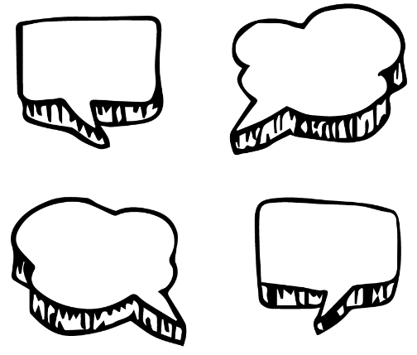
- When did the first gold rush begin in Australia?
- What were some of the activities that took place on the goldfields?
- What were some of the challenges that people faced living and working on the goldfields?
- Why is Eureka seen by some as the birthplace of Australian democracy?
KWLH
Students will be exploring the discovery of gold in Australia in the 1850s. They can develop their own key questions to investigate or respond to one or more of the questions below. Students can complete the following KWLH organiser to explore their knowledge and consider what they would like to know and learn.
What do I know? | What do I want to know? | What have I learnt? | How will I find out?

Topics of inquiry
Students will determine a focus for their gold era inquiry within an area of interest. Below are some possible questions for students to research:

- What impact did the discovery of gold have on Australia? Consider the wealth it created, immigration and social change.
- What was the Eureka Stockade? Investigate using the Who, What, When, Where and Why framework.
- Why was the gold rush a key event in the development of democracy in Australia?
- What were the roles and responsibilities of women during the gold rush? Using a Venn diagram (two overlapping circles) compare the life of women during the gold rush to that of women today.
- What effect did the gold rush have on the Aboriginal population? Create a list of advantages and disadvantages for Indigenous people.
- Where in Australia can you find gold? Research and create a map of gold fields and mines (both past and present) in Australia.


Journal writing
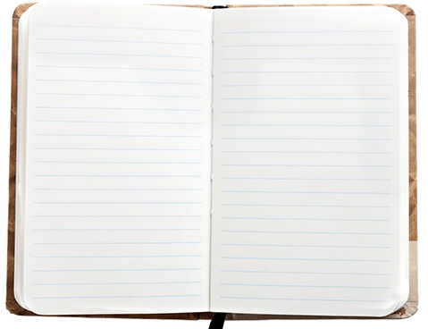
Students will imagine they are a person living during the gold era in Australia. Students will choose one of the following people that lived during the 1850s gold rush in Australia to research in more detail.

- Miner
- Aboriginal people
- Women and children
- Chinese migrants

Students will write a journal describing what life was like during the gold rush in Australia from the perspective of this group of people.

Students can play the Gold Rush Game to explore some of the challenges during the gold rush in Australia. In this game, students need to think clearly and strategically, as well as gaining a hearty dose of good luck, to win at this decision-maker game set in 1850–1900.

Visual literacy
In this activity students will examine, analyse and query a range of images which depict the gold rush in Australia in the 1850s. Students will choose one or more of the photographs below (alternatively, students can use Trove to choose their own photos to analyse). Students will then respond to the following:

- Write a short paragraph describing what you see in this image.
- When and where was the photo taken?
- What do you think is happening?
- Create a caption for each image.
- What question/s would you like to ask about the image? Choose one of your questions to investigate in more detail.

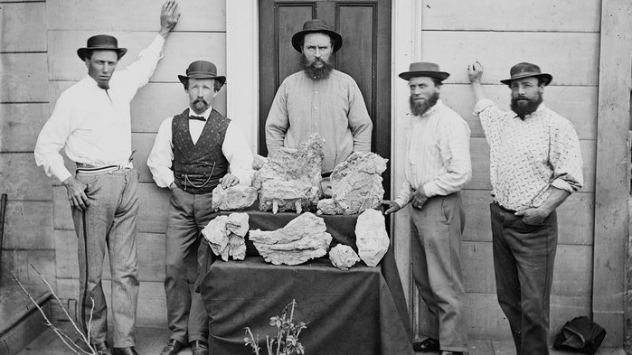  State Library of NSW | 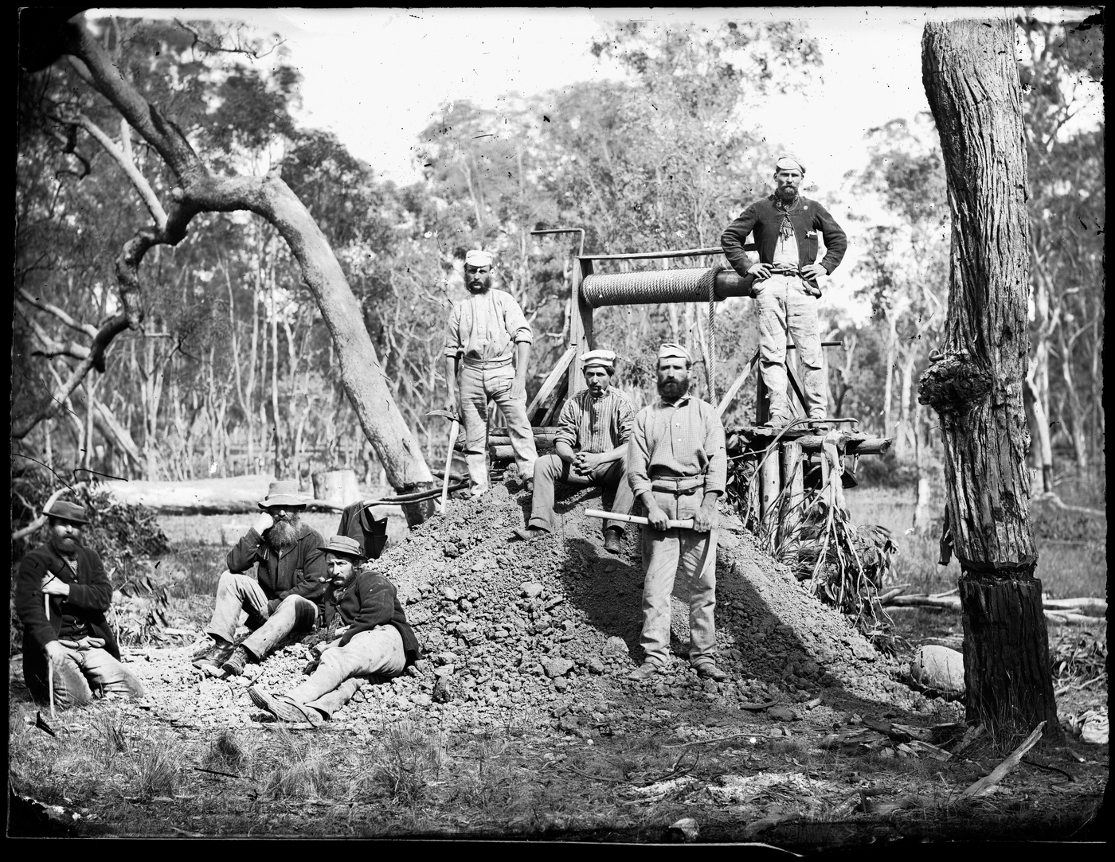  State Library of NSW

Students will look closely at the following paintings of Australian gold diggings.
- What does it tell you about how gold was mined on the goldfields?
- What equipment was used?
- What people are represented in the painting?
- Do you think this is an accurate reflection of those who worked on the goldfields?

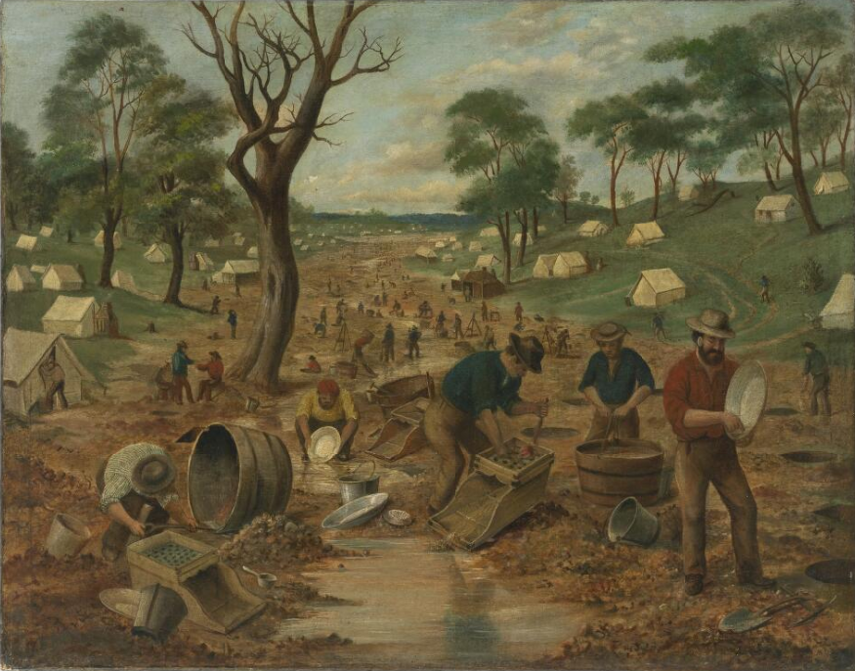  Trove | 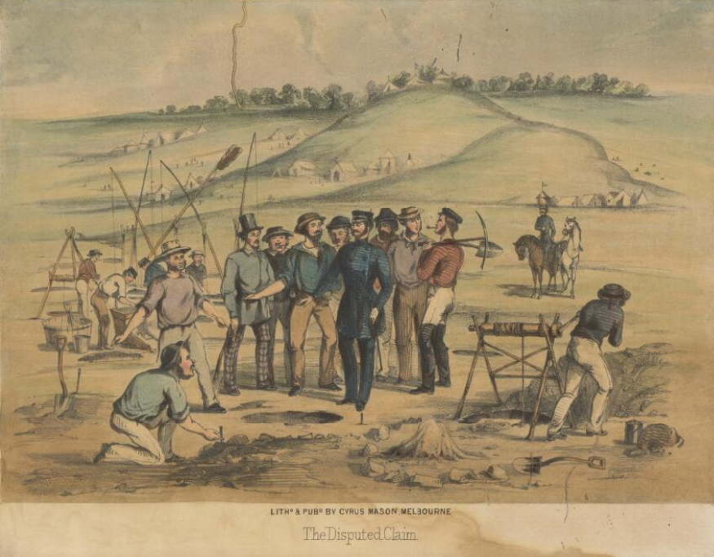  National Library of Australia

Students will choose one of the images (photograph or painting) and write a short, fictional story based on the image. Students might want to tell the story of the photographer/artist or a person in the photograph. Students will use their research to help them imagine what their characters were thinking and feeling.

Gold rush project

Students will choose one of the following projects to work on and then present their findings in an interesting way.
Glossary
Create a glossary of key gold fossicking and mining words.
Use pictures and diagrams to illustrate the meaning of each word in your glossary.


‘How to’ Book
Research and create a ‘how to’ book on the methods used to find gold. Each method will need to be written as a procedure. Include the tools and equipment needed. Use illustrations to demonstrate each of the steps.

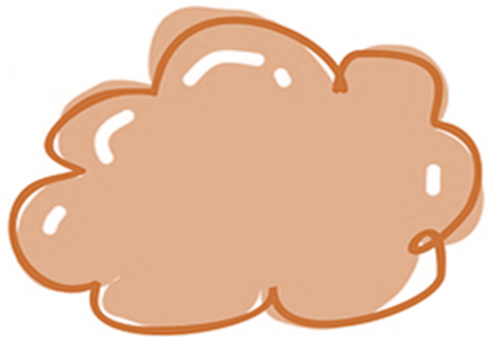
Artwork
Create an artwork that represents an aspect of life in the gold fields. Display your artwork in a class exhibition.


Largest nugget
Investigate the largest gold nugget ever discovered. What was its weight and value? Find out what the value of gold is at the moment. Calculate the value of an ounce of gold in Australian dollars. Create a model of the gold nugget to display in the classroom.


Eureka Stockade – BTN
https://www.abc.net.au/btn/classroom/eureka-stockade/10529206

Gold Rush – ABC Education
https://education.abc.net.au/home#!/topic/495292/gold-rush

Gold Rushes – National Museum Australia
https://www.nma.gov.au/defining-moments/resources/gold-rushes

Gold Rush Game – National Museum Australia
https://www.nma.gov.au/learn/classroom-resources/gold-rush-game

Teacher Resource
Episode 13
19th May 2020

Artificial Intelligence
Students will develop a deeper understanding of what artificial intelligence is and how it will impact on society.

Design and Technologies – Years 5 & 6
Select appropriate materials, components, tools, equipment and techniques and apply safe procedures to make designed solutions.

Design and Technologies – Years 7 & 8
Select and justify choices of materials, components, tools, equipment and techniques to effectively and safely make designed solutions.

Science – Year 4
Science knowledge helps people to understand the effect of their actions.

Science – Years 5 & 6
Scientific knowledge is used to solve problems and inform personal and community decisions.

- Before watching the BTN story, predict what you think it will be about.
- What is the name of the music studio that created the song for the AI Song Contest?
- Who won the song contest?
- Why was the AI Song Contest created?
- Explain how the song was created.
- Complete the following sentence. Computers find mathematical ________________ within music to create original songs.
- What is artificial intelligence?
- Who used computers to make music in 1961?
- What do you think the future of using AI in music is?
- What was surprising about this story?

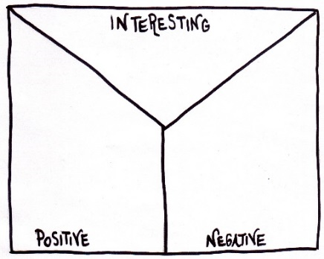
Note taking
Students will practise their notetaking while watching the BTN AI Song Contest story. After watching the story, ask students to reflect on and organise the information into three categories.

What information in the story was...?
- Positive
- Negative or
- Interesting

Discussion
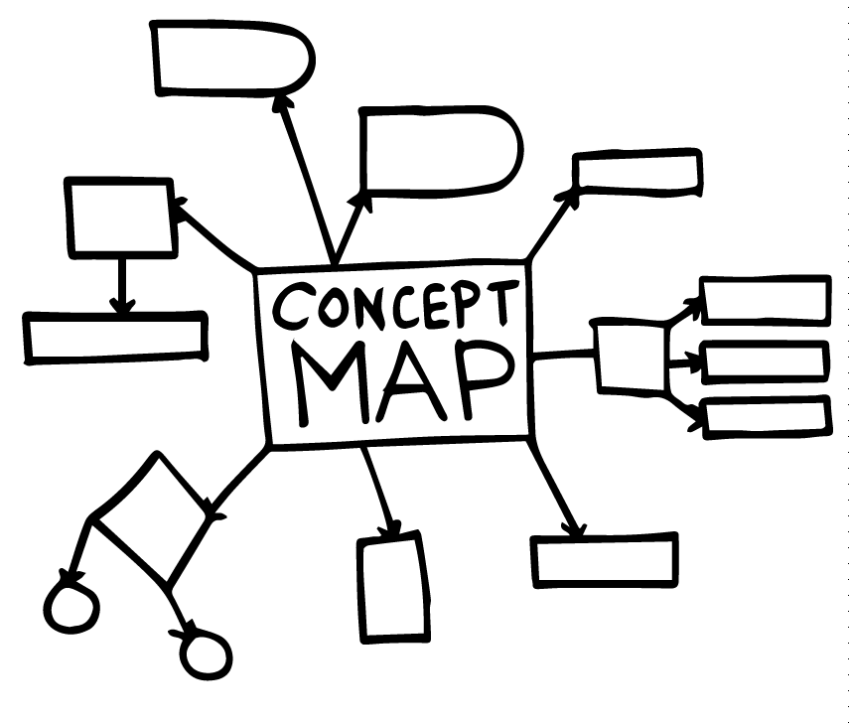
Discuss the information raised in the BTN AI Song Contest story. Ask students to record what they know about artificial intelligence or AI on a mind map. What words do they associate with AI? What questions do they have? Use the following questions to guide discussion:
- What is artificial intelligence? Come up with a class definition.
- What are some everyday examples of AI? (smartphones, streaming services and smart home devices)
- How was AI used in the BTN story?
- How can AI be used in creative jobs?
- What words do you associate with AI?
- What are some benefits of AI?
- What are the disadvantages?
- How do you think it will impact on the future of learning and work?
- What questions do you have about AI?
Glossary
Students will brainstorm a list of key words and terms that relate artificial intelligence. Here are some words to get you started.
Artificial intelligence | Machine learning | Technology
mimic | Innovation | Algorithm

Inquiry Questions
After watching and discussing the BTN AI Song Contest story, what questions do students have and what are the gaps in their knowledge? The following KWLH organiser provides students with a framework to explore their knowledge on this topic and consider what they would like to know and learn.

What do I know? | What do I want to know? | What have I learnt? | How will I find out?

Students will develop their own question/s for inquiry, collecting and recording information from a wide variety of sources. Students may develop their own question for inquiry or select one or more of the questions below.
- What is artificial intelligence and how is it currently being used?
- How will artificial intelligence change society? Make some predictions.
- Are there any areas where artificial intelligence should not be used?
- What is the history of artificial intelligence? When did the idea of artificial intelligence begin?
- How can we prepare for AI?
- How do you think it will impact on the future of learning and work?

AI Experiments
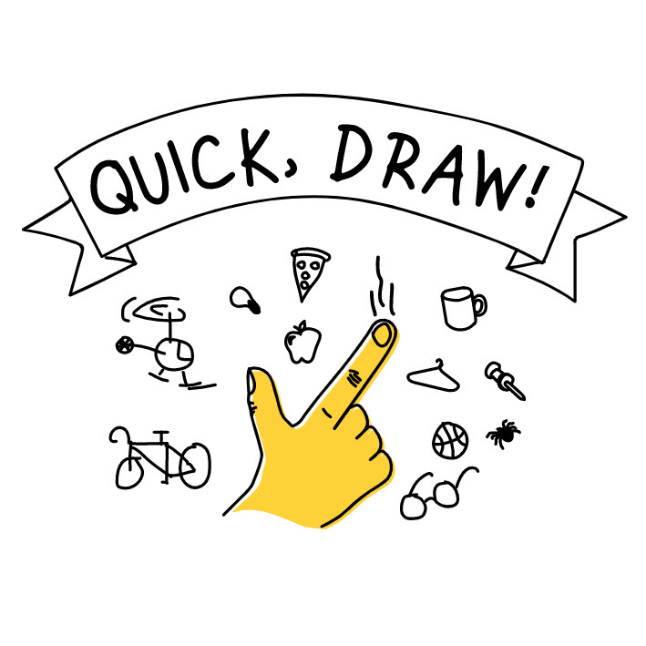
Students explore the following AI systems then ask them to reflect on how they know the system uses AI.
AI Duet – This experiment lets you play a duet with the computer. Just play some notes, and the computer will respond to your melody.

Freddie Meter – An AI-powered singing challenge that rates how closely your singing matches the voice of Freddie Mercury.

Quick Draw – A game that challenges players to draw a picture of an object or idea and then uses a neural network artificial intelligence to guess what the drawings represent.
Semantris – Word association games powered by machine learned. Each time you enter a clue, the AI looks at all the words in play and chooses the ones it thinks are most related.
Watch these BTN stories that explain the impact artificial intelligence will have on jobs in the future then answer the questions.
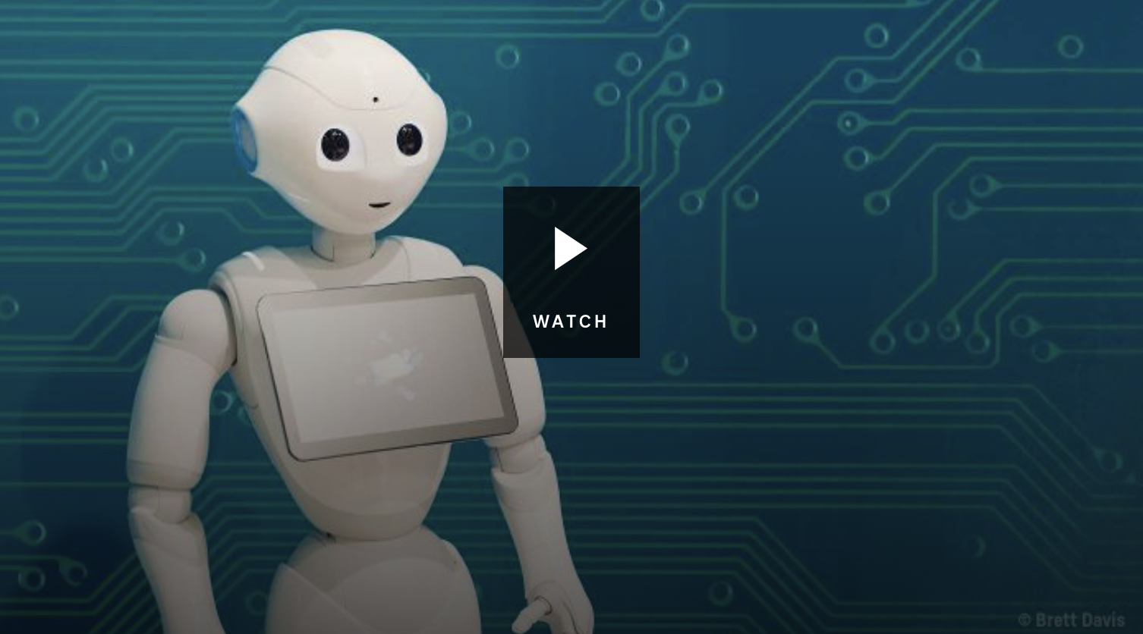
Artificial Intelligence Jobs
- What is artificial intelligence?
- Give examples of how artificial intelligence is being used.
- Scientists predict that in the next decade ______% of Australian jobs could be replaced by artificial intelligence.
- What sorts of jobs could be replaced by computers and robots?
- A student from the UK has developed software that can…
- What are STEM subjects and why is it important to learn them at school?
- Name three facts you learnt watching the BtN story.

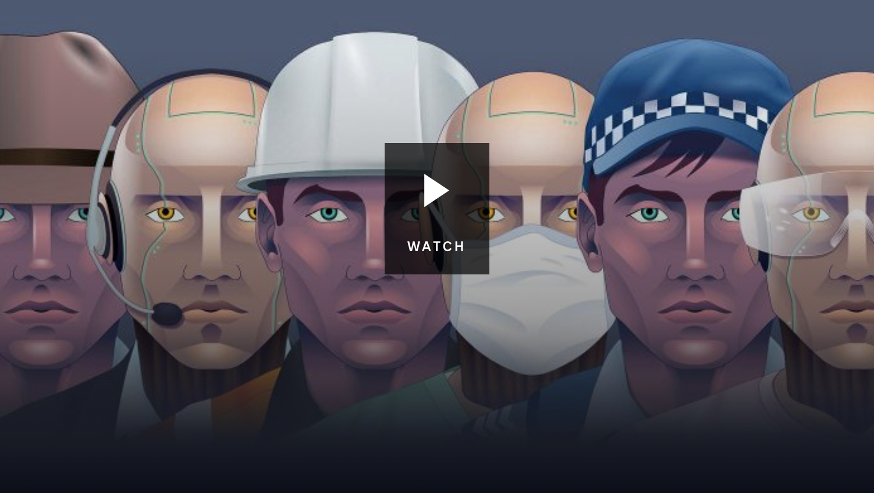
Robot Jobs
- Give examples of jobs that artificial intelligence is already doing.
- How are robots being used in the legal profession?
- What sorts of jobs could be replaced by artificial intelligence?
- What is an advantage of robots doing some jobs?
- According to experts, it’s important for kids to learn _____________ subjects.
- A recent report said that by 2030, workers will spend 77% more time using…
- Do you think artificial intelligence will make the world better? Give reasons for your answer.

Design an AI Robot
If you could build a robot that uses AI, what kind would you build? What would you make it do? Would it help you do your homework or play your favourite sport? Students will brainstorm ideas in pairs and then share their ideas as a class. Students will design a robot that performs a specific task. When thinking about their design, ask them to consider:
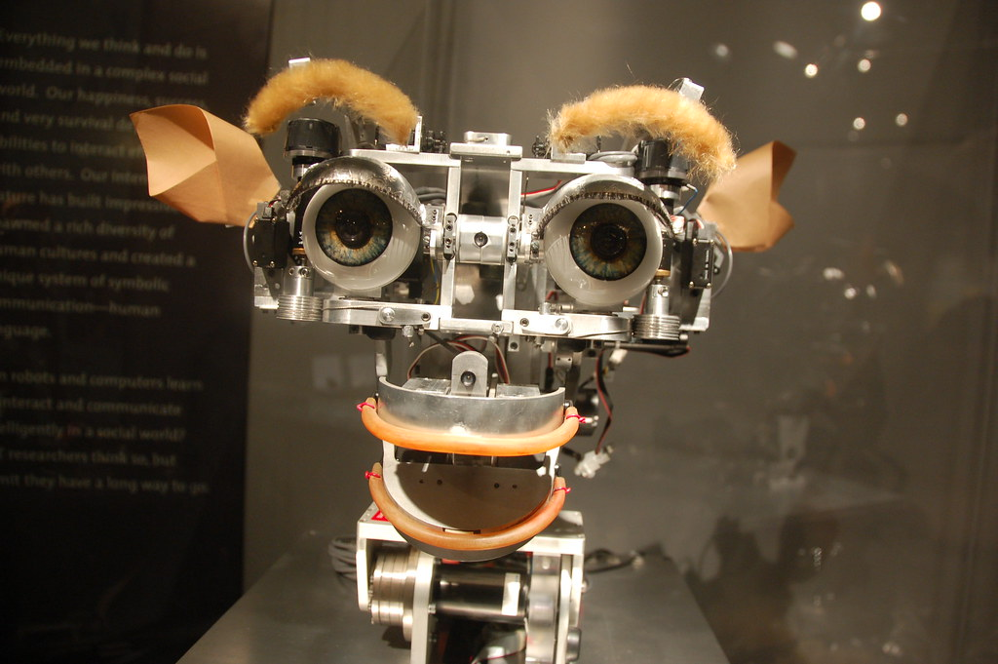
- What problem or challenge does the robot solve?
- What are some of the functions your program will carry out?
- How does your robot use artificial intelligence?
- Does the robot need any special features? If so, what are they?
- How will your robot function? Consider the following:
  - How will it be controlled?
  - How does it move?
  - How will it detect the environment around it?
Students will draw a design of their robot and present it to the class. Students will include a detailed diagram of each component and a description of how it works.
Australia Wins AI Eurovision Song Contest – BBC News
https://www.bbc.com/news/technology-52632916

Australia wins artificial intelligence song contest - AI Song Contest
https://www.vprobroadcast.com/titles/ai-songcontest/articles/australia-wins-ai-song-contest.html

AI Experiments – Experiments with Google
https://experiments.withgoogle.com/collection/ai

Robot Jobs - BTN
https://www.abc.net.au/btn/classroom/robot-jobs/10522582

Artificial Intelligence Jobs – BTN
https://www.abc.net.au/btn/classroom/artificial-intelligence-jobs/10523718

BTN Transcript: Episode 13 – 19/5/20

Hey, I’m Amelia Moseley and you're watching BTN. Here’s what’s coming up. We find out how kids around the world are coping with COVID-19, learn more about Australia's gold rush and discover how machines can make music.

Coronavirus Restrictions Ease

Reporter: Amelia Moseley

INTRO: All that soon, but first up to the government's plan to get Australia back to normal or, at least, as close to normal as possible. As you might have already noticed, states and territories have started to lift some of their COVID-19 restrictions and the PM says he wants the economy up and running again by July. Let’s find out more.

Finally, it's what we've all been waiting for, this piece of paper. With stuff written on it. Yay.
SCOTT MORRISON, AUSTRALIAN PRIME MINISTER: This is the plan for a COVID-safe Australia. Three steps moved at the pace of states and territories that will get us back where we need to be.
Coronavirus cases in Australia are low and the Government says it's time to start lifting restrictions, slowly and carefully, state by state.
AMELIA, REPORTER: So, here's the plan. But remember, it's up to each state and territory to decide how and when it's safe for these steps to happen.
OK. Step one. This one gives us such luxuries as grabbing a bite to eat at a cafe or restaurant, but with a max of ten other people inside. Shopping, going to the library, or the playground could also be back on your list of things to do. And so are gatherings with up to ten people in public and five visitors at home.
You'll probably have heard this step includes getting you back to school. If you're in New South Wales or Queensland, then you'll all be back in the classroom from the 25th of May In Victoria, the plan is for everyone to be back by the end of term two. SA, WA and the NT are mostly back at school already. While the ACT and Tassie are staggering the start dates into June, depending which grade you're in.
NATSHALI, VIC: When I heard school would open on June the 1st I was really excited.
ALICE, NSW: As much as I've enjoyed learning from home, it is gonna be really nice to be able to get back to school and be with all my friends again and be able to actually have face-to-face learning again.
Alright, onto step two. Gatherings will be boosted to up to 20 people and gyms, cinemas and camping grounds will also be open for business. Plus, some interstate travel could also be on the cards. Now if that isn't enough to get you out of your pyjamas, then check out step three. It's where we're really meant to start to feel normal again. Gatherings of up to 100 people will be allowed. All interstate travel and even some overseas travel might open up.
AMELIA: And everyone should be able to go back into work. Although pyjamas are still optional.
But wait, let's not get too far ahead of ourselves. The idea is that states and territories should stop and take a close look at where they're at every few weeks before making a decision to move up or even down a step. That's to make sure that COVID-19 outbreak isn't making a quiet comeback; something scientists say is definitely possible if we aren't careful and get a little too excited about our new-found freedom.
So remember, no matter where you live, it's still really important to be putting space between you and, well, most other people and keep washing your hands regularly. But I guess there's no harm in doing a bit of planning ahead.
ARYAN, VIC: I look forward to the restrictions being lifted so I can go to the cinemas, go out to dinner, play sport and catch up with my friends.
LUCAS, NSW: Also I can't wait to attend birthday parties and special events as well.
ALICE, NSW: I'm looking forward to sitting close to everyone, like ridiculously close, because it's kind of saying "ha. coronavirus is gone." and we can do this now.

Coronavirus Kids World Wrap

Rookie Reporters

INTRO: Hopefully that's given you a better idea of where Australia's at, but what about the rest of the world? People in different countries are being affected in very different ways, so we've been in touch with kids overseas to find out what it's been like for them.

Chinu, Maryland USA: Hi BTN. I'm Chinu Freeman James and I live in Maryland in the United States. I’ am 14 years-old and I’m in eighth grade starting high school next school year. Since the COVID-19 outbreak the numbers of people who've been infected is steadily rising here. There is over one million cases in the United States and where I live in Maryland there’s more than 33 thousand cases.
Chinu: This is my neighbourhood. As you can see nobody's outside because everyone's in quarantine. That school is where I live across from and it's been out for a really long time, but we can use the parking lot for when I want to skateboard or do anything over there. I'm also a competitive dancer, but since we can't go into the studio we practice on our own time and dance over zoom.
Maggie and Zach, Castagne, Italy: Hi BTN, I'm Maggie and I'm Zach and we live in Northern Italy.
Maggie: The government chose to put Italy under lockdown because the cases of COVID-19 were the highest in the world. We have to keep a metre distance and wear a mask. As of tomorrow, everything ill be able to reopen. Shops, restaurants and cafes. Also, we will be able to see our family and friends again.
Ellie and Lottie, Derbyshire UK: Hi I'm Ellie and I'm Lottie and we live in Derbyshire England. In the UK there have been 223,060 cases of the coronavirus and 32,060 deaths. This is the highest of Europe.
Ellie and Lottie: Our Prime Minister announced on the 23rd of March that we were only allowed to leave the house for essential shopping, one daily exercise, medical needs and work if necessary. Schools have been closed since Friday 20th of March and the country has been in lockdown since Monday the 23rd March.
Ellie and Lottie: We can't go out ourselves because our brother Tom is extremely vulnerable to the virus and so we're shielding him as much as possible. We go on daily walks and get some exercise. We facetime friends and family to stay in touch.
Ellie and Lottie: Every Thursday, we stand outside and clap for the doctors and nurses working to fight the virus.
Sanjay, Roseau, Dominica: Hi BTN, I'm Sanjay Robinson and I live in the city of Roseau on the island of Dominica, also known as the nature isle of the Caribbean.
Sanjay: The COVID-19 outbreak has affected my country in many ways. The government has taken swift actions to prevent the spread of the virus. All schools and businesses have been closed of the exception of essential businesses.
Sanjay: In my time at home, I take part in online classes almost every day via skype and zoom. I also use this time to play football with my dad and we have also been spending time outdoors and going to the river as it is very hot, however we observe strict social distancing rules.
Hvar AND Sam, Christchurch NZ: Hi BTN, my name's Hvar and I'm Sam. I'm 12 years old and I'm 11 years old and we are from Christchurch, New Zealand.
HVAR: Our country has had some of the strictest lockdown laws in the world. You can only leave your house if you’re an essential worker or if you’re going to the grocery store or you were getting some exercise. The good news is, that this has worked and now New Zealand has hardly any cases of coronavirus.
SAM: Today we move onto level two. That means we can go to school and work and we can also see our friends and gatherings up to ten people.
ELLIE AND LOTTIE: Even though restrictions are being eased that won't apply to my family because we have been separately instructed to stay at home and shield Tom for another two months. So far, I've been enjoying lockdown because I get on well with my family. Despite this I still miss my friends and other family and hope to see them soon.
ZACH: I'm feeling a little more positive because the infection rate is going down which means we'll be able to travel around a lot more. Also, my hopes for the future are that we'll be able to travel around Italy and maybe even travel around Europe.
CHINU: About eight weeks ago our Governor issued a stay at home order, but just yesterday he said that on Friday at 5pm that order would be lifted. Some businesses would be allowed to open if they practise social distancing and can only be filled to 50% capacity.
CHINU: I feel hopeful that the situation will get better but that can only happen if people continue to stay away from each other and wash their hands often and only go out when it's necessary.
SANJAY: I hope and pray that the pandemic will end soon and that things will just get back to normal. I really and truly with the best for everyone. Bye BTN.

News Quiz

Thanks, so much to all of our rookie reporters. Stay safe everyone. Now let's test your news knowledge with a quiz.

Do you know the name of this famous Australian radio personality who retired last week? I’ll give you a hint, his last name is Jones. Alan Jones. His often-controversial broadcast career has spanned 35 years, but he says it’s time to hang up the headphones.

Last week the world marked the birthday of Florence Nightingale. She was born in 1820, but do you know why she was famous? Was she a politician a nurse or a singer? She was a nurse. A really good one who helped to spread modern medical ideas like washing your hands. Her birthday, May 12th is now International Nurses’ Day which many people used to sing the praises of today’s nurses.

People around the world have been grooving to this new tune, Stuck with You. It’s a duet between Ariana Grande and which Canadian singer? Yep, it’s Justin Bieber.

This slightly creepy looking robotic dog, named Spot, has been let loose in a park in Singapore. Why? To make sure people pick up their dog droppings, to remind people to keep dogs on a lead or to remind them to keep socially distancing. It’s to encourage people to keep their distance.

Gold Rush

Reporter: Charlotte Batty
INTRO: Lets go back in time now, to the beginning of Australia's gold rush. On May 22nd in 1851, the New South Wales government declared that gold had been discovered at a site called Ophir sparking a rush for the golden stuff under the earth that would transform Australia. Here's Charlotte.
The year was 1851, the place, a creek outside of Orange in New South Wales, when a man named Edward Hargraves made a huge discovery.
Edward Hargraves: It's gold.
It was just five little flecks, but it was the start of a gold rush that would change the Australian colonies forever. It wasn't the first-time gold had been found in Australia. Since the early 1800s there had been small finds. Although authorities at the time didn't want to spread rumours of gold because they didn't trust the convicts that made up a lot of the population.
Governor: Put it away Mr Clarke or we shall all have our throats cut.
But their attitude changed pretty quickly in 1848, when the California Gold Rush began. It brought huge riches to America and lured much-needed workers away from Australia. So, governments in New South Wales and the new colony of Victoria, offered rewards to anyone who found a gold deposit big enough to be mined. Hargraves, who had just returned from the Californian goldfields, was one of hundreds who set out to claim the reward. He had help from an innkeeper's son named John Lister and brothers William and James Tom. Not that Hargraves shared any of the prize money or the credit.
On May 22nd, the New South Wales government announced the find and hundreds of diggers came to the site which Hargraves named Ophir. In July that year gold was found in Victoria and soon the gold rush had spread to other parts of the colonies. The population exploded as people came to Australia from all over the world, Europe, the Americas and China, bringing with them new skills, new ideas and different ways of life. At first gold was found along rivers and creeks. It was called alluvial gold and you only needed basic tools to get it out. But that was all snapped up pretty quickly, so diggers had to mine the gold from the earth and that was difficult and dangerous, and only a lucky few managed to get rich.
There was a lot of discrimination against Chinese miners, who tended to work in big groups and mine more successfully. There was also anger towards authorities who forced diggers to pay for mining licenses and gave them no say in the way they were governed. In 1854, that unrest led to a dramatic confrontation at the Eureka goldfield near Ballarat. Tens of thousands of miners came together to protest. They burned their licenses, built a stockade and raised their own flag. They fought soldiers and police officers and 22 people died, but in the end the miners' demands were met including eventually their right to vote.
As the gold rush continued, so did the transformation of Australia. As the population and the economy grew there were new roads, railways, libraries and theatres, and eventually electricity. The environment was also impacted as small diggings were replaced by big mining operations.

Today you can still see the lasting impact of the gold rush to massive modern mining sites that are still producing hundreds of thousands of ounces every year bringing our golden history into the future.

Did You Know?

The biggest gold nugget ever found was the Welcome Stranger which was discovered in 1869 in Victoria. It weighs around 78 kilos and is worth more than 3 million dollars in today's money.

AI Song Contest

Reporter: Cale Matthews

INTRO: Now to some good news for Eurovision fans. Australia just won. Well, sort of. Like many things, the massive song contest was cancelled this year, but a Dutch broadcaster decided to replace it with another competition, with a twist. All of the songs were composed by machines. Here's Cale to explain.

CALE: BTN is the world's best show, I like to watch it, with a big hippo?
ROBOT: Ahh excuse me Cale
CALE: Quiet Roblor, I'm creating.
ROBOT: Well, perhaps I could help you.
CALE: A robot writing music? Ha!
ROBOT: Feast your puny human ears on this.
CALE: Yep, believe it or not this song was written by a robot, with the help of these guys.
CHARLTON HILL: Hi my name is Charlton Hill and I'm the head of music and innovation at Uncanny Valley and this is my partner, who isn't a robot, it’s Justin Shave.
They were behind Australia's winning entry into the AI Song Contest. You see, Eurovision was cancelled this year, because of COVID-19, so a Dutch TV station decided to challenge teams to come up with a brand-new Eurovision-y sounding song using artificial intelligence, or AI, and Australia won.
CHARLTON: Thank you so very much. We are honoured to win this AI Song Contest.
So how did they do it?
JUSTIN: You could imagine the way a computer goes about creating a song the same way a human would go about creating a song. If you wanted to write a song you might perhaps listen to other songs and learn about how those songs are written.
See computers find mathematical patterns within the music, to create original but specific sounding songs. Just like we can hear the difference between heavy metal and classical, computers see the difference through math. So, by using some AI software and feeding the computer a bunch of Eurovision songs, the Uncanny Valley team managed to create a brand new Eurovision-y sounding tune.
In fact, computers and music go back a long, long time. Alan Turing, one of the fathers of computing, used them to make music way back in 1961. Fast forward to 2016 and programmers used 13,000 pop songs to teach AI to write a song in the style of The Beatles. These days there's stacks of software online that pump out randomly generated music and some artists are even creating entire albums, purely with AI. In fact, some people worry that eventually we human musicians might be replaced by robots, but that's not quite on the cards yet. AI still needs help from humans and even then some of the lyrics are pretty weird. Some, like Charlton, see a more collaborative future.
CHARLTON: It's very much a co-creation in terms of collaborating with the computers more an extra member of the band and we'll turn to AI for some ideas.
But who knows, maybe one day we'll see a robot topping the charts.
CALE: What would you do if you won a Grammy Roblor?
ROBLOR: I don't know Cale. I think I would just dance, dance, dance.
CALE: You can dance as well?
ROBLOR: Yes, but only the robot.

Ask a Reporter

Do you want to know more about AI music? Well, you can ask me live on Friday during Ask a Reporter. Just head to our website for the details.

Sport
Alright sports fans, write it in your diaries, circle it in your calendars the AFL is back on June 11th. This comes after weeks of negotiation between the leagues, state governments, and health officials about how to do it all safely. Teams started non-contact training yesterday and they'll move to contact training next week. Plus, all teams from WA and SA have moved to a special quarantine hub in Queensland
Aussie Formula 1 driver Daniel Riccardo is also on the move. He's signed a huge multi-year deal with McLaren after only one season racing with Renault. He'll still finish out the season before he makes the move and says he can't wait to get back on the racetrack which we all hope happens pretty soon.

Protective Mask Maker

Rookie Reporter

INTRO: Finally, today, you're about to meet an 8-year-old from the UK who's been using her spare time, her pocket money and a 3D printer to help medical workers who are treating people with COVID-19. Here's Nahla to tell you all about it.

Hi BTN. My name is Nahla and I'm eight years old. I live in Essex just outside London in England. I have been making these visors for our doctors and nurses who have been fighting the coronavirus in our hospitals. The reason why I started making these PPE masks is because I heard there was a shortage of them for the national health service. So, I asked my grandma if we could make some of them using this 3D printer and she said yes. She's been guiding me through the process ever since.
The way I make these face shields is first I make this headband bit on the 3D printer. Then I attach this acetate plastic which is meant to be the shield bit. After that I need to attach some elastic at the back to make sure that it fits on someone's head. I have made about 150 masks so far. 100 of those masks have been donated to local hospitals, care homes and doctors’ surgeries. I think it's really important that medics use these visors because it creates another layer of protection between them and the patient. The doctors and nurse’s reaction to my visors has been very good. They said that they were very comfortable, they felt very happy wearing them and most importantly they felt very safe in them, they've even asked me for more
Liam, Ward Manager: Hi Nahla, my name's Liam and I'm a ward manager here at St Bartholomew's Hospital in London. I'm wearing the visor that you so kindly made and donated to us here. We just wanted to say a very big thank you for your very kind support and donation to us and on behalf of the whole team here in cardiology at St Bartholomew's thank you very much.
Staff from Queen's Hospital: Thank you Nahla for our visors.
At the start I didn't have a GoFundMe page, but when people found out what I was doing they wanted to help too. So, we set up a fundraising page for me so when I run out of materials, I was able to buy more and any excess money that we have is going to go to the NHS staff. I don't think anyone should ever take anything for granted and also that this has been an opportunity for people to really realise what's important to them. The message that I'd like to give to other children that would like to help during this time is that no gesture is too small. Whether it's making PPE masks or any other contribution, every little bit helps.

Closer
That's so awesome Nahla thanks so much for that. Well that's it for today but we'll be back with more next week. In the meantime, you can jump on our website anytime or if you're 13 or over check out our YouTube channel. And don't forget, there's Newsbreak every weeknight. See you soon. Bye!

