

**EPISODE 16**  
13th June 2023

**KEY LEARNING**

Students will view a range of BTN stories and use comprehension skills to respond to a series of focus questions.

**CURRICULUM**

**English – Year 4**Use comprehension strategies to build literal and inferred meaning to expand content knowledge, integrating and linking ideas and analysing and evaluating texts.

**English – Year 5**

Use comprehension strategies to analyse information, integrating and linking ideas from a variety of print and digital sources.

**English – Year 6**

Use comprehension strategies to interpret and analyse information and ideas, comparing content from a variety of textual sources including media and digital texts.

**English – Year 7**

Use comprehension strategies to interpret, analyse and synthesise ideas and information, critiquing ideas and issues from a variety of textual sources.

Teacher Resource

**Focus Questions**

As a class, discuss the stories featured in the episode of BTN Classroom and record the main points of the discussion. Students will then respond to the following focus questions.

# Duck Hunting

1. What was the main point of the BTN story?
2. Which states are reviewing their duck hunting laws?
3. In which century did the sport of duck hunting grow in popularity?
4. What are the arguments for and against duck hunting?
5. Do you think duck hunting should be banned? Give reasons for your answer.

# Teen Smoking

1. What impact did the government's National Tobacco Campaign have on smoking rates in Australia?
2. Why do you think there has been an increase in teen smoking rates recently?
3. What is the substance in cigarettes that is addictive?
4. What are the short and long term effects of smoking?
5. What do you think could be done to help decrease teen smoking rates?

# AI Jobs

1. What is artificial intelligence?
2. How has changing technology impacted jobs in the past?
3. What are some pros and cons of AI?
4. What jobs could be taken by AI in the future? Name at least three.
5. How do you feel about the impact AI will have on jobs in the future?

Check out the [teacher](https://www.abc.net.au/btn/weekly-teacher-resources/10746906) resource on the Archives page.

# Macquarie Island

1. Macquarie Island is located in which ocean?
   1. Southern
   2. Atlantic
   3. Arctic
2. What is a marine park? What did the government recently announce about the marine park surrounding Macquarie Island?
3. Name three species of animals found on Macquarie Island.
4. What challenges have animals on Macquarie Island faced?
5. What did you learn about Macquarie Island? Create a short fact sheet to display your knowledge.

Check out the [teacher](https://www.abc.net.au/btn/weekly-teacher-resources/10746906) resource on the Archives page.

**Fishing Lure Business**

1. How did Olly get into making fishing lures?
2. What is the name of Olly’s business?
3. Describe the lures that Olly makes.
4. Explain how Olly makes the fishing lures.
5. How does he make the lures sustainable?



**EPISODE 16**  
13th June 2023

**KEY LEARNING**

Students will explore the impact of artificial intelligence on jobs and the future of work.

**CURRICULUM**

**Science – Year 4**

Science Knowledge helps people to understand the effect of their actions.

**Science – Year 5 & 6**

Scientific knowledge is used to solve problems and inform personal and community decisions.

**Design and Technologies – Years 5 & 6**

Select appropriate materials, components, tools, equipment and techniques and apply safe procedures to make designed solutions.

**Design and Technologies – Years 7 & 8**

Select and justify choices of materials, components, tools, equipment and techniques to effectively and safely make designed solutions.

Teacher Resource

**AI Jobs**

# Focus Questions

Discuss the BTN story as a class and record the main points of the discussion. Students will then respond to the following:

1. What is artificial intelligence?
2. How has changing technology impacted jobs in the past?
3. What are some pros and cons of AI?
4. What jobs could be taken by AI in the future? Name at least three.
5. How do you feel about the impact AI will have on jobs in the future?

# Activity: Note taking

Students will practise their note-taking skills while watching the BTN AI Jobs story. After watching the story, ask students to reflect on and organise the information into three categories. What information in the story was...?

* Positive
* Negative or
* Interesting

# Activity: Class Discussion

Discuss the BTN AI Jobs story as a class. What questions do students have about the story? Use the following questions to help guide discussion:

* What is artificial intelligence (AI)? Come up with a class definition.
* What are some everyday examples of AI?
* What are some benefits of AI?
* What are the disadvantages of AI?
* What jobs could be taken by AI in the future?

# Activity: Glossary

Students will brainstorm a list of key words that relate to the BTN AI Jobs story. Below are some words to get students started.

|  |  |  |
| --- | --- | --- |
| ARTIFICIAL INTELLIGENCE | AUTOMATION | ALGORITHM |
| CHATGPT | ROBOT | GENERATIVE AI |

Ask students to write what they think is the meaning of each word (including unfamiliar words). They will swap definitions with a partner and ask them to add to or change the definition. Check these against the dictionary definition.

# Activity: Inquiry Research

After watching the BTN AI Jobs story, hold a discussion to encourage students to engage with the topic and learn more about the future of jobs and the role artificial intelligence might have. What questions were raised in the discussion and what are the gaps in students’ knowledge? The following KWLH organiser provides students with a framework to explore their knowledge on this topic.

|  |  |  |  |
| --- | --- | --- | --- |
| What do I **know**? | What do I **want** to know? | What have I **learnt**? | **How** will I find out? |
|  |  |  |  |

Students will develop their own question/s to research or choose one or more of the questions below. Encourage students to collect and record information from a wide variety of sources and present the information they find in an interesting way.

* What is artificial intelligence? Provide a definition. Choose one type of AI technology and explain how it is used today. For example: chatbot, robotics, automation, augmented reality, social media.
* How have jobs changed or been replaced by technology over time? Investigate and record your findings on a timeline. Include the following on your timeline: Industrial Revolution, digital revolution, and artificial intelligence.
* When was AI first used? Investigate the history of AI and record your findings on a timeline.
* What jobs will artificial intelligence have an impact on in the future?
* Are there any jobs that *shouldn’t* use AI? Why?
* Which jobs face the biggest risk of automation? Which face the lowest risk of automation?
* How can we prepare for artificial intelligence?
* Why are people worried about AI?
* What do you think jobs will look like in 10 years or 50 years’ time? Make a prediction.

# Activity: Design an AI Robot

If you could build a robot that uses AI, what kind would you build? What would you make it do? Would it help you do your homework or play your favourite sport?

Students will brainstorm ideas in pairs and then share their ideas as a class. Students will design a robot that performs a specific task. When thinking about their design, ask them to consider:

* What problem or challenge does the robot solve?
* What are some of the functions your program will carry out?
* How does your robot use artificial intelligence?
* Does the robot need any special features? If so, what are they?
* How will your robot function? Consider the following:
  + How will it be controlled?
  + How does it move?
  + How will it detect the environment around it?

Students will draw a design of their robot and present it to the class. Students will include a detailed diagram of each component and a description of how it works.

# Activity: Spotting Deepfakes

A new study has found deepfake videos, which use artificial intelligence to fake a person’s likeness, are becoming more common, and harder to detect. For Media Literacy Week, BTN investigates how AI technology is changing, and how you can still spot 'fake news'. Students will watch this [BTN Spotting Deepfake Videos story](https://www.abc.net.au/btn/classroom/spotting-deepfake-videos/12804124) and then respond to the following discussion questions.

1. 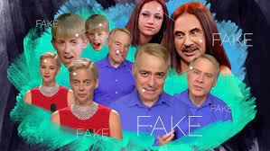What is a deepfake video?
2. Complete the following sentence. Deepfake videos use ______________ intelligence software.
3. What is the aim of project Fake Out?
4. Why are experts worried about people not being able to spot deepfake videos?
5. What questions do people need to ask themselves about spotting a deepfake video?

# Activity: AI Experiments

Students explore the following AI systems then ask them to reflect on how they know the system uses AI.

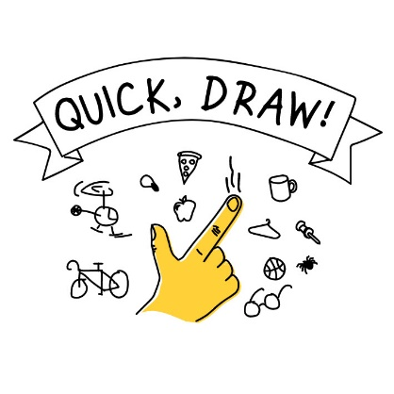[AI Duet](https://experiments.withgoogle.com/ai/ai-duet/view/) – This experiment lets you play a duet with the computer. Just play some notes, and the computer will respond to your melody.

[Freddie Meter](https://freddiemeter.withyoutube.com/) – An AI-powered singing challenge that rates how closely your singing matches the voice of Freddie Mercury.

[Quick Draw](https://quickdraw.withgoogle.com/) – A game that challenges players to draw a picture of an object or idea and then uses a neural network artificial intelligence to guess what the drawings represent.

[Semantris](https://experiments.withgoogle.com/semantris) – Word association games powered by machine learned. Each time you enter a clue, the AI looks at all the words in play and chooses the ones it thinks are most related.

# Activity: Persuasive Text

Students will explore the issues raised in the BTN AI Jobs story and then develop a persuasive text for or against the following statement: `*Artificial intelligence is better than humans*.’ Students need to weigh up the pros and cons of the issue then write a short persuasive argument using the following as a guide.

**Tips**

* Who is your audience? For example, are you directing your argument at kids, teachers, or politicians?
* Explore how language choices can have a big impact on persuading your audience.
* Which language devices give the report credibility and authority?
* Which are designed to create an emotional response in the listener?
* Provide facts and evidence to support your argument.
* Write in the present tense.
* Check your spelling and punctuation.

Use this *Read Write Think* [persuasion map](http://www.readwritethink.org/files/resources/interactives/persuasion_map/) to plan your exposition text.

**Introduction**

* What is the point you are trying to argue? Construct an introductory paragraph which states the issue or topic.
* Introduce the arguments that will be developed in the body of the text.

**Body**

* Construct arguments that support your point of view.
* Each paragraph starts with a topic sentence which introduces each point.
* The rest of the paragraph gives more reasons.
* Arguments can be ordered from strongest to weakest.

**Conclusion**

* Restate your position on the argument.
* Construct a concluding paragraph that provides a summary of your arguments and a call to action.

**Reflection**

* How difficult was it to think of points to support one side of the argument?
* Do you think you would have done a better job supporting the other side of the argument?
* Was I able to convince others of my opinion?
* What did you learn from this activity?

# BTN Stories

As a class watch one or more of the following BTN stories to learn about the future of jobs and the impact of artificial intelligence on work. After watching any one of the BTN videos ask students to respond to the discussion questions (to find the discussion questions and teacher resources go to the related BTN Classroom Episode and download the Episode Package).

|  |  |  |
| --- | --- | --- |
| Artificial Intelligence Jobs - Classroom - BTN[Artificial Intelligence Jobs](https://www.abc.net.au/btn/classroom/artificial-intelligence-jobs/10523718) | A person in a garment  Description automatically generated with low confidence[Sentient AI](https://www.abc.net.au/btn/classroom/sentient-ai/13931864) | A picture containing text, art, graphics, graphic design  Description automatically generated[Robot Revolution](https://www.abc.net.au/btn/classroom/robot-revolution/13494772) |
| A picture containing text, human face, person, smile  Description automatically generated[Future Jobs](https://www.abc.net.au/btn/classroom/future-jobs/10525832) | Graphical user interface  Description automatically generated with medium confidence  [Robot Jobs](https://www.abc.net.au/btn/classroom/robot-jobs/10522582) | Diagram  Description automatically generated[Future Careers](https://www.abc.net.au/btn/classroom/future-careers/10527338) |
| AI Art - Behind The News  [AI Art](https://www.abc.net.au/btn/classroom/ai-art/102273194) | ChatGPT - Behind The News  [ChatGPT](https://www.abc.net.au/btn/classroom/chatgpt/101915652) | AI Song Contest - Behind The News  [AI Song Contest](https://www.abc.net.au/btn/classroom/ai-song-contest/12246920) |

# Useful Websites

* [Artificial Intelligence Jobs](https://www.abc.net.au/btn/classroom/artificial-intelligence-jobs/10523718) – BTN
* [Robot Jobs](https://www.abc.net.au/btn/classroom/robot-jobs/10522582) – BTN
* [Aussie AI Regulation](https://www.abc.net.au/btn/newsbreak/btn-newsbreak-20230601/102422988) – Newsbreak
* [How AI could help solve Australia’s `productivity problem’ without leaving workers worse off](https://www.abc.net.au/news/2023-06-05/artificial-intelligence-australia-productivity-jobs-employers/102404754) – ABC News
* [What is AI? What does artificial intelligence do?](https://www.bbc.co.uk/newsround/49274918) – Newsround
* [ChatGPT: What is the AI bot and how does it work?](https://www.bbc.co.uk/newsround/64210050) – Newsround



**EPISODE 16**  
13th June 2023

**KEY LEARNING**

Students will learn more about Macquarie Island and what makes it unique. They will also create profile of a species found on the island.

**CURRICULUM**

**Geography – Year 5**

The management of Australian environments, including managing severe weather events such as bushfires, floods, droughts or cyclones, and their consequences.

**Science – Year 5**

Examine how particular structural features and behaviours of living things enable their survival in specific habitats.

**Science – Year 6**

Investigate the physical conditions of a habitat and analyse how the growth and survival of living things is affected by changing physical conditions.

Investigate how scientific knowledge is used by individuals and communities to identify problems, consider responses and make decisions.

Teacher Resource

**Macquarie Island**

# Focus Questions

Discuss the BTN story as a class and record the main points of the discussion. Students will then respond to the following:

1. Macquarie Island is located in which ocean?
   1. Southern
   2. Atlantic
   3. Arctic
2. What is a marine park? What did the government recently announce about the marine park surrounding Macquarie Island?
3. Name three species of animals found on Macquarie Island.
4. What challenges have animals on Macquarie Island faced?
5. What did you learn about Macquarie Island? Create a short fact sheet to display your knowledge.

# Activity: See, think and wonder?

After watching the Macquarie Island story students will respond to the following:

* What did you SEE in this story?
* What did this story make you WONDER?
* How did this story make you FEEL?
* Think of three questions you have about the BTN story.

# Activity: Discussion

Working in pairs or small groups, students discuss the BTN Macquarie Island story using the following questions as a guide.

* A picture containing text, vector graphics

  Description automatically generatedWhere is Macquarie Island? Locate using Google Maps. Where is it in relation to Australia and Antarctica?
* Why have the government increased the size of the marine park around Macquarie Island?
* What do you know about the wildlife found on Macquarie Island?
* What makes Macquarie Island unique?

# Activity: Glossary

Students will brainstorm a list of key words that relate to the BTN Macquarie Island story. Here are some words to get them started.

|  |  |  |
| --- | --- | --- |
| MARINE PARK | SUB-ANTARCTIC | WORLD HERITAGE |
| HABITAT | BIODIVERSITY | CONSERVATION |

# Activity: Macquarie Island Research

**Questions to research**

Students will develop their own question/s to research about Macquarie Island and what makes it unique. Students will collect and record information from a wide variety of sources. Students may develop their own question for inquiry or select one of the questions below.

* Who lives on Macquarie Island? Investigate what living conditions are like on the island and write a diary or journal entry that tells first-hand what it’s like living on the island. Look at photographs or [this short video](https://www.antarctica.gov.au/antarctic-operations/stations/macquarie-island/living/) to help imagine what living on the island would be like. Listen to the podcast [Resupply Macquarie Island](https://www.antarctica.gov.au/news/podcasts/) to go behind the scenes for the resupply of goods on the island.
* 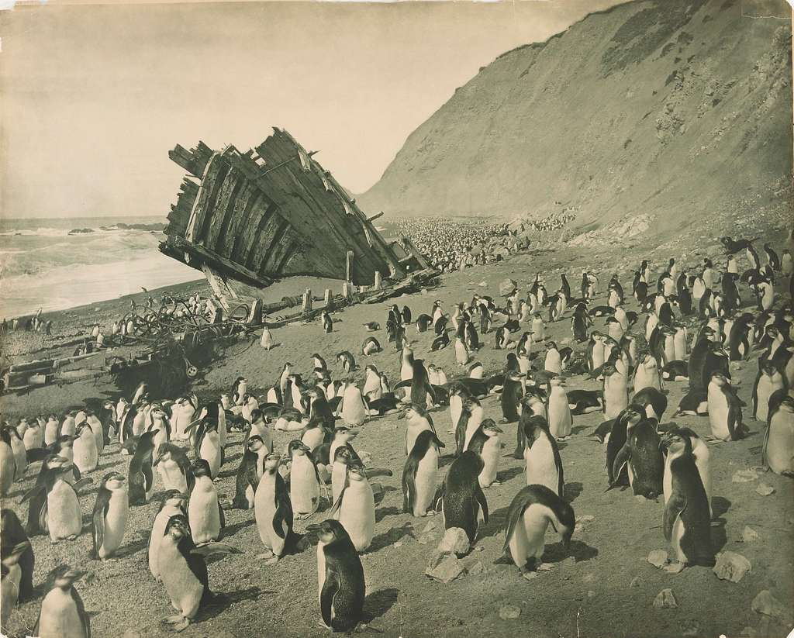What is the climate like on Macquarie Island? Graph average monthly temperatures, rainfall, wind speed and sunshine.
* What special geological features does Macquarie Island have?
* How does the isolation of Macquarie Island contribute to its unique ecosystem?
* What are the major plant and animal species on Macquarie Island and how have they adapted to survive in the harsh environment?

[Frank Hurley, Macquarie Island](https://cdn2.picryl.com/photo/1911/12/01/pxd-156-wreck-macquarie-island-hurley-cropped-54e83e-1024.jpg)

* How have native flora and fauna been affected by the introduction of animal and plant species? What progress has been made eradicating feral species?
* Why is Macquarie Island important in the survival of animals in the Southern Ocean?
* Macquarie Island Station is a permanent Australian subantarctic research base on Macquarie Island. [Take a tour of the research station](https://skyavenue.com.au/virtualtour/macca.html?html5=prefer). What is the history of the station and what research does it conduct?
* What was the significance of Macquarie Island in Douglas Mawson’s Australasian Antarctic Expedition?

# Activity: Macquarie Island Wildlife Profile

Students will imagine they are scientists and study a species that is found on Macquarie Island. Students will create a profile about the species, see below for some examples:

* A picture containing bird, penguin, aquatic bird, flightless bird

  Description automatically generated[Royal penguin](https://www.antarctica.gov.au/about-antarctica/animals/penguins/royal-penguin/)
* [Elephant seal](https://www.antarctica.gov.au/about-antarctica/animals/seals/elephant-seal/)
* [Wandering Albatross](https://en.wikipedia.org/wiki/Wandering_albatross)
* [King penguin](https://www.antarctica.gov.au/about-antarctica/animals/penguins/king-penguin/)
* [Petrel](https://en.wikipedia.org/wiki/Petrel)

Students will research the following and then share their research findings with the class or create a display in the classroom.

Image credit: Joe Baronio

* Name (common and scientific name)
* Biological illustration or photo
* 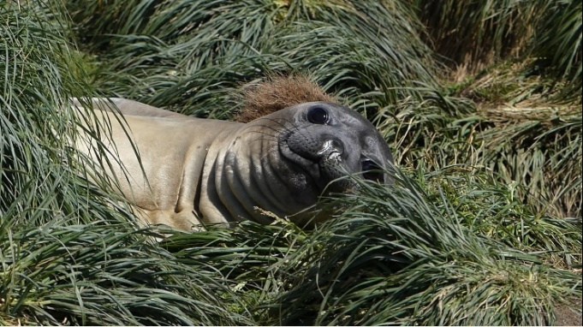Classification (class, family, genus)
* Description (size, colour, physical features)
* Habitat
* Diet
* Behaviours
* Conservation status
* Adaptations
* Threats

Image credit: Joe Baronio

* Contribution to the biodiversity on Macquarie Island.

# Activity: Macquarie Island World Heritage

Students will learn more Macquarie Island and its significance as a World Heritage site. Working in pairs or small groups, they can use the following questions to guide their research.

* What does World Heritage mean? Come up with a definition.
* A large group of penguins

  Description automatically generated with medium confidenceWhy was Macquarie Island chosen as a World Heritage site?
* What geological features make Macquarie Island significant?
* What conservation efforts are in place to protect Macquarie Island’s World Heritage status?
* What conservation challenges does Macquarie Island face?

Image credit: Joe Baronio

**Share**

* Share and compare your research with your classmates.
* Present your research in an interesting way.

# Activity: Macquarie Island Quiz

|  |  |
| --- | --- |
| **1.Macquarie Island is part of which country?**  A. New Zealand  B. Australia  C. United Kingdom  **2.Macquarie Island is closer to New Zealand than Australia.**  A. True  B. False  **3.Which of the following animals in NOT found on Macquarie Island?**  A. Seals  B. Penguins    C. Polar Bears  D. Albatrosses | **4.The federal government recently announced that the marine park around Macquarie Island would double in size.**  A. True  B. False  **5.Which species of penguin is only found on Macquarie Island?**  A. King  B. Royal  C. Gentoo  **6. The scientific research on Macquarie Island provides important information on climate change and marine ecosystems.**  A. True  B. False |

Quiz Answers: 1B, 2A, 3C, 4B, 5B, 6A

# Useful Websites

* [Macquarie Island marine park set to almost triple in size](https://www.abc.net.au/news/2023-06-05/macquarie-island-marine-park-to-triple-in-size/102438582) – ABC News
* [Macquarie Success](https://www.abc.net.au/btn/classroom/macquarie-success/10528308) – BTN
* [Macquarie Island](https://www.abc.net.au/btn/classroom/macquarie-island/10534316) – BTN
* [Macquarie Island Station: A brief history](https://www.antarctica.gov.au/about-antarctica/history/stations/macquarie-island/) – Australian Antarctic Program
* [Macquarie Island Research Station](https://www.antarctica.gov.au/antarctic-operations/stations/macquarie-island/living/) – Australian Antarctic Program
* [Macquarie Island Research Station](https://www.antarctica.gov.au/antarctic-operations/stations/macquarie-island/living/) – Australian Antarctic Program
* [Living on Macquarie Island](https://www.antarctica.gov.au/antarctic-operations/stations/macquarie-island/living/) – Australian Antarctic Program
* [Macquarie Island](https://whc.unesco.org/en/list/629/) – UNESCO



Teacher Resource

**BTN Transcript: Episode 16 - 13/6/2023**

Hey, I'm Amelia Moseley and you're watching BTN. Thanks for hanging out with us again, here’s what’s coming up on today’s show. Will AI take our jobs? Joe visits Macquarie Island and all of its amazing wildlife and we meet Olly, who started his own business.

# Duck Hunting

Reporter: Joseph Baronio

*INTRO: All that soon, but first up. It's duck hunting season in South Australia but a new poll has found most people in the state think the sport should be banned. Here's Joe to explain.*

JOE, REPORTER: Ducks. They're cute, quacky, and you're actually not supposed to feed them bread. But at this time of year some of them are in a bit of danger. See, every year from around March to June, it's duck hunting season in parts of the country including here in South Australia, and it causes a bit of a stir, not just for the ducks but because the sport divides opinion.   
  
KID 1: I think hunting ducks is a good source of food.  
  
KID 2: But if you're just doing it just to sort of kill them for fun, like, that's not really alright.  
  
Currently, duck hunting is banned in Western Australia, New South Wales, the ACT, and Queensland. But, everywhere else, it's legal.   
  
JOE: Now, even though it is legal in certain states, you can't just hunt any old duck anywhere.

Nope, there are a few rules like hunting can only happen in permitted areas during certain times of the day, hunters must have a license and pass a test so they can identify protected species and not accidentally shoot them, and they can only take a limited number of duck’s home.

JOE: But it's something that many people are pushing to change.

Through the 1980s and 1990s animal liberationists clashed with hunters at the start of every season saying the sport was cruel and dangerous to threatened species.  
  
ELISABETH JONES, CONSERVATIONIST: We're in a dangerous situation. There's two groups of people here, both with violently opposing views.  
  
Today, they say duck hunting isn't sustainable and duck populations in hunting states have been declining, which they think will only get worse thanks to climate change impacting their habitats. In Victoria, the parliament has already shortened their state's hunting season and is deciding whether they'll ban it altogether. South Australia might also go down the same path with a study from the Australia Institute showing that three out of four South Aussies support the idea.  
  
KID 2: Well, I think it should be banned if they’re doing it just to kill the ducks for fun.  
  
KID 1: I reckon that it shouldn't be banned but there should be some rules around it.  
  
Not everyone reckons the ban is a good idea though. See, people have been hunting ducks for food for thousands of years, but in the 17th century guns changed everything and the sport of duck hunting or "waterfowling" massively grew in popularity. Eventually, it made its way to Australia, and today there are still many hunters who see the sport as a tradition, and as a way to get a fresh feed.  
  
JESS BYFIELD, HUNTER: We love eating it and love doing it as a family and it's getting out together, in the outdoors, in the fresh air, and being able to do something that takes us back to our kind of traditional roots.   
  
Hunters also argue it's good for the economy.

JOE: But many people reckon it's time to move on from the past.  
  
JAN DAVIS, CEO, RSPCA TASMANIA: This is a recognition that times have changed, and what we've been doing in the past is no longer acceptable.  
  
The Victorian parliamentary inquiry has set a record for the most public input ever, and both the Victorian and South Australian parliament still have a lot of hearings to go before they make a decision. But what do you think?  
  
KID 2: If it's like in a controlled environment, where they're just killing them to get a food source, then I think it's alright.  
  
KID 1: They can help farmers get rid of some other animals that are harmful to our nature.  
  
KID 3: I think it should be banned, unless you need to hunt ducks for food or there's a big population of ducks and you need to get rid of some.

# News Quiz

This major city has been experiencing some of the worst air quality in the world lately. Which city are we looking at? Is it Delhi, India, New York City, United States or Beijing, China? It’s New York City. This wave of orange smoke drifted over the border from nearby Canada which has been dealing with massive wildfires.

What’s the name of this iconic spot which also happens to be a World Heritage Site and the world’s largest sand island? It’s K'gari. Formerly known as Fraser Island. The area has now been restored to its traditional name.

KID: It feels really good, and I really like that I got to come here today.

PERSON: It’s always been K’gari to a lot of people, but now we know that it’s K’gari to all people, all over the world.

The name will be replaced on maps, road signs and tourist information moving forward.

And let’s head back to the US where this car has an unexpected occupant. What’s in the car? Is it a dog, a wolf or a bear? Yep, the bear was attracted to some dog food left inside and got trapped. Luckily, it was no big deal for this park ranger.

# Teen Smoking

Reporter: Justina Ward

*INTRO: Pretty much everyone knows about the dangers of smoking and since the 90s Australians have done a lot less of it. But now, for the first time in 25 years the percentage of Aussie teenagers who smoke has gone up and health experts are worried. Here's Justina.*

ANTI-SMOKING ADVERTISEMENT: If the average 20-a-day smoker could collect and wring out what goes into his lungs over a year, he’d find this much. Cancer producing tar.

These are the kinds of ads I grew up seeing on TV.

ANTI-SMOKING ADVERTISEMENT: Every cigarette is doing you damage.

And they were everywhere. Since 1997, the government's National Tobacco Campaign has been fighting to end smoking in Australia. It’s increased health campaigns, brought out things like plain packaging, and raised taxes on cigarettes. All this has made a huge difference in reducing the number of smokers in Australia. But recently, things have started to go backwards.  
  
Professor Emily Banks, Epidemiology and Public health ANU: We've been having amazing progress and what we are seeing is increased proportions of 14 to 17 year olds taking up smoking.  
  
You see, teen smoking has increased for the first time in 25 years. In 2018, just over 2 percent of teens smoked cigarettes. But now, it's jumped to nearly 13 percent and this data just came days after the federal government released its proposed legislation to crack down on the tobacco industry.  
  
Mark Butler, Minister for Health and Aged Care: We will not stand by and allow vaping to create another generation of nicotine addicts.  
  
Yep, vaping is causing some pretty bug problems.

Professor Emily Banks, Epidemiology and Public health ANU: And we know that young people who vape are around three times as likely to take up smoking as young people who don't vape and tobacco companies know that if they can get somebody addicted in their teens, which is generally when people start smoking, well, then they can have a customer for life.  
  
All cigarettes and some vapes have something really addictive in common. And it's called nicotine. It's a chemical that's found naturally in the tobacco plant.  
  
Professor Emily Banks, Epidemiology and Public health ANU: But actually, addiction is a very serious problem. And what happens with people when they're really addicted to something is they only feel normal when they've had that substance.  
  
Nicotine is just one of more than 7,000 chemicals found in tobacco smoke and those chemicals can and do kill thousands of Australians every year.Two out of three long-term smokers will die of a smoking-related disease and have their life cut short by roughly 10 years compared to non-smokers.  
  
KID 1: You can get like mouth diseases and stuff. I researched that the other day.   
  
KID 2: Yeah, lung cancer, you get asthmatic attacks, stuff like that.   
  
KID 3: It can affect lung cancer, and it can affect your lungs in the long term and can, like, give you a higher risk of getting cancer.   
  
KID 4: It leads to cancer, like lung cancer, like breathing problems and all that. They teach us about it but no one really seems to think about it like properly.   
  
Hmm, so if we know smoking's bad for us, why do we do it?  
  
KID 5: But I reckon like a lot of people do it to maybe like feel older.   
  
KID 4: Yeah, I know a few kids who are like doing it for the trend, and they're young.  
  
KID 6: Watching other people and getting peer pressured.   
  
KID 7: Because they’re trying to be cool. And then vapes are getting banned. So, they sort of need their nicotine a different way.  
  
The government's already announced it's going to spend more money on public health campaigns, support programs, and it'll increase tobacco taxes too.  
  
Professor Emily Banks, Epidemiology and Public health ANU: There will be mass media campaigns about smoking because the industry is constantly innovating. They're constantly trying to sell more of their products. They're constantly trying to find replacement customers.   
  
Professor Sarah Durkin, Centre for Behavioural Research at Cannes Council Victoria: So, I think we have that window of opportunity still open to us, to really cut it off so that we can, we can stop that new generation getting addicted.

**AI Jobs**

Reporter: Justina Ward

*INTRO: It feels like AI is everywhere right now and getting smarter and more powerful all the time. But could artificial intelligence take our jobs? Well, a lot of Aussies are worried about that, and Justina looked into it.*

Remember the first computers? And then they started to shrink, landing in our homes, our desks and eventually in our pockets. We became connected and eventually these machines they started talking back, learning.  
  
TV PRESENTER: And now they could be taking our jobs and taking over the world. If you think you’ll be losing your job to AI call 01011011.

SANDRA, AI REPRESENTATIVE: Hello, welcome to AI Future. Press 1 if you're worried AI will take your job. My name is Sandra, how can I help you today?  
  
JUSTINA: Yeah, hi, um, I was just wondering, hang on a second, that, the voice you have is the one that I heard before, are you AI too? Hello?   
  
AI, aka artificial intelligence is the ability of a computer or other device or application to function as if possessing human intelligence. So, maybe it's no surprise that as AI keeps improving, so does its ability, to well, do all the things we humans can including work.   
  
Toby Walsh, Chief Scientist, AI Institute: AI is certainly starting to affect some people's jobs. There are some jobs that are actually being replaced.  
  
Lots of people are thinking the same thing. Nearly half of Australian workers say they're worried AI will replace them. Although at the same time, 65 percent of workers said they'd be pretty happy to hand over some of their boring tasks to AI.  
  
KID 1: I think AI is gonna take over the world.   
  
KID 2: I don't know about taking over jobs. But I think it can be used to enhance jobs   
  
KID 3: I think it would be cool to see a robot doing surgery on a person one day.   
  
KID 4: It's gotten very advanced within like a short amount of time so I reckon it will take over very, very soon.  
  
Stats show AI could create 69 million jobs by 2027, but also result in 83 million job losses and while that kind of change might sound scary, it's happened before. The Industrial Revolution was when much of the world went from creating goods by hand, to using machines. Some people lost their jobs over it to begin with, but it ended up being a huge turning point in modern history. It increased the production of goods, boosted economies, and even made it easier to get around.

Then came the digital revolution. We went from analogue machines to digital and invented computers, mobile phones and the internet. Some jobs did disappear completely but ultimately these changes led to a better quality of life for most people and opened up new careers and industries and some experts say that's something we need to consider with AI.  
  
Toby Walsh, Chief Scientist, AI Institute: We should be celebrating now that humans have their time freed up to do the things that give them satisfaction. And the machines can do all those dull, repetitive things that we never liked doing in the first place.  
  
JUSTINA: I wonder how AI feels about all this, let's go find one to find out. Well, I'm actually really interested to know what you have to say about AI?  
  
AI MACHINE: I'm no expert on the subject. But I do find it fascinating how quickly AI technology's advancing. It's like we're moving into a new era of automation and intelligence.  
  
JUSTINA: Will AI take over our jobs in the future? What do you think?   
  
AI MACHINE: Nothing like a bit of futuristic speculation to get the mind going. I think it's impossible to predict what might happen in the future. All we can do is stay informed and be open minded about technology and its potential implications.  
  
Yep. AI is kind of everywhere, for better and for worse. So, what do you think about it?  
  
KID 3: Basically, I see everything going into AI.

KID 5: It's already worse now. People using it for school and stuff. They're not really using their knowledge.  
  
KID 6: But I think it would also give you like a bit of motivation to try to, like, beat the robots.  
  
KID 7: It will become a big thing. I'm sure of it. Like, I know for a fact. Yeah.

**Macquarie Island**

Reporter: Joseph Baronio

*INTRO: Now to a little island south of Tasmania called Macquarie Island. It's home to millions of penguins and around one hundred thousand seals. And now the government's announced even more of the area around the island will be protected. Joe paid it a visit to learn more about its history and some of the interesting plants and animals that live there.*

JOSEPH BARONIO, REPORTER: Here in the middle of the Southern Ocean, thousands of kilometres from humanity, lies a sanctuary of wildlife, unrivalled beauty, and, ugh. Sorry, I can't keep that accent up. Anyway, ah.   
  
Macquarie Island is a little lump of volcanic rock in the Southern Ocean half-way between Hobart and Antarctica, which is part of a group of islands called the sub-Antarctic islands. And even though it's so far away from the mainland, it's actually part of Australia. That means the Aussie government is responsible for looking after it, and recently, the government announced it'll be expanding the marine park, which is a protected area around the island that bans things like fishing and mining. It's growing to a whopping 475,465 square kays. That's bigger than Germany.  
  
Tanya Plibersek, Minister for the Environment and Water: It's probably the biggest contribution that'll be made to conservation anywhere on the planet this year.  
  
JOE: There are good reasons why the government's gone all out in protecting this little spec on the map, which are, well, let's go find out for ourselves.

Now, I actually went on this trip back in December for a holiday, but I figured I should bring you along too. And after 3 days on a big ship through rough seas, I finally arrived, and was greeted by some of the island's residents. Macquarie Island is home to millions of different animals and native plants including elephant seals, like this little guy, huge native plants called mega herbs, and a whole lot of penguins, like these king penguins, and royal penguins, which are only found here and on two other nearby islands.

It's also home to a small group of researchers studying things like geology, weather patterns, and of course the wildlife. Macquarie Island is so important as a breeding ground for its unique wildlife and for scientific research that in 1997 it was awarded World Heritage status. Meaning it'll be internationally protected for the future.  
  
For a long time before that though, life for the wildlife here wasn't easy. When the island was first discovered in 1810, oil for things like lamp fuel and lubricants was big business, and millions of seals and penguins were killed in these huge machines called digesters, which extracted oil to be sold off. It happened for more than 100 years, and the population plummeted, until 1919 when the practice was finally banned.

It's not the only problem that the island's faced. Pests like rats, rabbits, and feral cats introduced by visiting ships killed a lot of native wildlife and vegetation, leading the government to launch a massive twenty-five-million-dollar project in 2007 to get rid of these pests once and for all, and by 2014, the island was finally pest free.

Today, some memories of the past are still here but the seal and penguin populations have bounced back. Like, big time. They're everywhere. But, while many think the expansion of the marine park is a good idea, commercial fisheries who operate in the area aren't happy, and say they felt left out of the decision.  
  
Veronica Papacosta, CEO of Seafood Industry Australia: The Australian seafood industry is highly sustainable, we have a commitment to environmental conservation because it’s our backyard too.  
  
The government reckons it won't affect their business and is just waiting for the final tick of approval from the Governor General. I've been super lucky to see it for myself and bring you along for the ride, but now I've got a long trip home.

# Sport

Australia's won its first ever World Test Championship title after beating India by 209 runs at The Oval. India needed 444 for victory in the final but the Aussie men's side bowled them out for just 235, thanks to some key wickets from Scott Boland. Australia's now the first team to have won world titles in all three formats of the game.  
  
Novak Djokovic has claimed a record-breaking 23rd men's singles Grand Slam title. He defeated Norway's Casper Ruud in straight sets in the French Open final. The Serbian's now the only male player to have won each of the four Grand Slams at least three times.

NOVAK DJOKOVIC, TENNIS PLAYER: I just want to send a message out there to every young person, be in the present moment, forget about what happened in the past. The future is something that is just going to happen but if you want a better future, you create it. Take the means in your hands, believe it, create it.

In Super Netball the New South Wales Swifts will finish minor premiers in the home and away season. They locked in top spot after defeating the Queensland Firebirds 78 to 65. It's their ninth win in a row with one round left to play.

**Fishing Lure Business**

Rookie Reporter: Olly

*INTRO: Finally, today, meet Olly from New South Wales. He loves fishing and recently started up his own business, selling fishing lures he makes himself. And he's even helping other anglers recycle their old tackle. But I'll let Olly tell you all about it.*

Hi, Behind the News. I'm Olly Neuseuss and I'm 14. And I have a passion for making soft plastic lures.  
  
I got into fishing when I was three. My Pop asked me one weekend if I wanted to come out in the boat with him. And I said, why not?  
  
There was a lure maker in Tweed Heads. The prices of lures had gone up by a couple of dollars. And I wasn't happy with it. So, I started buying off him. I started researching into lure making. Went from there.  
  
I made my own Facebook group. And I started posting on there and got a lot of attraction. My Facebook group's called Livewire Lures. I've got about 350 followers.  
  
I can do a heap of different sizes and shapes. I use a mould and injector. They can look like prawns; they can look like worms. Frogs. Any colour you want. They love the natural colour lures, because it's imitating a bait fish. They're pretending to be little prawns and little fish, they got tails that move, some wriggle, some shake, and some go in circles.

First, I get the plastisol, I put it in the microwave in a jug. Once it's melted, takes about five minutes. Then I'll add the pigments and all the colourants, whatever I want, and the glitter. And then I'll put it in the injector and put it in the moulds. They take about 10 minutes or so to actually cure it's called. I gotta hang them up and they dry. Once they're damaged or bitten or chewed up, I like to remelt them, and same process as the start. But they've already got the colouring in there.  
  
I got a passion for the environment, and I want to keep it clean and safe. If there's plastic left in the waterways our turtles and marine life, they'll get destroyed.  
  
I got prepaid postage satchels that I'll be sending out with orders. So, the customers they can return their lures to me, and I can remelt them and then they'll get a discount on their next order. I want to put containers in local stores. I'd like to have a little project bin for them to put their lures in. Please return your chewed plastics to me. My pop taught me everything I know now. He's passed away now so when I'm fishing, I think back all the memories and yeah, I know he's there with me.

**Closer**

Great work, Olly. Well, that's all for today but don't forget you can tune into Newsbreak every weeknight and there's heaps of stuff on our website for both teachers and students so make sure you check it out. Have a great week and I'll see you soon.