
EPISODE 18
23 June 2026

KEY LEARNING
Students will view a range of BTN stories and use comprehension skills to respond to a series of focus questions.

CURRICULUM
English – Year 4
Use comprehension strategies such as visualising, predicting, connecting, summarising, monitoring and questioning to build literal and inferred meaning, to expand topic knowledge and ideas, and evaluate texts.
English – Year 5
Use comprehension strategies such as visualising, predicting, connecting, summarising, monitoring and questioning to build literal and inferred meaning to evaluate information and ideas.

English – Year 6
Use comprehension strategies such as visualising, predicting, connecting, summarising, monitoring and questioning to build literal and inferred meaning, and to connect and compare content from a variety of sources.

  - Teacher Resource

Focus Questions
As a class, discuss the stories featured in the episode of BTN Classroom and record the main points of the discussion. Students will then respond to the following focus questions.

US and Iran Ceasefire
- What two countries recently agreed on a ceasefire?
- Where is the Strait of Hormuz? Find on a map.
- Complete the following sentence. The Strait of Hormuz is one of the world’s busiest transport routes for ______ and ______.
- What issues has the closure of the Strait of Hormuz caused?
- What questions do you have about this story?

Godzilla El Niño
- What is El Nino?
- What does El Nino mean in Spanish?
  - The Little Girl
  - The Little Boy
  - The Man
- How does El Nino usually affect the weather in Australia?
- How often do El Ninos usually happen?
- Why is it called a “Godzilla” El Nino?

Check out the teacher resource on the Archives page.

USA 250th Anniversary
- In pairs, or small groups, discuss the story. What were the main points of discussion?
- What date was the US Declaration of Independence created?
- Why did the British colonies rebel?
- Who was the main writer of the Declaration of Independence?
- Why is the US considered a global superpower?

NAIDOC Week
- Summarise the BTN story in 2-3 sentences.
- What is the theme for NAIDOC Week 2026?
  - 50 Years of Deadly
  - For Our Elders
  - Get Up! Stand Up! Show Up!
- What is the Day of Mourning?
- What does NAIDOC stand for?
- Who designed the poster for NAIDOC Week 2026?

Check out the teacher resource on the Archives page.

Max Fashion
- How old was Max when he first started designing clothes?
  - 4-years-old
  - 6-years-old
  - 10-years-old
- What is Max’s favourite part about making fashion?
- Where does Max get his ideas from when making fashion?
- Max is the youngest fashion designer to debut at Paris Fashion Week. True or false?
- Think of one question you would like to ask Max.

EPISODE 18
23 June 2026

KEY LEARNING
Students will investigate the cause and effects of El Nino. Students will create a comic which illustrates the key stages of an El Niño climate pattern.

CURRICULUM
Geography – Year 5
The impact of bushfires or floods on environments and communities, and how people can respond.

Science – Year 6
Sudden geological changes and extreme weather events can affect Earth’s surface.

Science involves testing predictions by gathering data and using evidence to develop explanations of events and phenomena and reflects historical and cultural contributions.

Scientific knowledge is used to solve problems and inform personal and community decisions.

Geography – Year 7
Causes, impacts and responses to an atmospheric or hydrological hazard.

  - Teacher Resource

Godzilla El Niño

Focus Questions
Discuss the BTN story as a class and record the main points of the discussion. Students will then respond to the following:
- What is El Nino?
- What does El Nino mean in Spanish?
- How does El Nino usually affect the weather in Australia?
- How often do El Ninos usually happen?
- Why is it called a “Godzilla” El Nino?

Activity: Comprehension
After watching the BTN Godzilla El Niño story students can answer one or more of the following questions, for example:
- What are some keywords from the BTN story?

- What did you learn from the story? Write a summary.
- What is the purpose of this news story? To entertain, persuade, inform, explain or describe?
- Why do you think BTN covered the story?

Activity: Class Discussion
Students will discuss the BTN Godzilla El Niño story in pairs and then share their thoughts with the class.
- What is El Niño? Come up with a class definition.
- What does El Niño mean in Spanish?
- What is the opposite of El Niño?
- Describe the weather in Australia during El Niño.


What did you learn from the story?
What questions do you have about the story?

Activity: Glossary
Students will brainstorm a list of key words that relate to the BTN Godzilla El Niño story. Here are some words to get them started.
EL NIÑO | LA NIÑA | SOUTHERN OSCILLATION
CLIMATE PATTERN | BUREAU OF METEOROLOGY | TRADE WINDS

- What does ENSO stand for?
- What is a “Godzilla” El Niño?
- Make a list of words that describe the weather changes caused by La Nina and El Niño.
- What are the origins of the name El Niño? What does it mean in Spanish and what is the story behind its name?

Activity: Graphic Organisers
Graphic organisers are a helpful learning tool for students to organise, clarify, or simplify complex information. Students will choose one type of graphic organiser to help them explore and analyse El Niño.

Venn Diagram  Purpose: To compare the similarities and differences between two or more things.  Procedure: Write the items being compared in the circles. Where the circles overlap, record similarities. Record the characteristics which are different in the areas that do not overlap.  Activity: Compare the similarities and differences between El Niño and La Niña climate patterns.   | Mind Map  Purpose: To assist in activities that involve planning, brainstorming, making notes, organising or problem solving.  Procedure: An issue or topic is written in the centre. Related ideas are linked to the central issue, and other ideas are developed from these.  Activity: Use a mind map to record what you know about El Niño.   | Cause-and-Effect  Purpose: To help identify causes for an effect or specific problem.  Procedure: Identify an event or action (cause) and explain the result that follows (effect).  Activity: Use a fishbone diagram to show how one stage leads to the next in El Niño.  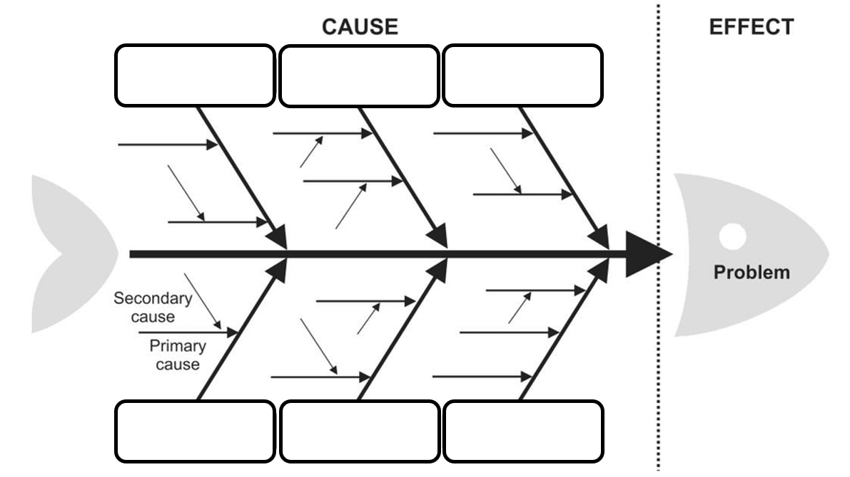

Activity: Comic Strip
In this activity students will create a comic strip which illustrates the key stages of El Niño. Students will identify the cause-and-effect relationships in the El Niño climate pattern.

Before illustrating their comic strip, students will identify and respond to the following:
- What causes El Niño to develop? (changes in ocean temperature and trade winds).
- How does El Niño affect the weather? (changes in the weather including temperature and rainfall).
- What impact does El Niño have on people in Australia? (heatwaves, drought, threat of bushfires).
- What impact does El Niño have on the environment? (marine heatwaves, soil and vegetation distress).
- What are some practical solutions to El Niño? (monitor forecasts, water saving, resilient farming, fire preparedness).

Students will the use the information they have gathered to illustrate a 5-panel comic strip which shows the key stages of an El Niño climate pattern. Students will include captions and dialogue using as many of the following key vocabulary.

Key Vocabulary
- Pacific Ocean
- Trade winds
- Climate pattern
- ENSO
- Ocean temperature
- Reduced rainfall
- Warmer weather
- Drought
- Bushfires

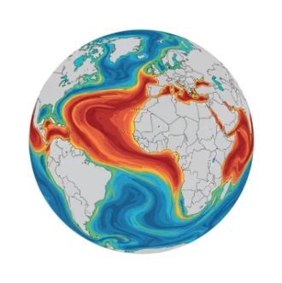

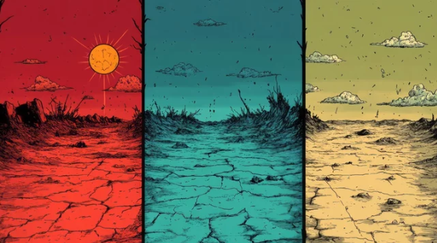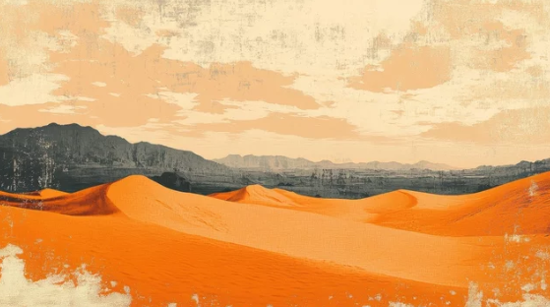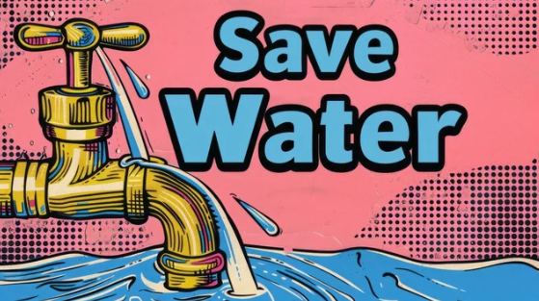

Activity: Quiz

- What is the opposite of El Niño?  A. La Niña  B. La Doña  C. El Hombre  - What does the term ENSO stand for?  A. East North South Ocean  B. Eastern Northern South Oscillation  C. El Niño-Southern Oscillation  - What does El Niño mean in Spanish?  A. The Little Girl  B. The Little Boy  C. The Man  - How does El Nino usually affect the  weather in Australia?  A. Hotter and drier weather  B. It doesn’t affect the weather  C. Cooler temperatures, more rainfall  - When was El Nino first identified?  A. By a meteorologist in the 1800s  B. By Peruvian fishermen in the 1500s  C. By scientists in the 1980s  Quiz Answers:  1A, 2C, 3B, 4A, 5B, 6A, 7A, 8B, 9B, 10B | - What statement best describes El Nino?  A. A climate pattern that affects weather around the world  B. A season that occurs every summer  C. A type of tropical cyclone  - During El Nino trade winds usually…  A. Weaken  B. Strengthen  - Which ocean is primarily affected by El Nino?  A. Indian Ocean  B. Pacific Ocean  C. Southern Ocean  - El Nino is a single storm that hits specific areas.  A. True  B. False  - In Australia, El Nino usually means higher than  average rainfall.  A. True  B. False

Useful Websites
- El Niño: what it means for Australia's climate – The Bureau of Meteorology
- El Niño and La Niña – The Bureau of Meteorology
- What Is El Niño? – NASA Science
- La Niña – BTN
- El Nino – National Geographic
- What is El Niño and how does it impact Australia? – The Bureau of Meteorology

EPISODE 18
23 June 2026

KEY LEARNING
Students will explore the history of NAIDOC Week.

CURRICULUM
HASS – Year 3
Significant events, symbols and emblems that are important to Australia’s identity and diversity, and how they are celebrated, commemorated or recognised in Australia, including Australia Day, Anzac Day, NAIDOC Week, National Sorry Day, Easter, Christmas, and other religious and cultural festivals.

The ways First Nations Australians in different parts of Australia are interconnected with Country/Place.

HASS – Year 4
The diversity of First Nations Australians, their social organisation and their continuous connection to Country/Place.

HASS – Year 5 and 6
Develop appropriate questions to guide an inquiry about people, events, developments, places, systems and challenges.

This document contains the names and images of Aboriginal and Torres Strait Islander people now deceased. It also contains links to sites that may use images of Aboriginal and Torres Strait Islander people now deceased.
  - Teacher Resource

NAIDOC Week

Focus Questions
Discuss the BTN story as a class and record the main points of the discussion. Students will then respond to the following:
- Summarise the BTN story in 2-3 sentences.
- What is the theme for NAIDOC Week 2026?
  - 50 Years of Deadly
  - For Our Elders
  - Get Up! Stand Up! Show Up!
- What is the Day of Mourning?
- What does NAIDOC stand for?
- Who designed the poster for NAIDOC Week 2026?

Activity: Personal Response
After watching the BTN NAIDOC Week story, ask students to finish one or more of the following incomplete sentences:
- It was interesting to learn that…
- It’s important to celebrate NAIDOC Week because…

What questions do you have about the story?
What did you learn from the story?

Activity: Class Discussion
Hold a class discussion after watching the BTN story using the following questions as a guide. Record the main points of the discussion on a mind map with NAIDOC WEEK at the centre.
- What is NAIDOC Week?
- Why is NAIDOC Week important?
- How does your class celebrate during NAIDOC Week?
- Why do we have special days and weeks like Reconciliation Week, Sorry Day, Mabo Day and NAIDOC Week?

Activity: Key Words
Students will brainstorm a list of key words that relate to the BTN NAIDOC Week story. Here are some words to get them started.

Country
Community
Protest
Reconciliation
NAIDOC Week
Native Title
First Nations peoples
Resilience

Ask students to write what they think is the meaning of each word (including unfamiliar words). They will swap definitions with a partner and ask them to add to or change the definition. Check these against the dictionary definition.

Activity: NAIDOC Poster
The theme for NAIDOC Week 2026 is “50 Years of Deadly”, which marks 50 years of the NAIDOC movement. Each year NAIDOC Week has a theme that represents current issues important to First Nations peoples. These themes are reflected throughout the years in the different NAIDOC posters.

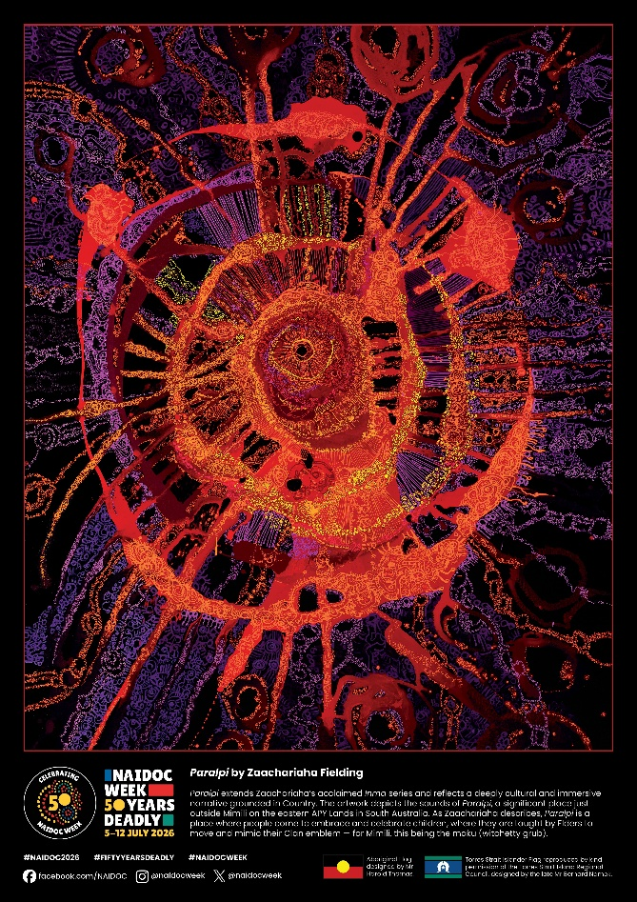
Students will look back on the history of NAIDOC Week and analyse how NAIDOC posters represent key events, achievements and moments in First Nations history.

Students will look at the NAIDOC Poster Gallery and choose one poster to analyse in more detail.

Students will then respond to the following:
- What year is the poster from?
- What are some of the images, symbols and colours used in the poster?
- Who designed it?
- What is the main message or theme of the poster?
- What historical issues or achievements are reflected in the poster?
- What does the poster tell us about Australia at that time?

NAIDOC Poster 2026 “Paralpi” by Zaachariaha Fielding

Activity: Recognise and Celebrate First Nations
Discuss with students ways they could celebrate and recognise Aboriginal and Torres Strait Islander history, culture and achievements during NAIDOC Week. Below are some ideas.

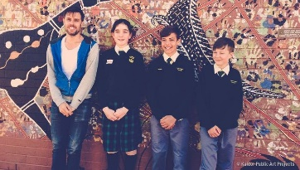  BTN Indigenous Art & Language | Celebrate the traditional custodians of the land where you live. Who are the traditional custodians and what language/s do they speak? Explore this map of Indigenous Australia. Watch this BTN Indigenous Art & Language story to meet some kids who recorded their voices in Wiradjuri, the traditional language they learn at school. Those recordings were then played as an important part of an art exhibition.
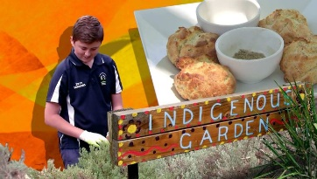BTN Bush Tucker Garden | Create a bush food trail/indigenous garden in your school. Find out if you have an indigenous food trail near your school that you could visit for inspiration and to learn about indigenous plants local to your area. Meet some kids in BTN’s Bush Tucker Garden story to learn about growing traditional Aussie foods and cooking them as well.
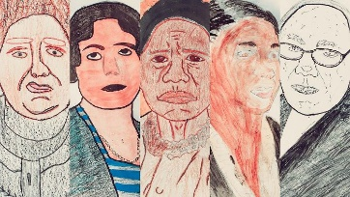  BTN NAIDOC Indigenous Women | Celebrate Aboriginal and Torres Strait Islander women who've made a difference and inspired others. Choose an Indigenous woman who inspires you and research in more detail. Share your findings with the class. Watch this BTN NAIDOC Indigenous Women story to learn more.
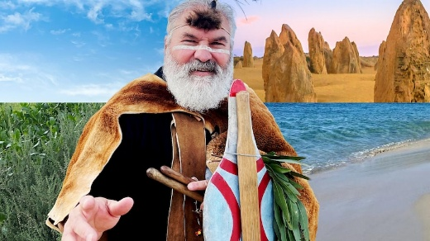  BTN Welcome to Country History | Have you held a Welcome to or Acknowledgement of Country at your school? Find out what the difference is between the two and why they are important in showing respect to and understanding First Nations people. Visit Reconciliation Australia for more info. Read this ABC article to find out why an Acknowledgement of Country is important (and advice on how to give one).
  BTN River Kids | Learn more about the dreaming trails in your local area. Use the internet to find out if there are any dreaming trails in your area that explain the creation theories of the traditional owners of the land. Meet Rookie Reporter Tyrone in this BTN story to tell you what the river means to his people - the Ngarrindjeri.
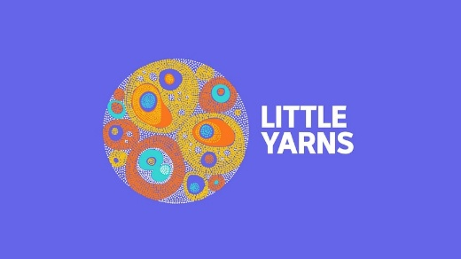 | Learn about First Nations cultures through storytelling, language and listening. Students will partner with younger students (buddy classes) to listen to an episode of the ABC’s Little Yarns. What new Indigenous language words did they learn?

Education Resources
ABC Education and the National NAIDOC Committee have launched the official NAIDOC Week Education Resources 2026, giving teachers the tools to bring this year’s theme, “50 Years of Deadly”, into Australian classrooms.

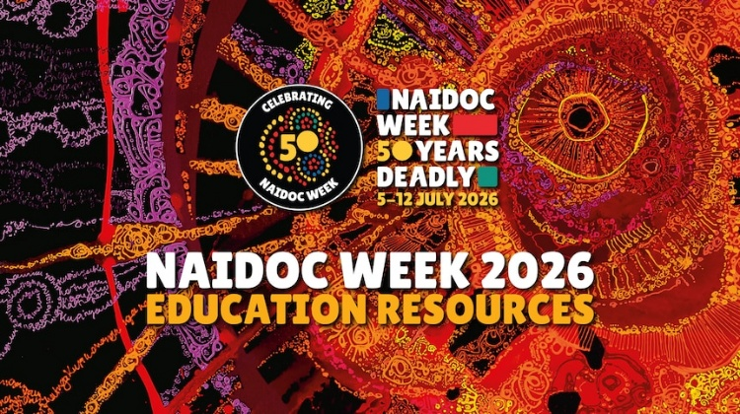
Available on the NAIDOC and ABC Education websites, the guide supports teachers to engage students and school communities with NAIDOC Week 2026.

The resources explore key moments across five decades of NAIDOC Week history, from land rights to the Stolen Generations and Reconciliation, alongside the music, art and culture that have defined Aboriginal and Torres Strait Islander histories.
NAIDOC Week 2026 poster artwork: Paralpi, by Zaachariaha Fielding (NAIDOC)

BTN First Nations collection

Visit BTN’s collection of stories which focus on First Nations. Look for BTN stories with the pencil icon to find supporting teacher resources all linked to the Australian Curriculum. BTN – First Nations Collection

Useful Websites
- National NAIDOC Theme – National NAIDOC Committee
- NAIDOC Anniversary 2025 – BTN
- NAIDOC history – National NAIDOC Committee
- NAIDOC Week Education Resources 2026 – ABC Education and the National NAIDOC Committee
- First Nations Stories – BTN
- Deep Time – ABC

  - Teacher Resource

BTN Transcript: Episode 18- 23/6/2026

Hey. I'm Amelia Moseley and you're watching BTN. Thanks for joining us again, and for the last show of the term, let’s see what’s coming up. We find out about a monster weather phenomenon, celebrate 50 years of NAIDOC Week and meet a 10-year-old fashion designer dressing the stars.

UN and Iran Ceasefire

Reporter: Justina Ward

INTRO: All that soon, but first today, to the big news of last week. The US and Iran agreed to stop fighting and start negotiations on a peace plan. Justina found out what happened and why the whole world is watching. Take a look.

VOLKER TURK, UN HIGH COMMISSIONER FOR HUMAN RIGHTS: I welcome the announcement that the United States and Iran have agreed on a peace deal.

JUSTINA, BTN REPORTER: It was the news that a lot of people were hoping for. After more than 3 months of fighting, the United States and Iran said they'd reached an agreement to end a war that's impacted people right around the world.

KEIR STARTMER, UK PRIME MINISTER: We have long called for de-escalation.

KAJA KALLAS, EUROPEAN UNION'S FOREIGN POLICY CHIEF: To end the war and reopen the Strait of Hormuz.

STEPHANE DUJARRIC, UN SPOKESPERSON: The Strait of Hormuz.

ANTHONY ALBANESE, AUSTRALIAN PRIME MINISTER: The Strait of Hormuz.

Yeah, the Strait of Hormuz. Remember this place? It's one of the world's busiest transport routes for oil and gas, or at least it was. These ships have been stranded since the war began on February 28th when the US and Israel attacked Iran, and Iran responded by threatening ships in the Strait. The result has been a worldwide fuel crisis that's driven up prices, closed down businesses and even led to rationing in some places. Iran's control over the Strait of Hormuz has given it a lot of power even against the world's biggest military and it's made ending the war difficult.

JUSTINA, BTN REPORTER: So, what's the plan? Well, there isn't a formal one, not yet anyway.

What they've signed is a memorandum of understanding, which outlines the next steps they'll take. A plan for a plan, if you like. It says all fighting will stop immediately including fighting in Lebanon.

ABBAS ARAQCHI, IRAN FOREIGN MINISTER: The continued occupation of Lebanese territories from now on, will, in our view, be considered a violation of the memorandum of understanding.

Israel has invaded Southern Lebanon, where it's fighting Hezbollah, a militant group that is backed by Iran and has been firing at Israel since the war began.

JUSTINA: Israel hasn't actually been a part of this agreement and that could get in the way of negotiations.

Israel’s prime minister says troops won’t be leaving Lebanon and the two sides have continued to fire at each other. Iran and the US have also agreed to reopen the Strait of Hormuz within 30 days. That includes removing explosive sea mines, and for 60 days ships will be allowed to pass free of charge.

JUSTINA: Now this is a big one. The Strait of Hormuz, it's always been free to travel through. But a lot of people worry, that might change.

The memorandum also says the US will get rid of sanctions on Iran, which are financial penalties designed to punish it's leaders, and set up a fund with regional partners to provide at least $300 billion US dollars for fixing some of the damage done during the war.

JUSTINA: The other main point they're negotiating is nuclear weapons.

DONALD TRUMP, US PRESIDENT: Iran will never have a nuclear weapon. They're not going to develop it, they're not gonna buy it. They're not going to do anything with it. And if they do, they suffer unbelievable consequences.

There's still a lot of negotiating to do, and things are still pretty tense. But many are hoping it's a start.

ANTHONY ALBANESE, AUSTRALIAN PRIME MINISTER: That doesn't mean that everything returns to normal in just a day or indeed a week, or even a month. It will be at a minimum, many months, before things return to normal.

As for people in Iran while some see it as a victory, others worry they are in a worse position than they were before the war, with leaders that won't respect their rights. No matter what, it's a big moment for the world and the world is watching closely to see what happens next.

News Quiz

A virus known as H5N1 has been detected for the first time ever on mainland Australia. It’s a type of influenza also known as what? Swine flu, bird flu or cow pox? The deadly H5N1 virus is also known as bird flu. It’s now been detected in multiple birds found on beaches in WA. Australia was the last continent in the world to be free of this strain of bird flu, which has had a big impact on bird populations around the world.

What is this student talking about?

REPORTER: So, suddenly, you're going to have a lot more time to fill, and what will you do?

KID: Stare at a wall.

Is it their favourite team knocked out of the World Cup, a ban on social media or a phone network outage? It’s a social media ban. But, no, not ours. The UK is following in the footsteps of Australia by announcing, well, I’ll let their Prime Minister, Keir Starmer, tell you.

PRIME MINISTER KEIR STARMER: Today, I can announce that the government will ban access to social media for all children under the age of 16.

And for the past two weeks there’s been a major search underway on the Gold Coast involving drones and sniffer dogs. But wait, what went missing? A Tassie devil, a labrador, or an engagement ring? It was Mary the Tasmanian devil. She escaped from a Gold Coast wildlife park after jumping out of her enclosure. But good news, she’s finally been found in bushland less than 2 kays from where she escaped.

KID: I’m very excited Mary has been found.

WILDLIFE PERSON: They never gave up, how amazing. And how tenacious is Mary.

Godzilla El Niño

Reporter: Tatenda Chibika

INTRO: Last week the Bureau of Meteorology declared that an El Niño is developing, and it could be the strongest one ever. But what does that mean and how will it affect us? Well, Tatenda can tell us more.

FILM NARRATOR: A force rises from our oceans wreaking havoc from the skies.

CITIZENS: Ahh.

FILM NARRATOR: And bringing warmer than average temperatures.

CITIZENS: Ahh.

WOMAN: Oh my, it's Godzilla. El Niño.

CITIZENS: Ahh.

FILM NARRATOR: El Niño.

Yeah, its official, El Niño is here.

ABC REPORTER: Those temperatures are now easily above the El Niño threshold, and they have been for a few weeks actually.

DAVID GOODING, BUREAU OF METEOROLOGY: The pressure, the winds and also the cloudiness among other things are all teaming up to produce I guess what we now understand as an El Niño.

And this is not just any El Niño; we're in for what some are calling a Godzilla El Niño.

CITIZENS: Ahh. Wait. What's an El Niño?

El Niño means 'Little Boy' in Spanish and it's part of a natural weather cycle called the El Niño Southern Oscillation, or ENSO for short. In an El Niño year waters in parts of the Pacific Ocean become warmer than usual, weakening or reversing the so-called trade winds which usually blow from east to west.

JANETTE LINDESAY, CLIMATOLOGIST: What we see is that there's a basically a blob of warm water, unusually warm, that's been slowly moving from the west of the Pacific, off the Australian coast, towards the South American coastal area.

The warm water brings moist air and wet conditions to the west of the Pacific, while here in Australia, the water is cooler and the weather is drier than normal. El Niños usually happen every two to seven years and they can increase the risks of bushfires, droughts and heatwaves. While North and South America might experience heavier rainfall and an increased risk of flooding. We measure the strength of an El Niño by water temperatures. If it's more than two degrees above average, it's considered very strong, sometimes called a Super El Niño or a Godzilla El Niño.

GODZILLA: Godzilla, king of the monsters.

And experts say this Godzilla could be the biggest one yet.

ABC REPORTER: So, this is the Bureau's modelling for those water temperatures for the rest of this year, and it's predicted to climb from about one degree above average now all the way up to about three degrees above average during spring and that would be a record El Niño.

It's not exactly the best news for farmers in states which are already experiencing drier than average conditions but luckily a record Godzilla El Niño doesn't guarantee record heat or drought.

CITIZENS: Ahh. Wait, wait, that’s good. Oh.

JANETTE LINDESAY, CLIMATOLOGIST: El Niño doesn't sort of necessarily act as the single trigger or cause of droughts or floods or anything like that, but it sets the conditions up in the atmosphere for excess heat and also flows of moisture around the atmosphere to be available for rainfall when weather events occur.

There are other climate patterns that influence our weather. And while our last El Niño in 2023 and 24 brought record heat, we’ve seen ones that were technically stronger but didn't affect the weather nearly as much. So, we'll have to wait and see how much of a menace this monster weather pattern turns out to be.

CITIZENS: Ahh.

Quiz

El Niño has an opposite weather system that brings cooler, wetter weather to Australia. Do you know its name? Is it El Hombre, La Nina or La Doña? It's La Nina, or The Little Girl.

USA 250th Anniversary

Reporter: Tatenda Chibika

INTRO: The US is getting ready for a very special anniversary. On the fourth of July, it'll mark 250 years since the country was founded. I'll let Tatenda tell you all about it.

TATENDA, REPORTER: It's a big country, known for its big monuments, it's big celebrities, and big personalities.

US FAN, WORLD CUP: We're number one, USA.

And it's getting ready to celebrate a big birthday.

TATENDA: Yep, on the 4th of July, the United States will turn 250.

It was way back in 1776 that this group of men gathered to create the Declaration of Independence.

THOMAS, REPORTER: By Authority of the good People of these Colonies, solemnly publish and declare, that these United Colonies are, and of Right ought to be Free and Independent States.

Back then there was no United States, just 13 British Colonies each with their own local governments, but their leaders were sick of paying taxes to the British and having no voting rights. So, they rebelled. The leaders of that rebellion are known as America's Founding Fathers, like George Washington, Benjamin Franklin, Samuel Adams, Alexander Hamilton, and Thomas Jefferson, who was the main writer of the Declaration of Independence.

TATENDA: It was a revolutionary document at the time, literally. And it had some unique things to say about human rights.

THOMAS, REPORTER: We hold these truths to be self-evident, that all men are created equal, that they are endowed by their creator with certain unalienable rights that among these are Life, Liberty and the pursuit of Happiness.

Eventually, the war with Great Britain ended and the United States created a constitution outlining a government that was of, for and by the people. Not all people were treated equally. Since colonisation, Native American people had been driven from their land and killed with violence or disease. American landowners also heavily relied on enslaved people from Africa and women were also denied the right to vote until 1920. But the country defined itself by its commitment to individual freedom and the spread of democracy. Over the years, the United States has experienced many highs and lows.

MARTIN LUTHER KING, CIVIL RIGHTS LEADER: I have a dream.

NEIL ARMSTRONG, APOLLO 11 ASTRONAUT: That's one small step for man. One giant leap for mankind.

MAN ON 9/11: We crashed. The other Trade Center's down. It's down.

But for a long time now, it’s been a global superpower. It's had a massive influence on the rest of the world politically and culturally, influencing our language, fashion, music, movies, and technology.

STEVE JOBS, APPLE CO-FOUNDER: You can change it, you can influence it, you can build your own things.

It's also the home of many important global institutions and has the world's most powerful military. The nation is also home to people from many different countries and backgrounds, who have all contributed to and shaped American culture. But it's also a divided country. Some are worried about how politics will affect the upcoming celebration, but for many it will be a chance to focus on the best bits of America.

TATENDA: So, in the meantime, let's all wish the USA a happy early birthday.

Quiz

Did you know there are six US flags on the Moon, one for each Apollo mission that landed there.

NAIDOC Week

Reporter: Wren Gillett

INTRO: Now to another special anniversary that's coming up over the holidays and that's NAIDOC Week. It's an annual celebration of First Nations cultures, and Wren found out about its history and this year's theme, 50 Years of Deadly. Check it out.

PROTEST: The next generation.

STUDENT: NAIDOC Week is like, celebrating the Aboriginal First Nations.

STUDENT: Celebrating the oldest living culture.

STUDENT: Coming together and learning about First Nations history and culture.

STUDENT: All kinds of community groups can come together.

STUDENT: Share their knowledge to other people.

WREN GILLETT, REPORTER: For decades, NAIDOC Week has been a massive celebration.

PROTEST: Strength. Vision. Legacy.

STUDENT: We can learn many, many things, even from the past and the present.

STUDENT: It's so important that we talk about First Nations culture because we don't want it to repeat again, the past.

It actually started as a protest way back in 1938. Australia was marking 150 years since the arrival of the First Fleet.

REPORTER: And now, they're all ready to see the reenactment of the landing of Captain Phillip, an event which took place 150 years ago today.

But for many, this was nothing to celebrate. So, in response, a large group of First Nations people gathered at the Australian Hall, to carry out a big protest, known as the Day of Mourning. The Day of Mourning protest became an annual event, but in 1955, the date changed, and so did its focus. Rather than being a day of sadness, it became a celebration of survival for the world's oldest living cultures. And in 1975, NADOC, now NAIDOC, the National Aboriginal and Islanders Day Observance Committee, decided the celebration should last longer than a day.

PROTEST: What do we want, land rights. What do we want, land rights.

And for the past 50 years we've celebrated NAIDOC Week.

GARY FOLEY, ACTIVIST: When we get land rights, it'll belong to them and their children.

WREN, BTN REPORTER: Each year, there's a new NAIDOC theme and poster, and each one has something important to say. They celebrate moments of resistance or people who've made an impact.

PROTEST: Land rights now, land rights now.

WREN: In 1998, the artist Ray Thomas made this poster, in light of the Bringing Them Home report, which was a massive investigation into the Stolen Generations. And 10 years later, we got this one, when our government said sorry.

KEVIN RUDD, FORMER AUSTRALIAN PM: For the pain, suffering and hurt, we say sorry.

WREN: We've also had posters honouring First Nations people in the military, and First Nations women. And this year we have this, from Zaachariaha Fielding, which is all about movement and carrying stories forward. It was made to celebrate this year's theme which is 50 Years of Deadly.

LYNETTE RILEY, NAIDOC COMMITTEE: Deadly for us, means it's amazing. It's something that we really want to highlight and is worth celebrating.

This year's theme is all about celebrating the NAIDOC Week’s that have come before, and the achievements, resilience and pride of First Nations People.

LYNETTE RILEY: The issues we are raising are issues for every single Aboriginal nation across Australia, and every single Torres Strait Islander group.

STUDENT: I reckon people should learn more about Aboriginal and Torres Strait Islander cultures.

STUDENT: We need to learn about First Nations culture so we can have a brighter, future together.

Sport

It’s been a disappointing weekend for Aussie soccer fans with the Socceroos losing their second World Cup game to the US, 2-nil. To make things worse one of the goals was scored by Aussie Cameron Burgess after he put the ball in his own net, yikes. But fans are staying hopeful for the next group stage game this Friday when the Socceroos are back on the grass to take on Paraguay.
And back on the grass is where you'll be seeing Serena Williams. Serena retired in 2022. But she recently accepted a Wimbledon doubles ‌wildcard to play with her sister Venus. She's now also been given a wildcard to the singles draw. Serena has won the singles title at Wimbledon 7 times, and many are excited to see her back at the tournament for the first time in four years.
And finally, the Adelaide Thunderbirds are through to the Super Netball grand final after defeating the Melbourne Vixens 58-44 in the semifinals. While it was a quick start for the Vixens it didn't take long for the T-Birds to jump in, in front and take the win. They now have a week off before the grand final.

Max Fashion

Rookie Reporter: Max

INTRO: Finally, today, we're hitting the runway with the world's youngest fashion designer. Max is 10 years old and he’s been sewing and designing since he was just 4. He's made clothes for his friends, dressed celebrities and earlier this year he even made his debut at Paris Fashion Week. Check it out.
MAX: Think. Drape. Sew. Done. Voila. It's called the dress cycle. I started at the age of four, designing, but I don't know how it started. I'm probably guessing I just said it. That's what my parents say. So, that's probably what happened. But I was not into fashion. I did not have a dream about fashion. I just said it and I don't know why, but I just said it.

My favorite part about making fashion is all the ideas you can have. It's like, the creativity is unlimited. You could use any fabric, any material. You can make a dress out of pickles. You can make a dress out of spoons. You can make a dress out of hangers. It's like crazy all the things you can do. My fashion ideas come from like the environment around me, because like, coffee bean bags, my mom is a coffee lover, so I was like why not make a dress out of coffee bean sacks and like just, it's really the environment around me that's giving me the ideas.

Being the youngest fashion designer to debut at Paris is very fun, and I'm very grateful for it. It was a very fun fashion show, I had 15 dresses, and overall, it was just a great experience to have a fashion show in Paris. When everybody started clapping when I came out, it was very fun. It wasn't scary for me. I was like, oh, like all these people appreciate me and I should be very grateful for that. I hope they feel happy and I really hope they know why I'm doing the fast fashion thing and why I'm trying to stand up and like they get why I make my dresses out of the materials I have.

I really hope that like more people see the cause of what they are doing and how fast fashion is also littering our planet other than pollution and like plastic in our oceans. That's also a big deal. And like how consumers have to buy things they will wear for a long time and not, like for one or two weeks and then they throw it away. Practice always makes perfect. I know teachers always say progress, but it actually is perfect. And big dream, even if you're small, because the size of your brain does not matter if you can dream big.

Closer

Oh, Max you're amazing. Keep up the good work. Well, that's it for this week and this term. That went quickly. Just like you guys we'll be taking a break over the next few weeks. But Newsbreak will still be here every weeknight keeping you up to date. And of course, you can see all of our shows online whenever you like. Have the best holidays can’t wait to see you on the other side. Bye.

