EPISODE 15
1st June 2021

KEY LEARNING
Students will view a range of BTN stories and use comprehension skills to respond to a series of focus questions.

CURRICULUM
English – Year 4
Use comprehension strategies to build literal and inferred meaning to expand content knowledge, integrating and linking ideas and analysing and evaluating texts.

English – Year 5
Use comprehension strategies to analyse information, integrating and linking ideas from a variety of print and digital sources.

English – Year 6
Use comprehension strategies to interpret and analyse information and ideas, comparing content from a variety of textual sources including media and digital texts.

English – Year 7
Use comprehension strategies to interpret, analyse and synthesise ideas and information, critiquing ideas and issues from a variety of textual sources.
  - Teacher Resource

Focus Questions
As a class, discuss the stories featured in the episode of BTN Classroom and record the main points of the discussion. Students will then respond to the following focus questions.

Kids Vaccines
- Discuss the BTN Kids Vaccines story as a class.
- What is the minimum age that kids in regional South Australia need to be to get a COVID vaccination?
- Where else in Australia can kids get the COVID vaccination?
- Where in the world have lots of 12-15 years old’s been getting the COVID vaccination? Name one country.
- What vaccine is safer for under-50s?
- COVID-19 symptoms tend to be less severe in healthy young people. True or false?
- Why is it important for kids to be vaccinated against COVID?
- What is herd immunity?
- Who will be the first in your family to get the vaccine?
- What questions do you have about the story?

Olympic Doubts
- Discuss the BTN story as a class and record the main points of the discussion.
- When were the Tokyo Olympic Games meant to be held?
- Do doctors in Japan want the Olympics to go ahead?
- What is an online petition which was signed by 350,000 people calling for?
- What are people living in Japan worried about?
- How many times have the Olympic Games been cancelled?
- Why were the Games cancelled?
- Who can make the decision to cancel the Olympic Games?
- How are they making the Olympic Games safe?
- Do you think the Games should be cancelled? Why or why not?

Check out the Olympic Doubts resource on the Teachers page.

Welcome to Country
- Retell the BTN Welcome to Country story to another student.
- What is the language of Tiyana’s family and people?
- What is a Welcome to Country?
- Complete the following sentence. When Indigenous people cross into another groups country they would need to request ____________.
- Describe how Tiyana does a Welcome to Country.
- What does Tiyana wear during a Welcome to Country?
- What is an Acknowledgement of Country?
- How does Tiyana feel when she performs a Welcome to Country?
- Have you ever seen a Welcome to Country ceremony? Describe the ceremony in your own words.
- How do you say welcome in the Indigenous language local to your area?

School Lunches
- Briefly summarise the BTN School Lunches story.
- Where in Australia are they trialling free hot lunches at school?
- What type of meals are the kids eating?
- What are some benefits to providing school kids with free hot lunches?
- What will the cost of the hot lunch be once the trial is finished?
- How many schools do they plan to trial the lunch program with?
- What do the kids in the BTN story think?
- Would you like hot lunches at your school? Why or why not?
- Plan a week of hot and nutritious lunches you would like at your school.
- What did you like about this story?

Cicadas
- Where can you find the Brood X cicada? Locate on a map.
- How often do Brood X cicadas come out from underground?
- What do the cicadas eat while living underground?
- What happens to the cicada’s skin when they come out?
- What does the Brood X cicada look like? Describe.
- Where do female cicadas lay their eggs?
- What do the baby cicadas do once they hatch?
- How long do the adult cicadas live for once they are above ground?
- What does the Brood X cicada taste like?
  - Shrimp
  - Locust
  - Ant
- Name three facts you learnt watching this story.

Check out the Cicadas resource on the Teachers page.

EPISODE 15
1st June 2021

KEY LEARNING
Students will explore the issues raised in the Olympic Doubts story and develop an argument for or against the issue.

CURRICULUM
English – Year 5 & 6
Plan, draft and publish imaginative, informative and persuasive print and multimodal texts, choosing text structures, language features, images and sound appropriate to purpose and audience.

English – Year 6
Plan, rehearse and deliver presentations, selecting and sequencing appropriate content and multimodal elements for defined audiences and purposes, making appropriate choices for modality and emphasis.

English – Year 7
Plan, draft and publish imaginative, informative and persuasive texts, selecting aspects of subject matter and particular language, visual, and audio features to convey information and ideas.

Plan, rehearse and deliver presentations, selecting and sequencing appropriate content and multimodal elements to promote a point of view or enable a new way of seeing.
  - Teacher Resource

Olympic Doubts

Focus Questions
Discuss the BTN story as a class and record the main points of the discussion. Students will then respond to the following:
- Discuss the BTN story as a class and record the main points of the discussion.
- When were the Tokyo Olympic Games meant to be held?
- Do doctors in Japan want the Olympics to go ahead?
- What is an online petition which was signed by 350,000 people calling for?
- What are people living in Japan worried about?
- How many times have the Olympic Games been cancelled?
- Why were the Games cancelled?
- Who can make the decision to cancel the Olympic Games?
- How are they making the Olympic Games safe?
- Do you think the Games should be cancelled? Why or why not?

Activity: Note taking
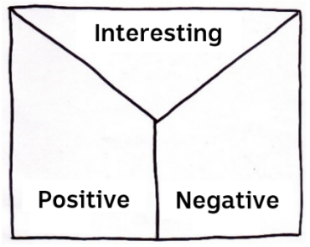
Students will practise their note-taking skills while watching the BTN Olympic Doubts story. After watching the story, ask students to reflect on and organise the information into three categories. What information in the story was...?
- Positive
- Negative or
- Interesting

Activity: Class Discussion
Discuss the information raised in the BTN Olympic Doubts story. Ask students to record what they know about the Olympics on a mind map. What questions do students have? Use the following questions to guide the discussion:
- Do you think the Tokyo Olympic Games should still go ahead? Why or why not?
- How will the games be different this year if they go ahead?
- What is Japan doing to make the 2021 Olympic Games COVID friendly?
- Is it important that we have the Olympic Games? Give reasons.

Activity: Class poll
Hold a poll in your class. Students will conduct their own opinion poll on the issue of whether the Tokyo Olympic Games should go ahead or not.

Working in groups, students will need to decide who their sample group will be and how many people will be polled. What method will they use to conduct the poll? (Face to face interviews or written responses). Ask students to graph the opinion poll results and then reflect on the results.

Activity: Research project
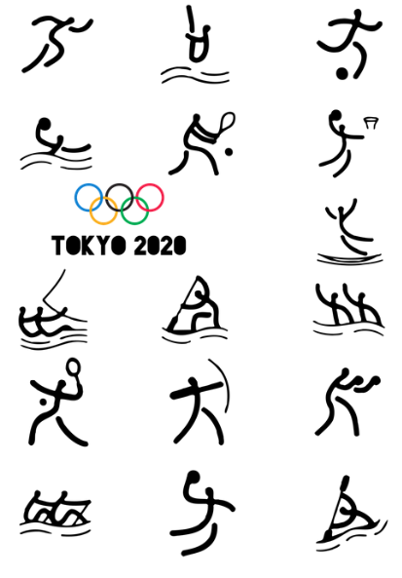
As a class discuss ways that the Tokyo Olympic Games are different to other Olympic Games. Students will then conduct their own investigation into the Tokyo Olympic Games and find out what will make it special. Students may want to choose one or more of the following topics to explore in more detail. Students will then share their findings with the class.
- Torch relay
- Mascots
- Medals
- New sports
- Youngest Olympian
- Robotic Olympics
- Athlete’s village

Activity: Persuasive text
Students will develop a persuasive text for or against the following statement: “The 2021 Tokyo Olympic Games should go ahead”. Students will explore one or more of the following questions as part of their research:
- Do all athletes participating in the Olympic Games have to be vaccinated?
- Will coaches, support staff and media attending have to be vaccinated?
- Will there be spectators at the Olympic Games?
- What affect will removing spectators from the games have?
- How will access to the COVID vaccine affect who can and can’t attend the Olympic Games? Is this fair? Watch this BTN story to learn more about who has access to the COVID vaccine around the world.
- Will the people who live in Tokyo be put at risk?
- Why do you think people want the games to go ahead even though there is so much risk?
- Do you think the Olympic Games will unite the world? Why or why not? Explain using your own words.

Encourage students to use a range of sources. Provide students with the following structure to follow when completing this activity.

Introduction
- What is the point you are trying to argue? Construct an introductory paragraph which states the issue or topic.
- Introduce the arguments that will be developed in the body of the text.

Body
- Construct arguments that support your point of view.
- Each paragraph starts with a topic sentence which introduces each point.
- The rest of the paragraph gives more reasons.
- Arguments can be ordered from strongest to weakest.

Conclusion
- Restate your position on the argument.
- Construct a concluding paragraph that provides a summary of your arguments and a call to action.
Tips
- Who is your audience? For example, are you directing your argument at kids, teachers or politicians?
- Explore how language choices can have a big impact on persuading your audience.
- Which language devices give the report credibility and authority?
- Which are designed to create an emotional response in the listener?
- Provide facts and evidence to support your argument.
- Write in the present tense.
- Check your spelling and punctuation.
- Use this Read Write Think persuasion map to organise your information.

Activity: Mini debate
Alternatively, students may want to prepare a mini debate. Use the following as a guide when preparing for your classroom debate.
- Working in pairs, students will prepare a 1-2-minute speech for a mini debate on the topic.
- One person will speak for the affirmative and the other will speak for the negative.
- Before students begin to construct their argument, ask them to record what they already know about the topic and what they would like to find out. Students then research the topic to gain a greater understanding of the issue.
- Ask students to list their arguments in point form on paper (without their partner seeing them). When they have done this, ask them to choose the five best points that will form the basis for their debate.
- Students will write in point form, their debate on cards that fit into the palm of their hand. Their debate needs to have an introduction (introducing the topic), middle (three main points) and a conclusion (restating their position). Students practise their speech and then present the mini debate to other students.
Guide for giving feedback
- Was the information clear and accurate?
- Were the arguments logical?
- Were the counter arguments accurate and relevant?
- Comments about the presentation style (tone of voice, body language, enthusiastic, convincing).
Reflection
- How difficult was it to think of points to support one side of the argument?
- Do you think you would have done a better job supporting the other side of the argument?
- Was I able to convince others of my opinion?
- Did my opinion change?
- What did you learn from this activity?

Activity: Choose a project
Individually or in small groups, students will choose one of the following projects to work on and then present their findings to the class.
Mascot
Design your own mascot for the 2032 Brisbane Olympic Games. What does it symbolise? Make a mini model of your mascot and put on display in your classroom.

Olympic Games cancelled
Take a look back at the times the Olympic Games have been cancelled. Why were the Games cancelled?

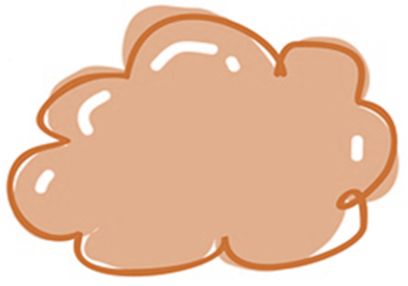
Torch Relay
Follow the torch relay for the Tokyo Olympic Games. Plot the route of the torch relay on a map. What is special about this year’s torch relay?

Test your classmates
Prepare a quiz about the Olympic Games and then test your classmate’s knowledge. Alternatively, create a word search.

Useful Websites
- Three of Australia’s skateboarding Olympic hopefuls contract COVID-19 – ABC News
- After Australian skateboarders tested positive, what’s next for Tokyo Olympic and Paralympic Games? – ABC News
- Brisbane Olympic Bid – BTN
- Breakdancing Olympic Sport – BTN

  - Teacher Resource
EPISODE 15
1st June 2021

KEY LEARNING
Students will learn more about the life cycle of a cicada and create a fact file of the species.

CURRICULUM
Science – Year 4
Living things have life cycles.

Science – Year 5
Living things have structural features and adaptations that help them to survive in their environment.
Science – Year 6
The growth and survival of living things are affected by physical conditions of their environment.
Science – Years 5 & 6
Scientific knowledge is used to solve problems and inform personal and community decisions.

Cicadas

Focus Questions
- Where can you find the Brood X cicada? Locate on a map.
- How often do Brood X cicadas come out from underground?
- What do the cicadas eat while living underground?
- What happens to the cicada’s skin when they come out?
- What does the Brood X cicada look like? Describe.
- Where do female cicadas lay their eggs?
- What do the baby cicadas do once they hatch?
- How long do the adult cicadas live for once they are above ground?
- What does the Brood X cicada taste like?
  - Shrimp
  - Locust
  - Ant
- Name three facts you learnt watching this story.

Activity: Quick Quiz
Begin the Cicadas activity with a quick true or false quiz. Circle the correct answer.
- Cicadas are the loudest insect in the world. | True False
- Both male and female cicadas sing. | True False
- Cicadas are part of the shrimp family. | True False
- All cicadas have the same song. | True False
- Someone who studies insects is known as an entomologist | True False
Answers: 1 True. 2 False, only the male sings. 3 True. 4 False, each species has its own song. 5 True.

Activity: Class Discussion
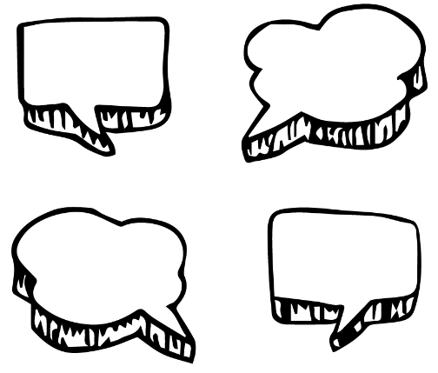
After watching the BTN Cicadas story, students will respond to the following questions:
- What do you know about cicadas?
- Have you ever heard a cicada? Where were you?
- What was SURPRISING about this story?
- What QUESTIONS do you have about this story?

Activity: Glossary
Students will brainstorm a list of key words that relate to the BTN Cicadas story. Here are some words to get them started.
LIFE CYCLE | CICADA NYMPH | INSECT
ENTOMOLOGIST | PREDATOR | EXOSKELETON

Activity: Profile of a Cicada
COMMON NAME:
SCIENTIFIC NAME:
APPEARANCE:
DIET:

Illustration/photo
LIFE CYCLE:

THREATS/PREDATORS:

UNIQUE FEATURES OR INTERESTING FACTS:

Students will choose a species of cicada to research and create a fact file. They can use the template below to help guide their research. Watch this video to learn more about the life cycle of the cicada.

Activity: Match the cicada
Did you know many of common names for cicadas were initially given to them by children? Match the cicada to their name.
Cherrynose
Double Drummer
Floury Baker
Greengrocer
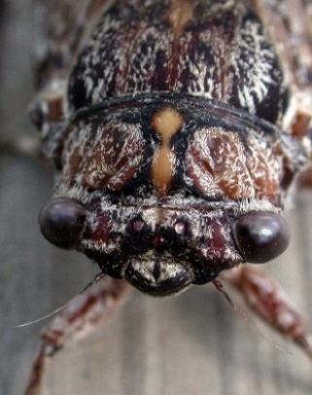

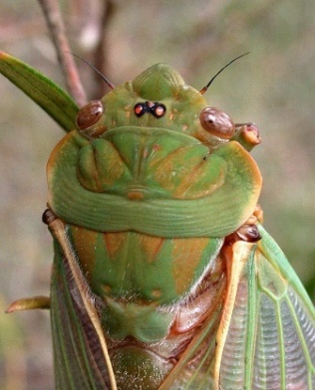

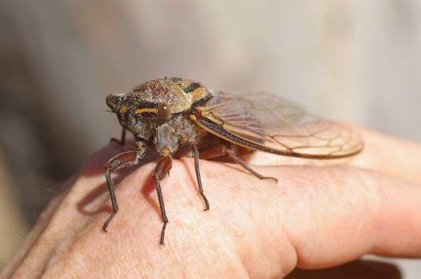

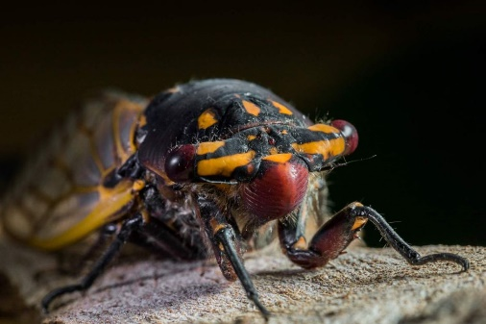

Activity: Eating Insects
In some restaurants in America, cicada tacos are on the menu. Watch this video to find out how chefs are using these crunchy critters in their recipes. Students can then respond to the following questions:
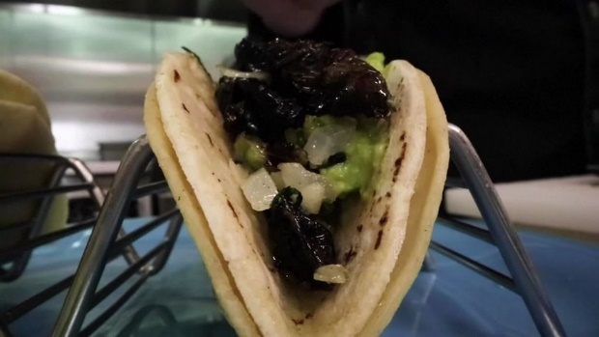
- Explain the process of preparing and cooking the cicadas.
- What do cicadas taste like?
- Would you eat cicadas or any insects? Why or why not?
How do other students in your class feel about eating insects?
- What are the benefits of eating insects?
- What are insects a good source of?
- Design your own recipe that includes cicadas (or another
edible insect). Think about ingredients, measurements, a procedure, cooking time and equipment required.

Further Investigation
What is entomophagy? In which countries is entomophagy common? Locate on a world map.

Useful Websites
- Brood X cicadas: Billions of cicadas emerge after 17-year hibernation – Newsround
- Cicada tacos on the menu as billions emerge from the ground across the US in 17-year cycle – ABC News
- Cicada – Superfamily Cicadoidea – Australian Museum
- Eating Insects – BTN
- Bug Meal – BTN

  - Teacher Resource

BTN Transcript: Episode 15 - 1/6/2021

Hey. I'm Amelia Moseley and you're watching BTN. Here's what's coming up. We find out why some people want the Olympics cancelled, rookie reporter Tiyana teaches us about Welcome to Country and why America's dealing with trillions of cicadas.
Kids Vaccines

Reporter: Amelia Moseley

INTRO: But first, the South Australian government has opened up COVID vaccines to anyone 16 and over living in regional areas. But it's not the only place in the world that's starting to vaccinate younger people. Let's find out why and I'll give you a first-hand look at what's it like to get the COVID vaccine. Check it out.
Move over, over-50s. The 16s and over are coming over to roll up their sleeves and join you in the battle against rona, because the pandemic's not over.
NURSE, SA HEALTH: You're here for your Pfizer first dose vaccination?
KAYLA, VACCINE RECIPIENT: I'm getting the COVID vaccine to be able to protect myself and my family members that are elderly from getting corona.
Kayla's one of the first teenagers in South Australia to get the jab after SA's government dropped the minimum age to include anyone 16 or over who lives in a regional part of the state.
YOUNG SA REGIONAL RESIDENT 2: I think getting the vaccine is definitely a good choice. Outweighs any risks.
YOUNG SA REGIONAL RESIDENT 2: I think it's great that it's now accessible to everyone because obviously it's needed by everyone because COVID doesn't discriminate.
While studies show the virus isn't as severe in otherwise healthy kids and teenagers, young people are still at risk of getting infected and spreading the virus.
DR OMAR KHORSHID, AUSTRALIAN MEDICAL ASSOCIATION: It is really important that we vaccinate our whole community including young people and eventually children because they can become a reservoir for the virus even though they don't necessarily get terribly sick and are very unlikely to end up in hospital.
PROF. STEPHANIE GRAS, VIRAL IMMUNOLOGIST: If kids get vaccinated, the chance of passing on the virus to someone else is greatly decreased. So about 60 to 70 per cent less chance to actually contaminate someone else.
When it comes to vaccinating young people, we're actually a little bit behind compared to some other countries. Over in the US and Canada, hundreds of thousands of 12 to 15-year-olds have already been vaccinated and many more kids and teens have been queuing up to get their first dose.
CANADIAN TEENAGERS: I'm excited. Excited.
CANADIAN TEENAGER: If everyone probably gets it then we can most probably go back to school.
In parts of Europe, it's a similar story. Germany has announced 12-to-16-year old’s will be included in its vaccine program from next week. Just like Aussie teens, they're all getting the Pfizer vaccine which has gone through trials on younger people and is shown to be the safer choice for under-50s.
Now if you're wondering when it might be your turn to get the vac, well, under-16s are included in the Aussie government's vaccine rollout plan, but not until phase three, so it's probably still a while until we get there. In the meantime…
AMELIA, REPORTER: Because of where I live in South Australia, I actually qualify to get the Pfizer covid vaccine now. So, I thought I'd come on down and get vaccinated, do you wanna come with me? Come on.
MATT, SA HEALTH: Hi Amelia.
AMELIA: Hi Matt.
MATT, SA HEALTH: You're here to have your first dose of the Pfizer vaccine?
AMELIA: I sure am.
MATT, SA HEALTH: Lovely, fantastic.

AMELIA: Ooh, exciting. That’s nothing.
MATT, SA HEALTH: Straight in and straight out.
AMELIA: I really didn’t feel that.
MATT, SA HEALTH: Liquid gold.
AMELIA: Alright, so now I have to just wait 15 minutes just to make sure that everything's okay after having had my COVID vaccine and I have to say, honestly, that just did not feel like anything. I didn't even feel that, and I'm really looking forward to getting my second dose in a few weeks and getting one step closer to protecting myself and the people around me from coronavirus. Yay.
News Quiz

Let's kick things off in Victoria where this happy couple recently tied the knot. But what are they so happy about? Apart from getting married, of course. They did it just before Victoria went into a 7-day lockdown. The lockdown's meant to stop the spread of COVID-19 after a recent outbreak and people have been told they're only allowed to leave their house for 5 reasons. To get food, to go to essential work, to give care, to exercise for 2 hours or to get vaccinated.
Eight Aussie teenagers have just won an historic court case against the Australian government. What was it about? COVID-19, climate change or the voting age. It's climate change. They went to court to try to stop the extension of a coal mine in New South Wales and while the extension will still go ahead, the court also found the government has a duty of care to protect young people from climate change.
People around the world took some incredible photos of the recent super moon. But what kind of supermoon was it? A blue moon, blood moon or harvest moon. The colour probably gave it away, it's a super blood moon. It happens when a full lunar eclipse coincides with a super moon, which is when the moon is particularly close to Earth and appears brighter than normal.
Kids Talk

How worried are you about COVID-19? How do you feel about school, family, friendships? Here at BTN, we want to know, so we're launching Kids Talk. It's a survey all about you and how your world's changed since the COVID-19 pandemic began. We also want your opinions on some big topics. And we'd like school kids all around Australia to get involved so we can learn more about you. Just head to our website for all the details.
Olympic Doubts

Reporter: Joseph Baronio
INTRO: Next up, to the Olympics. After a year-long delay, we're finally getting close to the start of the 2020 Games. But there's a problem. Host city Tokyo is dealing with another wave of COVID-19 and most people there say they don't really want the games to go ahead. So, could they and should they be cancelled? Let's take a look.
It doesn't matter if you're an athlete or a coach or just an increasingly impatient fan, it really hasn't been a good year or so for the Olympics. The games were originally meant to be held in July last year in Tokyo with the Paralympics following a month after. But, after countries started pulling out because of COVID-19, they both got pushed back.
A year on, the pandemic is still very much with us and while host country, Japan, is busy preparing, it's also dealing with a fourth wave of the virus. Hospitals are struggling with thousands of new cases every day and doctors there say they don't want the games to go ahead, and many locals feel the same way. An online petition calling for the Olympics to be cancelled has more than 350,000 signatures and a recent poll found that more than 80 per cent of locals want the games to be postponed or scrapped all together. They're worried about the thousands of athletes and coaches from all over the globe flying in and spreading the virus, or even getting sick themselves. And some athletes are a little unsure about whether they should go, too.
RAFAEL NADAL, TENNIS PLAYER: I don't know yet, honestly. In a normal world, I would never think about missing the Olympics. Under these circumstances, I don't know. Let's see what's going on.
So, does all this point to the Olympics being cancelled? Well, no. At least not yet. That would be huge because the Olympics hardly ever gets cancelled. In fact, it's only ever happened on three previous occasions. In 1916, 1940 and 1944 which were all because of World Wars. That decision is entirely down to the International Olympic Committee, or IOC, and, so far, they're pretty committed.
MARK ADAMS, IOC SPOKESMAN: Everything is telling us, from the test events to the international events, that the games can go ahead and will go ahead.
Not only because the hopes and dreams of thousands of athletes ride on it but because there's a lot of money involved. The Olympics rakes in billions of dollars in broadcasting and advertising which would all be lost if the games were cancelled. As for Japan, well part of agreeing to host the games means you can't back out; at least not without being on the hook for not just the costs but the loss of all the possible earnings that comes with it.
But, as this contract between the IOC and the host city of Tokyo states, there is one, quite relevant reason why it could still be cancelled and that's if the IOC has reason to believe that the safety of participants would be seriously threatened or jeopardised for any reason whatsoever. The question is now: is the pandemic a serious threat to participants? Well, the IOC say it's doing everything it can to make sure everyone is safe ahead of the start on July 23rd and a lot of countries are testing and vaccinating their athletes before the games and quarantining them in bubbles. That includes our Aussie athletes.
MATT CARROLL, AOC CEO: We're all working hard here at the AOC and with our member sports to take the Australian team to Tokyo, our largest since 2000.
So what do you guys think, should the games still go ahead?
KID 1: I think the Olympics should not be cancelled.
KID 2: Because a lot of people have been waiting for it and it was supposed to happen last year.
KID 3: Since they cancelled it, I'm pretty sure they don't want to cancel it again.
KID 4: I do believe that the Olympics should not go ahead because of COVID and even though the vaccines have been made and everything a lot of the athletes have still been getting COVID-19 and that could put in danger also their coaches, other athletes and the fans.
KID5: If everybody's had the COVID test, had a vaccine and you know that they're safe, I reckon it would all be fine.
Ask a Reporter

Do you want to know more about the Tokyo Olympics? Ask me live on Friday. Head to the website for more details.

Quiz

Which Australian city was the first to host the Olympics? Sydney, Melbourne or Brisbane? It was Melbourne back in 1956. Brisbane hasn't hosted the Games but is in the running for 2032.

Welcome to Country

Reporter: Jack Evans

INTRO: Now you might already know it's Reconciliation Week. A time for all Aussies to get together and celebrate Aboriginal and Torres Strait Islander people, history and culture. It's also a time to listen and learn from our First Nations people, including acknowledging their connection to the land. One way of doing that is through a Welcome to Country. So, we asked our Rookie Reporter Tiyana to tell us more about it.

Marni naa pudni Kaurna yarta-ana. Ngai nari Tiyana. That means welcome to Kaurna country. My name is Tiyana. Kaurna is the language of my family and people. Last time we caught up I taught you some Kaurna language. Today I'm going to be telling you about a really important ceremony, a Welcome to Country.
You've probably seen someone do a Welcome to Country before, maybe at a big event or a meeting or maybe at a school. I give welcomes with my nanny and my mum around the Adelaide area and sometimes my little sister comes too. I've done welcomes for the Women's AFL, my school assemblies and for the International Women's Day march.
So what is a Welcome to Country? Well, it's basically a way to welcome visitors onto country. It's been a part of the Indigenous cultures for thousands of years. You see, Australia is made up of hundreds of different Indigenous language groups or countries and while there aren't any visible borders, Indigenous people have clear boundaries to separate one country from another. When crossing into another group’s country you would need to request permission and be welcomed to enter their land.
While things have changed a lot since the colonisation, Welcome to Countries are still a way of welcoming outsiders and offering a safe passage. They're usually delivered by an Elder, but sometimes younger people, like me and my mum, are given permission to welcome people to our country. They can be done through singing, dancing, smoking ceremonies and in a traditional language.
My Nanny made this cloak for me and sometimes I wear it when I'm doing a welcome. The possum cloak has many uses. It was traditionally used as a baby carrier; it kept the baby safe and warm on mums back. My ancestors also wore it for protection from the weather and in ceremonies too and when it's turned inside out it was used as a water and food carrier.
There are also Acknowledgements of Country. They can be done by non-Aboriginal people as a way of showing respect for the traditional owners of the land which they are on and to recognise their continuing connection to the land. Welcome to Countries are really important to me because it gives us an opportunity to welcome people to a new camp where we can listen and learn together. When I perform I feel excited, happy and special. It makes me feel really proud and strong too. Ngaityalya, thanks for watching. Nakutha.
School Lunches

Reporter: Jack Evans

INTRO: How would you like to chuck out your lunchbox and pick up a knife and fork for a hot school lunch? It's something a few schools in Tasmania are trying out. Let's find out why and what kids think about it.
KID 1: Imagine what mornings would be like if we didn't have to pack a lunch box every day.
Well according to 3 schools in Tassie, it's pretty delicious and time saving. But mostly it's delicious. They've been taking part in a trial where students ditch the lunch box and instead get a free hot lunch every day.
KID 2: This one is one of my favourites, and the chicken curry was too.
KID 3: The chilli con carne was my favourite.
KID 4: I still prefer my recess and lunch, but I think these are pretty good as well.
KID 5: I like the lasagne and I also like the muffins.
KID 6: And the smoothie and the blueberry smoothie.
Providing kids with a sit down lunch at school isn't a new idea and it happens a lot in other countries. That's something the head of Tasmania's School Canteen Association noticed when she went on a research trip across the globe to see how other schools did it.
JULIE: You saw those beautiful social skills, children using knives and forks and pouring water for each other.
She reckons there are stacks of benefits to ditching the packed lunch. For starters the schools who have been taking part in the trial say students come to school more often and they're more focused. It also means no kid misses out on lunch and it guarantees they get something nutritious. All sounds pretty good, right? Well, so far, the trials have been free, but eventually parents would need to pay and according to these schools that could be around 4 dollars. Which most parents said was a hot deal for a hot meal. The Tasmanian Canteen Association plans to trial the lunch program at 30 more schools before deciding whether or not to roll it out across the state. But these guys don’t need any more convincing.
KID 7: It's um nice and the teachers and students get to help cook and stuff and learn.
KID 8: Sometimes it's actually really good, sometimes it's okay. It just means I don't have to make lunch.
Sport

Chelsea fans flooded the streets of London to celebrate their team winning the Champions League final. The Champions League is the biggest club competition in world soccer and features the best teams in Europe. Kai Havertz scored the winner for the Blues as they beat Manchester City 1-nil. It's just the 2nd time in Chelsea's 116 year history that they've won.
And Ajla Tomljanovic has the Aussies off to a good start in the French Open. She breezed through her opening round match in straight sets, pretty cool. What's not as cool is getting fined almost 20,000 dollars. World number 2, Naomi Osaka, copped that hefty bill for not going to a press conference after her first-round win. Naomi tweeted this, saying she's not going to do any press conferences, quoting mental health reasons but organisers say they may even kick her out of the tournament if she keeps skipping them.
And finally, check out this amazing goal, in the A-League. Perth Glory's Callum Timmins found the net from thirty metres out in a match against Wellington Phoenix. Some are already calling it the goal of the season and it helped his team to a 2 all draw.
Cicadas

Reporter: Amelia Moseley

INTRO: And finally, today, let's head to the US where quite a rare, beautiful and somewhat creepy natural event is taking place. The emergence of trillions of cicadas from underground. And it turns out their short life above ground is quite dramatic. Take a look.

MICHAEL RAUPP, ENTEMOLOGIST: There'll be birth. There'll be death. There'll be romance in the treetops. There'll be predators. It's going to be better than an episode of Game of Thrones.
Yup, get ready for the next Hollywood blockbuster. Well, not quite. But these insects do have an epic story. It all takes place in, where else? America. You see while cicadas are those famously noisy insects that are found all over the world; the kind starring in this story are different. They're Brood X cicadas which only come out every 17 years. They spend that time growing underground and living off sap from tree roots. But then, it's time.
MICHAEL RAUPP, ENTEMOLOGIST: They're going to emerge in such massive numbers synchronously. Boom.
Billions, possibly even trillions, of them come out all at once ready to take over the world. Or live out their lives peacefully, I guess.
MICHAEL RAUPP, ENTEMOLOGIST: Oh yeah, there they are. Hey teenagers, how you doin? What's life been underground like for the last 17 years?
As you can tell it's a pretty big deal for insect scientists like Professor Raupp.
MICHAEL RAUPP, ENTEMOLOGIST: This is just a spectacular event. I mean, there's nothing else like this on the entire planet Earth, even in the entire universe.
Yeah, ok, a very big deal. But this isn't where the drama stops. First, a costume change.
MICHAEL RAUPP, ENTEMOLOGIST: They shed their skins and by morning they're going to assume that wonderful colour, jet black body, bright red eyes, orange wings.
Then the cicadas make their way very slowly up trees.
MICHAEL RAUPP, ENTEMOLOGIST: Right now, everything on the planet wants to eat a cicada so once they get to the treetops, they're gonna be in relative safety.
That's when the romance happens. Oh, and the very noisy mating call. Female cicadas then lay their eggs in the tree branches and six weeks later they hatch and fall to the ground and the babies burrow metres underground to grow and start the cycle all over again. As for the parents, they only live above ground for about three weeks before they die. Alright, enough of that. Lately people all over America have been seeing and hearing the creatures come out in their backyards.
MICHAEL RAUPP, ENTEMOLOGIST: Come on, Willie, there we go. That's the cicada wave. Hey Willie, how you doing?
For some, it's a cool experience. For others, it's a slightly confronting sight.
MICHAEL RAUPP, ENTEMOLOGIST: Cicadas don't bite, cicadas don't sting. Cicadas don't fly away with small dogs and children like the monkeys in The Wizard of Oz.
WIZARD OF OZ MOVIE: My little party's just beginning.
Ah. Yep. Good to know. But there's another twist in the cicada story. A crunchy twist.
TOBIAS PADOVANO, CHEF: Cicadas and shrimp are in the same family. It's one of the reasons why when people taste cicadas, they say oh, that tastes like shrimp.
In some restaurants in America, they're being served up to hungry customers. Cicada taco, anyone?
CICADA EATING RESTAURANT PATRON 1: At first you can definitely feel a bit of the crunch, but you start to chew it, it kind of just like melts in.
CICADAD EATING RESTAURANT PATRON 2: I think going into it the concept of eating a cicada is a little odd, weird, but it's actually not bad.
Not to worry though. Entomologists say there are a lot of these cicadas to go around and nutritionists say they're a good source of protein. And that's it. But tune in for the sequel to this epic blockbuster when the next cicadas emerge in 2038.
AMELIA, REPORTER: Aw what? That's ages. I've already waited 11 years for the second Avatar.
Closer

Well, that's it for now, but we'll have more news for your next week. Until then, you can check out our website for more stories, teacher resources and specials and don't forget to have your say in our Kids Talk survey. Newsbreak’s also there for you every weeknight, and if you’re 13 or over you can subscribe to our YouTube channel. Have an awesome week. Bye.

