EPISODE 33
21st November 2023

KEY LEARNING
Students will view a range of BTN stories and use comprehension skills to respond to a series of focus questions.

CURRICULUM
English – Year 4
Use comprehension strategies to build literal and inferred meaning to expand content knowledge, integrating and linking ideas and analysing and evaluating texts.

English – Year 5
Use comprehension strategies to analyse information, integrating and linking ideas from a variety of print and digital sources.

English – Year 6
Use comprehension strategies to interpret and analyse information and ideas, comparing content from a variety of textual sources including media and digital texts.

English – Year 7
Use comprehension strategies to interpret, analyse and synthesise ideas and information, critiquing ideas and issues from a variety of textual sources.
  - Teacher Resource

Focus Questions
As a class, discuss the stories featured in the episode of BTN Classroom and record the main points of the discussion. Students will then respond to the following focus questions.

Tuvalu Resettlement Deal
- Where is Tuvalu? Find on a world map.
- How many islands make up Tuvalu?
- What is the highest point of Tuvalu?
  - 4.6 metres
  - 14.6 metres
  - 24.6 metres
- How are rising sea levels impacting the people and environment of Tuvalu?
- How does Australia plan to help the people of Tuvalu?

Check out the teacher resource on the Archives page.

Christmas COVID Wave
- Summarise the BTN Christmas COVID Wave story.
- Health experts are saying that this Christmas, Australia will be facing its…
  - 4th COVID wave
  - 8th COVID wave
  - 12th COVID wave
- How can we minimise the spread of COVID? Give 2 examples.
- What places are reintroducing mask mandates to help combat the wave?
- Why do you think BTN covered this story?

Palm Oil App
- What do you know about palm oil?
- What products contain palm oil? Give 2 examples.
- What animal is threatened by unsustainable palm oil production?
- What is the difference between sustainable and unsustainable palm oil?
- What is the purpose of the palm oil app?

Check out the teacher resource on the Archives page.

World TV Day
- What year was the TV invented?
- When did Australia first get television?
  - 1927
  - 1956
  - 1965
- How has television changed over time? Give 2 examples.
- How have streaming services and social media impacted television?
- Name three things you learnt watching the BTN story.

Bird of the Century
- What is New Zealand’s 2023 Bird of the Year?
  - Kiwi
  - Pūteketeke
  - Grey Warbler
- What is the aim of the competition?
- What was the controversy surrounding the winner?
- How many people voted in this year’s Bird of the Century?
- What did you like about the BTN story?

EPISODE 33
21st November 2023

KEY LEARNING
Students will investigate the impact of climate change on the Pacific Islands.

CURRICULUM
HASS – Year 4
Reflect on learning to propose actions in response to an issue or challenge and consider possible effects of proposed actions.

Science – Year 4
Science knowledge helps people to understand the effect of their actions.

Science – Years 5 & 6
Scientific knowledge is used to solve problems and inform personal and community decisions.

Science – Year 7
Scientific knowledge has changed peoples’ understanding of the world and is refined as new evidence becomes available.

  - Teacher Resource

Tuvalu Resettlement Deal

Focus Questions
Discuss the BTN story as a class and record the main points of the discussion. Students will then respond to the following:
- Where is Tuvalu? Find on a world map.
- How many islands make up Tuvalu?
- What is the highest point of Tuvalu?
  - 4.6 metres
  - 14.6 metres
  - 24.6 metres
- How are rising sea levels impacting the people and environment of Tuvalu?
- How does Australia plan to help the people of Tuvalu?

Activity: See, think and wonder?
After watching the BTN story students will respond to the following:
- What did you SEE in this story?
- What did this story make you WONDER?
- How did this story make you FEEL?
- Think of three questions you have about the BTN story.

Activity: Class Discussion
Engage students in a class discussion to explore their prior knowledge about climate change. Introduce key concepts and explain the impact on people living in the Pacific Islands. Use the following questions to help guide discussions about the topic:
- What do you know about rising sea levels?
- What causes rising sea levels?
- What impact is rising sea levels having on people in Tuvalu?
- What are some solutions to the problem?

Activity: Glossary
Students will brainstorm a list of key words that relate to the BTN Tuvalu Resettlement Deal story. Below are some words to get students started.

CLIMATE CHANGE | PACIFIC ISLANDS | GLOBAL WARMING
COASTAL EROSION | RISING SEA LEVELS | EXTREME WEATHER

Ask students to write what they think is the meaning of each word (including unfamiliar words). They will swap definitions with a partner and ask them to add to or change the definition. Check these against the dictionary definition.

Further activities for students:
- Students will add to their glossary by downloading the transcript for the BTN Tuvalu Resettlement Deal story and highlight all the words that relate to the topic.
- What other words relate to this issue? Students will choose additional keywords and concepts to add to their class glossary. E.g., carbon emissions, fossil fuels, climate refugee and global temperature.
- What is the difference between weather and climate change?
- How did this story make you feel? Make a list of words that describe how you felt after watching the BTN story.

Activity: Six Hat Thinking
As a class, use Edward De Bono’s Six Hat Thinking to explore the issues raised in the BTN Tuvalu Resettlement Deal story. Make your own coloured hat cut outs and place on the floor. Students will take it in turns answering questions in relation to what they already know about the issue, what they have learned from the story and what they want to learn further about the topic. Ask students to respond to the following questions:

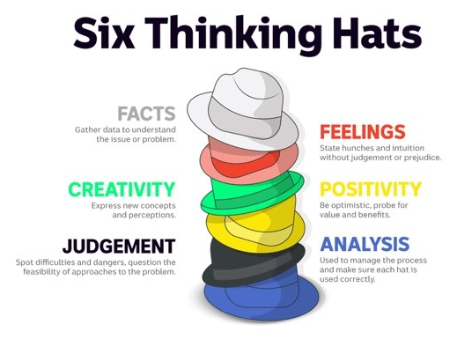
- How did the BTN Tuvalu Resettlement Deal story make you feel?
- What do you know about rising sea levels?
- What have you learnt from the story?
- Were there any positives from the story? If so, what were they?
- What are some of the negatives or challenges that you learnt from the story?
- Why is it important to find out more about the problem?
- What questions were raised during this activity? Think of three questions you would like to ask about the story.
- What do you want to learn further about this topic?

Activity: Country Profile
Students will research and develop a profile of a country in the Pacific Islands that has been affected by rising sea levels. Working in pairs, ask students to brainstorm what they know about the Pacific Islands and record their responses. Using the `Who, What, Why, When, Where and How’ framework, ask students to write questions that they would like to find the answers to. Students share their questions with the rest of the class. Discuss how students could find answers to the questions they generate.

Research
- Capital city, area, and population.
- Geography – physical features of the country, climate, environment. Who are its neighbours? Show on a map.
- People and culture – the people, language, culture, celebrations, customs, and religion.
- Government – who is the leader of the country and how is the country run?
- Economy – work, trade, industries, and products.
- Interesting facts!
Presentation
Discuss with students how they are going to present their profile of the country. Include the following: map, graph, statistics, photos, diagram, and facts.

Possibilities include:
- Create a postcard using Canva to share some of the things you have learnt about the country.
- A short oral presentation.
- Compare the Pacific Islands country to Australia using a Venn diagram.

Further Investigation
Students will develop their own question/s to research or choose one of the questions below. Encourage students to collect and record information from a wide variety of sources and present the information they find in an interesting way.
- How do we know sea levels are rising in the Pacific Islands?
- What impact does rising sea levels in the Pacific Islands have on people, the environment, and the economy? Give one example for each.
- What is the highest point of Tuvalu? Compare to the highest points of other countries.
- What is an atoll? What’s the difference between an atoll and an island? Give examples.
- How far is Australia from Tuvalu? Locate and mark on a world map. Find other countries in the Pacific Islands that are affected by rising sea levels, including Kiribati and the Marshall Islands.
- What connections do people in Australia have with the Pacific Islands? (e.g., birth, family, heritage, food, holiday, celebrations).
- What is a climate refugee? Visit this National Geographic website to learn more about environmental refugees.
- Examine the geographical information of Tuvalu (e.g., total land area, elevation, sea level, number of islands and atolls, coastline).
- How is Tuvalu and Australia similar or different?
- Learn about the culture of Tuvalu and share what you have learnt with your classmates.

Activity: Visual Literacy
Below is a range of photos that illustrate the impact of rising sea levels in the Pacific Islands. Encourage students to provide detailed and thoughtful responses based on their analysis of the photos. This exercise will help them deepen their understanding of climate change and think about the impact it has on the environment and people.

Students will analyse one or more of the images and then respond to the following questions:
- Describe what you see in the image. What objects or elements stand out to you the most?
- What does this photo tell us about rising sea levels?
- How does this photo make you feel? Is it a positive or a negative feeling? Why?
- What question/s would you like to ask about the image?
- Create a caption for each image.

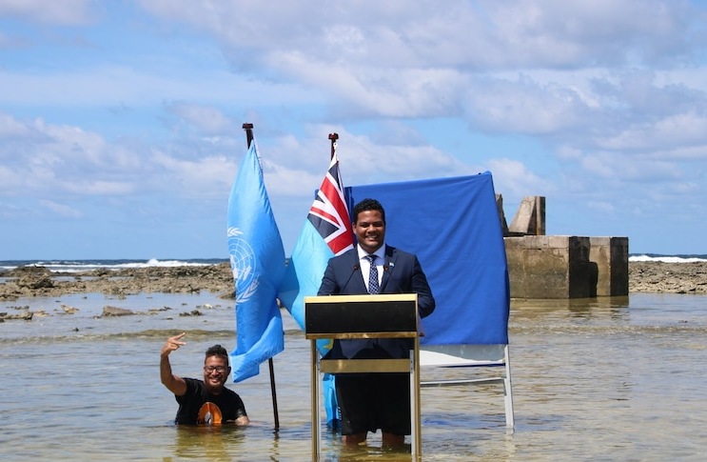  Source of image | 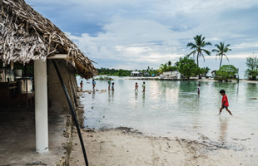  Source of image
Source of image | 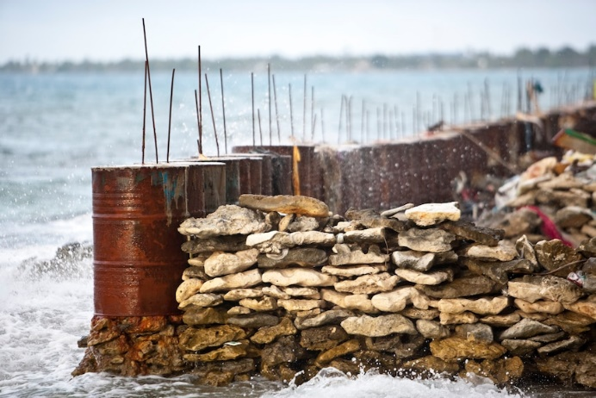  Source of image

Useful Websites
- Tuvalu is sinking, this is how Australia plans to help – BTN Newsbreak
- Anthony Albanese offers Tuvalu residents the right to resettle in Australia, as climate change 'threatens its existence' – ABC News
- Pacific Islands Forum – BTN
- Pacific Islands Climate Change – BTN
- Understanding Climate Change – BTN
- Climate Kids – NASA
- Our Changing Climate – TEDEd
- The Truth about Rising Sea Levels – TEDEd
- Fight for Planet A: Our Climate Change Challenge – TEDEd

EPISODE 33
21st November 2023

KEY LEARNING
Students will learn more about the impact palm oil production has on the habitat of orangutans.

CURRICULUM
Science – Year 6
The growth and survival of living things are affected by physical conditions of their environment.

Science – Year 7
Interactions between organisms including the effects of human activities can be represented by food chains and food webs.

HASS – Year 6
The obligations citizens may consider they have beyond their own national borders as active and informed global citizens.

  - Teacher Resource

Palm Oil App

Focus Questions
Discuss the BTN story as a class and record the main points of the discussion. Students will then respond to the following:
- What do you know about palm oil?
- What products contain palm oil? Give 2 examples.
- What animal is threatened by unsustainable palm oil production?
- What is the difference between sustainable and unsustainable palm oil?
- What is the purpose of the palm oil app?

Activity: Personal Response
After watching the BTN Palm Oil App story, ask students to finish one or more of the following incomplete sentences:
- It was interesting to learn that…
- Learning about palm oil made me feel…
- BTN did a story about palm oil because…
What did you learn from the story?
What questions do you have about the story?

Activity: Word Cloud
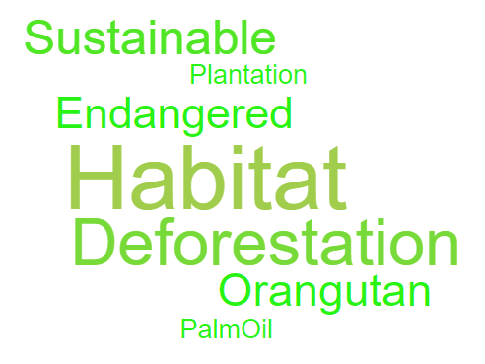
Students will create a word cloud poster about palm oil. A word cloud is a visual made up of important/key words relating to a topic. Ask students to think of words they associate with palm oil. Create a word cloud using a free online word cloud creator such as MonkeyLearn or Word It Out

Activity: Class Discussion
Discuss the BTN story as a class. Ask students what they know about palm oil. Use the following questions as a guide:
- What is palm oil?
- Give examples of products that contain palm oil.
- How are orangutans affected by palm oil production? How does it impact their habitats?
- Where is palm oil produced? Highlight the countries on a world map.
- What is the palm oil app and how does it work?

Activity: Glossary
Students develop a glossary of words about palm oil. Below are some words to get you started. Add words and meanings to your glossary as you come across unfamiliar words.

PALM OIL | DEFORESTATION | ORANGUTAN
SUSTAINABLE | ENDANGERED | HABITAT

Activity: Questions to Research
Discuss the information raised in the BTN Palm Oil App story. What questions were raised in the discussion and what are the gaps in students’ knowledge? The following KWLH organiser provides students with a framework to explore their knowledge on this topic. Students will develop their own question/s to research or choose one or more of the questions below.

- What is palm oil and why is it widely used in a range of products?
- How does the production of palm oil impact the habitat of orangutans?
- How does deforestation due to palm oil production affect the biodiversity of the ecosystems where orangutans live?
- What is sustainable palm oil and how is it produced?
- How are food products that contain palm oil labelled? Why is it often difficult to tell if a product contains palm oil?
- What role do consumers play in encouraging companies to use sustainable palm oil?
- Why is palm oil production important to the economies of Indonesia and Malaysia?
- Why should we protect orangutans and other endangered species affected by deforestation? Write a persuasive piece of writing explaining your reasons.

Activity: Species profile
Students will learn more about orangutans threatened by unsustainable palm oil production and create a profile of them.

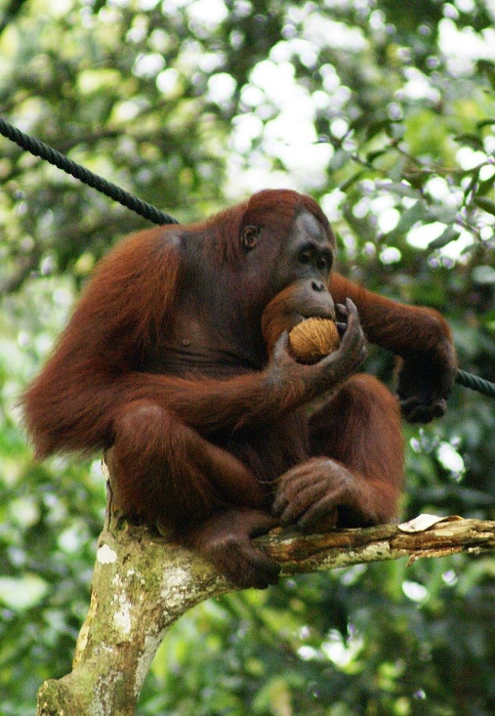
Research
Students will research the following and then share their research findings with the class or create a display in the classroom.

- Illustration or photo
- Name (common and scientific name)
- Conservation
- Appearance
- Adaptations
- Habitat – where would you find the species?
- Threats
- Unique features

Bornean Orangutan

Activity – Choose a project
Individually or in small groups, students will choose one of the following projects to work on and then present their findings to the class.

Pantry Audit
Check the products in your pantry using the PalmOil scan app. The app allows you to send a message to the company to let them know how they are doing.

Peel Back the Label
Investigate the use of palm oil in grocery products and peel back the label to learn more about which products contain palm oil and why.
Summary
Write a summary of the story. What was the story about? Why did BTN cover this story?
Quiz
Create a true or false quiz to test your classmate’s knowledge about palm oil.

Useful Websites
- WAZA Launches PalmOil Scan – WAZA
- Palm Oil Problem – BTN
- Palm Oil Ban – BTN

  - Teacher Resource

BTN Transcript: Episode 33 – 21/11/2023
Hey, I'm Amelia Moseley and you're watching BTN. Thanks for hanging out with us again. Let’s see what's coming up on today’s show. We find out about a Christmas wave that no-one wants to surf, learn how television changed the world and meet New Zealand's Bird of the Century.

Tuvalu Resettlement Deal

Reporter: Jack Evans

INTRO: But first today we're heading to the Pacific Island nation of Tuvalu. Australia's prime minister was there recently, and he announced a deal designed to help locals deal with climate change. Let's find out more.

About 5,067 kilometres north-east of Australia, in the South Pacific Ocean, you'll find Tuvalu. A country home to just a little over 11,000 people that's made up of 9 islands, that to be honest look pretty, well pretty. Actually, they look really pretty. But these small pretty islands are facing a pretty big problem.
You see, Tuvalu is only about 4.6 metres above sea level at its highest point which means as sea levels rise it's starting to sink. It's partly due to climate change. Which, as we know, is melting glaciers causing sea levels to rise. Climate change is also thought to be contributing to extreme weather events which can contribute to coastal erosion. All of this is threatening homes, destroying crops and a lot of people are worried the whole country will disappear in the next century.
HAWAII PAENIU, TUVALU RESIDENT: I hope that I will not have to leave my country. This is where I grew up and this is my home.
It's not just Tuvalu that is experiencing this problem. Not too far away countries like Vanuatu and Kiribati are both at risk of becoming submerged. It's why leaders from these countries want more to be done about climate change. It was actually a big topic at the recent Pacific Islands Forum, where countries like Fiji, the Solomon Islands, Tonga, PNG and Tuvalu, as well as Australia and New Zealand talk about things like trade, education, tourism and, yes, climate change. This year our Prime Minister, Anthony Albanese, made an announcement about what Australia will be doing to help Tuvalu with rising sea levels.
ANTHONY ALBANESE, PRIME MINISTER: I believe that developed nations have a responsibility to provide assistance and that is precisely what we are doing.
Every year we will resettle up to 280 people from Tuvalu to Australia under a new visa system that will allow people to live, work and study here.
ANTHONY ALBANESE, PRIME MINISTER: This is the most significant agreement between Australia and a Pacific Island nation ever.
KAUSEA NATANO, TUVALU PRIME MINISTER: This partnership stands as a beacon of hope.
While many see this as a massive deal that will help people affected by the rising sea levels. Others say way more needs to be done, because as the climate continues to change, more and more countries will be impacted. In fact, the UN predicts that by 2050 there could be more than 1.5 billion climate refugees needing a new home.
MAINA TALIA, TUVALU CLIMATE ACTION NETWORK: Most of the people in Tuvalu want to remain on their beautiful islands so of course they have mixed feelings. The treaty is something that came out positive. But on the other hand, we should continue to push Australia to remain strong and stand tall on their climate commitments to the Pacific region, and also to the world.

News Quiz

Australia’s prime minister went to San Francisco last week, along with a bunch of other world leaders, for a big international meeting. What was it called? Was it the G20, APEC or a COP? It was APEC, which stands for Asia Pacific Economic Co-operation. It involves 21 countries from around the Pacific Rim, who come together every year to talk about trade.
Can you name this very smoggy city? It’s Delhi in India. Authorities there had to briefly close schools, ask people to work from home and ban fire crackers at Diwali celebrations because of air pollution that was about 10 times worse than the World Health Organisation says is acceptable.

Who won this year’s ARIA award for album of the year? It was Genesis Owusu. Troy Sivan also did really well, picking up four awards including song of the year for his track Rush.

And the Australian Space Agency has revealed the shortlisted names for its’ moon rover after holding a public competition to name it. Which one of these was one the list? Rover McMannis, Roo-ver Rover McRovey face, or Pavrover? It was Roo-ver. The other names to make the list were Coolamon, Kakirra and Mateship. Australians can now vote for their favourite name for the rover, which is set to be launched as part of a NASA mission as early as 2026.

Christmas COVID Wave

Reporter: Justina Ward

INTRO: Now to that wave I told you about earlier. Yep, it's a COVID wave. While it's not what any of us wants to hear, authorities say there's been a surge in COVID-19 cases. And they're warning that we need to be careful this Christmas.
ELF: Oh dear.
SANTA: This better be important.
ELF: It's COVID. It's on the rise across Australia, just before Christmas.
SANTA: For-real?
ELF: ‘Snow joke.
SANTA: Then we need to get the word out.
ELF: Does that mean?
SANTA: Yes. It's time to call BTN.
ELF: I've been waiting my whole life for this -
JUSTINA: Hello Justina speaking?
SANTA: BTN, it's Santa. We have a tree-mendous problem. COVID's snowballing just before Christmas, and we need you to deliver a message to Australia to save Christmas. Ho, ho, ho.
JUSTINA: Sorry, who this?
Yeah, remember COVID? The mask wearing, hand sanitising, and keeping your distance from people days? Well, although COVID-19 might seem like a distant memory and despite it globally being declared not really a thing anymore.
Dr Tedros Adhanom Ghebreyesus, WHO: I declare COVID-19 over as a global health emergency.
It hasn't really gone anywhere. And over time, the virus has evolved and mutated creating dozens of different variations and while they're not more deadly they are more contagious plus were all getting out a lot more and social distancing a lot less and now authorities are saying we're facing our 8th wave of the virus just in time for Christmas.
Peter Malinauskas, SA Premier: When we see a spike in the number of COVID cases in an environment where most people aren't testing themselves anymore you know there's a lot in the community.
JUSTINA: Well, that's a Christmas present no one's asked for.
Because of that lack of testing, we don't really know how many COVID cases are out there but we do know that there's been an increase in antiviral prescriptions and hospital admissions. And while we're not facing anything we did during the pandemic, that doesn't mean we shouldn't take it seriously.
Professor Nicola Spurrier, SA Health: We have got a COVID wave happening and the most important thing for all of us to think about are people who are going to be more susceptible to infection.
JUSTINA: So, are we expected to wear masks again?
Rachel Stephen-Smith, ACT Health Minister: Well, I might had over to Andrew for that one.
Andrew Barr, Chief Minister: No.
Although it's not mandatory in most states and territories. Some high-risk places like hospitals are reintroducing mask mandates to help combat the wave.
Rachel Stephen-Smith, ACT Health Minister: So, if you're going to visit a hospital for example, please do a rapid antigen test and just check that you haven't' got COVID unknowingly.
And with Christmas on our doorstep, authorities say it's not a bad idea to remember things we can do to help stop the spread; like wearing a mask in busy or high-risk places, sanitising and washing our hands, keeping our distance when we can, and staying home if testing positive.
JUSTINA: Right got it, I won't let you down Santa.
MICHELLE: Did you say Santa?
JUSTINA: Yep, and we're going to save Christmas.
MICHELLE: Cool.
Palm Oil App

Reporter: Joshua Langman

INTRO: Now, what do all these things have in common? Yep, they might all taste good, but they also contain palm oil. It's a really common ingredient but farming it can cause serious harm to orangutan habitats. Now, a new app is setting out to make it easier to spot on our shelves. Here's Josh.
SHOPPER JOSH: Ooh. Sorry.
SHOPPER JUSTINA: Ugh, you need to add some soap to that basket. When was the last time you showered?
SHOPPER JOSH: I do not buy soap, okay?
SHOPPER JUSTINA: Why?
SHOPPER JOSH: Because soap contains palm oil.
SHOPPER JUSTINA: Uhh, not all soap has it and a lot of chocolate has palm oil in it too, you know.
SHOPPER JOSH: Yeah, I know.
JOSH LANGMAN, REPORTER: Yeah, as I figured out the hard way, palm oil isn't just in soap and chocolate, but it's actually in about 50 percent of the products on our shelves. Like cookies, donuts, lipstick, bread, ice cream, pizza dough, butter, cake, cereal, crackers, pet food, canned soup, peanut butter.
Phew, yeah, I think you get the idea. And while it might make a good ingredient for our products, it's not good for something else, orangutans.
Why? Well, Jodie from Adelaide Zoo might have the answer.
JOSH: G'day Jodie, nice to meet you.
JODIE SHERIDAN, PRIMATE KEEPER AT ADELAIDE ZOO: Ugh, wow. When was the last time you showered?
JOSH: Serious? Alright Jodie, who do we have behind us here?
JODIE: This is Puspa. She is one of the Sumatran orangutans that lives here at Adelaide Zoo.
JOSH: What do orangutans like Puspa here actually have to do with palm oil, and why is it bad for them?
JODIE: Orangutans only live on the island of Borneo and Sumatra, so that's within Indonesia and Malaysia. Currently, 85 percent of the world's palm oil is grown on the islands of Borneo and Sumatra. When the orangutans need the forest, and then the palm oil sometimes comes in and takes away the forest, then orangutans are in lots of trouble. It means tigers are losing their home, elephants are losing their homes, so many birds and other animals.
JOSH: How do we spot palm oil on packaging? Is that an easy thing to do?
JODIE: Here in Australia, palm oil can be over 200 different names. And a lot of them are really fancy chemical kind of names. So, we're talking about it in foods, but it can be even used in plastics, in fuels, in medications.
JOSH: So, it sounds like the solution here is to not buy products with palm oil in them. Or is that not quite right?
JODIE: That's not quite right. So, if we were to just stop using palm oil, many items would need to find a different oil to use. And then many of those oils, like soy, or canola end up needing more land to make the same amount of oil. So, we would end up with an even bigger problem somewhere else.
Jodie says we should be going for products that use sustainable palm oil, but what's the difference?
JODIE: So, unsustainable is when we're chopping down loads and loads of forest to be able to have the palm oil plantations there. If it's just grown in a clear patch of land, palm oil is not a big deal.
And while figuring out which palm oil is which might sound kind of tricky, Jodie has a solution.
JODIE: So, here at Adelaide Zoo, we have been part of an international app that is helping people find palm oil. People can look at the items that they're buying, scan the barcode, and then make a decision on whether they want to buy the item because it's sustainable, or whether maybe they don't want to buy it because it's unsustainable. And of course, that gives them choice over what they're buying every day.
Huh, well I guess maybe I can buy soap after all.
JODIE: Oh, wait this might be helpful.
BTN High Promo

The BTN team has been super busy this year, working on a new project: BTN High.

JACK: Are you ready?

STUDENT: I am.

They're stories exclusively for high schoolers that teachers can use in the classroom.

JOE: Space junk, what is it?

You can check out new stories every week during term. So, teachers, if you want to be the first to see them, make sure you sign up to our BTN High newsletter. Just scan the QR code or visit our website.
World TV Day

Reporter: Joshua Langman

INTRO: Tuesday November 21st is World Television Day. And no, it's not about spending the whole day watching TV, well, except for BTN of course. It's actually about recognising the huge impact it's had on our world. Josh looked into it.

TV MAN: Hey, you there.
JOSH: Are you talking to me?
TV MAN: Yes, I'm talking to you.
JOSH: Agh.
TV MAN: I bet you love watching the TV - but have you ever wanted to know how it all started, and how it changed the world?
JOSH: Well, I mean, not really. I was kind of just trying to find something to watch.
TV MAN: Well, too bad. Come with me, because I'm about to take you on a wild ride through the past, present and future of TV.
JOSH: You're inside the screen. I don't think I can literally come with you.
TV MAN: Don't act like it's a stupid thing to say. There's a person in the TV talking to you.
JOSH: Yeah, fair enough.
TV MAN: Now. Let's begin.
JOSH LANGMAN, REPORTER: While many people (COUGH) …

While many people had a hand in the invention of TV, a guy named Philo Farnsworth is who most people credit for it. In 1927, he wowed the press with a demo of the first electronic television transmission.

MAN: The simple image, the straight line being hazily reproduced.

And while it might look like a few squiggly lines, at the time, this was huge.
Soon, TV stations began to pop up, like the BBC Television Service in the UK. Then, almost 30 years later, mainstream television arrived down under. Wait a second, 30 years? Took ya long enough.

MAN 2: Hello there, and good evening.
TV was a game-changer, and it grew fast. Soon enough, things became a little more colourful - and the way we saw the world changed, literally. TV meant we could actually see the world, and even beyond.

MIKE COLLINS: How is the quality of the TV?

MAN 3: Oh, it’s beautiful Mike, it really is.

Television became the way we remembered and interacted with historic events. It changed the way we related to politicians.

RONALD REAGAN: My fellow Americans.

And to the news. It influenced the way we dressed, the way we talked.

BART SIMPSON: Eat my shorts.

And influenced our attitudes towards race, religion, gender and class.

BIG BIRD: Luisa Maria, I’m going to have a baby!

It was also a powerful educational tool, helping kids around the world to learn about the world.

TANIA NUGENT: Welcome to this week’s BTN.
Of course, TV had its critics. In fact, it was sometimes called the "idiot box" because some thought it was making us less intelligent, shortening our attention spans, stopping us from reading books and going outside to play. TV was also criticised for exposing young people to violence, unrealistic beauty standards and of course - lots and lots of advertising.
Fast forward to 2023, and the way we get our entertainment and news fix has changed again. Now, broadcast TV is competing for eyeballs with streaming services and social media. And once again, these new mediums are changing the way we see the world and the way we interact with it.
So where does that leave the old TV? Well, some have predicted that pretty soon it'll go the way of the radio, or even disappear altogether. But that hasn't happened yet. In fact, last year, TV viewership in Australia rose for the first time in 5 years. And with streaming services becoming more expensive and less profitable, some reckon broadcast TV could make a comeback. But whatever happens, this box has cemented its place in human history.
TV MAN: And that is the history, and possible future of TV.
JOSH: Huh cool. Well, let's see what else is on.
TV MAN: Wait, what are you doing? No, no, don’t do that. Don’t do that -
Quiz

When was the first colour TV broadcast in Australia? 1965, 1975 or 1985? It was in 1975. The ABC went colour during this special episode of the Aunty Jack show.
Sport

Australia are cricket world champions after a Travis Head masterclass.

COMMENTATOR: And he goes again! Long on is a spectator.

In front of about 125,000 fans at Narendra Modi Stadium, Head smacked his way to 137 runs silencing the home crowd.

COMMENTATOR 2: 100 for Travis Head on the biggest of stages!

India came into the one day World Cup Final as heavy favourites after not losing a game all tournament. And things were looking good to start.

COMMENTATOR 2: That’s high. That’s so high!

That was until this classic catch by yep, you guessed it, Travis Head.

COMMENTATOR 2: One of the great catches.

The home team were eventually knocked over for 240 and after some early Aussie nerves. Travis Head and Marnus Labuschagne steadied the ship, piling on a 192-run partnership and leading the Aussie’s to a 6 wicket win.

COMMENTATOR: And Australia win the World Cup for the sixth time.

Bird of the Century

Reporter: Jack Evans

INTRO: Finally, today to a really important vote that's just taken place in New Zealand. No, no, no not the election. This vote was for the Bird of the Century. Jack explains.

We now return to a brand-new season of New Zealand's Bird of the Year.
HOST: Hello, hello. My birds, one of you lucky ducks will be crowned New Zealand’s most popular bird.
Ok, so hashtag spoiler alert I've already seen this. The winner is a duck like bird called a Pūteketeke. But the story of how it won is definitely worth watching again.
HOST: Flap your feathers and may the best bird win.
First of all, yes New Zealand's Bird of the Year is a real competition. I mean this isn't, but this definitely is. It's run by a conservation organisation in New Zealand, who every year ask people from all over the world to vote for their favourite feathery New Zealand friend. In the past we've had winners like the Grey Warbler, the Kakapo and the kiwi. But this year this year things are a little different.
HOST: For the first time in New Zealand’s Bird of the Year history we will be crowning New Zealand’s Bird of the Century. I can't wait to see how this turns out.
LYNN FREEMAN, FOREST & BIRD: Well, it's actually our 100th birthday, the forest and bird Royal Society of New Zealand. So, we thought, hey, it's our 100th birthday, we'll make it bird of the century. It's quite grand title, isn't it?
So, does a bigger title mean bigger competition? Yes, yes it does and let's just say people really get into the whole thing.
LYNN FREEMAN, FOREST & BIRD: So, we have campaign managers, and almost all of the birds, particularly this year, have someone who puts a hand up or an organisation and says I'll be your campaign manager.
This year comedian, TV host and non-New Zealander, John Oliver, decided to poke his beak into the mix running a campaign encouraging people to vote for the Pūteketeke.
JOHN OLIVER: New Zealand’s contest is not restricted to just New Zealand. Anyone in the world can vote. By now I'm pretty sure you know where this is going.
He not only dressing up as the bird, poked fun at some of the other birds in the comp …

JOHN OLIVER: That’s a hipster penguin.

… but also paid for billboards around the world. So, did it work? Did Pūteketeke win? Yes, yes we already knew that I told you at the start of the story. But the whole thing did cause a right flap.
HOST: You birds really know how to ruffle some feathers.
LYNN FREEMAN, FOREST & BIRD: There are people who are gutted that their bird didn't win, and they feel that it's unfair. And I understand that.
Believe it or not this isn't the first time the competition has been hit by controversy. In the past there has been accusations of rigging and 2 years ago a bat won the competition.
LYNN FREEMAN, FOREST & BIRD: It's all about plight. And I think more people came to understand that there are many threats to the Pekapeka, the long-tailed bat. That's a cute little fuzzy creature. And I think that was you know, that was one year well spent. The rigged voting was really interesting. So, one of the reasons we've delayed our results this year is not only that we had hundreds of 1000s of votes, but also in the past, there has been rigging.
While there are plenty of people who have been squawking over this, the organisers say that the comp is all about raising awareness for these animals and given that this year there was a record breaking turn out of more than 350,000 votes I think it's fair to say they achieved their goal.
LYNN: It's all about giving the bird some profile. It's the conversations around the bird that wins. So, we can talk about any threats to them to their habitats, climate change, how we can help. And we're saying: you know what, everyone can help.
Ooh, speaking of which, they're about to crown the winner.
HOST: Two birds stand before me, but only one of you has what it takes to be crowned New Zealand's Bird of the Century. Kiwi, you truly are a tweetheart. But Pūteketeke this season you have been I'm-peck-able. ConBIRDulations Pūteketeke you are the winner; you are New Zealand's Bird of the Century.
Wow! Who saw that coming? Oh, wait, we all did. We all saw that coming.
HOST: Now fly my pretties. Fly, fly!
Closer

That's the show for today. Did you have fun? I sure did! And we'll be back with more next week. In the meantime, don't forget you can jump online whenever you like to check out more stories and quizzes and resources are up there for your teachers. Have the best week and I'll see you next time. Bye!

