EPISODE 8
26th March 2024

KEY LEARNING
Students will view a range of BTN stories and use comprehension skills to respond to a series of focus questions.

CURRICULUM
English – Year 4
Use comprehension strategies to build literal and inferred meaning to expand content knowledge, integrating and linking ideas and analysing and evaluating texts.

English – Year 5
Use comprehension strategies to analyse information, integrating and linking ideas from a variety of print and digital sources.

English – Year 6
Use comprehension strategies to interpret and analyse information and ideas, comparing content from a variety of textual sources including media and digital texts.

English – Year 7
Use comprehension strategies to interpret, analyse and synthesise ideas and information, critiquing ideas and issues from a variety of textual sources.
  - Teacher Resource

Focus Questions
As a class, discuss the stories featured in the episode of BTN Classroom and record the main points of the discussion. Students will then respond to the following focus questions.

TikTok Future
- Briefly summarise the BTN story.
- TikTok is owned by a Chinese company called…
  - ByteDance
  - ByteParty
  - ByteJig
- Why does the US government want to ban TikTok?
- Do you think Australia should ban the app? Explain your answer.
- What did you learn watching this story?

Tasmanian AFL Team
- What is the mascot for the new Tasmanian AFL team?
- How long has Aussie rules been played in Tasmania?
  - 1.5 years
  - 15 years
  - 150 years
- When will the new Tasmanian AFL team start playing matches?
- What do the kids in the BTN story think about the new team?
- What did you like about the BTN story?

Icelandic Volcano
- Where is Iceland? Find on a world map.
- Iceland is one of the most volcanically active places in the world. True or false?
- What is a volcanic hotspot?
- What is geothermal power? Describe using your own words.
- Name three facts you learnt watching this story.

Check out the teacher resource on the Archives page.

Ramadan
- What did you learn about Ramadan? Discuss in pairs.
- What is one of the 5 pillars of Ramadan?
- What is the Quran?
- Why do Muslim people fast during Ramadan?
- What is the festival that marks the end of Ramadan?
  - Eid al-Fitr
  - Suhoor
  - Fajr

Dr Lowitja O'Donoghue – Women’s History Month
- What were some significant achievements in Lowitja O'Donoghue’s life?
- What was Lowitja O’Donoghue’s first job?
- How did Lowitja help Indigenous people?
- Which award did Lowitja receive?
  - Australian of the Year
  - The Order of Australia
  - Order of the British Empire
  - All of the above
- Why is she an important Australian?

Check out the teacher resource on the Archives page.

EPISODE 8
26th March 2024

KEY LEARNING
Students will learn more about the characteristics of volcanoes and what causes them to erupt.

CURRICULUM
Science – Year 6
Sudden geological changes and extreme weather events can affect Earth’s surface.

Science involves testing predictions by gathering data and using evidence to develop explanations of events and phenomena and reflects historical and cultural contributions.

Scientific understandings, discoveries and inventions are used to solve problems that directly affect peoples’ lives.

Scientific knowledge is used to solve problems and inform personal and community decisions.

Science – Years 5 & 6
With guidance, pose clarifying questions and make predictions about scientific investigations.

  - Teacher Resource

Icelandic Volcano

Focus Questions
Discuss the BTN story as a class and record the main points of the discussion. Students will then respond to the following:
- Where is Iceland? Find on a world map.
- Iceland is one of the most volcanically active places in the world. True or false?
- What is a volcanic hotspot?
- What is geothermal power? Describe using your own words.
- Name three facts you learnt watching this story.

Activity: Word Cloud
Students will create a word cloud poster about volcanoes. A word cloud is a visual made up of important/key words relating to a topic. Ask students to think of words they associate with volcanoes. Create a word cloud using a free online word cloud creator such as MonkeyLearn or Word It Out
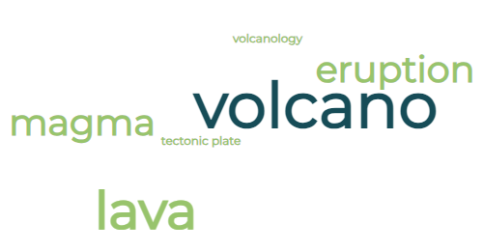

Activity: Class Discussion
After watching the BTN story, hold a class discussion using the following discussion starters.
- What do you know about volcanoes? Record what you know on a mind map.
- Why does Iceland have a lot of volcanoes?
- How have the eruptions impacted the community in Grindavik?

Activity: Glossary
Students will brainstorm a list of key words that relate to the BTN Icelandic Volcano story. Here are some words to get them started.

LAVA | MAGMA | FISSURE
TECTONIC PLATES | GEOTHERMAL | MANTLE

Ask students to write what they think is the meaning of each word (including unfamiliar words). They will swap definitions with a partner and ask them to add to or change the definition. Check these against the dictionary definition.

Activity: Volcanoes Research
Discuss the information raised in the BTN Icelandic Volcano story. What questions were raised in the discussion and what are the gaps in students’ knowledge?
What do I know? | What do I want to know? | What have I learnt? | How will I find out?

Students will develop their own question/s to research or choose one or more of the questions below.

- What is the connection between volcanoes and tectonic plates?
- Where are volcanoes typically found? Explore the similarities and differences between volcanoes found on hotspots across tectonic plates or at the boundaries.
- How many active volcanoes are there worldwide? Locate some of Earth’s active volcanoes on a map and describe their proximity to Australia. Draw the Ring of Fire on your world map.
- Are there any volcanoes in Australia? Locate these volcanoes on a map of Australia. Choose one to research in more detail.
- How can you tell if a volcano is active or dormant? Explore and describe the features of an active and dormant volcano. How do scientists monitor volcanoes?
- What are the different layers of a volcano? Draw a cross section of a volcano showing the following features: crust, mantle, crater, magma chamber, magma, ash, cloud, vent. Explain some of the features of each layer.
- What is the difference between shield, composite, and cinder cone volcanoes?
- What impact can volcanic eruptions have on people and the environment? Consider the negative and positive effects.

Activity: Volcano Facts
In small groups, students will find out as much as they can about volcanoes and compile the information they find into a list of facts. Provide students with a list of suggested questions and/or topics to guide their research, for example:
- What is a volcano?
- How do volcanoes form?
- What causes a volcano to erupt?
- What are the different types of volcanoes?
- What are some of the main risks during a volcanic eruption?

Hold a class discussion by asking each group to share one interesting fact they learned during their exploration. Record students’ responses to create a collective list of facts about volcanoes.

Students will use the facts they have discovered about volcanoes to create a quiz and then test their classmates. Students will include a range of quiz styles, for example:
- Multiple choice
- True or false
- Fill in the blank
- Use photos or pictures
- When an answer is revealed, provide extra information to explain the answer.

Students can make their quizzes in Kahoot or Quizizz. Make it fun, engaging, and educational!

Activity: Visual Literacy
In this activity students will analyse images which show the volcano in Iceland and the impact it has had. Students will choose one or more of the images below and respond to the following:

- What is happening in the image? Create a caption for each image.
- What does the image help you understand about volcanoes?
- What does the image tell you about the impact volcanoes have on a community?
- What questions do you have about what you see in the image?

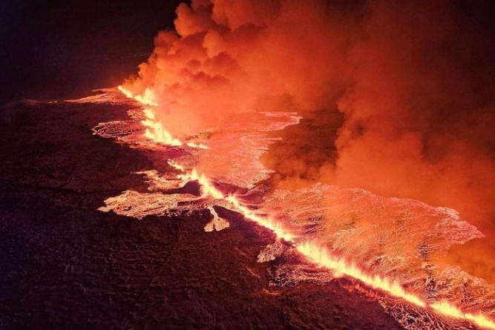  ABC News | 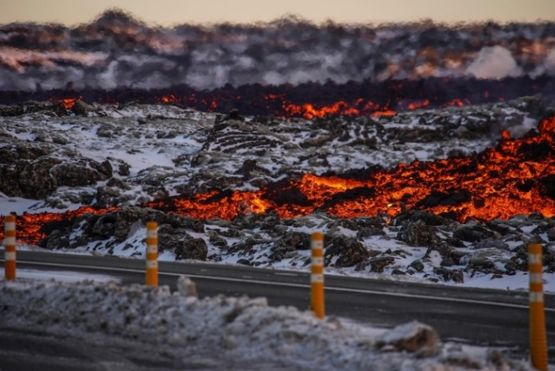  ABC News
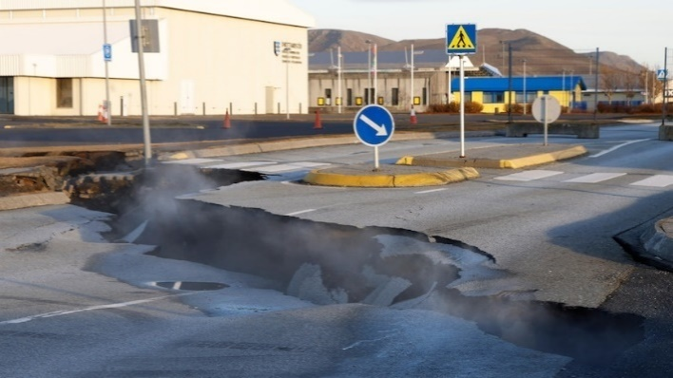ABC News | 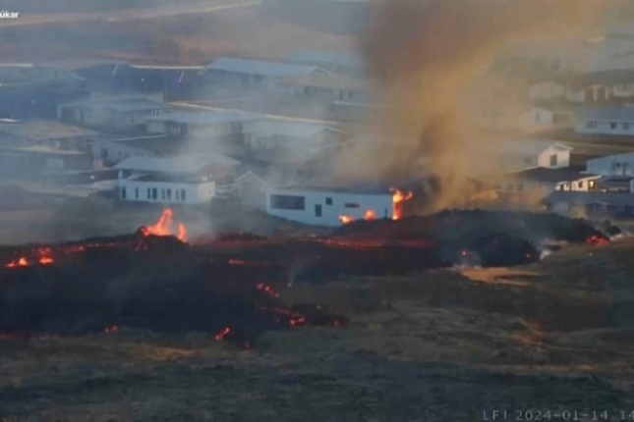ABC News

Activity – Choose a Project
Individually or in small groups, students will choose one of the following projects to work on and then present their findings to the class.

Famous volcanoes
What are some of the world’s most famous volcanoes? Create a “Who Am I” quiz about the top 3 most famous volcanoes and test your classmates.

Make a volcano
Make your own pocket volcano. Follow these instructions from the Australian Museum.
Did you know?
Using the information in the BTN story and your own research, create a Did You Know fact sheet about volcanoes. Publish using Canva.
The stages of volcanic eruption
Research the sequence of events that leads to a volcano erupting. Watch this TedEd video What Makes Volcanoes Erupt to learn more.

Useful Websites
- Iceland volcano: Fourth eruption since December – Newsround
- Icelandic town of Grindavik evacuated again after further volcanic eruption – Newsround
- Volcanoes Explained – BTN
- Volcanic Activity – BTN
- What is a volcano? – Geoscience Australia
- Structure of volcanoes – Australian Museum
EPISODE 8
26th March 2024

KEY LEARNING
Students will recognise and celebrate Australian women who have made significant positive changes in society.

CURRICULUM
HASS – Year 3 and 4
Pose questions to investigate people, events, places and issues.

Locate and collect information and data from different sources, including observations.

HASS – Year 5 and 6
Develop appropriate questions to guide an inquiry about people, events, developments, places, systems and challenges.

Locate and collect relevant information and data from primary sources and secondary sources.

History – Year 6
The contribution of individuals and groups to the development of Australian society since Federation.

HASS – Year 7
Construct significant questions and propositions to guide investigations about people, events, developments, places, systems and challenges.

This document contains the names and images of Aboriginal and Torres Strait Islander people now deceased. It also contains links to sites that may use images of Aboriginal and Torres Strait Islander people now deceased.

  - Teacher Resource

Lowitja O’Donoghue

Women’s History Month

Focus Questions
Discuss the BTN story as a class and record the main points of the discussion. Students will then respond to the following:
- What were some significant achievements in Lowitja O'Donoghue’s life?
- What was Lowitja O’Donoghue’s first job?
- How did Lowitja help Indigenous people?
- Which award did Lowitja receive?
  - Australian of the Year
  - The Order of Australia
  - Order of the British Empire
  - All of the above
- Why is she an important Australian?

Activity: Personal Response
Respond to the BTN Lowitja O’Donoghue story as a class. Students will complete one or more of the following incomplete sentences:
- Lowitja O’Donoghue is an important Australian because…
- It was interesting to learn…
- These are five words that I would use to describe Lowitja O’Donoghue …
- This story made me feel…
- It is important to celebrate Lowitja O’Donoghue because…

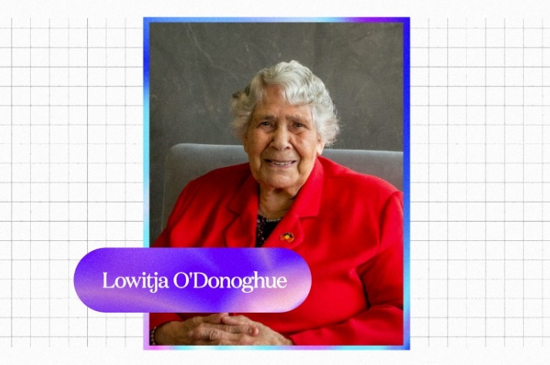

Activity: Vocabulary
Students will brainstorm a list of key words that relate to the BTN Lowitja O’Donoghue story. Below are some words to get them started. As a class discuss the meaning of each word/terminology and how it relates to Lowitja O’Donoghue and her story.

Advocacy
Trailblazer
Indigenous Rights
Equality
First Nations peoples
Stolen Generations
Activist
Elders

Further Investigation
- What is advocacy? Ask students to give an example of when Lowitja O’Donoghue was an advocate on Indigenous issues.
- Lowitja O'Donoghue was one of many Indigenous children separated from their families. Take the time to learn what your students know about the Stolen Generations. As a class, find out more about Lowitja O'Donoghue’s story. Refer to this Educators Guide to the Stolen Generations (Healing Foundation).

Activity: Research and Document
5 W’s
Students will choose one key event in Lowitja O’Donoghue’s life and research as much as they can about it. They will write a summary on the key event which answers the 5 W’s – Who, What, Where, When and Why?

When
Asks about a time
Why
Asks about a reason
Who
Asks about people
What
Asks about an action
Where
Asks about a place

KWLH
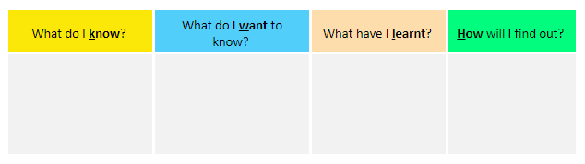
The following KWLH organiser provides students with a framework to explore their knowledge on Lowitja O’Donoghue and her advocacy for Indigenous rights. After watching the BTN Lowitja O’Donoghue story, students will develop their own question to research in more detail.

Timeline
Students will research and document the story of Lowitja O’Donoghue, to teach future generations about her life, her achievements, and her challenges. They will use a timeline to document their findings. Below is a timeline highlighting Lowitja O’Donoghue’s trailblazing achievements. Visit the Lowitja O’Donoghue Foundation website to read and learn more about her biography and achievements.

1954  Lowitja O’Donoghue became the first Aboriginal person to train as a nurse at the Royal Adelaide Hospital.  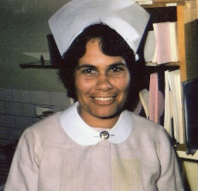  ABC News | 1973  Lowitja O’Donoghue was appointed as regional director of the Department of Aboriginal Affairs in SA, the first woman to hold a position like this in a federal government dept.  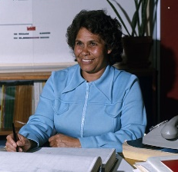  ABC News | 1976  Lowitja O’Donoghue was the first Aboriginal woman inducted into the Order of Australia. | 1992  Lowitja O’Donoghue was the ﬁrst Aboriginal person to address the United Nations General Assembly, in Geneva.  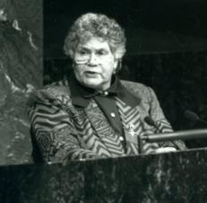  ABC News | 2000  Lowitja O’Donoghue was the first Indigenous person to give the annual national address as part of Australia Day celebrations.

Activity: BTN Stories
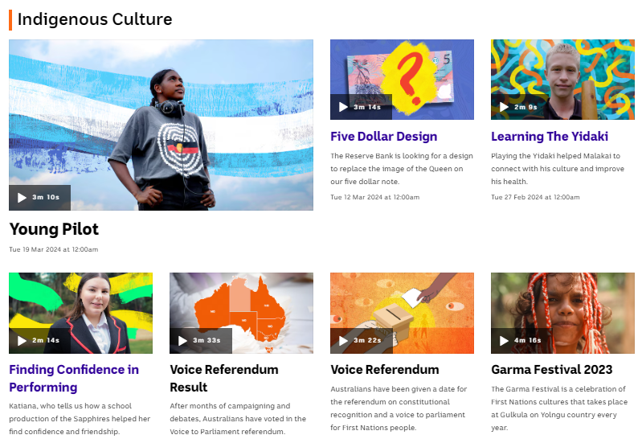
Visit BTN’s collection of stories which focus on Aboriginal and Torres Strait Islander peoples’ culture and issues.

After watching any one of the BTN videos ask students to respond to the discussion questions (to find the discussion questions and teacher resources go to the related BTN Classroom Episode and download the Episode Package).

Collection of BTN stories about Indigenous culture

Activity: Portrait
In this activity students will identity and understand the importance of individuals who have used their voice to make a positive change in society. As a class discuss the importance of individuals or groups who have used their voice to make a positive change in society and brainstorm a list of people that have made a significant impact.

Below are examples of Australians who have fought for the right to voice, such as civil rights activists, suffragettes, or advocates for free speech.

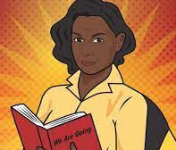  ABC Fierce Girls – Oodgeroo Noonuccal | 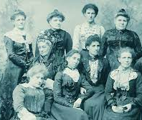  BTN – Australian Women in Politics | 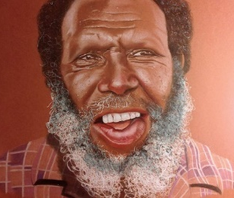  BTN – Mabo Day | 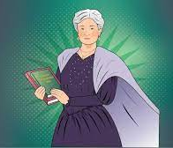  ABC Fierce Girls – Edith Cowan
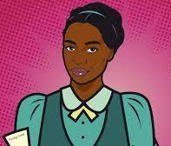  ABC Fierce Girls – Fanny Finch | 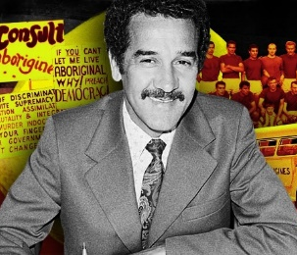  BTN – Charlie Perkins | 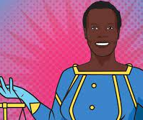  ABC Fierce Girls – Nyadol Nyuon | 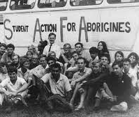  BTN – Freedom Ride

Students will then choose one of these people or groups that they find inspiring. Alternatively, they can choose someone in their community who has used their voice to make a positive change in society.

Students will use the following as a guide:
- Research the individual and record their achievements, their values, and the impact they have had on society.
- Use a range of primary and secondary sources during your research including biographies, articles, letters, speeches, artworks, photographs, and news stories.
- Plan and create a portrait of the person or group. Think about the expressions, symbolism, and colours that reflect the person, their values, and their impact.
- Explore and experiment with different techniques and mediums to produce a portrait.
- Present your portrait to the class, introducing who the person is, the impact they had and then explain your portrait and what each of the elements in the portrait mean.
- Organise a class exhibition of your artworks to share with the school and local community.

Useful Websites
- Dr Lowitja O’Donoghue – Lowitja O’Donoghue Foundation
- How Lowitja O'Donoghue changed the way Australia looked at Aboriginal affairs – ABC News
- Dr Lowitja O’Donoghue AC CBE DSG: biography and achievements timeline – Lowitja O’Donoghue Foundation
- Classroom resources to help schools promote a broader understanding of the Stolen Generations – ABC Education

  - Teacher Resource

BTN Transcript: Episode 8 - 26/3/2024

Yaama, I'm Jack and you're watching BTN. Here’s what’s coming up. We find out about Tasmania's new football team, get a lesson on Icelandic geology, and learn about the holy month of Ramadan.

TikTok Ban

Reporter: Jack Evans

INTRO: But first up today to TikTok which is an app, apparently? I'm kidding. It's one of the most popular apps around. But right now, politicians in the US are looking at a bill which could force TikTok to either find new owners or face a ban. Let's find out more about what's going on and why this little app is so controversial.

CLOCK 1: Oh Clarence, have you heard the news, The US Government is trying to ban TikTok-ing.
CLOCK 2: What? How will we keep time if we're not allowed to go tick, tock.
CLOCK 1: I know. It's all to do with China.
CLOCK 2: But I'm not even made in China.
JACK: Yep, it's looking like there could soon be a ban on TikTok in the US. But errr, it's got nothing to do with clocks.
CLOCK 1: Tick tock.
JACK: It's very much to do with the social media app, TikTok.
CLOCK 1: Yeah that's what we're doing, tick tock.

JACK: No, no the app, TikTok.
PERSON: I feel like it'd be very disruptive specifically for people that are content creators.
PERSON: I don't like it cause I use TikTok a lot, so it would affect me.
PERSON: I'm surprised actually it got this far, so I'll be very intrigued to see what the end result is. Yeah.
JACK: Now, you're probably thinking, wait a second Jack why does the US want to ban TikTok anyway?
CLOCK 1: Well, I guess constantly going Tick Tock can get kinda annoying.
JACK: No, no no, this isn’t about you. this has nothing to do about clocks.
CLOCK 1: Then why are we here.
CLOCK 2: Yeah.
TikTok is owned by the Chinese company ByteDance and like most social media apps, when you sign up you agree to sharing some of your data and personal information, like your age, name and location. In China, apps like TikTok have to legally share that data with the Chinese Government, if they request it and that's what some people are worried about.
MIKE GALLAGHER, US CONGRESSMAN: TikTok is a threat to our national security because it is owned by ByteDance which does the bidding of the Chinese Communist Party. We know this because ByteDance leadership says so.
Recently the US lower house voted in favour of a bill that would give ByteDance two options, sell TikTok to a non-Chinese owner or face a ban in the US.

CONGRESSWOMAN BETH VAN DUYNE: The yeas are 352, nays are 65…

China responded by saying that there is no evidence of a national security threat and that the ban is an act of bullying. While TikTok’s CEO says it's not sharing personal data and that all user information is stored in Singapore and the US.
SHOU CHEW, TIKTOK CEO: We have invested to keep your data safe and our platform free from outside manipulation.
It's also been encouraging it's more than 170 million US users to speak out against the ban. But there are many who say it's only a matter of time before TikTok starts sharing data and a couple of countries, including India, have already banned the app. While others have restricted the app from being used on government devices, including here in Australia where recently the Leader of the Opposition suggested that perhaps we should be following in the US's footsteps.
PETER DUTTON, LEADER OF THE OPPOSITION: If all of that data is being extracted against your knowledge or consent than I think the Prime Minister does need to step up.
JACK: Back in the US and there are many people who don't want to see the app banned.
CLOCK 1: Yeah, I personally believe…
JACK: No, no, no no, this is not about clocks. I'm talking about the millions content creators who rely on the app for work.
CLOCK 1: Oh sure.
SI WILLIS, CONTENT CREATOR: If it fully gets a ban, then those creators could totally lose out on any income. And there's not many backup options when you have this career.
MACY ELENI, CONTENT CREATOR: It obviously would be, yeah, awful to lose those, that audience. I love that audience. I love TikTok, the amazing like creators I've been able to find on it, whose voices were elevated through it.
The bill still has to go through the senate before anything is official. So as time ticks on I'm sure there will be more TikTok talk to come.
CLOCK 1: Wait a second, digital clocks don't go tick tock. Why don't we just become digital clocks.
CLOCK 2: Genius.
JACK: No, no no, you don't have to worry because this has nothing to do with clocks. Although talking clocks would make a pretty good TikTok… hang on, can I film you saying that?

News Quiz
What’s the name of the cyclone which caused a fair bit of damage in the NT last week? Megan, Martha or Michelle? It was cyclone Megan. It wrecked roads and even sent a container ship crashing into a wharf on Groote Eylandt before moving towards the mainland where it caused record floods and forced hundreds of people to be evacuated from the community of Borroloola.

RESIDENT: My home probably gonna be under water on the other side of Garawa camp. Um, I hope not, 'cause that's most of our stuff in there.

Uber has agreed to pay out $272 million to which group of people in Australia? Uber passengers, taxi drivers or bus drivers? It was taxi drivers. More than 8,000 taxi and hire care owners took the ride share company to court, saying it had broken the law by using cars and drivers without the licences and accreditations that taxis need.

Elon Musk has caused a stir, again, by releasing the code behind his company’s AI chatbot. Do you know its name? Grug, Grok or Groot? It’s Grok. Grok was created by AI-x as a rival to ChatGPT and releasing the source code means anyone can now work on it and make their own improvements.

And this six-month-old baby platypus made researchers pretty happy when they found her in the Royal National Park, south of Sydney. Do you know what a baby platypus is called? A Muggle, Puggle or Buggle. It's a puggle, although this one's name is Gilly, and she's the first to be born in the park in more than 50 years.

Tassie AFL

Reporter: Saskia Mortarotti

INTRO: Now to some big news from Tasmania. After years of campaigning, the state finally has its own AFL and AFLW teams. The Tasmania Devils will start playing in 2028 and Sas spoke to some locals to find out what it means to them.

SASKIA MORTAROTTI, BTN REPORTER: If you live in Tassie, and you love footy, this is the news you've been waiting to hear.
PRIYA BOWERING: We are the Tasmania Devils, or “purinina” in the language of Palawa.
STUDENT: I'm very keen to get a Tasmanian AFL and AFLW team.
STUDENT: I can't wait to see them run out for the first time.
Aussie rules has been played here for more than 150 years, but when the Victorian Football League expanded and became the AFL in the 90s, Tasmania didn't get a team in the competition. It's now the only state that's not represented, although Tasmania produces a lot of talent.
JIMI PARTRIDGE: For the Essendon football club I like Jye Menzie.
This is Jimi, and last week he played a big part in the launch of the Tasmania Devils.
JIMI PARTRIDGE: I was like excited and nervous at the same time. I like took off my shirt and showed the jumper.
So, what do you think of the name and the guernsey?
JIMI PARTRIDGE: I really like the name; it suits Tassie and the guernsey is really cool.
The colours were actually chosen by the Tasmanian Football League way back in 1908. As for the name, there was a bit of controversy there. You see, Warner Brothers owns the rights to Tasmanian Devil, you know, this guy:

[snippet from Warner Brothers animation of Taz the Tasmanian Devil]

And the AFL had to do a bit of negotiating, pointing out that it's actually a real animal before they got the all-clear to use it.
For young Aussie rules players, having a state team is a huge deal.
JIMI PARTRIDGE: It's really important because kids from Tassie like that might not be able to travel interstate and do those academies. But they can just stay here and do the Tassie Devils Academy.
STUDENT: I think it's important because it gives this new generation something to strive for.
STUDENT: We are a state in Australia so I reckon we should have the privilege to have a team.
STUDENT: Would be a great opportunity for young girls and boys to play for their state.
It's not just these young footy lovers that feels this way. Within 24 hours of the launch the Devils had more than 100,000 members, that’s more than most teams in the league. But there's one small problem. The Devils still need a place to play. Tassie's bid to get to be included in the AFL included a promise to build a new stadium, that's going to cost a lot of money and it's controversial.
PROTESTOR: What does Tassie want?
PROTESTORS: NO STADIUM!
PROTESTER: There are so many other things that are so much more important to spend the money on.
It was actually a big issue during the election that was held on the weekend. The Liberal Party made building the stadium one of its big promises. But it didn't win the election outright and needs the support of minor parties and independents to stay in government.
JACQUI LAMBIE: It's about priorities and it's about priorities of people's lives and I'm not sure how a new stadium is going to have a positive effect on lives here in Tasmania.
The Devils won't start playing until 2028, so there's plenty of time to iron out the details, like writing a team song, building the dream team, and you never know, maybe one of these guys will wear the guernsey.
JIMI PARTRIDGE: A bit too young but hopefully soon I'll play for them.
STUDENT: 100% I would love to play for the new Tasmania Devils.
STUDENT: I would really like to not play professionally for Tasmania when I'm older but would sure love to sit down on the couch and watch the footy.
Iceland Volcano

Reporter: Justina Ward

INTRO: Now to Iceland, which is looking decidedly less icy in some places and more red hot and full of lava. The country is experiencing it's fourth volcanic eruption in just three months. Here's Justina with a bit of a lesson in Icelandic geology.

JUSTINA WARD, REPORTER: Welcome to the Reykjanes Peninsula, Iceland. It's so hot right now. Literally. Molten lava has been spewing out from a 3-kilometre fissure in the ground and oozing all over the place.
Student: Ahhh, wait a second, you said Iceland, right? As in ice?
Justina: Yeah.
Student: I thought it was cold, why does it have fire and volcanoes and stuff?
Justina: I'm glad you asked. To answer that question, we need a little lesson in geology.
TINA: Iceland, the land of fire and ice, and fire on ice and most of all volcanoes. Iceland is one of the most volcanically active places in the world. What's a volcano, you ask? This is a volcano.
Student: Yeah, obviously.
TINA: A volcano is an opening in the earth's crust, through which lava and volcanic ash escape. You see the earth is actually made of different layers, like an onion.
The cool layer we live on is called the crust and under that is the mantle, which is very, very hot. Volcanos happen when melted rock from mantle makes its way to the surface, either at a particularly hot spot in the mantle, known as a hotspot, or where two tectonic plates meet.
TINA: You see, the earth's crust is actually made of jig-saw pieces, I mean tectonic plates. And when they slide together or come apart, they make mountains, earthquakes, and volcanoes. Ooh, lovely.
Iceland sits on a hotspot and is a meeting place of two tectonic plates. So yeah, It has a lot of volcanos. And they have their advantages, not only are they spectacular but all that underground heat creates amazing hot springs and can be used to generate power. In fact 30% of Iceland's electricity comes from geothermal power plants.
Tina: You see geothermal power works using steam like a kettle.
Justina: Ok, that's a different lesson. Back to volcanos.
Yep, volcanic eruptions can obviously cause huge problems. The lava from this one is just kilometres from the fishing town of Grindavik, which is home to around 3,800 people. Most of them evacuated last year after some pretty big signs an eruption was on the way.
RESIDENT: You Don't think it's real, I feel like I've accepted that I won’t probably come back here.
There's been some pretty big efforts to protect the town, as well as a popular thermal spa and a power plant that the lava's been flowing towards.
TINA: Luckily the lava flow is quite slow and steady, like honey. But it's still very dangerous.
And there could be more to come. It's been about 800 years since the Reykjanes Peninsula has had this much seismic activity and scientists think the area could now be entering a new volcanic era.
Halldor Geirsson, Geophysicist, The University of Iceland: We might have eruptions on the peninsula on and off for the next few hundred years.
For now, tourists have been warned to keep their distance, and the locals, well, they'll be expecting more of this to come.
Student: Oh, that was amazing. How am I the only person in this class? That was incredible.
Quiz
What's the difference between lava and magma? A, they come from different types of volcanos, B, they're made of different types of rock, or C, one is above ground the other is underground. It's C. Magma becomes lava when it breaks to the surface.
Ramadan

Rookie Reporters

INTRO: Right now, millions of people around the world are observing Ramadan. It's a really important religious festival for Muslim people and we asked some kids to tell us more about it.
KIDS: Hi BTN.
Aisha: I'm Aisha
Muhammad K: I'm Muhammad Khan.
Mohammad: I'm Mohammad
Farangiz: And I'm Farangiz
KIDS: And we're going to tell you all about Ramadan.
Mohammad: Ramadan is a really important time for all the Muslims around the world. It marks the ninth month of the Islamic lunar calendar. But because the calendar is based on cycles of the moon, each year, Ramadan starts on a different date. And this year the Holy Month started on March 12th. It's special to Muslims because it's believed to be the month when Prophet Muhammad - salla Allahu alayhi wa-sallam - received the final parts of their holy book 'The Quran' from Allah. So, what do you do during Ramadan?
Muhammad K: I'm glad you asked. Ramadan is a time Muslims try to get closer to Allah through things like prayer, fasting and doing good deeds. Chairity is really important to Muslims. It's one of the five pillars of Islam and it's extra important during Ramadan. For me I'm reciting surahs, reading Quran, I'm memorising Quran, and I'm praying.
Aisha: The other really important thing we do during Ramadan is fasting. Fasting is also a pillar of Islam. During Ramadan we fast from dawn till dusk which means we don't eat or drink anything. But some people don't have to fast, do they?
Farangiz: Nope. Everyone doesn't have to fast during Ramadan. People that are young, old, sick, or pregnant don't have to fast.
Aisha: Although many Muslims don't eat or drink through the day during Ramadan, they do have some extra big meals before dawn and after sunset.
Farangiz: Suhoor is the predawn meal that we eat before we start fasting.
Muhammad K: I like to eat my favourite wrap in my Suhoor time.
Farangiz: The most important thing during Suhoor, is to eat and drink enough to last you throughout the day.
Muhammad K: Right now, I'm going to Fajr Prayers, and Fajr prayers is the first prayer of the day.
Farangiz: Not eating or drinking can be hard, but we do it for Allah, it brings us closer to our Deen, and helps us be more patient. The hardest thing is when a few hours before Iftar, you get a lot hungrier, and your tummy starts to hurt a bit.
Aisha: You can smell like your parents cooking food and like, you're just trying hard as you can not to eat it.
Farangiz: When the sun sets, it's time for Iftar which is when we break our fast with a big meal and have what we want. Many people break their fast with a date, milk, or salt or water.
Muhammad K: Sometimes before Iftar I play games.
Farangiz: At the end of Ramadan, is a festival called Eid Al-Fitr. It's held to celebrate the end of another successful Ramadan. During Eid Al-Fitr, we celebrate with our family, friends, we go to a fun place, give out presents, and even get some money.
Mohammad: The thing I love about Ramadan is that your good deeds get multiplied by 70 times each Ramadan.
Muhammad K: Ramadan is important to me because it makes me, and other people feel equal.
Aisha: Everyone's allowed to celebrate because, it's not only for Muslims, even non-Muslims can join. It's all about making everyone happy.
KIDS: We hope you've enjoyed learning about Ramadan.
Quiz

What's the name of the meal that Muslims eat in the morning before the sun comes up during Ramadan? Suhoor, Iftar or Fajr? It's Suhoor.

Sport

COMMENTATOR: And Formular 1 is under way in Melbourne…

Yep, it was an action packed weekend in Melbourne for the Australian Grand Prix. World #1 Red Bull's Max Verstappen was in pole position heading into the race, but then this happened. Yeah, his car burst into flames, sending him to the sidelines. And the big names continued to fall with Mercedes' Lewis Hamilton also exiting early, due to an engine failure. In the end, it was all about Ferrari with Spain's Carlos Sainz coming in first and Monaco's Charles Leclerc coming in second. Oh, and we can't forget about Australia's very own Oscar Piastri who finished fourth for McLaren.
Now to basketball, where this shot right on the buzzer won the game for the Tassie JackJumpers. Yep, with just 1.2 seconds left on the clock, this score from Jack McVeigh took them from a point down to two points up securing the win over Melbourne United. Now they're just one win away from clinching the NBL Championship title.

Now to cricket, where Australia has thumped Bangladesh by six wickets in the second women's ODI in Dhaka to take the series two-nil. It was Sophie Molineux's first one-dayer since 2021 and she didn't skip a beat, taking three wickets to help her team bowl out Bangladesh for 97, which the Aussies chased down in just over 20 overs.
And finally, to the Urban Downhill Mountain bike race in Mexico. It saw competitors race down steep stair wells, around tight corners and through narrow alleyways landing this giant jump right before the finish line. Phwa, impressive stuff. I wish I could do that.

Lowitja O’Donoghue – Women’s History Month
Rookie Reporter: Ila

Lowitja O'Donoghue was born in August in 1932, but for many years she didn't know that was her name. She was one of six children born in the APY lands in South Australia. Her mother, Lily, was Yankunytjatjara Pitjantjatjara. But when Lowitja was two she was taken from her family, like many other Indigenous children. At the time the government thought it was better for Indigenous kids to be raised by non-Indigenous people.
LOWITJA O'DONOGHUE: I don't remember of course very much of the actual removal from my mother, and I didn't remember my mother at all.
Lowitja was sent to live at Colebrook Home in Quorn, where she couldn't speak her mother’s language or practice her culture and she was given the name Lois.
LOWITJA O'DONOGHUE: I didn't know her for 30 years, and she told me at the time your name Lowitja.
Despite the challenges she faced as a member of the Stolen Generations Lowitja was determined to get an education and make a difference in her community. So, she trained to become a nurse. In 1958 she became the first Indigenous women to work at the Royal Adelaide Hospital. Her job was all about helping people, but she was also opening the door for other Aboriginal people to do the jobs they wanted to do, and she didn't stop there.
Lowitja was passionate about helping all Indigenous people to get access to health care. So, she started working for organisations dedicated to First Nations rights and reconciliation.

LOWITJA O'DONOGHUE: And we are not talking about easy words, or quick fixes. We are talking about reclaiming a shared humanity.

In 1992 She was the first Indigenous Australian to address the United Nations.
LOWITJA O'DONOGHUE: The Australian constitution should be changed to recognise Aboriginal and Torres Strait Islander people as the continents original inhabitants.
As Chairperson of the the Aboriginal and Torres Strait Islander Commission she worked alongside the government to create the Native Title Act of 1993, which recognised that Aboriginal and Torres Strait Islander people had the right to the land they had been living on for thousands of years.
LOWITJA O'DONOGHUE: It has stamped a new dimension between the relationship of Indigenous and Non Indigenous Australians and it has meant an enormous boost to the confidence of Indigenous Australians.
Over the years Dr Lowitja O'Donoghue was given many honours and awards for her work. Like Australian of the year, the Order of Australia and the Order of the British Empire.
LOWITJA O'DONOGHUE: I feel proud, not on my own behalf, but I think for the sake of Aboriginal People.
In 2008, Lowitja retired but her work didn't end. In 2010 the Lowitja Institute was opened, dedicated to researching better ways to improve the health of Aboriginal and Torres Strait Islander people. When Lowitja died earlier this year at the age of 91 she was given a state funeral. Where people from all around Australia came together to honour her life and her work, helping to make sure that the name her mother gave her all those years ago will never be forgotten.
Closer

Well, that's all we've got for this week, but you can check out more stories on our website including the rest of our women's history month profiles. And, of course, Newsbreak will be here every week night to keep you up to date. Have a great week and we'll see you next time. Bye-bye!

