
EPISODE 32
11 November 2025

KEY LEARNING
Students will view a range of BTN stories and use comprehension skills to respond to a series of focus questions.

CURRICULUM
English – Year 4
Use comprehension strategies to build literal and inferred meaning to expand content knowledge, integrating and linking ideas and analysing and evaluating texts.

English – Year 5
Use comprehension strategies to analyse information, integrating and linking ideas from a variety of print and digital sources.

English – Year 6
Use comprehension strategies to interpret and analyse information and ideas, comparing content from a variety of textual sources including media and digital texts.

English – Year 7
Use comprehension strategies to interpret, analyse and synthesise ideas and information, critiquing ideas and issues from a variety of textual sources.
  - Teacher Resource

Focus Questions
As a class, discuss the stories featured in the episode of BTN Classroom and record the main points of the discussion. Students will then respond to the following focus questions.

Net Zero
- What does net zero mean?
- What are greenhouse gases?
- When does Australia want to reach net zero carbon emissions by?
  - 2030
  - 2040
  - 2050
- What did the National Party announce recently about net zero carbon emissions?
- What questions do you have about the BTN story?

Nuclear Tests
- When was the first nuclear test?
- Where in Australia were nuclear tests conducted in the 1950s and 1960s?
  - Montebello Islands, WA
  - Emu Field, SA
  - Maralinga, SA
  - All of the above
- What is nuclear fallout and what impact can it have on people and the environment?
- When did many countries sign an agreement to reduce the number of nuclear weapons in the world?
- What did the US announce recently about nuclear testing?

Check out the teacher resource on the Archives page.

The Dismissal Anniversary
- How many Prime Ministers have been sacked in Australia?
- What were some of Gough Whitlam’s achievements? Name two.
- Explain the events that led to Gough Whitlam getting sacked on November 11th1975.
- How did people react to the dismissal of the Whitlam government?
- What surprised you have about the story?

Check out the teacher resource on the Archives page.

Takeover Ballarat
- Briefly explain the ABC Takeover competition.
- Why is it important for young people in regional Australia to tell their stories?
- Give examples of stories told as part of the Takeover competition.
- Why do the students in the BTN story like being a part of the competition?
- How did this story make you feel?

Riverina Fuse Cup
- What is the FUSE Cup?
- What game are the kids playing?
- Why do the kids taking part in the competition think it’s a great opportunity?
- How is the competition trying to change the way people think about gaming?
- How has your thinking changed since watching the BTN story?

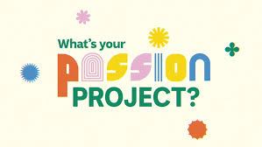
We're inviting schools around the country to tell us what their passion project is. Amazing artistic achievements? Super sporting success? Terrific technological triumphs? Enthusiastic environmental education! It could be anything but make sure it's something your whole class or school is buzzing about. We'll choose the best pitches and help you turn them into BTN stories to share with other kids around Australia.

EPISODE 32
11 November 2025

KEY LEARNING
Students will explore the impact that nuclear tests have on people and the environment.

CURRICULUM
HASS – Year 4
Locate, collect and record information and data from a range of sources, including annotated timelines and maps.

Sustainable use and management of renewable and non-renewable resources, including the custodial responsibility First Nations Australians have for Country/Place.

HASS – Years 5/6
Develop questions to investigate people, events, developments, places and systems.

Propose actions or responses to issues or challenges and use criteria to assess the possible effects.

Locate, collect and organise information and data from primary and secondary sources in a range of formats.

History – Year 7
Develop historical questions about the past to inform historical inquiry.

Locate and identify primary and secondary sources to use in historical inquiry.

Identify the origin, content, context and purpose of primary and secondary sources.

  - Teacher Resource

Nuclear Tests

Focus Questions
Discuss the BTN story as a class and record the main points of the discussion. Students will then respond to the following:
- When was the first nuclear test?
- Where in Australia were nuclear tests conducted in the 1950s and 1960s?
- What is nuclear fallout and what impact can it have on people and the environment?
- When did many countries sign an agreement to reduce the number of nuclear weapons in the world?
- What did the US announce recently about nuclear testing?

Activity: Class Discussion
What do you see, think and learn?
After watching the BTN Nuclear Tests story, students will respond to the following questions:

- What did you SEE in this video?
- What do you THINK about what you saw in this video?
What did you see, think and learn?
- What was SURPRISING about this story?
- Think of two QUESTIONS you have about this story.
- Why do you think BTN covered this story?

Activity: Comprehension
After watching the Nuclear Tests story students can answer one or more of the following questions, for example:
- What are some keywords from the BTN story?
- What did you learn from the story? Write a summary.
- What is the purpose of this news story? To entertain, persuade, inform, explain or describe?

Activity: Six Hat Thinking
As a class, use Edward De Bono’s Six Hat Thinking to explore the issues raised in the BTN Nuclear Tests story. Make your own coloured hat cut outs and place on the floor. Students will take it in turns answering questions in relation to what they already know about the issue, what they have learned from the story and what they want to learn further about the topic. Ask students to respond to the following questions:

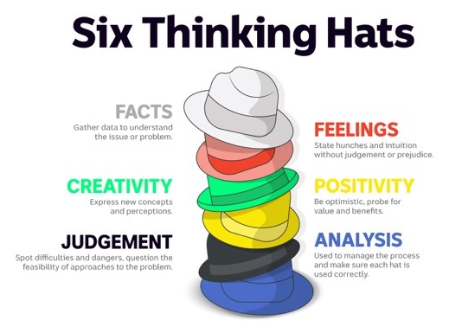
- How did the BTN Nuclear Tests story make you feel?
- What do you know about nuclear testing and nuclear weapons?
- What have you learnt from the story?
- Were there any positives from the story? If so, what were they?
- What are some of the negatives or challenges that you learnt from the story?
- Why is it important to learn about the issue?
- What questions were raised during this activity? Think of three questions you would like to ask about the story.
- What do you want to learn further about this topic?

Reflection
After this activity, ask students to reflect on what they have learnt. Students can include details about how their thinking on this issue has changed.

Activity: Visual literacy
In this activity students will examine the cartoon below to explore the issue of nuclear testing and its impact on the environment. Students will analyse the image and respond to the following:

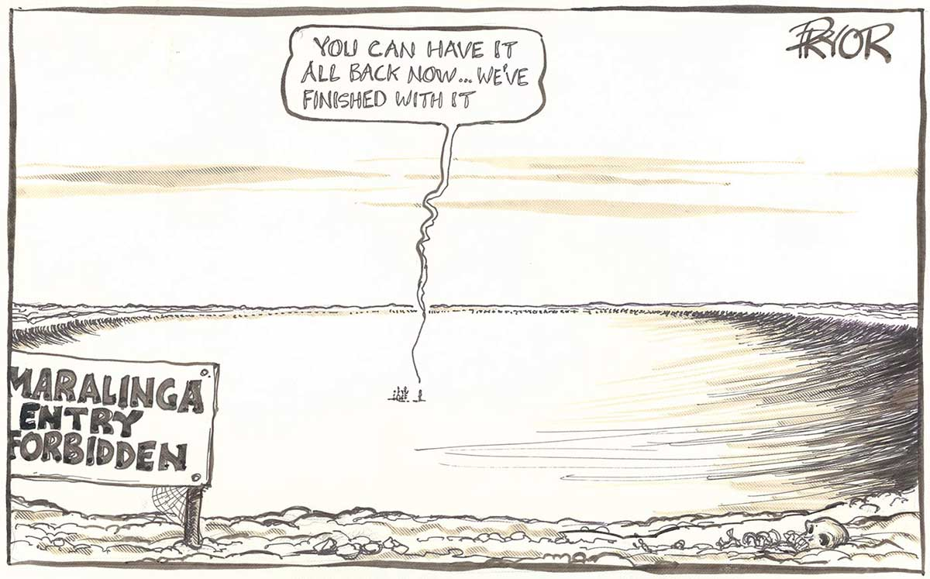
- Who is the illustrator of the cartoon?
- When was the cartoon published?
- What is happening in the cartoon?
- What do you think the cartoon is trying to tell us? What is the message?
- How does the cartoon make you feel?
- What questions do you have about the cartoon?
- Is this cartoon a primary or secondary source? Explain your answer.
Cartoon by Geoff Pryor (Source: National Museum Australia)

Activity: History of Nuclear Testing
Provide your students with the opportunity to act as historians to learn more about the history of nuclear testing. Students will investigate in more depth some questions they have about nuclear testing and the impact it has had on people and the environment.

Students can take notes as they watch the BTN Nuclear Tests story or download the transcript after watching the story to guide them through the activity. Students will use the following as a guide, or students can write their own inquiry question to investigate.
- Write a summary about nuclear testing in Australia, which answers the 5 W’s – Who, What, Where, When and Why?
- Find one primary source and one secondary source which helps you understand more about the history of nuclear testing in Australia.
- Create a timeline highlighting key events in the history of nuclear testing. Include a title, date, and description for each event. Collect and reference primary and secondary sources (including photographs, newspapers, stories and maps). Consider using internet search engines, museums and library catalogues to find your information.
- How were Indigenous communities affected by nuclear testing in Australia? Include the following words in your summary: Maralinga, Emu Field, Montebello Islands, contamination, health effects, radiation, Royal Commission.
- What impact has nuclear testing had on the environment and people?

Share
- Share and compare your research with your classmates.
- Present your research in an interesting way.

Persuasive writing
Should countries be allowed to conduct nuclear testing? Develop an argument for or against the issue.

Useful Websites
- Nuclear Testing (2024) – BTN
- Trump wants to resume US nuclear weapons testing. This is what it could look like – ABC News
- Maralinga History – BTN
- Hiroshima Anniversary – BTN
- Maralinga – National Museum Australia

EPISODE 32
11 November 2025

KEY LEARNING
Students will learn about the dismissal of the Whitlam government and the role of the Governor-General.

CURRICULUM
HASS – Year 6
Significant individuals, events and ideas that led to Australia’s Federation, the Constitution and democratic system of government.

The key institutions of Australia’s system of government, how it is based on the Westminster system, and the key values and beliefs of Western democracies.

Develop questions to investigate people, events, developments, places and systems.

  - Teacher Resource

The Dismissal Anniversary

Focus Questions
Discuss the BTN story as a class and record the main points of the discussion. Students will then respond to the following:
- How many Prime Ministers have been sacked in Australia?
- What were some of Gough Whitlam’s achievements? Name two.
- Explain the events that led to Gough Whitlam getting sacked on November 11th1975.
- How did people react to the dismissal of the Whitlam government?
- What surprised you have about the story?

Activity: Note taking

Students will practise their note-taking skills while watching the BTN Dismissal Anniversary story. After watching the story, ask students to reflect on and organise the information into three categories. What information in the story was...?
- Positive
- Negative or
- Interesting

Activity: Discuss
After watching the BTN Dismissal Anniversary story students discuss the story in pairs, using the following questions to guide the discussion:
- What events led to Gough Whitlam’s dismissal?
- Who were the key people involved in the dismissal?
- How did people react to the dismissal of the Whitlam government?

What questions do you have?
What surprised you about this story?

Activity: Key words
Students will brainstorm a list of key words that relate to the BTN Dismissal Anniversary story. Here are some words to get them started.

GOVERNOR-GENERAL | HEAD OF STATE | CONSTITUTION
DOUBLE DISSOLUTION | LOWER HOUSE | SENATE

Ask students to write what they think is the meaning of each word (including unfamiliar words). They will swap definitions with a partner and ask them to add to or change the definition. Check these against the dictionary definition.

Activity: Whitlam Dismissal Research
Discuss the information raised in the BTN Dismissal Anniversary story. What questions were raised in the discussion and what are the gaps in students’ knowledge? Students will develop their own question/s to research or choose one or more of the questions below
Research
- What events led to Whitlam’s dismissal on 11 November 1975?
- What role did the Governor-General, John Kerr, play in Gough Whitlam’s dismissal?
- What are `reserve powers’? When can the Governor-General use them?
- How did Australians react to Whitlam’s dismissal?
- Why was Whitlam’s dismissal a significant event in Australian history?
- What did the dismissal mean for politics and democracy in Australia?
- Could the dismissal happen again? Does the Governor-General still have the power to dismiss the government?

Activity: Whitlam’s Dismissal Speech
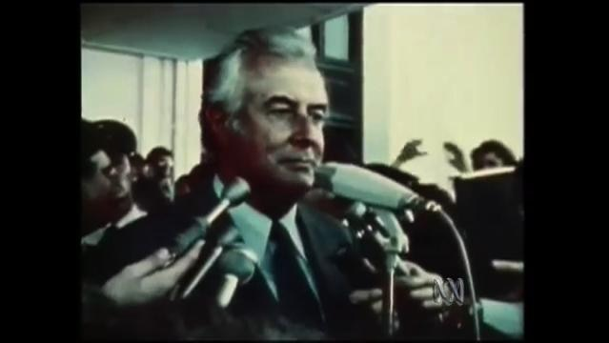
Students watch Gough Whitlam’s dismissal speech then respond to the following questions:
- What words would you use to describe Whitlam’s speech?
- What did Whitlam mean when he said
“Well may we say `God save the Queen’, because nothing will save the Governor-General”?
- What do you think Gough Whitlam wanted Australians to remember from the speech?

Activity: Role of the Governor-General
Students will investigate the role of Australia’s Governor-General. Below are some research questions:
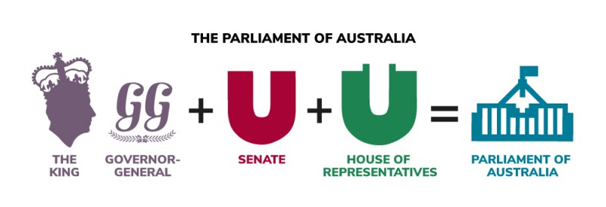
- Who does the Governor-General represent?
- What is the role of the Governor-General?
- Who is our current Governor-General?
- Why was it controversial for the Governor-General to sack Gough Whitlam as Prime Minister in 1975?

Activity: Biography
Students will research and write a biography of Gough Whitlam exploring his life, career, achievements, and impact. Before they begin their biographies, discuss what students already know about biographies. What type of information is included in a biography and what do they tell us about a person.
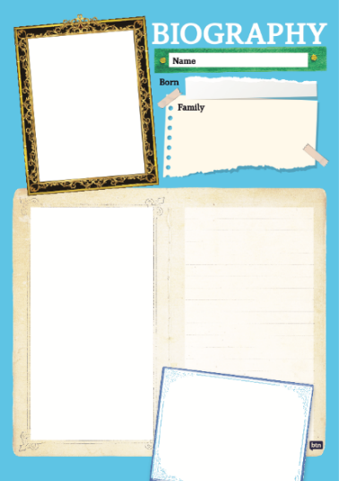
Class Discussion
Use the questions below to get a class discussion started with your students about biographical writing.
- What does a biography tell us about a person?
- Where can you look to find information for your biographical writing? Why is it important to use more than one source of information?
- What makes a biography interesting? For example, key information and facts, a timeline of events, photographs, illustrations and quotes.

Create your Biography
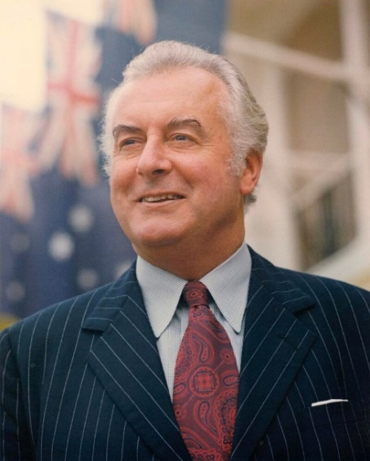
Using the biography worksheet at the end of this activity, students will research and record information. Some possible areas of research include:
- When and where was Gough Whitlam born? Describe his family life growing up.
- What were some of his achievements? Choose one to explore in more detail.
- What inspired him to enter politics?
- What were some challenges that he faced?
- What contributions did he make to Australian society? What do you think is Gough Whitlam’s legacy?
- Interesting facts about him.
Source of image

Further Investigation
- Imagine you could sit down and talk to Gough Whitlam. What questions would you ask about him? Do you have any questions about the dismissal?
- In pairs, students can role play the interview – one taking on the role of interviewer, the other, as the person.
- Create a timeline of important events in their life.
- What are some of the key events in his life? Write a summary for one key event, which answers the 5 W’s – Who, What, Where, When and Why?

Useful Websites
- Whitlam dismissal – National Museum Australia
- The Whitlam dismissal – Parliamentary Education Office
- Whitlam Legacy – BTN
- Why was Whitlam sacked and not just a double dissolution called: - Parliamentary Education Office
- `We’ve been sacked’: The 1975 Whitlam government dismissal – MoAD
- Governor-General – Parliamentary Education Office

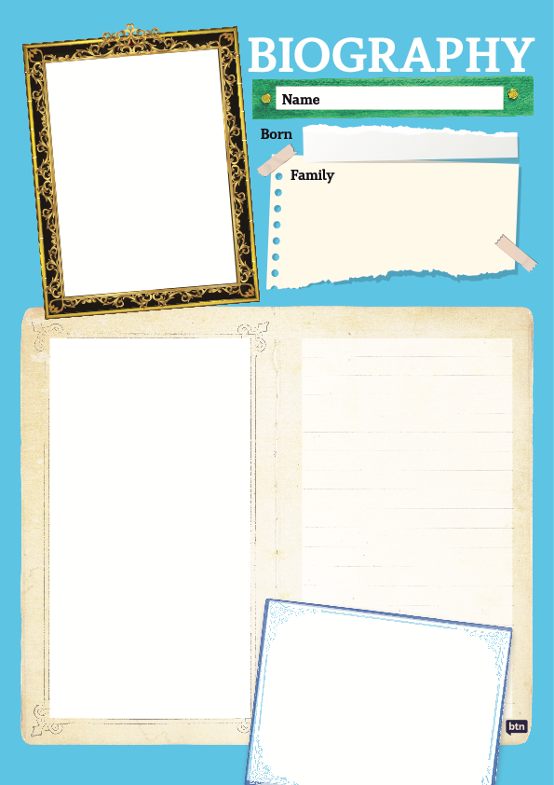

  - Teacher Resource

BTN Transcript: Episode 32 – 11/11/2025

Yama. I'm Jack Evans, and you're watching BTN. Here's what's coming up. We learn about a dramatic event in Australia's political history. Find out why nuclear tests are back in the news. And meet some kids testing their skills in Mario Kart.

Net Zero

Reporter: Jack Evans

INTRO: But first, today, to a phrase you might have heard before, which has been causing some political drama lately. It's 'net zero'. Last week, the National Party announced it was dropping net zero as a policy. So what does that mean? Let's find out.

FISHERMAN: Any luck catching fish today?
FISHERWOMAN: No! Not since I went net-zero.
FISHERMAN: Net zero?
FISHERWOMAN: Yeah, no nets, zero. It's better for the climate.
FISHERMAN: Oh, right, yeah nah.
JACK EVANS, REPORTER: Ahh net zero doesn't mean no nets.
FISHERWOMAN: What else could it mean then?
Net means the amount that is left after you take stuff out, in this case greenhouse gas. Net zero means balancing the amount we put into the atmosphere with the amount we take out. That way the total added to the atmosphere is zero, net zero if you will.
FISHERWOMAN: Oh, right gotcha and what about the greenhouse one?
FISHERMAN: Yeah, what's that?
Alright, get comfortable.
FISHERMAN: I'll put the kettle on.
Ah, well, the gas coming out your stove is a greenhouse gas, methane.
FISHERMAN: Oh, no, but the kettle's electric.
Oh, well, it could still be using greenhouse gases. You see a lot of the electricity we use comes from burning fossil fuels, like coal and oil, which releases greenhouse gases into the atmosphere and when there are too many greenhouse gases in the atmosphere it can trap the suns heat.

FISHERMAN: Oh-oh! Like a net!
FISHERWOMAN: Just like a net!
No, like a greenhouse. Scientists have known for a while now that since we started burning fossil fuels, global temperatures have risen by about 1 degree. That might not sound like much, but just a few degrees can make a huge difference to global weather systems. We're talking more heat waves and bushfires as well as other extreme events like floods, cyclones and even extreme cold snaps. It's why many countries, including Australia, have signed something called the Paris Climate Agreement to try and stop global temperatures rising by reducing our output of greenhouse gases.
At the moment about 65% of Australia's power comes from coal. The Government says it's aiming to have 82% of electricity from renewable sources, like solar and wind, by 2030. And at the same time, try to take greenhouse gases out of the atmosphere by doing things like planting trees so we get to net zero by 2050. Up until recently all of Australia's main political parties agreed that net zero was a good idea. But the National Party isn't so keen to ditch coal. They say it's cheap, employs a lot of people and isn't as polluting as it used to be. Last week the Nationals leader, David Littleproud, announced they were dropping their commitment to net zero.
DAVID LITTLEPROUD, LEADER OF THE NATIONAL PARTY: We continue to believe that we need to reduce emissions, but we've got to do it in a better, fairer, cheaper way for all Australians.
But it made things a bit awkward with their coalition partners the Liberal party. Opposition Leader Sussan Ley hasn't decided whether the Liberals will keep or drop the net zero target.
SUSSAN LEY, LEADER OF THE LIBERALS: I'm looking forward to the work that will happen between now and the Liberal Party's position becoming known, and then us sitting down together as two mature parties.
So, there you go, that's all cleared up. Nothing to do with fishing nets.
FISHERWOMAN: What about soccer nets? Because I don't mind a bit of the beautiful game.
No, it's not... they're not physical nets. Soccer nets aren't... No, nets are impacted. We will still have nets.

News Quiz

The Philippines has been hit by two deadly tropical storms in the space of a week. What are storms like this called in this part of the world. Cyclones, hurricanes or typhoons? They’re typhoons, in fact, the latest one, Fung-Wong, was a super-typhoon, which is a storm that brings winds of more than 185 kilometres an hour. More than a million people were evacuated before Fung-wong, which came just days after another deadly typhoon named Kalmaegi.

World leaders are gathering for the 30th Conference of the Parties, the UN’s annual Climate Change meeting. Where is being held this year? Brazil, Türkiye or Peru? It’s in Brazil.

Why were flights cancelled in major US cities over the weekend? Is it because of bad weather, because of a pilots' strike, or because air traffic controllers weren't getting paid? It's because air traffic controllers weren't getting paid. They're among more than a million federal employees who were affected by the longest government shutdown in US history. It happened because, basically, the country's Congress couldn't agree on a plan to spend the government's money.

What significant military event is marked every year on November 11? Is it the end of the First World War, the end of the Second World War, or the bombing of Hiroshima? It's the end of the First World War. The armistice, or agreement that ended the war, was signed on 11 November, in France, and took effect at 11am.

The Dismissal Anniversary

Reporter: Wren Gillett

INTRO: Now we're going to take a closer look at one of the most dramatic moments in Australian politics; the Whitlam dismissal. It happened on the 11th of November, 50 years ago. Here's Wren to find out why it's still being talked about today.

We've had lots of Prime Ministers over the years. Some have served for a long time, others for a short time.
WREN GILLETT, REPORTER: But only one of them has ever been fired. It's quite a story, so let me tell you about it.
It's 1972, and after 23 years of Liberal-Country Party governments, the Labor Party, led by Gough Whitlam, wins a huge victory.
GOUGH WHITLAM, FORMER PM: It's time for a new team, a new program, a new drive for equality of opportunity.
As Prime Minister, Whitlam did a lot. He brought in Australia's first Universal healthcare system, made university free, lowered the voting age and ended the White Australia Policy. Then, something called the oil crisis hit. The economy suffered, and a lot of Aussies weren't happy. There was also trouble in Parliament.
You see, while Whitlam's Labor Party had more seats in the Lower House, they didn't have a majority in Upper House, or Senate, and as ya might know, laws can only become laws if both houses agree. But the Senate kept blocking laws that Labor tried to make. Eventually triggering something called a Double Dissolution.
WREN: That's a little trick in Australia's Constitution designed to make sure Parliament doesn't stop running JUST because politicians can't agree.
If the same bill gets rejected twice by the Senate with three months in between, the Prime Minister can ask the Governor General to dissolve Parliament and call an early election.
WREN: The Governor General by the way, that's the King's, or back then, the Queen's, representative here in Australia.
So, in 1974, Australia had another election that Whitlam won, just. But the Government's problems were about to get worse. In August 1975, Labor introduced its budget, which is basically its spending plan for the year. But the Senate refused to pass it, twice, and soon, teachers, doctors and other public servants stopped getting paid.
WHITLAM: Where will it end? It will end as soon as the senate stops this nonsense.
On the 11th of November, it all came to a head at the Governor General's home, Government House.
WHITLAM: At one o'clock, we went there with the letters, written advice that he should have this election.
But the opposition leader Malcom Fraser was already there. The Governor General had decided to do something no Governor General had ever done before. Sack the Prime Minister. What followed was one of the most famous events in Australia's political history.
The Governor General's Secretary explained that Malcom Fraser would be stepping in as Caretaker Prime Minister ...or at least he tried.

CROWD: (CHANTS) We want Gough! We want Gough!

After that, the mic was Whitlam's.
WHITLAM: Well may we say God save the Queen, because nothing will save the Governor General.
RALLY: We want Gough. We want Gough.
A lot of people were furious that an unelected official like the Governor General, could sack an elected Prime Minister.
PERSON: I will not be told by Sir John Kerr, I will not be told by Fraser that I cannot have my elected Government.
REPORTER: So, what do you think this election is about?
PERSON: The survival of democracy.
Caretaker Prime Minister, Malcom Faser, went on to win the election by a landslide, serving for seven and a half years. And eventually, he and Whitlam became friends.
WREN: But while they buried the hatchet, Australia never forgot the dismissal. Partly because, well technically, it could happen again.
The Governor-General is still our Head of State, and the Constitution hasn't changed. But so far, history hasn't repeated, and many say it's unlikely we'll ever see another drama quite like that of November 11, 1975.

Quiz

What was Prime Minister Whitlam's first name? Gough, Edward or George? It was Edward. Gough was actually his middle name.

Nuclear Tests

Reporter: Tatenda Chibika

INTRO: Recently the US President, Donald Trump, made international headlines by suggesting the US should start testing its nuclear weapons. That's something that most countries haven't done for more than three decades. Tatenda found out more about the history of nuclear tests and why President Trump's comments are a big deal.
Tatenda Chibika, Reporter: Imagine a flash as bright as the sun and a roar that seems to tear the air apart. A shockwave that flattens everything in its path and a glowing mushroom cloud rising into the sky.
This an example of a nuclear weapon test something that has happened in the past thousands of times right around the world. It started in July 1945 with Trinity. Since the beginning of World War Two, America and its allies had been racing to develop a weapon that could harness the huge amounts of energy inside atoms.
Two weeks after the first successful test, two nuclear weapons were dropped over Hiroshima and Nagasaki in Japan. More than one hundred and seventy thousand people died. Within days, the Second World War was over, but a new arms race had begun.
The Soviet Union, which was a huge country made up of Russia and nearby countries, started developing and testing its own nuclear weapons. To keep up, the US and its allies set up more testing locations around the world sometimes forcing the people who lived there to relocate.

SOLDIER: Will you tell them that the United States government now wants to turn this great destructive force into something good for mankind?

The UK even tested here in Australia in Montebello, Emu Fields and Maralinga.
Yami Lester, Maralinga Veteran: We all got sick. Diarrhoea, vomiting, skin rash and sore eyes, I couldn't open my eyes it was that sore.
As well as the explosion, nuclear tests create fallout, radioactive particles that can spread out and make people sick long afterwards. Over the years, the opposition to nuclear testing started to grow. People were worried about the fallout and just how big the weapons were getting. So, in 1963, world leaders came together to sign the Partial Test Ban Treaty which banned nuclear testing under water, in the atmosphere, and outer space. But the testing didn't stop. In fact, more countries joined the nuclear race.
By the mid-90s, nuclear testing had become less common. The Soviet Union had collapsed and there was a push to stop the spread of nuclear weapons. By the end of 1996, all five major nuclear states signed the Comprehensive Nuclear-Test-Ban Treaty agreeing to ban tests completely. And with that, the age of nuclear testing came to an end.
Well, almost. India and Pakistan both conducted tests in 1998 and since then, North Korea has been the only country that's openly tested nuclear weapons. But recently, the leader of the world's biggest nuclear power said that might change.

Donald Trump, US President: I'm saying that we're going to test nuclear weapons like other countries do, yes.
President Trump's suggestion has been really controversial and even some in his own government say it's unlikely to happen.
Chris Wright, US Energy Secretary: These are not nuclear explosions. These are what we call non-critical explosions. So, you're testing all the other parts of a nuclear weapon.
Some worry that if US did start testing other countries might follow and that we could find ourselves heading into a new nuclear age.

Did you know?

Did you know the biggest nuclear explosion ever was Tsar Bomba? It was a soviet thermonuclear bomb that was tested on October 30th, 1961, and was about 1500 times more powerful than the bombs used on Hiroshima and Nagasaki combined.
Takeover Ballarat

Reporter: Joe Baronio

INTRO: Now we're heading to Ballarat for ABC's Takeover. It's a storytelling competition for students and you might have seen some of them on BTN before. Joe and Sas went along to meet some of the students taking part and find out what it's all about, take a look.
Welcome to Ballarat, the home of the gold rush, Victoria's only dine-in Pizza Hut and thousands of young people with interesting stories to tell.
They're all taking part in ABC Takeover which is a competition that's been helping young people tell their stories since 2022 from places like Shepparton, Mildura, Melbourne, Lismore, Latrobe Valley, WA Goldfields, and Burnie.
See, in regional towns and cities like these it can sometimes feel like you're a long way from the action.
JOHN: it's most like mostly everyone in Ballarat does like to go to Melbourne or interstate just to get their voice heard.
So, Takeover comes to them teaching them how to turn their life stories into a ripping yarn.
SAS: What's your story about?
TOBY: Bowling, AFL, and music.
PAT: Of course, about my radio segment that I do here, Events and Weather Forever.
LOGAN: Things that I learnt in the past, like history.
For some, their stories include some big challenges, like Toby's dad's health problems.
TOBY: He got unfortunately diagnosed with lung cancer in 2021 and then got diagnosed with brain cancer this year, which I sacrificed missing school to support my dad each and every way.

He says hobbies like singing and bowling helped with the tough times.
TOBY: I've actually been a winner of the league before in 2021, when I finished in first place. It was the best time of my life.
Pat's story is about his passion for presenting.
PAT: I guess I just love that I'm there talking because I like to talk a lot.
And Logan, well, he loves to sing.
LOGAN: I started back in 2024, and I was really proud of myself for performing last year's Farm Fest. And right now, I'm looking forward to this year's Farm fest. It’s gonna be good.
For the Takeover team, the hardest part is choosing just 35 winners out of hundreds of entries to be turned into stories for TV, radio and even BTN:

JACK FROM PREVIOUS EPISODE: Lucas was one of the winners of the ABC's Takeover Burnie competition. Check it out.

And, at the end of it all, there's a red-carpet screening and a chance for the winners to talk to local leaders about how to make their communities a better place. But, even if they don't win, these guys say they've learnt a lot.
TOBY: It's like being the biggest opportunity I've had in just a very short fortnight.
LOGAN: Because that's what people like friends do. They tell back stories.
PAT: I feel like young people definitely do deserve a chance to talk about their feelings, because they're probably going to lead the world when all the other old guys die, so, yeah.
And to whoever does win.
TOBY: I'd like to congratulate them… and if my story gets selected, then congratulations to myself.

Social Media Promo

Australia is about to become the first country in the world to ban social media for kids under 16. And we want to know what you think.

STUDENT: For me, social media is like a way that I usually get my news.
STUDENT: I can't talk to all my friends now.
STUDENT: It could help a lot of people.
STUDENT: I think that it will bring people closer together.
Head to the BTN website and fill in our social media ban survey, and we'll give you the results in December in our special episode, All About The Ban.

STUDENT: They shouldn't have just banned it completely 'cause us teenagers, we can do anything.

Sport

COMMENTATOR: Stengle strikes!

The AFL Finals season is set to get even bigger with a wild card round to be introduced next season.

Andrew Dillion, AFL CEO: So, we go from a final 8 now to an addition of a wildcard finals weekend where 7 will play 10 and 8 will play 9.
The AFL CEO says it'll give fans an extra week of finals fun but, not everyone is convinced.
@DANDOESFOOTY: No-one asked for this.
@DAVISJARRA: Once we start handing out finals spots like participation medals, suddenly September football doesn't feel special like it should.

Lando Norris has increased his lead in the F1taking out the Sao Paulo Grand Prix. His Aussie teammate Oscar Piastri was handed a ten second time penalty for this collision with Mercedes Kimi Antonelli…

COMMENTATOR: He hits Antonelli!
…which led to Ferrari's Charles Leclerc crashing out of the race.
And finally, the 2025 world rowing beach sprint finals have taken place Türkiye ahead of the sport's debut at the next Olympic games. The USA's Christopher Bak took home the win in the men's final, while New Zealand's Emma Twigg also snagged herself a gold medal for the women's.
Riverina Fuse Cup

Reporter: Tatenda Chibika

INTRO: Now to a different type of sport which has become quite a big deal around the world. I'm talking about esports. Recently some kids in the New South Wales Riverina got a chance to take part in an international esports comp called the Fuse Cup. Here's Tatenda.

Tatenda Chibika, Reporter: This is the at the Roxy Theatre in Leeton usually where you'd go to catch a play or watch the latest blockbuster but, these guys are here for Mario Kart.
It's all part of the Fuse Cup, an esports tournament that's held around the world including many locations in Australia.
But this is the first time it's been held in Leeton, New South Wales.
KID: Being a rural town, we don't really get these types of opportunities. So, I think it's really good for us to have these situations happen for us.
KID: I got to skip the whole day of school just to play video games.
KID: I'm never allowed to play video games, and this is basically my only chance to play it as well
While it looks like a lot of fun, competitive video gaming is serious stuff.
KID: It's not like anybody can win there is skill involved.
KID: Hand coordination, like you need to if you're facing bosses or drifting in or shooting people in Mario Kart with your objects.
Organisers say the comp is all about creating positive gaming experiences for students and teaching them different ways to game responsibly.
Emma, Roxy Theatre Manager: Gaming is often seen as something that a young, especially teen boy, will do locked away in his room. But this FUSE Cup is really important for us and for the competitors because they teach etiquette, they talk about how to make sure they're getting enough sleep and how they should be sitting.
They also say it's an important opportunity for regional students to try gaming and see if they'd like it as a career. That's right, career. Professional gaming is definitely a thing and some international esport titles are worth millions of dollars.
This year's Riverina Fuse Cup Riverina winner Jack isn't an instant millionaire, but he will go on to compete in the state finals on the Gold Coast.
KID: This is the first time I've made it so far in a tournament, and I'm really stoked to follow through.
And for the other competitors, they say there's more to the competition than taking home the prize.
KID: Having the chance to play with new people and like, meet other people from different schools.
KID: learning new life skills really coz you can like learn how to interact with people in games.
KID: It feels good to prove to people that in the city that, yeah, the Bush kids can play. It's not always the city kids are the best. Sometimes they're a good hidden gems from the country.
Closer

Well, that's all we've got for you today. But of course, we'll be back next week with more. And in the meantime, there's heaps to see and do on our website. You can check out stories and specials or catch episodes of BTN Newsbreak or BTN High. Have an awesome week, and I'll see you next time. Bye!

