

Australian Women in Politics
- Before watching the BTN story, make a list of Australian women in politics.
- In pairs, discuss the Australian Women in Politics story and record the main points of the discussion.
- How many years ago did women not have the right to vote?
- The South Australian Government was the first in the world to give women the right to run for election. True or false?
- Who was Catherine Helen Spence?
- In what year were the first women elected to Federal Parliament?
  - 1902
  - 1943
  - 1980
- Who was Australia’s first female prime minister?
- Who was the first Indigenous woman to sit in parliament?
- What was surprising about this story?
- What did you learn watching the BTN story?

Women at Work
- Discuss the BTN Women at Work story as a class. What points were raised in the discussion?
- What was it like for women living in the 1800s?
- What changes started to happen for women in the late 1800s?
- Which state was the first to give women the vote?
- How did the Second World War change the role of women?
- After the war, most women were forced to go back to _______________.
- Describe work for women in the 1950s.
- How did women fight for their rights in the 1960s and 1970s?
- What changes still need to be made to make women and men more equal?
- How has your thinking changed since watching the Women at Work story?

NAIDOC Indigenous Women
- Briefly summarise the BTN story.
- Where was Rosalie Kunoth-Monks born? Find using Google Maps.
- Rosalie Kunoth-Monks is best known for being the first Indigenous women to have a lead role in a film. True or false?
- Why are the songs that Fanny Cochrane Smith recorded on wax cylinders really important?
- Gladys Elphick was a Kaurna and Ngadjuri woman. Locate the traditional lands of Kaurna and Ngadjuri people on a map of Australia.
- Complete this sentence. The Aboriginal Women’s Council campaigned for the ‘yes’ vote in the 1967 ____________.
- How did the Aboriginal Community Centre, that Gladys Elphick set up, help Aboriginal people?
- Who was Truganini?
- Name the different careers that Nova Peris has had.
- What did you learn watching the BTN story? Make a list of three facts.

Teacher Resource

Australian Women in Politics

Students will learn more about the suffrage movement in Australia
and significant political milestones for Australian women.


History – Year 3
Days and weeks celebrated or commemorated in Australia (including Australia Day, Anzac Day, and National Sorry Day) and the importance of symbols and emblems.

History – Year 6
Experiences of Australian democracy and citizenship, including the status and rights of Aboriginal and Torres Strait Islander Peoples, migrants, women and children.

- Before watching the BTN story, make a list of Australian women in politics.
- In pairs, discuss the Australian Women in Politics story and record the main points of the discussion.
- How many years ago did women not have the right to vote?
- The South Australian Government was the first in the world to give women the right to run for election. True or false?
- Who was Catherine Helen Spence?
- In what year were the first women elected to Federal Parliament?
  - 1902
  - 1943
  - 1980
- Who was Australia’s first female prime minister?
- Who was the first Indigenous woman to sit in parliament?
- What was surprising about this story?
- What did you learn watching the BTN story?



Class discussion
After watching the BTN Women in Politics story hold a class discussion. Here are some discussion starters:
- How did you feel after watching the story?
- What surprised you about the story?
- What did the video make you wonder?
- List some facts that you learnt from this story.
- Is it important to see female politicians in parliament? Why?
- Think of three questions you have about the BTN story.

Glossary
Students will develop a glossary of terms that relate to women in politics. Below are some key terms and concepts to get you started:
Suffrage | Suffragette | Parliament
House of Representatives | Senate | Equality

Suffragette movement
Students will develop an understanding of the suffragette movement and then present their findings in an interesting way.

- What does suffrage mean? Find a dictionary meaning.
- Describe the suffragette movement in Australia.
- Imagine you are a suffragette living in the late 1800s. Write a persuasive letter to your local government, write a newspaper article or start a petition explaining why women should be able to vote.

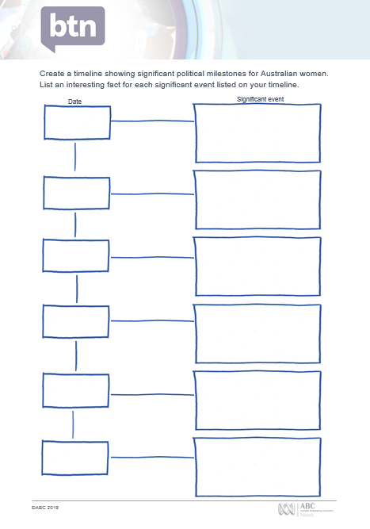
Women in Politics Timeline
Students create a timeline showing significant political milestones for Australian women. Use the timeline template at the end of this activity to record key dates and milestones. Students can use the following questions to guide their research:

- When did women get the right to vote in Australia?
- Which state first gave women the right to vote?
- When were women first given the right to stand for Federal Parliament in Australia?
- When were Australian Aboriginal women given the right to vote?
- Who was the first woman to be elected to the House of Representatives?
- Who was the first woman to be elected in the Senate?
- Who was Australia’s first female prime minister?

Class discussion: What is a biography?
Before students begin to write their biographies, hold a class discussion to find out what they already know about biographical writing. Record students’ responses. Below are some discussion starters:

- What does a biography tell us about a person?
- Where can you look to find information for your biographical writing? It could include the internet, newspaper articles, magazine articles and interviews, other biographies, historical books or television interviews. Why is it important to use more than one source of information?
- What makes a biography interesting? For example, key information and facts, a timeline of events, photographs, illustrations and quotes.

Women in Politics – Create a biography
Students will choose a woman in Australian politics (past or present) and write a biography about them. Using the Biography Organiser template at the end of this activity, students will find and record information about the female politician they have chosen. Some possible areas of research include:
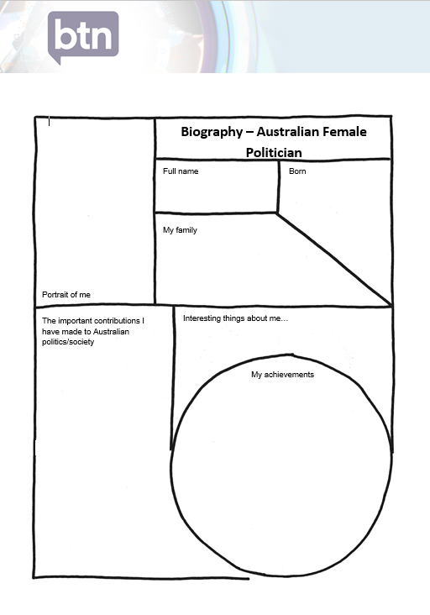
- Where and when were they born? Describe their family life growing up.
- What are some of their achievements? Choose one to explore in more detail.
- What inspired/motivated them to become a politician?
- What were their challenges?
- How do we recognise their achievements?
- How have they made an impact on people’s lives?
- How did they change our understanding of the world?
- What do you admire about them?
- Imagine you could sit down and talk to them. What questions would you ask about their life and work?

Present your findings in an interesting way.
- Give a presentation on their achievements
- Create a portrait
- Make a “Did you know?” for other students
- Write a letter thanking them for their achievements and how they have changed the world
- Create a timeline highlighting significant events

The following BTN story may help students with their research. They can also respond to the questions relating to each story.
BTN History of Voting
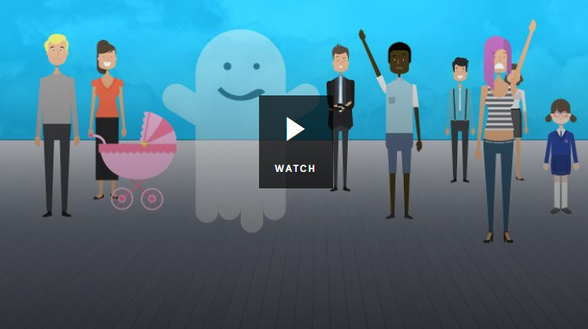
- Who was allowed to vote in Australia in the 1800s?
- What does suffrage mean?
- Who were the suffragettes?
- When did women get the right to vote in Australia?
- When did all Indigenous people get the right to vote in federal elections?
- In which year did the voting age change from 21 to 18 years of age?
- Do you think the right to vote is important? Explain your answer.

BTN Women at Work
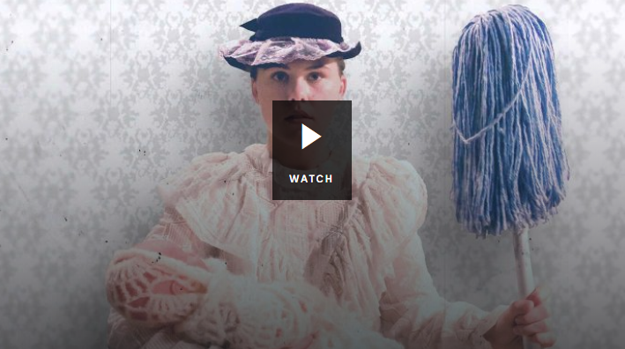
- What changes started to happen for women in the late 1800s?
- Which state was the first to give women the vote?
- How did the Second World War change the role of women?
- After the war, most women were forced to go back to _______________.
- Describe work for women in the 1950s.
- How did women fight for their rights in the 1960s and 1970s?
- How has your thinking changed since watching the Women at Work story?

National Museum Australia – First women in Parliament
https://www.nma.gov.au/defining-moments/resources/first-women-in-parliament
National Museum Australia – Women’s suffrage
https://www.nma.gov.au/defining-moments/resources/womens-suffrage
BTN – History of Voting
http://www.abc.net.au/BTN/classroom/history-of-voting/10524754
BTN – Women at Work
http://www.abc.net.au/BTN/classroom/women-at-work/10523414

Create a timeline showing significant political milestones for Australian women. List an interesting fact for each significant event listed on your timeline.

Date
Significant event




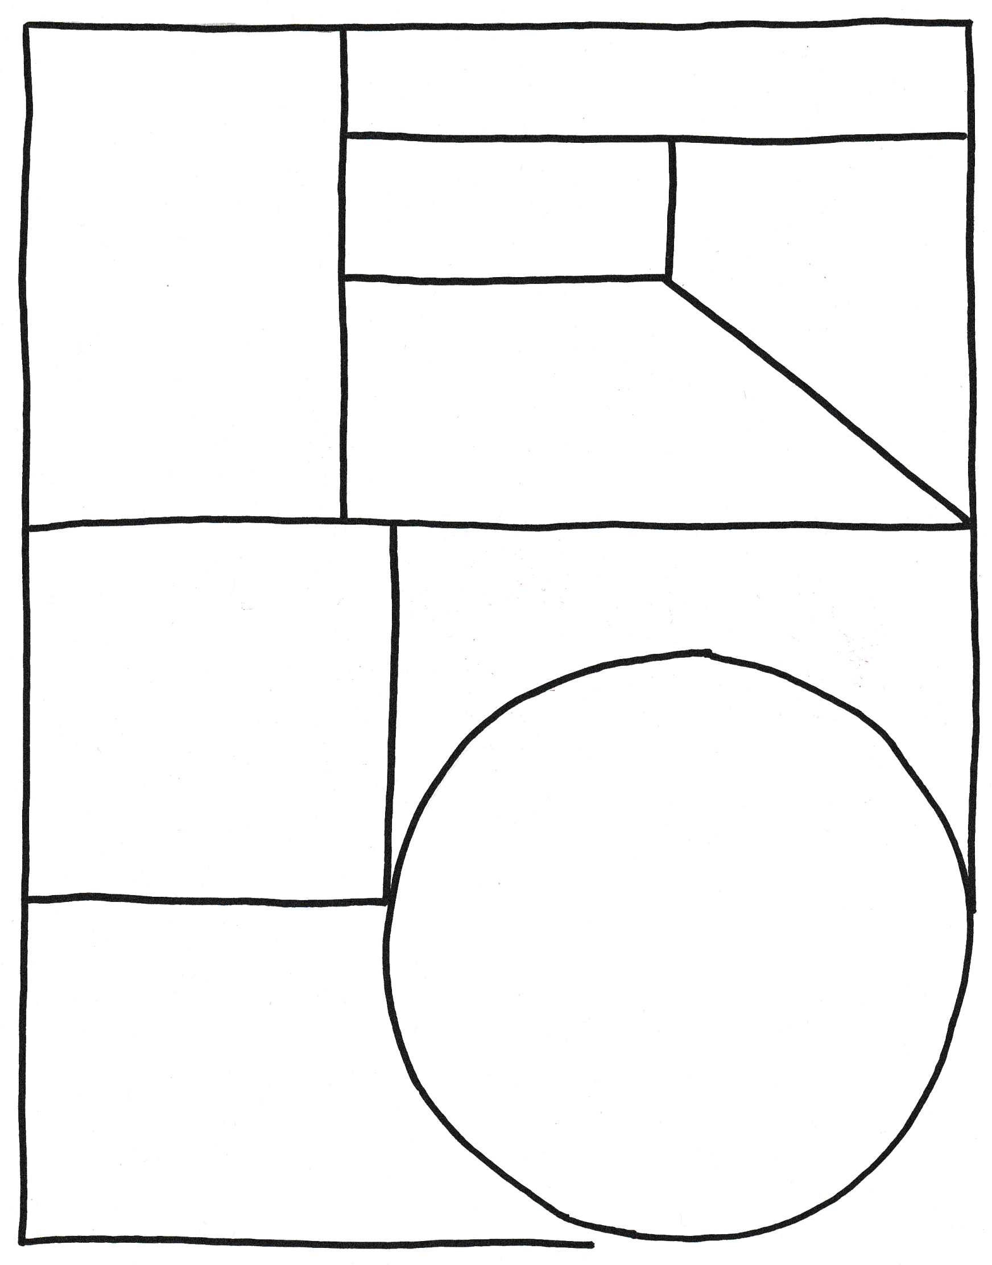
Biography – Australian Female Politician
My family
Full name
Portrait of me
The important contributions I have made to Australian politics/society

Born
My achievements
Interesting things about me…

Teacher Resource
Women at Work

Students will develop a deeper understanding of milestones for women in Australia’s history and create a biography of a significant woman.

History – Year 3
Days and weeks celebrated or commemorated in Australia (including Australia Day, Anzac Day, and National Sorry Day) and the importance of symbols and emblems.

History – Year 6
Experiences of Australian democracy and citizenship, including the status and rights of Aboriginal and Torres Strait Islander Peoples, migrants, women and children.
- Discuss the BTN Women at Work story as a class. What points were raised in the discussion?
- What was it like for women living in the 1800s?
- What changes started to happen for women in the late 1800s?
- Which state was the first to give women the vote?
- How did the Second World War change the role of women?
- After the war, most women were forced to go back to _______________.
- Describe work for women in the 1950s.
- How did women fight for their rights in the 1960s and 1970s?
- What changes still need to be made to make women and men more equal?
- How has your thinking changed since watching the Women at Work story?

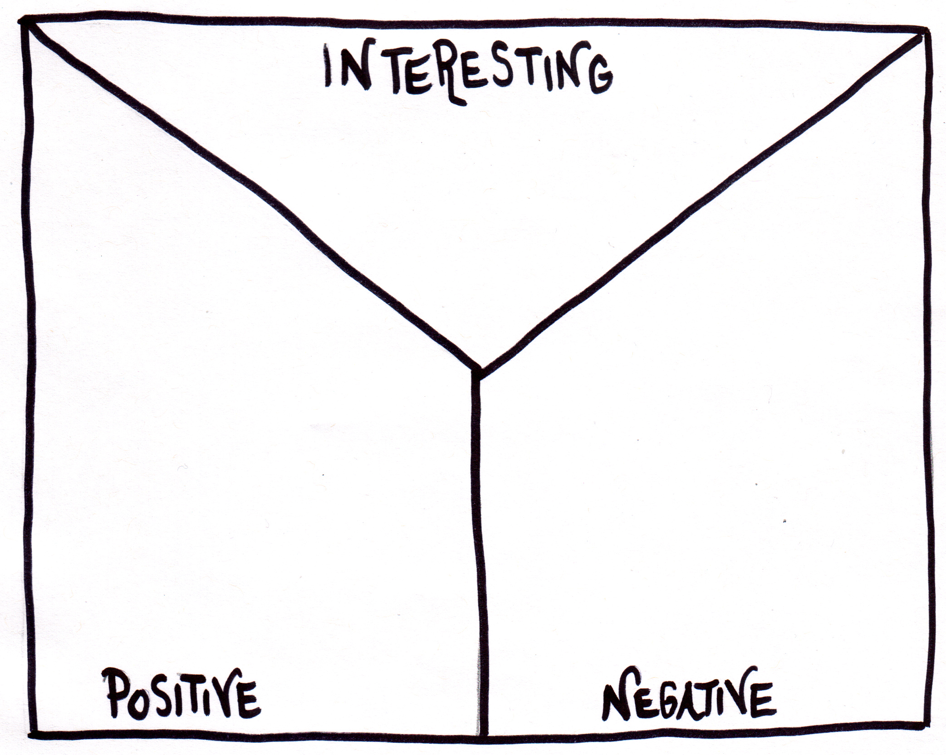
Students will practise their notetaking while watching the BTN Women at Work story. After watching the story, ask students to reflect and organise the information into three categories. Students may want to watch the story again or download a copy of the Women at Work transcript to assist them with this activity. What information was...?
- Positive
- Negative or
- Interesting

Class Discussion
After watching the BTN Women at Work story hold a class discussion. Here are some discussion starters:
- What does gender equality mean to you?
- How did you feel after watching the story?
- What surprised you about the story?
- List some facts that you learnt from this story.
- What challenges have women faced in the past? What challenges do women still face today?
- How would your life be different if people didn’t fight for women’s rights?

Australian Women’s Timeline
Students create a timeline showing significant political, education, legal and social milestones for Australian women. Students can use the following questions to guide their research:

- When did women get the right to vote in Australia?
- Which state first gave women the right to vote?
- When were Australian Aboriginal Women given the right to vote?
- Who was the first woman elected to an Australian parliament?
- Who was Australia’s first female Prime Minister?
- In which year was the first International Women’s Day?

Significant Women – Create a biography
Students will choose a significant woman in Australia’s history and write a biography about them. Ask students to think about the sort of information included in a biography. What does a biography tell us about a person? Some possible areas of research include:

- Where and when was the person born?
- Describe their family life growing up.
- What are some of their achievements? Choose one to explore in more detail.
- What are some of the challenges they have faced?

Who were the suffragettes?
Students will develop an understanding of the suffragette movement and then present their findings in an interesting way.
- What does suffrage mean? Find a dictionary meaning.
- Describe the suffragette movement.
- Imagine you are a suffragette living in the late 1800’s – write a persuasive letter to your local government explaining why women should be able to vote.

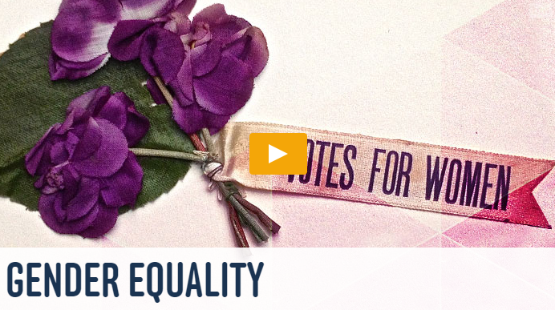
Watch the BTN Gender Equality story then answer the following questions:
- Describe what life was like for women in the 1800s.
- What does suffrage mean?
- Who were the suffragettes?
- What did they do to change things for women?
- Which state was one of the first in the world to give women the right to vote?
- How did war change the role of women in society?
- What were some important changes for women in the 1960s?
- Do you think women have equal rights to men? Explain your answer.
BTN – Gender Equality
http://www.abc.net.au/BTN/story/s3784907.htm
International Women’s Day
https://www.internationalwomensday.com/
National Museum Australia – Women’s Suffrage
http://www.nma.gov.au/online_features/defining_moments/featured/womens_suffrage
National Women’s Alliance – Australian Women’s Timeline
http://timeline.awava.org.au/timeline?m=jr

Teacher Resource

NAIDOC Indigenous Women

Students will choose a significant Indigenous woman to investigate in depth and create a biography about her.

HASS / History – Year 3
Days and weeks celebrated or commemorated in Australia (including Australia Day, Anzac Day, and National Sorry Day) and the importance of symbols and emblems.

HASS – Year 4
Pose questions to investigate people, events, places and issues.

History – Year 6
The contribution of individuals and groups to the development of Australian society since Federation.

Experiences of Australian democracy and citizenship, including the status and rights of Aboriginal and Torres Strait Islander Peoples, migrants, women and children.

Visual Arts – Years 3 & 4
Explore ideas and artworks from different cultures and times, including artwork by Aboriginal and Torres Strait Islander artists, to use as inspiration for their own representations.
- Briefly summarise the BTN story.
- Where was Rosalie Kunoth-Monks born? Find using Google Maps.
- Rosalie Kunoth-Monks is best known for being the first Indigenous women to have a lead role in a film. True or false?
- Why are the songs that Fanny Cochrane Smith recorded on wax cylinders really important?
- Gladys Elphick was a Kaurna and Ngadjuri woman. Locate the traditional lands of Kaurna and Ngadjuri people on a map of Australia.
- Complete this sentence. The Aboriginal Women’s Council campaigned for the ‘yes’ vote in the 1967 ____________.
- How did the Aboriginal Community Centre, that Gladys Elphick set up, help Aboriginal people?
- Who was Truganini?
- Name the different careers that Nova Peris has had.
- What did you learn watching the BTN story? Make a list of three facts.
Aboriginal and Torres Strait Islander readers please note that this document contains images of deceased Indigenous people.

What do you see, think and wonder?
After watching the BTN NAIDOC Indigenous Women story, students will respond to the following questions:

- What did you SEE in this video?
- What do you THINK about what you saw in this video?
- What did you LEARN from this story?
- What was SURPRISING about this story?
- What QUESTIONS do you have about this story?

Students will then write a personal response to the story and leave a comment on the BTN NAIDOC Indigenous Women story page.

Class Discussion
After watching the BTN NAIDOC Indigenous Women story hold a class discussion. Here are some discussion starters:
- What is NAIDOC Week?
- Why do we have NAIDOC Week?
- The theme for NAIDOC Week this year is Because of her, we can! What do you think it means?
- Why do you think the theme was chosen?
- Brainstorm a list of well-known Indigenous women.
- What challenges have Indigenous women faced?

Significant Indigenous Women
Students will choose a well-known Indigenous woman to research and write a biography about. The students in the BTN story chose women that inspire them. The HerStory and NITV websites are a good starting point to help students choose.

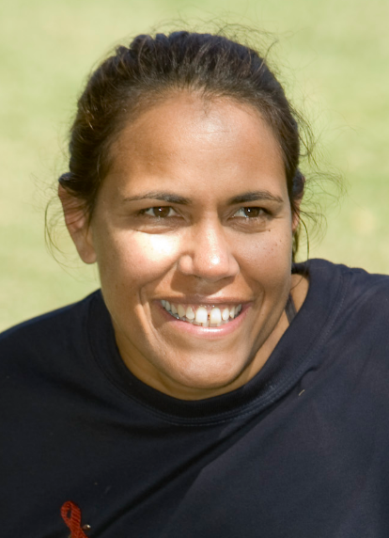
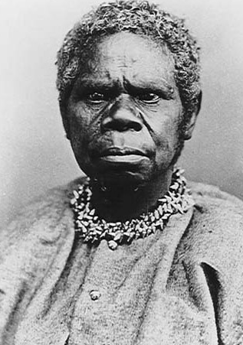
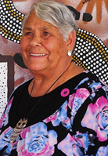

Truganini: Source Cathy Freeman: Source Lowitja O’Donoghue: Source


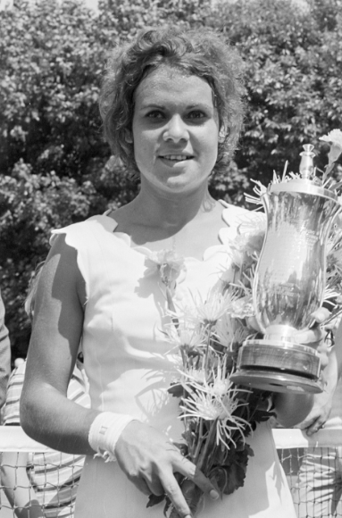
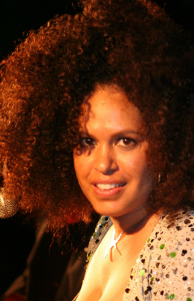

Evonne Goolagong Cawley: Source Jessica Mauboy: Source Christine Anu: Source

What is a biography?
Before students begin to construct their biographies, hold a class discussion to find out what they already know about biographical writing. Below are some discussion starters:

- What does a biography tell us about a person?
- Where can you look to find information for your biographical writing? It could include the internet, newspaper articles, magazine articles and interviews, other biographies, historical books or television interviews. Why is it important to use more than one source of information?
- What makes a biography interesting? For example, key information and facts, a timeline of events, photographs, illustrations and quotes.

Significant Indigenous Women – Create a biography
Using the Biography Organiser template at the end of this activity, students will record information about the significant Indigenous woman they have chosen. Some possible areas of research include:
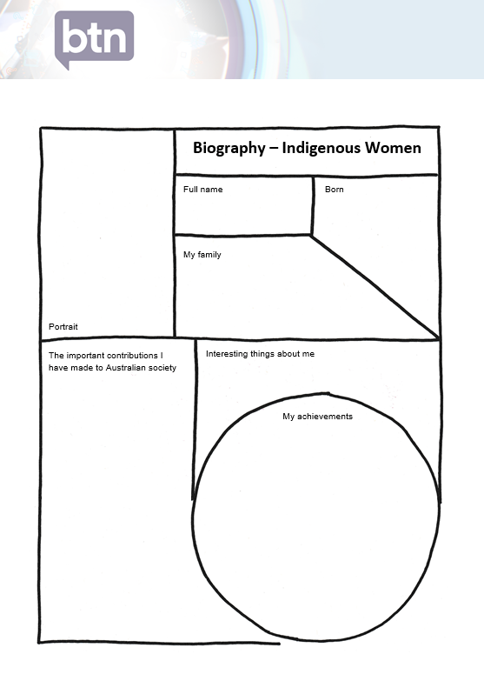
- Where are they from? Locate using Google Maps.
- When were they born? Describe their family life growing up.
- What are some of their achievements? Choose one to explore in more detail.
- What were their challenges?
- How do we recognise their achievements?
- How have they made an impact on people’s lives?
- How did they change our understanding of the world?
- What do you admire about them?

Further investigation
- Imagine you could sit down and talk to them. What questions would you ask about their life and achievements?
- Sketch a portrait of the Indigenous woman you have chosen. Explore and experiment with different techniques and media to produce a portrait. Look at the portraits painted by the students in the BTN story for inspiration.

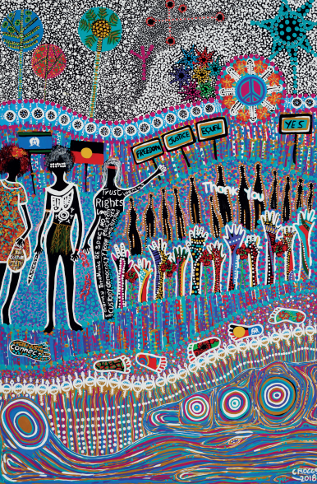
NAIDOC Week Poster
Working in pairs, students examine the NAIDOC Week poster created by Bigambul woman, Cheryl Moggs. Ask them to respond to the following questions:

- How does the artwork reflect the theme of NAIDOC Week?
- What words are in the image? What do they mean?
- What do you like about the artwork? Why?
- What materials and techniques are used?
- What emotions does the artwork evoke/how does it make you feel?

To learn more about the artwork, read the inspiration behind it here In small groups, discuss the three sections of the poster
- Stories of the Stars (top section)
- Connection to Country (middle section)
- Connection to Waterways (lower section)
Students design their own poster based on this year’s theme. Tarmunggie-woman Source

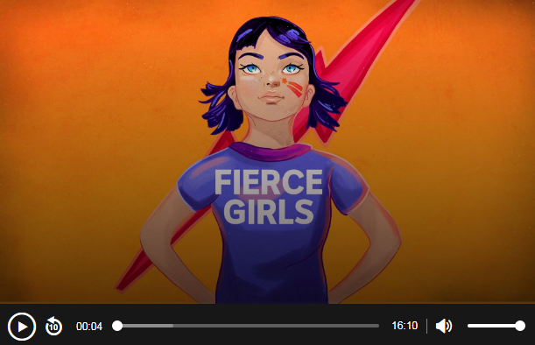
Fierce Girls Podcast – Daisy Bindi
Aboriginal activist Daisy Bindi fought for the rights of Aboriginal workers in the Pilbara strike in Western Australia.

Listen to the Fierce Girls Podcast to learn more about her life and how she advocated for the rights of Indigenous people.

NAIDOC – NAIDOC Week 2018
https://www.naidoc.org.au/
BTN – NAIDOC Art
http://www.abc.net.au/BTN/story/s4487792.htm

My family
Full name
Portrait
The important contributions I have made to Australian society

Born
My achievements
Interesting things about me

Biography – Indigenous Women

